Note that the program is built with the Microsoft net6.0 (<https://dotnet.microsoft.com/en-us/download/dotnet/6.0>)

**Step 1: Load the window form**

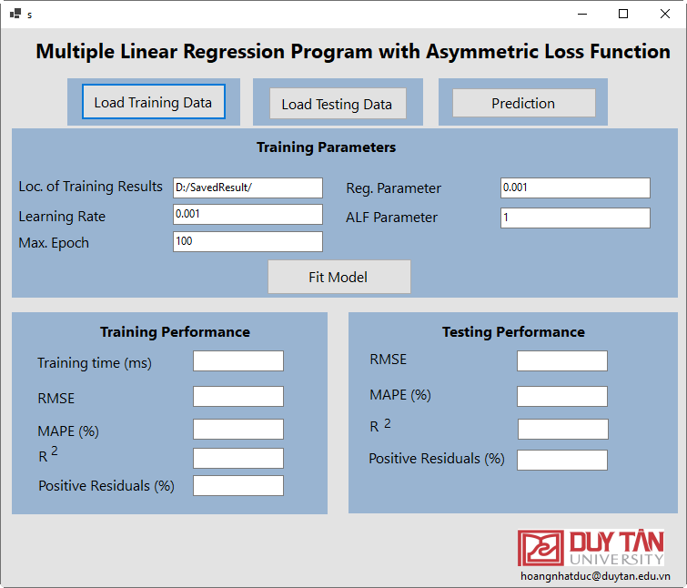

**step 2: Import the training dataset**

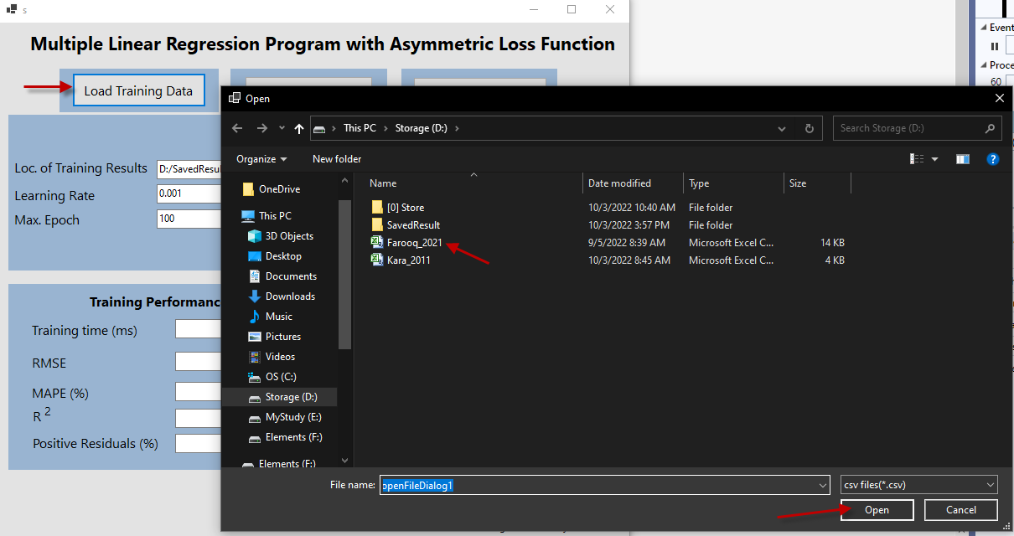

**Step 3: Import the testing dataset**

*Note: For purpose of demonstration, the training and testing dataset are identical. We can randomly split the dataset (e.g. Farooq_2021) into two distinctive subsets (e.g. Trainingset.csv and TestingSet.csv). One is used for training the model. The other one is used for testing the model.*

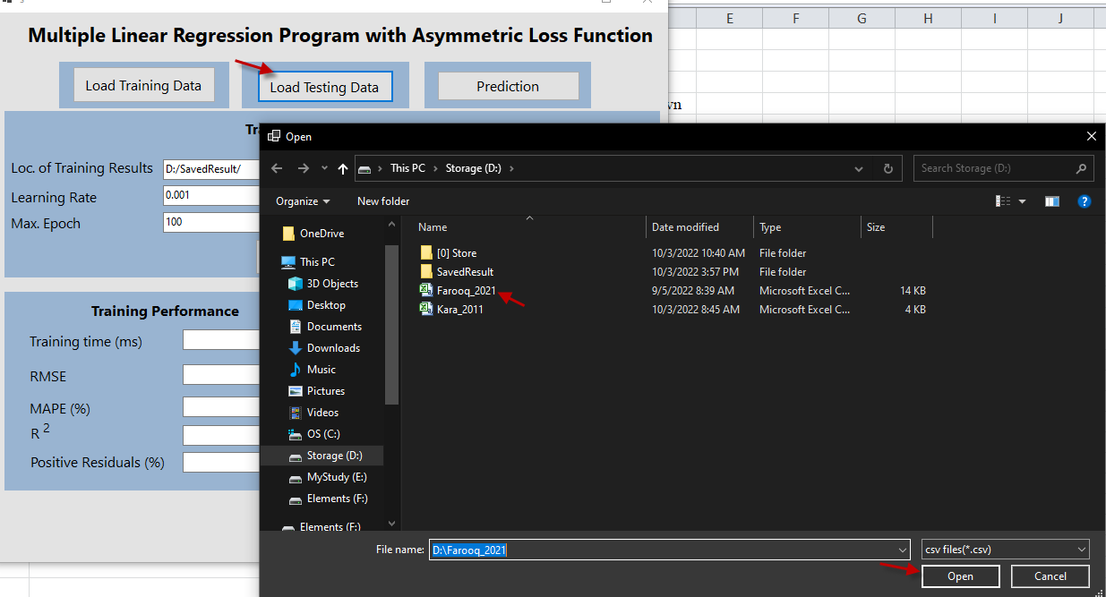

**4. Set the training parameters and press the button Fit Model.**

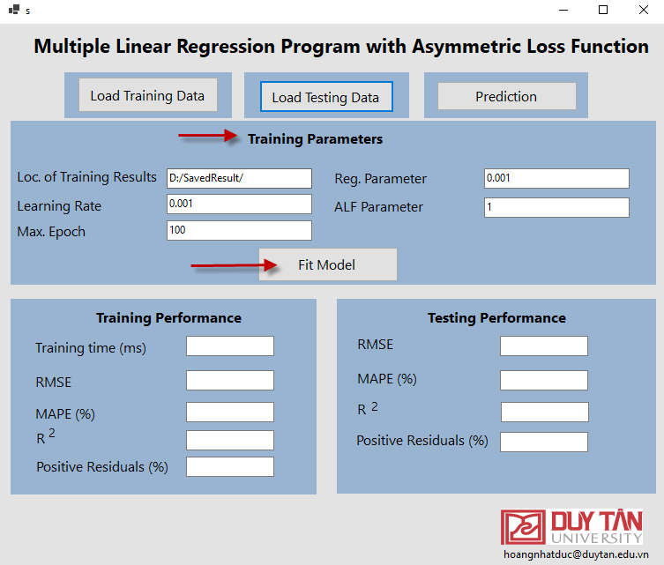

The training performance is presented as follows:

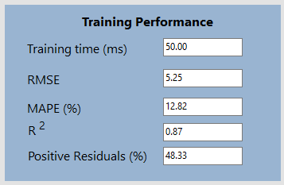

**Step 5: Press the button Prediction to see the testing performance.**

