unnamed-chunk-132.png

unnamed-chunk-133.png

unnamed-chunk-134.png

unnamed-chunk-135.png

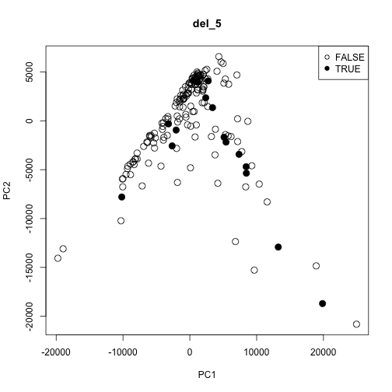

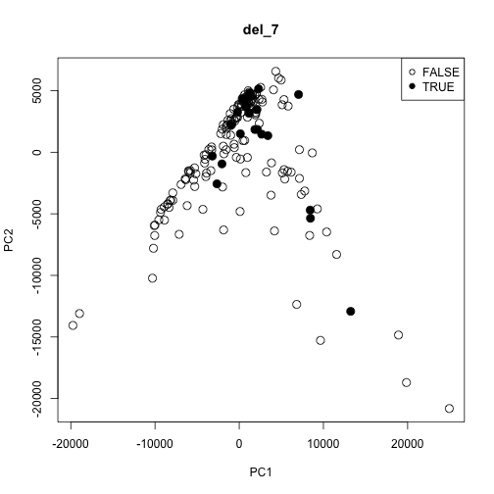



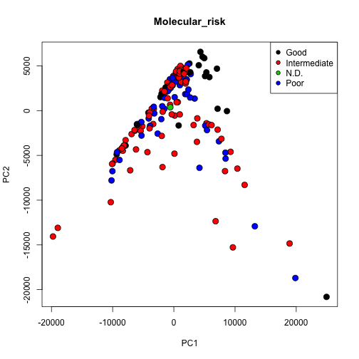

**del_5 result**

## sensetivity specificty

## Basic PCA 0.9448 0.4375

## Kernelized PCA 0.9448 0.1250

**Cytogenetic_risk**

c("Good","Intermediate","Poor"), c(1,0,0)

specificty sensetivity

Basic PCA 0.9580420 0.6363636

Kernelized PCA 0.9090909 0.5757576

c("Good","Intermediate","Poor"), c(1,0,1)

specificty sensetivity

Basic PCA 0.6633663 0.6933333

Kernelized PCA 0.6732673 0.6000000

c("Good","Intermediate","Poor"), c(0,0,1)

specificty sensetivity

Basic PCA 0.8432836 0.4523810

Kernelized PCA 0.7985075 0.3095238

**Molecular_risk**

c("Good","Intermediate","Poor"), c(0,0,1)

specificty sensetivity

Basic PCA 0.8188976 0.3877551

Kernelized PCA 0.7244094 0.4081633