FLOW CHART

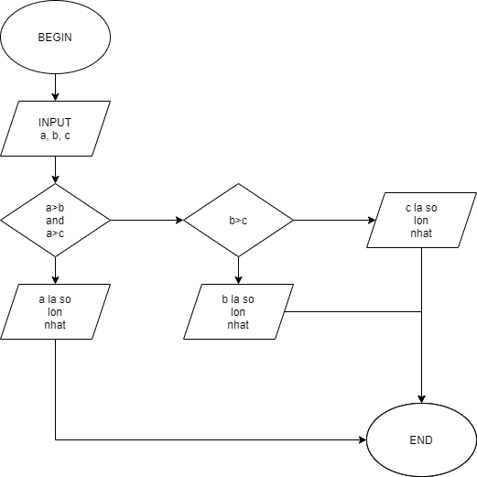

PSEUDO CODE

BEGIN

INPUT a, b, c

IF a>b and a>c THEN

OUTPUT a la so lon nhat

ELSE

IF b>c THEN

OUTPUT b la so lon nhat

ELSE

OUTPUT c la so lon nhat

END IF

END.