Flow chart

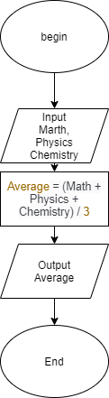

Pesudo-code:

BENGIN

INPUT Marth, Physics, Chemistry

Average=(Marth + Physics + Chemistry) / 3

Output Average

End