Flow Chart

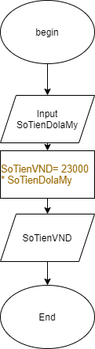

Pesudo code

BEGIN

INPUT SoTienDolaMy

SoTienVND= 23000\* SoTienDolaMy

OUTPUT SoTienVND

END