Flow Chart

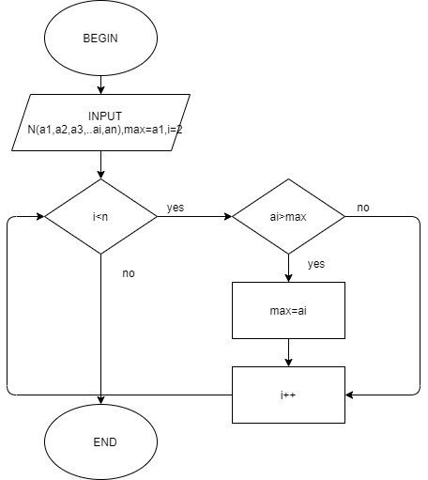

Pesudo Code

BEGIN

INPUT N, (a1, a2, …ai.an)

max=a1

i=2,

WHILE (i<n)

DO

If ai>max THEN

max=ai

END IF

i++

END DO

OUTPUT max

END