BÁO CÁO THỰC HÀNH LAB 03

THỰC HÀNH LẬP TRÌNH HƯỚNG ĐỐI TƯỢNG

Contents

1. Working with method overloading 2

1.1. Overloading by differing types of parameter 2

Code 2

Result 2

1.2. Overloading by differing the number of parameters 4

Code 4

Result 6

2. Passing parameter 7

Code 7

Result 8

3. Class Member and Instance Member 9

Code 9

Result 12

4. Open the Cart class 12

Code 12

Result 15

5. Implement the Store class 16

Code 16

Result 17

6. String, StringBuilder and StringBuffer 18

Code 18

Result 18

7 Class Diagram 21

Table of Figures 22

# Working with method overloading

## Overloading by differing types of parameter

### Code

Figure 1 Method addDigitalVideoDisc(DigitalVideoDisc [] dvdList)

Figure 2 Aims Class

### Result

Figure 3 Result

## Overloading by differing the number of parameters

### Code

Figure 4 Method addDigitalVideoDisc(DigitalVideoDisc [] dvdList)

Figure 5 Aims Class

### Result

Figure 6 Result

# Passing parameter

## Code

Figure 7 Passing parameter code

## Result

Figure 8 Passing parameter result

# Class Member and Instance Member

## Code

Figure 9 Class member and Instance member

## Result

Figure 10 Result

# Open the Cart class

## Code

Figure 11 Code method to print the content in Cart

Figure 12 Code method search by id

Figure 13 Code method search by title

Figure 14 IsMatch() in DigitalVideoDisc class

## Result

Figure 15 CartTest class

Figure 16 Result

# Implement the Store class

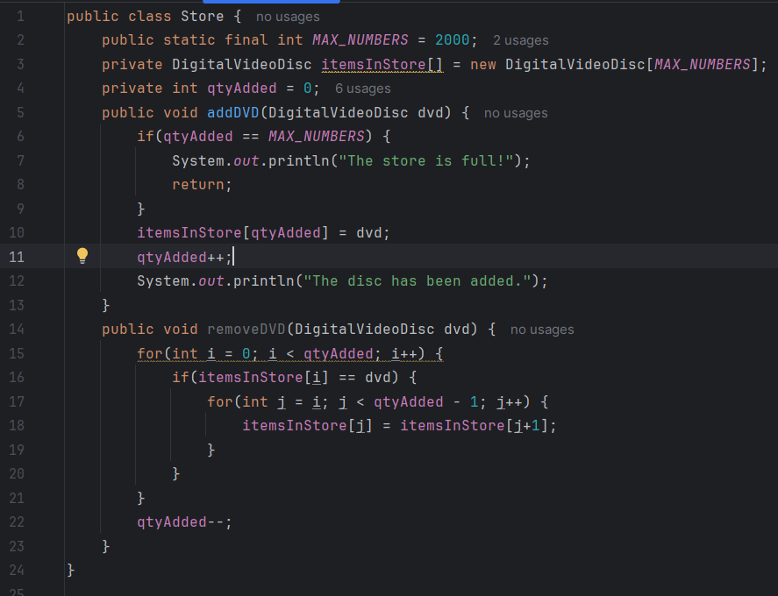

## Code

Figure 17 Store Class

## 

## Result

Figure 18 StoreTest class

Figure 19 Result

# String, StringBuilder and StringBuffer

## Code

## 

## Result

Figure 20 So sánh String và StringBuilder

Figure 21 GarbageCreator class

Figure 22 Result: program hangs

Figure 23 NoGarbage class

Figure 24 Result: Program finishes quickly

# 7 Class Diagram

Figure 25 Class Diagram

# Table of Figures

Figure 1 Method addDigitalVideoDisc(DigitalVideoDisc [] dvdList) 2

Figure 2 Aims Class 2

Figure 3 Result 3

Figure 4 Method addDigitalVideoDisc(DigitalVideoDisc [] dvdList) 4

Figure 5 Aims Class 4

Figure 6 Result 5

Figure 7 Passing parameter code 6

Figure 8 Passing parameter result 6

Figure 9 Class member and Instance member 8

Figure 10 Result 9

Figure 11 Code method to print the content in Cart 9

Figure 12 Code method search by id 10

Figure 13 Code method search by title 10

Figure 14 IsMatch() in DigitalVideoDisc class 10

Figure 15 CartTest class 11

Figure 16 Result 11

Figure 17 Store Class 12

Figure 18 StoreTest class 13

Figure 19 Result 13

Figure 20 So sánh String và StringBuilder 14

Figure 21 GarbageCreator class 14

Figure 22 Result: program hangs 15

Figure 23 NoGarbage class 15

Figure 24 Result: Program finishes quickly 15

Figure 25 Class Diagram 16