###### This is a National Statistics Publication



National Statistics status means that the official statistics meet the highest standards of trustworthiness, quality and public value. They are identified by the quality mark shown above. They comply with the Code of Practice for statistics and are awarded National Statistics status following an assessment by the UK Statistics Authority’s regulatory arm. The Authority considers whether the statistics meet the highest standards of Code compliance, including the value they add to public decisions and debate.

Find out more about the Code of Practice at:  
<https://www.statisticsauthority.gov.uk/osr/code-of-practice/>

Find out more about National Statistics at:  
<https://www.statisticsauthority.gov.uk/national-statistician/types-of-official-statistics/>

Introduction

This report by Information Services Division presents Hospital Standardised Mortality Ratios (HSMR) at Scotland, NHS Board and hospital levels for the latest 12 month period. It includes additional information and commentary on patterns of mortality by key demographic factors. There is extensive information on the development of the measure and how it compares to similar information used in other parts of the UK.

Information Services Division has produced quarterly Hospital Standardised Mortality Ratios for all Scottish hospitals participating in the Scottish Patient Safety Programme since December 2009.

The HSMR methodology used up until May 2019 was agreed in 2015/16. The purpose of the HSMR at that time was to measure change in mortality over time, and to enable acute hospitals to monitor their progress towards the Scottish Patient Safety Programme (SPSP) aim of reducing hospital mortality by a further 10% by December 2018.

The end of this phase of the Scottish Patient Safety Programme provided the opportunity to review the model methodology and subsequently update and refine it, ensuring that the methodology continues to be robust and that comparisons which are made against the national average continue to be appropriate and relevant for each point in time.

**HSMRs published from August 2019 onwards cannot be compared to prior releases using a different methodology.**

These latest statistics reflect completeness of validated hospital SMR01 returns as at 11 January 2020. This information has previously been released to NHS Boards as management information.

Hospital Standardised Mortality Ratios

Hospital Standardised Mortality Ratios (HSMRs) adjust death data (referred to in this report as mortality data) to take account of some of the factors known to affect the underlying risk of death.

The calculation uses information from acute inpatient and day case patients admitted to all medical and surgical specialties in NHSScotland (apart from obstetrics and psychiatry which are excluded). The calculation takes account of patients who died within 30 days from hospital admission. This means that the HSMR also includes deaths that occur outside hospital.

These statistics are updated on a quarterly basis and reflect the HSMR for the latest 12 month reporting period when drawing comparisons against the Scottish average, whilst crude mortality data is presented by quarter to show trends. A link to the relevant Excel data table has also been provided alongside each chart.

How is HSMR calculated?

For a standard population (Scotland) during a three year baseline period, the risk of dying for particular patient subgroups (e.g. age, sex, diagnosis, type of admission, number and severity of illness etc.) is calculated.

This risk is then applied to the corresponding subgroups in different hospitals to calculate how many deaths would be predicted to occur in that hospital if the standard level of risk was applied.

This predicted figure is then compared with the actual observed number of deaths that did occur within the hospital to give the standardised ratio.

**HSMR = Observed Deaths / Predicted Deaths**

Main Points

* For the period October 2018 to September 2019 no hospitals had a significantly higher standardised mortality ratio than the national average.
* For the period October 2018 to September 2019 one hospital had a significantly lower standardised mortality ratio than the national average: Western General Hospital (0.78)
* Over the five year period from October 2014 to September 2019, although exhibiting clear seasonal patterns, unadjusted hospital mortality has remained relatively stable at around 3%.
* Non-elective admissions consistently account for the largest proportion of deaths within 30-days of admission.
* Patients from the least deprived areas of Scotland consistently have lower levels of crude 30-day mortality than patients from more deprived areas.
* Almost three quarters of deaths within 30-days of admission take place in hospital with the other quarter of deaths in community.
* The next update, reporting on admissions to 31 December 2019, will be published on Tuesday 12 May 2020.

Comparing HSMR with Previous Years

During 2018/19, ISD undertook a review of the methodology used to calculate HSMR. A [Review Paper](http://www.isdscotland.org/Health-Topics/Quality-Indicators/HSMR/Research-and-Development/_docs/HSMR-Model-Review-Discussion-Paper.pdf) was subsequently produced with recommendations for refining the model following the end of the Scottish Patient Safety Programme aim. The methodology used by ISD was updated in August 2019. Please note HSMR quarterly releases from August 2019 onwards are not comparable to previous releases.

The main changes made to the HSMR methodology at this time were to:

* Move to a dynamic three year base period, advanced by three months with each reporting period, ensuring the Scottish HSMR is always representative of current outcomes and reflective of changing case-mix and provision of services.
* Move to a twelve month reporting period – rather than three months – when drawing comparisons against the national average, smoothing out seasonal variation and reducing variation for smaller hospitals.
* Use less aggregated specialty groupings to improve performance of the model and allow more in-depth analysis.

A **[Technical Document](http://www.isdscotland.org/Health-Topics/Quality-Indicators/HSMR/Methodology)** is available on how the HSMR is currently calculated and describes the methodology used in more detail. [**Interpretation Guidance and Frequently Asked Questions**](http://www.isdscotland.org/Health-Topics/Quality-Indicators/HSMR/FAQ/) documents are also available, answering questions on the differences between the previous and current methodologies.

Interpreting HSMR results

### Point in time comparison

The Scottish HSMR is 1.00:

* If an HSMR value for a hospital is less than one: This means the number of deaths within 30 days of admission for this hospital is fewer than predicted.
* If an HSMR value for a hospital is greater than one: This means the number of deaths within 30 days for this hospital is more than predicted.

If the number of deaths is more than predicted this does not necessarily mean that these were avoidable deaths (i.e. that they should not have happened), or that they were unexpected, or attributable to failings in the quality of care. Trends in HSMR are impacted by variations in case mix and coding practices over the period, as such crude mortality is used to monitor change over time.

How HSMR information is used

Safety is a priority ambition for the **[Healthcare Quality Strategy for NHSScotland](http://www.scotland.gov.uk/Topics/Health/Policy/Quality-Strategy)** and a lower HSMR should reflect work in individual hospitals to review mortality, and reflect reduction in serious adverse events and infections under the Scottish Patient Safety Programme and other improvement initiatives.

**Health Improvement Scotland** reviews the data, alongside other indicators, with the Information Services Division to identify potential areas for further exploration. Healthcare Improvement Scotland offer advice/support to NHS Boards, on request, about using hospital mortality data to help learn about and improve the quality of patient care.

**The Scottish Government** use these statistics to: monitor hospital mortality; inform policy decision making; respond to parliamentary and public business. One example of this was in the commissioning of the **[NHS Lanarkshire Rapid Review Assessment](http://www.healthcareimprovementscotland.org/our_work/governance_and_assurance/programme_resources/nhs_lanarkshire__review.aspx)**.

**NHS Boards** use these statistics to reflect on the quality of patient care, monitor local hospital mortality and report on their progress. A considerable amount of activity is being carried out in individual hospitals nationwide to use this tool to reflect on clinical practice and facilitate improvements in patient care.  
In addition, a guide for NHS Boards –has been developed **[‘Using the Hospital Standardised Mortality Ratio to help improve patient care’](http://www.healthcareimprovementscotland.org/his/idoc.ashx?docid=712b01d0-1cbc-4c2f-8c9e-bb3bf4086a16&version=-1)**. To help local users better understand their data, and to encourage a sense of ownership of the information an infrastructure has been put in place, in partnership between ISD and Healthcare Improvement Scotland, offering:

* sub-group analysis;
* individual audit of case-listing;
* our assistance in interpretation of the national statistics and local intelligence.

1 Results and Commentary

### Point in Time Comparisons

A funnel plot is a type of ‘Statistical Process Control’ chart that helps to show data at a particular point in time. Funnel plots in this report allow comparisons to be made between each hospital and the average for Scotland for a particular period. Please refer to the Funnel Plots appendix for further information on interpretation.

Chart 1 shows the funnel plot for the latest 12 month period. This shows that there are no hospitals above the upper control limit which is three standard deviations above the Scottish average. This also shows that there is one hospital below the lower control limit which is three standard deviations below the Scottish average: Western General Hospital (0.78).

Chart 1: HSMR for deaths within 30-days of admission (Funnel Plot); October 2018 to September 2019

The data relating to this chart can be found in [Table1](http://www.isdscotland.org/Health-Topics/Quality-Indicators/Publications/2020-02-11/2020-02-11-Table1-HSMR.xlsx) 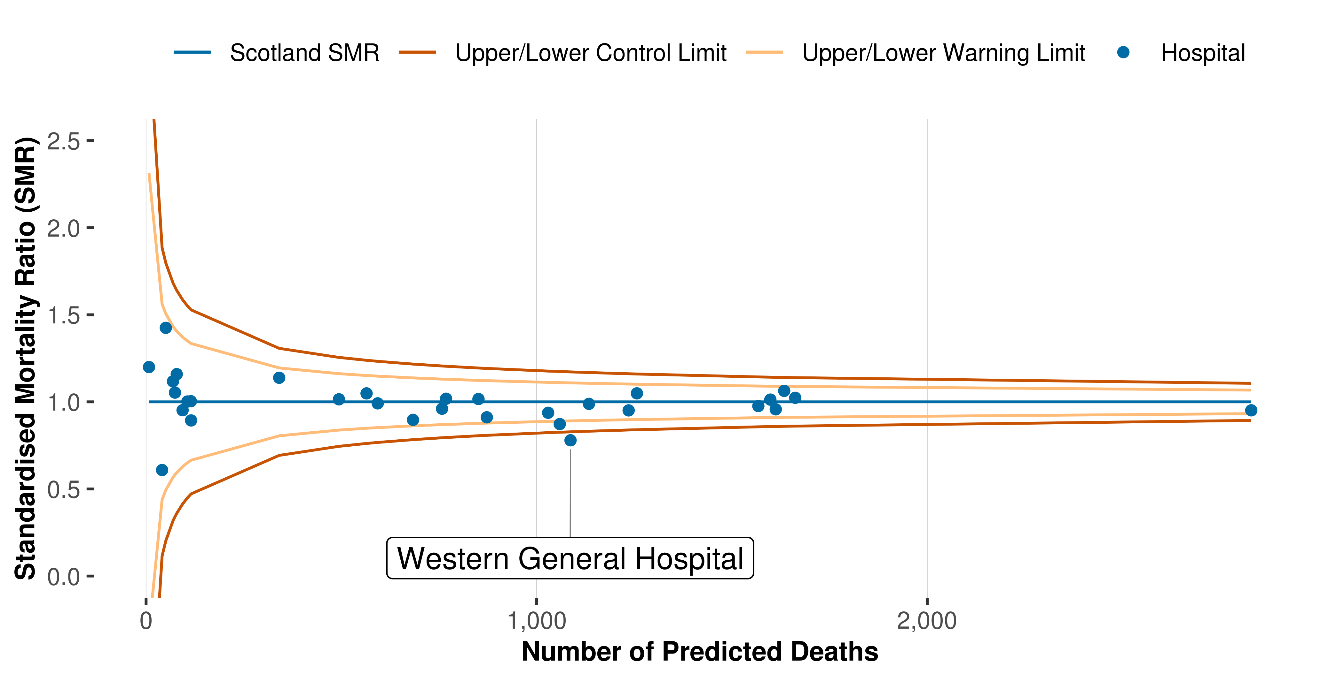

2 Trends at Scotland Level

### Scotland Crude Mortality Trends

Chart 2 shows that overall crude hospital mortality (%) at Scotland level from October to December 2014 to July to September 2019, according to the existing definition of deaths within 30-days of admission, is fluctuating around 3% with clear seasonal patterns exhibited. This means crude mortality is consistently higher around winter quarters (i.e. October - December and January - March).

Chart 2: Overall crude mortality rates (%) for deaths within 30-days of admission; Scotland, Oct-Dec 2014 to Jul-Sep 2019p

The data relating to this chart can be found in [Table 2](http://www.isdscotland.org/Health-Topics/Quality-Indicators/Publications/2020-02-11/2020-02-11-Table2-Crude-Mortality-Subgroups.xlsx) 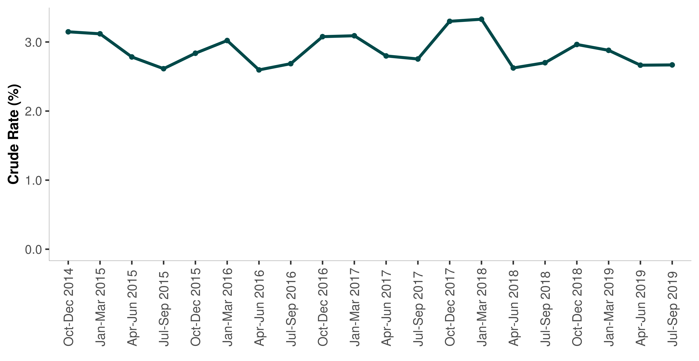

3 Scotland (Sub-Groups)

### Scotland – by type of admission

HSMR is by definition an overall indicator that encapsulates mortality outcomes against overall hospital activity. It is possible to examine trends in the same 30-day mortality outcome for some of the underlying factors. Chart 3 shows the mortality trend according to admission type (i.e. whether the patient was an elective or non-elective admission). It shows that non-elective patients consistently account for the largest proportion of deaths within 30-days of admission.

Chart 3: Crude mortality rates (%) for deaths within 30-days of admission by type of admission; Scotland, Oct-Dec 2014 to Jul-Sep 2019p

The data relating to this chart can be found in [Table 2](http://www.isdscotland.org/Health-Topics/Quality-Indicators/Publications/2020-02-11/2020-02-11-Table2-Crude-Mortality-Subgroups.xlsx) 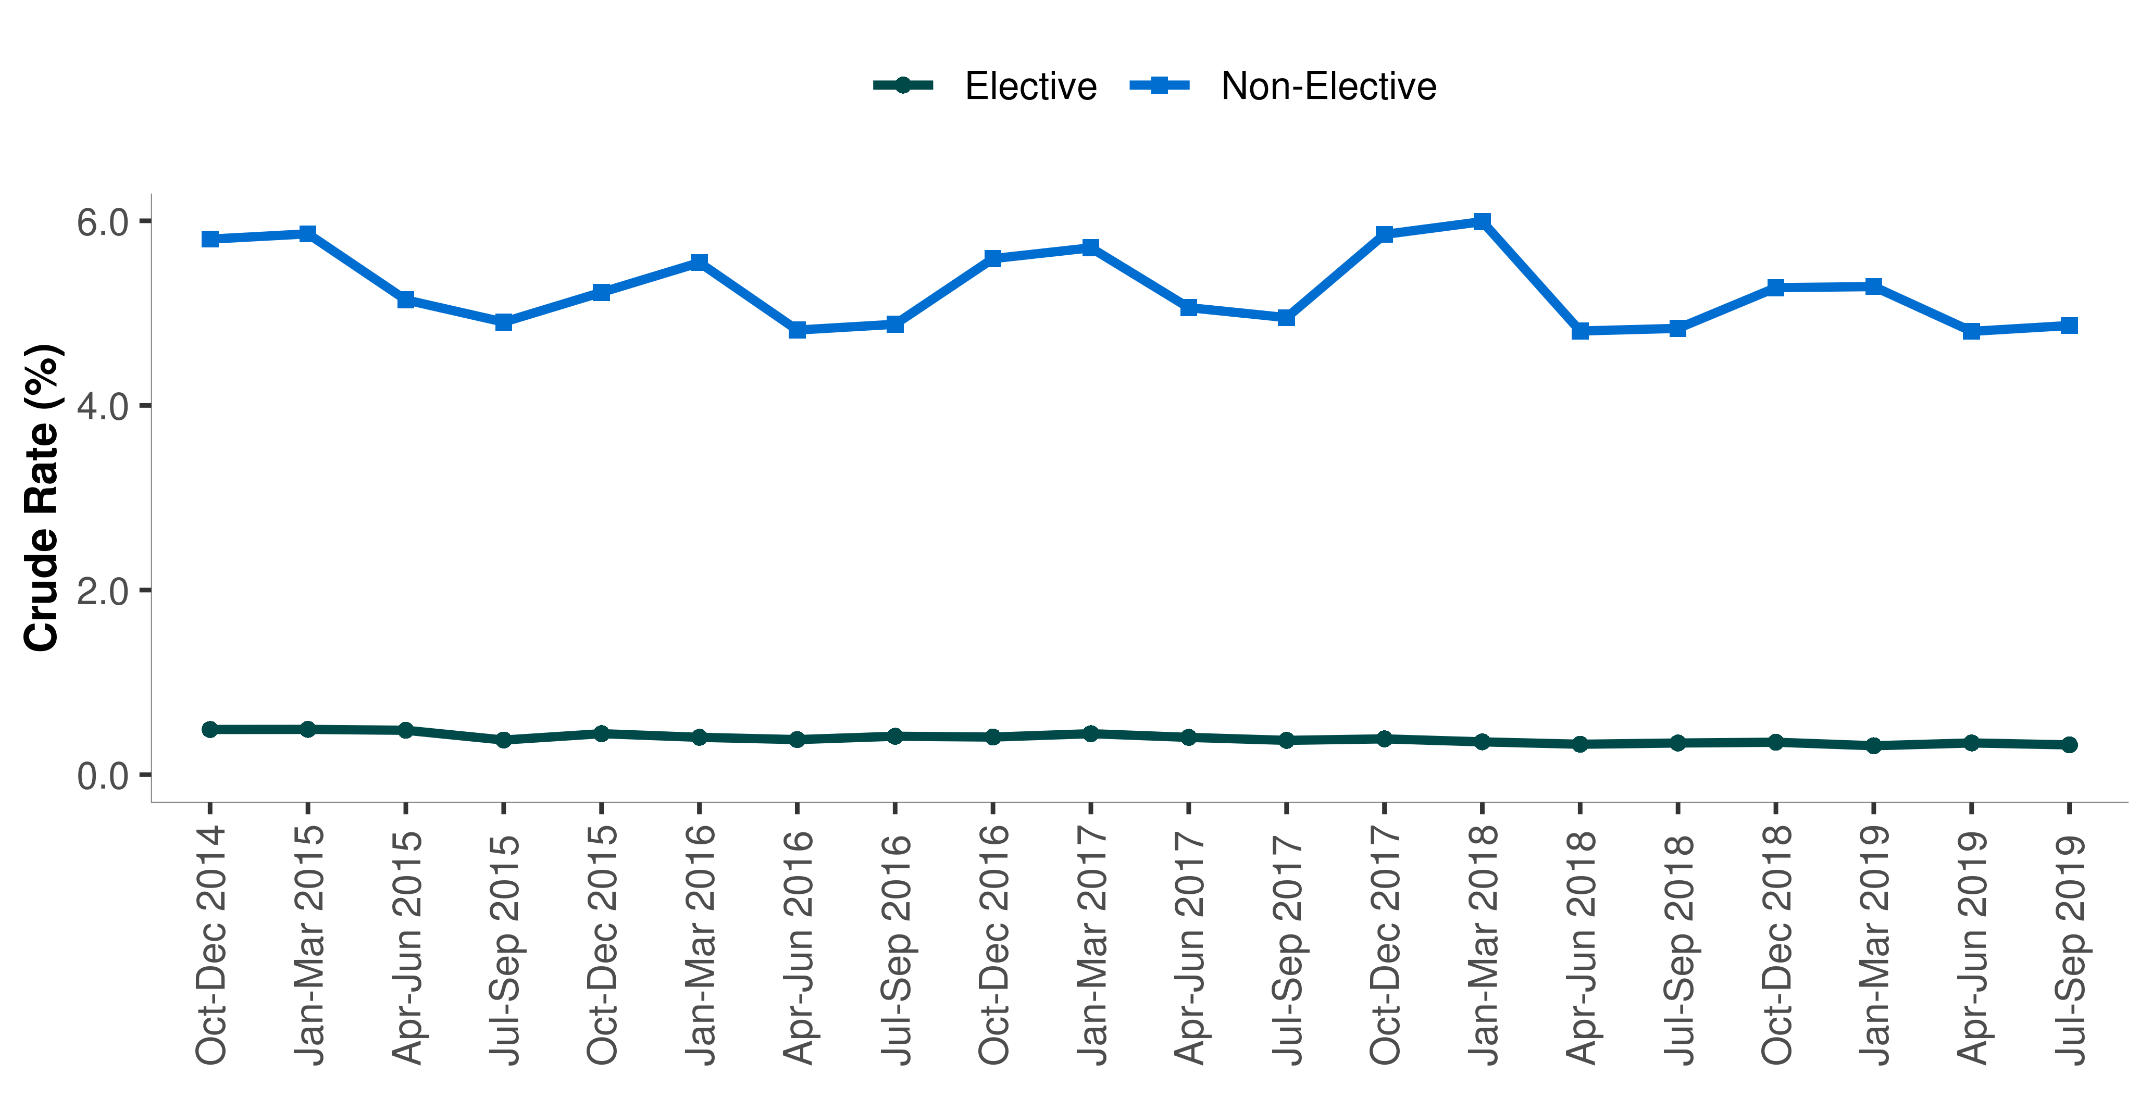

Scotland – by specialty

Chart 4 shows the mortality trend according to seven distinct specialty groups. Specialty group is classified according to the specialty of the consultant/GP/HCP who is in charge of the patient episode. It shows that patients under the Community specialty have the highest rate of crude mortality within 30-days of admission, followed by medical and then surgical. Those recorded under Dental or Women and Newborn specialty having the lowest rate.

Chart 4: Crude mortality rates (%) for deaths within 30-days of admission by specialty group; Scotland, Oct-Dec 2014 to Jul-Sep 2019p

The data relating to this chart can be found in [Table 2](http://www.isdscotland.org/Health-Topics/Quality-Indicators/Publications/2020-02-11/2020-02-11-Table2-Crude-Mortality-Subgroups.xlsx) 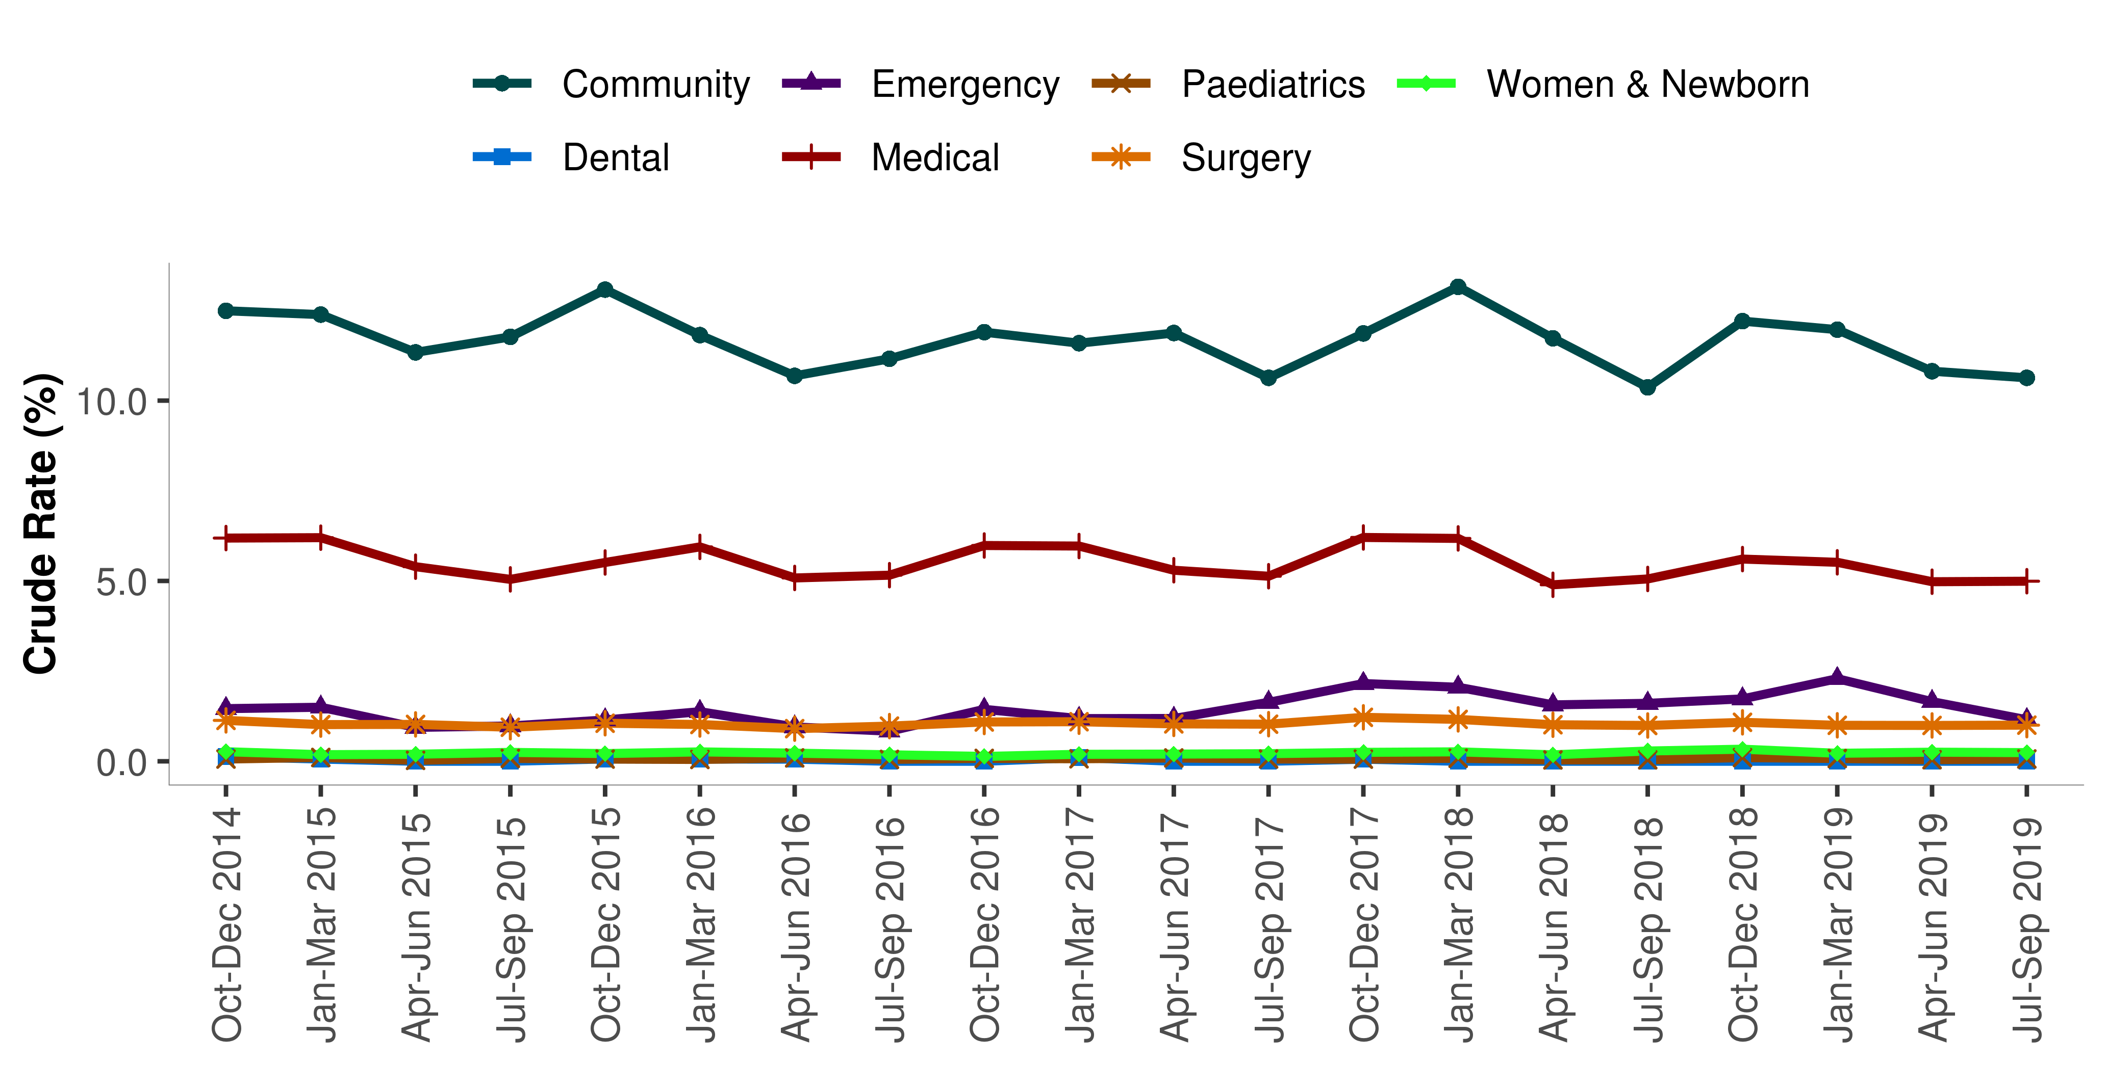

Scotland – by age

Chart 5 shows that mortality within 30-days of admission increases with age.

Chart 5: Crude mortality rates (%) for deaths within 30-days of admission by age group; Scotland, Oct-Dec 2014 to Jul-Sep 2019p

The data relating to this chart can be found in [Table 2](http://www.isdscotland.org/Health-Topics/Quality-Indicators/Publications/2020-02-11/2020-02-11-Table2-Crude-Mortality-Subgroups.xlsx) 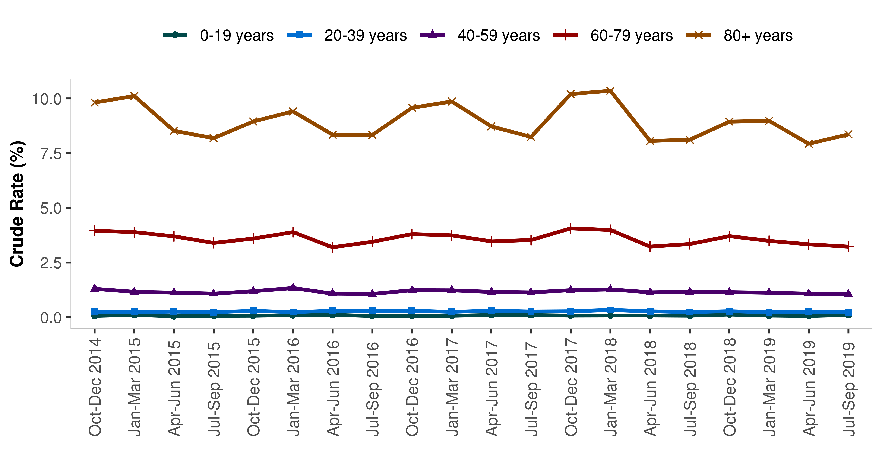

Scotland – by Gender

Chart 6 shows that mortality rates are consistently higher for males throughout the time period. The difference between the mortality for males and females has also remained relatively constant.

Chart 6: Crude mortality rates (%) for deaths within 30-days of admission by gender; Scotland, Oct-Dec 2014 to Jul-Sep 2019p

The data relating to this chart can be found in [Table 2](http://www.isdscotland.org/Health-Topics/Quality-Indicators/Publications/2020-02-11/2020-02-11-Table2-Crude-Mortality-Subgroups.xlsx) 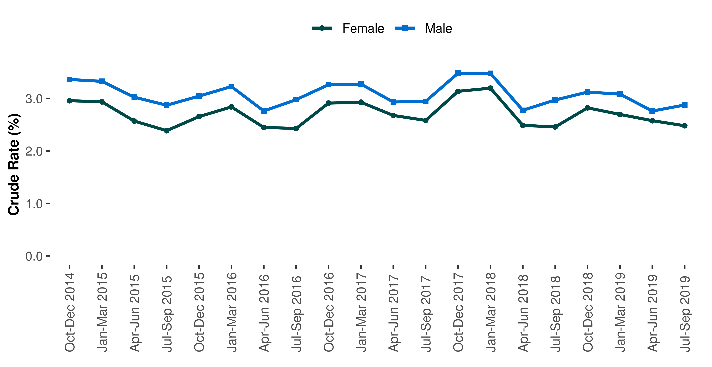

Scotland – by Scottish Index of Multiple Deprivation

The Scottish Index of Multiple Deprivation identifies small area concentrations of multiple deprivation across all of Scotland in a consistent way. It identifies small area concentrations of multiple deprivation across all of Scotland based on six domains - employment, income, health, education, access and crime.

Chart 7 shows that patients from the least deprived areas of Scotland consistently have lower levels of 30-day mortality than patients from more deprived areas.

Chart 7: Crude mortality rates (%) for deaths within 30-days of admission by deprivation; Scotland, Oct-Dec 2014 to Jul-Sep 2019p

The data relating to this chart can be found in [Table 2](http://www.isdscotland.org/Health-Topics/Quality-Indicators/Publications/2020-02-11/2020-02-11-Table2-Crude-Mortality-Subgroups.xlsx) 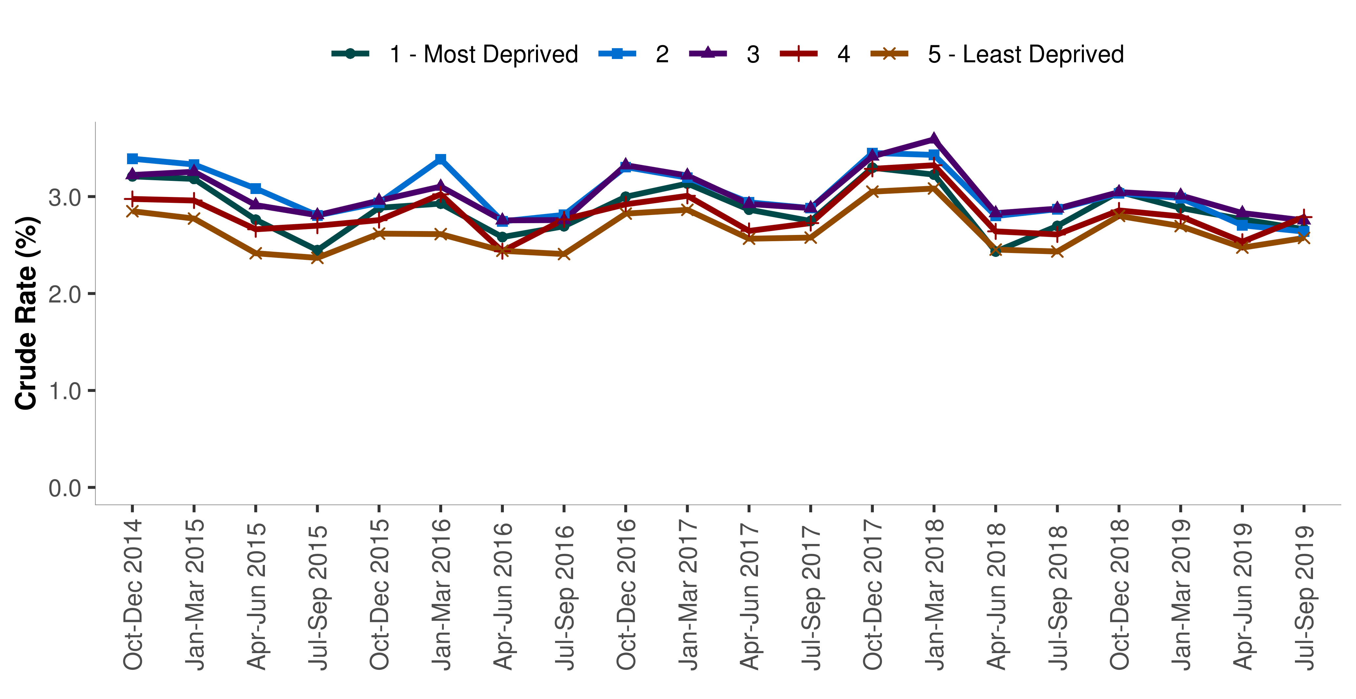

Scotland – by Place of Death

Chart 8 shows the proportion of deaths within 30 days of admission by place of death (i.e. in-hospital or in community). A quarter of these deaths occured in the community with the remaining three quarters taking place in hospital.

Chart 8: Proportion of deaths within 30-days of admission by place of death; Scotland, Oct-Dec 2014 to Jul-Sep 2019p

The data relating to this chart can be found in [Table 2](http://www.isdscotland.org/Health-Topics/Quality-Indicators/Publications/2020-02-11/2020-02-11-Table2-Crude-Mortality-Subgroups.xlsx) 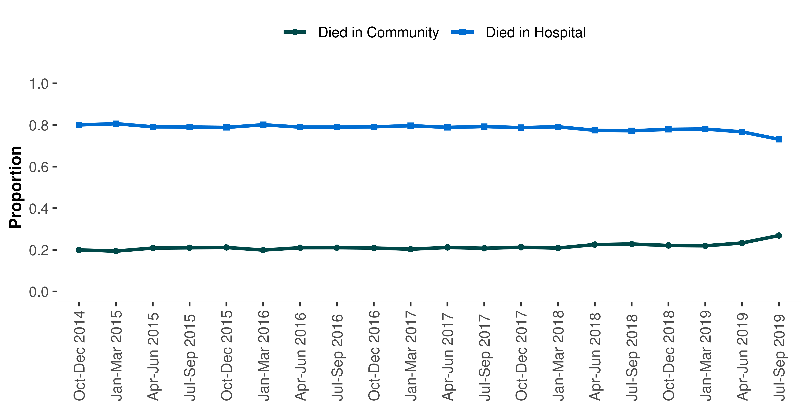

Hospital and NHS Board Level

HSMR data are provided by ISD to allow an individual hospital to monitor its mortality in comparison to the National average. The process is not designed to compare hospitals. Trends in crude mortality are provided to allow individual hospitals to monitor variation over time.

**NHS Fife:** In order to reflect current service configuration, an HSMR is not reported on separately for Queen Margaret Hospital as this site does not include any acute wards.

### Combined Institutions

In order to reflect current service configuration, some hospitals are presented as combined institutions for the purposes of these reports. This applies to the following NHS Boards.

* **NHS Greater Glasgow and Clyde**: In order to reflect current service configuration, the HSMRs for Stobhill Hospital and Glasgow Royal Infirmary have been combined as have the activity for Royal Alexandra Hospital and Vale of Leven. These changes have been applied to all time points retrospectively back to the initial reporting period. In addition NHS Greater Glasgow & Clyde combine any activity (historic or current) from Blawarthill Hospital, Drumchapel Hospital, Glasgow Homoeopathic Hospital, Knightswood Hospital, and Beatson Oncology Centre with West Glasgow Hospital data. Please note that the Queen Elizabeth University Hospital opened to patients in April 2015, with services from the Southern General, old Victoria Infirmary and old Western Infirmary/ Gartnavel transferred to this new hospital.

Individual hospital level data for any combined sites are available on request.

In-patient mortality and deaths within 30-days of discharge

Chart 9 shows the trend in mortality at Scotland level according to a definition similar to the Summary Hospital-level Mortality Indicator in England. SHMI takes account of in-patient mortality and deaths within 30-days of discharge. The Scottish HSMR does not include patients that die in-hospital more than 30-days from admission. In Scotland the decision was to associate the outcome with decisions made at the point of admission (see Inter-UK Comparisons: England and Wales section for more information on the differences between the Scottish and English approaches).

For the latest quarter (July to September 2019) there were 5861 deaths within 30-days of admission to hospital in Scotland, and 6843 deaths within 30-days of ultimate hospital discharge (including all in-hospital deaths). The mortality rates are inevitably higher than the admission-based method, reflecting the longer opportunity for follow-up. The trend is however consistent with the admission based mortality patterns, and show that although exhibiting seasonal variation, hospital mortality had been showing a general decrease over time, with exception of the winter of 2017/18 where mortality rates were back at similar levels to those prior to the baseline period.

Chart 9: Crude mortality rates (%) for deaths within 30-days of ultimate hospital discharge (includes all in-hospital mortality); Scotland, Oct-Dec 2014 to Jul-Sep 2019p

The data relating to this chart can be found in [Table 3](http://www.isdscotland.org/Health-Topics/Quality-Indicators/Publications/2020-02-11/2020-02-11-Table3-Crude-Mortality-population-based-and-30-day-from-discharge.xlsx) 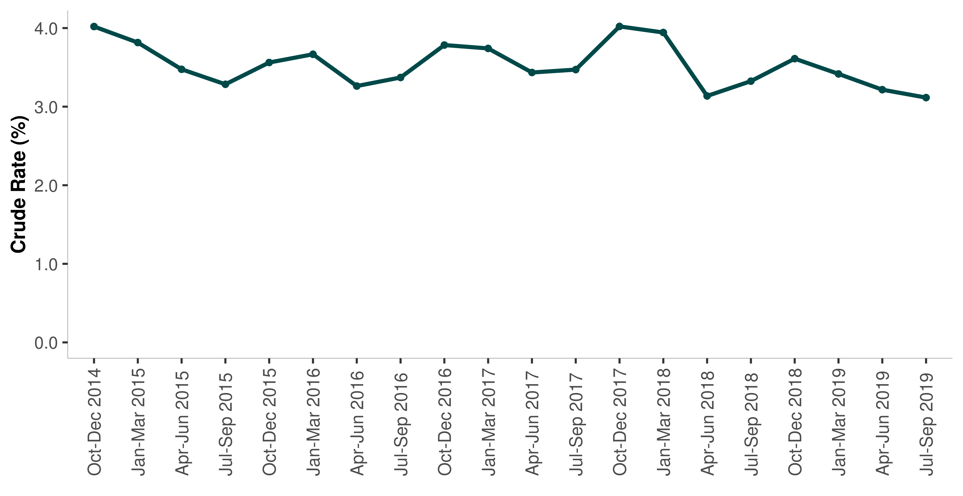

[Table 3](http://www.isdscotland.org/Health-Topics/Quality-Indicators/Publications/2020-02-11/2020-02-11-Table3-Crude-Mortality-population-based-and-30-day-from-discharge.xlsx) provides a chart similar to Chart 9 containing the trend for each NHS Board of treatment plotted against Scotland.

Population-based Mortality

Trends in crude death rates are useful for getting an overall picture of the number of deaths relative to the population.

Trends in crude underlying population mortality rates have been derived from the total number of deaths (numerator), and mid-year population estimates (denominator), both available from the National Records of Scotland at Scotland level and by NHS Board of residence.

Chart 10 shows the trend in overall population mortality for Scotland between October to December 2014 and July to September 2019. The series, although exhibiting seasonal characteristics, has remained relatively stable over the last three years.

Chart 10: Underlying Population Death Rates (crude rates per 1,000 population); Scotland, Oct-Dec 2014 to Jul-Sep 2019p

The data relating to this chart can be found in [Table 3](http://www.isdscotland.org/Health-Topics/Quality-Indicators/Publications/2020-02-11/2020-02-11-Table3-Crude-Mortality-population-based-and-30-day-from-discharge.xlsx) 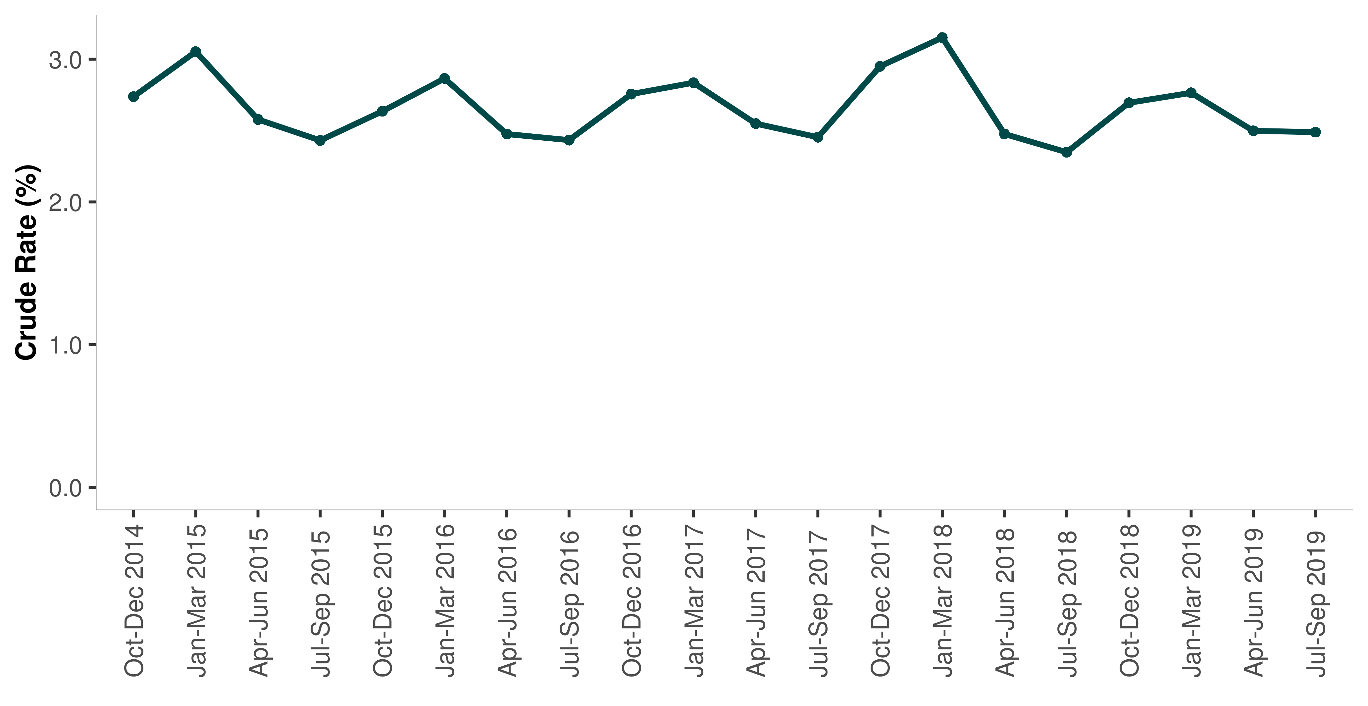

[Table 3](http://www.isdscotland.org/Health-Topics/Quality-Indicators/Publications/2020-02-11/2020-02-11-Table3-Crude-Mortality-population-based-and-30-day-from-discharge.xlsx) provides a series of mortality charts for the resident populations of each NHS Board area.

Data Files

The latest NHSScotland data from **Oct-Dec 2014 to Jul-Sep 2019** and comparable information by NHS Board of treatment and Hospital are given in the Excel files that accompany this publication. Please note the following.

**Table 1 – HSMR**  
Table 1 presents: hospital-level HSMR on a **funnel plot** for each rolling 12 month period since April 2018, allowing comparisons to be made between each hospital and the average for Scotland for that particular period.

**Table 2 – Overall 30-day crude mortality demographics for NHS Scotland**  
The data within Table 2 provides overall crude mortality rates by hospital, and crude mortality demographics for NHSScotland. The following series of tables and charts are presented for the latest five year period:

* Overall crude mortality rates (%) for deaths within 30-days of admission
* Overall crude mortality rates (%) for deaths within 30-days of admission by:
  + type of admission
  + age group
  + specialty group
  + sex
  + deprivation
* Proportion of deaths (%) within 30-days of admission by place of death

**Table 3 – Crude mortality from discharge, and population based mortality rates**  
The data within Table 3 contains a ‘drop-down’ selection option for NHSScotland and any of the NHS Boards. The following series of tables and charts are presented.

* Crude mortality rates (%) within 30-days of ultimate hospital discharge (including all in-hospital deaths)
* Crude population mortality rates (%).

These results have also been published in an interactive dashboard format. A link to the latest dashboard is available on the HSMR webpage.

Refinements to HSMR Methodology

Since the HSMR statistics were first released in 2009, ISD have periodically reviewed the model methodology to ensure that it continues to be robust and that comparisons which are made against the national average continue to be appropriate and relevant for each point in time.

Any improvements needed to be balanced against the overall policy strategy and purpose of the HSMR which, since 2016, was to monitor progress towards the Scottish Patient Safety Programme aim of reducing mortality by a further 10% by end December 2018. The end of this phase of the SPSP provided the opportunity to review the model methodology for a second time (the last significant review took place in 2015/16) and subsequently update/refine it.

The main changes made to the HSMR methodology from August 2019 were:

* Moving to a dynamic three year base period, advanced by three months with each reporting period, ensuring the Scottish HSMR is always representative of current outcomes and reflective of changing case-mix and provision of services.
* Move to a twelve month reporting period – rather than three months – when drawing comparisons against the national average, smoothing out seasonal variation and reducing variation for smaller hospitals.
* Use less aggregated specialty groupings to improve performance of the model and allow more in-depth analysis. More details of the review work and recommendations are available in the HSMR Review Paper. A Technical Document is also available on how the HSMR is now calculated and describes the methodology used in more detail.

## Next Update

The next update, reporting on admissions to 31 December 2019, will be published on Tuesday 12 May 2020.

Glossary

|  |  |
| --- | --- |
| HSMR | Hospital Standardised Mortality Ratio |
| NRS | National Records for Scotland (formerly General Register Office for Scotland) |
| SHMI | The Summary Hospital-level Mortality Indicator (SHMI) is an indicator which reports on mortality at trust level across the NHS in England. It is produced and published quarterly as an official statistic by the Health and Social Care Information Centre (HSCIC). |
| SIMD | Deprivation for individuals is estimated from aggregate data derived from the census and other routine sources. These are used to estimate the deprivation of small geographical areas. The Scottish Index of Multiple Deprivation (SIMD) has seven domains (income, employment, education, housing, health, crime, and geographical access, which have been combined into an overall index to pick out area concentrations of multiple deprivation. |
| SMR | Scottish Morbidity Record |
| SMR(01) | SMR containing non-obstetric and non-psychiatric inpatient and daycase activity. |
| SPSP | The Scottish Patient Safety Programme (SPSP) is a national programme that aims to improve the safety and reliability of healthcare and reduce harm, whenever care is delivered. The SPSP is led by Healthcare Improvement Scotland. |

List of Tables

|  |  |
| --- | --- |
| **File Name** | **File and Size** |
| [Table 1 (Hospital Standardised Mortality Ratios)](http://www.isdscotland.org/Health-Topics/Quality-Indicators/Publications/2020-02-11/2020-02-11-Table1-HSMR.xlsx) | Excel 48 KB |
| [Table 2 (NHSScotland, NHS Board and hospital overall crude mortality trends and NHSScotland crude mortality trends by demographics and quarter)](http://www.isdscotland.org/Health-Topics/Quality-Indicators/Publications/2020-02-11/2020-02-11-Table2-Crude-Mortality-Subgroups.xlsx) | Excel 257 KB |
| [Table 3 (Crude 30-day mortality from discharge and Overall population crude mortality rates by NHS Board and quarter)](http://www.isdscotland.org/Health-Topics/Quality-Indicators/Publications/2020-02-11/2020-02-11-Table3-Crude-Mortality-population-based-and-30-day-from-discharge.xlsx) | Excel 91 KB |

Contact

**Robyn Munro, Principal Information Analyst**  
Quality Indicators  
Phone: 0131 275 6967  
Email: [Robyn.Munro@nhs.net](mailto:Robyn.Munro@nhs.net)

**David Caldwell, Senior Information Analyst**  
Quality Indicators  
Phone: 0131 275 7421  
Email: [David.Caldwell1@nhs.net](mailto:David.Caldwell1@nhs.net)

**Lucinda Lawrie, Information Analyst**  
Quality Indicators  
Phone: 0131 275 7929  
Email: [Lucinda.Lawrie1@nhs.net](mailto:Lucinda.Lawrie1@nhs.net)

## Further Information

Further Information can be found on the [ISD website](http://www.isdscotland.org/).  
For more information on HSMR see the [HSMR section of our website](http://www.isdscotland.org/Health-Topics/Quality-Indicators/HSMR/).  
The next release of this publication will be 12 May 2020.

## Rate this publication

Please [provide feedback](http://www.isdscotland.org/Health-Topics/HEALTHTOPIC/Publications/rate-this-publication.asp?ID=XXXX) on this publication to help us improve our services.

Appendices

### Appendix 1 – Background information

#### Methods Used to Calculate the HSMR

The HSMR is calculated for all acute inpatient and day case patients admitted to all specialties (medical and surgical). The calculation takes account of patients who died within 30 days from admission; that is, it includes deaths that occurred in the community (out of hospital deaths) as well as those occurring in-hospital.

The HSMR is calculated as: **HSMR = Observed Deaths / Predicted Deaths**

To calculate the predicted deaths, a predicted probability of death within 30 days from admission was calculated for each patient based on the patient’s primary diagnosis; specialty group; age; sex; where the patient was admitted from; the number and severity of prior morbidities in the previous (i) 12 months (ii) 5-years; the number and severity of co-morbidities on the admitting episode; the number of emergency admissions in the previous 12 months; whether admitted as an inpatient or day case; type of admission (elective / non-elective); and deprivation quintile. To calculate the HSMR the predicted probabilities are calculated using data from the latest rolling three year base period (this is advanced by three months with each reporting period). These probabilities are then applied to the data for the final 12 month period of the base period. The predicted probabilities are summed to hospital level in order to produce the predicted number of deaths. See [HSMR Technical Document](http://www.isdscotland.org/Health-Topics/Quality-Indicators/HSMR/Methodology/) for more detailed information on the methodology.

In order to count the number of patients and deaths within each reporting period the patient’s last stay within the reporting period is selected. The outcome (whether the patient was alive or dead within 30 days) and the variables used for case-mix adjustment are taken from the first episode of the stay. Patients with admissions in different periods will be counted once in each period. If a patient was admitted in one period but died in the subsequent period, any admissions in this latter period are excluded. This ensures that the analysis is patient-based, within period, and that deaths are counted only once.

There are a number of caveats to be considered and addressed in relation to whether the HSMR is a good indicator of quality. For example, the statistical model used to produce the HSMR does not take account of palliative care, and so changes over time in palliative care services could be expected to impact on the HSMR. In addition, the current model looks at deaths within 30 days of admission to hospital, which means that in-hospital deaths are not captured if the patient is in hospital for more than 30 days.

Funnel Plots

A funnel plot is a type of ‘Statistical Process Control’ chart that helps to show data at a particular point in time. Funnel plots in this report allow comparisons to be made between each hospital and the average for Scotland for a particular period.

The Chart below provides an illustration of a funnel plot. The rate of the process, the HSMR, is plotted on the vertical axis. The denominator, predicted deaths, is plotted on the horizontal axis.

Example Funnel Plot

There are three lines in the funnel plots in this report.

The first line in dark blue is the average for Scotland. Plotted on either side of the average are two sets of curved lines called control limits (red). The red control limits are plotted at three standard deviations from the average. Orange warning limits have also been plotted on the charts presented here, at two standard deviations from the average. In the example below data points presented as circles represent hospitals. The limits are wider at the left hand side of the graph because the data points plotted here represent smaller hospitals which are made up of fewer observations and subject to greater variability. This means that smaller hospitals will appear towards the left hand side of the graph and larger hospitals towards the right.

#### Overdispersion

An overdispersion factor has been applied to the funnel plot limits to reduce the effect of possibly false outliers. This is discussed in more detail in the [Scottish HSMR Technical Document](https://www.isdscotland.org/Health-Topics/Quality-Indicators/HSMR/Methodology/).

#### How to Interpret a Funnel Plot

Data points out with the control limits (referred to here as ‘outliers’) are said to exhibit ‘special cause variation’. Variations may reflect a number of factors, such as characteristics of the patients being cared for (case-mix), the quality of clinical care, errors in the data submitted by hospitals or even variation by chance. A single apparently high value of the HSMR is not sufficient evidence on which to conclude that a poor quality or unsafe service is being provided. This is why it is important not to focus solely on ‘outliers’ when making reliable judgements about the quality of patient care.

Inter-UK Comparisons: England and Wales

There is more than one measure routinely produced and used in England and Wales for the measurement of hospital mortality – HSMR and SHMI.

**HSMR – England and Wales** What is now commonly referred to as HSMR indicator, was developed by Imperial College and is now routinely produced by Dr Foster Intelligence for England and Wales. This was a first for the UK in terms of national coverage and the development of the Scottish model was, initially, largely informed by the work done in England for this indicator.

For England and Wales there is an emphasis on comparisons made between a trust’s HSMR and the national average. This is also similar to the current Scottish approach, although trends in unadjusted mortality still form a significant part of our publication report and commentary.

**Summary Hospital-level Mortality Indicator (SHMI)** More recently other alternatives have become available, most notably the Summary Hospital-level Mortality Indicator (SHMI) (Department of Health / NHS Information Centre).

The SHMI was developed in collaboration with the Department of Health and overseen by an expert reference group. Its development followed publication of the first Francis report into Mid Staffordshire Hospital which included a recommendation for an NHS-owned and produced summary hospital mortality indicator.

Like the HSMR in Scotland, the SHMI is updated and published quarterly and is based on a statistical model developed from the national hospital dataset (equivalent to the SMR01 in Scotland), which calculates for each hospital how many deaths would be expected to occur if they were like the national average at that point in time. The model takes into account a number of factors such as differences in age, sex, diagnosis, type of admission and other diseases (co-morbidity). This figure is then compared with the number of deaths that did occur in the hospital and the SHMI is the ratio between the two. SHMI acknowledges that there are unaccounted for factors affecting mortality in hospitals and recognition that there is random variation in the number of deaths as we do in Scotland. Chart 8 showed the crude mortality in Scotland over time according to the same definition as SHMI.

In England the SHMI model is re-calibrated every quarter so comparisons that are made against the average are appropriate and relevant for each point in time. As of August 2019, Scotland moved to a similar approach of re-calibrating every quarter using a rolling three year base period.

However, the two approaches still differ significantly and therefore, no direct comparison can be made between HSMRs for England and Scotland.

**England and Wales SHMI and HSMR comparison** There are three key differences between the SHMI and the Dr Foster HSMR used in England and Wales

* The proportion of in-hospital deaths included in the index – this is all deaths in the SHMI but only 80% in the HSMR
* The inclusion of deaths outside acute hospitals in the SHMI but not in the HSMR
* The factors adjusted for vary between the two indicators

**Comparison with Scotland** Regardless of the method, one message holds true for both the Scottish and English / Welsh approaches. That is, a high or higher than expected HSMR/SHMI should be a trigger for further investigation as on its own it cannot be taken to imply a poorly performing hospital or poor quality of care nor can it rule out quality issues or high levels of avoidable mortality.

A measure of uncertainty is calculated for the SHMI and the NHS Information Centre calculates statistical bands to help decide when the SHMI for any trust exceeds expected limits. There is a scientific debate about how best to calculate these bands, so two different methods have been used.

In Scotland, we also calibrate our model each quarter and, as part of our governance process, look at point in time comparisons against the national average using statistical methods in combination with a more subjective review of patterns in the unadjusted mortality trends backed-up by Statistical Process Control (control chart) methodologies. See section on Quarterly Process for more information.

As there remains a subjective element to the assessment of when a communication should be triggered, work in Scotland is focused on developing a whole-system suite of indicators that includes HSMR underpinned by a set of statistical /subjective rules and formal multi-agency governance arrangements involving ISD, HIS and Scottish Government.

One important difference between the SHMI and other publicly available measures of hospital mortality in England is the inclusion of deaths within 30 days of discharge wherever they occur, not just in the hospital. There are other differences such as the proportion of all in hospital deaths included, and factors taken into account in the statistical model.

In Scotland, the HSMR has focussed only on deaths within 30-days of admission (but includes deaths in the community). It differs therefore from both SHMI and Dr Fosters HSMR in that respect alone. Also the adjustment factored into the different models varies, although they are very similar in many respects.

Table 3 shows a summary of some of the key comparisons between the English and Scottish approaches.

Table 3: Key comparisons between the favoured methods for hospital mortality indicators in Scotland and England.

|  |  |  |  |
| --- | --- | --- | --- |
|  | **Scotland (HSMR)** | **England and Wales Summary Hospital-level Mortality Indicator (SHMI)** | **England and Wales Dr Foster (HSMR)** |
| **Patients** | One patient observation per spell attributed to the last acute trust prior to death. | One patient observation per spell attributed to the last acute trust prior to death. | One patient observation per spell attributed to each acute trust involved in care. Only patients with a diagnosis that falls within 56 diagnosis groups are included (~80% of all activity) |
| **Deaths** | Deaths within 30 days of admission to an acute hospital (wherever they occur); In-hospital deaths occurring beyond 30-days are excluded. | All deaths occurring in hospital; and deaths within 30 days of discharge from acute hospital (wherever they occur) | All inpatient and day case deaths in hospital |
| **Adjustments** | CCS group (primary diagnosis)/ Specialty (medical or surgical) / age / sex / admitted from / number and severity of prior morbidities in the previous (i) 12 months (ii) 5-years / number and severity of co-morbidities on admitting episode / number of emergency admissions in the previous 12 months / inpatient or day case / type of admission (elective / non-elective)/ deprivation | Age/ sex/ admission type/ CCS group (diagnosis) / comorbidity (modified Charlson score) | Age/ sex/ admission type/ CCS group (diagnosis) / comorbidity (modified Charlson score)/ deprivation/ previous emergency admissions / palliative care (specialty code 315; ICD10 code Z515/source of admission) |

Appendix 2 - Quarterly Process

Since the first release of quarterly HSMR statistics to NHS Boards across Scotland in December 2009, a pattern of analysis and reporting coupled with cross agency governance procedures has been established.

There are three key stages to this quarterly process which include other indicators of quality.

**Stage One: HSMR Management Information Tool**

The HSMR Management Information Tool is produced and shared with the NHS Boards first. This allows NHS Boards the opportunity to gain a greater understanding of some of the implications of the fairly complex adjustments that were applied in the model and to reconcile this with their own local data and intelligence.

**Stage Two: Official Statistics Publication of HSMR for Scotland**

The first Official Statistics release of the information was in June 2010, when a set of abbreviated summary tables were published on a dedicated website and linked to the main ISD site. The timing of the publication has been altered to better synchronise with the availability of death data from National Records of Scotland and to optimise the timeliness of reporting. See the section on Timeliness for further information. The publication has been expanded to include more substantial commentary and context, including a look at stratified patterns of mortality at Scotland level and longer-term trends. There is also more commentary on the evolution of the measure in Scotland; where it came from, where we are now and where we are headed. We also take a more comprehensive look at how the Scottish HSMR compares to similar measures in other parts of the UK.

**Stage Three: Hospital Intelligence Dashboard**

The Hospital Intelligence Dashboard is a management information product commissioned by the Scottish Government’s Directorate for Health Performance and Delivery. The dashboard incorporates HSMR with a series of other indicators, some of which are already routinely published. The other indicators are readmissions, length of stay, hospital acquired infection rates, A&E waiting times and patient experience. The purpose of the dashboard is to provide an overview with different indicators synchronised to a common point in time. A major benefit of using a dashboard approach is that it addresses concerns raised about governance processes based on the review of HSMR alone.

A summary of the processes and key dates for the latest quarterly cycle is shown in the table below.

Throughout the quarterly cycle, interaction with NHS Boards is of paramount importance. There has been dialogue with the majority of NHS Boards since HSMRs were first released. This has been through a number of routes, including SPSP learning sessions, and the QI Hub.

|  |  |
| --- | --- |
| **Month** | **Process and Key Dates** |
| January | Source database refreshed (11 January 2020); Analytical work begins, involving extraction of patient observations with outcome, mapping of predictions from baseline model, calculation of observed & predicted deaths at Hospital-level calculated by aggregating outcomes and predictions, import to reporting template, internal QA and data scrutiny (data completeness); Management Information Tool made available to NHS Boards (31 January 2020) |
| February | Official statistics report production cycle commences; Scottish Government and NHS Boards receive standard pre-release access (04 February 2020); ISD briefs Scottish Government on content of report (05 February 2020); Report published on ISD website at 09:30 on Tuesday 11 February 2020. |
| March | Hospital Scorecard (containing HSMR and suite of additional indicators) released to Scottish Government’s Directorate for Health Performance and Delivery (date tbc); Scottish Government and HIS briefed by ISD on analytical data issues and interpretation of the scorecard; Scorecard presented to Scottish Government Health & Social Care Management Meeting (date tbc) |

Appendix 3 - Data Quality and Timeliness

HSMR is being used extensively across Scotland as one of a number of indicators of quality and safety. The credibility of the HSMR is dependent on robust data quality, particularly around the accuracy and consistency of the recording of main diagnosis.

#### Source Data

The HSMR measure is derived from the routine returns that hospitals submit to the information Services Division for their non-obstetric and non-psychiatric inpatient and day case activity (known as the SMR01 dataset). ISD have well established mechanisms to work with providers to ensure the quality of the SMR01 records is maintained and where necessary enhanced.

The data is submitted to ISD on a monthly basis and are retrospectively linked together at patient-level. The hospital patient-profiles are then linked to the NRS death records on a monthly basis. During interaction with NHS Boards ISD has found that widespread use of the HSMR has drawn the focus of attention to the quality of data and clinical coding.

#### Data Quality Assurance

In August 2016, ISD published the findings of their most recent [quality assurance assessment](http://www.isdscotland.org/Products-and-Services/Data-Quality/docs/Assessment-of-SMR01-Data-2014-15-report-181019.pdf) which was undertaken during 2014-15 to ensure that SMR01 (General / Acute Inpatient and Day Case) data items are being recorded consistently and to a high standard throughout NHS Scotland. The report shows that:

* main condition (used as a fundamental part of the HSMR calculation) is being recorded with an accuracy rate of 89%;
* however, not all of the hospitals participating in the SPSP were included in the sample, and the sample included hospitals not participating in the SPSP
* Recommendations include an improved and increased recording of conditions identified as acute or background conditions affecting the management of the patient

#### Timeliness

The majority of hospital admission data will be complete for the latest quarter, however it should still be considered provisional on the basis that the source data are dynamic and additional hospital returns will come in and be reflected in future calculations of the HSMR for that quarter. Death registrations from NRS are linked to hospital admissions in Scotland on a monthly basis. This has enabled the crude trends to include admissions up to January 2020 in this release.

A new patient management system (TrakCare PMS) has been implemented in eleven NHS Boards, with the exception of NHS Dumfries & Galloway, NHS Forth Valley and NHS Western Isles.

ISD continues to work with PMS Consortium Boards on national outputs to ensure they meet national definitional and processing requirements.

All hospitals have HSMRs calculated for the most recent quarters based on their current levels of data completeness. All NHS Board HSMRs are based on completeness levels of 95% and above for July to September 2019 with the exception of Dumfries & Galloway (90%), Fife (92%), Forth Valley (2%) and Greater Glasgow & Clyde (72%).

HSMRs should therefore be interpreted within the context of changes over time to the denominator patient numbers. ISD continues to work with NHS Boards to assist in the resolution of any data submission issues.

For more information about SMR completeness: <http://www.isdscotland.org/Products-and-Services/Data-Support-and-Monitoring//SMR-Completeness/>

#### Refreshing Previously Provisional Data

The previous report, published on November 2019, presented provisional data up to April to June 2019 along with data completeness estimates for those hospitals undergoing PMS implementation. The data for that period has now been refreshed to reflect additional returns that have subsequently been submitted for that time period. The impact of those further submissions suggests that previous completeness estimation was appropriate, and at Scotland level the data were approximately 98% complete.

Appendix 4 – Publication Metadata

|  |  |
| --- | --- |
| **Metadata Indicator** | **Description** |
| **Publication title** | Hospital Standardised Mortality Ratios |
| **Description** | Release of HSMR at Scotland, NHS Board and Hospital levels for the period October 2018 to September 2019. Also includes analyses of crude mortality trends over the longer term from October to December 2014 to July to September 2019. |
| **Theme** | Health and Social Care, Mortality |
| **Topic** | Quality Indicators |
| **Format** | Web Publication |
| **Data source(s)** | SMR01/NRS Death Registrations – Linked Database |
| **Date that data are acquired** | 11 January 2020 |
| **Release date** | 11 February 2020 |
| **Frequency** | Quarterly |
| **Timeframe of data and timeliness** | Hospital Standardised Mortality Ratios (HSMR) for the latest 12 month period October 2018 to September 2019 Quarterly crude mortality trends from October to December 2014 to July to September 2019 (one quarter reporting lag) |
| **Continuity of data** | SMR01 has recorded data in current form since April 2007 |
| **Revisions statement** | The publication contains a refresh of previously reported crude mortality data to reflect additional source data that has been received since last publication. |
| **Revisions relevant to this publication** | This release of HSMR uses an updated methodology; it is not comparable to previous releases using the old methodology |
| **Concepts and definitions** | Contains sections on Data Source, Methodology and Development |
| **Relevance and key uses of the statistics** | Quality improvement and assurance. |
| **Accuracy** | Quality assured by NHS Boards (management information version of reports) and ISD |
| **Completeness** | Approximately 86% for the latest quarter. |
| **Comparability** | Contains section on inter-UK comparisons, data not directly comparable with similar measures used in England. |
| **Accessibility** | It is the policy of ISD Scotland to make its websites and products accessible according to published guidelines. |
| **Coherence and clarity** | Measures to enhance coherence and clarity within this report include: explanatory chart/table notes, minimal use of abbreviations/abbreviations explained in the text, comprehensive notes on background and methodology. |
| **Value type and unit of measurement** | Ratio of observed over predicted deaths (HSMR); Crude Mortality (expressed as percentage of patients that die within 30-days of admission) |
| **Disclosure** | The ISD protocol on Statistical Disclosure Protocol is followed |
| **Official Statistics designation** | National Statistic |
| **UK Statistics Authority Assessment** | Assessment report published (ref no. 249). Confirmed as National Statistics April 2014 |
| **Last published** | 12 November 2019 |
| **Next published** | 12 May 2020 |
| **Date of first publication** | June 2010 |
| **Help email** | [NSS.isdQualityIndicators@nhs.net](mailto:NSS.isdQualityIndicators@nhs.net) |
| **Date form completed** | 21 January 2020 |

Appendix 5 – Early access details

**Pre-Release Access**  
Under terms of the “Pre-Release Access to Official Statistics (Scotland) Order 2008”, ISD is obliged to publish information on those receiving Pre-Release Access (“Pre-Release Access” refers to statistics in their final form prior to publication). The standard maximum Pre-Release Access is five working days. Shown below are details of those receiving standard Pre-Release Access.

**Standard Pre-Release Access:**  
Scottish Government Health Department  
NHS Board Chief Executives  
NHS Board Communication leads

**Early Access for Management Information**  
These statistics will also have been made available to those who needed access to ‘management information’, ie as part of the delivery of health and care:

|  |  |
| --- | --- |
| **NHS Health Board** | **Standard Pre-Release Access** |
| Ayrshire & Arran | Clinical Improvement Manager, Assistant Director (Healthcare Quality, Governance and Standards), Associate Medical Director |
| Borders | Director of Nursing, Patient Safety Programme Manager |
| Dumfries & Galloway | Nurse Director and Director for Patient Safety, Patient Safety & Improvement Manager |
| Fife | Patient Safety Programme Manager |
| Forth Valley | Director of Nursing, Head of Clinical Governance |
| Golden Jubilee | Clinical Governance Manager, Director of Nursing & Clinical Services |
| Grampian | Director of Nursing, SPSP Programme Manager |
| Greater Glasgow & Clyde | Head of Clinical Governance |
| Highland | Head of Quality, Health Intelligence Specialist |
| HIS | Executive Clinical Director, Consultant in Public Health Medicine, National Clinical Lead for Quality and Safety, 2x Health Improvement Advisors |
| Lanarkshire | Head of Clinical Governance and Risk Management, Patient Safety Manager, 2x Quality Facilitators |
| Lothian | Consultant in Public Health, SPSP Programme Manager, Associate Medical Director |
| Orkney | Clinical Governance & Risk Management Lead |
| Shetland | Director of Pharmacy, Programme Manager - 18 Weeks / SPSP, Senior Planning & Information Officer |
| Tayside | Patient Safety Co-ordinator, Patient Safety Development Manager |
| Western Isles | Nurse Director & Director of Patient Safety, SPSP Programme Manager |

**Early Access for Quality Assurance**  
These statistics will also have been made available to those who needed access to help quality assure the publication:

Appendix 6 – ISD and Official Statistics

**About ISD**  
Scotland has some of the best health service data in the world combining high quality, consistency, national coverage and the ability to link data to allow patient based analysis and follow up. Information Services Division (ISD) is a business operating unit of NHS National Services Scotland and has been in existence for over 40 years. We are an essential support service to NHSScotland and the Scottish Government and others, responsive to the needs of NHSScotland as the delivery of health and social care evolves.  
**Purpose**: To deliver effective national and specialist intelligence services to improve the health and wellbeing of people in Scotland.  
**Mission**: Better Information, Better Decisions, Better Health  
**Vision**: To be a valued partner in improving health and wellbeing in Scotland by providing a world class intelligence service.

**Official Statistics**  
Information Services Division (ISD) is the principal and authoritative source of statistics on health and care services in Scotland. ISD is designated by legislation as a producer of ‘Official Statistics’. Our official statistics publications are produced to a high professional standard and comply with the Code of Practice for Official Statistics. The Code of Practice is produced and monitored by the UK Statistics Authority which is independent of Government. Under the Code of Practice, the format, content and timing of statistics publications are the responsibility of professional staff working within ISD. ISD’s statistical publications are currently classified as one of the following:

* National Statistics (ie assessed by the UK Statistics Authority as complying with the Code of Practice)
* National Statistics (ie legacy, still to be assessed by the UK Statistics Authority)
* Official Statistics (ie still to be assessed by the UK Statistics Authority)
* other (not Official Statistics)

Further information on ISD’s statistics, including compliance with the Code of Practice for Official Statistics, and on the UK Statistics Authority, is available on the [ISD website](http://www.isdscotland.org/About-ISD/About-Our-Statistics/).