# Hospital Standardised Mortality Ratios

## October 2018 to September 2019

#### A National Statistics publication for Scotland

#### Publication date: 11 February 2020

##### RESTRICTED STATISTICS: embargoed to 09:30 11/02/2020

### About this release

This release by Information Services Division (ISD) provides information on Hospital Standardised Mortality Ratios (HSMRs) for the period October 2014 to September 2019. These statistics are updated on a quarterly basis and reflect the HSMR for the latest 12-month reporting period when drawing comparisons against the Scottish average, whilst crude mortality data is presented by quarter to show trends.

### Main Points

* For the period October 2018 to September 2019 no hospitals had a significantly higher standardised mortality ratio than the national average.
* For the period October 2018 to September 2019 one hospital had a significantly lower standardised mortality ratio than the national average: Western General Hospital (0.78)

**Chart 1: HSMR for deaths within 30-days of admission (Funnel Plot); October 2018 to September 2019p** 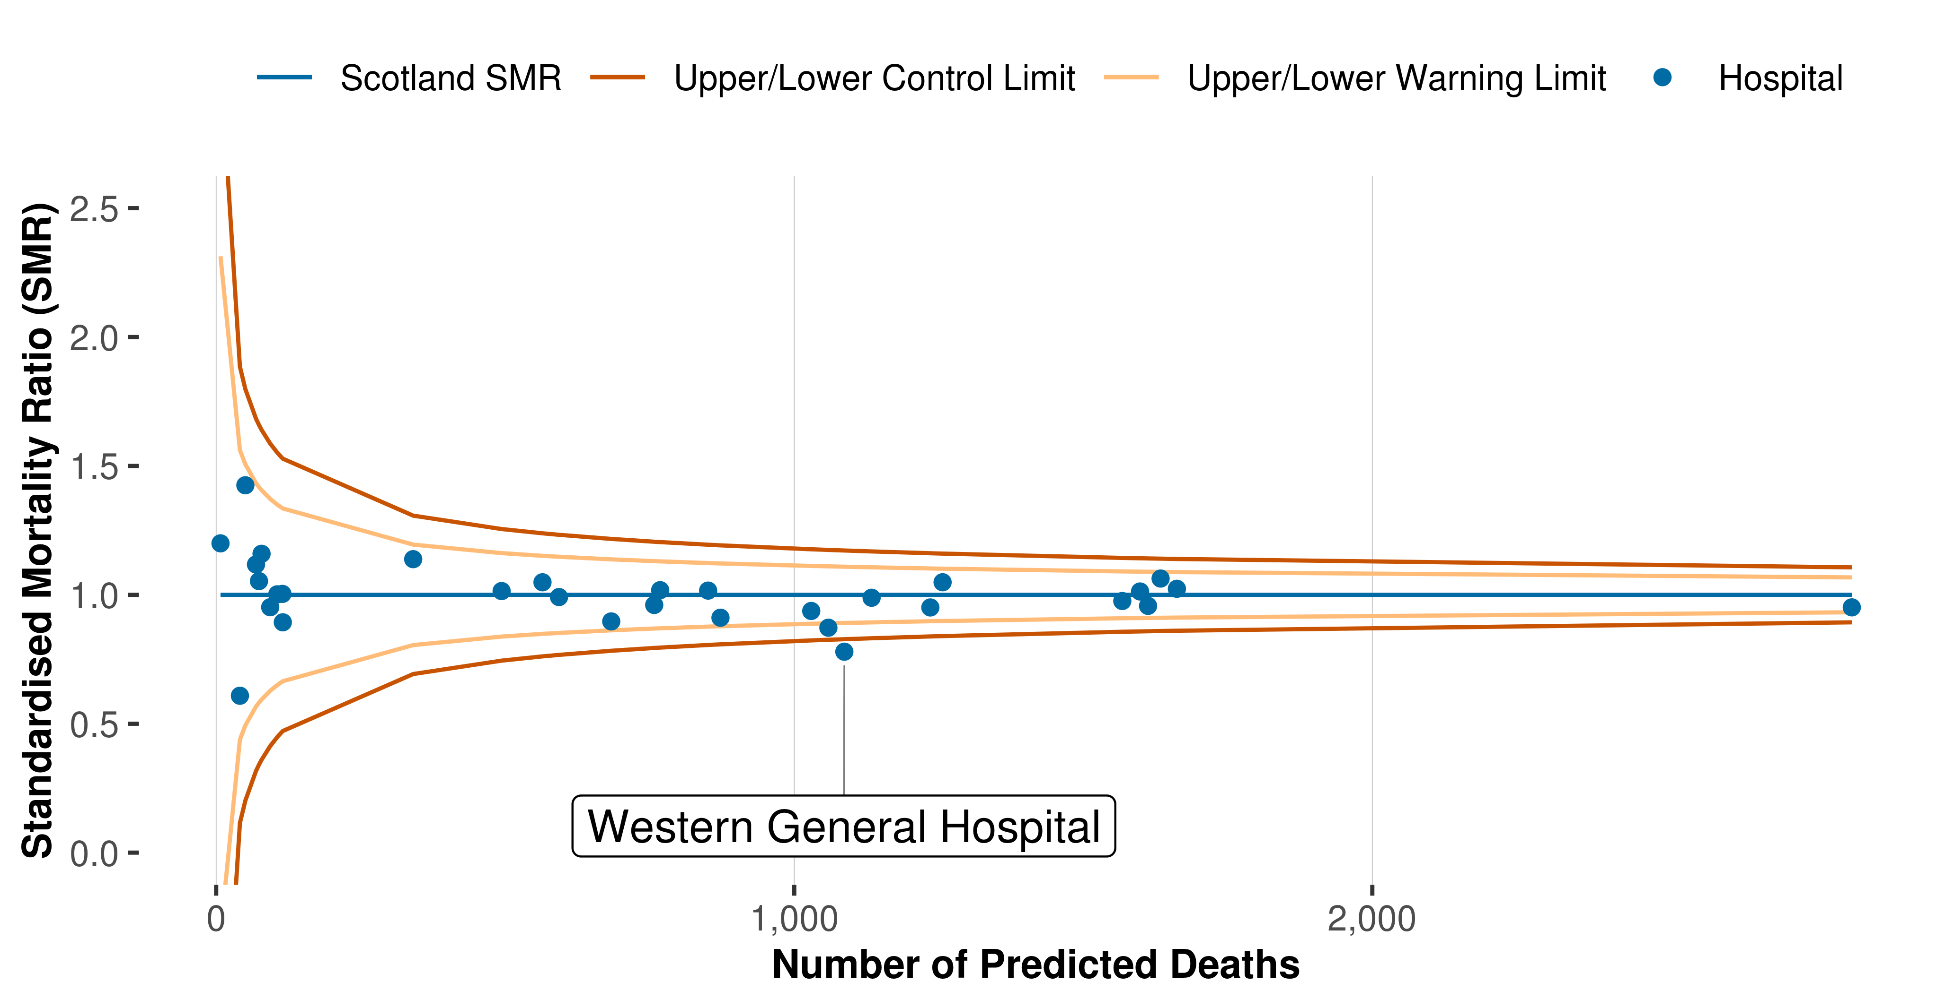

### Background

Hospital mortality measures have an important role to play in stimulating reflection on the quality and safety of patient care. ISD has produced quarterly HSMRs for hospitals since December 2009.

The HSMR methodology used up until May 2019 was agreed in 2015/16. The purpose of the HSMR at that time was to measure change in mortality over time, and to enable acute hospitals to monitor their progress towards the Scottish Patient Safety Programme (SPSP) aim of reducing hospital mortality by a further 10% by December 2018.

The end of this phase of the Scottish Patient Safety Programme provided the opportunity to review the model methodology and subsequently update and refine it, ensuring that the methodology continues to be robust and that comparisons which are made against the national average continue to be appropriate and relevant for each point in time. This is the first release using a refined methodology.

The HSMR is based on all acute inpatient and day case patients admitted to all specialties in hospital. The calculation takes account of patients who died within 30 days from admission and includes deaths that occurred in the community as well as those occurring in hospitals.

The Scottish HSMR is 1.00. If an HSMR value for a hospital is less than one, this means the number of deaths within 30 days of admission for this hospital is fewer than predicted. If an HSMR value for a hospital is greater than one, this means the number of deaths within 30 days for this hospital is more than predicted.

If the number of deaths is more than predicted this does not necessarily mean that these were avoidable deaths (ie that they should not have happened), or that they were unexpected, or attributable to failings in the quality of care.

### Contact

|  |  |  |
| --- | --- | --- |
| **Robyn Munro** | **David Caldwell** | **Lucinda Lawrie** |
| Principal Information Analyst | Senior Information Analyst | Information Analyst |
| 0131 275 6967 | 0131 275 7421 | 0131 275 7929 |
| [Robyn.Munro@nhs.net](mailto:Robyn.Munro@nhs.net) | [David.Caldwell1@nhs.net](mailto:David.Caldwell1@nhs.net) | [Lucinda.Lawrie1@nhs.net](mailto:Lucinda.Lawrie1@nhs.net) |

### Further Information

The data from this publication is available to download from our [web page](http://www.isdscotland.org/Health-Topics/Quality-Indicators/Publications/data-tables2017.asp). A [Technical Document](http://www.isdscotland.org/Health-Topics/Quality-Indicators/HSMR/Methodology/_docs/HSMR_2016_technical_specification.pdf) is available on how HSMR is calculated. A [Frequently Asked Questions](http://www.isdscotland.org/Health-Topics/Quality-Indicators/HSMR/FAQ/) document is also available. For more information on HSMR see [HSMR section of our website](http://www.isdscotland.org/Health-Topics/Quality-Indicators/HSMR/). **HSMRs published from August 2019 onwards cannot be compared to prior releases using a different methodology**. For more information see [Research and Development](https://www.isdscotland.org/Health-Topics/Quality-Indicators/HSMR/Research-and-Development/).

### NHS Performs

A selection of information from this publication is included in [NHS Performs](http://www.nhsperforms.scot/). NHS Performs is a website that brings together a range of information on how hospitals and NHS Boards within NHSScotland are performing.