Open Data Portal Managed Service
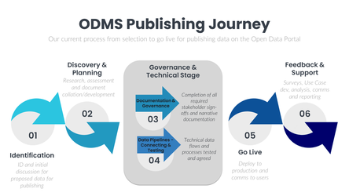

ODMS Background
As a strategic initiative, the NHSBSA want to publish more data in the open. By making more data open we can create social value, by helping others innovate, and help reduce demand on NHSBSA service areas.
Our approach is based around the following six principles, which align with work across the wider health and care system:
· NHSBSA data will be open by default.
· Proactive data publication.
· Make data accessible and easy for all.
· Demonstrate value and impact of Open Data.
· Grow Open Data through partnerships.
· Promoting innovative use of Open Data.
To support this ambition the Data Services team within DDAT run the Open Data Portal (ODP). The vision is for the Open Data Portal to be the home of open data for the NHSBSA.
To make it easier for all parts of the NHSBSA to use the Open Data Portal, a managed service has been introduced. This enables NHSBSA teams and directorates to understand Open Data, how and why they should publish and to enable the technical solution for publishing. High level steps involved for this can be seen below.
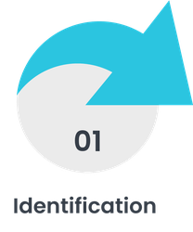
Four entry routes have been identified for contacting the Open Data Portal team to start the process of publishing data on the ODP.
During this stage the business area and the Open Data team have an initial meeting to scope out their requirements for publishing data via the ODP.
Insert docs/links related to step 1:
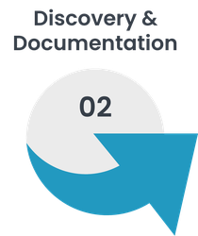
Discovery & Planning
There is a tailored check list that will be provided by the Open Data team to the business area following their initial meeting with some feedback from the Open Data team on what is needed to progress and an invite to a follow up meeting for planning.
This could include sharing of relevant documentation or highlighting the need for key information to progress to the next stage (data dictionaries, guidance, high level information on the data).
The Open Data team will agree a Terms of Reference (ToR) including provisional timelines (with what we know at this point in time), the resource available from the business area and the responsibilities between the Open Data Team and the business areas agreed single point of contact (SPOC). This will also include agreement to share test data (where possible).
Insert docs/links related to step 2 here
- Open Data Portal - Publish data request (office.com)
- Insert ODMS Publishing check list,
- Example completed checklists
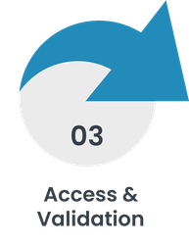
Documentation and Governance - from the business point of view, ensuring they have sign-off from whoever they need signoff and agreement from (internal/external) - new heading - change graphics.
From ODP side - help or get the Statistical control and IG signoff.
Statistical control steps:
IG steps:
Insert docs/links related to step 3 here
- Nominated people for sharing the relevant data documentation.
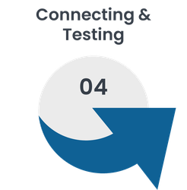
Insert text for step 4 here Data Pipelines - Connecting & Testing
Technical team meets to scope the data flow.
- Scoping data locations
- Agreeing steps to test if the data pipelines work
- Agreeing the data delivery process implementation
- ETL - Creation of bespoke Alteryx workflow
- Carry out a test on the technical solution once everything is in place
Insert docs/links related to step 4 here
- Example workflows
- Best practice sharing
- Technical documentation
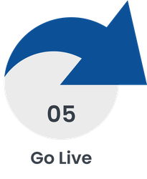
Flowing data to the staging area and putting the narrative and guidance documents for public to view alongside the data.
Final meeting with the business area to demo their data on the ODP and review the guidance etc.

Date agreed for go live - ODP team implement the data plan, making this data available on the Open Data Portal.
Insert docs/links related to step 5 here
- Example final published data pack - containing ToR, Sign-off, Technical documentation and any other relevant info for the specific piece of work.
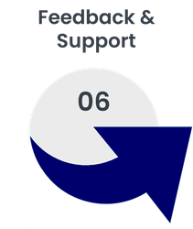
Will provide the relevant business areas with their usage statistics. If a communications plan has been agreed as part of the overall piece of work then will share the impact of this.
Insert docs/links related to step 6 here
- Example of a user stats report
- Example of comms plan impact

