
National SPINE

2087
External Interface Specification: Appendix B Errors

Issue 11.6 Draft C
26th November 2008

Document Control
Title | 2087 External Interface Specification: Appendix B Errors
Author | Joseph Waller
Doc Ref | 0000.doc

Note: The document history is held in part one of this document.
Contents
B Appendix B 6
B.1 Introduction 6
B.2 Code Namespace 7
B.3 Guidance on the Spine Error base 8
B.3.1 Error Base Attributes 9
B.4 Domain specific guidance. 12
B.4.1 ACF 12
B.4.2 EBS 13
B.4.3 ETP / Medication management 13
B.4.4 PDS 13
B.4.5 PPD 15
B.4.6 PSIS / Clinical domain 15
B.4.7 TMS 15
B.5 EIS Process 15
B.5.1 Introduction 15
B.5.2 Error Base process 16

Appendix B

Introduction
This section of the EIS details two aspects of Spine Errors:

- the process around creation of the Spine Error Base
- detail on how to interpret the Error Base for individual domains

National Program services require both an interface and an implementation supported by a Service Provider. A service consumer holds a "service contract" with a particular version of the interface. However, the implementation can evolve independently. Service Providers are REQUIRED to ensure that an interface will return exception codes applicable to that interface version UNLESS the following events have occurred with the implementation:
- New CfH agreed validation has been added to the implementation.
- CfH has agreed a change to existing validation of the implementation.
- CfH has agreed the removal of existing validation within the implementation.
- CfH has agreed validation changes resulting from agreed changes to the business process defined within the implementation.
Service consumers SHOULD implement a level of abstraction between the error code and text supplied by the service, and the user. This will allow the consumer to provide context aware reporting to the user and consuming system logs.

Code Namespace
Each service on the Spine has an OID that is used to reference the namespace that an error, information or warning code is derived from. This implies that a code need only be unique within its namespace. The NPfIT is the owner of all namespaces. The NPfIT assigns a custodian for each namespace. The custodian is responsible for performing the following activities:
- Publishing the codes (and other code meta data, such as descriptions) within the namespace.
- Advising NPfIT when change occurs within the namespace through formal change control.
- Acting on change requests required by the owner.
An MHS supporting P1R1 [EIS 5.5] will receive error codes in a format specified in [EIS 5.5]. However, the current error base for any release will include all error codes to date including the P1R1 error codes. Suppliers are expected to review the error code base in order to understand the implication of the errors defined on their application. This will be communicated to them by CFH. Where this is shown service consumers should assume this refers to the MIM 6.2 MIM.

Subsystem | Error Code Namespace | Namespace Custodian | Codesystem Version | Codes Supported since
ACF | 2.16.840.1.113883.2.1.3.2.4.17.12 | BT | 1.00.00 | 2.3.0
ACF | 2.16.840.1.113883.2.1.3.2.4.17.12 | BT | 1.00.00 | 3.1.10
EBS | 2.16.840.1.113883.2.1.3.2.4.17.100 | Atos Origin | unknown | 2.3
ETP | 2.16.840.1.113883.2.1.3.2.4.16.34 | BT | 1.1.0 | 3.1.07
ETP | 2.16.840.1.113883.2.1.3.2.4.17.22 | BT | 1.1.0 | 3.1.07
ETP | 2.16.840.1.113883.2.1.3.2.4.17.22 | BT | 1.2.0 | 5.5
ETP | 2.16.840.1.113883.2.1.3.2.4.17.19 | BT | 1.1.0 | 3.1.07
ETP | 2.16.840.1.113883.2.1.3.2.4.17.19 | BT | 1.2.0 | 5.5
PDS | 2.16.840.1.113883.2.1.3.2.4.17.42 | BT | 1.0.0 | 2.3
PDS | 2.16.840.1.113883.2.1.3.2.4.17.42 | BT | 1.1.0 | 3.1.10
PDS | 2.16.840.1.113883.2.1.3.2.4.17.42 | BT | 1.2.0 | 5.5
PDS | 2.16.840.1.113883.2.1.3.2.4.17.32 | BT | 1.0.01 | 2.3
PDS | 2.16.840.1.113883.2.1.3.2.4.17.32 | BT | 1.1.0 | 3.1.10
PDS | 2.16.840.1.113883.2.1.3.2.4.17.32 | BT | 1.2.0 | 5.5
PPD | 2.16.840.1.113883.2.1.3.2.4.16.37 | PPD | unknown | 3.1.07
PSIS | 2.16.840.1.113883.2.1.3.2.4.17.33 | BT | 1.00.00 | 4.2
PSIS | 2.16.840.1.113883.2.1.3.2.4.17.33 | BT | 2.00.00 | 6.2.01
TMS | urn:nhs:names:errors:tms | BT | 1.0.0 | 2.2
TMS | urn:nhs:names:errors:tms | BT | 1.0.2 | 3.1.10
TMS | 2.16.840.1.113883.2.1.3.2.4.17.32 | BT | 1.0.0 | 2.2
TMS | 2.16.840.1.113883.2.1.3.2.4.17.32 | BT | 1.0.1 | 3.1.07
TMS | 2.16.840.1.113883.2.1.3.2.4.17.32 | BT | 1.0.3 | 4.2.00
TMS | urn:nhs:names:errors:QASI | BT | 1.0.0 | n/a
TMS | urn:nhs:names:errors:lm | BT | 1.0.0 | n/a

Guidance on the Spine Error base
The spine error base is an attempt to formalise the production and representation of errors on spine with a definitive model. The error base comprises of a spreadsheet per domain containing a comprehensive list of errors with associated error attributes. It is produced in conjunction with CfH. This spreadsheet is then reviewed by BT, CfH and communicated through the supplier channels for supplier review.

The error base and error base spreadsheets may be interpreted slightly differently for different subsystems. However the following general interpretations apply:

- Clients built against older releases of the Spine can recognise new errors that are relevant to them by observing the ‘supportedFromMIM’ and ‘releaseIntroduced’ fields. If an error has a ‘supportedFromMIM’ value that is applicable to a client’s MIM but the ‘releaseIntroduced’ value is more recent than the release to which the client has built, clients will know that a new code has been introduced that they may need to support (for example, where new validation has been introduced in agreement with CFH.)

- The errorbase is produced at a level of granularity associated with the Detected Issue Event (or other unit of an XML error). This means that where single error ‘scenarios’ result in multiple Detected Issue Events – for whatever reason – multiple lines will occur in the error base.

- Errors marked as ‘IsExternal’= true are relevant to a client. HL7 clients MUST consider errors for which the Exceptions Mechanism is ‘DetectedIssueEvent’. They MAY consider errors for which the Exception Mechanism is HL7AcknowledgmentDetail and the SHOULD NOT consider other exceptions. MHSs MUST consider errors for which the Exception Mechanism is HTTPError, SOAP Fault, ebXML Error or HL7AcknowledgmentDetail. However implementations differ and non standard systems should interpret this according to their own architectures.

Error Base Attributes
The Spine Error Base uses the following attributes:

Attribute | Descriptions | Type | Optionality | Example
Subsystem | A general allocation to a subsystem just for the purposes of categorisation and aiding documentation | string | Mandatory | PDS
isExternal | Indicates whether this error is returned to an External Spine Client. The error base is also capable of tracking internal messages for a service provider, though this is not relevant to external clients.  Service consumers are advised to filter this column to display only external codes. | Boolean | Mandatory | TRUE
supportedFromMIM | This is a single element indicating the specific single MIM version from which that error was introduced. It is from this MIM onwards, that the error is applicable.  In other words, this field indicates which clients could be recipients of this error based on the MIM they use regardless of the release the clients were built to support.  Also note that this includes all MIMs from the listed MIM forward. E.g. if you are a 6.2.01 client, you will need to consider all errors which have values earlier than 6.2.01 (unless ‘supportedToMIMInclusive’ is populated, see below) | pattern value="[0-9][0-9]?.[0-9][0-9]?(.[0-9][0-9]?)?|MIM[0-9][0-9]?.[0-9][0-9]?(.[0-9][0-9]?)?|n/a | Mandatory | 3.1.10
supportedToMIMInclusive | Elements indicating the MIMs to which this error is applicable. This element shows whether an error has been deprecated and will not be observed by later clients. | pattern value="[0-9][0-9]?.[0-9][0-9]?(.[0-9][0-9]?)?|MIM[0-9][0-9]?.[0-9][0-9]?(.[0-9][0-9]?)?|n/a | Optional | 3.1.10
errorCodeGroupId | This is the code domain of the error represented as an OID or URN. This value is found in the ‘codeSystem’ of the detectedIssueEvent | enumeration values: "2.16.840.1.113883.2.1.3.2.4.17.42"  "2.16.840.1.113883.2.1.3.2.4.17.100"  "2.16.840.1.113883.2.1.3.2.4.17.32"  "2.16.840.1.113883.2.1.3.2.4.17.12"  "2.16.840.1.113883.2.1.3.2.4.17.33"  "2.16.840.1.113883.2.1.3.2.4.16.37"  "2.16.840.1.113883.2.1.3.2.4.16.34"  "2.16.840.1.113883.2.1.3.2.4.17.22"  "2.16.840.1.113883.2.1.3.2.4.17.19"  "2.16.840.1.113883.2.1.3.2.4.16.34"  "urn:nhs:names:errors:tms"  "urn:nhs:names:errors:lm"  "urn:nhs:names:errors:gazetteer"  "urn:nhs:names:errors:QASI" | Mandatory | 2.16.840.1.113883.2.1.3.2.4.17.42
fromCodeVersion | This attribute is intended to provide a mechanism to correlate sets of related codes. However it’s use is not yet fully defined and is not mandatory. | pattern value="[0-9][0-9]?.[0-9][0-9]?.[0-9][0-9]?" | Optional | 1.1
toCodeVersionInclusive | This attribute is intended to provide a mechanism to correlate sets of related codes. However it’s use is not yet fully defined and is not mandatory. | pattern value="[0-9][0-9]?.[0-9][0-9]?.[0-9][0-9]?" | Optional | 1.2
Description | An optional additional description of the error. For information and documentation purposes. Subsystem teams may use this field to communicate any additional information about this error to the user. | string | Optional | Used by the Update Service
errorText | The text that describes the error and is provided to client systems. This is not recommended for display to a user. In some cases this text may contain further embedded subsystem codes. | string | Mandatory | Update Failed - Source not permitted to insert new patient records
errorCode | This is the errorCode that is sent in the error response. | string | Mandatory | 0
sourceCode | This is the original code of the message that caused the error.  This represents the initial error code as generated by a subsystem. The code may then be translated to the displayed errorCode for a variety of reasons.  If the source code differs from the error code this means that two Detected Issue Events will be returned for the same source code (source exception scenario). They are associated via that source code (Note that PDS is an exception to this, see PDS notes)  If not present the sourceCode is assumed to be the same as the error code. | string | Optional | IU024
errorCodeGroup | Unused at this time | string | Optional | n/a
exceptionMechanism | This element indicates the type of exception and hence also provides an indication where the exception might be found in the returned error message. | enumeration values:  "HL7DetectedIssueEvent"  "SOAP Fault"  "ebXML error"  "HL7AcknowledgmentDetail"  "HL7 Payload"  "HTTP error" | Mandatory | HL7DetectedIssueEvent
Location | May be an XPath to an error in an XML message, may be any general indication of the location of an error, e.g. “in the header” | string | Optional
Severity | this is the error severity and indicates an ER Error, WG Warning or FI For Information | Enumeration values:  "ER"  "WG"  "IF" | Mandatory | ER
Remediation | Proposed remedial action | string | Optional | Log message failure and indicate failure of process to client.
releaseIntroduced | Indicates the Spine release at which this error code was introduced. | string | Mandatory | 2006-B
releaseWithdrawn | Indicates that an error code has been withdrawn in a release. i.e. it will now never be seen by any Spine client. | String | Optional | 2008-B

Domain specific guidance.

ACF
ACF exceptions are provided as a series of three digit codes (errorCode in the Error Base). In addition, more detailed five digit codes (sourceCode in the error base) are provided in the error text, concatenated with the error text itself. Clients MAY parse the five digit codes if they decide that use of these codes will be beneficial.

For ACF the 5 digit source code always differs from the 3 digit error code. Note that this means for ACF that only one detected issue event will be returned per error scenario.

The SDS Workgroup messages are also published in the ACF error base with 4 digit detailed codes and standard 3 digit ACFH codes.

EBS
Code | Property | Value
The codes in this domain are maintained by Atos Origin and are published separately.

ETP / Medication management
ETP codes are provided as a series of four digit codes divided into one of three subsets depending on the OID (see section 6 Code Namespace above). Please refer to the MIM (‘Vocabulary for ActDetectedIssueCode’) for details of each of these OIDs.

PDS

- All error codes and warning codes which can be sent to an LSP system from PDS are encoded as DetectedIssue events or AcknowledgementDetail elements.
- Each error code is associated in the PDS Error Base with a single specified ‘response code’.
- A ‘response code’ represents a general category of an error and SHOULD be used by clients to indicate certain expected programmatic responses.
- For P1R1, only the associated response code with an error code is carried in a single detected issue event (i.e. for MIM2.3 clients).
- For all other spine releases, for error codes, a preceding detected issue event is sent containing the associated response code.
- A warning code is currently sent as a single detected issue event. In future, Warnings MAY have additional detected issue events, however, suppliers MAY choose to ignore further detectedIssueEvents but should be designed not to cause a fatal fault if further detectedIssueEvents are present.
- Successful interactions do not result in detectedIssueEvents being returned; hence consumers should not expect to receive success response codes.

Applicable PDS error codes are translated into response codes for P1R1 clients who cannot accept full error codes. This means that if there is a line in the error base with a different source and error code AND the supportedFromMIM field is MIM 2.3 then that MIM 2.3 clients will receive just one detectedIssueEvent with the code shown in the Error Code element on the error base.

For all other supportedFromMIM values, an entry where the source code and error code differ represents an associated response code that will be returned alongside the detailed error code. In other words there will be two detected issue events, one with a detailed code and one with a response code.

Acknowledgement Detail errors reflect transport problems with the message and take precedence over errors in the Detected Issue Event.

The PDS Error Base also contains an additional optional Interaction column that indicates the interaction that could invoke the stated error code.
These PDS Examples show various permutations of error codes as described by the principles outlined above:
Example description | Error  Code | Source  Code | severity | errorText | description | Exception  Mechanism | Supported  FromMIM | Supported  ToMIM  Inclusive | Release  Introduced
Represents a single detected issue event returned to a P1R1 (MIM 2.3) client | 2 | 2 | ER | Multiple match - number of entries exceed current operational limit for number of matches returned | Response Codes | HL7DetectedIssueEvent | 2.3 |  | 2005-5
Represents a single detected issue event returned to a P1R1 client introduced in 2006-A that is translated from code '22' to code '0'. | 0 | 22 | ER | Generic Error | Response Codes | HL7Detected  IssueEvent | 2.3 | 2.3 | 2006-A
Represents a pair of Detected Issue Events that will be returned to MIM 3.1.10 and later clients. One response code (15) and one error code (IU024). | 15 | IU024 | ER | Update Failed | - | HL7Detected  IssueEvent | 3.1.10 |  | 2005-5
 | IU024 | IU024 | ER | Update Failed - Source not permitted to insert new patient records | - | HL7Detected  IssueEvent | 3.1.10 |  | 2005-5

PPD
Code | Property | Value
The codes in this domain are maintained by PPD and are published separately.

PSIS / Clinical domain
PSIS errors return two detectedIssueEvents, one containing a 3 digit and one containing a 5 digit error code. The 3 digit error code categorises an error and provides guidance as to the expected response behaviour. The 5 digit response codes relate to the detailed event that initiated an error. In some circumstances additional 5 digit codes MAY be returned.

TMS
TMS does not return detected issue events but returns one of the of errors from the other exception mechanisms on a channel appropriate for that mechanism. For example if an error occurs such that TMS is unable to process a SOAP header then a SOAP fault is returned. Similarly, if an error occurs in the ebXML attributes, then an ebXML error is returned.

EIS Process

Introduction
The EIS Process includes the following key artefacts:
- The External Interface Specification
- 4258 Message Definitions and Sets
- The Spine Error Bases
The process for the Error Base is described below.

Error Base process
The error base is produced as a realisation artefact. During construction further error scenarios may be discovered as an exception and these will be added and reviewed as per the process below. Best endeavours will be made to fit any new codes into the existing error code base.
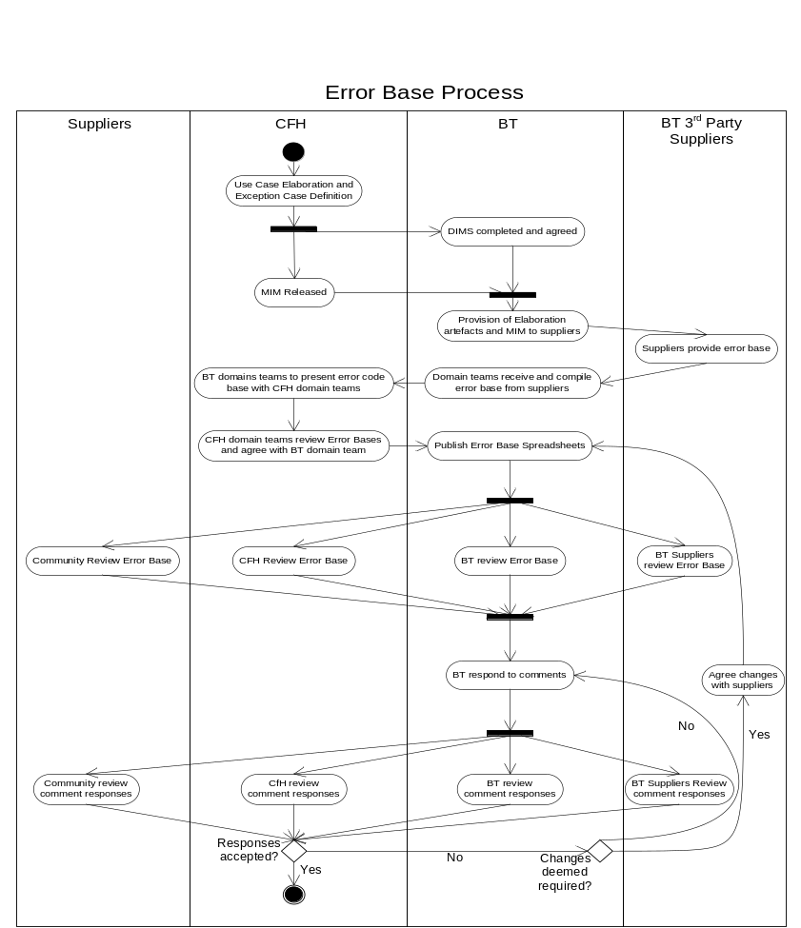

The interaction in HL7 terminology
NASP, LSP, ESP, etc, can all be service providers
As defined in the specifications that describe the interface
Note that for release 2008-B the mapping to 3 digit codes is changed for some error codes from those in 2008A.

