This is the main heading
Dear parent or guardian of {d.fullName},
This is the body text.

Bullet points
Use a lead-in line before bullet points. For example:
- item 1 in a bulleted list
- item 2 in a bulleted list

Headings
Use headings to break up your message content.

Personalisation
To add a personalisation field, include a placeholder with double brackets around it. For example:
Hello {d.fullName}, your NHS Number is {d.nhsNumber}. Your appointment is on {d.appointmentDate} at {d.gpSurgery}.

Links
Write links in full. For example, www.service-manual.nhs.uk/content. Put links in bold to make them stand out. Do not use underlined text for links.
Do not split links across different pages. Add a page break before the paragraph with the link.

QR codes
If you want to include a QR code, put it in the body of your letter. Insert it as an image.
You’ll need to generate the QR code yourself.
You must also provide a short URL or written instructions for how to find your webpage. For example:
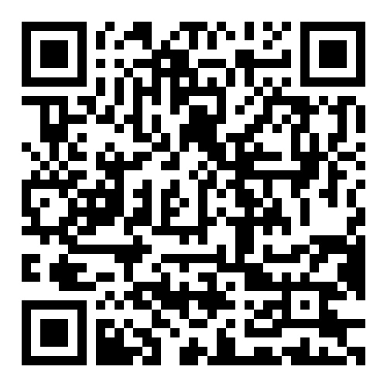
Scan the QR code or visit www.notify.nhs.uk.

Paragraphs
Paragraphs can be split across 2 pages.
If you do not want a paragraph to run over different pages, add a page break before the paragraph.

Images
Images must be black and white. Position them within the same page margins as the text.

Data protection
If you want to include data protection information, put this at the end of your letter. You can write this yourself. NHS Notify does not provide text for data protection or privacy notices.

