This tutorial provides detailed instructions on how to install **R**, **RStudio**, and the **tidyverse** package. It caters for both Windows and Mac users.

Notes:

* If you are unable to complete this tutorial, please seek assistance from a member of your IT service team.

- You will need to complete the following steps in order.

**1. Install R**

Visit the CRAN website: <https://cran.r-project.org>

Select the link that corresponds to your operating system:

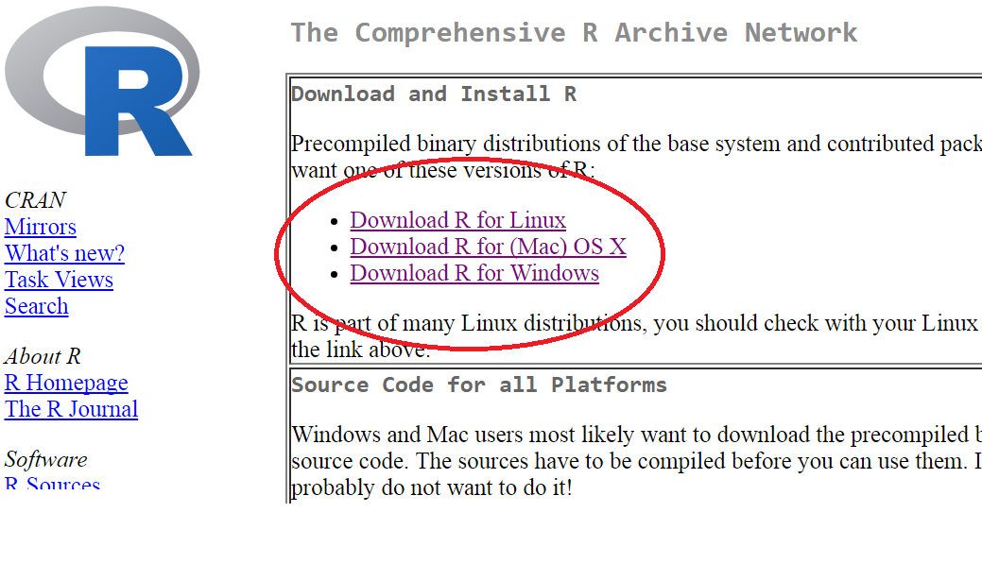For Windows users:

Having selected the Windows option, select the “base” install. Next, select “Download R 3.4.3 for Windows”. Once the download has finished, open the file and proceed through the menus, choosing the default options.

This should install R on your machine.

For Mac users:

Having selected the OS X (Mac) option, scroll down the new page and choose the option

R-3.4.3.pkg . Once the download has finished, open the file and proceed through the menus (choosing the default options).

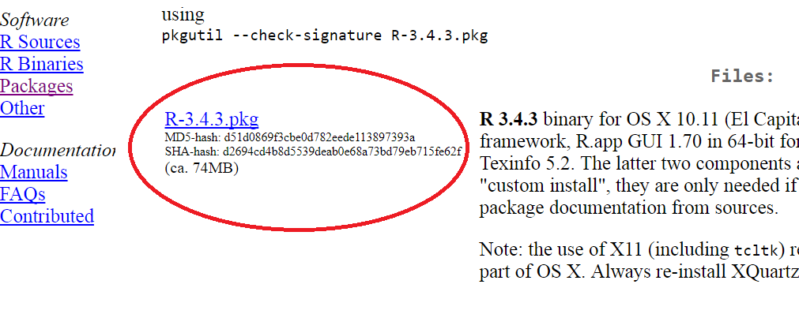

This should install R on your machine.

**2. Install RStudio:**

Visit: <https://www.rstudio.com/products/rstudio/download/#download>

Click on the DOWNLOAD button under the FREE option: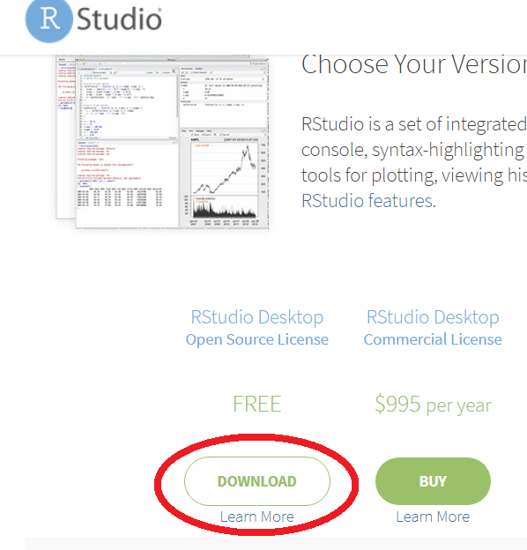

Next, click on the option that corresponds to your operating system:

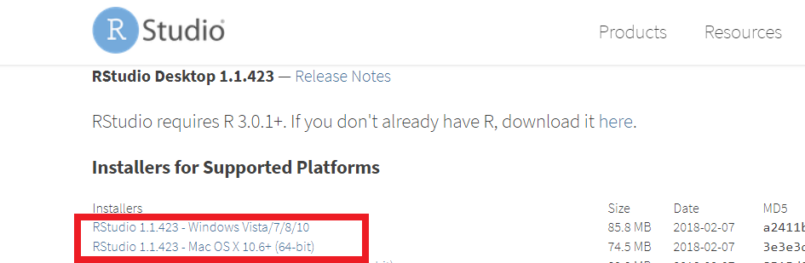

Once the download has finished, open the file and proceed through the menus (choosing the default options).

This should install RStudio on your machine.

**3. (Important.) Installing Packages**

*If possible, we suggest you try the following at home, to make sure that you are able to install packages when away from your workplace (as you will be for the workshop).*

R packages (which are like apps for R), will be used extensively in the workshop (and for any R analyses you conduct in the future). Below, we provide instructions for installing the **tidyverse** package, and for verifying that all installations have been successful.

So, find the **RStudio** in your list of programs, and open it (Mac users: choose “Not Now” when asked if you want to install developer tools). You should see something resembling the picture below. Click the **Tools** option on the menu bar at the top of the RStudio window:

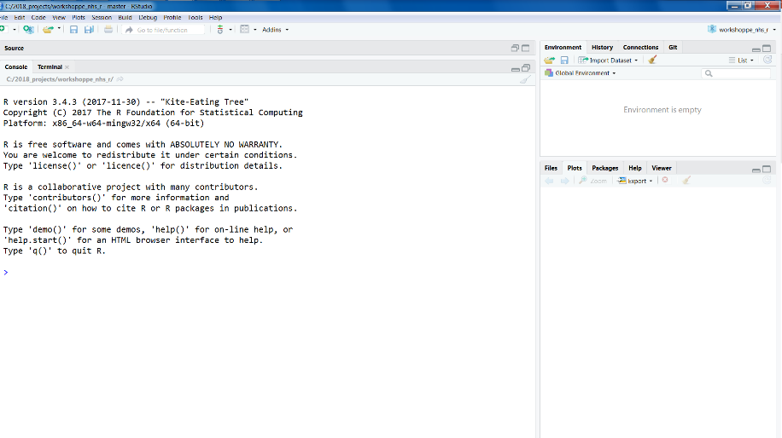

Select the first option; “Install Packages…”. In the text box for packages, type *tidyverse*. (The option “tidyverse” should appear below the text as you type, and we advise you to click on this to ensure correct package selection). Click the Install button (Mac users: again, “Not Now” to dev. tools).

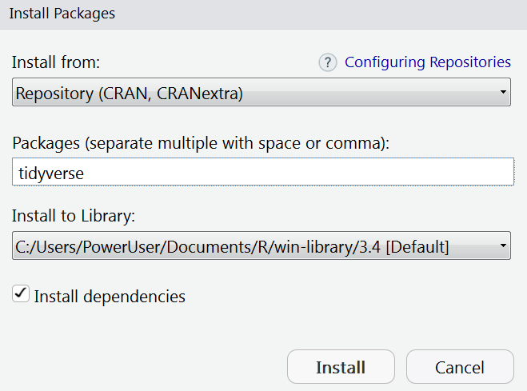

Text and progress bars should start appearing on your screen. If you are prompted about installing packages which need compilation, type **y** and press Enter. An installation of the tidyverse can take 1-5+ minutes depending on your internet connection and computer speed.

*Note: If the warning and error messages (similar to below) appear, it may be that you do not have administrator privileges enabled. If you have administrator privileges on your machine then you may be able to address this issue with the following steps: Close RStudio, find the RStudio icon again and right click it. Select “Run as administrator”. Confirm that you want this program to make changes to the computer. Repeat the instructions above (Tools 🡪 Install Packages… )*

Warning in install.packages :

'lib = "C:/Program Files/R/R-3.4.0/library"' is not writable

“Error in install.packages : unable to install packages”

Once the installation has finished, click beside the command prompt in the Console window (it’s the arrow symbol, **>** , without text afterward). The cursor should be flashing.

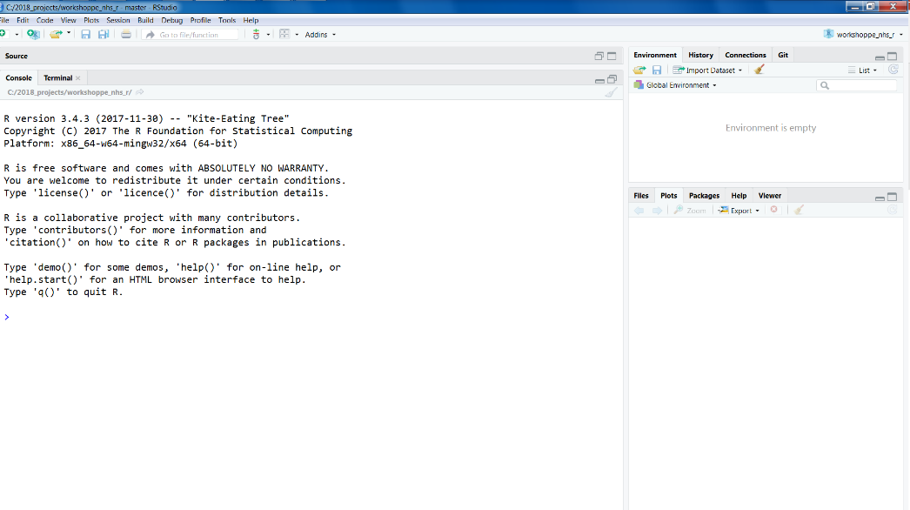

Type (rather than copy and paste) the following, carefully (it is case sensitive):

**tidyverse::tidyverse_lo**

At this point the autocomplete feature should provide the option “tidyverse_logo” beneath the text you are typing:

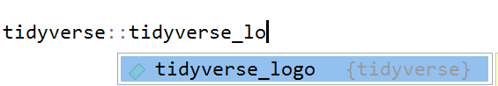

Press Enter to select this option.

Then press Enter to execute the line of code.

You should see the logo (as below), meaning you have successfully installed the tidyverse!

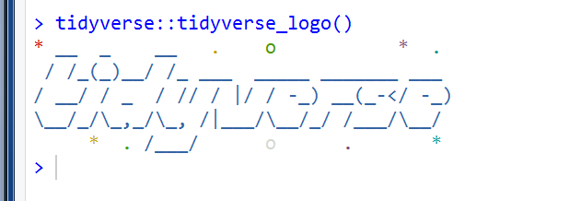

*Once again, if you are unable to complete this tutorial, please seek assistance from a member of your IT service team.*