Microservices Happy5 Social Media  
  
**Scalability, Performance, Rapid & flexible development**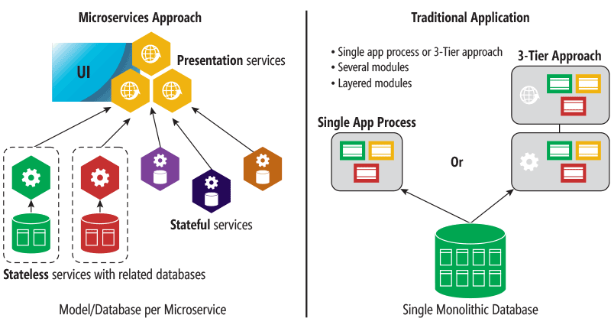

Archictecture Design

Core  
 Common (Core of Code [Services, Utilities, Security, etc])  
 Presentation  
 Mobile (Access Microservices)  
 Desktop (Access Microservices)  
 Web (Access Microservices)  
 Microservices (Louse Coupling, Reuseable, Maintainable, Scalable, Faster)  
 Activity  
 Message  
 User  
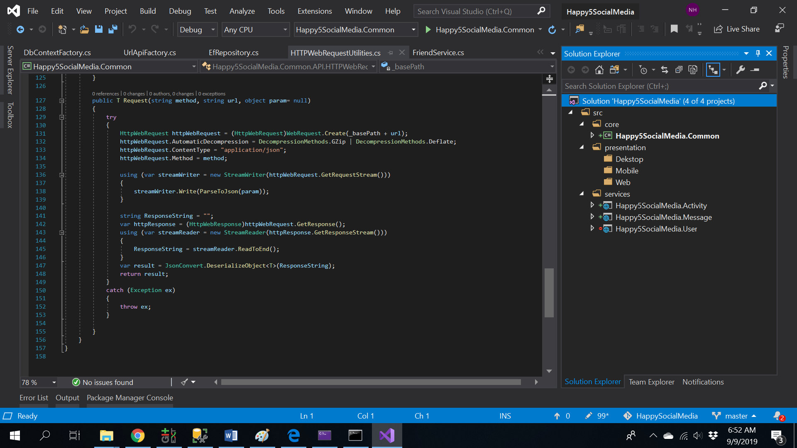

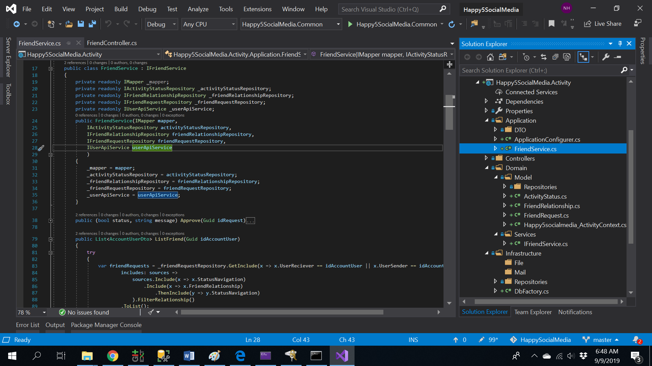

Centralized Core   
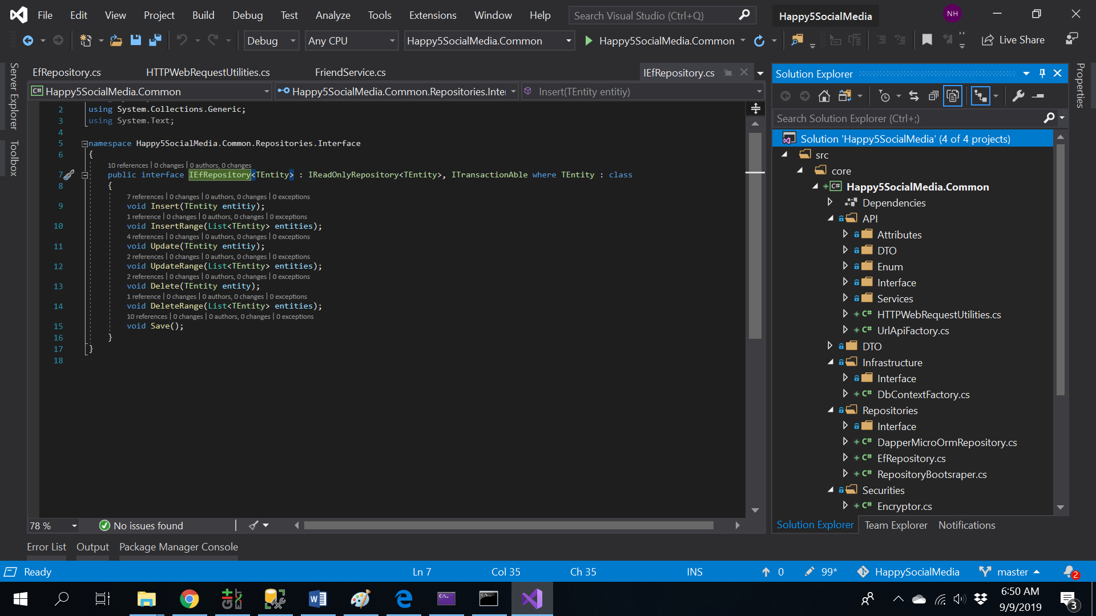

Domain Driven Design Architecture  
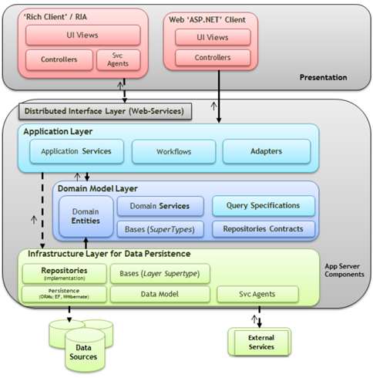

Microservices Design Database   
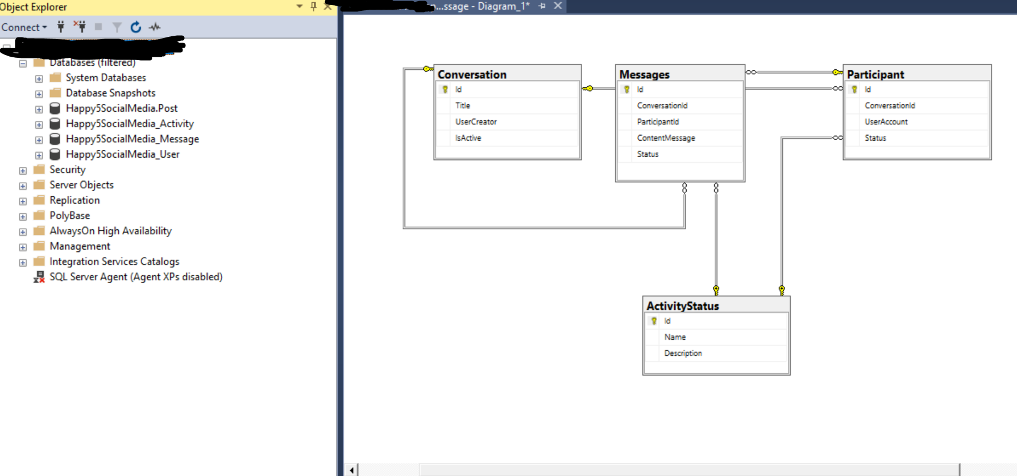

1. User Services  
     
   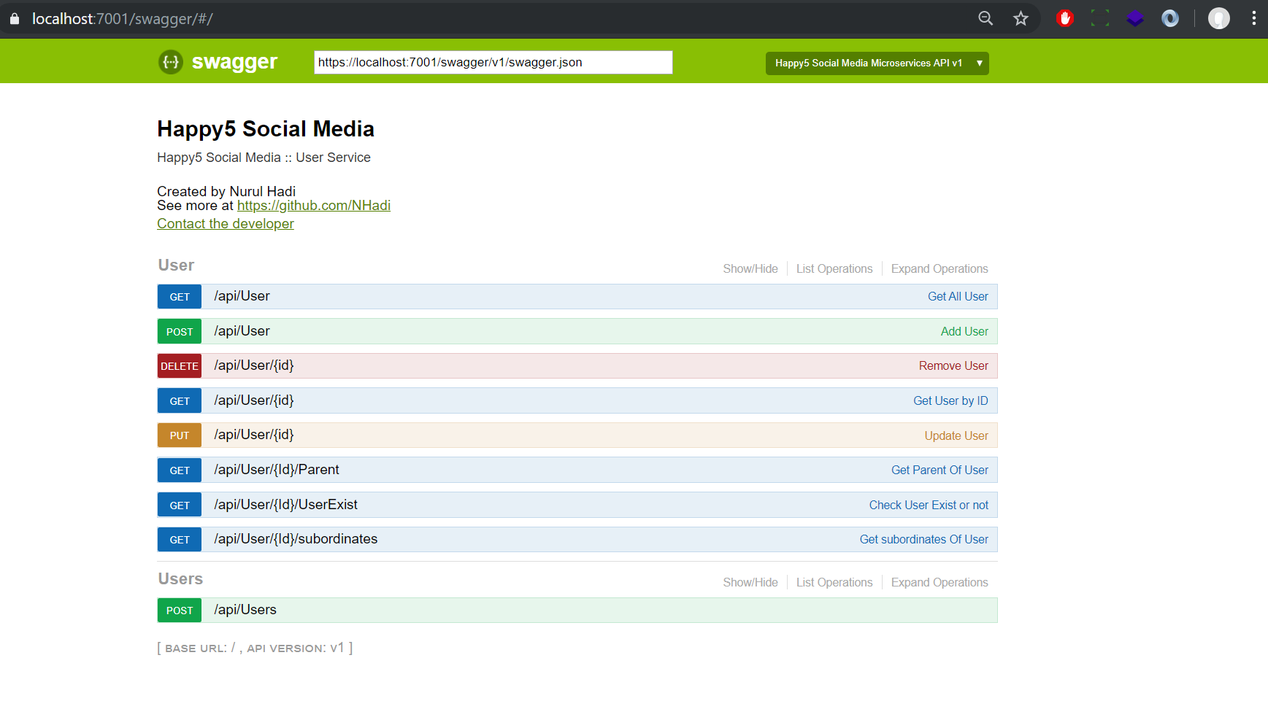
   1. API Add User  
      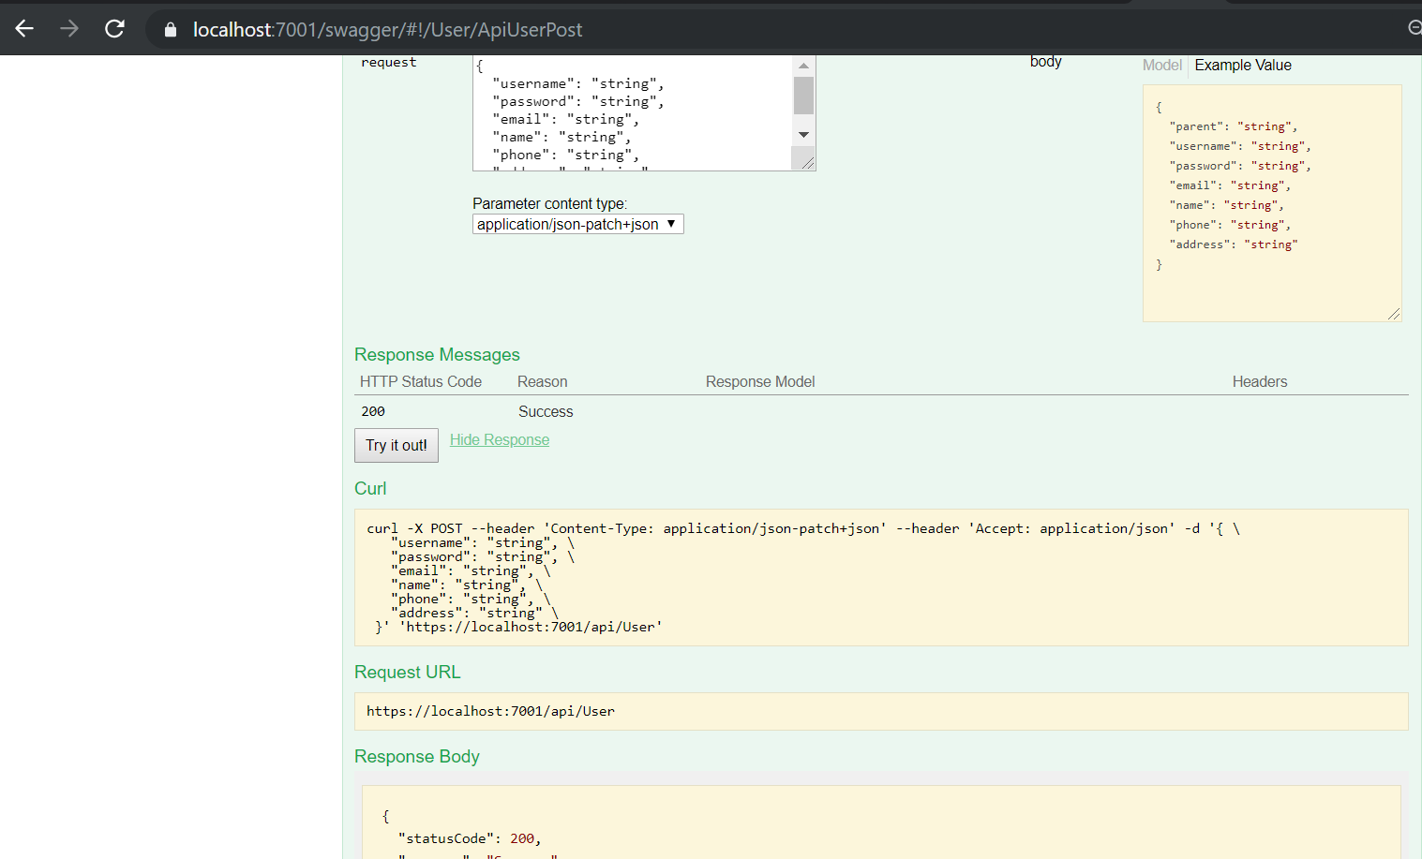
   2. API Update Database  
      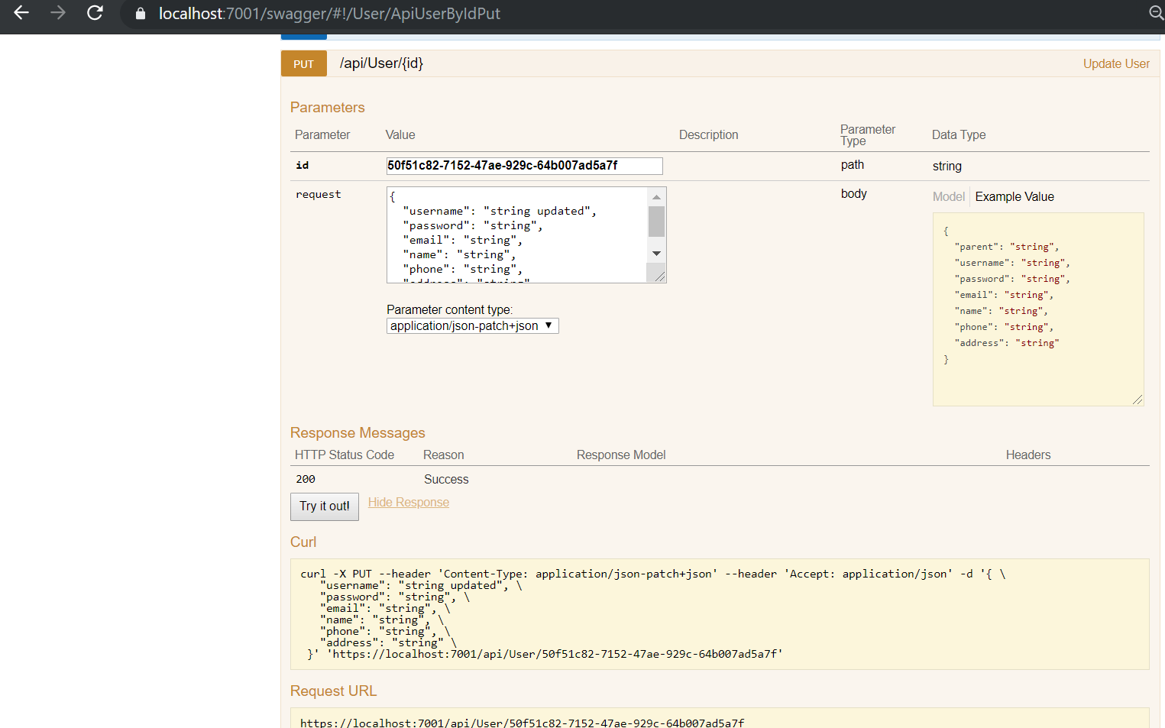
   3. API For Get List Of User  
      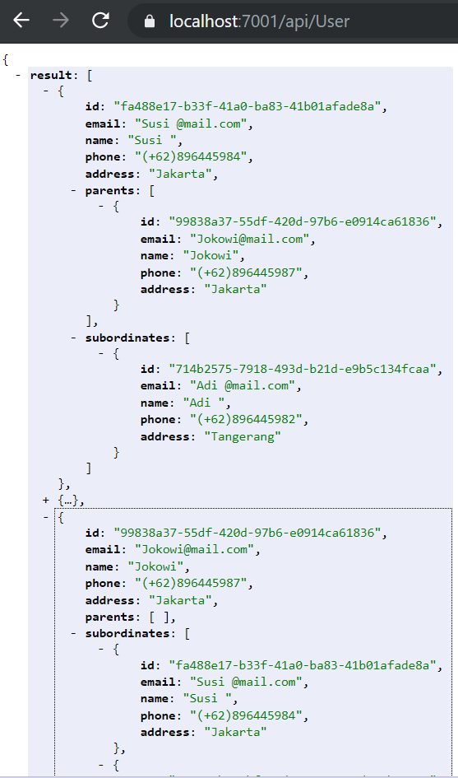
2. User positions feature  
     
   2.1 See the ​list of subordinates ​from a specific user.

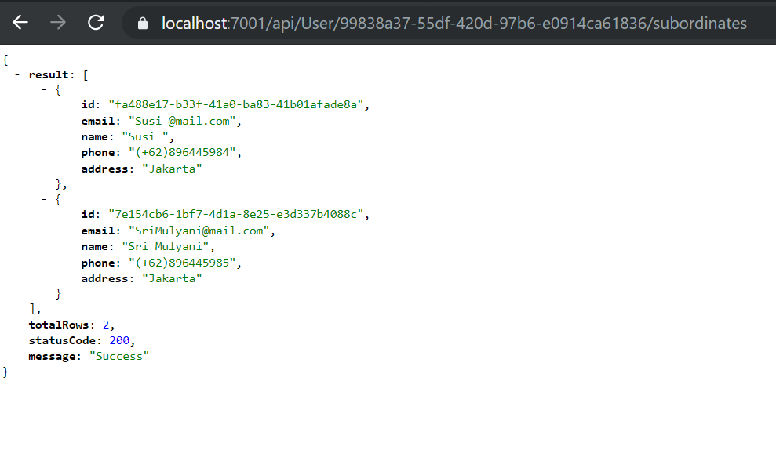

See ​parents​ from a specific user.   
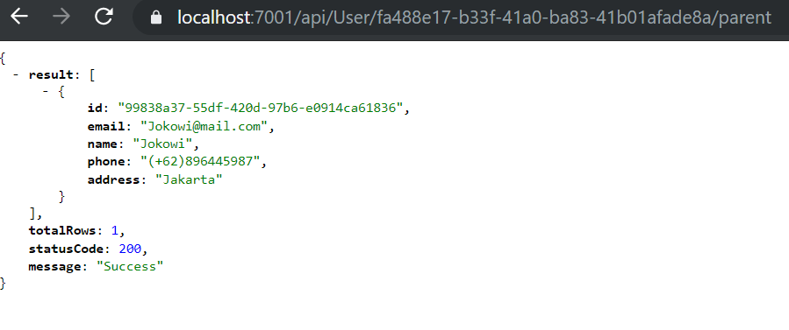

1. Friend Service  
   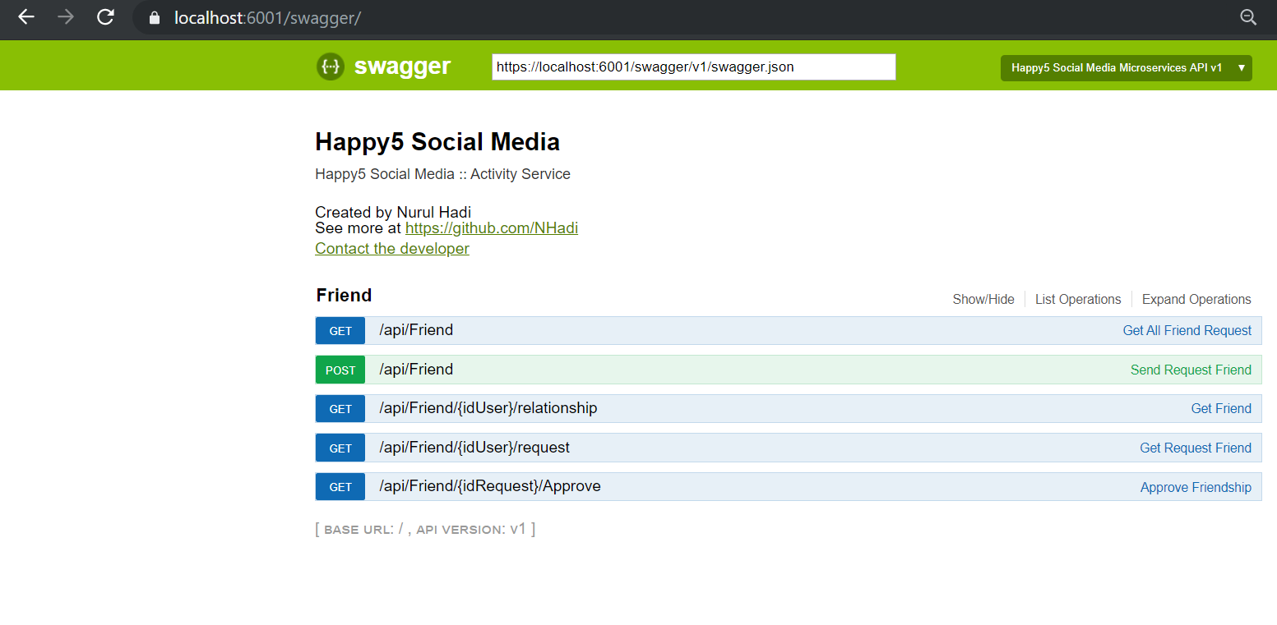  
   3.1 Request Friend  
   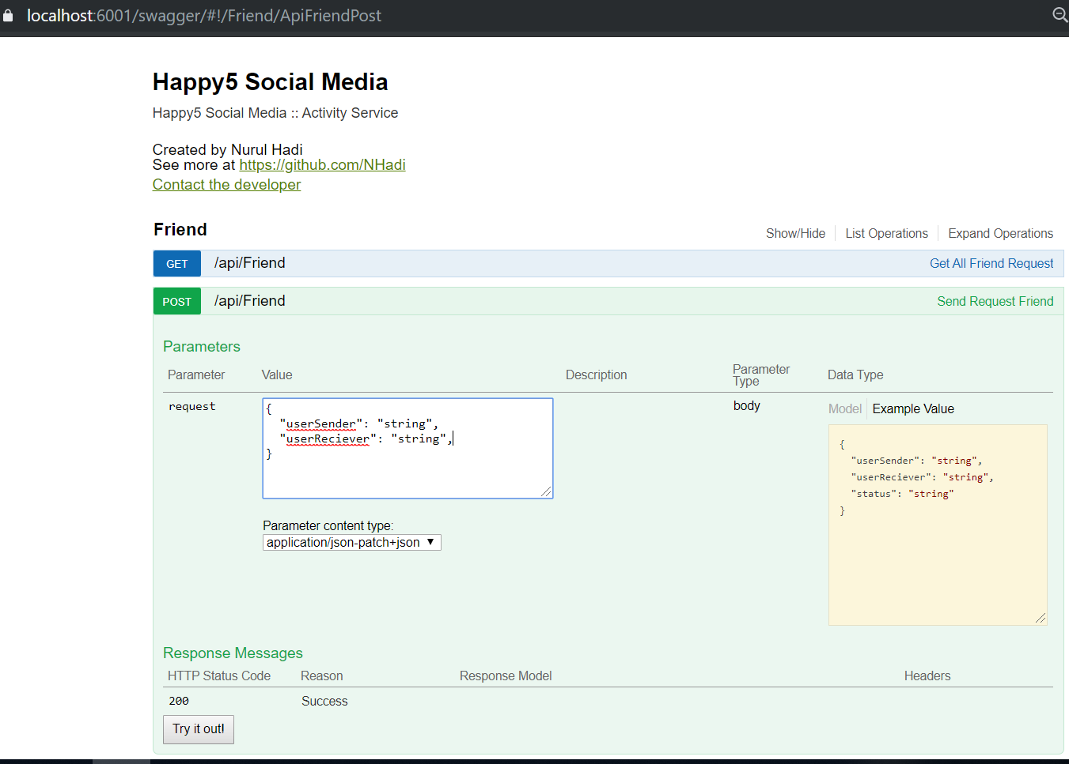  
     
   UserSender , UserReciever : ID User  
     
   3.2 List Friend   
   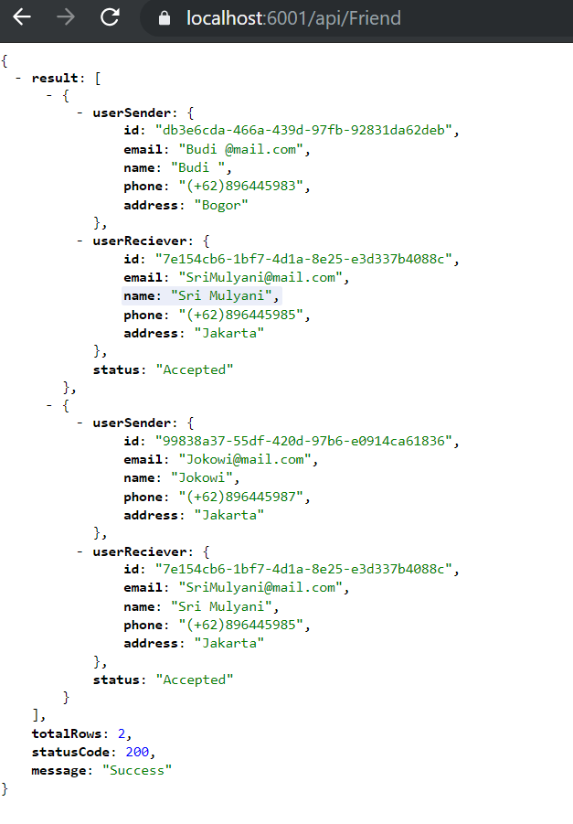

3.3 List Request Friend  
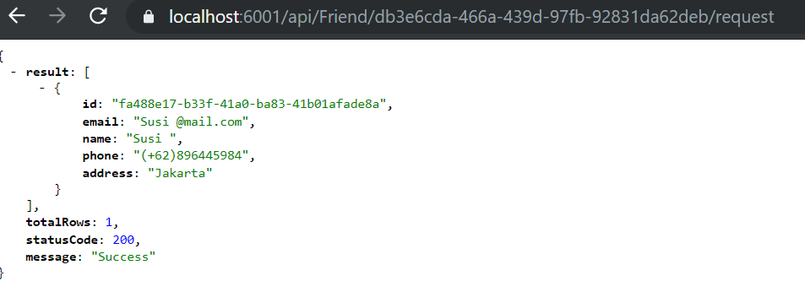  
Param : IdUser  
  
  
3.4 List Relationship 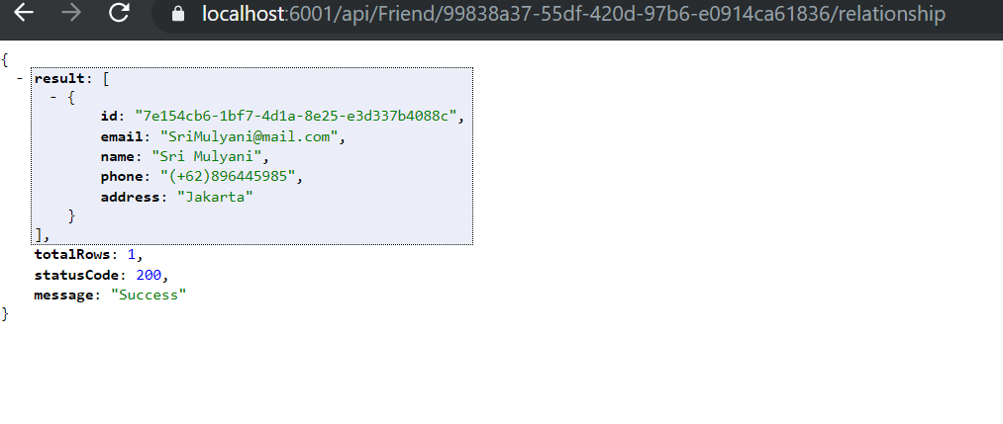   
Param : IdUser

3.5 Approve User  
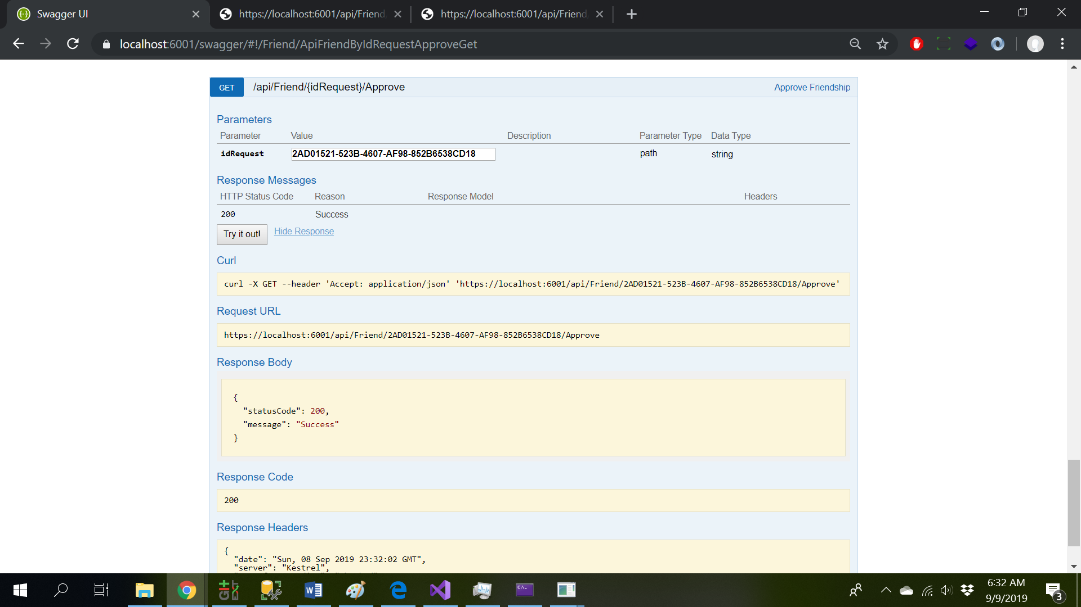  
Param : IdRequestFriend

1. Message Service  
     
   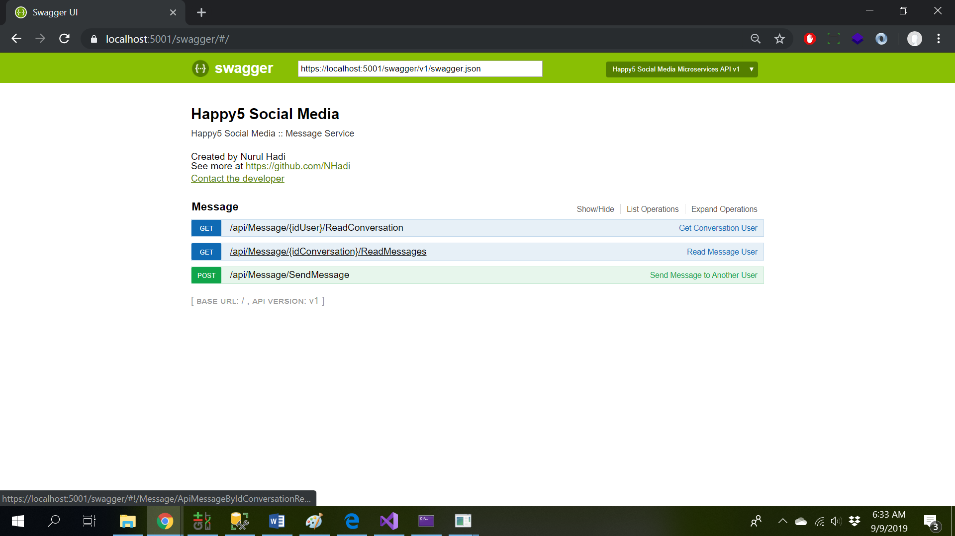

4.1 List Conversation  
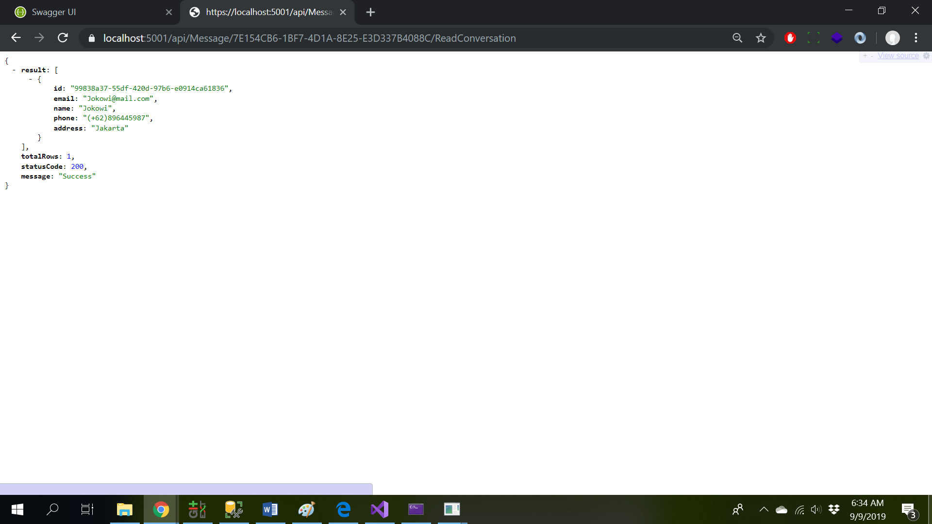  
  
Param : IdUser  
  
4.2 List Message  
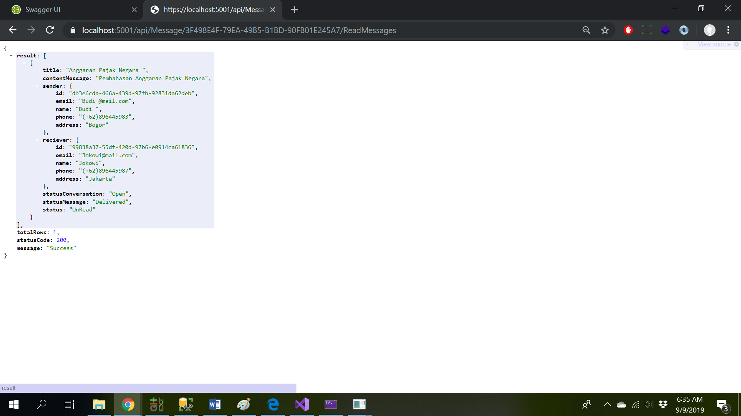Param : Id Conversation

4.3 Send Message

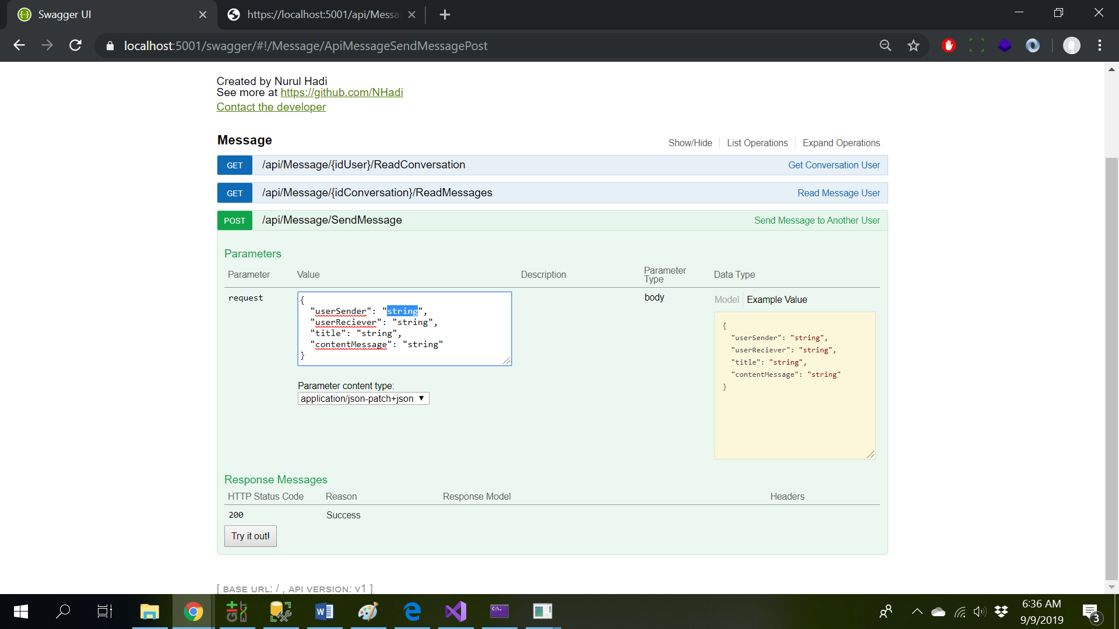  
Param : UserSender [UserId]  
UserReciever[UserId]  
Title [Fill Title of Conversastion]  
ContentMessaege [Fill Message]