**Topic 1:**

**Introduction:**

1.Gudio van russom was developed by python at National Research Institute at Netherlands. But official launched on 20th Feb 1991.

**History:**

1.Python was named from TV show ‘Monty python flying circus’

2.Gudio developed Python by taking almost all programming features from different programming language which are:

1. Uses Object programming from C++.
2. Functional Programming features from C.
3. Scripting language features from shell and Perl Script.
4. Modular programming features from Modula-3.
5. Most of syntax is derived from C and ABC language in python.

**Uses:**

1. Data analysis Application
2. ML
3. Developing AI Application
4. Developing Desktop Application
5. Developing Database Application
6. Developing Web Application
7. Developing Games

**Features:**

1.Python is simple programming , having 30+keywords

2.open source.

3.It is high level language ,

4. platform independent,

5.Portable.

6.Python is dynamical typed language

7.both procedure oriented and object oriented

8.Interpreted.

**Who Uses Python:**

1.Internally Google and Youtube using python.

2.NASA and Network Stock Exchange Application developed with help of python.

3.Top softwares like Youtube ,Netflix,Instagram,etc

**Topic 2:**

**Datatypes:**

**Datatypes**

**Set**

**Sequence**

**Dictionary**

**Boolean**

**Numeric**

**Dictionary**

**Tuple**

**List**

**Complex**

**Float**

**Integer**

**Variable in python:**

Python uses variable only a given to a memory location and rules are:

1._ABC_

2.cannot start with number

3.contain alphanumeric charater and underscore.

4. variable are case sensitive

5.reserved key words are not used .

**Reserved words (or) keywords:**

They are 32 keywords which are reserved we cannot use them.

If we want to access we can access by using ***import keyword.***

***keyword.kwlist*** #Accessing kwlist by using keyword.

*Keywords list:*

['False', 'None', 'True', 'and', 'as', 'assert', 'async', 'await', 'break', 'class', 'continue', 'def', 'del', 'elif', 'else', 'except', 'finally', 'for', 'from', 'global', 'if', 'import', 'in', 'is', 'lambda', 'nonlocal', 'not', 'or', 'pass', 'raise', 'return', 'try', 'while', 'with', 'yield']

**Identifiers:**

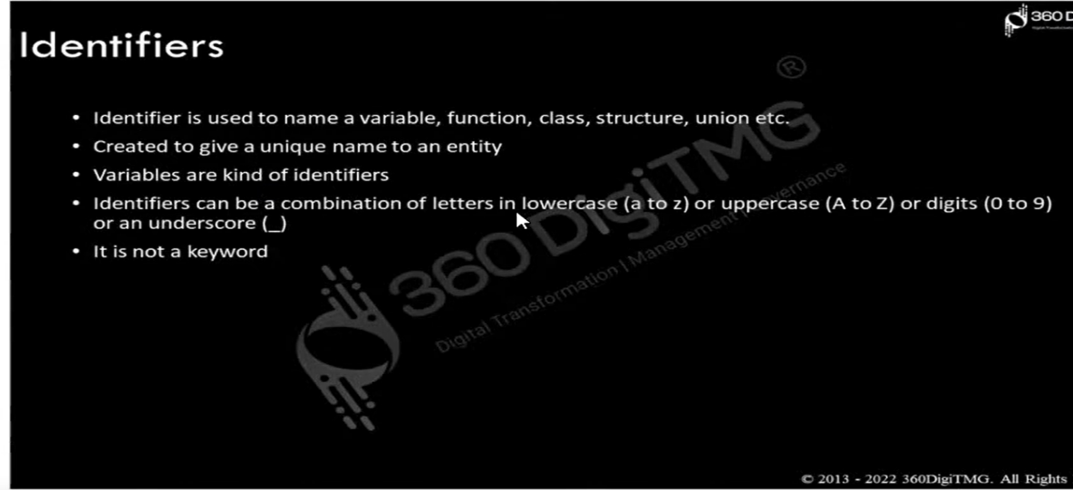

**Operators:**

e.g: a+b = c

a,b 🡪 operands + 🡪operator

1. arthematic operator (+,-,*,/,%,//,**)
2. assignment operator (=,+=,-=.*=,/=,%=,//=,**=,&=,|=,^=,>>=,<<=)
3. comparsion operator (>,<,==,!=,>=,<=)
4. logical operator (and ,or, not)
5. bitwise operators (&,|,~,^,>>,<<)
6. membership operator (in, notin)
7. identity operator(is , isnot)

**Topic 3:**

**Conditional Statements and Loops:**

**1.IF condition:**

A)If statement

B)If-else statement

C)If-elif statement

D)Nested if..else statement

Program statement are executed sequentially one after another . In some situations , a block of code needs a time.

These are repetative program codes , the computer have to perform to complete tasks.

The following are the loop strutures available in the python:

1. While statement
2. For loop statement
3. Nested loop statement

**Topic 4:**

**Functions in Python:**

1. Functions help break our program into smaller and modular chunks
2. As our program grows larger and and larger , functions make it more organized and manageable.
3. The functions are broad of two types :

* User- Defined functions
* Bulit - in functions

**Python user defined functions:**

def fun(parameters):

#block of statements

fun()

Types of arguments:

1.default arguments

2.keyword arguments

3.variable-length arguments

4.Keyword arguments

**Variable-length arguments:**

In Python , we can pass a variable number of arguments to a function using special symbols.

There are 2 special symbols :

1.*args(Non-Keyword Arguments)

2.**kwargs(Keyword-arguments)

We can use ‘**return’** keyword in functions

**Python bulid in functions:**

1. The bulid in functions are defined as the functions whose functionally is pre defined in python.
2. The Python interpreter has several functions that are always present for use .these functions are called Bulid in functions.
3. They are abs(),min(),max(),len() ,ord(),sorted() etc..

**Python Anonymous Functions:**

In python an anonymous function means that a function is without a name.**lambda** keyword is used to create the anonymous function

**\*map() ,reduce(),filter():**

**map():**

Map is function in which we can place function and variables

Syntax: map(function,iterable)

**reduce():**

Reduce is function in which we can apply condition to 2 variable of given variablewhich we pass.

*We need to* ***import*** *from* ***funtools module for reduce() function***

Syntax:reduce(function,sequence[,intial])

**Filter():**

Filter is function used the condition and clean the data which we are given.

Syntax:filter(function return true/false,iterables)

**Collections:**

1.Collections in python are containers used for storing data and are commonly known datastrutures such as lists,tuples,arrays and dictioanries etc..

2.Python has bulid in collections module providing additional datastruture for collections of data .

Import collections as cl

def[‘a’] = 1

def[‘b’]=2

defd=cl.defaultdict(lambda:’Key Not available’)

Print(“The value of c is :”,end=””)

Print(def[‘c’])

**Output:**

Key is not available

**Iterator:(__iter__() is object ,iter() is function)**

Iterators is a object which allow programmer to transverse through all the elements of a collections regardless of its specific implementation.

names = [‘a’,’b’,’c’,’d’,’e’]

new_list1 = iter(names)

Print(next(new_list1))

**Generators:**

Generator is a object that **yeilds** a sequence of values using **‘yeild’ method**

**Topic 5:**

**Exception Handling and File Handling:**

**Exception:**

1.An exception can be defined as an abnormal condition in a program resulting in the discruption in the flow of program.

2.Whenever the exception occur the program halts the execution and further code is not executed.

Commonly exceptions are:

A)zero division error

B)Name error

C)Indentation error

D)I/O error

E)EOF error

**Syntax Error:**

Syntax error are detected when we have not followed the rules of a programming language while writing a program..

**Raising Exceptions:**

Exception handlers are designed to execute when a specific exception is raised.Programmers can also forcefully raise exception in a program using the **raise** and **assert** statements.

*Syntax: raise exception_class*

**Assertions:**

An assert in python is used to test an expression in program code.If the result after testing comes false , then exception is raised.This statement is generally used in the beginning of the function or after a function call to check for valid output.

*The syntax for assert statement is:*

*assert condition,error_message*

**Handling Exceptions:**

Each exception must be handled by the programmer to avoid the program from the crashing abruptly.

This is done by writing additional in a program to give proper messages or instrutions to the user on encountering an exception.

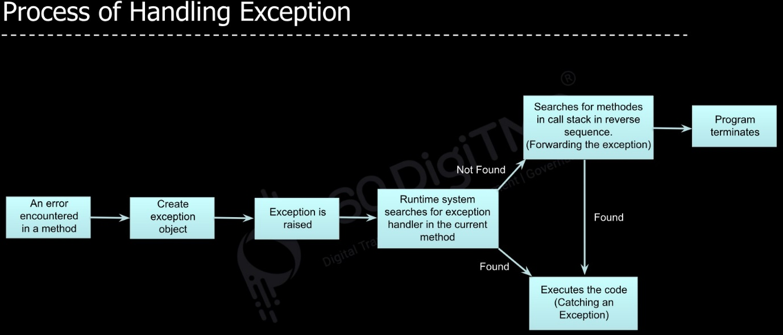

**Syntax:**

try:

#block of code

except:

#block of code

else:

#block of code

finally:

#block of code

**Topic 6:**

**File Handling in Python:**

1. A file is a collection of data stored in one unit identified by its name.Python also supports file handling and allow users to handle files, i.e read and write files, along with many other file handling options.

2.Python handles files differently as text or binary and this is important.

3.Each line of code contains a sequence of charaters and forms a text file.Each line of a file is terminated by a special charater called EOL or the End of the Line charater such as the or new line charaters.It ends the current line and inform the interpreter that a new line has began.

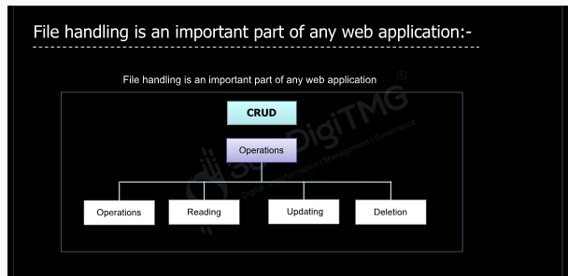

**Text File Modes**:

1.Read mode – r

2.write mode – w

3.append mode-a

4.read and write mode-r+

5.write and read mode – w+

6.append and read mode – a+

7.open file in read binary – rb

8.open file in write binary- wb

9. open file read and write in binary format-rb+

10.open the file write and read in binary format-wb+

11.open the file to open file to append the data in binary format – ab

12.append at read in binary format-at+

**Methods to read the data**:

1.read() –reads the whole content of the file and returns a string object.

2.read(num of char)- reads the specified no of charaters of the file and returns a string object.

3.readline()-reads one line at a tie and returns a string object.

4.readlines()- reads all the lines from the file and returns a list of strings where every trying will be one line.

**Methods to write the data**:

1.write(‘str’)- takes a string as input and writes it into a file

2.writelines(list of string)

**Seek function:**

In python seek() function is used to change the position of the file handle to a specific position.

Syntax: file.seek(offset,[,from])

**tell() method:**

The tell() method returns the current file position in a file stream.

Syntax: file.tell()