Nathan,
Comments to the Author
The manuscript presents the development of a data collection device for monitoring hens.
1. The signal processing and data analytics aspects are relatively limited, with the results primarily presented through qualitative graphical observations.
Correct. We only have a single figure (4a and 4b), with data analysis. At the time stamps at 12:15, 13:30, and 14:15 seconds, you see the bird do slight movement upwards and then abruptly drop, indicating the effect seen in the figure below.
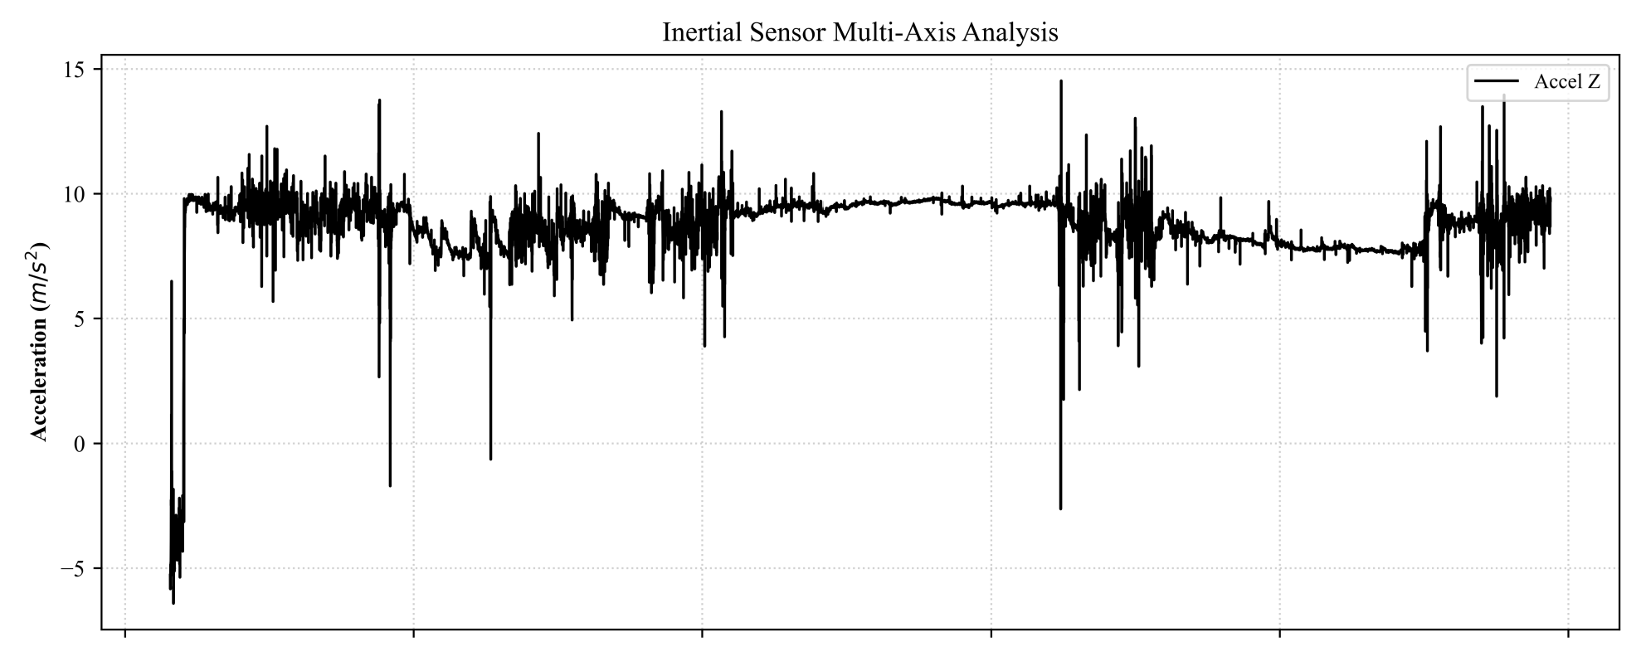
2. Let say the contribution is meant to be mainly lie in the electronic and hardware design rather than in data analysis, from an electronic system design perspective, several practical considerations are still insufficiently addressed.
Bird jumps / flies
Our aim is primarily in design for data collection on birds.
a. Scalability is a major concern. Commercial poultry farms typically contain a large number of hens, often in the hundreds or thousands. The manuscript does not describe and evaluate how the proposed system would perform when many devices are deployed and operating simultaneously, nor does it discuss potential issues related to wireless communication reliability, data transmission congestion, synchronization, or system management at scale.
Our aim is not to deploy this to hundreds of thousands of hens, but few hundred, to monitor the movement of a subset of them.
b. Battery life is a critical factor for wearable monitoring devices. The manuscript lacks an investigation of power consumption, expected operating duration, charging frequency, and maintenance requirements.
The battery life for the purely capacitive sensor is directly proportional to the frequency of the system. Currently at the sampling rate of 1 kHz, we can capture around 8 hours of data. By selective choosing the sampling rate, we can set battery life to a maximum of around 35 to capture the needed data. Approximately every 24 hours (daily), the battery should be charged, but then it should last for the next 24 hours. This can be done by setting the downtime of one study so it coincides with the charging of the lower battery device.
c. The mechanical robustness of the device requires further consideration. The current prototype is attached to the hen's feathers with exposed wiring, but no evaluation is provided regarding attachment reliability under realistic farm conditions. Hens frequently move, interact, and may engage in aggressive behaviors, which could cause the device to loosen, detach, or sustain damage. Additional testing and discussion on the durability, safety, and long-term wearability of the device would strengthen the manuscript.
Mechanical robustness mainly relies on the deployability inside a pouch / “chicken backpack”, which is an industry standard [23]
3. Overall, while the hardware prototype demonstrates initial feasibility, further investigation into scalability, power management, and mechanical robustness is necessary to establish its suitability for practical deployment in commercial poultry farming environments. Additionally, data analytics must be numerical, not qualitative.
Analyzing the data again, we see values of 10 m/s^2 of upwards acceleration around the 12:30 and 13:30 marks, implying that the bird is flying and the effects of gravity have been negated. The angular velocity is also increasing, implying that the bird is rotating in some way.
Reviewer: 2
Comments to the Author
The manuscript entitled “Design of a Keel Bone Monitoring System in Egg Laying Hens” demonstrates preliminary hardware design, component selection, power optimization, and data analysis. The current version of this manuscript requires substantial revision before it can be considered for real-world applications. So, my recommendation is this article needs a compulsory major revision before publishing in this journal.
1. Authors are requested to analysis the sensitivity, and response time and stability for the long-term reliability of the sensor. Follow the article: https://doi.org/10.1109/LSENS.2025.3639618
it appears that the reviewer mis-read our paper. We did not disclose development of a new sensor (but rather system design), as such the requested analysis is not necessary. However, we do need to show that the data is “good”, for instance say something like “measured data (bird acceleration) was verified with in-person observations”, or something like that. The data was run over 5 averages over several trials, and whenever the bird had an impulse, the nature was similar to all graphs.

2. While the hardware miniaturization and integration are commendable, the manuscript should more clearly articulate how this design advances beyond prior wireless monitoring devices.
Correct. We should briefly describe what is “out there”, and why we needed to design our own system (why what’s available does not meet our requirements). There have been individual sensors that sense the data, but all of these are bulky and have not been subsidized into one system.
3. The study emphasizes preliminary design and prototyping, yet lacks sufficient quantitative validation of sensor accuracy, reliability, and non-interference with chicken behavior.
Again, our design does not feature a custom-made sensor, but rather COTS (commercial-off-the-shelf) components assembled in a new way, to do something that was previously impossible
4. The manuscript should provide a stronger comparison with existing monitoring devices to highlight the novelty and advantages of the proposed system.
This is a duplicate of #2

