CMN-100 Conductivity Probe

Overview
The CM-100 Conductivity Probe is intended for water quality testing, general chemistry and ecology experiments. It has two switch selectable ranges of 0-200 and 0-20,000 microsiemens. Exercises may include relating conductivity to temperature, measuring the conductivity of water samples from a variety of sources, and correlating conductivity to pH.

Conductivity is the ability of a substance to conduct an electric current. The principle by which conductivity is measured is fairly easy - two electrodes are placed in the solution, a potential is applied across the electrodes, and the current is measured. Conductivity (G) is the inverse of resistivity (R). This can be determined from the voltage and current values according to Ohm's law:
G = I/R = I (amps) / E (volts)

Since the ions in a solution facilitate the conductance of an electrical current, the conductivity of a solution is proportional to its ion concentration. Conductivity is generally measured in microsiemens (uS). Microsiemens are the modern units of the inverse of resistivity or mho.
In some situations, however, conductivity may not correlate directly to concentration. The graphs below illustrate the relationship between conductivity and ion concentration for two common solutions. Notice that the graph is linear for the sodium chloride solution, but not for a highly concentrated sulfuric acid solution. Ionic interactions can alter the linear relationship between conductivity and concentration in some highly concentrated solutions.
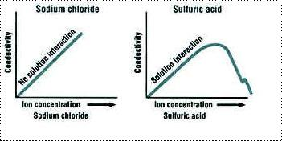

Ions that move through solution easily are better conductors. Small, fast moving ions like hydrogen (H+) have a greater conductivity than do larger ions like bromide ion (Br-), or heavily hydrated ions like the sulfate ion (SO42-).

Conductivity is a useful method for measuring how good a conductor a substance will be. Conductive substances are usually referred to as electrolytes. Thus, electrolytes are compounds that dissolve in water and dissociate into ions. In solutions of electrolytes, several different substances may be present, including complete, whole molecules and dissociated ions.

Strong electrolytes dissociate completely into ions. A 1.0 M solution of the strong ionic electrolyte “AB” contains 1.0 M “A+” ions, 1.0 M “B-” ions, and 0.0 M “AB” molecules. In other words, the ions are the only substances present in a solution of a strong electrolyte. Diluting a 1.0 M solution of “AB” with water to 0.50 M reduces the concentration of ions by one half, which also reduces the conductivity of the solution by one half.
Weak electrolytes dissociate incompletely, or do not fully separate into their respective ions. A 1.0 M solution of a weak electrolyte “CD” may contain less than 0.20 M “C+" ions, the same molarity of “D-” ions, and greater than 0.80 M “CD” molecules. In a solution of a weak electrolyte the main substance present is the entire molecule, not necessarily the dissociated ions.

The dissociation of a weak electrolyte is an equilibrium process, in which molecules are constantly dissociating, a forward reaction, and reforming, the reverse reaction, at identical rates. At equilibrium, the forward and reverse processes occur at the same rate, so molecules dissociate and reform at the same rate, and the concentrations of the molecule, its positive ions and its negative ions all remain constant.

The probability of spontaneous dissociation of a molecule is constant, but the probability of reformation of the molecule from its ions depends on the concentration of ions present; low concentration makes reformation infrequent which makes the reverse reaction slower. This means that diluting a weak electrolytic solution slows down the reverse reaction more than it slows down the forward reaction. After dilution, dissociation outpaces reformation until the concentrations of the ions rise, their reformation rate increases, and the rate of the reverse reaction rises to match that of the forward reaction. As a result, dilution leads to dissociation of additional molecules before equilibrium is reached again. So diluting a 1.0 M solution of a weak electrolyte to 0.50 M with water reduces the conductivity, but by less than the 50% expected with strong electrolytes.

Photo
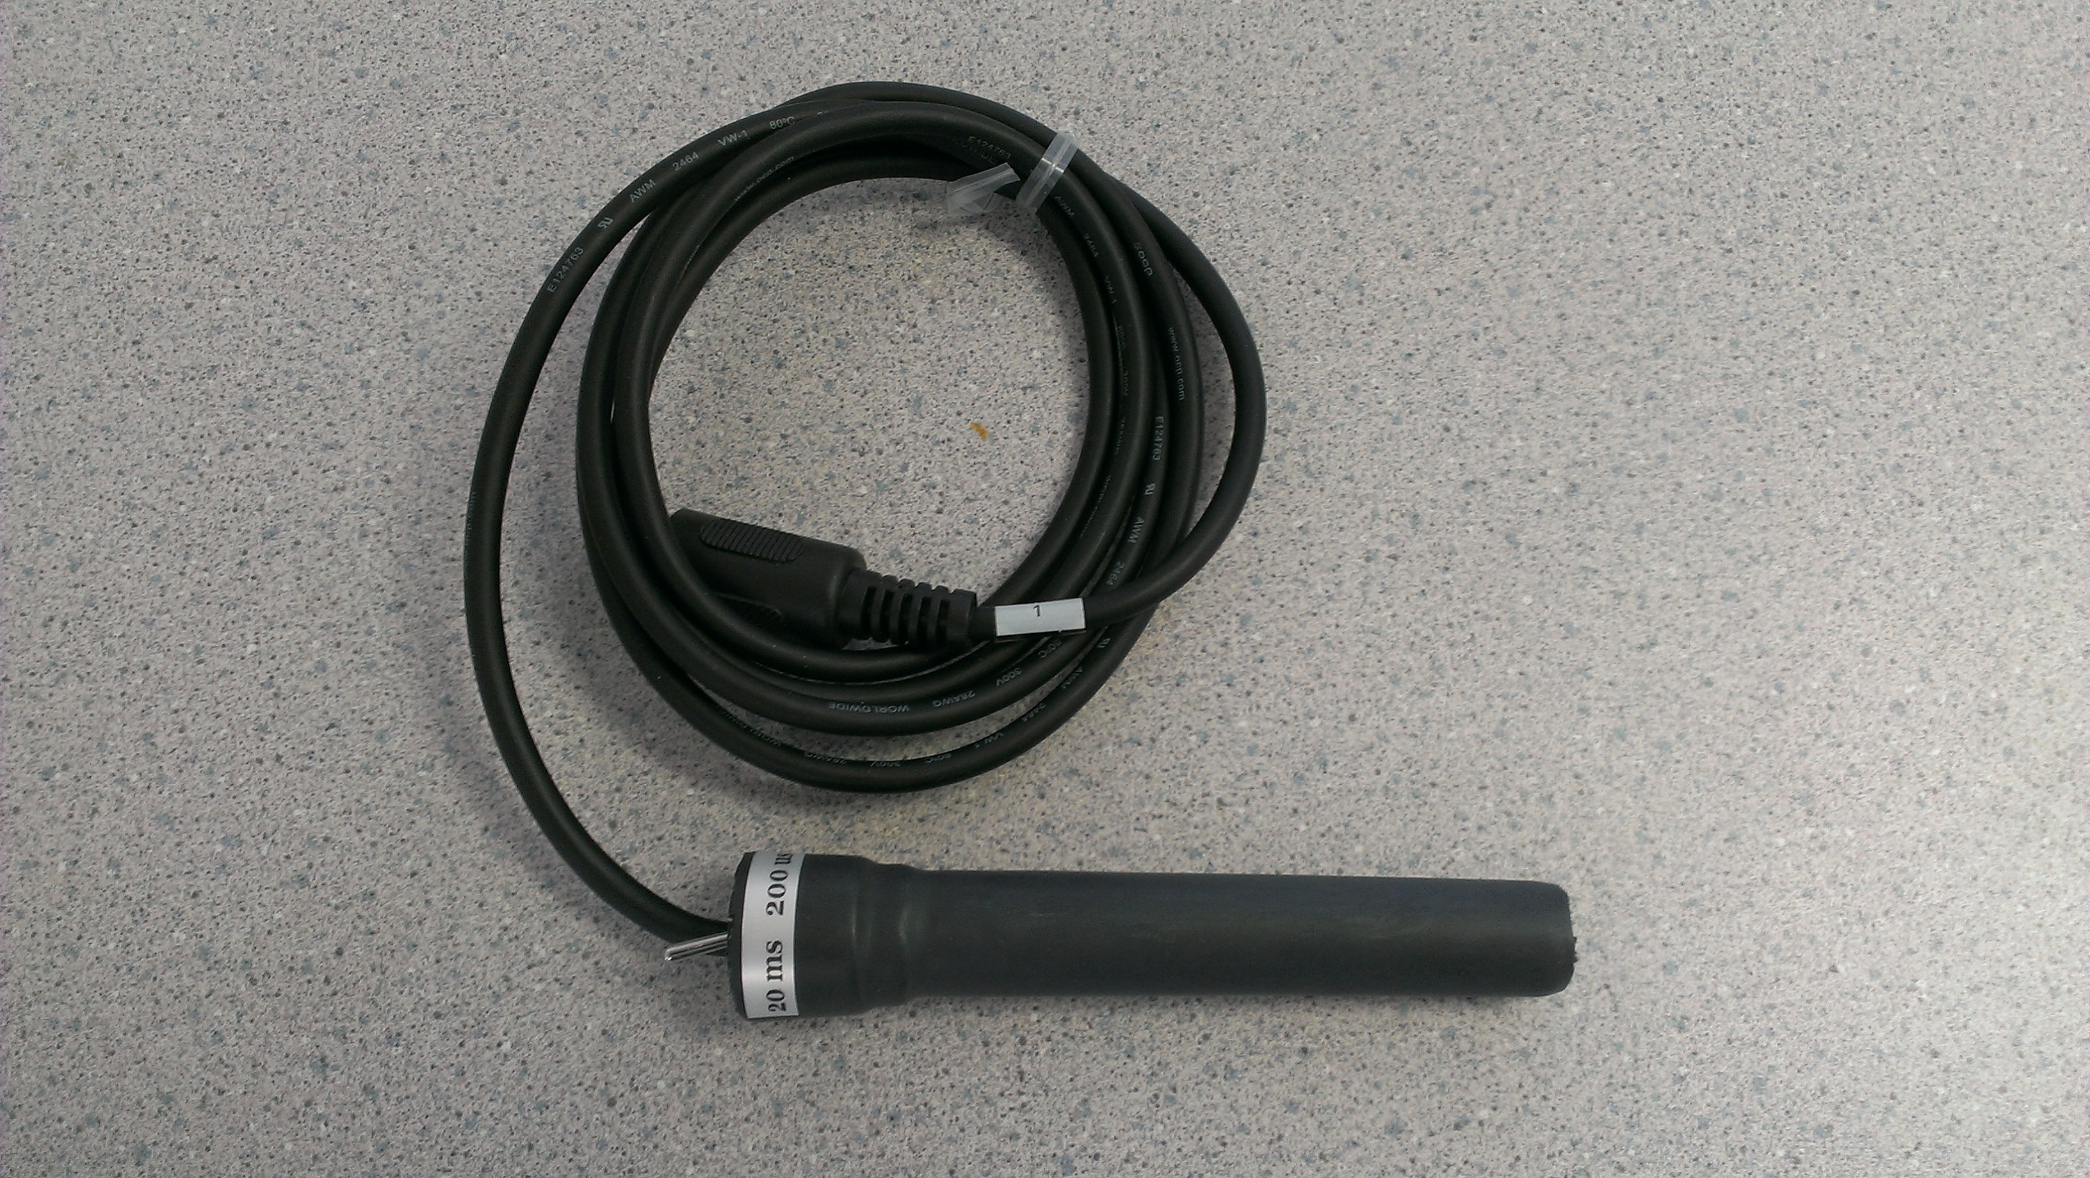
Specifications
Input Range | Range: 0-200 and 0-20,000 microsiemens
Output Range | 0V to 4V
Calibration | Required every use
Default scaling Value | There are 2ranges. 20 mS and 200uS. 20 mS: 0.4V is approximately 1 mS 4V is approximately 20 mS 200 uS: 0.4V is approximately 10 uS 4V is approximately 200 uS

Calibration Instructions
1. Plug the IX-ELVIS board into the National Instrument ELVIS platform. Connect the power supply to the ELVIS platform and connect to the computer via a USB cable. Ensure both of the switches are in the on position.
2. Connect the MINIDIN7 connector of the CMN-100 to the IX-ELVIS board.
3. Open the recording software, select the channel that the CMN-100 is plugged into and ensure the range is set to 0V to 5V.
4. The CMN-100 should be calibrated within the expected range. For example: If the expected range is 500uS to 1000uS perform a 2 point calibration with the first point (SP1) at 400uS and the second point (SP2) at 1000uS.

*Note: If using the IX-MYDAQ the signal may be inverted.

Measurement Instructions
The Effect of Concentration on the Conductivity of Solutions
Aim: To determine the effect of concentration on the conductivity of various solutions.
Note: Always begin testing samples with the conductivity selector switch in the 0-200 uS range. While recording the conductivity of each test sample, toggle the switch to the 0-20,000 uS position. This is especially important for measuring solutions with higher conductivities.
Procedure:
1. Follow the calibration procedure above.
2. Add 50 ml deionized water to a 100 ml beaker.
3. Place the CMN-100 conductivity meter in the beaker and click Record.
4. When the recording on the Conductivity channel reaches a stable baseline, record that it is DI Water.
5. Add 1 drop of 1.0 M NaCl solution to the deionized water. Carefully swirl the CMN-100 to ensure thorough mixing. Record the event.
6. Add a second drop of 1.0 M NaCl solution to the beaker. Record the event as it reaches a stable value.
7. Add a third drop of 1.0 M NaCl solution to the beaker. Record the event as it reaches a stable value.
8. Continue following these steps until 10 drops of 1.0 M NaCl have been added to the beaker.
9. Click Stop to halt the recording.
10. Save the File.
11. Remove the conductivity meter from the beaker. Hold the meter over the beaker used for collecting waste deionized water, and rinse it with a wash bottle. Blot any drops of DI water from the meter and place the meter in the beaker containing fresh DI water.
12. Repeat steps 1 through 11 for both 1.0 M CaCl2
and 1.0 M AlCl3
13. Discard the contents of each beaker as directed by your instructor

*Note: If using the IX-MYDAQ the signal may be inverted.

Intended Usage
Iworx Systems Inc. instruments, components, and accessories are designed for educational and research oriented life science applications and investigations. Iworx Systems Inc. does not condone the use of its instruments for clinical medical applications. Instruments, components, and accessories provided by Iworx Systems Inc. are not intended for the diagnosis, cure, mitigation, treatment, or prevention of disease.

Company Information:

Headquarters
iWorx Systems, Inc.
62 Littleworth Road
Dover, NH 03820

Phone: (800) 234-1757
Fax: (603) 742-2455
Website: www.iWorx.com

