DCN-100 Drop Counter

Overview
The Drop Counter is an optical sensor that accurately records the number of drops passing through the optical slot.

Photo
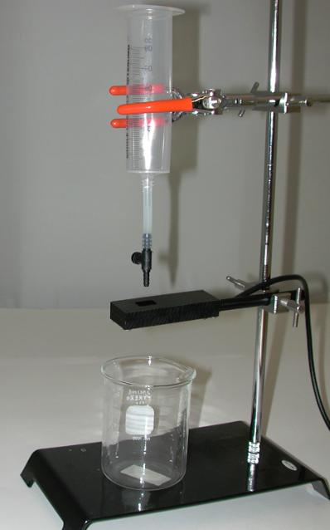

Specifications
Output Range | +/-5V
Calibration | N/A
Default scaling Value | N/A
Infrared Source | 940nm
Drip Rate | 2 Seconds or slower

Measurement Instructions
1. Plug the IX-ELVIS board into the National Instrument ELVIS platform. Connect the power supply to the ELVIS platform and connect to the computer via a USB cable. Ensure both of the switches are in the on position.
2. Connect the MINIDIN7 connector of the DCN-100 to the IX-ELVIS board.
3. Open the recording software, select the channel that the DCN-100 is plugged into and ensure the range is set to +/-5V.
4. Set the sensor so that drops fall directly through the center of the hole and are about 1" above the optical slot.
5. Test your system by sending a few drops through the sensor so you see the signal on the waveform chart. A pulse will represent each drop.
6. Set the drip rate to 2 seconds per drop or slower.
7. Set the Threshold so that the voltage signal rises above it when a drop is detected but well above the baseline of the signal.

*Note: The signal may be inverted when using the myDAQ setup.

Intended Usage
Iworx Systems Inc. instruments, components, and accessories are designed for educational and research oriented life science applications and investigations. Iworx Systems Inc. does not condone the use of its instruments for clinical medical applications. Instruments, components, and accessories provided by Iworx Systems Inc. are not intended for the diagnosis, cure, mitigation, treatment, or prevention of disease.

Company Information:

Headquarters
iWorx Systems, Inc.
62 Littleworth Road
Dover, NH 03820

Phone: (800) 234-1757
Fax: (603) 742-2455
Website: www.iWorx.com

