DO2N-200E Dissolved Oxygen Sensor

Overview
The DO2N-300E is a current to voltage adapter designed to work with a Clark-style oxygen electrode. This adapter delivers a polarizing voltage of -0.8V to the electrode to create a current, or flow of electrons, between the silver and platinum elements in the electrode. The flow of electrons between these elements increases and decreases as the concentration of oxygen in the polarograph chamber increases and decreases, respectively. The adapter then converts the changes in current to changes in voltage that can be recorded.

Photo
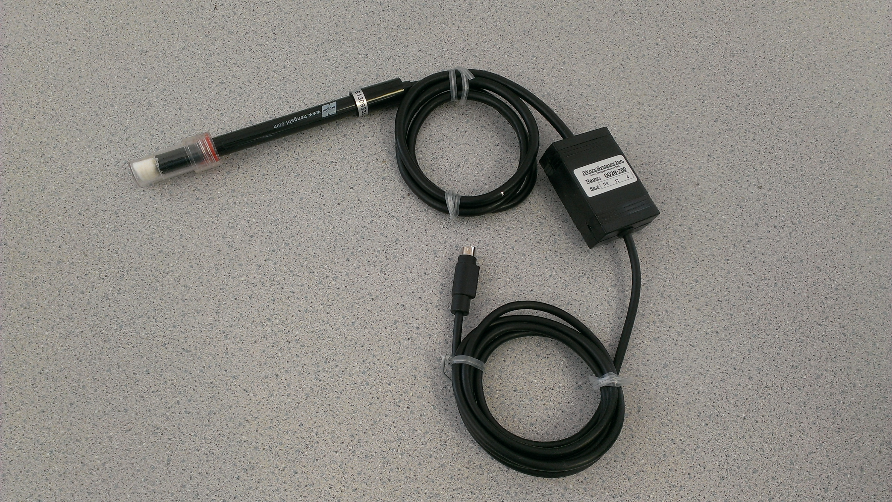

Specifications
Output Range | +/-5V
Calibration | Required every use
Default scaling Value | Water = 20% Diet Soda = 0%

Calibration Instructions
1. Plug the IX-ELVIS board into the National Instrument ELVIS platform. Connect the power supply to the ELVIS platform and connect to the computer via a USB cable. Ensure both of the switches are in the on position.
2. Connect the MINIDIN7 connector of the DO2N-200E to the IX-ELVIS board. Wait 15 mins for the sensor to warm up.
3. Open the recording software, select the channel that the DO2N-200E is plugged into and ensure the range is set to +/-5V.
4. Prepare 2 beakers, 1 with diet soda and 1 with tap water. Ensure the volumes are the same.
5. Place the electrode of the DO2N-200E in the beaker with the water. Once the trace settles click Set for SP2 for 20 % dissolved oxygen.
6. Place the electrode in the beaker with the diet soda. Once the trace settles click Set for SP1 for 0 % dissolved oxygen.

*Note: The signal may be inverted if the IX-MYDAQ is used.

Measurement Instructions
1. Follow the calibration procedure above.
2. Set up desired experiment and press record.

*Note: The signal may be inverted if the IX-MYDAQ is used.

Intended Usage
Iworx Systems Inc. instruments, components, and accessories are designed for educational and research oriented life science applications and investigations. Iworx Systems Inc. does not condone the use of its instruments for clinical medical applications. Instruments, components, and accessories provided by Iworx Systems Inc. are not intended for the diagnosis, cure, mitigation, treatment, or prevention of disease.

Company Information:

Headquarters
iWorx Systems, Inc.
62 Littleworth Road
Dover, NH 03820

Phone: (800) 234-1757
Fax: (603) 742-2455
Website: www.iWorx.com

