HSN-100 Relative Humidity Sensor

Overview
The HSN-100 can provide measurements of relative humidity from 20 to 85% (+/-5%) over a temperature range from 0°C to +50°C.
The HSN-100 is a sensor designed for measuring the relative humidity (RH) in environmental chambers, plant growth chambers, model ecosystems, or the atmosphere.

Photo
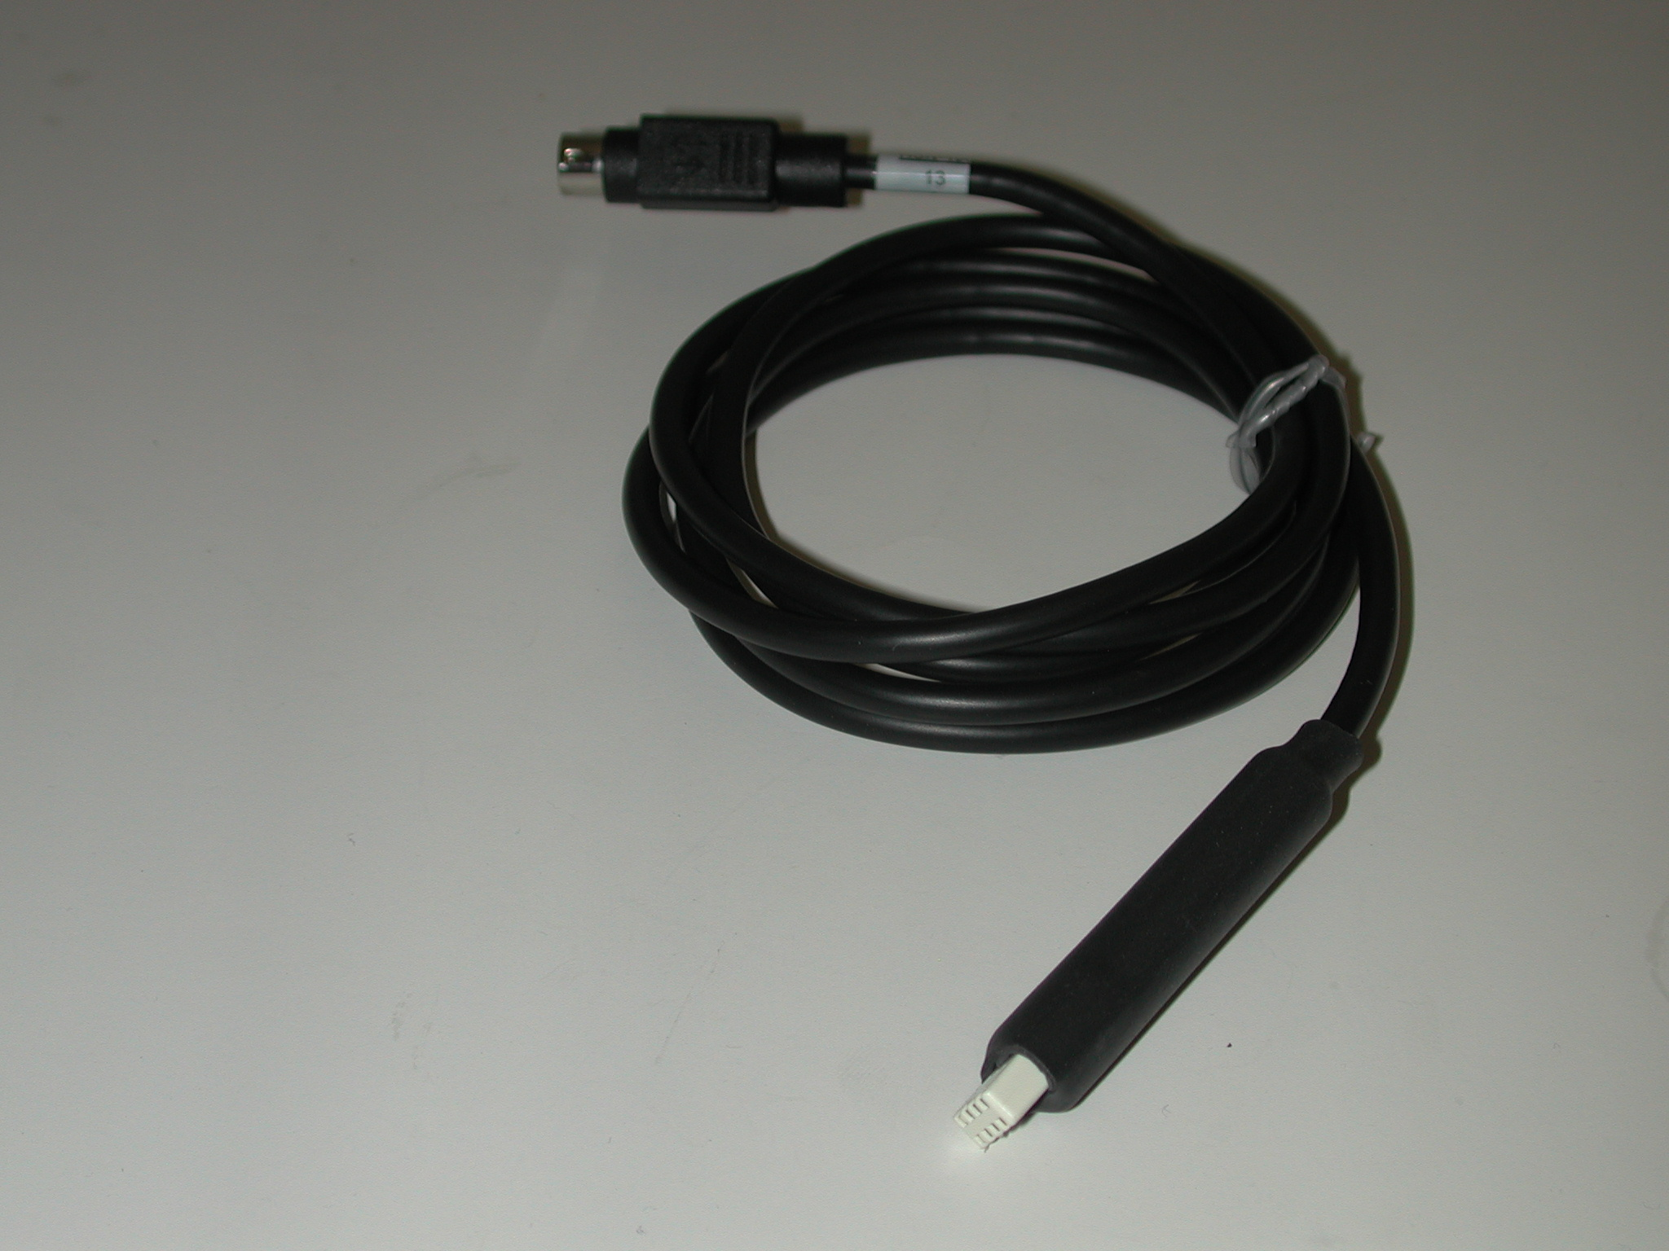

Specifications
Input Range | 20% to 85% RH (+/- 5%)
Output Range | 0.2V to 0.85V
Calibration | Multiply the output voltage in Volts by 100 to get the %RH.

Measurement Instructions
1. Plug the IX-ELVIS board into the National Instrument ELVIS platform. Connect the power supply to the ELVIS platform and connect to the computer via a USB cable. Ensure both of the switches are in the on position.
2. Connect the MINIDIN7 connector of the HSN-100 to the IX-ELVIS board.
3. Open the recording software; select the channel that the HSN-100 is plugged into and ensure the range is set to 0V to 1V.
4. Multiply the output voltage in Volts by 100 to get the %RH.

*Note: The signal may be inverted if the NI myDAQ setup is used.

Intended Usage
Iworx Systems Inc. instruments, components, and accessories are designed for educational and research oriented life science applications and investigations. Iworx Systems Inc. does not condone the use of its instruments for clinical medical applications. Instruments, components, and accessories provided by Iworx Systems Inc. are not intended for the diagnosis, cure, mitigation, treatment, or prevention of disease.

Company Information:

Headquarters
iWorx Systems, Inc.
62 Littleworth Road
Dover, NH 03820

Phone: (800) 234-1757
Fax: (603) 742-2455
Website: www.iWorx.com

