IX-ELADP Adapter Board for Use with the IX-ELVIS

Overview
The IX-ELADP is a small adapter board used to interface iWorx Systems transducers to breadboards on the stock NI ELVIS II SERIES PROTOTYPING BOARD component of the NI ELVIS system manufactured by National Instruments.

It is an open PCB with 2 MINIDIN7 connectors that allow access to the analog outputs from the transducers. There is also a gain set resistor option.
Photo
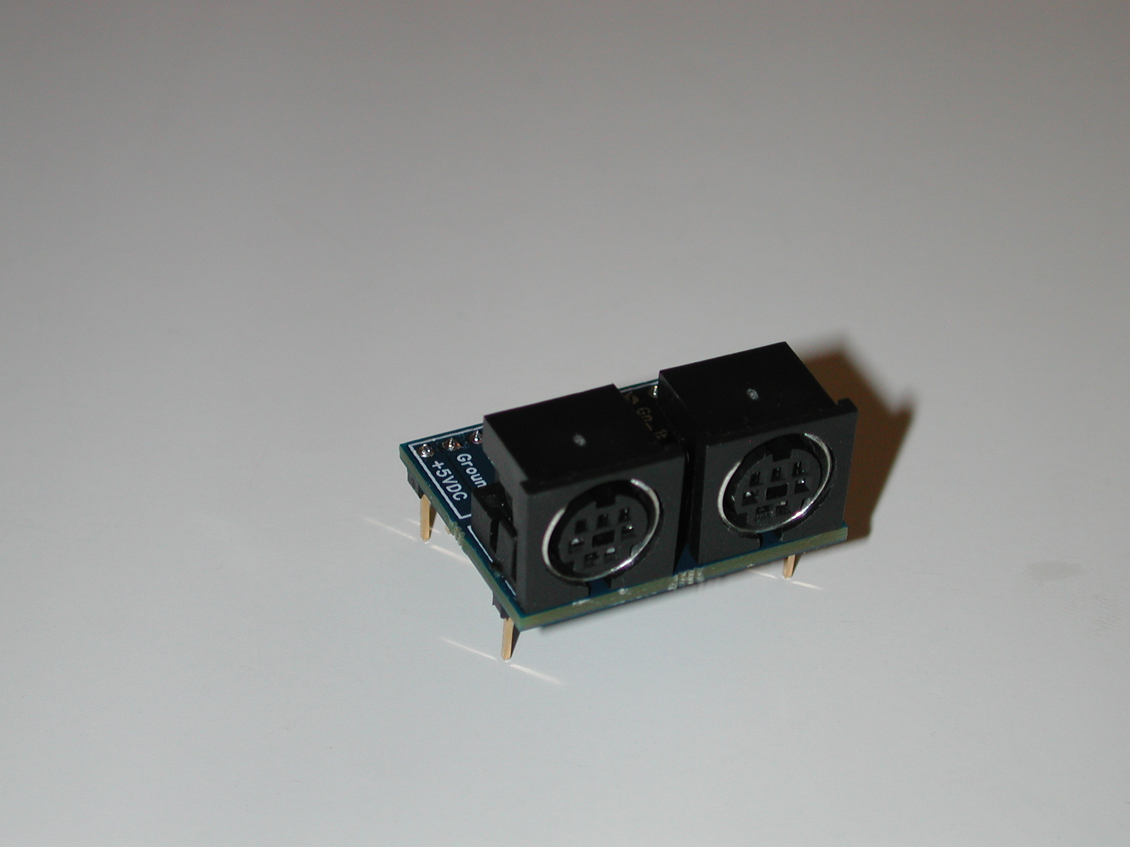

Specifications
Input Range | +/- 5V
Output Range | +/- 5V
Calibration | N/A
Default scaling Value | N/A
Input connectors | MINIDIN 7 (x2)
Pin dimensions | 1.225"L X 1"W
Height above breadboard | 0.737"

PCB pin out
Pin Name | Pin Function | Description
A_+ | Channel 1 Positive Analog Input | Output to ELVIS Breadboard
A_- | Channel 1 Negative Analog Input | Output to ELVIS Breadboard
Gn_1A | Channel 1 Gain-Set Resistor End ”A”; No polarity | Output to ELVIS Breadboard
Gn_1B | Channel 1 Gain-Set Resistor End ”B”  No polarity | Output to ELVIS Breadboard
A_2+ | Channel 2 Positive Analog Input | Output to ELVIS Breadboard
A_2- | Channel 2 Negative Analog Input | Output to ELVIS Breadboard
Gn_2A | Channel 2 Gain-Set Resistor End ”A”  No polarity | Output to ELVIS Breadboard
Gn_2B | Channel 2 Gain-Set Resistor End ”B”  No polarity | Output to ELVIS Breadboard
Ground | Ground connection | Connection to ELVIS System ground
-15VDC | Negative 15 Volt DC supply | Input from ELVIS System power supply
Ground | Ground connection | Connection to ELVIS System ground
+5VDC | Positive 5 Volt DC supply | Input from ELVIS System power supply
The ground connections are equivalent

Using the IX-ELADP
There are many configurations to utilize this adapter. The below outlines a few:

Inserting the IX-ELADP into the breadboard:
The IX-ELADP connects to the breadboard with a 0.1" pitch, 12-pin SIP connector and 2 single-pin mechanical support pins. The support pins are located under the MINIDIN7 connectors at the PCB corners located 0.7" from the 12-pin SIP connector. The mechanical support pins are not connected to any electrical node, this limits the opportunity to inadvertently cause an electrical short on the breadboard.

Power Supply Overview:
The topside of the adapter is populated with the two MINIDIN7 connectors, and the silkscreen describing the pin functionality of the electrical nodes on the 12-pin SIP connector. There are 3 sections, power, channel 1, and channel 2. The power section has two Ground pins, a +5 VDC pin, and a -15 VDC pin. These connections allow the adapter to be powered from the NI ELVIS +5V and -15V supplies. A negative linear regulator on the bottom of the adapter PCB is powered by the ELVIS -15V supply, and outputs -5V to the coupled transducers. The ELVIS +5V supply is simply channeled directly to the channel 1 and channel 2 transducers.

The PCB bottom side linear regulator is populated with a SOT223-4 packaged component capable of dissipating the heat generated by the 10V input-output differential multiplied by the current drawn by the channel 1 and channel 2 transducers. Typical transducers are limited to less than 40mA, providing a likely maximum heat dissipation of 800mW (2 x 40mA x 10V). The PCB sinks heat from the linear regulator into the ELVIS -15V copper plane. The plane has the solder mask removed to maximize heat transfer, and it is important that this plane is not shorted to GROUND or other nodes while prototyping. When properly used, the exposed heat sink is inaccessible.

Care must be exercised to ensure that the prototyping loads do not overload the ELVIS power supplies. The ELVIS ii Hardware User Manual “Appendix A” specifies that the +5V supply provide +5 V at ±5% no load, limited to 2A. The -15V supply provides -15 V at ±5% no load, and combined with the -15V variable supply is limited to 500mA. It is advised that the user read the ELVIS ii Hardware User Manual to understand the capabilities and limitations of the provided power supplies, including the load regulation specifications.

Using the gain capability:
Each Channel provides four electrical node connections, differential analog outputs, and connections to both nodes of a gain set resistor embedded in transducers that typically require gain from an instrumentation amplifier. Many transducer outputs are single-ended, and for these, one of the differential analog outputs will be internally grounded in the transducer.

For transducers that do provide a differential output, it may be driven into the NI ELVIS differential ADC analog inputs without gain, or it may first be routed to a gain block on the breadboard. If the gain set resistor (Rgs) provided in some transducers is to be used, the gain-block should conform to a nominal gain equation of G=((50K/Rgs)+1) as is typical of AD620 or LT1167 instrumentation amplifiers in order for the transducer gain set resistor to appropriately configure the gain applied to the transducer output.

Intended Usage
IWorx Systems Inc. instruments, components, and accessories are designed for educational and research oriented life science applications and investigations. IWorx Systems Inc. does not condone the use of its instruments for clinical medical applications. Instruments, components, and accessories provided by IWorx Systems Inc. are not intended for the diagnosis, cure, mitigation, treatment, or prevention of disease.

Company Information:

Headquarters
iWorx Systems, Inc.
62 Littleworth Road
Dover, NH 03820

Phone: (800) 234-1757
Fax: (603) 742-2455
Website: www.iWorx.com

