IX-MYDAQ Breakout board for NI myDAQ

Overview
The IX-MYDAQ is a breakout board that enables connection of iWorx transducers to the National Instruments NI myDAQ data acquisition device via mini DIN 7 connectors. Also, the IX-MYDAQ utilizes the NI myDAQ analog outputs via two BNC connectors.

Photo
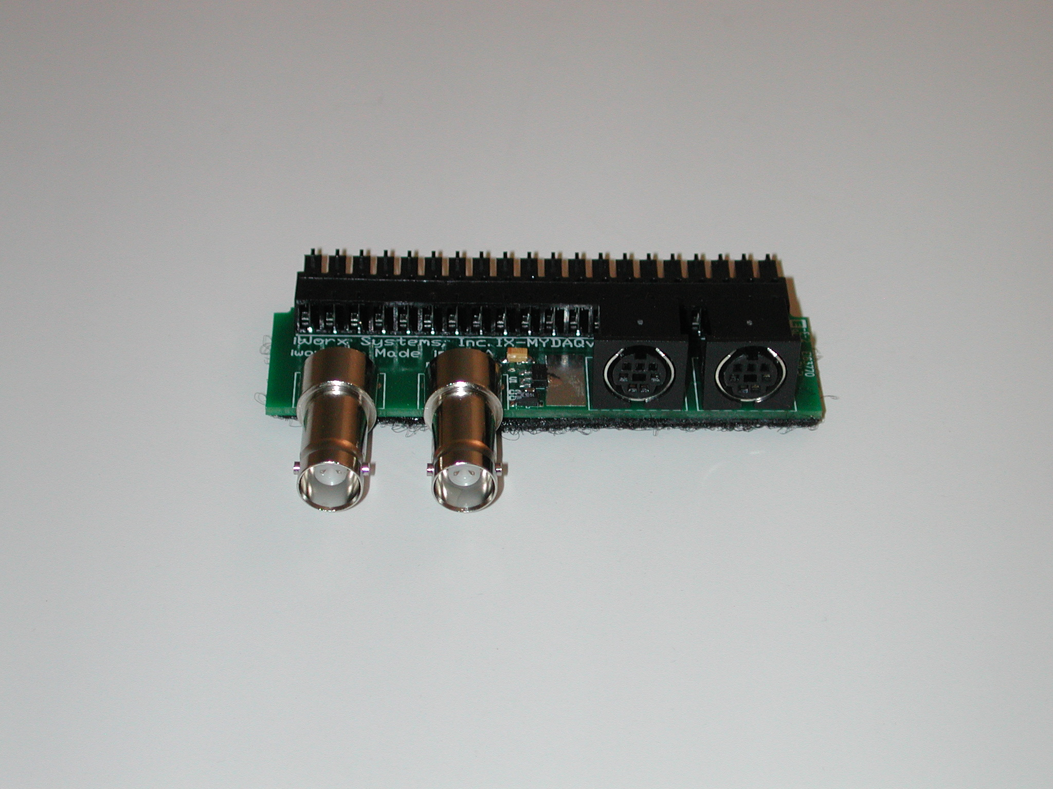

Specifications
Input Range | +/- 5V
Output Range | +/- 5V
Excitation voltage | +/- 5V
Default scaling Value | N/A
Analog Inputs | MINIDIN7(x2)
Analog Outputs | BNC (x2)

MINI DIN 7 Connector Wiring
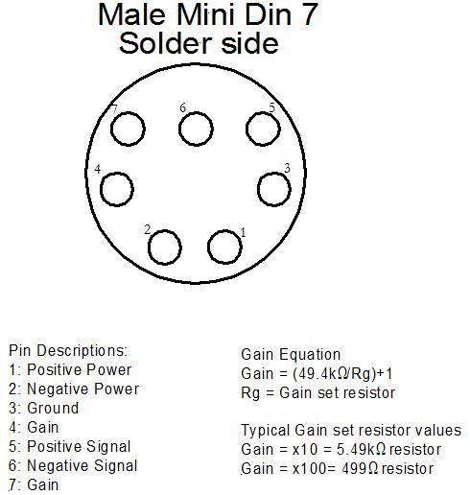
*Note: The IX-ELVIS board has gain connections on it, however the IX-MYDAQ does not.

Measurement Instructions
1. Connect the IX-MYDAQ to the NI myDAQ. Plug a USB cable into the top of the NI myDAQ and the other end into the computer being used.
2. Connect the desired transducer to the IX-MYDAQ and record.
3. See the individual transducer instructions for detailed calibration and use procedures.

*Note: The signals may be inverted while using the IX-MYDAQ.

Intended Usage
Iworx Systems Inc. instruments, components, and accessories are designed for educational and research oriented life science applications and investigations. Iworx Systems Inc. does not condone the use of its instruments for clinical medical applications. Instruments, components, and accessories provided by Iworx Systems Inc. are not intended for the diagnosis, cure, mitigation, treatment, or prevention of disease.

Company Information:

Headquarters
iWorx Systems, Inc.
62 Littleworth Road
Dover, NH 03820

Phone: (800) 234-1757
Fax: (603) 742-2455
Website: www.iWorx.com

