TMN-100 Temperature Sensor

Overview
The TMN-100 is a self-contained temperature transducer with a range of 0ºC to 50ºC. The TMN-100 is capable of responding to changes in temperature within a few seconds because of its small size (1mm x 3mm) and mass. The TMN-100 is suitable for monitoring the temperature of nasal airflow, changes in skin temperature that indicate evaporative cooling, and changes in atmospheric temperature and temperature in environmental chambers. Since the sensor element is water-resistant, the tip of the TMN-100 can be immersed in aqueous solutions, including saline solutions, for a few hours.

Photo
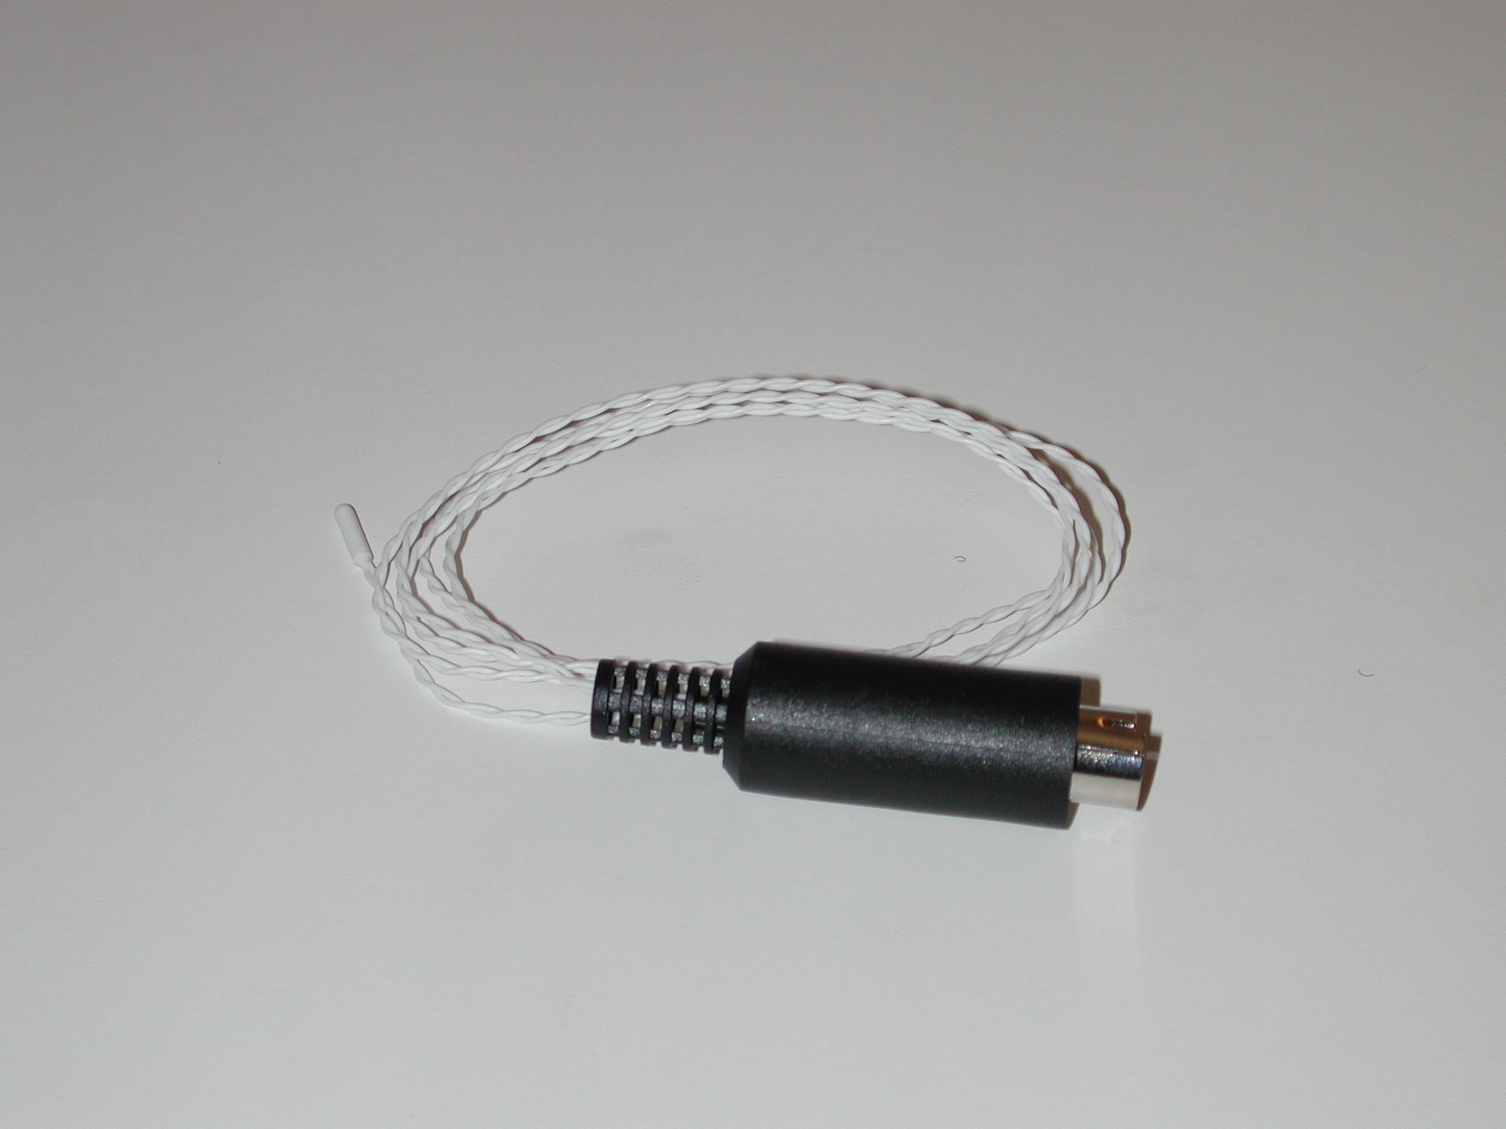

Specifications
Temperature Range | 0 - 50ºC
Calibration | Required every use
Default scaling Value | Temp in ºC = 9.875*Volt + 31.98

*Note: If the default scaling equation is used instead of the calibration procedure a look up table may need to be used as that equation is non-linear.

Calibration Instructions
1. Plug the IX-ELVIS board into the National Instrument ELVIS platform. Connect the power supply to the ELVIS platform and connect to the computer via a USB cable. Ensure both of the switches are in the on position.
2. Connect the MINIDIN7 connector of the TMN-100 to the IX-ELVIS board.
3. Open the recording software, select the channel that the TMN-100 is plugged into and ensure the range is set to +/-5V.
4. Prepare two beakers of water, one at 30ºC, and the other at 40ºC. Measure the temperature of the cold water with a thermometer just before the TMN-100 temperature sensor is placed in the beaker.
5. Place the tip of the TMN-100 temperature sensor in the center of the beaker of cold water. Click the start button of the recording software and record for about 20 seconds.
7. Measure the temperature of the warm water with a thermometer just before the TMN-100 temperature sensor is placed in the beaker. Click the start button of the recording software and record for about 20 seconds.
8. Click stop and perform a 2 point calibration using the stable sections of the output signals.

*Note: The signal may be inverted if the IX-MYDAQ is used.

Measurement Instructions
1. Follow the calibration procedure above.
2. Prepare the sample(s) and press record.

*Note: The signal may be inverted if the IX-MYDAQ is used.

Intended Usage
Iworx Systems Inc. instruments, components, and accessories are designed for educational and research oriented life science applications and investigations. Iworx Systems Inc. does not condone the use of its instruments for clinical medical applications. Instruments, components, and accessories provided by Iworx Systems Inc. are not intended for the diagnosis, cure, mitigation, treatment, or prevention of disease.

Company Information:

Headquarters
iWorx Systems, Inc.
62 Littleworth Road
Dover, NH 03820

Phone: (800) 234-1757
Fax: (603) 742-2455
Website: www.iWorx.com

