Supplementary Materials
Whole genome sequencing, antibiotic resistance, and epidemiology features of nontyphoidal Salmonella isolated from diarrheic children: evidence from north China
Wei Zhao *ª, Xin Li ^{b}, Xuening Shi ^{b}, Kewei Li ª, Ben Shi ª, Jingyu Sun ª, Chao Zhao ^{b}, Juan Wang *^{b}
a. Jilin Center for Disease Prevention and Control, Changchun 130062, Changchun, China
b. School of Public Health, Jilin University, Changchun 130021, China

*Corresponding author:
*Email: weizhao81226@126.com ; jwang0723@jlu.edu.cn

Table S2 The basic information of 260 Salmonella strains
Strain name | Specimen type | City | Year
B154_2018 | Stool | Jilin | 2018
057_2014 | Stool | Yanbian | 2014
056_2014 | Stool | Yanbian | 2014
B084_2017 | Stool | Jilin | 2017
A024_2016 | Stool | Tonghua | 2016
JLS47 | Stool | Liaoyuan | 2015
165_2015 | Stool | Liaoyuan | 2015
164_2015 | Stool | Liaoyuan | 2015
163_2015 | Stool | Liaoyuan | 2015
162_2015 | Stool | Liaoyuan | 2015
B355_2019 | Stool | Baishan | 2019
B356_2019 | Stool | Baishan | 2019
B351_2019 | Stool | Changchun | 2019
B349_2019 | Stool | Changchun | 2019
B013_2017 | Stool | Jilin | 2017
jl19S69 | Stool | Changchun | 2019
B303_2019 | Stool | Changchun | 2019
B212_2018 | Stool | Changchun | 2018
JLS136 | Stool | Changchun | 2018
B194_2018 | Stool | Changchun | 2018
B193_2018 | Stool | Changchun | 2018
JLS122 | Stool | Jilin | 2018
B152_2018 | Stool | Jilin | 2018
JLS91 | Stool | Jilin | 2017
B078_2017 | Stool | Jilin | 2017
B040_2017 | Stool | Jilin | 2017
JLS77 | Stool | Jilin | 2017
B014_2017 | Stool | Jilin | 2017
B006_2017 | Stool | Jilin | 2017
A069_2016 | Stool | Tonghua | 2016
A068_2016 | Stool | Jilin | 2016
A052_2016 | Stool | Tonghua | 2016
A057_2016 | Stool | Tonghua | 2016
JLS55 | Stool | Tonghua | 2015
jl19S75 | Stool | Baishan | 2019
B361_2019 | Stool | Changchun | 2019
jl19S4 | Stool | Baicheng | 2019
B066_2017 | Stool | Jilin | 2017
151_2015 | Stool | Tonghua | 2015
159_2015 | Stool | Tonghua | 2015
158_2015 | Stool | Tonghua | 2015
155_2015 | Stool | Changchun | 2015
093_2014 | Stool | Yanbian | 2014
094_2014 | Stool | Yanbian | 2014
098_2014 | Stool | Yanbian | 2014
B163_2018 | Anal swab | Jilin | 2018
180_2015 | Anal swab | Tonghua | 2015
JLS7 | Stool | Siping | 2014
048_2014 | Anal swab | Yanbian | 2014
050_2014 | Stool | Yanbian | 2014
JLS8 | Anal swab | Yanbian | 2014
jl19S55 | Stool | Baicheng | 2019
B373_2019 | Stool | Baishan | 2019
B358_2019 | Stool | Changchun | 2019
JLS130 | Stool | Changchun | 2018
JLS79 | Stool | Jilin | 2017
B021_2017 | Stool | Jilin | 2017
B018_2017 | Stool | Jilin | 2017
JLS78 | Stool | Jilin | 2017
B016_2017 | Stool | Jilin | 2017
JLS73 | Stool | Jilin | 2017
B002_2016 | Stool | Jilin | 2016
A086_2016 | Stool | Jilin | 2016
A067_2016 | Stool | Jilin | 2016
A066_2016 | Stool | Jilin | 2016
JLS65 | Stool | Tonghua | 2016
149_2015 | Stool | Changchun | 2015
147_2015 | Stool | Changchun | 2015
146_2015 | Stool | Songyuan | 2015
145_2015 | Stool | Tonghua | 2015
144_2015 | Stool | Liaoyuan | 2015
143_2015 | Stool | Liaoyuan | 2015
140_2015 | Stool | Liaoyuan | 2015
044_2014 | Stool | Yanbian | 2014
045_2014 | Stool | Yanbian | 2014
043_2014 | Stool | Yanbian | 2014
041_2014 | Stool | Yanbian | 2014
042_2014 | Stool | Yanbian | 2014
B309_2019 | Stool | Changchun | 2019
B308_2019 | Stool | Changchun | 2019
JLS140 | Stool | Changchun | 2018
B202_2018 | Stool | Changchun | 2018
JLS141 | Stool | Changchun | 2018
JLS131 | Stool | Baishan | 2018
B199_2018 | Stool | Jilin | 2018
JLS127 | Stool | Jilin | 2018
B172_2018 | Stool | Jilin | 2018
B057_2017 | Stool | Jilin | 2017
JLS88 | Stool | Jilin | 2017
A116_2016 | Stool | Jilin | 2016
JLS69 | Stool | Jilin | 2016
A038_2016 | Stool | Tonghua | 2016
A010_2016 | Stool | Tonghua | 2016
JLS40 | Stool | Changchun | 2015
JLS39 | Stool | Changchun | 2015
126_2015 | Stool | Changchun | 2015
125_2015 | Stool | Changchun | 2015
JLS38 | Stool | Changchun | 2015
123_2015 | Stool | Changchun | 2015
JLS36 | Stool | Changchun | 2015
JLS33 | Stool | Songyuan | 2015
JLS32 | Stool | Songyuan | 2015
JLS34 | Stool | Tonghua | 2015
115_2015 | Stool | Tonghua | 2015
113_2015 | Stool | Liaoyuan | 2015
067_2014 | Stool | Yanbian | 2014
JLS12 | Stool | Siping | 2014
B360_2019 | Stool | Baishan | 2019
B336_2019 | Stool | Changchun | 2019
B335_2019 | Stool | Changchun | 2019
B329_2019 | Stool | Changchun | 2019
B323_2019 | Stool | Changchun | 2019
B319_2019 | Stool | Changchun | 2019
B188_2018 | Stool | Changchun | 2018
B190_2018 | Stool | Jilin | 2018
B186_2018 | Stool | Jilin | 2018
JLS74 | Stool | Jilin | 2017
A017_2016 | Stool | Tonghua | 2016
A015_2016 | Stool | Tonghua | 2016
A012_2016 | Stool | Tonghua | 2016
097_2015 | Stool | Changchun | 2015
JLS25 | Stool | Liaoyuan | 2015
JLS18 | Stool | Yanbian | 2014
jl19S96 | Stool | Changchun | 2019
B135_2018 | Stool | Jilin | 2018
JLS85 | Stool | Jilin | 2017
B043_2017 | Stool | Jilin | 2017
B007_2017 | Stool | Jilin | 2017
A062_2016 | Stool | Tonghua | 2016
A060_2016 | Stool | Tonghua | 2016
A059_2016 | Stool | Tonghua | 2016
A019_2016 | Stool | Tonghua | 2016
104_2015 | Stool | Tonghua | 2015
JLS30 | Stool | Tonghua | 2015
101_2015 | Stool | Songyuan | 2015
GL10 | Stool | Songyuan | 2015
110_2015 | Stool | Liaoyuan | 2015
JLS24 | Stool | Liaoyuan | 2015
B402_2019 | Stool | Baicheng | 2019
B403_2019 | Stool | Baicheng | 2019
B405_2019 | Stool | Baicheng | 2019
jl19S46 | Stool | Baishan | 2019
B347_2019 | Stool | Changchun | 2019
B345_2019 | Stool | Changchun | 2019
B342_2019 | Stool | Changchun | 2019
B348_2019 | Stool | Changchun | 2019
B228_2018 | Stool | Changchun | 2018
JLS143 | Stool | Changchun | 2018
B235_2018 | Stool | Changchun | 2018
B234_2018 | Stool | Changchun | 2018
JLS145 | Stool | Changchun | 2018
B182_2018 | Stool | Jilin | 2018
B181_2018 | Stool | Jilin | 2018
JLS129 | Stool | Jilin | 2018
B177_2018 | Stool | Jilin | 2018
B174_2018 | Stool | Jilin | 2018
B091_2017 | Stool | Jilin | 2017
JLS96 | Stool | Jilin | 2017
JLS95 | Stool | Jilin | 2017
JLS87 | Stool | Jilin | 2017
JLS75 | Stool | Jilin | 2017
B390_2019 | Stool | Baicheng | 2019
B388_2019 | Stool | Baicheng | 2019
B386_2019 | Stool | Baicheng | 2019
B385_2019 | Stool | Changchun | 2019
B384_2019 | Stool | Changchun | 2019
B320_2019 | Stool | Changchun | 2019
jl19S27 | Stool | Changchun | 2019
B307_2019 | Stool | Changchun | 2019
B304_2019 | Stool | Changchun | 2019
B241_2018 | Stool | Changchun | 2019
JLS149 | Stool | Changchun | 2018
JLS148 | Stool | Changchun | 2018
JLS135 | Stool | Changchun | 2018
B208_2018 | Stool | Jilin | 2018
JLS134 | Stool | Changchun | 2018
JLS133 | Stool | Jilin | 2018
B204_2018 | Stool | Jilin | 2018
B203_2018 | Stool | Jilin | 2018
JLS125 | Stool | Jilin | 2018
JLS124 | Stool | Jilin | 2018
B106_2018 | Stool | Jilin | 2018
JLS100 | Stool | Jilin | 2018
B103_2018 | Stool | Jilin | 2018
JLS98 | Stool | Jilin | 2018
B063_2017 | Stool | Jilin | 2017
B062_2017 | Stool | Jilin | 2017
B061_2017 | Stool | Jilin | 2017
B060_2017 | Stool | Jilin | 2017
B059_2017 | Stool | Jilin | 2017
B047_2017 | Stool | Jilin | 2017
JLS82 | Stool | Jilin | 2017
B029_2017 | Stool | Jilin | 2017
B010_2017 | Stool | Jilin | 2017
B009_2017 | Stool | Jilin | 2017
B008_2017 | Stool | Jilin | 2017
B004_2017 | Stool | Jilin | 2017
JLS41 | Stool | Tonghua | 2015
074_2014 | Stool | Yanbian | 2014
030_2014 | Stool | Yanbian | 2014
031_2014 | Stool | Yanbian | 2014
A009_2016 | Stool | Tonghua | 2016
A006_2016 | Stool | Tonghua | 2016
136_2015 | Stool | Tonghua | 2015
135_2015 | Stool | Tonghua | 2015
132_2015 | Stool | Liaoyuan | 2015
131_2015 | Stool | Liaoyuan | 2015
130_2015 | Stool | Liaoyuan | 2015
129_2015 | Stool | Liaoyuan | 2015
JLS4 | Stool | Yanbian | 2014
JLS3 | Stool | Yanbian | 2014
026_2014 | Stool | Yanbian | 2014
072_2014 | Stool | Yanbian | 2014
028_2014 | Stool | Yanbian | 2014
029_2014 | Stool | Yanbian | 2014
073_2014 | Stool | Jilin | 2014
024_2014 | Stool | Jilin | 2014
025_2014 | Stool | Jilin | 2014
020_2014 | Stool | Jilin | 2014
023_2014 | Stool | Jilin | 2014
B366_2019 | Stool | Changchun | 2019
B213_2018 | Stool | Changchun | 2018
B337_2019 | Stool | Changchun | 2019
jl19S57 | Stool | Changchun | 2019
B240_2018 | Stool | Changchun | 2019
B115_2018 | Stool | Jilin | 2018
B058_2017 | Stool | Jilin | 2017
JLS21 | Stool | Liaoyuan | 2015
JLS23 | Stool | Liaoyuan | 2015
006_2014 | Stool | Yanbian | 2014
008_2014 | Stool | Yanbian | 2014
007_2014 | Stool | Yanbian | 2014
004_2014 | Stool | Yanbian | 2014
jl19S7 | Stool | Changchun | 2019
B374_2019 | Stool | Changchun | 2019
jl19S12 | Stool | Baishan | 2019
B378_2019 | Stool | Baicheng | 2019
jlS121 | Stool | Baicheng | 2018
jlS120 | Stool | Jilin | 2018
B147_2018 | Stool | Baishan | 2018
jlS119 | Stool | Baishan | 2018
jlS115 | Stool | Jilin | 2018
jlS117 | Stool | Jilin | 2018
B137_2018 | Stool | Jilin | 2018
JLS94 | Stool | Jilin | 2017
JLS93 | Stool | Jilin | 2017
B052_2017 | Stool | Jilin | 2017
JLS86 | Stool | Jilin | 2017
B025_2017 | Stool | Jilin | 2017
B023_2017 | Stool | Jilin | 2017
A025_2016 | Stool | Tonghua | 2016
081_2015 | Stool | Changchun | 2015
080_2015 | Stool | Changchun | 2015
GL07 | Stool | Tonghua | 2015
077_2015 | Stool | Tonghua | 2015
074_2015 | Stool | Liaoyuan | 2015
073_2015 | Stool | Liaoyuan | 2015
003_2014 | Stool | Yanbian | 2014
014_2014 | Stool | Yanbian | 2014
017_2014 | Stool | Yanbian | 2014

Table S3 Distribution of human Salmonella isolates by region (2014–2019)
Year
Region | 2014 | 2015 | 2016 | 2017 | 2018 | 2019 | Total
Changchun | 0 | 13 | 0 | 0 | 19 | 31 | 63
Jilin | 5 | 0 | 7 | 45 | 30 | 0 | 87
Baishan | 0 | 0 | 0 | 0 | 3 | 7 | 10
Baicheng | 0 | 0 | 0 | 0 | 1 | 9 | 10
Tonghua | 0 | 15 | 17 | 0 | 0 | 0 | 32
Yanbian | 31 | 0 | 0 | 0 | 0 | 0 | 31
Liaoyuan | 0 | 20 | 0 | 0 | 0 | 0 | 20
Siping | 2 | 0 | 0 | 0 | 0 | 0 | 2
Songyuan | 0 | 5 | 0 | 0 | 0 | 0 | 5
Total | 38 | 48 | 24 | 45 | 53 | 47 | 260

Table S4 Distribution of Salmonella isolates of frequently detected serotypes in each year
Years(n) | The frequently detected Salmonella serotypes in each year (No. of isolates)
Years(n) | 2014(n=38) | 2015(n=52) | 2016(n=23） | 2017(n=45) | 2018(n=51) | 2019(n=44) | Total(n=253)
No. of Salmonella  serotype | 5 | 6 | 4 | 9 | 9 | 7 | 17
S. Enteritidis | 18 | 35 | 9 | 19 | 21 | 21 | 123
S. 1,4,[5],12:i:- | 15 | 8 | 13 | 16 | 18 | 16 | 86
S. Typhimurium | 2 | 3 | 1 | 4 | 5 | 4 | 19
S. Agona | 2 | 4 | 0 | 0 | 1 | 1 | 8
S. Stanley | 0 | 2 | 0 | 1 | 1 | 1 | 5
S. Litchfield | 0 | 1 | 0 | 0 | 2 | 0 | 3
S. London | 0 | 0 | 0 | 0 | 1 | 2 | 3
S. Thompson | 0 | 0 | 0 | 1 | 1 | 0 | 2
S. I 4:b:- | 0 | 0 | 0 | 0 | 2 | 0 | 2
S. Virchow | 0 | 0 | 0 | 1 | 0 | 0 | 1
S. Chailey | 0 | 0 | 0 | 0 | 0 | 1 | 1
S. Braenderup | 0 | 0 | 0 | 1 | 0 | 0 | 1
S. Singapore | 0 | 0 | 0 | 1 | 0 | 0 | 1
S. Havana | 0 | 0 | 0 | 1 | 0 | 0 | 1
S. Derby | 1 | 0 | 0 | 0 | 0 | 0 | 1
S. Infants | 0 | 0 | 1 | 0 | 0 | 0 | 1
Untypable | 0 | 0 | 0 | 0 | 1 | 1 | 2

Figure S1 A minimum spanning tree of Salmonella based on MLST displayed by cities sources. The circle size represents the number of strains. STs were labeled in circles and distinguished by color. Gray shadows between strains hint the close relationships between strains.

Figure S2 A minimum spanning tree of Salmonella based on cgMLST displayed by cities sources. The circle size represents the number of strains. STs were labeled in circles and distinguished by color. Gray shadows between strains hint the close relationship between strains.

Figure S3 Dendrogram of 92 Salmonella isolates of cluster A constructed based on cgMLST. Strain names were showed along with isolate city, year, STs.
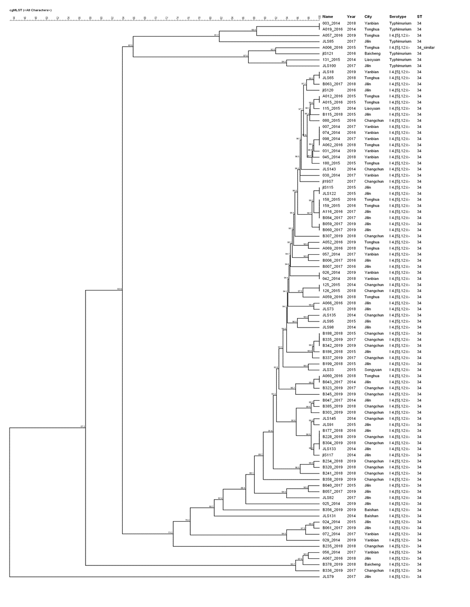

Figure S4 Dendrogram of 9 Salmonella isolates of cluster B constructed based on cgMLST. Strain names were indicated along with isolate city, year, STs.
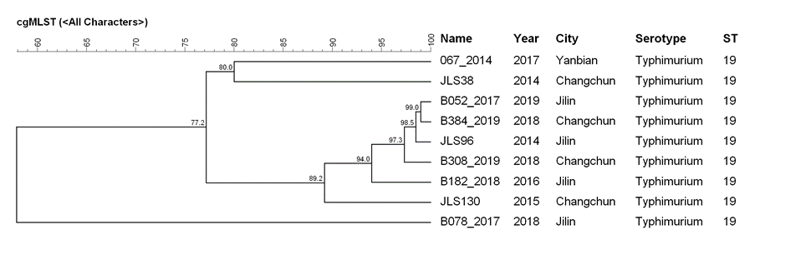

Figure S5 Dendrogram of 112 Salmonella isolates of cluster C constructed based on cgMLST. Strains names were indicated along with isolate city, year, STs.

