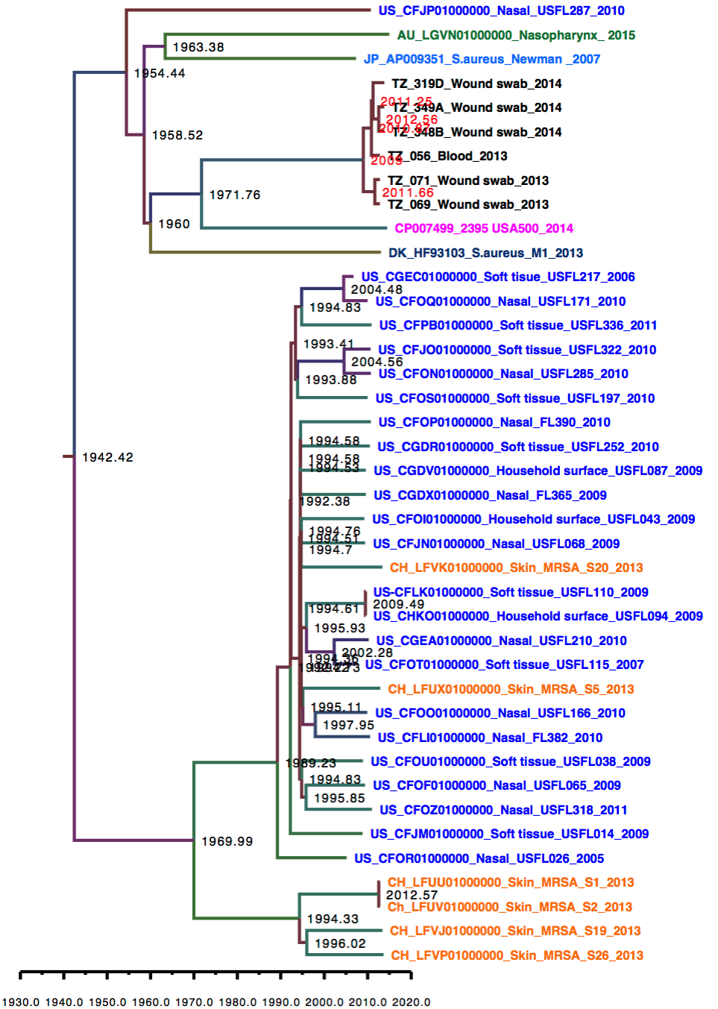

Figure 1a. BEAST tree using USA300_FPR37357 as a reference. Node labels indicate years

