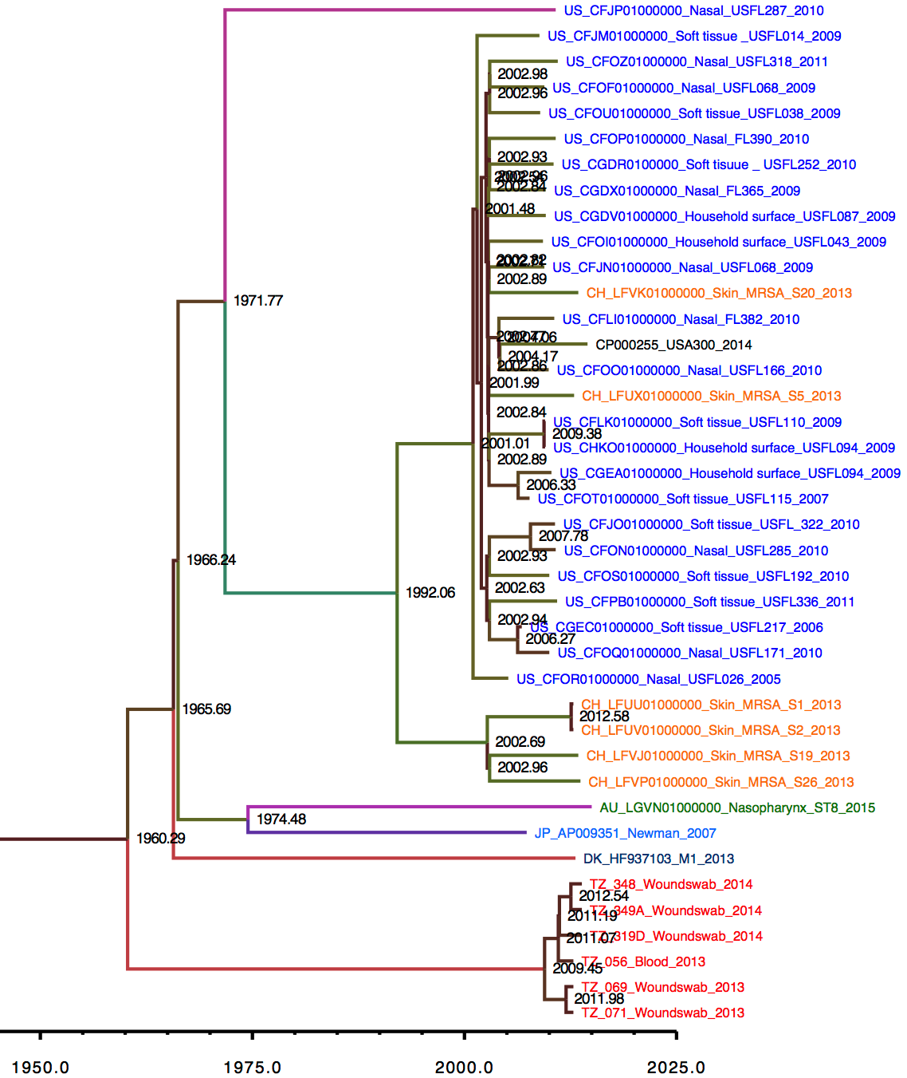

Figure 1b. BEAST using USA500_2395 as a reference. Node labels indicate years.

