# Welcome.

Project Name

Permissions

Data protection agency

Protocol clinical trial ID

Website

# Aim and time commited.

This study aims to find new correlations between what you buy and your health, using receipt data donated by you.

Our initial focus will be on the determinants of flares in chronic diseases.

The purpose of this form is to help you to decide whether you want to participate in the study.

We expect participating in the study, reading, and filling out this form will take 10 to 15 minutes.

You must be at least 18 years old to participate.

# The consent.

Your consent to participate is entirely voluntary and you can, at any time, withdraw from the study and have your data deleted.

Data identifying you is securely stored and will not be disclosed to any third party without your consent.

Any medical treatment you receive is not affected by your participation, but your participation may improve treatment and prevention in the future.

It is important that we explain the study properly to you, and we will therefore ask some questions at the end of this form, to ensure that we have infromed you adequatly.

# Why participate (background)

There is a lack of knowlegde regarding how our lifestyle, i.e. everything we eat, drink, breathe, and apply to our skin. affects our health.

This includes questions like:

Is what additives is dangourous for my health

Are ecological product healthier than concentional products

How does my lifestyle affect my pregnancy

What are the dietary risk factor for inflammatory diseases?

And more…

# Why participate (method)

We invite you to help us increase our knowledge of how our lifestyle and surroundings affect our health. You can help us by agreeing to donate your receipt data for research. Along with health information from public records we can discover new knowledge.

# Why participate (usefulness)

Because this data can be collected over a long time, we can find patterns in data that can potetially lead us to determinants of several diseases and thus perhaps even prevent some diseases in the future, that might affect you or your loved ones.

# Is there any risk to me?

There is no health risk associated with the project, and we expect that the project will benefit you within a few years through better understanding disease determinats and improved lifestyle advice.

history have shown that , and do our outmost to prevent this.

# What happens to my data?

Your data will be collected on a secure server in de-identified form. Your contact information is stored on a separate server. To ensure confidentiality, the same person will not have access to both identification and research data.

The project has been aproved by the danish data protection authority.

# What is required from me?

• That you read and understand this form.

• That you have a free storebox account (if you do not have one, you will be prompted to create one after your consent to participate).

• That you enter contact details and your username with storebox.

• That you consent to link data from public sources (health data) with your receipts data using NEM ID.

Of note, the project also retrieves data from a private data source. See privacy policy here. [https://dk.storebox.com/beta/#/webview/terms](https://dk.storebox.com/beta/" \l "/webview/terms)

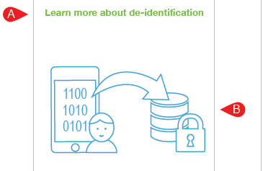

# Short multiple-choice questionnaire on the above content

This study collects

1. My receipts data and health dataMuliger
2. Questionaires that I fill weekly

The study poses no health risk to me

1. True
2. False

It is possible to withdraw my consent at any time

1. Yes
2. No

# 2 possible messages

1. It is imortant to us that we have conveyed the information above to you We urge you to revisit the information to ensure that you have the received adequete information to provide consent.

Great, you are set to:

Go to consent

# Consent aproach

You sign up by

1. Checking the boxes below,
2. Enter your contact information, free storebox account email, if different from the above.
3. Giving consent with the NEM-ID signature.

# Focusing research:

Our initial focus will be on the determinants of flares in chronic diseases. We therefore ask you fill out the items below:

Do you suffer from one or more chronic diseseas that you would like us to prioritze?

* No chronic disease checkbox.
* Text with Dropdown selection
* Text with Dropdown selection 2

# Contact Information:

✓ Email

✓ Email again

✓ Phone

✓ Phone again

# Storebox account?

✓ Yes ->

* The same as aboove (autofills)

1. Storebox email account

2. Storebox email again

3. Storebox tel no. Storebox tel no. again.

✓ no->You will get a link to create a storebox account at the reciept page. Remember to use the same mail as above.

# Consent

* I accept that my de-didentifed data can be accessed by other researchers including other countries.
* Please contact me if the project is expanded.

(This could be an app that can advise you on your purchases, or that we would like to use other data sources)

* Send me newsletters about the project

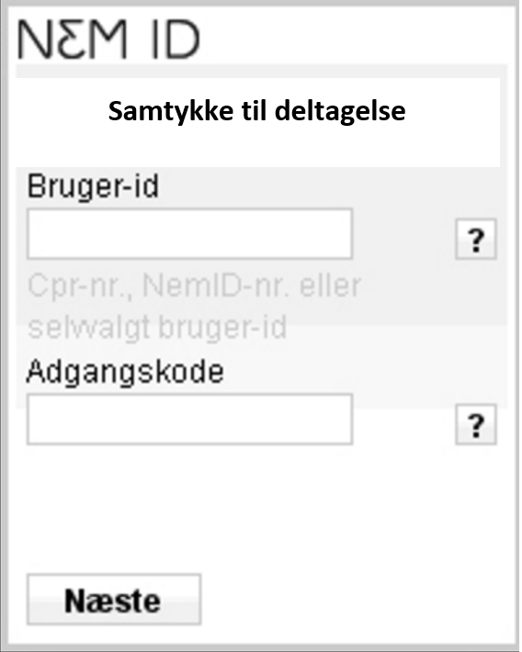

# Receipt Page

Thank you for participating in the project.

A copy of this receipt and your consent has been sent to XXX@XXX.XX

**If you do not have a storebox account :**

Use the contact email and phone number you entered above and register here:

[https://dk.storebox.com/beta/#/signup/info](https://dk.storebox.com/beta/" \l "/signup/info)

You can read more about storebox here:

[https://dk.storebox.com/beta/#/web](https://dk.storebox.com/beta/" \l "/web)

More about the project: Back to landing page

You may at any time withdraw from the study:

Withdraw consent.

Share: 