Hello R Markdown

Awesome Me

2018-02-14

This is a paragraph in an R Markdown document.

Below is a code chunk:

fit = lm(dist ~ speed, data = cars)  
b = coef(fit)  
plot(cars)  
abline(fit)

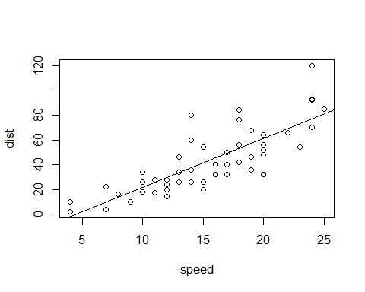

The slope of the regression is 3.9324088.