Programming Assignment Unit 7: Online Chat Application

Nicanor Maswili
Department of Computer Science, University of the People
CS 1103: Programming 2
Instructor: Dr. Abeena Azad
October 21, 2026

Programming Assignment Unit 7: Online Chat Application

Overview
This program is a text-based online chat application in Java. A central server, ChatServer, accepts any number of clients over TCP sockets, gives each user a unique ID, keeps a list of the users who are online, and broadcasts every message to all of them. Each user runs ChatClient, which sends what the user types and, at the same time, displays the messages of everyone else. As Eck (2022) explains, Java treats a network connection like any other source of input and output, so once a socket is open the program reads and writes it with the same stream classes it would use for a file.

Design
The program has four classes, each with one job (Table 1, Figure 1).
Table 1
Classes in the Program
Class | Role
ChatServer | Opens the ServerSocket, accepts connections, assigns user IDs, keeps the user list, and broadcasts messages
ClientHandler | Serves one client on its own thread: asks for a name, reads messages and commands, and sends replies
ChatClient | The text-based client: one thread sends what the user types, another prints what the server sends
ChatTest | 17 automated checks that start a real server and connect real socket clients

Figure 1
Architecture of the Chat Application
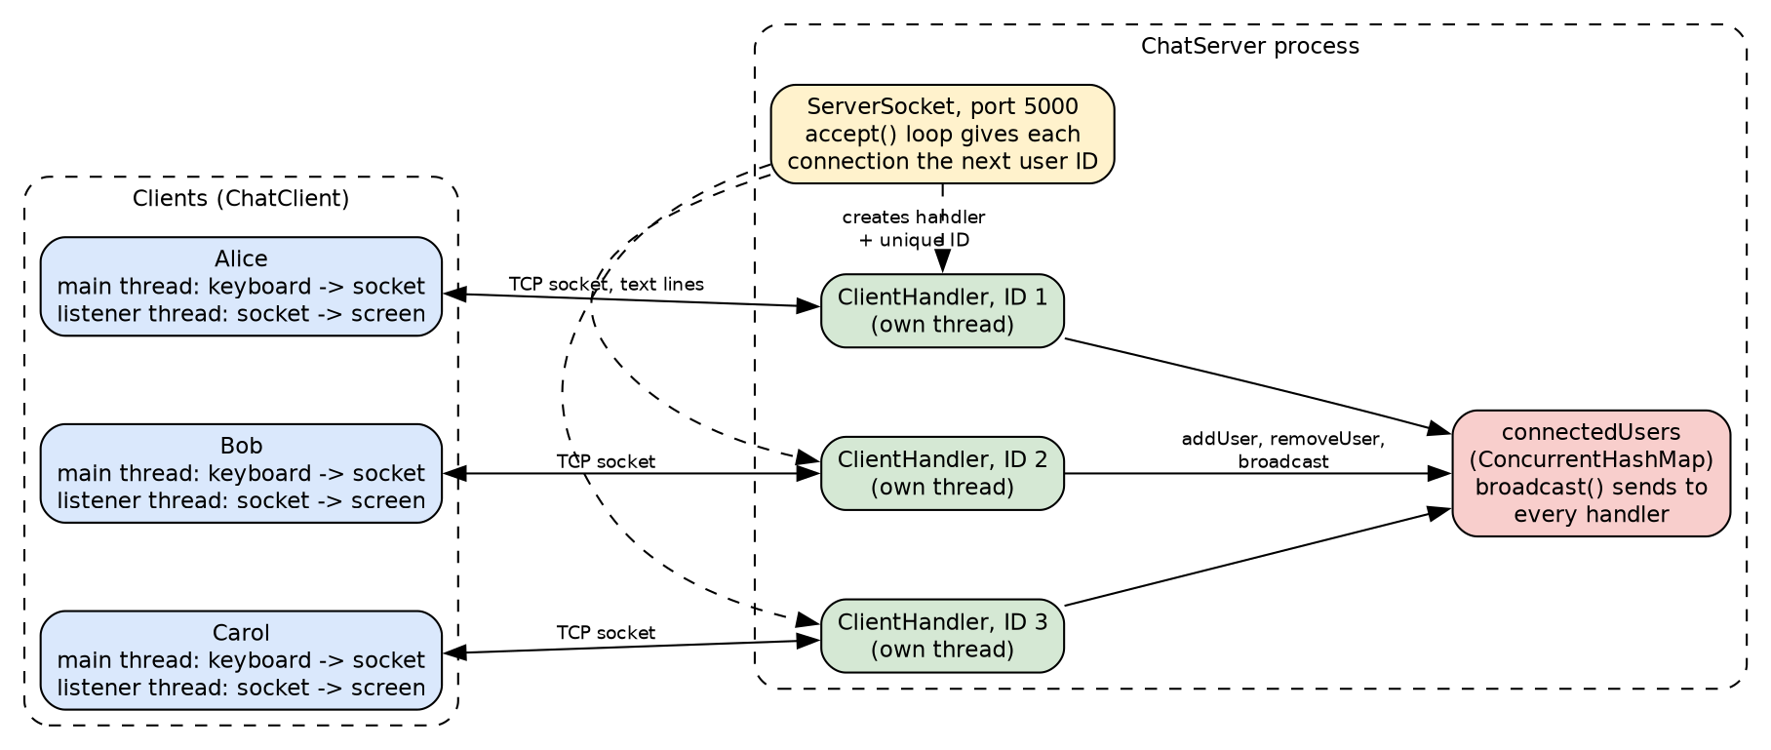

Server Implementation
Socket programming and connection handling. ChatServer creates a ServerSocket on port 5000 (or a port given on the command line) and loops on accept(). Eck (2022) notes that accept() blocks until a client connects and then returns a Socket for talking to that client. He also names the key problem for a chat server: "to allow multiple clients to be connected at the same time, it is necessary to use threads" (Eck, 2022, Section 11.4.2). My server therefore never talks to a client inside the accept loop. It hands each new Socket to a ClientHandler running on a thread from a cached thread pool and goes straight back to waiting for the next connection. This is the same structure as Oracle's multi-client KKMultiServer example, where the main server only listens and a separate thread object serves each connection (Oracle, n.d.-c). It is also the main difference from Kumar's (2022) socket example, which reads one message per connection and serves clients one at a time.
User management. Every accepted connection gets the next number from an AtomicInteger, so user IDs are unique and are never reused, even after a user leaves. Once the user types a name, the handler registers itself in connectedUsers, a ConcurrentHashMap<Integer, ClientHandler> keyed by user ID. I chose ConcurrentHashMap because several handler threads add, remove, and read users at the same time, and this class is fully thread-safe while still allowing reads without locking (Oracle, n.d.-a). Users are shown as Name#ID, for example Alice#1, so two people with the same name are still told apart. The /users command lists everyone online, ordered by ID.
Broadcasting. broadcast() sends a message to every handler in the map, including the sender, so the sender sees that the message was delivered. ClientHandler.send() is synchronized, so if two users send messages at the same instant, the two lines are never mixed together on one connection.
Leaving and failures. Each handler opens its socket and reader in a try-with-resources statement, which guarantees that they are closed when the handler finishes (Oracle, n.d.-b). The user is removed from the map in a finally block, so the others are told that the user left whether the user typed /quit, closed the window, or lost the network connection. When the server is stopped with Ctrl+C, a shutdown hook closes every connection cleanly.

Client Implementation
ChatClient connects with new Socket(host, port) and wraps the socket's streams in a BufferedReader and an auto-flushing PrintWriter, both using UTF-8. Chat is two-way at the same time, so the client uses two threads:
1. The main thread reads lines from the keyboard and sends each one to the server.
2. A background listener thread reads lines from the server and prints them.
Because the listener runs on its own, messages from other users appear immediately, even while this user is in the middle of typing. When the user types /quit, the client sends it, waits for the server's goodbye, and exits. If the server goes away, the listener reports that the server closed the connection. If no server is running at all, the client prints a clear message instead of a stack trace.

How One Message Travels
The steps below follow a single message from Alice's keyboard to every screen, naming the method that does each step.
1. Alice types "Hello" and presses Enter. The main thread of her ChatClient reads the line from the keyboard and writes it to the socket with toServer.println().
2. On the server, Alice's ClientHandler thread is waiting in in.readLine(). It receives "Hello" and passes it to handleLine(), which sees that it is not a command.
3. handleLine() calls server.broadcast() with the text "[10:01:30] Alice#1: Hello".
4. broadcast() loops over every ClientHandler in connectedUsers and calls send() on each, which writes the line to that user's socket.
5. In every client, including Alice's, the listener thread is waiting in fromServer.readLine(). It receives the line and prints it on the screen.
Because the server reads from each client on that client's own thread, Bob can be sending a message at the same moment, and both messages are delivered.

The Text-Based User Interface and Protocol
The protocol is plain text, one message per line. The server greets each client with its user ID, asks for a name, and then accepts messages and the commands in Table 2. Every chat message is shown with a time stamp and the sender's name and ID.
Table 2
What the User Can Type
Input | Result
any text | Broadcast to everyone as [time] Name#ID: text
/users | Lists everyone online with their user IDs
/help | Shows the list of commands
/quit | Leaves the chat; everyone else is told

Error Handling and Robustness
Table 3
Error Cases and How They Are Handled
Situation | Handling
Client started with no server running | ConnectException caught: "Could not connect ... Is ChatServer running?"
User closes the window without /quit | readLine returns null or throws; finally block removes the user and tells the others
Server stopped with Ctrl+C | Shutdown hook closes all sockets; clients print "The server closed the connection"
Port already in use or invalid port argument | Clear message, or fall back to the default port 5000
Empty message | Ignored
Message longer than 500 characters | Rejected with the reason
Unknown command such as /hello | Reply suggests /help
Name with spaces or symbols | Cleaned to letters, digits, _ and -, at most 20 characters

Requirements Checklist
Table 4
Assignment Requirements and Where They Are Met
Requirement | Where it is met
ChatServer class using socket programming | ServerSocket and accept() loop in ChatServer
Manage connections from multiple clients | One ClientHandler thread per client from a thread pool
Assign a unique user ID to each client | AtomicInteger nextUserId; IDs are never reused
Maintain a list of connected users | ConcurrentHashMap connectedUsers, shown with /users
ChatClient connects using sockets | new Socket(host, port) in ChatClient.run
Send messages to the server, which broadcasts them | ChatClient main thread, then ChatServer.broadcast
Receive messages from other users | ChatClient listener thread
Simple text-based user interface | Prompts, commands, time stamps, join and leave notices (Figures 3 and 4)
Well-commented source code | Javadoc on every class, method, and field; javac -Xdoclint:all reports zero warnings
README file | README.md and README.txt in the Assignment folder (also summarized below)

Testing

Automated Tests
ChatTest starts a real server on a free port and connects real TCP clients to it, so it tests the actual networking code rather than a simulation. It also drives the real ChatClient class by giving it scripted keyboard input. All 17 checks pass (Figure 2), and they passed in ten repeated runs, which matters for multi-threaded code. To make sure the tests can catch real mistakes, I temporarily broke the broadcast method so that half of the users stopped receiving messages, and the tests reported the failures.
Figure 2
Compiling the Program and Running the 17 Automated Checks
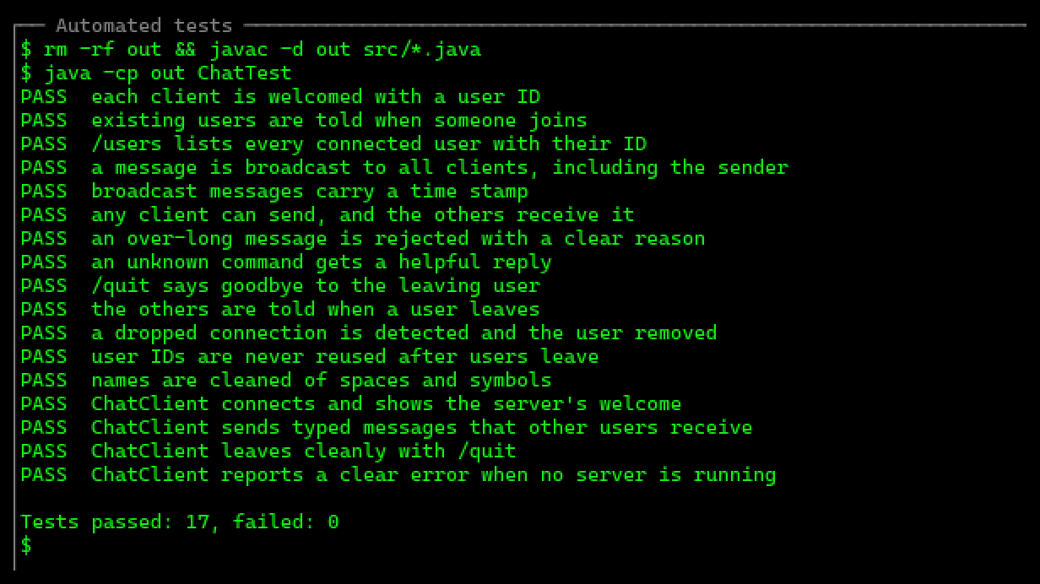

Live Chat Session
I then ran the server and two clients in three terminal windows. In Figure 3, Alice (user ID 1) and Bob (user ID 2) join, exchange messages that both of them receive, Bob lists the users with /users, Alice tries an unknown command, and Bob leaves with /quit. The server window logs every connection with its user ID.
Figure 3
Server and Two Clients: Joining, Broadcasting, /users, an Unknown Command, and /quit
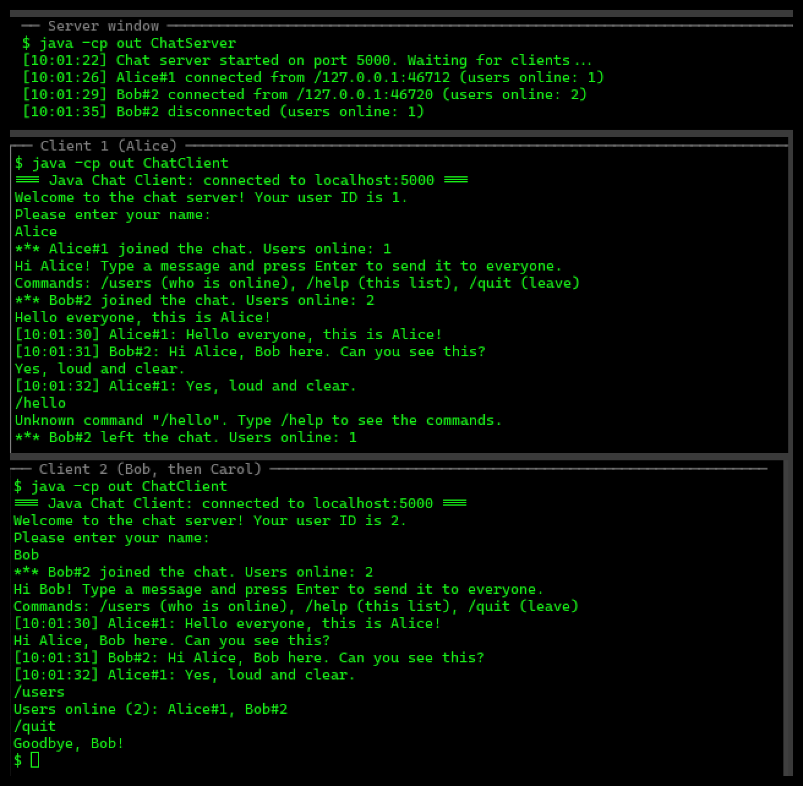
In Figure 4, Carol joins in Bob's old window and receives user ID 3, which shows that IDs are not reused. Carol and Alice chat, Carol lists the users, Alice leaves, and finally the server is stopped with Ctrl+C. Carol's client reports that the server closed the connection instead of crashing.
Figure 4
A New User Joining, a User Leaving, and the Server Shutting Down
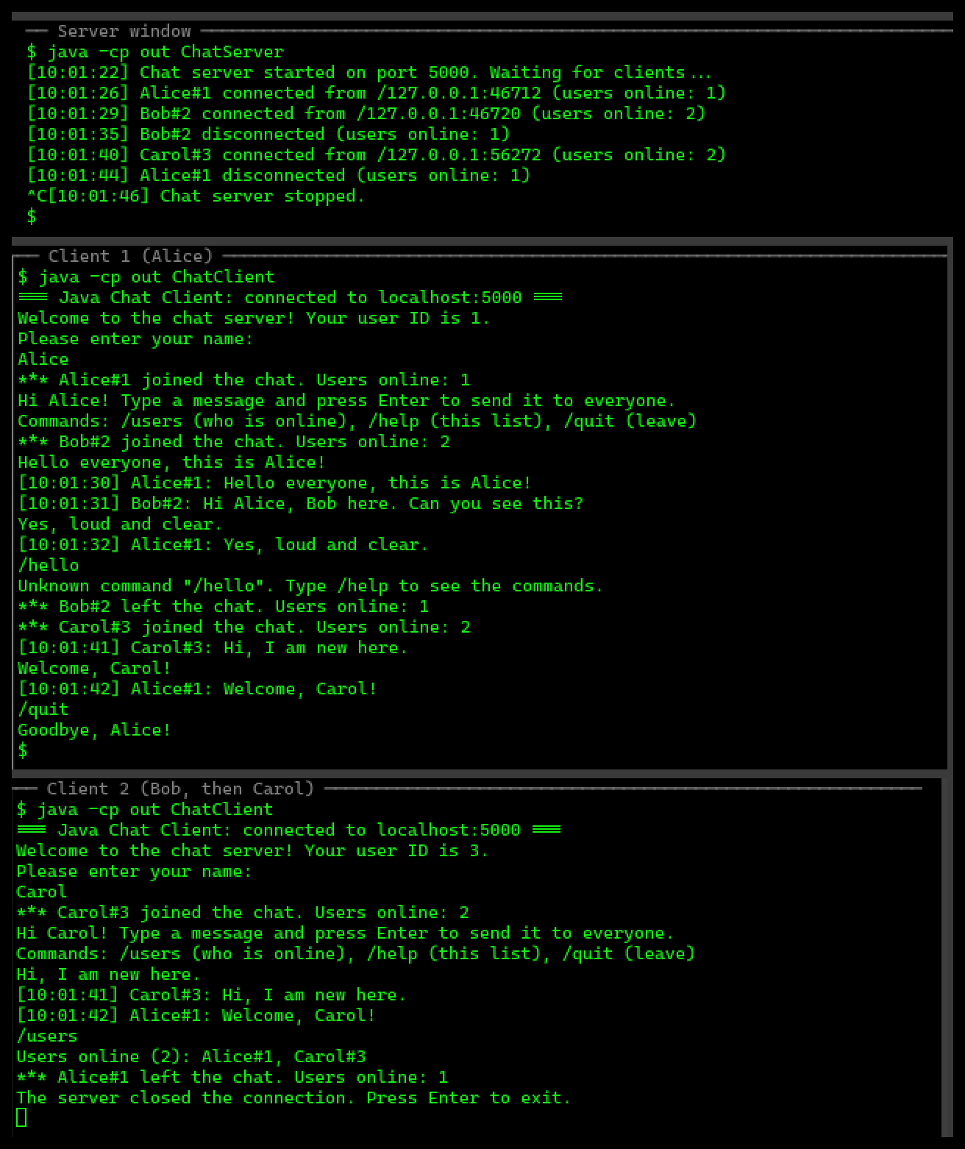

README: How to Run the Application
The README file submitted with the code contains these instructions.
1. Compile (Java 17 or newer), from the Assignment folder:
javac -d out src/*.java
2. Start the server (default port 5000; another port can be given):
java -cp out ChatServer
java -cp out ChatServer 6000
3. In a new terminal for each user, start a client (default localhost 5000):
java -cp out ChatClient
java -cp out ChatClient 192.168.1.20 6000
4. Type your name, then type messages and press Enter.
Commands: /users /help /quit
5. Run the automated tests (they start their own server):
java -cp out ChatTest

In IntelliJ IDEA: run ChatServer, then run ChatClient. For a second client,
open Run > Edit Configurations > ChatClient > Modify options >
Allow multiple instances, and run ChatClient again.

Source Code
ChatServer.java
import java.io.IOException;
import java.net.ServerSocket;
import java.net.Socket;
import java.time.LocalTime;
import java.time.format.DateTimeFormatter;
import java.util.Comparator;
import java.util.List;
import java.util.Map;
import java.util.concurrent.ConcurrentHashMap;
import java.util.concurrent.ExecutorService;
import java.util.concurrent.Executors;
import java.util.concurrent.atomic.AtomicInteger;

/**
* The central server of the chat application.
*
* <p>The server listens on a TCP port and accepts any number of clients. Each client gets a
* unique user ID and its own {@link ClientHandler} thread, so one slow client never blocks the
* others. The server keeps the list of connected users and broadcasts every chat message to all
* of them.
*/
public class ChatServer {

/** Port used when none is given on the command line. */
public static final int DEFAULT_PORT = 5000;

/** Format of the time stamps in chat messages and log lines. */
private static final DateTimeFormatter CLOCK = DateTimeFormatter.ofPattern("HH:mm:ss");

/** Port to listen on; 0 lets the operating system choose a free one. */
private final int port;
/** Source of unique user IDs; thread-safe, and IDs are never reused. */
private final AtomicInteger nextUserId = new AtomicInteger(1);
/** Everyone who is online, keyed by user ID; safe to use from many threads. */
private final Map<Integer, ClientHandler> connectedUsers = new ConcurrentHashMap<>();
/** Thread pool that runs one ClientHandler per connected client. */
private final ExecutorService clientThreads = Executors.newCachedThreadPool();
/** The listening socket, created by {@link #open()}. */
private ServerSocket serverSocket;
/** True while the server accepts clients; volatile so stop() is seen by serve(). */
private volatile boolean running;

/**
* Creates a server that will listen on the given port.
*
* @param port the TCP port, or 0 to let the operating system choose a free one
*/
public ChatServer(int port) {
this.port = port;
}

/**
* Opens the server socket so clients can start connecting.
*
* @return the port the server is actually listening on
* @throws IOException if the port is already in use or cannot be opened
*/
public int open() throws IOException {
serverSocket = new ServerSocket(port);
running = true;
log("Chat server started on port " + serverSocket.getLocalPort()
+ ". Waiting for clients...");
return serverSocket.getLocalPort();
}

/**
* Accepts clients until {@link #stop()} is called. Every accepted client is given the next
* user ID and handed to its own thread from the pool.
*/
public void serve() {
while (running) {
try {
Socket socket = serverSocket.accept();
int userId = nextUserId.getAndIncrement();
clientThreads.execute(new ClientHandler(this, socket, userId));
} catch (IOException e) {
if (running) {
log("Could not accept a connection: " + e.getMessage());
}
}
}
}

/**
* Adds a client to the list of connected users and tells everyone that the user joined.
*
* @param user the handler of the user who has just chosen a name
*/
void addUser(ClientHandler user) {
connectedUsers.put(user.getUserId(), user);
log(user.getDisplayName() + " connected from " + user.getAddress()
+ " (users online: " + connectedUsers.size() + ")");
broadcast("*** " + user.getDisplayName() + " joined the chat. Users online: "
+ connectedUsers.size());
}

/**
* Removes a client from the list of connected users and tells the others that the user
* left. Calling it twice for the same user has no further effect.
*
* @param user the handler of the user who disconnected
*/
void removeUser(ClientHandler user) {
if (connectedUsers.remove(user.getUserId()) != null) {
log(user.getDisplayName() + " disconnected (users online: "
+ connectedUsers.size() + ")");
broadcast("*** " + user.getDisplayName() + " left the chat. Users online: "
+ connectedUsers.size());
}
}

/**
* Sends a message to every connected user, including the sender, so the sender can see
* that the message was delivered.
*
* @param message the text to send
*/
void broadcast(String message) {
for (ClientHandler user : connectedUsers.values()) {
user.send(message);
}
}

/**
* Returns the display names of all connected users, ordered by user ID.
*
* @return a list such as [Alice#1, Bob#2]
*/
List<String> getUserList() {
return connectedUsers.values().stream()
.sorted(Comparator.comparingInt(ClientHandler::getUserId))
.map(ClientHandler::getDisplayName)
.toList();
}

/** Stops accepting clients and closes every open connection. */
public void stop() {
running = false;
try {
if (serverSocket != null) {
serverSocket.close();
}
} catch (IOException e) {
log("Error while closing the server socket: " + e.getMessage());
}
for (ClientHandler user : connectedUsers.values()) {
user.close();
}
clientThreads.shutdownNow();
log("Chat server stopped.");
}

/**
* Returns the current time formatted for chat messages and log lines.
*
* @return the time as HH:mm:ss
*/
static String timestamp() {
return LocalTime.now().format(CLOCK);
}

/**
* Prints a time-stamped line to the server console.
*
* @param text the event to log
*/
void log(String text) {
System.out.println("[" + timestamp() + "] " + text);
}

/**
* Starts the server.
*
* @param args optional port number (default 5000)
*/
public static void main(String[] args) {
int port = DEFAULT_PORT;
if (args.length > 0) {
try {
port = Integer.parseInt(args[0]);
} catch (NumberFormatException e) {
System.out.println("\"" + args[0] + "\" is not a valid port. Using "
+ DEFAULT_PORT + ".");
}
}

ChatServer server = new ChatServer(port);
try {
server.open();
} catch (IOException e) {
System.out.println("Could not start the server on port " + port + ": "
+ e.getMessage());
return;
}
Runtime.getRuntime().addShutdownHook(new Thread(server::stop));
server.serve();
}
}

ClientHandler.java
import java.io.BufferedReader;
import java.io.IOException;
import java.io.InputStreamReader;
import java.io.OutputStreamWriter;
import java.io.PrintWriter;
import java.net.Socket;
import java.nio.charset.StandardCharsets;
import java.util.List;

/**
* Serves one connected client on its own thread.
*
* <p>The handler greets the client with its user ID, asks for a name, registers the user with
* the server, and then reads the client's lines one at a time. Plain text is broadcast to
* everyone; lines that start with "/" are commands (/users, /help, /quit).
*/
public class ClientHandler implements Runnable {

/** Longest chat message the server accepts, in characters. */
static final int MAX_MESSAGE_LENGTH = 500;

/** Longest user name, in characters. Longer names are shortened. */
static final int MAX_NAME_LENGTH = 20;

/** The list of commands shown by /help and after joining. */
private static final String HELP =
"Commands: /users (who is online), /help (this list), /quit (leave)";

/** The server that owns this client. */
private final ChatServer server;
/** The connection to this client. */
private final Socket socket;
/** Unique ID assigned by the server. */
private final int userId;
/** Text output to this client; created when the handler starts running. */
private PrintWriter out;
/** The name the user chose, after cleaning. */
private String name;

/**
* Creates a handler for a newly accepted connection.
*
* @param server the server that owns this client
* @param socket the client's socket
* @param userId the unique ID the server assigned to this client
*/
public ClientHandler(ChatServer server, Socket socket, int userId) {
this.server = server;
this.socket = socket;
this.userId = userId;
}

@Override
public void run() {
try (socket;
BufferedReader in = new BufferedReader(
new InputStreamReader(socket.getInputStream(), StandardCharsets.UTF_8))) {
out = new PrintWriter(
new OutputStreamWriter(socket.getOutputStream(), StandardCharsets.UTF_8), true);

send("Welcome to the chat server! Your user ID is " + userId + ".");
send("Please enter your name:");
name = cleanName(in.readLine());
if (name == null) {
return; // the client disconnected before choosing a name
}
server.addUser(this);
send("Hi " + name + "! Type a message and press Enter to send it to everyone.");
send(HELP);

String line;
while ((line = in.readLine()) != null) {
if (!handleLine(line.strip())) {
break;
}
}
} catch (IOException e) {
server.log("Connection with user " + userId + " was lost: " + e.getMessage());
} finally {
server.removeUser(this);
}
}

/**
* Processes one line typed by the client.
*
* @param line the line with surrounding spaces removed
* @return false if the client wants to leave, true otherwise
*/
private boolean handleLine(String line) {
if (line.isEmpty()) {
return true; // ignore empty lines
}
switch (line.toLowerCase()) {
case "/quit" -> {
send("Goodbye, " + name + "!");
return false;
}
case "/users" -> {
List<String> users = server.getUserList();
send("Users online (" + users.size() + "): " + String.join(", ", users));
return true;
}
case "/help" -> {
send(HELP);
return true;
}
default -> {
if (line.startsWith("/")) {
send("Unknown command \"" + line + "\". Type /help to see the commands.");
} else if (line.length() > MAX_MESSAGE_LENGTH) {
send("Message not sent: it is longer than " + MAX_MESSAGE_LENGTH
+ " characters.");
} else {
server.broadcast("[" + ChatServer.timestamp() + "] " + getDisplayName()
+ ": " + line);
}
return true;
}
}
}

/**
* Turns the raw name the client typed into a safe display name.
*
* @param rawName the line the client sent, or null if it disconnected
* @return the cleaned name, a default name if it was blank, or null if disconnected
*/
private String cleanName(String rawName) {
if (rawName == null) {
return null;
}
String cleaned = rawName.strip().replaceAll("[^A-Za-z0-9_-]", "");
if (cleaned.isEmpty()) {
return "User";
}
return cleaned.length() > MAX_NAME_LENGTH ? cleaned.substring(0, MAX_NAME_LENGTH) : cleaned;
}

/**
* Sends one line to this client. Synchronized so that two broadcasts arriving at the same
* time cannot mix their characters together.
*
* @param message the line to send
*/
synchronized void send(String message) {
if (out != null) {
out.println(message);
}
}

/** Closes the connection; the reading loop then ends and the user is removed. */
void close() {
try {
socket.close();
} catch (IOException e) {
server.log("Error while closing the connection of user " + userId);
}
}

/**
* Returns this client's unique user ID.
*
* @return the user ID
*/
int getUserId() {
return userId;
}

/**
* Returns the name shown in the chat: the chosen name plus the unique ID, e.g. Alice#1.
* The ID keeps two users with the same name apart.
*
* @return the display name
*/
String getDisplayName() {
return name + "#" + userId;
}

/**
* Returns the client's network address, for the server log.
*
* @return the remote address and port
*/
String getAddress() {
return socket.getRemoteSocketAddress().toString();
}
}

ChatClient.java
import java.io.BufferedReader;
import java.io.IOException;
import java.io.InputStream;
import java.io.InputStreamReader;
import java.io.OutputStreamWriter;
import java.io.PrintStream;
import java.io.PrintWriter;
import java.net.ConnectException;
import java.net.Socket;
import java.nio.charset.StandardCharsets;

/**
* Text-based chat client.
*
* <p>The client connects to the {@link ChatServer} and uses two threads. A background
* listener thread prints every message the server sends, while the main thread reads what the
* user types and sends it to the server. Because the two jobs run at the same time, messages
* from other users appear even while this user is typing.
*/
public class ChatClient {

/** Host name or IP address of the server. */
private final String host;
/** Port the server listens on. */
private final int port;
/** Where the user's typing is read from. */
private final BufferedReader keyboard;
/** Where messages are displayed. */
private final PrintStream screen;
/** Set when the user types /quit, so a closed connection is not reported as an error. */
private volatile boolean quitting;

/**
* Creates a client. The input and output streams are parameters so the automated tests
* can drive a client without a real keyboard.
*
* @param host the server's host name or IP address
* @param port the server's port
* @param input where the user's typing comes from (normally System.in)
* @param output where messages are shown (normally System.out)
*/
public ChatClient(String host, int port, InputStream input, PrintStream output) {
this.host = host;
this.port = port;
this.keyboard = new BufferedReader(new InputStreamReader(input, StandardCharsets.UTF_8));
this.screen = output;
}

/** Connects to the server and runs the chat until the user types /quit. */
public void run() {
try (Socket socket = new Socket(host, port);
BufferedReader fromServer = new BufferedReader(
new InputStreamReader(socket.getInputStream(), StandardCharsets.UTF_8));
PrintWriter toServer = new PrintWriter(
new OutputStreamWriter(socket.getOutputStream(), StandardCharsets.UTF_8),
true)) {

screen.println("=== Java Chat Client: connected to " + host + ":" + port + " ===");

Thread listener = new Thread(() -> listen(fromServer), "server-listener");
listener.setDaemon(true);
listener.start();

String typed;
while ((typed = keyboard.readLine()) != null) {
if (!listener.isAlive()) {
break; // the server has closed the connection
}
if (typed.strip().equalsIgnoreCase("/quit")) {
quitting = true; // set before sending, so the listener knows we chose to leave
toServer.println(typed);
break;
}
toServer.println(typed);
}
listener.join(2000); // let the server's goodbye message be printed
} catch (ConnectException e) {
screen.println("Could not connect to the chat server at " + host + ":" + port
+ ". Is ChatServer running?");
} catch (IOException e) {
screen.println("Connection error: " + e.getMessage());
} catch (InterruptedException e) {
Thread.currentThread().interrupt();
}
}

/**
* Prints every line the server sends until the connection closes.
*
* @param fromServer the reader connected to the server
*/
private void listen(BufferedReader fromServer) {
try {
String message;
while ((message = fromServer.readLine()) != null) {
screen.println(message);
}
if (!quitting) {
screen.println("The server closed the connection. Press Enter to exit.");
}
} catch (IOException e) {
if (!quitting) {
screen.println("Lost the connection to the server.");
}
}
}

/**
* Starts the client.
*
* @param args optional host (default localhost) and port (default 5000)
*/
public static void main(String[] args) {
String host = args.length > 0 ? args[0] : "localhost";
int port = ChatServer.DEFAULT_PORT;
if (args.length > 1) {
try {
port = Integer.parseInt(args[1]);
} catch (NumberFormatException e) {
System.out.println("\"" + args[1] + "\" is not a valid port. Using "
+ ChatServer.DEFAULT_PORT + ".");
}
}
new ChatClient(host, port, System.in, System.out).run();
}
}

ChatTest.java
import java.io.BufferedReader;
import java.io.ByteArrayInputStream;
import java.io.ByteArrayOutputStream;
import java.io.IOException;
import java.io.InputStreamReader;
import java.io.OutputStream;
import java.io.OutputStreamWriter;
import java.io.PrintStream;
import java.io.PrintWriter;
import java.net.ServerSocket;
import java.net.Socket;
import java.net.SocketTimeoutException;
import java.nio.charset.StandardCharsets;

/**
* Automated tests for the chat application.
*
* <p>Each test starts a real {@link ChatServer} on a free port and connects real TCP clients
* to it, so the tests check the actual networking code, not a simulation. Run it with
* {@code java ChatTest}; it prints PASS or FAIL for every check.
*/
public class ChatTest {

/** How long a test client waits for an expected line before the check fails. */
private static final int TIMEOUT_MS = 3000;

/** Number of checks that passed. */
private static int passed;

/** Number of checks that failed. */
private static int failed;

/** Utility class: not meant to be instantiated. */
private ChatTest() {
}

/**
* A minimal client that talks to the server directly through a socket.
*/
private static final class TestClient implements AutoCloseable {
/** The connection to the server. */
private final Socket socket;

/** Lines coming from the server. */
private final BufferedReader in;

/** Lines going to the server. */
private final PrintWriter out;

/**
* Connects to the server on this computer.
*
* @param port the server's port
* @throws IOException if the connection fails
*/
TestClient(int port) throws IOException {
socket = new Socket("localhost", port);
socket.setSoTimeout(TIMEOUT_MS);
in = new BufferedReader(
new InputStreamReader(socket.getInputStream(), StandardCharsets.UTF_8));
out = new PrintWriter(
new OutputStreamWriter(socket.getOutputStream(), StandardCharsets.UTF_8), true);
}

/**
* Sends one line to the server.
*
* @param line the text to send
*/
void send(String line) {
out.println(line);
}

/**
* Reads lines from the server until one contains the given text.
*
* @param text the text to wait for
* @return the first line containing the text, or null if the connection closes or
* nothing matching arrives before the timeout
* @throws IOException if reading fails for another reason
*/
String readUntil(String text) throws IOException {
try {
String line;
while ((line = in.readLine()) != null) {
if (line.contains(text)) {
return line;
}
}
} catch (SocketTimeoutException e) {
// nothing matching arrived in time: fall through and report null
}
return null;
}

/**
* Connects, reads the welcome line, sends a name, and waits for the greeting.
*
* @param port the server's port
* @param name the name to join with
* @param welcome receives the welcome line, so the test can check the user ID
* @return the connected client
* @throws IOException if the connection fails
*/
static TestClient join(int port, String name, StringBuilder welcome) throws IOException {
TestClient client = new TestClient(port);
welcome.append(client.readUntil("Your user ID is"));
client.send(name);
client.readUntil("Hi ");
return client;
}

/**
* Drops the connection without /quit, like a crash or a closed window.
*
* @throws IOException if closing fails
*/
void disconnect() throws IOException {
socket.close();
}

/**
* Closes the connection when the try-with-resources block ends.
*
* @throws IOException if closing fails
*/
@Override
public void close() throws IOException {
disconnect();
}
}

/**
* Runs every check against a real server and prints the results.
*
* @param args not used
* @throws Exception if the server cannot be started
*/
public static void main(String[] args) throws Exception {
PrintStream console = System.out;
System.setOut(new PrintStream(OutputStream.nullOutputStream())); // hide server log

ChatServer server = new ChatServer(0);
int port = server.open();
Thread serverThread = new Thread(server::serve, "server");
serverThread.setDaemon(true);
serverThread.start();

StringBuilder w1 = new StringBuilder();
StringBuilder w2 = new StringBuilder();
StringBuilder w3 = new StringBuilder();
try (TestClient alice = TestClient.join(port, "Alice", w1);
TestClient bob = TestClient.join(port, "Bob", w2);
TestClient carol = TestClient.join(port, "Carol", w3)) {

check(console, "each client is welcomed with a user ID",
w1.toString().contains("Your user ID is 1")
&& w2.toString().contains("Your user ID is 2")
&& w3.toString().contains("Your user ID is 3"));

check(console, "existing users are told when someone joins",
alice.readUntil("Carol#3 joined the chat. Users online: 3") != null);

alice.send("/users");
check(console, "/users lists every connected user with their ID",
"Users online (3): Alice#1, Bob#2, Carol#3".equals(
alice.readUntil("Users online (")));

alice.send("Hello everyone!");
String atBob = bob.readUntil("Alice#1: Hello everyone!");
String atCarol = carol.readUntil("Alice#1: Hello everyone!");
String atAlice = alice.readUntil("Alice#1: Hello everyone!");
check(console, "a message is broadcast to all clients, including the sender",
atBob != null && atCarol != null && atAlice != null);
check(console, "broadcast messages carry a time stamp",
atBob != null && atBob.matches("\\[\\d{2}:\\d{2}:\\d{2}] Alice#1: .*"));

bob.send("Hi Alice, Bob here.");
check(console, "any client can send, and the others receive it",
alice.readUntil("Bob#2: Hi Alice, Bob here.") != null
&& carol.readUntil("Bob#2: Hi Alice, Bob here.") != null);

carol.send(" ");
carol.send("x".repeat(ClientHandler.MAX_MESSAGE_LENGTH + 1));
check(console, "an over-long message is rejected with a clear reason",
carol.readUntil("Message not sent") != null);

carol.send("/dance");
check(console, "an unknown command gets a helpful reply",
carol.readUntil("Unknown command \"/dance\"") != null);

carol.send("/quit");
check(console, "/quit says goodbye to the leaving user",
carol.readUntil("Goodbye, Carol!") != null);
check(console, "the others are told when a user leaves",
alice.readUntil("Carol#3 left the chat. Users online: 2") != null);

bob.disconnect();
check(console, "a dropped connection is detected and the user removed",
alice.readUntil("Bob#2 left the chat. Users online: 1") != null);

StringBuilder w4 = new StringBuilder();
try (TestClient dave = TestClient.join(port, " D@ve! ", w4)) {
check(console, "user IDs are never reused after users leave",
w4.toString().contains("Your user ID is 4"));
dave.send("/users");
check(console, "names are cleaned of spaces and symbols",
"Users online (2): Alice#1, Dve#4".equals(
dave.readUntil("Users online (")));
}

testChatClient(console, port, alice);
}

testClientWithoutServer(console);

server.stop();
System.setOut(console);
console.println();
console.println("Tests passed: " + passed + ", failed: " + failed);
}

/**
* Runs the real ChatClient class with scripted keyboard input.
*
* @param console where results are printed
* @param port the running server's port
* @param alice a connected user who should receive the client's message
* @throws Exception if the client cannot be run
*/
private static void testChatClient(PrintStream console, int port, TestClient alice)
throws Exception {
String typed = "Erin\nHello from ChatClient\n/quit\n";
ByteArrayOutputStream screen = new ByteArrayOutputStream();
ChatClient client = new ChatClient("localhost", port,
new ByteArrayInputStream(typed.getBytes(StandardCharsets.UTF_8)),
new PrintStream(screen, true, StandardCharsets.UTF_8));
client.run();
String shown = screen.toString(StandardCharsets.UTF_8);

check(console, "ChatClient connects and shows the server's welcome",
shown.contains("connected to localhost:" + port)
&& shown.contains("Your user ID is"));
check(console, "ChatClient sends typed messages that other users receive",
alice.readUntil("Hello from ChatClient") != null);
check(console, "ChatClient leaves cleanly with /quit",
shown.contains("Goodbye, Erin!"));
}

/**
* Checks that a client started while no server is running explains the problem instead of
* crashing.
*
* @param console where results are printed
* @throws IOException if a free port cannot be found
*/
private static void testClientWithoutServer(PrintStream console) throws IOException {
int unusedPort;
try (ServerSocket probe = new ServerSocket(0)) {
unusedPort = probe.getLocalPort(); // free port; closed again right away
}
ByteArrayOutputStream screen = new ByteArrayOutputStream();
new ChatClient("localhost", unusedPort, new ByteArrayInputStream(new byte[0]),
new PrintStream(screen, true, StandardCharsets.UTF_8)).run();
check(console, "ChatClient reports a clear error when no server is running",
screen.toString(StandardCharsets.UTF_8).contains("Is ChatServer running?"));
}

/**
* Records one check and prints PASS or FAIL.
*
* @param console where results are printed
* @param description what the check verifies
* @param condition true if the check passed
*/
private static void check(PrintStream console, String description, boolean condition) {
if (condition) {
passed++;
console.println("PASS " + description);
} else {
failed++;
console.println("FAIL " + description);
}
}
}

References
Eck, D. J. (2022). Introduction to programming using Java (Version 9, JavaFX ed.). Hobart and William Smith Colleges. https://math.hws.edu/javanotes/c11/s4.html
Kumar, P. (2022, August 4). Java socket programming: Server-client tutorial. DigitalOcean. https://www.digitalocean.com/community/tutorials/java-socket-programming-server-client
Oracle. (n.d.-a). Class ConcurrentHashMap<K,V>. Java SE 21 & JDK 21 API documentation. https://docs.oracle.com/en/java/javase/21/docs/api/java.base/java/util/concurrent/ConcurrentHashMap.html
Oracle. (n.d.-b). The try-with-resources statement. The Java Tutorials. https://docs.oracle.com/javase/tutorial/essential/exceptions/tryResourceClose.html
Oracle. (n.d.-c). Writing the server side of a socket. The Java Tutorials. https://docs.oracle.com/javase/tutorial/networking/sockets/clientServer.html

