Written Assignment Unit 8: Systems of Linear and Nonlinear Equations

Nicanor Maswili
Department of Mathematics, University of the People
MATH 1201: College Algebra
Instructor: Chibuike Agu
October 28, 2026

Written Assignment Unit 8: Systems of Linear and Nonlinear Equations
This assignment solves three systems of equations: a word problem about the prices of three toys, a system of three linear equations solved by Gaussian elimination, and a nonlinear system solved algebraically and checked with a GeoGebra graph. Every step is shown, and every answer was checked by substituting it back into the original equations and with a computer algebra tool.

Task 1: The Prices of Daniel's Toys

(i) The System of Linear Equations
Let the prices of the three toys be:
• a = the price of the first toy (in dollars)
• b = the price of the second toy
• c = the price of the special toy, which costs $20 more than three times the other two combined
Each sentence of the problem becomes one equation:
"three toys for $25 in total" a + b + c = 25 (1)
"$20 more than three times the other two" c = 3(a + b) + 20 (2)
"total cost multiplied by five is $125" 5(a + b + c) = 125 (3)

In standard form, with all variables on the left (Abramson, 2021, Section 11.2):
a + b + c = 25 (1)
3a + 3b - c = -20 (2)
5a + 5b + 5c = 125 (3)

(ii) The Nature of the System
Equation (3) gives no new information. Dividing both sides of (3) by 5 gives a + b + c = 25, which is exactly equation (1). So the system really contains only two different equations for three unknowns.
The augmented matrix shows this clearly. Subtracting 5 times row (1) from row (3) turns row (3) into all zeros:
[ 1 1 1 | 25 ] [ 1 1 1 | 25 ]
[ 3 3 -1 | -20 ] R3 -> R3 - 5 R1 -> [ 3 3 -1 | -20 ]
[ 5 5 5 | 125 ] [ 0 0 0 | 0 ]

A row of zeros on both sides, 0 = 0, is always true, so it causes no contradiction. A system is dependent when its equations do not determine a single solution and it has infinitely many solutions; it is inconsistent only when the work leads to a false statement such as 0 = 5 (Abramson, 2021, Section 11.2).
Table 1
Nature of the System in Task 1
Property | Answer | Reason
Consistent? | Yes | It has solutions; no step produces a false statement such as 0 = 5
Independent? | No, it is dependent | Equation (3) is 5 times equation (1), so only two equations are independent
Number of solutions | Infinitely many | Two independent equations cannot fix three unknowns

(iii) The Cost of Each Toy
Although the system is dependent, it still fixes the price of the special toy exactly.
Step 1. From equation (1), the two ordinary toys together cost:
a + b = 25 - c

Step 2. Substitute this into equation (2):
c = 3(25 - c) + 20
c = 75 - 3c + 20
c = 95 - 3c
4c = 95
c = 23.75

Step 3. Then the other two toys together cost:
a + b = 25 - 23.75 = 1.25

Check: c = 3(1.25) + 20 = 3.75 + 20 = 23.75, the total is 1.25 + 23.75 = 25, and 5 × 25 = 125. All three statements in the problem hold.
Answer. The special toy costs $23.75, and the other two toys together cost $1.25. The individual prices of those two toys cannot be determined from the information given, because the third statement only repeats the first. Every pair with a + b = 1.25 works, so the solution set is
(a, b, c) = (a, 1.25 - a, 23.75), for any price a between 0 and 1.25

For example, $0.25 and $1.00, or $0.50 and $0.75, are both possible. In real money, where prices are whole cents and every toy costs at least one cent, there are 124 possible pairs. A further fact, such as "the two toys cost the same" or a third independent price relation, would be needed to find a single answer.

Task 2: Gaussian Elimination
Solve the system:
x - y + z = 4
5x - y + z = 6
3x - y + 5z = 5

Gaussian elimination writes the system as an augmented matrix and uses row operations, which do not change the solution, to reach row-echelon form: zeros below the main diagonal (Abramson, 2021, Section 11.6; Mathispower4u, 2010). The allowed operations are swapping two rows, multiplying a row by a nonzero number, and adding a multiple of one row to another.
Step 1. Write the augmented matrix.
[ 1 -1 1 | 4 ]
[ 5 -1 1 | 6 ]
[ 3 -1 5 | 5 ]

Step 2. Make zeros below the first entry of column 1.
R2 -> R2 - 5 R1: (5 - 5, -1 + 5, 1 - 5 | 6 - 20) = (0, 4, -4 | -14)
R3 -> R3 - 3 R1: (3 - 3, -1 + 3, 5 - 3 | 5 - 12) = (0, 2, 2 | -7)

[ 1 -1 1 | 4 ]
[ 0 4 -4 | -14 ]
[ 0 2 2 | -7 ]

Step 3. Make the second entry of row 2 equal to 1.
R2 -> (1/4) R2: (0, 1, -1 | -7/2)

[ 1 -1 1 | 4 ]
[ 0 1 -1 | -7/2 ]
[ 0 2 2 | -7 ]

Step 4. Make a zero below it in column 2.
R3 -> R3 - 2 R2: (0, 2 - 2, 2 + 2 | -7 + 7) = (0, 0, 4 | 0)

[ 1 -1 1 | 4 ]
[ 0 1 -1 | -7/2 ]
[ 0 0 4 | 0 ]

Step 5. Make the last diagonal entry 1.
R3 -> (1/4) R3: (0, 0, 1 | 0)

[ 1 -1 1 | 4 ]
[ 0 1 -1 | -7/2 ]
[ 0 0 1 | 0 ]

The matrix is now in row-echelon form.
Step 6. Back-substitute from the bottom row up.
Row 3: z = 0
Row 2: y - z = -7/2 -> y = -7/2 + 0 = -7/2
Row 1: x - y + z = 4 -> x = 4 + y - z = 4 - 7/2 - 0 = 1/2

Solution: x = 1/2, y = -7/2, z = 0, or (0.5, -3.5, 0).
Check in all three original equations:
x - y + z = 0.5 + 3.5 + 0 = 4 ✓
5x - y + z = 2.5 + 3.5 + 0 = 6 ✓
3x - y + 5z = 1.5 + 3.5 + 0 = 5 ✓

This system is consistent and independent, with exactly one solution, because elimination left a nonzero number in every diagonal position.

Task 3: A Nonlinear System
Solve and verify the system:
x + y = 4 (1) a straight line
x² - 2xy - 3 = 0 (2) a curve (a hyperbola)

Algebraic Solution (Substitution)
For a system with one linear equation, the substitution method works best: solve the linear equation for one variable, substitute it into the nonlinear equation, solve, and check both equations (Abramson, 2021, Section 11.3; Mathispower4u, 2012).
Step 1. Solve the line for y.
x + y = 4 -> y = 4 - x

Step 2. Substitute into equation (2).
x² - 2x(4 - x) - 3 = 0
x² - 8x + 2x² - 3 = 0
3x² - 8x - 3 = 0

Step 3. Solve the quadratic by factoring. Two numbers that multiply to 3 × (-3) = -9 and add to -8 are -9 and 1:
3x² - 9x + x - 3 = 0
3x(x - 3) + 1(x - 3) = 0
(3x + 1)(x - 3) = 0
x = 3 or x = -1/3

(The quadratic formula agrees: x = [8 ± √(64 + 36)] / 6 = (8 ± 10) / 6, so x = 3 or x = -1/3.)
Step 4. Find y for each x using y = 4 - x.
x = 3: y = 4 - 3 = 1 -> point (3, 1)
x = -1/3: y = 4 + 1/3 = 13/3 -> point (-1/3, 13/3) ≈ (-0.333, 4.333)

Solution: (3, 1) and (-1/3, 13/3).

Algebraic Verification
Table 2
Checking Both Points in Both Equations
Point | Equation (1): x + y | Equation (2): x² - 2xy - 3
(3, 1) | 3 + 1 = 4 ✓ | 9 - 2(3)(1) - 3 = 9 - 6 - 3 = 0 ✓
(-1/3, 13/3) | -1/3 + 13/3 = 12/3 = 4 ✓ | 1/9 - 2(-1/3)(13/3) - 3 = 1/9 + 26/9 - 27/9 = 0 ✓

Both points satisfy both equations, so they are exactly the points where the line meets the curve.

Graphical Verification
Solving equation (2) for y shows what the curve looks like:
x² - 3 = 2xy -> y = (x² - 3) / (2x) = x/2 - 3/(2x)

This is a hyperbola. It is undefined at x = 0, so the y-axis is a vertical asymptote, and for large |x| the term 3/(2x) shrinks to 0, so the curve approaches the slanted line y = x/2. It has two branches, one on each side of the y-axis. The line x + y = 4 slopes downward and crosses each branch once, which is why there are exactly two intersection points, one on each branch.
Figure 1 shows both graphs drawn in GeoGebra, with the intersection points found by GeoGebra's Intersect command: A = (3, 1) on the right branch and B ≈ (-0.33, 4.33) on the left branch. The graph agrees with the algebraic solution.
Figure 1
The Line x + y = 4 and the Hyperbola x² - 2xy - 3 = 0, Meeting at A(3, 1) and B(-1/3, 13/3)
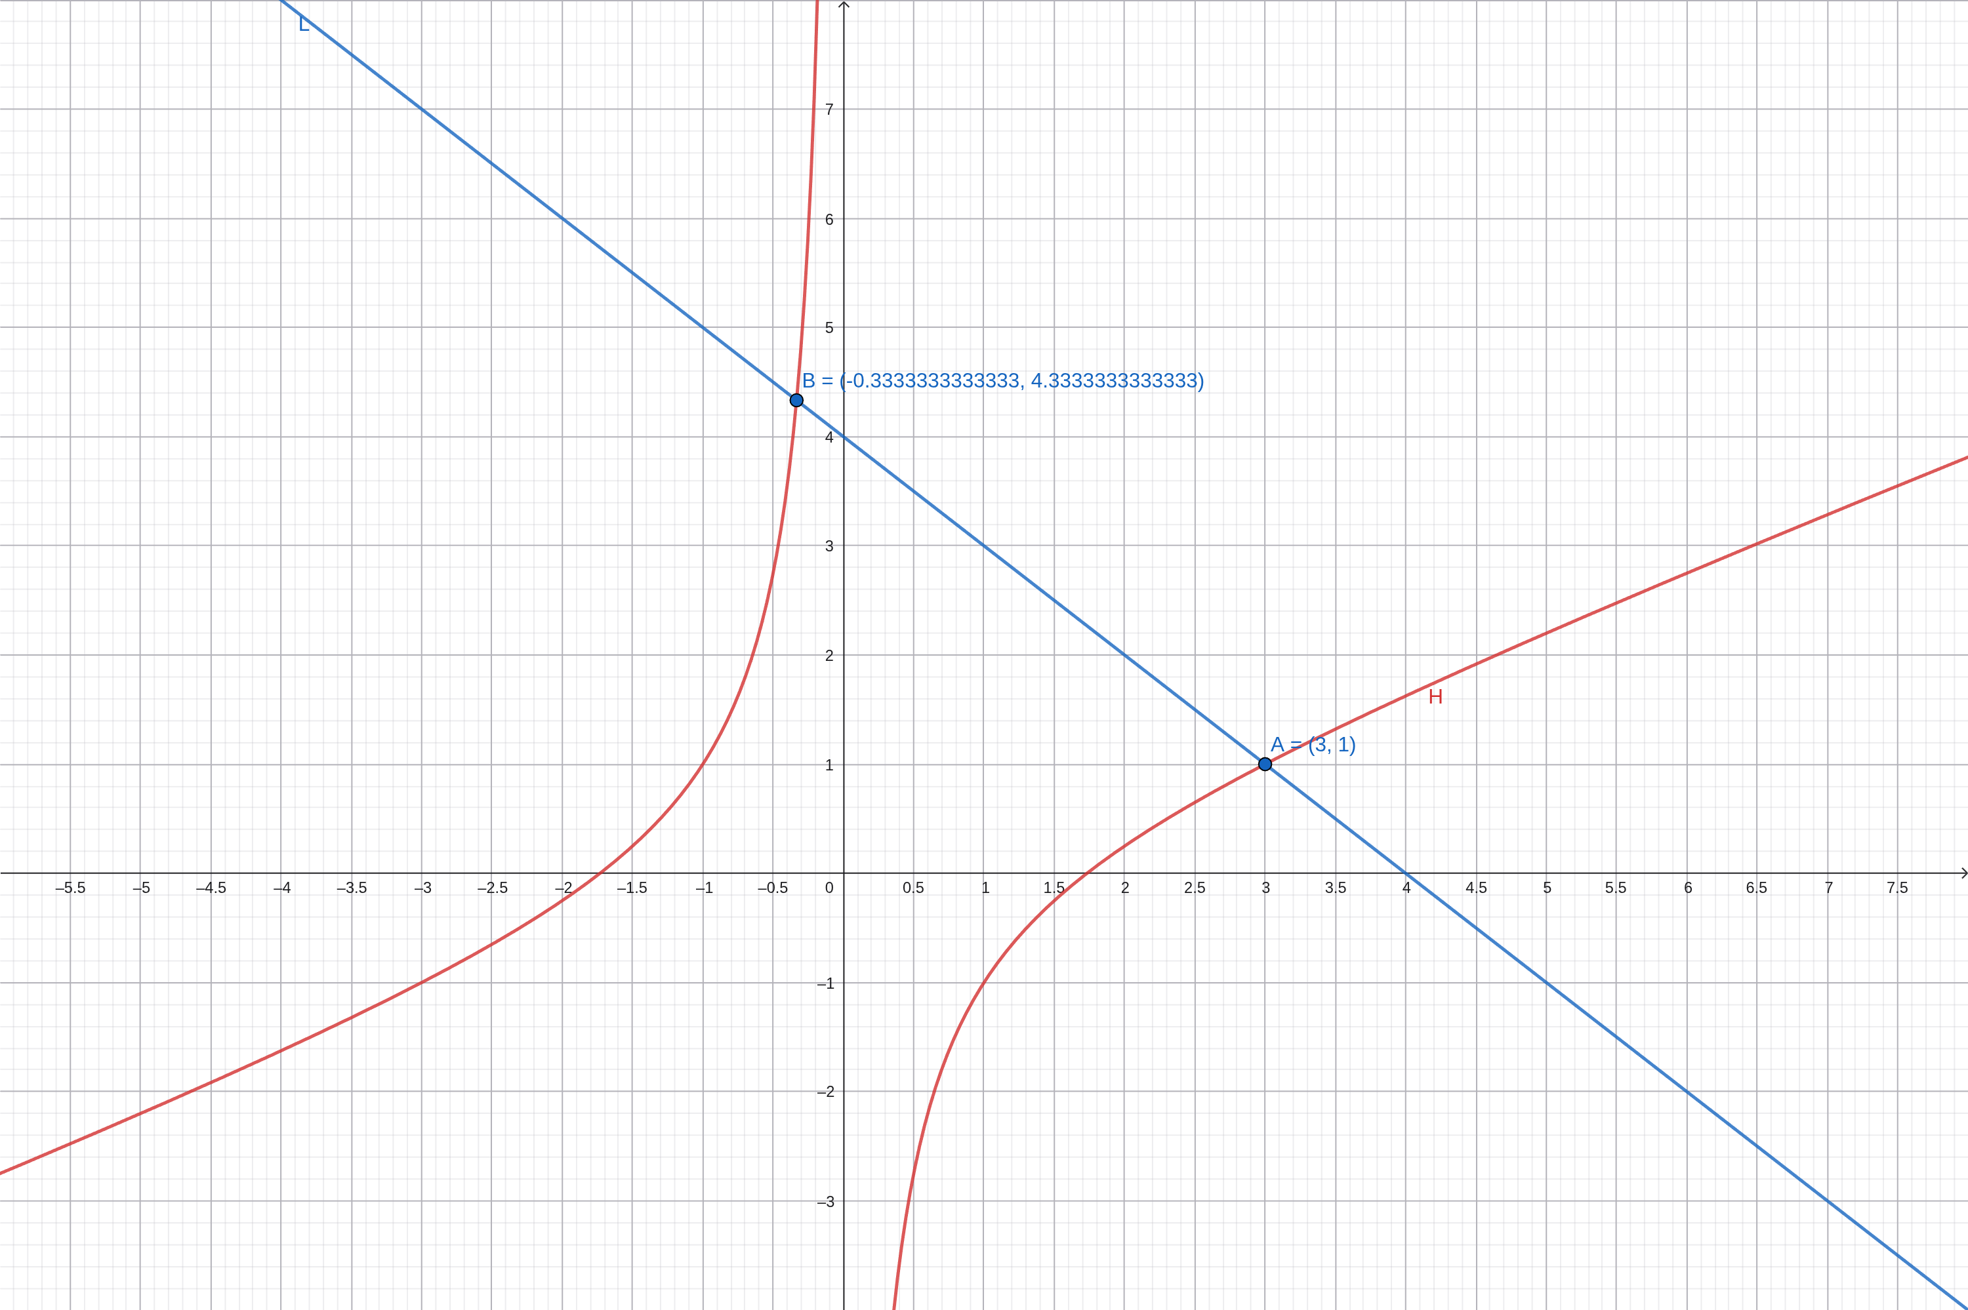

Summary of Answers
Table 3
Final Answers
Task | Answer
1 (i) | a + b + c = 25; c = 3(a + b) + 20; 5(a + b + c) = 125
1 (ii) | Consistent, dependent (not independent), infinitely many solutions
1 (iii) | Special toy $23.75; the other two together $1.25 (individual prices not determined)
2 | x = 1/2, y = -7/2, z = 0
3 | (3, 1) and (-1/3, 13/3), confirmed algebraically and on the GeoGebra graph

References
Abramson, J. (2021). Algebra and trigonometry (2nd ed.). OpenStax. https://openstax.org/details/books/algebra-and-trigonometry-2e
Mathispower4u. (2010, August 22). Augmented matrices: Reduced row echelon form [Video]. YouTube. https://www.youtube.com/watch?v=-aAucWVD--M
Mathispower4u. (2012, September 10). Ex 1: Solve a system of nonlinear equations (substitution) [Video]. YouTube. https://www.youtube.com/watch?v=VI4V_X_ZZLc

