Written Assignment Unit 6: Trigonometry I, Foundations of Trigonometry

Nicanor Maswili
Department of Mathematics, University of the People
MATH 1201: College Algebra
Instructor: Chibuike Agu
October 14, 2026

Written Assignment Unit 6: Trigonometry I, Foundations of Trigonometry
This assignment works through four tasks on trigonometric functions: finding all six function values from a point on the unit circle, using angles of elevation in a real situation, analysing sine, cosine, and tangent equations and graphs, and comparing a trigonometric function with its inverse. Every step and formula is shown, the values were checked with a computer algebra tool, and the Task 4 graph was drawn in GeoGebra.

Task 1: Trigonometric Functions From a Point on the Unit Circle
Point A lies on the unit circle at A = (-√3/2, 1/2), after one full revolution from the initial line (the positive x-axis).

(i) All Six Trigonometric Values
On the unit circle the radius is r = 1, so for a point (x, y) the six functions are defined as follows (Abramson, 2021, Sections 7.3 and 7.4; Mathispower4u, 2011c):
Function | Formula | Value
sin θ | y / r = y | 1/2
cos θ | x / r = x | -√3/2
tan θ | y / x | (1/2) ÷ (-√3/2) = -1/√3 = -√3/3
csc θ | 1 / sin θ = r / y | 1 ÷ (1/2) = 2
sec θ | 1 / cos θ = r / x | 1 ÷ (-√3/2) = -2/√3 = -2√3/3
cot θ | 1 / tan θ = x / y | (-√3/2) ÷ (1/2) = -√3

Check that A is on the unit circle: x² + y² = (3/4) + (1/4) = 1, so r = 1. The Pythagorean identity sin²θ + cos²θ = 1/4 + 3/4 = 1 also holds.

(ii) The Quadrant
Point A lies in Quadrant II. The reason is the signs of its coordinates: x = -√3/2 is negative and y = 1/2 is positive, and Quadrant II is exactly the region where x < 0 and y > 0. This matches the signs of the six values above: in Quadrant II only sine and its reciprocal cosecant are positive, while cosine, tangent, secant, and cotangent are negative.

(iii) The Angle and the Reference Angle
Reference angle. The reference angle θ' is the acute angle between the terminal side and the x-axis. Using the absolute values of the coordinates:
tan θ' = |y| / |x| = (1/2) / (√3/2) = 1/√3
θ' = tan⁻¹(1/√3) = 30° (π/6 radians)

Angle with the positive x-axis. In Quadrant II the angle is θ = 180° - θ' (Abramson, 2021, Section 7.3):
θ = 180° - 30° = 150° (5π/6 radians)

Because the point is reached after completing one revolution, the total rotation measured from the initial line is 360° + 150° = 510° (or 17π/6 radians). An angle of 510° is coterminal with 150°, since they differ by a full turn of 360° (Abramson, 2021, Section 7.1), so it ends at the same point A and has the same six function values and the same 30° reference angle. Figure 1 shows the point, the angle, and the reference angle.
Figure 1
Point A on the Unit Circle With θ = 150° and a Reference Angle of 30°
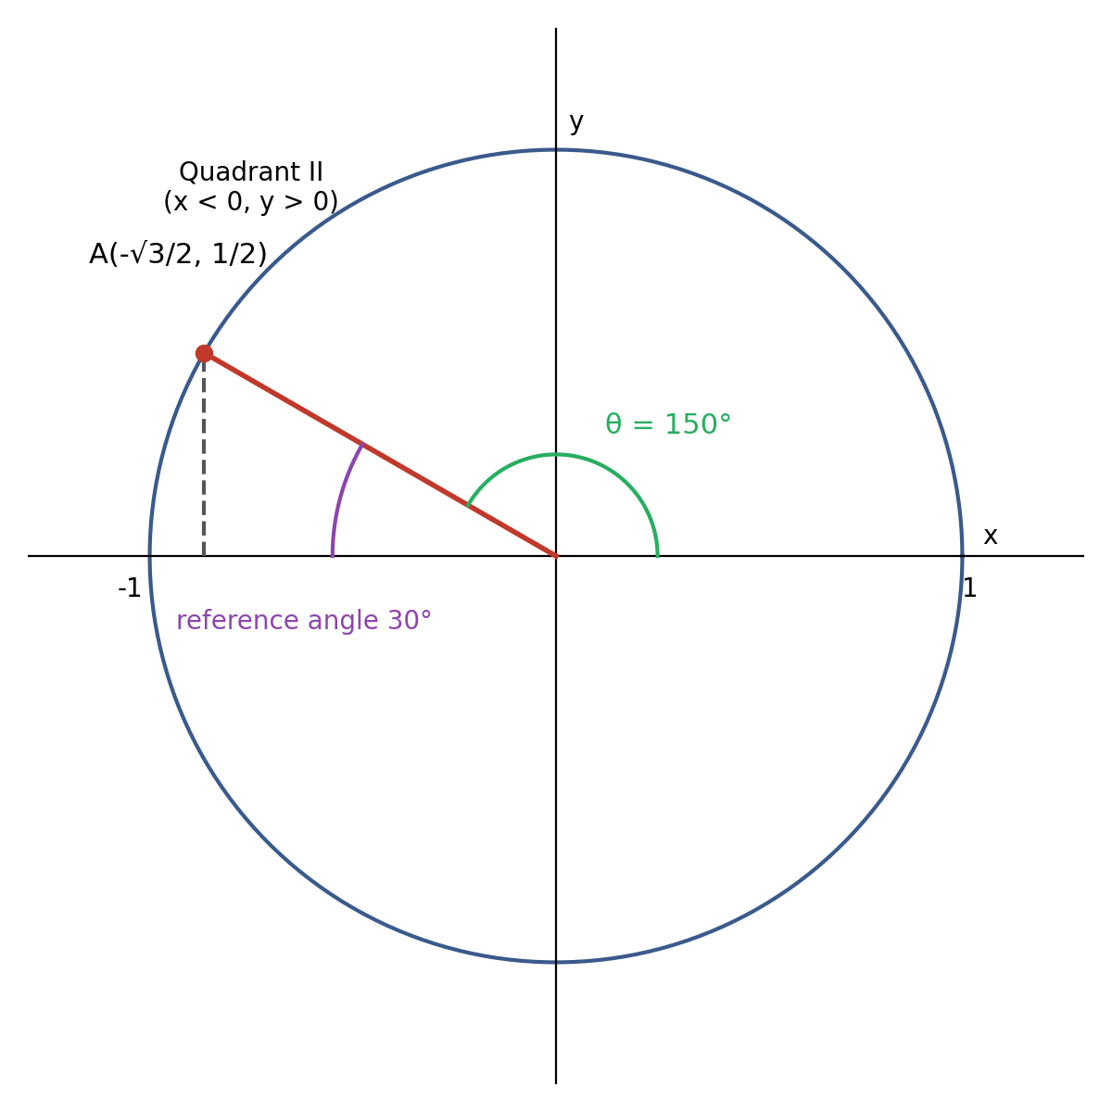

Task 2: Angles of Elevation
Alice first stands at point A, 4 m from the tree, then moves 2 m closer to point B, so B is 2 m from the tree. The object is at the top of the tree, 6 m above the ground. Each position forms a right triangle with the tree, where the height of the tree is the side opposite the angle and the ground distance is the adjacent side (Figure 2). As in the textbook model, Alice's eyes are taken to be at ground level.
Figure 2
Right Triangles Formed at Points A and B
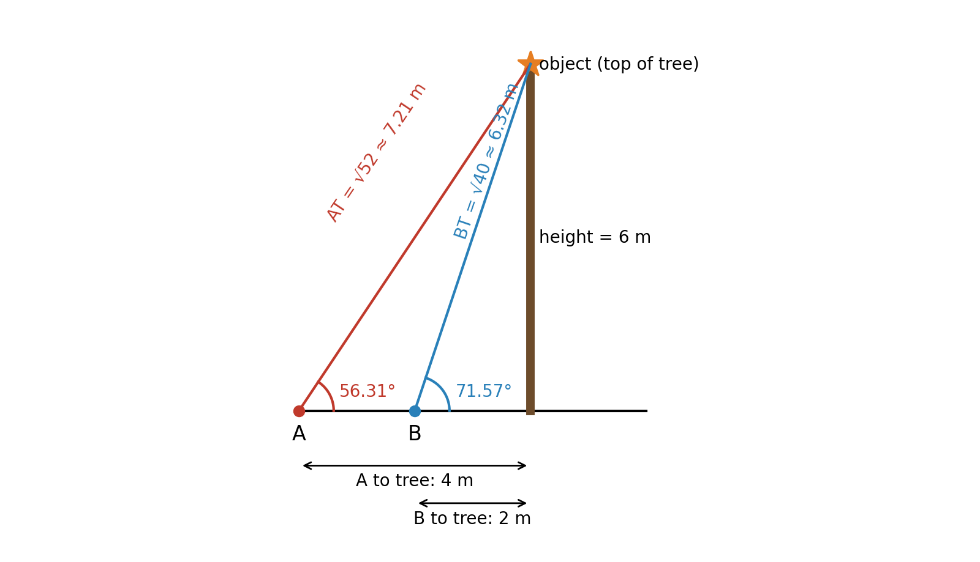

(i) The Angles at A and B
The formula linking the opposite and adjacent sides is the tangent ratio (Abramson, 2021, Section 7.2; Mathispower4u, 2011a):
tan θ = opposite / adjacent, so θ = tan⁻¹(opposite / adjacent)
At A: tan A = 6 / 4 = 1.5 -> A = tan⁻¹(1.5) ≈ 56.31°
At B: tan B = 6 / 2 = 3 -> B = tan⁻¹(3) ≈ 71.57°

These are angles of elevation: each is the angle between the horizontal ground and Alice's line of sight as she looks up at an object above her.

(ii) Comparing the Angles
Angle A (56.31°) is not larger than angle B (71.57°). Angle B is larger by about 15.26°.
Conclusion. For an object at a fixed height, the closer the observer stands, the larger the angle of elevation. Moving closer shrinks the adjacent side while the opposite side stays 6 m, so the ratio opposite/adjacent grows (from 1.5 to 3), and because tangent increases on 0° to 90°, the angle grows too. Far away, the angle gets smaller and approaches 0°; standing almost at the base, it approaches 90°.

(iii) The Distances to the Object
The direct distance from each point to the object is the hypotenuse of its right triangle, found with the Pythagorean theorem, c = √(a² + b²):
Distance AT = √(4² + 6²) = √(16 + 36) = √52 = 2√13 ≈ 7.21 m
Distance BT = √(2² + 6²) = √(4 + 36) = √40 = 2√10 ≈ 6.32 m

Check with trigonometry. Using sin θ = opposite / hypotenuse, the hypotenuse = 6 / sin θ: 6 / sin 56.31° ≈ 7.21 m and 6 / sin 71.57° ≈ 6.32 m, which agree. So the object is about 7.21 m from point A and about 6.32 m from point B.

Task 3: Sinusoidal and Tangent Functions
The general forms used here are (Abramson, 2021, Sections 8.1 and 8.2; Mathispower4u, 2010):
• y = A sin(Bx - C) + D and y = A cos(Bx - C) + D, where |A| is the amplitude, the period is 2π / |B|, the phase shift is C / B, and y = D is the midline.
• y = A tan(Bx - C) + D, where |A| is the stretching factor, the period is π / |B|, and the phase shift is C / B.

(a) A Sine or Cosine Function With the Given Properties
Midline 5, amplitude 13, period 2π, phase shift 0.
Midline D = 5
Amplitude |A| = 13 -> A = 13
Period 2π / |B| = 2π -> B = 1
Phase shift C / B = 0 -> C = 0

y = 13 sin(x) + 5 (an equally valid cosine answer is y = 13 cos(x) + 5).
Check: the function swings 13 units above and below y = 5, from a minimum of -8 to a maximum of 18, and repeats every 2π.

(b) Analysing y = 15 tan(πx/3 + 2)
Rewrite it in the form A tan(Bx - C): here A = 15, B = π/3, and -C = 2, so C = -2.
Property | Formula | Result
Stretching factor | ∣A∣ | 15
Period | π / ∣B∣ = π ÷ (π/3) | 3
Phase shift | C / B = -2 ÷ (π/3) = -6/π | -6/π ≈ -1.91 (a shift 6/π units to the left)
Vertical asymptotes | set Bx - C = π/2 + kπ: πx/3 + 2 = π/2 + kπ | x = 3/2 - 6/π + 3k ≈ -0.41 + 3k, k an integer
Domain | all real x except the asymptotes | {x : x ≠ 3/2 - 6/π + 3k, k ∈ ℤ}

Solving for the asymptotes step by step:
πx/3 + 2 = π/2 + kπ
πx/3 = π/2 - 2 + kπ
x = (3/π)(π/2 - 2 + kπ) = 3/2 - 6/π + 3k

Neighbouring asymptotes are 3 apart, which matches the period. The range is all real numbers.

(c) The Points on the Graph
The graph reaches its maximum value of 1 at θ = 0°, crosses zero at ±90°, and reaches -1 at ±180°. That is exactly the shape of y = cos θ, which starts at its maximum on the y-axis, so the graph represents a cosine function (Abramson, 2021, Section 8.1). The vertical grid lines are 45° apart, which places each point at a multiple of 45°:
Point | θ | y = cos θ | Coordinates
a | -315° | cos(-315°) = cos 45° = √2/2 ≈ 0.71 | (-315°, √2/2)
b | -135° | cos(-135°) = -√2/2 ≈ -0.71 | (-135°, -√2/2)
c | -90° | cos(-90°) = 0 | (-90°, 0)
d | 135° | cos(135°) = -√2/2 ≈ -0.71 | (135°, -√2/2)
e | 180° | cos(180°) = -1 | (180°, -1)
f | 225° | cos(225°) = -√2/2 ≈ -0.71 | (225°, -√2/2)

The values also show the symmetry of cosine: b and d are mirror images about the y-axis, with cos(-135°) = cos(135°), and d and f are symmetric about the minimum at e.

Task 4: A Trigonometric Function and Its Inverse

(i) The Table
I chose Y = f(X) = cos X, with inverse f⁻¹(Y) = cos⁻¹(Y) = arccos(Y). The inverse cosine returns the angle in [0, π] whose cosine is Y (Abramson, 2021, Section 8.3; Mathispower4u, 2011b).
X | 0 | π/3 | 2π/3 | π/2 | π | 4π/3 | 2π
Y = f(X) = cos X | 1 | 1/2 | -1/2 | 0 | -1 | -1/2 | 1
f⁻¹(Y) = arccos Y | 0 | π/3 | 2π/3 | π/2 | π | 2π/3 | 0

The table reveals something important. For the first five columns, where X is between 0 and π, the inverse gives back exactly the original X. For X = 4π/3 and X = 2π it does not: arccos(-1/2) returns 2π/3, not 4π/3, and arccos(1) returns 0, not 2π. That happens because cosine is not one-to-one over a full turn, so its inverse can only be defined by restricting cosine to [0, π], and arccos always answers with an angle from that interval.

(ii) The Graph
Figure 3 shows Y = cos X and its inverse Y = arccos X drawn on the same axes in GeoGebra, with the line y = x. The arccos curve is the reflection of cos X, restricted to [0, π], across the line y = x, which is the graphical meaning of an inverse.
Figure 3
Y = cos X and Y = arccos X on the Same Graph in GeoGebra
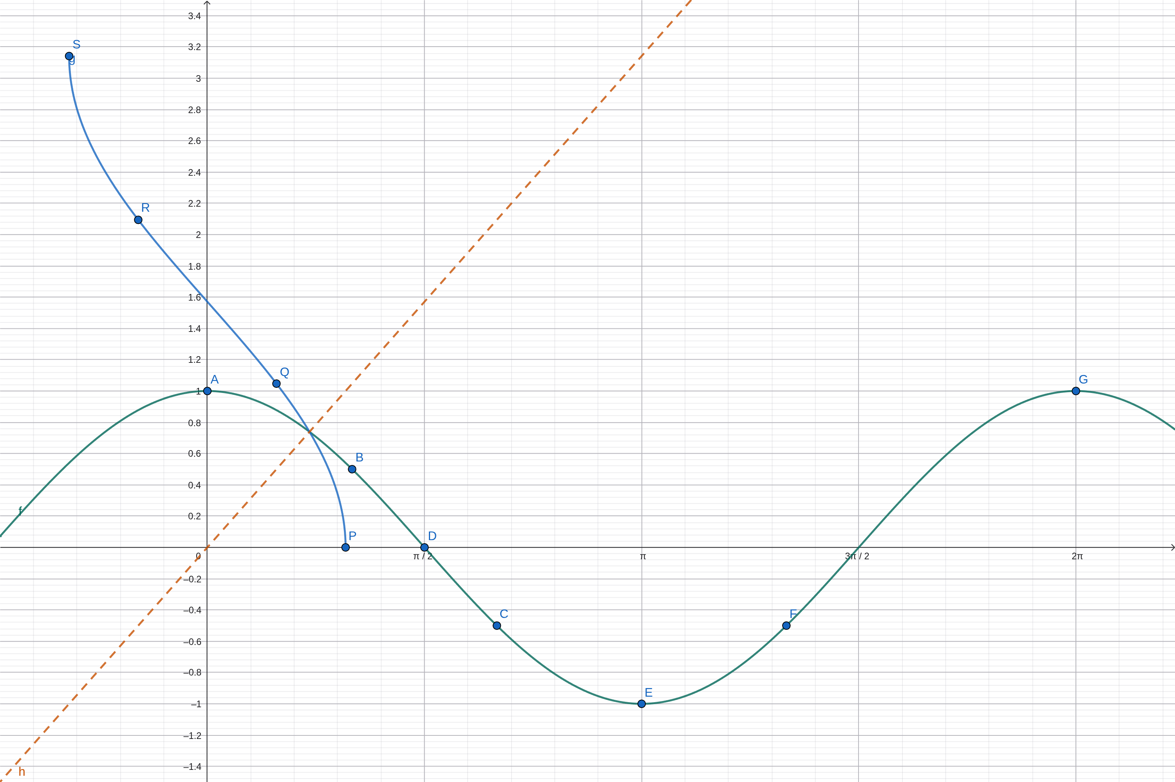

(iii) Observations
(a) Periodicity. The table shows that cos X repeats: cos 0 = cos 2π = 1, and the values 1, 1/2, -1/2, -1 return in reverse as X goes from π to 2π. In general cos(X + 2π) = cos X, so cosine is periodic with period 2π (Abramson, 2021, Section 8.1). The inverse arccos is not periodic: it is one-to-one and decreases steadily from π at Y = -1 to 0 at Y = 1, so it never repeats a value.
(b) Domain and range.
Function | Domain | Range
f(X) = cos X | all real numbers, (-∞, ∞) | [-1, 1]
f⁻¹(Y) = arccos Y | [-1, 1] | [0, π]

The domain of arccos is the range of cosine, and the range of arccos is the restricted domain [0, π] of cosine, as expected for inverse functions.
(c) Even, odd, or neither. A function is even if f(-X) = f(X) and odd if f(-X) = -f(X). Cosine satisfies cos(-X) = cos X; for example cos(-π/3) = 1/2 = cos(π/3). So f(X) = cos X is an even function (Abramson, 2021, Section 7.4), and its graph is symmetric about the y-axis, as the points b and d in Task 3 also show. (By contrast, arccos is neither even nor odd, because arccos(-Y) = π - arccos(Y).)

Conclusion
The unit circle turns trigonometry into coordinates: the point A = (-√3/2, 1/2) gave all six function values, its quadrant, and its 150° angle at once. Right-triangle ratios turned Alice's situation into angles of elevation and distances, and showed that angles of elevation grow as an observer moves closer. The general forms of sine, cosine, and tangent made it possible to build and read equations and graphs, and the cosine table showed why an inverse trigonometric function needs a restricted domain.

References
Abramson, J. (2021). Algebra and trigonometry (2nd ed.). OpenStax. https://openstax.org/details/books/algebra-and-trigonometry-2e
Mathispower4u. (2010, May 11). Graphing sine and cosine with transformations [Video]. YouTube. https://www.youtube.com/watch?v=wUzARNIkH-g
Mathispower4u. (2011a, May 24). Example: Determine what trig function relates specific sides of a right triangle [Video]. YouTube. https://www.youtube.com/watch?v=QfQYY6FsPss
Mathispower4u. (2011b, June 3). Examples: Evaluate expression involving inverse trig functions (Part 1) [Video]. YouTube. https://www.youtube.com/watch?v=4qO0qUqBQEU
Mathispower4u. (2011c, May 26). More examples: Determining trig function values using the unit circle [Video]. YouTube. https://www.youtube.com/watch?v=BFtqhHgXSMk

