Programming Assignment Unit 8: Weather Information App

Nicanor Maswili
Department of Computer Science, University of the People
CS 1103: Programming 2
Instructor: Dr. Abeena Azad
October 28, 2026

Programming Assignment Unit 8: Weather Information App

Overview
The Weather Information App is a Java Swing desktop program that shows real-time weather for any city or pair of coordinates. It fetches live data from the Open-Meteo weather API and displays the temperature, humidity, wind speed, and conditions with a drawn weather icon, a five-day forecast, and the local time at the searched place. The user can switch between Celsius and Fahrenheit and between three wind speed units, see a timestamped history of recent searches, and watch the background change with the time of day at that place. Every kind of error, from an empty search box to a lost internet connection, produces a clear message instead of a crash.
Like every GUI program, the app is event-driven: it waits for the user to click, type, or choose, and responds to each event as it happens (Eck, 2022, Chapter 6).

Requirements Checklist
Table 1
Assignment Requirements and Where They Are Met
Requirement | How the app meets it | Shown in
API integration | Open-Meteo Geocoding and Forecast APIs over HTTPS with java.net.http.HttpClient | Figures 2 to 5; live tests
GUI design | Swing window with a search bar, unit lists, weather area, forecast row, history list, and status bar | Figure 2
Location input | Text field for a city name or "latitude, longitude"; Enter or Search starts the search | Figures 2 and 5
Weather information | Temperature, humidity, wind speed, conditions, and local time | Figure 2
Icons | Sun, moon, clouds, rain, snow, fog, and lightning drawn with Java 2D for each WMO weather code | Figures 2 to 4
Forecast | Five-day forecast with an icon, high and low temperatures, and conditions per day | Figures 2 to 5
Unit conversion | °C or °F; km/h, m/s, or mph; switches instantly, including the history | Figure 4
Error handling | Empty input, invalid coordinates, unknown places, network failures, timeouts, API errors | Figure 6
History tracking | Ten most recent searches, newest first, each with a timestamp; double-click to repeat | Figure 4
Dynamic backgrounds | Morning, daytime, evening (sunset), and night gradients based on the place's local time | Figure 3
Well-commented code and README | Javadoc on every class, method, and field; README.md and README.txt | Source Code; README section

Design
The program is split into three layers, following the Model-View-Controller idea that Eck (2022, Section 13.3) describes: the model holds the data, the view presents it, and the controller responds to the user's actions. Figure 1 shows the classes in each layer.
Figure 1
Classes and How They Work Together
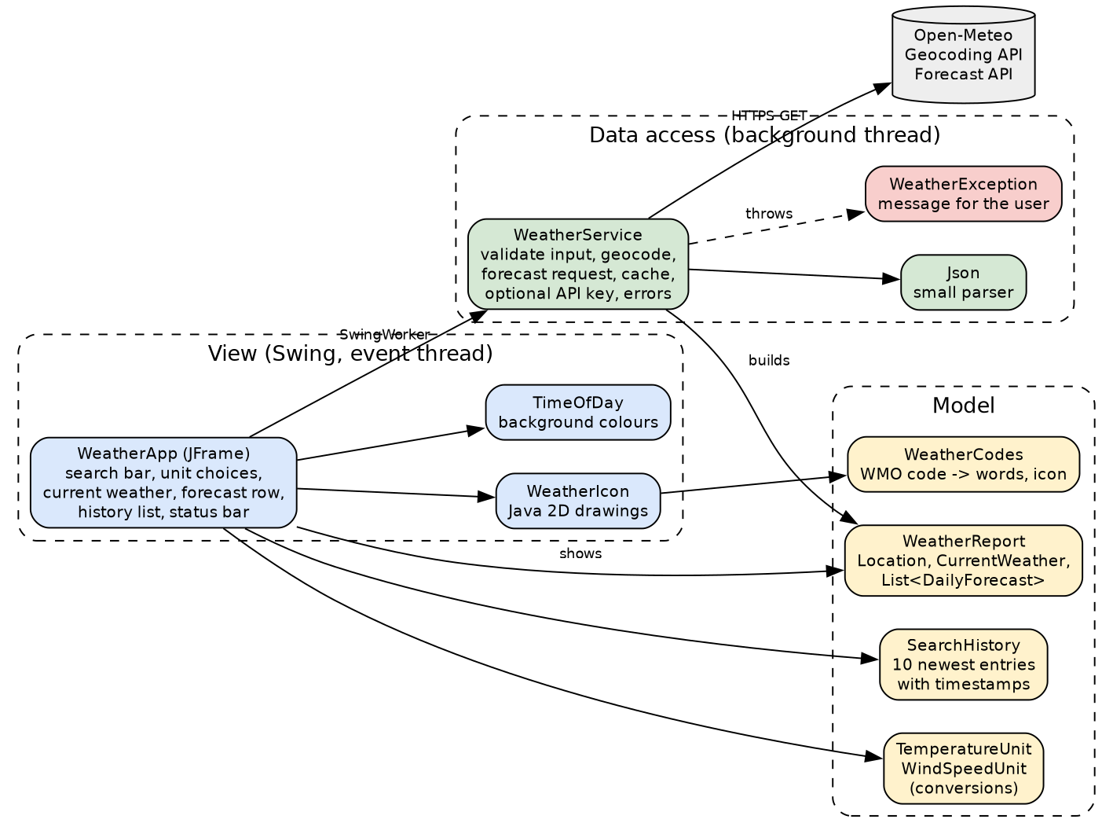
Table 2
Classes in the Program
Layer | Class | Role
View and controller | WeatherApp | The window, its components, and the event handlers
View | WeatherIcon, TimeOfDay | Weather pictures and background colours
Model | Location, CurrentWeather, DailyForecast, WeatherReport | Records holding the weather data
Model | TemperatureUnit, WindSpeedUnit, WeatherCodes, SearchHistory | Conversions, code descriptions, and the history
Data access | WeatherService, Json, WeatherException | API calls, JSON parsing, and user-facing errors
Testing | WeatherAppTest | 26 offline checks and 3 live checks

API Integration
A search makes two HTTPS requests to Open-Meteo, using Java's built-in HttpClient, which sends requests and receives responses with configurable timeouts (Oracle, n.d.-a):
1. Geocoding. The Geocoding API turns a place name into coordinates (Open-Meteo, n.d.-a). For "Nairobi" it returns Nairobi, Nairobi County, Kenya at latitude -1.28333 and longitude 36.81667. If the user typed coordinates instead, this step is skipped.
2. Forecast. The Forecast API returns the current temperature, relative humidity, wind speed, WMO weather code, and day or night flag, plus the daily weather code and high and low temperatures for five days. The request uses timezone=auto, so the times come back in the place's local time, which the dynamic background needs (Open-Meteo, n.d.-d).
https://api.open-meteo.com/v1/forecast?latitude=-1.2833&longitude=36.8167
&current=temperature_2m,relative_humidity_2m,wind_speed_10m,weather_code,is_day
&daily=weather_code,temperature_2m_max,temperature_2m_min
&timezone=auto&forecast_days=5

The API returns JSON. Java has no built-in JSON parser, so the app includes a small one (Json.java) and reads each field into records, checking that every required field is present.
API key and usage guidelines. The rubric asks for appropriate use of an API key and adherence to the API's guidelines. Open-Meteo's free API needs no key for non-commercial use, but it limits each user to fewer than 10,000 calls per day, 5,000 per hour, and 600 per minute, and licenses its data under CC BY 4.0 (Open-Meteo, n.d.-c). Paying customers get a key and use a separate customer endpoint, where the only differences are the domain and the apikey parameter (Open-Meteo, n.d.-b). The app handles both correctly:
• It credits "Weather data by Open-Meteo.com (CC BY 4.0)" in the status bar.
• It caches each place's report for 10 minutes, so repeated searches and history clicks do not spend extra calls.
• Every request has a connection timeout and a 15-second response timeout, and identifies the app with a User-Agent header.
• If the environment variable OPEN_METEO_API_KEY is set, it switches to the customer endpoint and sends the key. The key is read from the environment and never written into the source code, so it cannot leak through the submitted files.

GUI Design
The window uses a BorderLayout: the search bar at the top, the weather area in the centre, the history list on the right, and the status bar at the bottom. Layout managers arrange components the same way on every operating system (Chua, n.d.), and BorderLayout's north, south, east, west, and centre regions match this design directly (Morelli & Walde, n.d.). Inside the regions, a FlowLayout holds the search controls, a GridLayout lays out the five forecast cards evenly, and a BoxLayout stacks the current weather details.
Several choices make the interface easy to use:
• One obvious action. The Search button is the default button, so pressing Enter in the text field searches, and Alt+S also works.
• Readable on any background. The search bar, cards, and status bar are light, rounded panels, and the large labels switch to white text on the dark evening and night backgrounds.
• Clear feedback. While a search runs, the button is disabled and the status bar says "Searching for ...". Errors appear in red in the same place, and the last good result stays on screen.
• Tooltips and hints. The text field explains the accepted formats, and each forecast icon has a tooltip with its conditions.
A responsive window. Swing event handling runs on a single event dispatch thread, and most Swing methods are not thread-safe (Oracle, n.d.-b). A network request on that thread would freeze the window, so each search runs in a SwingWorker, a background worker thread whose done() method is called back on the event dispatch thread to update the screen safely (Oracle, n.d.-c). The Search button follows Java's event model: the button generates an ActionEvent, and the listener registered with it responds (Morelli & Walde, n.d.).

Logic: How One Search Works
1. The user types "Tokyo" and presses Enter. The Search button's action listener calls startSearch().
2. The button is disabled and a SwingWorker starts. On the background thread, WeatherService.findLocation() checks the input, then asks the Geocoding API for coordinates.
3. WeatherService.fetchReport() checks the cache. If there is no recent copy, it requests the forecast and parses it into a WeatherReport.
4. Back on the event dispatch thread, done() shows the report: the icon, temperature, conditions, details, local time, and forecast cards, all in the selected units.
5. The search is added to the history with a timestamp, and the background is set from the local hour (17:45 in Tokyo, so the evening sunset colours appear).
6. If any step fails, the WeatherException's message appears in red in the status bar.

Unit Conversion
The API always sends Celsius and kilometres per hour. The app keeps the original values and converts only for display, so switching units is instant and needs no new request.
Table 3
Unit Conversions
Conversion | Formula | Check (from the tests)
Celsius to Fahrenheit | °F = °C × 9/5 + 32 | 0 °C = 32 °F, 100 °C = 212 °F, -40 °C = -40 °F
km/h to m/s | m/s = km/h × 1000 / 3600 | 36 km/h = 10.0 m/s
km/h to mph | mph = km/h ÷ 1.609344 | 36 km/h = 22.4 mph

Error Handling
Table 4
Error Cases and the Messages Shown
Situation | Message in the status bar
Empty search box | Please type a city name or coordinates (latitude, longitude).
Coordinates off the Earth, such as "200, 10" | Coordinates must be latitude -90 to 90 and longitude -180 to 180.
Unknown or misspelled place | No place called "Nairobbbii" was found. Check the spelling, or add the country, e.g. "Paris, France".
No internet connection | Could not reach the weather service. Please check your internet connection.
The server is too slow | The weather service took too long to answer. Please try again.
HTTP 429 (too many requests) | Too many requests to the weather service. Please wait a minute and try again.
Other API error | The weather service rejected the request: (the API's own reason)
Missing or malformed data | The weather service sent data that could not be read.

All of these are thrown as a checked WeatherException, so the compiler makes sure every caller handles them, and none of them ever reaches the user as a stack trace.

History and Dynamic Backgrounds
History. SearchHistory keeps the ten most recent searches, newest first. Searching for the same place again moves it to the top instead of listing it twice. Each entry stores the temperature in Celsius, so the history also switches when the user changes units.
Dynamic backgrounds. The background is a vertical gradient chosen from the local hour at the searched place, not the user's own clock, so searching Los Angeles from Nairobi shows night.
Table 5
Background for Each Time of Day
Local time | Part of day | Background
05:00 to 10:59 | Morning | Peach sunrise to light blue
11:00 to 16:59 | Daytime | Bright blue sky
17:00 to 19:59 | Evening | Orange sunset to purple
20:00 to 04:59 | Night | Dark navy, with light text and a moon icon for clear skies

Testing
WeatherAppTest runs 26 checks offline, using a real Open-Meteo response saved in the test, so the results never depend on today's weather. With --live, it adds three checks against the real API. All 29 pass, and the program compiles with javac -Xlint:all -Xdoclint:all with no warnings.
PASS JSON parser reads objects, arrays, numbers, escapes, true, and null
PASS JSON parser rejects invalid text
PASS geocoding response gives name, region, country, and coordinates
PASS current weather: temperature, humidity, wind, and conditions are read
PASS local time at the place is read for the dynamic background
PASS forecast has five days with dates, codes, highs, and lows
PASS typed coordinates are recognized without a geocoding request
PASS a normal city name is not mistaken for coordinates
PASS empty input is rejected with a helpful message
PASS coordinates off the Earth are rejected
PASS an unknown place gives a 'not found' message with a tip
PASS an API error shows the API's own reason
PASS too many requests (HTTP 429) asks the user to wait
PASS a response with missing fields is reported, not crashed on
PASS a response that is not JSON is reported clearly
PASS Celsius to Fahrenheit: 0 -> 32, 100 -> 212, -40 -> -40
PASS temperatures are formatted with the unit symbol
PASS wind: 36 km/h = 10.0 m/s = 22.4 mph
PASS WMO codes give the documented descriptions
PASS each kind of weather gets a matching icon
PASS hours map to morning, day, evening (sunset), and night
PASS evening and night use light text for contrast
PASS history keeps only the 10 most recent searches, newest first
PASS searching a place again moves it to the top instead of duplicating it
PASS history entries show a timestamp
PASS history temperatures can be shown in the unit chosen later
PASS LIVE: London is found and real weather is returned
PASS LIVE: a second request within 10 minutes is served from the cache
PASS LIVE: an unknown place gives the 'not found' message

Tests passed: 29, failed: 0

Screenshots of the GUI
All screenshots are from the running program with live data on October 23, 2026, between 11:55 and 11:57 East Africa Time.
Figure 2
Main Window: Current Weather, Icon, Details, and 5-Day Forecast for Nairobi
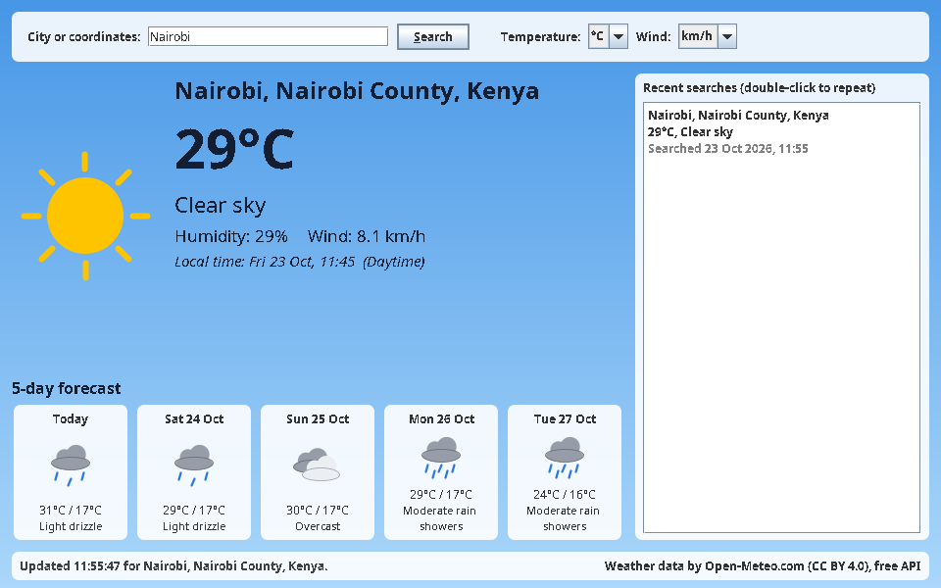
Figure 3
Dynamic Backgrounds for the Local Time of Day at Four Cities
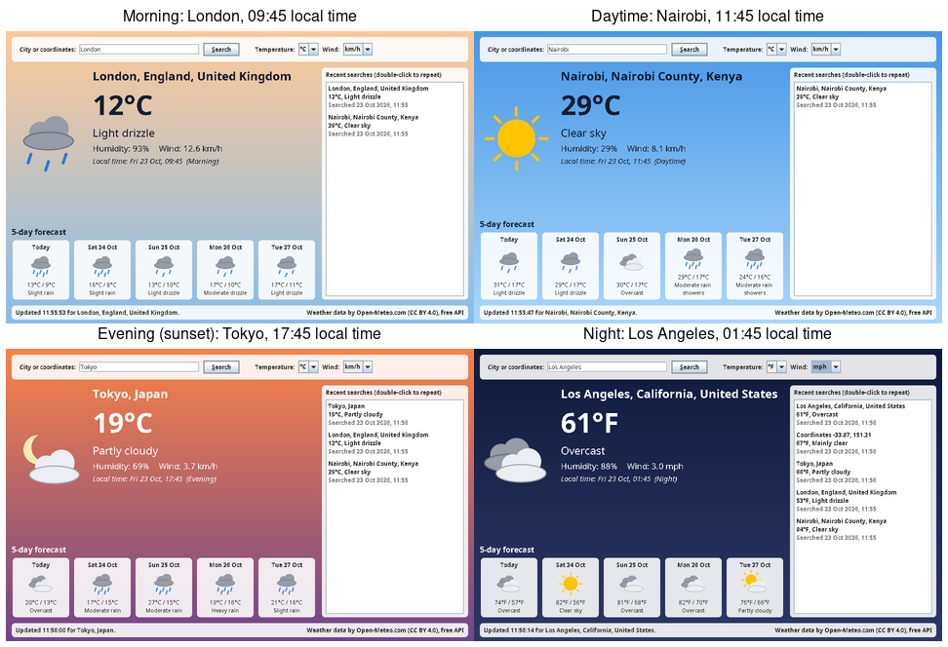
Figure 4
Units Switched to °F and mph, With the Full Search History (Including a Coordinates Search)
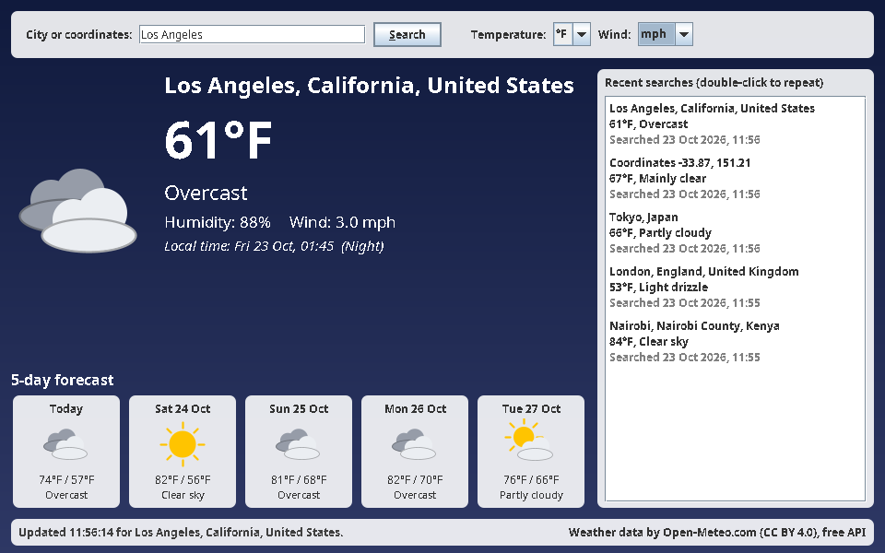
Figure 5
Searching by Coordinates (-33.87, 151.21) at Evening Local Time
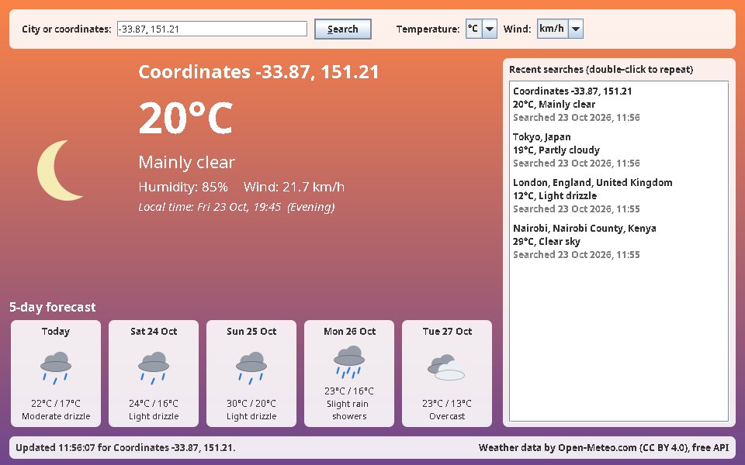
Figure 6
Error Messages: Unknown Place, Empty Input, and No Connection to the Weather Service
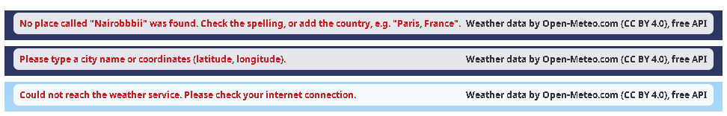

README: How to Use and Run the App
The README file submitted with the code contains these instructions and the implementation details above.
Run (Java 17 or newer, from the Assignment folder):
javac -d out src/*.java
java -cp out WeatherApp
Tests:
java -cp out WeatherAppTest (offline)
java -cp out WeatherAppTest --live (also calls the real API)

Use:
1. Type a city (Nairobi, Paris, France) or coordinates (-1.29, 36.82).
2. Press Enter or click Search.
3. Change Temperature (°C/°F) or Wind (km/h, m/s, mph) at any time.
4. Double-click a recent search on the right to repeat it.
5. Red messages in the status bar explain any problem.
Optional: set OPEN_METEO_API_KEY to use a paid Open-Meteo key.

Source Code
WeatherApp.java
import java.awt.BorderLayout;
import java.awt.Color;
import java.awt.Component;
import java.awt.Dimension;
import java.awt.FlowLayout;
import java.awt.Font;
import java.awt.GradientPaint;
import java.awt.Graphics;
import java.awt.Graphics2D;
import java.awt.GridLayout;
import java.awt.LayoutManager;
import java.awt.RenderingHints;
import java.awt.event.ActionEvent;
import java.awt.event.KeyEvent;
import java.awt.event.MouseAdapter;
import java.awt.event.MouseEvent;
import java.time.LocalDateTime;
import java.time.format.DateTimeFormatter;
import java.util.List;
import java.util.concurrent.ExecutionException;
import javax.swing.AbstractAction;
import javax.swing.BorderFactory;
import javax.swing.Box;
import javax.swing.BoxLayout;
import javax.swing.DefaultListCellRenderer;
import javax.swing.DefaultListModel;
import javax.swing.JButton;
import javax.swing.JComboBox;
import javax.swing.JFrame;
import javax.swing.JLabel;
import javax.swing.JList;
import javax.swing.JPanel;
import javax.swing.JScrollPane;
import javax.swing.JTextField;
import javax.swing.KeyStroke;
import javax.swing.SwingConstants;
import javax.swing.SwingUtilities;
import javax.swing.SwingWorker;
import javax.swing.UIManager;
import javax.swing.UnsupportedLookAndFeelException;

/**
* The Weather Information App: a Swing window that shows real-time weather for any place.
*
* <p>The user types a city name or coordinates and presses Search. The app shows the current
* temperature, humidity, wind speed, and conditions with an icon, a five-day forecast, and a
* history of recent searches. Units can be switched at any time, and the background changes with
* the local time of day at the searched place. Network work runs on a background thread
* (SwingWorker) so the window never freezes.
*/
public final class WeatherApp extends JFrame {

/** Version number for serialization. */
private static final long serialVersionUID = 1L;

/** Format of the local time shown under the current weather. */
private static final DateTimeFormatter LOCAL_TIME = DateTimeFormatter.ofPattern("EEE d MMM, HH:mm");

/** Format of the day names in the forecast row. */
private static final DateTimeFormatter FORECAST_DAY = DateTimeFormatter.ofPattern("EEE d MMM");

/** Colour for error messages in the status bar. */
private static final Color ERROR_RED = new Color(200, 30, 30);

/** Fetches weather data from the API. */
private final transient WeatherService service = new WeatherService();

/** Recent successful searches. */
private final transient SearchHistory history = new SearchHistory();

/** The report currently shown, kept so units can be changed without a new request. */
private transient WeatherReport currentReport;

/** The window background, which changes with the time of day. */
private final GradientPanel background = new GradientPanel();

/** Where the user types a city name or coordinates. */
private final JTextField locationField = new JTextField(22);

/** Starts a search. */
private final JButton searchButton = new JButton("Search");

/** Temperature unit choice. */
private final JComboBox<TemperatureUnit> temperatureUnit = new JComboBox<>(TemperatureUnit.values());

/** Wind speed unit choice. */
private final JComboBox<WindSpeedUnit> windUnit = new JComboBox<>(WindSpeedUnit.values());

/** Large picture of the current conditions. */
private final JLabel iconLabel = new JLabel();

/** Name of the place. */
private final JLabel placeLabel = new JLabel("Search for a city to see its weather");

/** Current temperature. */
private final JLabel temperatureLabel = new JLabel(" ");

/** Current conditions in words. */
private final JLabel conditionLabel = new JLabel(" ");

/** Humidity and wind speed. */
private final JLabel detailsLabel = new JLabel(" ");

/** Local time and part of the day at the place. */
private final JLabel timeLabel = new JLabel(" ");

/** Holds one small panel per forecast day. */
private final JPanel forecastRow = new JPanel(new GridLayout(1, WeatherService.FORECAST_DAYS, 10, 0));

/** The history entries shown in the list. */
private final DefaultListModel<SearchHistory.Entry> historyModel = new DefaultListModel<>();

/** The list that shows the history. */
private final JList<SearchHistory.Entry> historyList = new JList<>(historyModel);

/** Messages and errors for the user. */
private final JLabel statusLabel = new JLabel("Type a city such as \"Nairobi\" or coordinates such as \"-1.29, 36.82\".");

/** Title above the forecast row. */
private final JLabel forecastTitle = new JLabel("5-day forecast");

/** Labels whose colour follows the background (light text on dark backgrounds). */
private final transient List<JLabel> adaptiveLabels = List.of(
placeLabel, temperatureLabel, conditionLabel, detailsLabel, timeLabel, forecastTitle);

/** Builds the window and all its components. */
public WeatherApp() {
super("Weather Information App");
setDefaultCloseOperation(EXIT_ON_CLOSE);
setMinimumSize(new Dimension(960, 600));

background.setLayout(new BorderLayout(12, 12));
background.setBorder(BorderFactory.createEmptyBorder(12, 12, 8, 12));
background.add(buildSearchBar(), BorderLayout.NORTH);
background.add(buildWeatherArea(), BorderLayout.CENTER);
background.add(buildHistoryPanel(), BorderLayout.EAST);
background.add(buildStatusBar(), BorderLayout.SOUTH);
setContentPane(background);

searchButton.addActionListener(e -> startSearch(locationField.getText()));
getRootPane().setDefaultButton(searchButton); // Enter in the text field searches
temperatureUnit.addActionListener(e -> {
showReport();
historyList.repaint(); // history temperatures follow the chosen unit too
});
windUnit.addActionListener(e -> showReport());

applyTimeOfDay(TimeOfDay.fromHour(LocalDateTime.now().getHour()));
pack();
setLocationRelativeTo(null);
}

/**
* Builds the row with the location field, Search button, and unit choices.
*
* @return the search bar
*/
private JPanel buildSearchBar() {
JPanel bar = card(new FlowLayout(FlowLayout.LEFT, 8, 6));
locationField.setToolTipText("A city name (e.g. Paris, France) or latitude, longitude (e.g. 48.85, 2.35)");
searchButton.setMnemonic(KeyEvent.VK_S);
bar.add(new JLabel("City or coordinates:"));
bar.add(locationField);
bar.add(searchButton);
bar.add(Box.createHorizontalStrut(16));
bar.add(new JLabel("Temperature:"));
bar.add(temperatureUnit);
bar.add(new JLabel("Wind:"));
bar.add(windUnit);
return bar;
}

/**
* Builds the centre area: the current weather above the forecast row.
*
* @return the weather area
*/
private JPanel buildWeatherArea() {
JPanel current = transparent(new BorderLayout(16, 0));
JPanel text = transparent(null);
text.setLayout(new BoxLayout(text, BoxLayout.Y_AXIS));
placeLabel.setFont(placeLabel.getFont().deriveFont(Font.BOLD, 24f));
temperatureLabel.setFont(temperatureLabel.getFont().deriveFont(Font.BOLD, 56f));
conditionLabel.setFont(conditionLabel.getFont().deriveFont(Font.PLAIN, 22f));
detailsLabel.setFont(detailsLabel.getFont().deriveFont(Font.PLAIN, 17f));
timeLabel.setFont(timeLabel.getFont().deriveFont(Font.ITALIC, 15f));
for (JLabel label : List.of(placeLabel, temperatureLabel, conditionLabel, detailsLabel, timeLabel)) {
text.add(label);
text.add(Box.createVerticalStrut(4));
}
current.add(iconLabel, BorderLayout.WEST);
current.add(text, BorderLayout.CENTER);

forecastRow.setOpaque(false);
JPanel forecastBox = transparent(new BorderLayout(0, 6));
forecastTitle.setFont(forecastTitle.getFont().deriveFont(Font.BOLD, 16f));
forecastBox.add(forecastTitle, BorderLayout.NORTH);
forecastBox.add(forecastRow, BorderLayout.CENTER);

JPanel area = transparent(new BorderLayout(0, 18));
area.add(current, BorderLayout.CENTER);
area.add(forecastBox, BorderLayout.SOUTH);
return area;
}

/**
* Builds the history list on the right.
*
* @return the history panel
*/
private JPanel buildHistoryPanel() {
JPanel panel = card(new BorderLayout(0, 6));
panel.setPreferredSize(new Dimension(300, 0));
JLabel title = new JLabel("Recent searches (double-click to repeat)");
title.setFont(title.getFont().deriveFont(Font.BOLD));
historyList.setCellRenderer(new HistoryRenderer());
historyList.addMouseListener(new MouseAdapter() {
@Override
public void mouseClicked(MouseEvent e) {
if (e.getClickCount() == 2 && historyList.getSelectedValue() != null) {
repeatSearch(historyList.getSelectedValue());
}
}
});
historyList.getInputMap().put(KeyStroke.getKeyStroke(KeyEvent.VK_ENTER, 0), "repeat");
historyList.getActionMap().put("repeat", new AbstractAction() {
/** Version number for serialization. */
private static final long serialVersionUID = 1L;

@Override
public void actionPerformed(ActionEvent e) {
if (historyList.getSelectedValue() != null) {
repeatSearch(historyList.getSelectedValue());
}
}
});
panel.add(title, BorderLayout.NORTH);
panel.add(new JScrollPane(historyList), BorderLayout.CENTER);
return panel;
}

/**
* Builds the status bar with messages on the left and the data credit on the right.
*
* @return the status bar
*/
private JPanel buildStatusBar() {
JPanel bar = card(new BorderLayout());
String source = "Weather data by Open-Meteo.com (CC BY 4.0)"
+ (service.usesApiKey() ? ", customer API" : ", free API");
bar.add(statusLabel, BorderLayout.CENTER);
bar.add(new JLabel(source), BorderLayout.EAST);
return bar;
}

/**
* Starts a search in the background so the window stays responsive.
*
* @param query what the user typed
*/
private void startSearch(String query) {
searchButton.setEnabled(false);
setStatus("Searching for \"" + query.strip() + "\"...", false);
new SwingWorker<WeatherReport, Void>() {
@Override
protected WeatherReport doInBackground() throws WeatherException {
Location location = service.findLocation(query);
return service.fetchReport(location);
}

@Override
protected void done() {
searchButton.setEnabled(true);
try {
WeatherReport report = get();
currentReport = report;
showReport();
addToHistory(query.strip(), report);
setStatus("Updated " + LocalDateTime.now().format(DateTimeFormatter.ofPattern("HH:mm:ss"))
+ " for " + report.location().label() + ".", false);
} catch (ExecutionException e) {
String message = e.getCause() instanceof WeatherException we
? we.getMessage()
: "Something went wrong: " + e.getCause();
setStatus(message, true);
} catch (InterruptedException e) {
Thread.currentThread().interrupt();
setStatus("The search was interrupted.", true);
}
}
}.execute();
}

/**
* Repeats a search from the history list.
*
* @param entry the remembered search
*/
private void repeatSearch(SearchHistory.Entry entry) {
locationField.setText(entry.query());
startSearch(entry.query());
}

/**
* Records a successful search in the history list.
*
* @param query what the user typed
* @param report the result
*/
private void addToHistory(String query, WeatherReport report) {
CurrentWeather now = report.current();
history.add(new SearchHistory.Entry(query, report.location().label(), now.temperatureC(),
now.weatherCode(), LocalDateTime.now()));
historyModel.clear();
history.entries().forEach(historyModel::addElement);
}

/** Shows the current report in the selected units. Does nothing before the first search. */
private void showReport() {
if (currentReport == null) {
return;
}
TemperatureUnit tUnit = (TemperatureUnit) temperatureUnit.getSelectedItem();
WindSpeedUnit wUnit = (WindSpeedUnit) windUnit.getSelectedItem();
CurrentWeather now = currentReport.current();

iconLabel.setIcon(new WeatherIcon(now.weatherCode(), now.isDay(), 150));
placeLabel.setText(currentReport.location().label());
temperatureLabel.setText(tUnit.format(now.temperatureC()));
conditionLabel.setText(WeatherCodes.describe(now.weatherCode()));
detailsLabel.setText("Humidity: " + now.humidity() + "% Wind: " + wUnit.format(now.windKmh()));
TimeOfDay part = TimeOfDay.fromHour(now.localTime().getHour());
timeLabel.setText("Local time: " + now.localTime().format(LOCAL_TIME) + " (" + part + ")");

forecastRow.removeAll();
for (int i = 0; i < currentReport.forecast().size(); i++) {
forecastRow.add(forecastCard(currentReport.forecast().get(i), i == 0, tUnit));
}
applyTimeOfDay(part);
forecastRow.revalidate();
repaint();
}

/**
* Builds the small panel for one forecast day.
*
* @param day the forecast
* @param isToday true for the first day
* @param unit the temperature unit to show
* @return the panel
*/
private JPanel forecastCard(DailyForecast day, boolean isToday, TemperatureUnit unit) {
JPanel cardPanel = card(new BorderLayout(0, 2));
JLabel name = centered(isToday ? "Today" : day.date().format(FORECAST_DAY), Font.BOLD);
JLabel icon = new JLabel(new WeatherIcon(day.weatherCode(), true, 56));
icon.setHorizontalAlignment(SwingConstants.CENTER);
icon.setToolTipText(WeatherCodes.describe(day.weatherCode()));
JLabel temps = centered(unit.format(day.maxC()) + " / " + unit.format(day.minC()), Font.PLAIN);
JLabel words = centered("<html><div style='text-align:center'>"
+ WeatherCodes.describe(day.weatherCode()) + "</div></html>", Font.PLAIN);
words.setFont(words.getFont().deriveFont(11f));
JPanel bottom = transparent(new BorderLayout());
bottom.add(temps, BorderLayout.NORTH);
bottom.add(words, BorderLayout.CENTER);
cardPanel.add(name, BorderLayout.NORTH);
cardPanel.add(icon, BorderLayout.CENTER);
cardPanel.add(bottom, BorderLayout.SOUTH);
return cardPanel;
}

/**
* Changes the background and text colours for a part of the day.
*
* @param part the part of the day at the searched place
*/
private void applyTimeOfDay(TimeOfDay part) {
background.setTimeOfDay(part);
Color text = part.isDark() ? Color.WHITE : new Color(20, 30, 50);
adaptiveLabels.forEach(label -> label.setForeground(text));
}

/**
* Shows a message in the status bar.
*
* @param message the text
* @param isError true to show it in red as an error
*/
private void setStatus(String message, boolean isError) {
statusLabel.setText(message);
statusLabel.setForeground(isError ? ERROR_RED : Color.DARK_GRAY);
}

/**
* Creates a white, slightly rounded "card" panel that stays readable on any background.
*
* @param layout the layout manager
* @return the panel
*/
private static JPanel card(LayoutManager layout) {
JPanel panel = new CardPanel(layout);
panel.setBorder(BorderFactory.createEmptyBorder(6, 8, 6, 8));
return panel;
}

/**
* Creates a see-through panel, so the gradient background shows behind it.
*
* @param layout the layout manager, or null to set it later
* @return the panel
*/
private static JPanel transparent(LayoutManager layout) {
JPanel panel = new JPanel(layout);
panel.setOpaque(false);
return panel;
}

/**
* Creates a centred label.
*
* @param text the text
* @param style Font.BOLD or Font.PLAIN
* @return the label
*/
private static JLabel centered(String text, int style) {
JLabel label = new JLabel(text, SwingConstants.CENTER);
label.setFont(label.getFont().deriveFont(style));
return label;
}

/** Shows each history entry on three lines: the place in bold, the result, and the time. */
private final class HistoryRenderer extends DefaultListCellRenderer {

/** Version number for serialization. */
private static final long serialVersionUID = 1L;

/** Format of the timestamp under each entry. */
private static final DateTimeFormatter STAMP = DateTimeFormatter.ofPattern("d MMM yyyy, HH:mm");

/** Creates the renderer. */
HistoryRenderer() {
setVerticalAlignment(SwingConstants.TOP);
}

@Override
public Component getListCellRendererComponent(JList<?> list, Object value, int index,
boolean isSelected, boolean cellHasFocus) {
super.getListCellRendererComponent(list, value, index, isSelected, cellHasFocus);
if (value instanceof SearchHistory.Entry entry) {
TemperatureUnit unit = (TemperatureUnit) temperatureUnit.getSelectedItem();
setText("<html><b>" + escape(entry.place()) + "</b><br>" + escape(entry.summary(unit))
+ "<br><span style='color:gray'>Searched " + entry.searched().format(STAMP)
+ "</span></html>");
}
setBorder(BorderFactory.createEmptyBorder(4, 4, 4, 4));
return this;
}

/**
* Makes text safe to show inside HTML.
*
* @param text the text
* @return the text with &amp;, &lt;, and &gt; escaped
*/
private static String escape(String text) {
return text.replace("&", "&amp;").replace("<", "&lt;").replace(">", "&gt;");
}
}

/** A see-through panel that paints a rounded, mostly white background behind its contents. */
private static final class CardPanel extends JPanel {

/** Version number for serialization. */
private static final long serialVersionUID = 1L;

/** Fill colour: white with a little transparency. */
private static final Color FILL = new Color(255, 255, 255, 225);

/**
* Creates a card.
*
* @param layout the layout manager
*/
CardPanel(LayoutManager layout) {
super(layout);
setOpaque(false); // the rounded background is painted below instead
}

@Override
protected void paintComponent(Graphics g) {
Graphics2D g2 = (Graphics2D) g.create();
g2.setRenderingHint(RenderingHints.KEY_ANTIALIASING, RenderingHints.VALUE_ANTIALIAS_ON);
g2.setColor(FILL);
g2.fillRoundRect(0, 0, getWidth(), getHeight(), 14, 14);
g2.dispose();
super.paintComponent(g);
}
}

/** A panel that paints a vertical colour gradient for the current part of the day. */
private static final class GradientPanel extends JPanel {

/** Version number for serialization. */
private static final long serialVersionUID = 1L;

/** The part of the day whose colours are painted. */
private TimeOfDay timeOfDay = TimeOfDay.DAY;

/** Creates the background panel with the daytime colours. */
GradientPanel() {
setOpaque(true);
}

/**
* Changes the colours and repaints.
*
* @param timeOfDay the new part of the day
*/
void setTimeOfDay(TimeOfDay timeOfDay) {
this.timeOfDay = timeOfDay;
repaint();
}

@Override
protected void paintComponent(Graphics g) {
Graphics2D g2 = (Graphics2D) g.create();
g2.setPaint(new GradientPaint(0, 0, timeOfDay.top(), 0, getHeight(), timeOfDay.bottom()));
g2.fillRect(0, 0, getWidth(), getHeight());
g2.dispose();
}
}

/**
* Starts the app on the Swing event thread.
*
* @param args not used
*/
public static void main(String[] args) {
SwingUtilities.invokeLater(() -> {
try {
UIManager.setLookAndFeel(UIManager.getSystemLookAndFeelClassName());
} catch (ReflectiveOperationException | UnsupportedLookAndFeelException e) {
// the default look and feel is fine
}
new WeatherApp().setVisible(true);
});
}
}

WeatherService.java
import java.io.IOException;
import java.net.URI;
import java.net.URLEncoder;
import java.net.http.HttpClient;
import java.net.http.HttpRequest;
import java.net.http.HttpResponse;
import java.net.http.HttpTimeoutException;
import java.nio.charset.StandardCharsets;
import java.time.Duration;
import java.time.Instant;
import java.time.LocalDate;
import java.time.LocalDateTime;
import java.time.format.DateTimeParseException;
import java.util.ArrayList;
import java.util.List;
import java.util.Locale;
import java.util.Map;
import java.util.concurrent.ConcurrentHashMap;
import java.util.regex.Matcher;
import java.util.regex.Pattern;

/**
* Fetches real-time weather from the Open-Meteo API.
*
* <p>A search happens in two steps. The Geocoding API turns a place name into coordinates, and
* the Forecast API returns the current weather and a daily forecast for those coordinates. Typed
* coordinates such as "-1.29, 36.82" skip the first step.
*
* <p><b>API key and usage guidelines.</b> Open-Meteo's free API needs no key for non-commercial
* use, within 10,000 calls per day and 600 per minute. If the environment variable
* {@value #API_KEY_VARIABLE} is set, the app uses the paid customer endpoint and sends the key,
* which is read from the environment and never written into the code. To stay well inside the
* limits, results are cached for {@link #CACHE_TIME}, every request has a timeout, and the app
* identifies itself with a User-Agent header. The data is credited to Open-Meteo (CC BY 4.0) in
* the window, as the terms require.
*/
public class WeatherService {

/** Name of the environment variable that may hold a paid Open-Meteo API key. */
public static final String API_KEY_VARIABLE = "OPEN_METEO_API_KEY";

/** How long a fetched report is reused before the API is asked again. */
public static final Duration CACHE_TIME = Duration.ofMinutes(10);

/** Number of forecast days requested (today plus four). */
public static final int FORECAST_DAYS = 5;

/** Free forecast endpoint. */
private static final String FREE_FORECAST_URL = "https://api.open-meteo.com/v1/forecast";

/** Paid forecast endpoint, used only when an API key is configured. */
private static final String CUSTOMER_FORECAST_URL = "https://customer-api.open-meteo.com/v1/forecast";

/** Geocoding (place name search) endpoint. */
private static final String GEOCODING_URL = "https://geocoding-api.open-meteo.com/v1/search";

/** Matches typed coordinates such as "-1.29, 36.82" or "51.5 -0.12". */
private static final Pattern COORDINATES =
Pattern.compile("\\s*(-?\\d+(?:\\.\\d+)?)\\s*[, ]\\s*(-?\\d+(?:\\.\\d+)?)\\s*");

/** Longest place name accepted, to keep requests sensible. */
private static final int MAX_QUERY_LENGTH = 100;

/**
* A cached report and the moment it was fetched.
*
* @param report the report
* @param fetched when it was fetched
*/
private record CachedReport(WeatherReport report, Instant fetched) {
}

/** HTTP client shared by all requests; it is thread-safe. */
private final HttpClient http = HttpClient.newBuilder()
.connectTimeout(Duration.ofSeconds(10))
.build();

/** Paid API key, or null to use the free API. */
private final String apiKey;

/** Recent reports keyed by rounded coordinates; safe to use from several threads. */
private final Map<String, CachedReport> cache = new ConcurrentHashMap<>();

/** Creates a service that reads the optional API key from the environment. */
public WeatherService() {
String key = System.getenv(API_KEY_VARIABLE);
this.apiKey = (key == null || key.isBlank()) ? null : key.strip();
}

/**
* Tells whether the paid endpoint with an API key is in use.
*
* @return true if an API key was found in the environment
*/
public boolean usesApiKey() {
return apiKey != null;
}

/**
* Turns what the user typed into a location: either typed coordinates or a place name.
*
* @param query a place name such as "Nairobi" or coordinates such as "-1.29, 36.82"
* @return the location found
* @throws WeatherException if the input is empty, invalid, or matches no place
*/
public Location findLocation(String query) throws WeatherException {
String text = query == null ? "" : query.strip();
if (text.isEmpty()) {
throw new WeatherException("Please type a city name or coordinates (latitude, longitude).");
}
if (text.length() > MAX_QUERY_LENGTH) {
throw new WeatherException("That place name is too long. Please shorten it.");
}
Location typed = parseCoordinates(text);
if (typed != null) {
return typed;
}
String url = GEOCODING_URL + "?count=1&language=en&format=json&name="
+ URLEncoder.encode(text, StandardCharsets.UTF_8);
return parseGeocoding(get(url), text);
}

/**
* Fetches the current weather and forecast for a location, reusing a recent result if there
* is one.
*
* @param location where to get the weather for
* @return the weather report
* @throws WeatherException if the request fails or the reply cannot be read
*/
public WeatherReport fetchReport(Location location) throws WeatherException {
String key = String.format(Locale.ROOT, "%.2f,%.2f", location.latitude(), location.longitude());
CachedReport cached = cache.get(key);
if (cached != null && cached.fetched().plus(CACHE_TIME).isAfter(Instant.now())) {
return cached.report();
}
String url = String.format(Locale.ROOT,
"%s?latitude=%.4f&longitude=%.4f"
+ "&current=temperature_2m,relative_humidity_2m,wind_speed_10m,weather_code,is_day"
+ "&daily=weather_code,temperature_2m_max,temperature_2m_min"
+ "&timezone=auto&forecast_days=%d",
apiKey == null ? FREE_FORECAST_URL : CUSTOMER_FORECAST_URL,
location.latitude(), location.longitude(), FORECAST_DAYS);
if (apiKey != null) {
url += "&apikey=" + URLEncoder.encode(apiKey, StandardCharsets.UTF_8);
}
WeatherReport report = parseForecast(get(url), location);
cache.put(key, new CachedReport(report, Instant.now()));
return report;
}

/**
* Sends a GET request and returns the body, turning every failure into a clear message.
*
* @param url the full request URL
* @return the response body
* @throws WeatherException if the network fails, times out, or the API reports an error
*/
private String get(String url) throws WeatherException {
HttpRequest request = HttpRequest.newBuilder(URI.create(url))
.timeout(Duration.ofSeconds(15))
.header("User-Agent", "CS1103-WeatherInformationApp/1.0 (student project)")
.GET()
.build();
try {
HttpResponse<String> response = http.send(request, HttpResponse.BodyHandlers.ofString());
if (response.statusCode() != 200) {
throw new WeatherException(apiErrorMessage(response.statusCode(), response.body()));
}
return response.body();
} catch (HttpTimeoutException e) {
throw new WeatherException("The weather service took too long to answer. Please try again.", e);
} catch (IOException e) {
throw new WeatherException(
"Could not reach the weather service. Please check your internet connection.", e);
} catch (InterruptedException e) {
Thread.currentThread().interrupt();
throw new WeatherException("The search was interrupted.", e);
}
}

/**
* Builds a user-facing message for an HTTP error, using the API's own reason when present.
*
* @param status the HTTP status code
* @param body the response body, which may contain {"error":true,"reason":"..."}
* @return the message to show
*/
static String apiErrorMessage(int status, String body) {
String reason = null;
try {
if (Json.parse(body) instanceof Map<?, ?> map && map.get("reason") instanceof String r) {
reason = r;
}
} catch (IllegalArgumentException e) {
// the body is not JSON; fall back to a general message below
}
if (status == 429) {
return "Too many requests to the weather service. Please wait a minute and try again.";
}
return reason != null
? "The weather service rejected the request: " + reason
: "The weather service returned an error (HTTP " + status + "). Please try again later.";
}

/**
* Recognizes typed coordinates and checks that they are on Earth.
*
* @param text the user's input
* @return a location for the coordinates, or null if the text is not coordinates
* @throws WeatherException if the numbers are outside the valid ranges
*/
static Location parseCoordinates(String text) throws WeatherException {
Matcher m = COORDINATES.matcher(text);
if (!m.matches()) {
return null;
}
double lat = Double.parseDouble(m.group(1));
double lon = Double.parseDouble(m.group(2));
if (lat < -90 || lat > 90 || lon < -180 || lon > 180) {
throw new WeatherException(
"Coordinates must be latitude -90 to 90 and longitude -180 to 180.");
}
String name = String.format(Locale.ROOT, "Coordinates %.2f, %.2f", lat, lon);
return new Location(name, "", "", lat, lon);
}

/**
* Reads the first match from a Geocoding API response.
*
* @param json the response body
* @param query what the user searched for, used in the "not found" message
* @return the location found
* @throws WeatherException if no place matched or the response is malformed
*/
static Location parseGeocoding(String json, String query) throws WeatherException {
Map<?, ?> root = asMap(parseJson(json), "geocoding response");
if (!(root.get("results") instanceof List<?> results) || results.isEmpty()) {
throw new WeatherException("No place called \"" + query
+ "\" was found. Check the spelling, or add the country, e.g. \"Paris, France\".");
}
Map<?, ?> first = asMap(results.get(0), "geocoding result");
return new Location(
text(first, "name"), text(first, "admin1"), text(first, "country"),
number(first, "latitude"), number(first, "longitude"));
}

/**
* Reads a Forecast API response into a report.
*
* @param json the response body
* @param location the place the forecast is for
* @return the weather report
* @throws WeatherException if a required field is missing or malformed
*/
static WeatherReport parseForecast(String json, Location location) throws WeatherException {
try {
return readForecast(asMap(parseJson(json), "forecast response"), location);
} catch (DateTimeParseException | ClassCastException | IndexOutOfBoundsException e) {
throw new WeatherException("The weather service sent a forecast in an unexpected format.", e);
}
}

/**
* Builds the report from the parsed forecast object.
*
* @param root the parsed response
* @param location the place the forecast is for
* @return the weather report
* @throws WeatherException if a required field is missing
*/
private static WeatherReport readForecast(Map<?, ?> root, Location location) throws WeatherException {
Map<?, ?> now = asMap(root.get("current"), "current weather");
CurrentWeather current = new CurrentWeather(
number(now, "temperature_2m"),
(int) Math.round(number(now, "relative_humidity_2m")),
number(now, "wind_speed_10m"),
(int) number(now, "weather_code"),
number(now, "is_day") == 1,
LocalDateTime.parse(text(now, "time")));

Map<?, ?> daily = asMap(root.get("daily"), "daily forecast");
List<?> dates = list(daily, "time");
List<?> codes = list(daily, "weather_code");
List<?> highs = list(daily, "temperature_2m_max");
List<?> lows = list(daily, "temperature_2m_min");
List<DailyForecast> days = new ArrayList<>();
for (int i = 0; i < dates.size(); i++) {
if (codes.get(i) instanceof Double code && highs.get(i) instanceof Double high
&& lows.get(i) instanceof Double low) {
days.add(new DailyForecast(LocalDate.parse((String) dates.get(i)),
code.intValue(), high, low));
}
}
return new WeatherReport(location, current, days);
}

/**
* Parses JSON, reporting bad data as a weather error.
*
* @param json the text to parse
* @return the parsed value
* @throws WeatherException if the text is not valid JSON
*/
private static Object parseJson(String json) throws WeatherException {
try {
return Json.parse(json);
} catch (IllegalArgumentException e) {
throw new WeatherException("The weather service sent data that could not be read.", e);
}
}

/**
* Checks that a value is a JSON object.
*
* @param value the value to check
* @param what what the value should be, for the error message
* @return the value as a map
* @throws WeatherException if it is not an object
*/
private static Map<?, ?> asMap(Object value, String what) throws WeatherException {
if (value instanceof Map<?, ?> map) {
return map;
}
throw new WeatherException("The weather service sent an incomplete " + what + ".");
}

/**
* Reads a required number field.
*
* @param map the JSON object
* @param field the field name
* @return the number
* @throws WeatherException if the field is missing or not a number
*/
private static double number(Map<?, ?> map, String field) throws WeatherException {
if (map.get(field) instanceof Double d) {
return d;
}
throw new WeatherException("The weather service did not send \"" + field + "\".");
}

/**
* Reads a required array field.
*
* @param map the JSON object
* @param field the field name
* @return the array
* @throws WeatherException if the field is missing or not an array
*/
private static List<?> list(Map<?, ?> map, String field) throws WeatherException {
if (map.get(field) instanceof List<?> l) {
return l;
}
throw new WeatherException("The weather service did not send \"" + field + "\".");
}

/**
* Reads an optional text field.
*
* @param map the JSON object
* @param field the field name
* @return the text, or an empty string if it is missing
*/
private static String text(Map<?, ?> map, String field) {
return map.get(field) instanceof String s ? s : "";
}
}

Json.java
import java.util.ArrayList;
import java.util.LinkedHashMap;
import java.util.List;
import java.util.Map;

/**
* A small JSON parser, so the app needs no external libraries.
*
* <p>It turns JSON text into plain Java objects: objects become {@code Map<String, Object>},
* arrays become {@code List<Object>}, numbers become {@code Double}, and true, false, and null
* become {@code Boolean} and {@code null}. It supports everything the Open-Meteo API returns.
*/
public final class Json {

/** The text being parsed. */
private final String text;

/** Position of the next character to read. */
private int pos;

/**
* Creates a parser for one JSON document.
*
* @param text the JSON text
*/
private Json(String text) {
this.text = text;
}

/**
* Parses a complete JSON document.
*
* @param text the JSON text
* @return the parsed value (Map, List, String, Double, Boolean, or null)
* @throws IllegalArgumentException if the text is not valid JSON
*/
public static Object parse(String text) {
Json parser = new Json(text);
Object value = parser.readValue();
parser.skipSpaces();
if (parser.pos != text.length()) {
throw parser.error("unexpected text after the end of the document");
}
return value;
}

/**
* Reads one value of any type at the current position.
*
* @return the value read
*/
private Object readValue() {
skipSpaces();
if (pos >= text.length()) {
throw error("unexpected end of text");
}
char c = text.charAt(pos);
return switch (c) {
case '{' -> readObject();
case '[' -> readArray();
case '"' -> readString();
case 't' -> readWord("true", Boolean.TRUE);
case 'f' -> readWord("false", Boolean.FALSE);
case 'n' -> readWord("null", null);
default -> readNumber();
};
}

/**
* Reads an object such as {"a": 1}.
*
* @return the object as an ordered map
*/
private Map<String, Object> readObject() {
Map<String, Object> map = new LinkedHashMap<>();
pos++; // skip {
skipSpaces();
if (peek() == '}') {
pos++;
return map;
}
while (true) {
skipSpaces();
String key = readString();
skipSpaces();
expect(':');
map.put(key, readValue());
skipSpaces();
if (peek() == ',') {
pos++;
} else {
expect('}');
return map;
}
}
}

/**
* Reads an array such as [1, 2, 3].
*
* @return the array as a list
*/
private List<Object> readArray() {
List<Object> list = new ArrayList<>();
pos++; // skip [
skipSpaces();
if (peek() == ']') {
pos++;
return list;
}
while (true) {
list.add(readValue());
skipSpaces();
if (peek() == ',') {
pos++;
} else {
expect(']');
return list;
}
}
}

/**
* Reads a string, including escape sequences such as \" and °.
*
* @return the string without its quotes
*/
private String readString() {
expect('"');
StringBuilder sb = new StringBuilder();
while (pos < text.length()) {
char c = text.charAt(pos++);
if (c == '"') {
return sb.toString();
}
if (c != '\\') {
sb.append(c);
continue;
}
if (pos >= text.length()) {
break;
}
char esc = text.charAt(pos++);
switch (esc) {
case 'n' -> sb.append('\n');
case 't' -> sb.append('\t');
case 'r' -> sb.append('\r');
case 'b' -> sb.append('\b');
case 'f' -> sb.append('\f');
case 'u' -> {
if (pos + 4 > text.length()) {
throw error("incomplete \\u escape");
}
sb.append((char) Integer.parseInt(text.substring(pos, pos + 4), 16));
pos += 4;
}
default -> sb.append(esc); // covers \" \\ and \/
}
}
throw error("string is not closed");
}

/**
* Reads a number such as -12.5 or 3e2.
*
* @return the number as a Double
*/
private Double readNumber() {
int start = pos;
while (pos < text.length() && "+-0123456789.eE".indexOf(text.charAt(pos)) >= 0) {
pos++;
}
if (start == pos) {
throw error("unexpected character '" + text.charAt(pos) + "'");
}
try {
return Double.valueOf(text.substring(start, pos));
} catch (NumberFormatException e) {
throw error("invalid number");
}
}

/**
* Reads one of the fixed words true, false, or null.
*
* @param word the expected word
* @param value the value it stands for
* @return the value
*/
private Object readWord(String word, Object value) {
if (!text.startsWith(word, pos)) {
throw error("expected " + word);
}
pos += word.length();
return value;
}

/** Moves past spaces, tabs, and line breaks. */
private void skipSpaces() {
while (pos < text.length() && Character.isWhitespace(text.charAt(pos))) {
pos++;
}
}

/**
* Returns the next character without consuming it.
*
* @return the next character, or 0 at the end of the text
*/
private char peek() {
return pos < text.length() ? text.charAt(pos) : 0;
}

/**
* Consumes the given character or fails.
*
* @param c the character that must come next
*/
private void expect(char c) {
if (peek() != c) {
throw error("expected '" + c + "'");
}
pos++;
}

/**
* Builds an error that says where the problem is.
*
* @param message what went wrong
* @return the exception to throw
*/
private IllegalArgumentException error(String message) {
return new IllegalArgumentException("Invalid JSON at position " + pos + ": " + message);
}
}

Location.java
/**
* A place on Earth that weather can be looked up for.
*
* @param name the place name, e.g. "Nairobi"
* @param region the state, county, or province (may be empty)
* @param country the country name (may be empty)
* @param latitude degrees north (negative for south), -90 to 90
* @param longitude degrees east (negative for west), -180 to 180
*/
public record Location(String name, String region, String country,
double latitude, double longitude) {

/**
* Returns a readable label such as "Nairobi, Nairobi County, Kenya".
*
* @return the place name followed by the non-empty region and country
*/
public String label() {
StringBuilder sb = new StringBuilder(name);
for (String part : new String[] {region, country}) {
if (part != null && !part.isBlank() && !part.equals(name)) {
sb.append(", ").append(part);
}
}
return sb.toString();
}
}

CurrentWeather.java
import java.time.LocalDateTime;

/**
* The weather right now at one location, always stored in metric units.
*
* @param temperatureC temperature in degrees Celsius
* @param humidity relative humidity in percent
* @param windKmh wind speed in kilometres per hour
* @param weatherCode WMO weather code (see {@link WeatherCodes})
* @param isDay true between sunrise and sunset
* @param localTime the current local time at the location
*/
public record CurrentWeather(double temperatureC, int humidity, double windKmh,
int weatherCode, boolean isDay, LocalDateTime localTime) {
}

DailyForecast.java
import java.time.LocalDate;

/**
* The forecast for one day, in metric units.
*
* @param date the day
* @param weatherCode WMO weather code for the day's main condition
* @param maxC highest temperature in degrees Celsius
* @param minC lowest temperature in degrees Celsius
*/
public record DailyForecast(LocalDate date, int weatherCode, double maxC, double minC) {
}

WeatherReport.java
import java.util.List;

/**
* Everything the app shows for one search: the place, the current weather, and the forecast.
*
* @param location the place the report is for
* @param current the weather right now
* @param forecast one entry per day, starting today
*/
public record WeatherReport(Location location, CurrentWeather current, List<DailyForecast> forecast) {

/**
* Makes the forecast list unmodifiable, so a report cannot change after it is created.
*
* @param location the place the report is for
* @param current the weather right now
* @param forecast one entry per day, starting today
*/
public WeatherReport {
forecast = List.copyOf(forecast);
}
}

WeatherCodes.java
import java.util.Map;

/**
* Translates WMO weather codes, which the API returns, into words and icon types.
*
* <p>The descriptions follow the WMO code table in the Open-Meteo documentation.
*/
public final class WeatherCodes {

/** The kind of picture used for a condition. */
public enum IconType {
/** Sun, or moon at night. */
CLEAR,
/** Sun or moon partly behind a cloud. */
PARTLY_CLOUDY,
/** Two clouds. */
CLOUDY,
/** Cloud with fog bands. */
FOG,
/** Cloud with a few raindrops. */
DRIZZLE,
/** Dark cloud with heavy rain. */
RAIN,
/** Cloud with snowflakes. */
SNOW,
/** Dark cloud with lightning. */
THUNDER
}

/** Code to description, as listed in the Open-Meteo documentation. */
private static final Map<Integer, String> DESCRIPTIONS = Map.ofEntries(
Map.entry(0, "Clear sky"), Map.entry(1, "Mainly clear"),
Map.entry(2, "Partly cloudy"), Map.entry(3, "Overcast"),
Map.entry(45, "Fog"), Map.entry(48, "Depositing rime fog"),
Map.entry(51, "Light drizzle"), Map.entry(53, "Moderate drizzle"),
Map.entry(55, "Dense drizzle"), Map.entry(56, "Light freezing drizzle"),
Map.entry(57, "Dense freezing drizzle"), Map.entry(61, "Slight rain"),
Map.entry(63, "Moderate rain"), Map.entry(65, "Heavy rain"),
Map.entry(66, "Light freezing rain"), Map.entry(67, "Heavy freezing rain"),
Map.entry(71, "Slight snowfall"), Map.entry(73, "Moderate snowfall"),
Map.entry(75, "Heavy snowfall"), Map.entry(77, "Snow grains"),
Map.entry(80, "Slight rain showers"), Map.entry(81, "Moderate rain showers"),
Map.entry(82, "Violent rain showers"), Map.entry(85, "Slight snow showers"),
Map.entry(86, "Heavy snow showers"), Map.entry(95, "Thunderstorm"),
Map.entry(96, "Thunderstorm with slight hail"), Map.entry(97, "Heavy thunderstorm"),
Map.entry(99, "Thunderstorm with heavy hail"));

/** Utility class: not meant to be instantiated. */
private WeatherCodes() {
}

/**
* Returns the description of a weather code.
*
* @param code the WMO weather code
* @return the description, or "Unknown conditions" for a code not in the table
*/
public static String describe(int code) {
return DESCRIPTIONS.getOrDefault(code, "Unknown conditions");
}

/**
* Chooses the icon type for a weather code.
*
* @param code the WMO weather code
* @return the icon type that best pictures the condition
*/
public static IconType iconFor(int code) {
if (code <= 1) {
return IconType.CLEAR;
} else if (code == 2) {
return IconType.PARTLY_CLOUDY;
} else if (code == 3) {
return IconType.CLOUDY;
} else if (code == 45 || code == 48) {
return IconType.FOG;
} else if (code >= 51 && code <= 57) {
return IconType.DRIZZLE;
} else if ((code >= 61 && code <= 67) || (code >= 80 && code <= 82)) {
return IconType.RAIN;
} else if ((code >= 71 && code <= 77) || code == 85 || code == 86) {
return IconType.SNOW;
} else if (code >= 95) {
return IconType.THUNDER;
}
return IconType.CLOUDY; // unknown code: a neutral picture
}
}

WeatherIcon.java
import java.awt.BasicStroke;
import java.awt.Color;
import java.awt.Component;
import java.awt.Graphics;
import java.awt.Graphics2D;
import java.awt.Polygon;
import java.awt.RenderingHints;
import java.awt.geom.Area;
import java.awt.geom.Ellipse2D;
import java.awt.geom.Line2D;
import javax.swing.Icon;

/**
* A weather picture drawn with Java 2D, so the app needs no image files.
*
* <p>The picture is chosen from the WMO weather code: a sun (or a moon at night) for a clear
* sky, clouds, rain streaks, snowflakes, fog bands, or a lightning bolt.
*/
public class WeatherIcon implements Icon {

/** Sun yellow. */
private static final Color SUN = new Color(255, 196, 0);

/** Moon pale yellow. */
private static final Color MOON = new Color(245, 235, 180);

/** Light cloud grey. */
private static final Color CLOUD = new Color(235, 238, 242);

/** Dark storm-cloud grey. */
private static final Color DARK_CLOUD = new Color(150, 156, 168);

/** Rain blue. */
private static final Color RAIN = new Color(40, 120, 220);

/** Lightning yellow. */
private static final Color BOLT = new Color(255, 220, 40);

/** What to draw. */
private final WeatherCodes.IconType type;

/** True to draw a sun, false to draw a moon. */
private final boolean isDay;

/** Width and height of the icon in pixels. */
private final int size;

/**
* Creates an icon for a weather code.
*
* @param weatherCode the WMO weather code
* @param isDay true for daytime (sun), false for night (moon)
* @param size width and height in pixels
*/
public WeatherIcon(int weatherCode, boolean isDay, int size) {
this.type = WeatherCodes.iconFor(weatherCode);
this.isDay = isDay;
this.size = size;
}

@Override
public int getIconWidth() {
return size;
}

@Override
public int getIconHeight() {
return size;
}

@Override
public void paintIcon(Component c, Graphics g, int x, int y) {
Graphics2D g2 = (Graphics2D) g.create();
g2.setRenderingHint(RenderingHints.KEY_ANTIALIASING, RenderingHints.VALUE_ANTIALIAS_ON);
g2.translate(x, y);
g2.scale(size / 100.0, size / 100.0); // draw on a 100 x 100 grid
switch (type) {
case CLEAR -> drawSunOrMoon(g2, 50, 50, 26);
case PARTLY_CLOUDY -> {
drawSunOrMoon(g2, 36, 36, 20);
drawCloud(g2, 58, 62, CLOUD);
}
case CLOUDY -> {
drawCloud(g2, 40, 46, DARK_CLOUD);
drawCloud(g2, 56, 60, CLOUD);
}
case FOG -> {
drawCloud(g2, 50, 42, CLOUD);
g2.setColor(new Color(220, 224, 230));
g2.setStroke(new BasicStroke(5, BasicStroke.CAP_ROUND, BasicStroke.JOIN_ROUND));
for (int row = 0; row < 3; row++) {
g2.draw(new Line2D.Double(18 + row * 6, 70 + row * 10, 82 - row * 6, 70 + row * 10));
}
}
case DRIZZLE -> drawPrecipitation(g2, false, 3);
case RAIN -> drawPrecipitation(g2, false, 5);
case SNOW -> drawPrecipitation(g2, true, 4);
case THUNDER -> {
drawCloud(g2, 50, 42, DARK_CLOUD);
g2.setColor(BOLT);
g2.fillPolygon(new Polygon(new int[] {52, 38, 50, 44, 64, 52},
new int[] {58, 80, 80, 98, 72, 72}, 6));
}
}
g2.dispose();
}

/**
* Draws a sun with rays during the day, or a crescent moon at night.
*
* @param g2 the graphics context
* @param cx centre x
* @param cy centre y
* @param r radius
*/
private void drawSunOrMoon(Graphics2D g2, double cx, double cy, double r) {
if (isDay) {
g2.setColor(SUN);
g2.setStroke(new BasicStroke(4, BasicStroke.CAP_ROUND, BasicStroke.JOIN_ROUND));
for (int i = 0; i < 8; i++) {
double angle = Math.PI / 4 * i;
g2.draw(new Line2D.Double(cx + Math.cos(angle) * (r + 6), cy + Math.sin(angle) * (r + 6),
cx + Math.cos(angle) * (r + 16), cy + Math.sin(angle) * (r + 16)));
}
g2.fill(new Ellipse2D.Double(cx - r, cy - r, 2 * r, 2 * r));
} else {
// a crescent: a full disc minus an offset disc
Area moon = new Area(new Ellipse2D.Double(cx - r, cy - r, 2 * r, 2 * r));
moon.subtract(new Area(
new Ellipse2D.Double(cx - r * 0.45, cy - r * 1.15, 2 * r, 2 * r)));
g2.setColor(MOON);
g2.fill(moon);
}
}

/**
* Draws a cloud made of overlapping circles.
*
* @param g2 the graphics context
* @param cx centre x
* @param cy centre y
* @param color the cloud colour
*/
private static void drawCloud(Graphics2D g2, double cx, double cy, Color color) {
g2.setColor(color);
g2.fill(new Ellipse2D.Double(cx - 34, cy - 4, 68, 24));
g2.fill(new Ellipse2D.Double(cx - 26, cy - 18, 30, 30));
g2.fill(new Ellipse2D.Double(cx - 8, cy - 26, 36, 36));
g2.setColor(color.darker());
g2.setStroke(new BasicStroke(1.5f));
g2.draw(new Ellipse2D.Double(cx - 34, cy - 4, 68, 24));
}

/**
* Draws a cloud with rain streaks or snowflakes underneath.
*
* @param g2 the graphics context
* @param snow true for snowflakes, false for rain
* @param count how many drops or flakes
*/
private static void drawPrecipitation(Graphics2D g2, boolean snow, int count) {
drawCloud(g2, 50, 40, snow ? CLOUD : DARK_CLOUD);
g2.setStroke(new BasicStroke(4, BasicStroke.CAP_ROUND, BasicStroke.JOIN_ROUND));
for (int i = 0; i < count; i++) {
double x = 26 + i * (48.0 / Math.max(1, count - 1));
double y = 72 + (i % 2) * 10;
if (snow) {
g2.setColor(Color.WHITE);
g2.fill(new Ellipse2D.Double(x - 5, y - 5, 10, 10));
g2.setColor(new Color(170, 200, 235));
g2.draw(new Ellipse2D.Double(x - 5, y - 5, 10, 10));
} else {
g2.setColor(RAIN);
g2.draw(new Line2D.Double(x, y - 6, x - 4, y + 6));
}
}
}
}

TemperatureUnit.java
/** Temperature units the user can choose. The API always returns Celsius. */
public enum TemperatureUnit {

/** Degrees Celsius (the API's unit). */
CELSIUS("°C"),

/** Degrees Fahrenheit: F = C × 9/5 + 32. */
FAHRENHEIT("°F");

/** The symbol shown after a value. */
private final String symbol;

/**
* Creates a unit.
*
* @param symbol the symbol shown after a value
*/
TemperatureUnit(String symbol) {
this.symbol = symbol;
}

/**
* Converts a Celsius value to this unit.
*
* @param celsius the temperature in degrees Celsius
* @return the temperature in this unit
*/
public double fromCelsius(double celsius) {
return this == CELSIUS ? celsius : celsius * 9.0 / 5.0 + 32.0;
}

/**
* Formats a Celsius value in this unit, rounded to a whole degree, e.g. "84°F".
*
* @param celsius the temperature in degrees Celsius
* @return the formatted temperature
*/
public String format(double celsius) {
return Math.round(fromCelsius(celsius)) + symbol;
}

@Override
public String toString() {
return symbol;
}
}

WindSpeedUnit.java
import java.util.Locale;

/** Wind speed units the user can choose. The API always returns kilometres per hour. */
public enum WindSpeedUnit {

/** Kilometres per hour (the API's unit). */
KMH("km/h", 1.0),

/** Metres per second: 1 km/h = 1000 m / 3600 s. */
MS("m/s", 1000.0 / 3600.0),

/** Miles per hour: 1 mile = 1.609344 km. */
MPH("mph", 1.0 / 1.609344);

/** The symbol shown after a value. */
private final String symbol;

/** How many of this unit equal 1 km/h. */
private final double perKmh;

/**
* Creates a unit.
*
* @param symbol the symbol shown after a value
* @param perKmh how many of this unit equal 1 km/h
*/
WindSpeedUnit(String symbol, double perKmh) {
this.symbol = symbol;
this.perKmh = perKmh;
}

/**
* Converts a km/h value to this unit.
*
* @param kmh the speed in kilometres per hour
* @return the speed in this unit
*/
public double fromKmh(double kmh) {
return kmh * perKmh;
}

/**
* Formats a km/h value in this unit with one decimal place, e.g. "2.3 m/s".
*
* @param kmh the speed in kilometres per hour
* @return the formatted speed
*/
public String format(double kmh) {
return String.format(Locale.ROOT, "%.1f %s", fromKmh(kmh), symbol);
}

@Override
public String toString() {
return symbol;
}
}

TimeOfDay.java
import java.awt.Color;

/**
* Parts of the day, each with its own background colours, used for the dynamic background.
*/
public enum TimeOfDay {

/** 05:00 to 10:59, a soft sunrise sky. */
MORNING("Morning", new Color(255, 200, 150), new Color(135, 190, 235)),

/** 11:00 to 16:59, a bright blue sky. */
DAY("Daytime", new Color(70, 150, 230), new Color(170, 215, 250)),

/** 17:00 to 19:59, an orange and purple sunset. */
EVENING("Evening", new Color(250, 130, 70), new Color(110, 70, 140)),

/** 20:00 to 04:59, a dark night sky. */
NIGHT("Night", new Color(15, 25, 60), new Color(45, 55, 100));

/** The name shown to the user. */
private final String label;

/** Colour at the top of the window. */
private final Color top;

/** Colour at the bottom of the window. */
private final Color bottom;

/**
* Creates a part of the day.
*
* @param label the name shown to the user
* @param top colour at the top of the window
* @param bottom colour at the bottom of the window
*/
TimeOfDay(String label, Color top, Color bottom) {
this.label = label;
this.top = top;
this.bottom = bottom;
}

/**
* Finds the part of the day for an hour on the 24-hour clock.
*
* @param hour the hour, 0 to 23
* @return the matching part of the day
*/
public static TimeOfDay fromHour(int hour) {
if (hour >= 5 && hour < 11) {
return MORNING;
} else if (hour >= 11 && hour < 17) {
return DAY;
} else if (hour >= 17 && hour < 20) {
return EVENING;
}
return NIGHT;
}

/**
* Returns the colour at the top of the background.
*
* @return the top colour
*/
public Color top() {
return top;
}

/**
* Returns the colour at the bottom of the background.
*
* @return the bottom colour
*/
public Color bottom() {
return bottom;
}

/**
* Tells whether light text is needed for good contrast on this background.
*
* @return true for the darker evening and night backgrounds
*/
public boolean isDark() {
return this == EVENING || this == NIGHT;
}

@Override
public String toString() {
return label;
}
}

SearchHistory.java
import java.time.LocalDateTime;
import java.time.format.DateTimeFormatter;
import java.util.ArrayList;
import java.util.List;

/**
* Remembers the most recent successful searches, newest first, each with a timestamp.
*/
public class SearchHistory {

/** How many searches are kept. */
public static final int CAPACITY = 10;

/** Format of the timestamp shown in the history list. */
private static final DateTimeFormatter STAMP = DateTimeFormatter.ofPattern("yyyy-MM-dd HH:mm");

/**
* One remembered search. The temperature is stored in Celsius so it can be shown in
* whichever unit the user picks later.
*
* @param query what the user typed, so the search can be repeated
* @param place the place that was found
* @param temperatureC the temperature at the time of the search, in degrees Celsius
* @param weatherCode the WMO weather code at the time of the search
* @param searched when the search was made (the user's own clock)
*/
public record Entry(String query, String place, double temperatureC, int weatherCode,
LocalDateTime searched) {

/**
* Returns a short result in the given unit.
*
* @param unit the temperature unit to use
* @return e.g. "84°F, Clear sky"
*/
public String summary(TemperatureUnit unit) {
return unit.format(temperatureC) + ", " + WeatherCodes.describe(weatherCode);
}

/**
* Returns a one-line description in Celsius.
*
* @return e.g. "2026-10-23 11:45 Nairobi, Kenya: 29°C, Clear sky"
*/
@Override
public String toString() {
return searched.format(STAMP) + " " + place + ": " + summary(TemperatureUnit.CELSIUS);
}
}

/** The entries, newest first. */
private final List<Entry> entries = new ArrayList<>();

/** Creates an empty history. */
public SearchHistory() {
// starts empty; searches are added with add()
}

/**
* Adds a search. A repeated search of the same place moves to the top instead of
* appearing twice, and the oldest entry is dropped when the list is full.
*
* @param entry the search to remember
*/
public void add(Entry entry) {
entries.removeIf(old -> old.place().equals(entry.place()));
entries.add(0, entry);
if (entries.size() > CAPACITY) {
entries.remove(entries.size() - 1);
}
}

/**
* Returns the remembered searches, newest first.
*
* @return an unmodifiable copy of the entries
*/
public List<Entry> entries() {
return List.copyOf(entries);
}
}

WeatherException.java
/**
* A problem that stops a weather search, with a message written for the user.
*
* <p>It is a checked exception, so every caller of {@link WeatherService} must handle invalid
* input, unknown places, and network or API failures.
*/
public class WeatherException extends Exception {

/** Version number for serialization. */
private static final long serialVersionUID = 1L;

/**
* Creates an exception with a message that can be shown to the user.
*
* @param message what went wrong, in plain language
*/
public WeatherException(String message) {
super(message);
}

/**
* Creates an exception that also keeps the technical cause.
*
* @param message what went wrong, in plain language
* @param cause the underlying exception
*/
public WeatherException(String message, Throwable cause) {
super(message, cause);
}
}

WeatherAppTest.java
import java.time.LocalDate;
import java.time.LocalDateTime;
import java.util.List;
import java.util.Map;

/**
* Automated checks for the Weather Information App.
*
* <p>Most checks run offline against a real Open-Meteo response saved below, so they give the
* same result every time. Run with {@code --live} to also call the real API over the internet.
*/
public final class WeatherAppTest {

/** A real Forecast API response for Nairobi (October 23, 2026), shortened to one line. */
private static final String NAIROBI_FORECAST = "{\"latitude\":-1.3005272,\"longitude\":36.824646,"
+ "\"utc_offset_seconds\":10800,\"timezone\":\"Africa/Nairobi\","
+ "\"current_units\":{\"temperature_2m\":\"\\u00b0C\",\"wind_speed_10m\":\"km/h\"},"
+ "\"current\":{\"time\":\"2026-10-23T11:45\",\"interval\":900,\"temperature_2m\":29.0,"
+ "\"relative_humidity_2m\":29,\"wind_speed_10m\":8.1,\"weather_code\":0,\"is_day\":1},"
+ "\"daily\":{\"time\":[\"2026-10-23\",\"2026-10-24\",\"2026-10-25\",\"2026-10-26\",\"2026-10-27\"],"
+ "\"weather_code\":[51,51,3,81,81],"
+ "\"temperature_2m_max\":[30.7,28.8,30.2,28.8,23.6],"
+ "\"temperature_2m_min\":[16.7,16.8,17.0,16.6,16.1]}}";

/** A real Geocoding API response for "Nairobi". */
private static final String NAIROBI_GEOCODING = "{\"results\":[{\"id\":184745,\"name\":\"Nairobi\","
+ "\"latitude\":-1.28333,\"longitude\":36.81667,\"timezone\":\"Africa/Nairobi\","
+ "\"country\":\"Kenya\",\"admin1\":\"Nairobi County\"}],\"generationtime_ms\":0.2}";

/** Number of checks that passed. */
private static int passed;

/** Number of checks that failed. */
private static int failed;

/** Utility class: not meant to be instantiated. */
private WeatherAppTest() {
}

/**
* Runs every check and prints the results.
*
* @param args "--live" to include checks against the real API
*/
public static void main(String[] args) {
testJson();
testParsing();
testErrors();
testUnits();
testWeatherCodes();
testTimeOfDay();
testHistory();
if (args.length > 0 && args[0].equals("--live")) {
testLiveApi();
}
System.out.println();
System.out.println("Tests passed: " + passed + ", failed: " + failed);
}

/** The JSON parser handles every type of value, escapes, and bad input. */
private static void testJson() {
Object parsed = Json.parse("{\"a\": [1, 2.5, -3e2], \"b\": \"x\\\"y \\u00b0C\", \"c\": true, \"d\": null}");
check("JSON parser reads objects, arrays, numbers, escapes, true, and null",
parsed instanceof Map<?, ?> m
&& m.get("a").equals(List.of(1.0, 2.5, -300.0))
&& m.get("b").equals("x\"y °C")
&& m.get("c").equals(Boolean.TRUE)
&& m.containsKey("d") && m.get("d") == null);
check("JSON parser rejects invalid text", throwsIllegalArgument("{\"a\": }"));
}

/** Real API responses are turned into the right values. */
private static void testParsing() {
try {
Location place = WeatherService.parseGeocoding(NAIROBI_GEOCODING, "Nairobi");
check("geocoding response gives name, region, country, and coordinates",
place.label().equals("Nairobi, Nairobi County, Kenya")
&& place.latitude() == -1.28333 && place.longitude() == 36.81667);

WeatherReport report = WeatherService.parseForecast(NAIROBI_FORECAST, place);
CurrentWeather now = report.current();
check("current weather: temperature, humidity, wind, and conditions are read",
now.temperatureC() == 29.0 && now.humidity() == 29 && now.windKmh() == 8.1
&& now.weatherCode() == 0 && now.isDay());
check("local time at the place is read for the dynamic background",
now.localTime().equals(LocalDateTime.of(2026, 10, 23, 11, 45)));
check("forecast has five days with dates, codes, highs, and lows",
report.forecast().size() == 5
&& report.forecast().get(0).equals(
new DailyForecast(LocalDate.of(2026, 10, 23), 51, 30.7, 16.7))
&& report.forecast().get(4).minC() == 16.1);

Location typed = WeatherService.parseCoordinates("-1.29, 36.82");
check("typed coordinates are recognized without a geocoding request",
typed != null && typed.latitude() == -1.29 && typed.longitude() == 36.82);
check("a normal city name is not mistaken for coordinates",
WeatherService.parseCoordinates("Nairobi") == null);
} catch (WeatherException e) {
check("parsing real responses (" + e.getMessage() + ")", false);
}
}

/** Every error case gives a clear message instead of crashing. */
private static void testErrors() {
WeatherService service = new WeatherService();
check("empty input is rejected with a helpful message",
messageOf(() -> service.findLocation(" ")).startsWith("Please type a city name"));
check("coordinates off the Earth are rejected",
messageOf(() -> WeatherService.parseCoordinates("200, 10")).contains("latitude -90 to 90"));
check("an unknown place gives a 'not found' message with a tip",
messageOf(() -> WeatherService.parseGeocoding("{\"generationtime_ms\":0.1}", "Xyzzyqqq"))
.startsWith("No place called \"Xyzzyqqq\" was found"));
check("an API error shows the API's own reason",
WeatherService.apiErrorMessage(400, "{\"reason\":\"Latitude must be in range of -90 to 90\","
+ "\"error\":true}").endsWith("Latitude must be in range of -90 to 90"));
check("too many requests (HTTP 429) asks the user to wait",
WeatherService.apiErrorMessage(429, "").startsWith("Too many requests"));
check("a response with missing fields is reported, not crashed on",
messageOf(() -> WeatherService.parseForecast("{\"current\":{}}", null))
.contains("did not send"));
check("a response that is not JSON is reported clearly",
messageOf(() -> WeatherService.parseForecast("<html>error</html>", null))
.contains("could not be read"));
}

/** Unit conversions are correct. */
private static void testUnits() {
check("Celsius to Fahrenheit: 0 -> 32, 100 -> 212, -40 -> -40",
TemperatureUnit.FAHRENHEIT.fromCelsius(0) == 32
&& TemperatureUnit.FAHRENHEIT.fromCelsius(100) == 212
&& TemperatureUnit.FAHRENHEIT.fromCelsius(-40) == -40);
check("temperatures are formatted with the unit symbol",
TemperatureUnit.CELSIUS.format(29.0).equals("29°C")
&& TemperatureUnit.FAHRENHEIT.format(29.0).equals("84°F"));
check("wind: 36 km/h = 10.0 m/s = 22.4 mph",
WindSpeedUnit.MS.format(36).equals("10.0 m/s")
&& WindSpeedUnit.MPH.format(36).equals("22.4 mph")
&& WindSpeedUnit.KMH.format(36).equals("36.0 km/h"));
}

/** Weather codes map to the right words and pictures. */
private static void testWeatherCodes() {
check("WMO codes give the documented descriptions",
WeatherCodes.describe(0).equals("Clear sky") && WeatherCodes.describe(63).equals("Moderate rain")
&& WeatherCodes.describe(95).equals("Thunderstorm")
&& WeatherCodes.describe(1234).equals("Unknown conditions"));
check("each kind of weather gets a matching icon",
WeatherCodes.iconFor(0) == WeatherCodes.IconType.CLEAR
&& WeatherCodes.iconFor(2) == WeatherCodes.IconType.PARTLY_CLOUDY
&& WeatherCodes.iconFor(45) == WeatherCodes.IconType.FOG
&& WeatherCodes.iconFor(81) == WeatherCodes.IconType.RAIN
&& WeatherCodes.iconFor(73) == WeatherCodes.IconType.SNOW
&& WeatherCodes.iconFor(99) == WeatherCodes.IconType.THUNDER);
}

/** The background changes with the local hour. */
private static void testTimeOfDay() {
check("hours map to morning, day, evening (sunset), and night",
TimeOfDay.fromHour(6) == TimeOfDay.MORNING && TimeOfDay.fromHour(12) == TimeOfDay.DAY
&& TimeOfDay.fromHour(18) == TimeOfDay.EVENING && TimeOfDay.fromHour(23) == TimeOfDay.NIGHT
&& TimeOfDay.fromHour(3) == TimeOfDay.NIGHT);
check("evening and night use light text for contrast",
TimeOfDay.EVENING.isDark() && TimeOfDay.NIGHT.isDark() && !TimeOfDay.DAY.isDark());
}

/** The search history keeps recent searches in order. */
private static void testHistory() {
SearchHistory history = new SearchHistory();
LocalDateTime t = LocalDateTime.of(2026, 10, 23, 9, 0);
for (int i = 1; i <= 12; i++) {
history.add(new SearchHistory.Entry("City" + i, "City" + i, 20.0, 0, t.plusMinutes(i)));
}
check("history keeps only the 10 most recent searches, newest first",
history.entries().size() == SearchHistory.CAPACITY
&& history.entries().get(0).place().equals("City12")
&& history.entries().get(9).place().equals("City3"));
history.add(new SearchHistory.Entry("City5", "City5", 21.0, 2, t.plusHours(1)));
check("searching a place again moves it to the top instead of duplicating it",
history.entries().get(0).place().equals("City5")
&& history.entries().stream().filter(e -> e.place().equals("City5")).count() == 1);
check("history entries show a timestamp",
history.entries().get(0).toString().equals("2026-10-23 10:00 City5: 21°C, Partly cloudy"));
check("history temperatures can be shown in the unit chosen later",
history.entries().get(0).summary(TemperatureUnit.FAHRENHEIT).equals("70°F, Partly cloudy"));
}

/** Calls the real API (needs internet). */
private static void testLiveApi() {
WeatherService service = new WeatherService();
try {
Location place = service.findLocation("London");
WeatherReport report = service.fetchReport(place);
check("LIVE: London is found and real weather is returned",
place.label().contains("United Kingdom") && report.forecast().size() == 5
&& report.current().humidity() >= 0 && report.current().humidity() <= 100);
check("LIVE: a second request within 10 minutes is served from the cache",
service.fetchReport(place) == report);
check("LIVE: an unknown place gives the 'not found' message",
messageOf(() -> service.findLocation("Xyzzyqqqplace")).startsWith("No place called"));
} catch (WeatherException e) {
check("LIVE: API reachable (" + e.getMessage() + ")", false);
}
}

/** An action that may throw a WeatherException. */
@FunctionalInterface
private interface WeatherAction {
/**
* Runs the action.
*
* @throws WeatherException if the action fails
*/
void run() throws WeatherException;
}

/**
* Runs an action that should fail and returns its error message.
*
* @param action the action
* @return the WeatherException message, or "" if no exception was thrown
*/
private static String messageOf(WeatherAction action) {
try {
action.run();
return "";
} catch (WeatherException e) {
return e.getMessage();
}
}

/**
* Tells whether parsing the text throws IllegalArgumentException.
*
* @param json the text to parse
* @return true if it was rejected
*/
private static boolean throwsIllegalArgument(String json) {
try {
Json.parse(json);
return false;
} catch (IllegalArgumentException e) {
return true;
}
}

/**
* Records one check and prints PASS or FAIL.
*
* @param description what the check verifies
* @param condition true if the check passed
*/
private static void check(String description, boolean condition) {
if (condition) {
passed++;
System.out.println("PASS " + description);
} else {
failed++;
System.out.println("FAIL " + description);
}
}
}

References
Chua, E. H. (n.d.). Java programming tutorial: Programming graphical user interface (GUI). Nanyang Technological University. https://www3.ntu.edu.sg/home/ehchua/programming/java/J4a_GUI.html
Eck, D. J. (2022). Introduction to programming using Java (Version 9, JavaFX ed.). Hobart and William Smith Colleges. https://math.hws.edu/javanotes/
Morelli, R., & Walde, R. (n.d.). Chapter 13: Graphical user interfaces. In Java, Java, Java: Object-oriented programming. LibreTexts Engineering. https://eng.libretexts.org/Bookshelves/Computer_Science/Programming_Languages/Java_Java_Java_-_Object-Oriented_Programming_(Morelli_and_Walde)/13%3A_Graphical_User_Interfaces
Open-Meteo. (n.d.-a). Geocoding API. https://open-meteo.com/en/docs/geocoding-api
Open-Meteo. (n.d.-b). Pricing. https://open-meteo.com/en/pricing
Open-Meteo. (n.d.-c). Terms of use. https://open-meteo.com/en/terms
Open-Meteo. (n.d.-d). Weather forecast API. https://open-meteo.com/en/docs
Oracle. (n.d.-a). Class HttpClient. Java SE 21 & JDK 21 API documentation. https://docs.oracle.com/en/java/javase/21/docs/api/java.net.http/java/net/http/HttpClient.html
Oracle. (n.d.-b). The event dispatch thread. The Java Tutorials. https://docs.oracle.com/javase/tutorial/uiswing/concurrency/dispatch.html
Oracle. (n.d.-c). Worker threads and SwingWorker. The Java Tutorials. https://docs.oracle.com/javase/tutorial/uiswing/concurrency/worker.html

