Programming Assignment Unit 6: Generic Library Catalog

Nicanor Maswili
Department of Computer Science, University of the People
CS 1103: Programming 2
Instructor: Dr. Abeena Azad
October 14, 2026

Programming Assignment Unit 6: Generic Library Catalog

Overview
This program is a generic library catalog in Java that stores and manages different kinds of library items: books, DVDs, and magazines. Generics let one catalog class and one item class work with many data types while the compiler still checks every type, which removes the need for casts and catches mistakes at compile time instead of at run time (Divertitto, 2022; Eck, 2022). The program has a command-line menu for adding, removing, viewing, and searching items, custom exceptions for every error case, and an automated test class.

Design
The program is made of seven small classes, each with one job.
Table 1
Classes in the Program
Class | Kind | Role
LibraryItem<T> | generic class | One item: itemID, title, author, and type-specific details of type T
BookDetails, DvdDetails, MagazineDetails | records | The type-specific details (pages and ISBN; runtime and rating; issue and month)
Catalog<T extends LibraryItem<?>> | generic class | Stores items and provides add, remove, retrieve, list, search, and map operations
ItemNotFoundException | checked exception | Thrown when an ID is not in the catalog
DuplicateItemException | checked exception | Thrown when an ID is already used
LibraryApp | main program | The command-line menu
CatalogTest | test program | 16 automated checks of the catalog and items

+--------------------------------------+
| Catalog<T extends LibraryItem<?>> |
| addItem(T) removeItem(id) |
| getItem(id) getAllItems() |
| findItems(Predicate<? super T>) |
| <R> mapItems(Function<..., R>) |
| <E> printItems(label, List<E>) |
+------------------+-------------------+
| stores many
v
+--------------------------------------+
| LibraryItem<T> |
| itemID, title, author, T details |
+----+-------------+--------------+----+
| | |
BookDetails DvdDetails MagazineDetails

How Generics Are Used
1. A generic class for items. LibraryItem<T> keeps the fields every item shares (title, author, itemID) and stores the type-specific data in a field of type T. A LibraryItem<BookDetails> therefore returns BookDetails from getDetails(), so the program reads the page count directly, without a cast. Adding a new item type, such as an audiobook, only needs a new details record; LibraryItem and Catalog do not change.
2. A bounded generic class for the catalog. Catalog<T extends LibraryItem<?>> accepts any kind of library item but nothing else. Eck (2022) explains that a bounded type parameter restricts the types that can be used while keeping full type checking. The same class works in two ways: a Catalog<LibraryItem<DvdDetails>> accepts only DVDs, while the menu program uses a Catalog<LibraryItem<?>> that holds a mix of books, DVDs, and magazines.
3. Wildcards for flexible methods. findItems takes a Predicate<? super T>, so a search condition written for the general type LibraryItem<?> can be reused on a catalog of books. A lower-bounded wildcard, written with super, accepts the named type or any of its supertypes, which is exactly what a reusable condition needs (Coding with John, 2021; Kumar, 2023).
4. Generic methods. A generic method declares its own type parameter before its return type (Bro Code, 2020; Eck, 2022). The catalog has two. The static method <E extends LibraryItem<?>> printItems(String, List<E>) prints any list of library items, so the same code displays the full catalog and the search results. The instance method <R> List<R> mapItems(Function<? super T, ? extends R>) turns every item into a value of whatever type R the caller chooses, for example a list of titles (List<String>).
5. A type-safe collection inside. The catalog stores items in a LinkedHashMap<String, T>, part of the Java Collection Framework, keyed by the upper-case ID. Lookups by ID are fast, IDs are case-insensitive, and items are listed in the order they were added (Eck, 2022).

Error Handling
Every error is caught and turned into a clear message, so the program never crashes.
Table 2
Error Cases and How They Are Handled
Situation | Handling | Message shown
Removing or viewing an ID that does not exist | ItemNotFoundException | No item with ID "X999" exists in the catalog.
Adding an ID that is already used | DuplicateItemException | An item with ID "B001" already exists in the catalog.
A blank title, author, or ID | IllegalArgumentException from the constructor | Title cannot be empty.
Zero or negative pages, runtime, or issue | IllegalArgumentException from the record | Pages must be greater than zero.
Letters typed where a number is expected | NumberFormatException, caught; the prompt repeats | Please enter a whole number.
A menu number that does not exist | default case of the switch | Please choose a number from the menu.

Making ItemNotFoundException and DuplicateItemException checked exceptions means the compiler forces every caller of removeItem, getItem, and addItem to handle them.

Requirements Checklist
Table 3
Assignment Requirements and Where They Are Met
Requirement | Where it is met
Generic catalog class for books, DVDs, magazines | Catalog<T extends LibraryItem<?>>
Generic LibraryItem class with title, author, itemID | LibraryItem<T>
LibraryItem compatible with the catalog | The bound T extends LibraryItem<?>
Add, remove, and retrieve item details | addItem, removeItem, getItem (plus getAllItems and findItems)
Error handling for removing a non-existent item | ItemNotFoundException with a clear message
Command-line interface: add, remove, view catalog | LibraryApp menu options 1 to 5
Comprehensive testing with various item types | CatalogTest: 16 checks covering books, DVDs, magazines, and mixed catalogs

Compile and Run
From the src folder (Java 17 or newer, because the details classes are records):
javac -d ../bin *.java
java -cp ../bin CatalogTest (runs the automated tests)
java -cp ../bin LibraryApp (starts the menu program)

The code compiles with javac -Xlint:all with no errors and no warnings.

Testing

Automated Tests
CatalogTest checks the catalog with every item type, a mixed catalog, both generic methods, and every error case. All 16 checks pass:
PASS add then retrieve returns the same item
PASS retrieved details keep their type
PASS size is 1 after one add
PASS DVD catalog returns DvdDetails without casting
PASS magazine catalog works with MagazineDetails
PASS mixed catalog holds books, DVDs, and magazines
PASS items are listed in the order added
PASS remove returns the removed item
PASS catalog shrinks after remove
PASS removing a missing item throws ItemNotFoundException
PASS viewing a missing item throws ItemNotFoundException
PASS adding a duplicate ID throws DuplicateItemException
PASS a blank title is rejected
PASS zero pages is rejected
PASS search by author finds the matching item
PASS generic mapItems returns each item's title

Tests passed: 16, failed: 0

Menu Program Test Run
The menu program was run through the steps in Table 4, which use every operation and every error message.
Table 4
Menu Test Steps and Results
Step | Action | Result
1 | View the catalog | Shows the 3 sample items (a book, a DVD, a magazine)
2 | Add book B002, "Effective Java" by Joshua Bloch | Added: [B002] "Effective Java" by Joshua Bloch, 412 pages
3 | Add a DVD that reuses the existing ID B001 | Error: an item with ID "B001" already exists
4 | Type "abc", then 9, at the menu | "Please enter a whole number", then "Please choose a number from the menu"
5 | View details of B002 | Shows its ID, title, author, and book details
6 | Remove X999 | Error: no item with ID "X999" exists
7 | Remove D001 | Removed: The Imitation Game
8 | Search for author "bloch" | Finds Effective Java
9 | View the catalog | 3 items: B001, M001, B002

Screenshots of Output
Figure 1
Automated Tests: All 16 Checks Pass
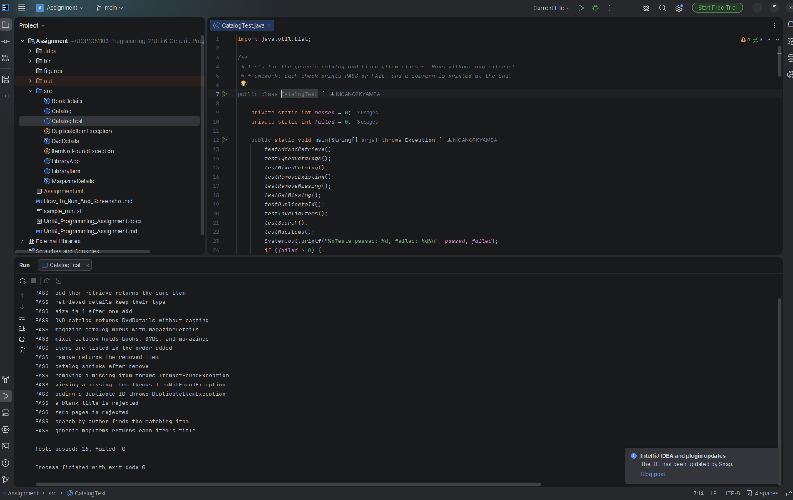
Figure 2
Adding an Item, and the Duplicate-ID and Invalid-Input Errors
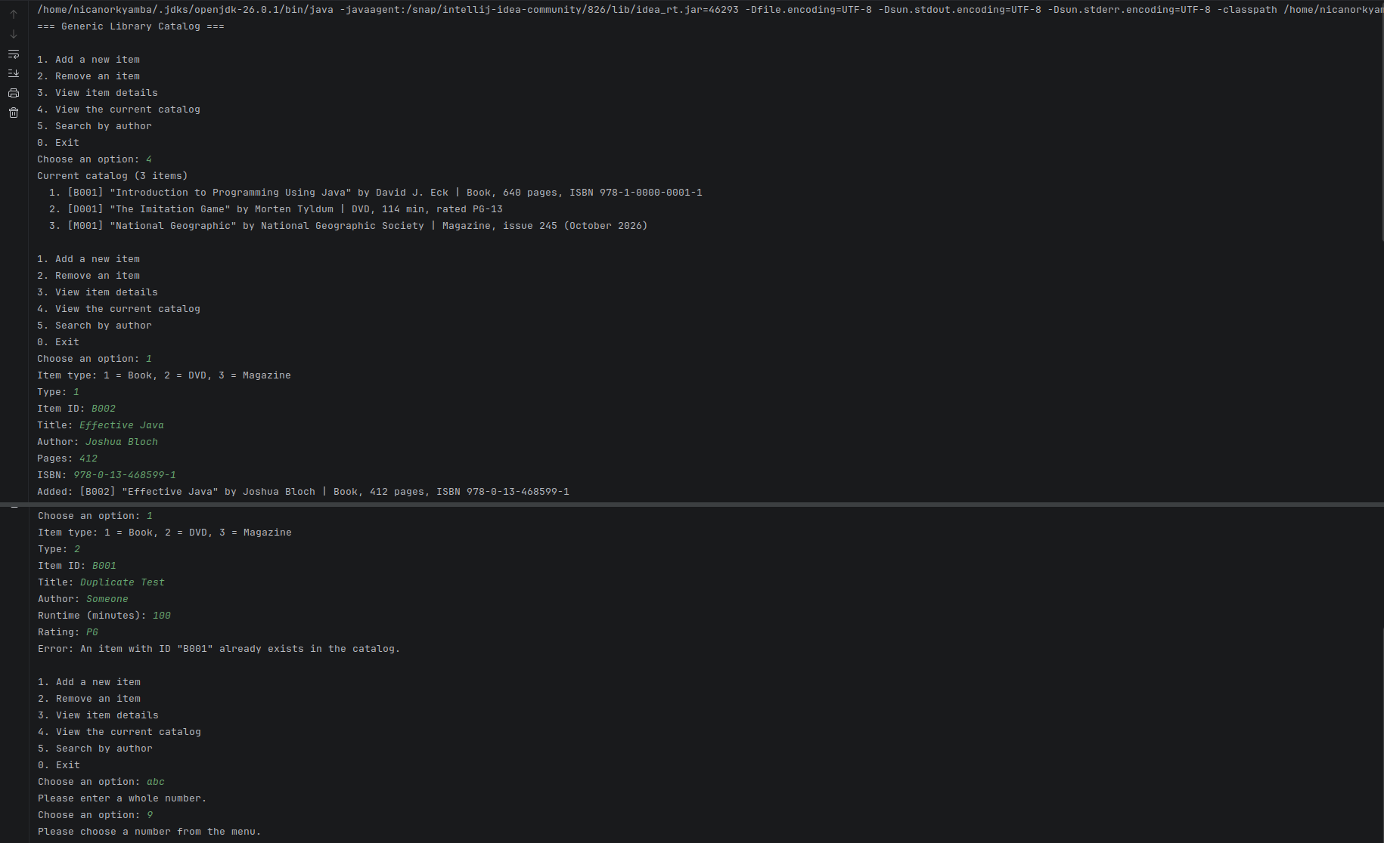
Figure 3
Viewing Details, Removing a Missing and an Existing Item, Searching, and the Final Catalog
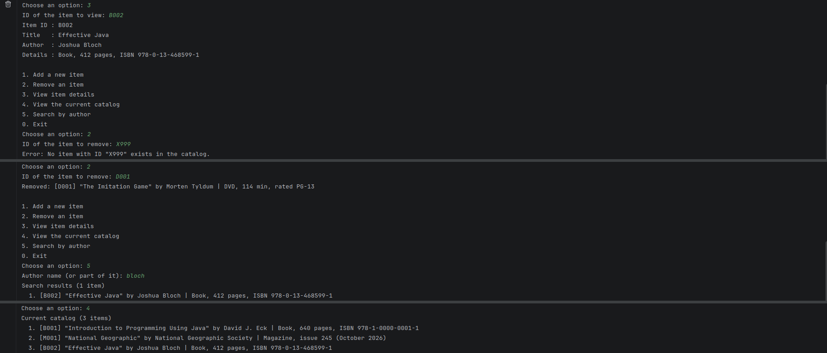

Source Code
LibraryItem.java
import java.util.Objects;

/**
* A single item in the library, such as a book, DVD, or magazine.
*
* <p>The class is generic in {@code T}, the type of the item's type-specific details.
* A book can carry {@link BookDetails}, a DVD {@link DvdDetails}, and a magazine
* {@link MagazineDetails}, while every item shares the same title, author, and itemID.
*
* @param <T> the type of the extra details stored for this kind of item
*/
public class LibraryItem<T> {

private final String itemID;
private final String title;
private final String author;
private final T details;

/**
* Creates a library item.
*
* @param itemID unique identifier, for example "B001"
* @param title title of the item
* @param author author, director, or publisher
* @param details type-specific details (may not be null)
* @throws IllegalArgumentException if any text field is blank or details is null
*/
public LibraryItem(String itemID, String title, String author, T details) {
this.itemID = requireText(itemID, "Item ID");
this.title = requireText(title, "Title");
this.author = requireText(author, "Author");
if (details == null) {
throw new IllegalArgumentException("Details cannot be null.");
}
this.details = details;
}

private static String requireText(String value, String fieldName) {
if (value == null || value.isBlank()) {
throw new IllegalArgumentException(fieldName + " cannot be empty.");
}
return value.trim();
}

public String getItemID() {
return itemID;
}

public String getTitle() {
return title;
}

public String getAuthor() {
return author;
}

public T getDetails() {
return details;
}

/** Two items are equal when they have the same item ID. */
@Override
public boolean equals(Object other) {
if (this == other) {
return true;
}
if (!(other instanceof LibraryItem<?> item)) {
return false;
}
return itemID.equalsIgnoreCase(item.itemID);
}

@Override
public int hashCode() {
return Objects.hash(itemID.toUpperCase());
}

@Override
public String toString() {
return String.format("[%s] \"%s\" by %s | %s", itemID, title, author, details);
}
}

BookDetails.java
/** Extra details stored for a book. */
public record BookDetails(int pages, String isbn) {

public BookDetails {
if (pages <= 0) {
throw new IllegalArgumentException("Pages must be greater than zero.");
}
}

@Override
public String toString() {
return "Book, " + pages + " pages, ISBN " + isbn;
}
}

DvdDetails.java
/** Extra details stored for a DVD. */
public record DvdDetails(int runtimeMinutes, String rating) {

public DvdDetails {
if (runtimeMinutes <= 0) {
throw new IllegalArgumentException("Runtime must be greater than zero.");
}
}

@Override
public String toString() {
return "DVD, " + runtimeMinutes + " min, rated " + rating;
}
}

MagazineDetails.java
/** Extra details stored for a magazine. */
public record MagazineDetails(int issueNumber, String month) {

public MagazineDetails {
if (issueNumber <= 0) {
throw new IllegalArgumentException("Issue number must be greater than zero.");
}
}

@Override
public String toString() {
return "Magazine, issue " + issueNumber + " (" + month + ")";
}
}

ItemNotFoundException.java
/** Thrown when an operation refers to an item ID that is not in the catalog. */
public class ItemNotFoundException extends Exception {

private static final long serialVersionUID = 1L;

public ItemNotFoundException(String itemID) {
super("No item with ID \"" + itemID + "\" exists in the catalog.");
}
}

DuplicateItemException.java
/** Thrown when adding an item whose ID is already used in the catalog. */
public class DuplicateItemException extends Exception {

private static final long serialVersionUID = 1L;

public DuplicateItemException(String itemID) {
super("An item with ID \"" + itemID + "\" already exists in the catalog.");
}
}

Catalog.java
import java.util.ArrayList;
import java.util.Collections;
import java.util.LinkedHashMap;
import java.util.List;
import java.util.Map;
import java.util.function.Function;
import java.util.function.Predicate;

/**
* A generic catalog that stores and manages library items.
*
* <p>The bounded type parameter {@code T extends LibraryItem<?>} means the catalog accepts
* any kind of library item, whatever its details type, while still giving compile-time type
* safety. A {@code Catalog<LibraryItem<BookDetails>>} accepts only books, and a
* {@code Catalog<LibraryItem<?>>} accepts a mix of books, DVDs, and magazines.
*
* @param <T> the type of library item stored in this catalog
*/
public class Catalog<T extends LibraryItem<?>> {

/** Items keyed by upper-case ID; LinkedHashMap keeps the order items were added. */
private final Map<String, T> items = new LinkedHashMap<>();

/**
* Adds a new item to the catalog.
*
* @param item the item to add
* @throws DuplicateItemException if an item with the same ID is already stored
* @throws IllegalArgumentException if item is null
*/
public void addItem(T item) throws DuplicateItemException {
if (item == null) {
throw new IllegalArgumentException("Cannot add a null item.");
}
String key = keyFor(item.getItemID());
if (items.containsKey(key)) {
throw new DuplicateItemException(item.getItemID());
}
items.put(key, item);
}

/**
* Removes an item from the catalog.
*
* @param itemID the ID of the item to remove
* @return the item that was removed
* @throws ItemNotFoundException if no item has this ID
*/
public T removeItem(String itemID) throws ItemNotFoundException {
T removed = items.remove(keyFor(itemID));
if (removed == null) {
throw new ItemNotFoundException(itemID);
}
return removed;
}

/**
* Retrieves the details of one item.
*
* @param itemID the ID of the item
* @return the matching item
* @throws ItemNotFoundException if no item has this ID
*/
public T getItem(String itemID) throws ItemNotFoundException {
T item = items.get(keyFor(itemID));
if (item == null) {
throw new ItemNotFoundException(itemID);
}
return item;
}

/** Returns every item, in the order added, as a read-only list. */
public List<T> getAllItems() {
return Collections.unmodifiableList(new ArrayList<>(items.values()));
}

/**
* Returns the items that match a condition. The wildcard {@code ? super T} lets a
* condition written for a more general type, such as {@code LibraryItem<?>}, be reused.
*
* @param condition the test each returned item must pass
* @return matching items, in the order added
*/
public List<T> findItems(Predicate<? super T> condition) {
List<T> matches = new ArrayList<>();
for (T item : items.values()) {
if (condition.test(item)) {
matches.add(item);
}
}
return matches;
}

/**
* Generic method that converts every item into a value of another type, for example
* each item's title (a String) or its ID. The method's own type parameter {@code R}
* is chosen by the caller, so one method serves many purposes.
*
* @param <R> the type of value produced for each item
* @param mapper the conversion applied to each item
* @return the converted values, in the order the items were added
*/
public <R> List<R> mapItems(Function<? super T, ? extends R> mapper) {
List<R> results = new ArrayList<>();
for (T item : items.values()) {
results.add(mapper.apply(item));
}
return results;
}

/** Returns the number of items in the catalog. */
public int size() {
return items.size();
}

/** Returns true when the catalog holds no items. */
public boolean isEmpty() {
return items.isEmpty();
}

/**
* Generic static helper that prints any list of library items as a numbered list.
*
* @param <E> the item type
* @param label heading to print
* @param list the items to print
*/
public static <E extends LibraryItem<?>> void printItems(String label, List<E> list) {
System.out.println(label + " (" + list.size() + " item" + (list.size() == 1 ? "" : "s") + ")");
if (list.isEmpty()) {
System.out.println(" (none)");
}
for (int i = 0; i < list.size(); i++) {
System.out.println(" " + (i + 1) + ". " + list.get(i));
}
}

private static String keyFor(String itemID) {
if (itemID == null || itemID.isBlank()) {
throw new IllegalArgumentException("Item ID cannot be empty.");
}
return itemID.trim().toUpperCase();
}
}

LibraryApp.java
import java.util.List;
import java.util.Scanner;

/**
* Command-line interface for the generic library catalog.
*
* <p>Users can add books, DVDs, and magazines, remove an item, view one item's details,
* view the whole catalog, and search by author. Every error is caught and shown as a clear
* message, so the program never crashes on bad input.
*/
public class LibraryApp {

private final Catalog<LibraryItem<?>> catalog = new Catalog<>();
private final Scanner input;

public LibraryApp(Scanner input) {
this.input = input;
}

public static void main(String[] args) {
LibraryApp app = new LibraryApp(new Scanner(System.in));
app.loadSampleItems();
app.run();
}

/** Adds a few starting items so the catalog is not empty on launch. */
private void loadSampleItems() {
try {
catalog.addItem(new LibraryItem<>("B001", "Introduction to Programming Using Java",
"David J. Eck", new BookDetails(640, "978-1-0000-0001-1")));
catalog.addItem(new LibraryItem<>("D001", "The Imitation Game",
"Morten Tyldum", new DvdDetails(114, "PG-13")));
catalog.addItem(new LibraryItem<>("M001", "National Geographic",
"National Geographic Society", new MagazineDetails(245, "October 2026")));
} catch (DuplicateItemException e) {
System.out.println("Could not load sample items: " + e.getMessage());
}
}

/** Shows the menu until the user chooses to exit. */
public void run() {
System.out.println("=== Generic Library Catalog ===");
boolean running = true;
while (running) {
printMenu();
int choice = readInt("Choose an option: ");
switch (choice) {
case 1 -> addItem();
case 2 -> removeItem();
case 3 -> viewItem();
case 4 -> Catalog.printItems("Current catalog", catalog.getAllItems());
case 5 -> searchByAuthor();
case 0 -> running = false;
default -> System.out.println("Please choose a number from the menu.");
}
}
System.out.println("Goodbye!");
}

private void printMenu() {
System.out.println();
System.out.println("1. Add a new item");
System.out.println("2. Remove an item");
System.out.println("3. View item details");
System.out.println("4. View the current catalog");
System.out.println("5. Search by author");
System.out.println("0. Exit");
}

private void addItem() {
System.out.println("Item type: 1 = Book, 2 = DVD, 3 = Magazine");
int type = readInt("Type: ");
if (type < 1 || type > 3) {
System.out.println("Unknown item type, nothing was added.");
return;
}
String id = readLine("Item ID: ");
String title = readLine("Title: ");
String author = readLine("Author: ");
try {
LibraryItem<?> item = switch (type) {
case 1 -> new LibraryItem<>(id, title, author,
new BookDetails(readInt("Pages: "), readLine("ISBN: ")));
case 2 -> new LibraryItem<>(id, title, author,
new DvdDetails(readInt("Runtime (minutes): "), readLine("Rating: ")));
default -> new LibraryItem<>(id, title, author,
new MagazineDetails(readInt("Issue number: "), readLine("Month: ")));
};
catalog.addItem(item);
System.out.println("Added: " + item);
} catch (DuplicateItemException | IllegalArgumentException e) {
System.out.println("Error: " + e.getMessage());
}
}

private void removeItem() {
String id = readLine("ID of the item to remove: ");
try {
LibraryItem<?> removed = catalog.removeItem(id);
System.out.println("Removed: " + removed);
} catch (ItemNotFoundException | IllegalArgumentException e) {
System.out.println("Error: " + e.getMessage());
}
}

private void viewItem() {
String id = readLine("ID of the item to view: ");
try {
LibraryItem<?> item = catalog.getItem(id);
System.out.println("Item ID : " + item.getItemID());
System.out.println("Title : " + item.getTitle());
System.out.println("Author : " + item.getAuthor());
System.out.println("Details : " + item.getDetails());
} catch (ItemNotFoundException | IllegalArgumentException e) {
System.out.println("Error: " + e.getMessage());
}
}

private void searchByAuthor() {
String author = readLine("Author name (or part of it): ").toLowerCase();
List<LibraryItem<?>> found =
catalog.findItems(item -> item.getAuthor().toLowerCase().contains(author));
Catalog.printItems("Search results", found);
}

/** Reads a whole number, asking again until the user enters one. */
private int readInt(String prompt) {
while (true) {
System.out.print(prompt);
if (!input.hasNextLine()) {
return 0; // end of input: treat as Exit
}
String line = input.nextLine().trim();
try {
return Integer.parseInt(line);
} catch (NumberFormatException e) {
System.out.println("Please enter a whole number.");
}
}
}

private String readLine(String prompt) {
System.out.print(prompt);
return input.hasNextLine() ? input.nextLine().trim() : "";
}
}

CatalogTest.java
import java.util.List;

/**
* Tests for the generic catalog and LibraryItem classes. Runs without any external
* framework: each check prints PASS or FAIL, and a summary is printed at the end.
*/
public class CatalogTest {

private static int passed = 0;
private static int failed = 0;

public static void main(String[] args) throws Exception {
testAddAndRetrieve();
testTypedCatalogs();
testMixedCatalog();
testRemoveExisting();
testRemoveMissing();
testGetMissing();
testDuplicateId();
testInvalidItems();
testSearch();
testMapItems();
System.out.printf("%nTests passed: %d, failed: %d%n", passed, failed);
if (failed > 0) {
System.exit(1);
}
}

private static void check(String name, boolean condition) {
if (condition) {
passed++;
System.out.println("PASS " + name);
} else {
failed++;
System.out.println("FAIL " + name);
}
}

private static LibraryItem<BookDetails> book(String id) {
return new LibraryItem<>(id, "Java Basics", "Ada Writer", new BookDetails(300, "111"));
}

private static void testAddAndRetrieve() throws Exception {
Catalog<LibraryItem<BookDetails>> books = new Catalog<>();
books.addItem(book("B1"));
LibraryItem<BookDetails> found = books.getItem("b1"); // IDs are case-insensitive
check("add then retrieve returns the same item", found.getTitle().equals("Java Basics"));
check("retrieved details keep their type", found.getDetails().pages() == 300);
check("size is 1 after one add", books.size() == 1);
}

private static void testTypedCatalogs() throws Exception {
Catalog<LibraryItem<DvdDetails>> dvds = new Catalog<>();
dvds.addItem(new LibraryItem<>("D1", "Inception", "Christopher Nolan", new DvdDetails(148, "PG-13")));
int minutes = dvds.getItem("D1").getDetails().runtimeMinutes(); // no cast needed
check("DVD catalog returns DvdDetails without casting", minutes == 148);

Catalog<LibraryItem<MagazineDetails>> magazines = new Catalog<>();
magazines.addItem(new LibraryItem<>("M1", "Wired", "Conde Nast", new MagazineDetails(10, "May")));
check("magazine catalog works with MagazineDetails", magazines.getItem("M1").getDetails().issueNumber() == 10);
}

private static void testMixedCatalog() throws Exception {
Catalog<LibraryItem<?>> mixed = new Catalog<>();
mixed.addItem(book("B1"));
mixed.addItem(new LibraryItem<>("D1", "Up", "Pete Docter", new DvdDetails(96, "PG")));
mixed.addItem(new LibraryItem<>("M1", "Time", "Time USA", new MagazineDetails(3, "June")));
check("mixed catalog holds books, DVDs, and magazines", mixed.size() == 3);
check("items are listed in the order added",
mixed.getAllItems().get(2).getItemID().equals("M1"));
}

private static void testRemoveExisting() throws Exception {
Catalog<LibraryItem<BookDetails>> books = new Catalog<>();
books.addItem(book("B1"));
books.addItem(book("B2"));
LibraryItem<BookDetails> removed = books.removeItem("B1");
check("remove returns the removed item", removed.getItemID().equals("B1"));
check("catalog shrinks after remove", books.size() == 1);
}

private static void testRemoveMissing() {
Catalog<LibraryItem<BookDetails>> books = new Catalog<>();
try {
books.removeItem("X99");
check("removing a missing item throws ItemNotFoundException", false);
} catch (ItemNotFoundException e) {
check("removing a missing item throws ItemNotFoundException",
e.getMessage().contains("X99"));
}
}

private static void testGetMissing() {
Catalog<LibraryItem<?>> mixed = new Catalog<>();
try {
mixed.getItem("NOPE");
check("viewing a missing item throws ItemNotFoundException", false);
} catch (ItemNotFoundException e) {
check("viewing a missing item throws ItemNotFoundException", true);
}
}

private static void testDuplicateId() throws Exception {
Catalog<LibraryItem<BookDetails>> books = new Catalog<>();
books.addItem(book("B1"));
try {
books.addItem(book("b1"));
check("adding a duplicate ID throws DuplicateItemException", false);
} catch (DuplicateItemException e) {
check("adding a duplicate ID throws DuplicateItemException", books.size() == 1);
}
}

private static void testInvalidItems() {
boolean blankTitleRejected;
try {
new LibraryItem<>("B5", " ", "Someone", new BookDetails(10, "1"));
blankTitleRejected = false;
} catch (IllegalArgumentException e) {
blankTitleRejected = true;
}
check("a blank title is rejected", blankTitleRejected);

boolean badPagesRejected;
try {
new BookDetails(0, "1");
badPagesRejected = false;
} catch (IllegalArgumentException e) {
badPagesRejected = true;
}
check("zero pages is rejected", badPagesRejected);
}

private static void testSearch() throws Exception {
Catalog<LibraryItem<?>> mixed = new Catalog<>();
mixed.addItem(book("B1"));
mixed.addItem(new LibraryItem<>("D1", "Up", "Pete Docter", new DvdDetails(96, "PG")));
List<LibraryItem<?>> found = mixed.findItems(item -> item.getAuthor().contains("Ada"));
check("search by author finds the matching item", found.size() == 1
&& found.get(0).getItemID().equals("B1"));
}

private static void testMapItems() throws Exception {
Catalog<LibraryItem<?>> mixed = new Catalog<>();
mixed.addItem(book("B1"));
mixed.addItem(new LibraryItem<>("D1", "Up", "Pete Docter", new DvdDetails(96, "PG")));
List<String> titles = mixed.mapItems(LibraryItem::getTitle);
check("generic mapItems returns each item's title", titles.equals(List.of("Java Basics", "Up")));
}
}

References
Bro Code. (2020, July 27). Java generics [Video]. YouTube. https://www.youtube.com/watch?v=jUcAyZ5OUm0
Coding with John. (2021, December 20). Generics in Java - Full simple tutorial [Video]. YouTube. https://www.youtube.com/watch?v=K1iu1kXkVoA
Divertitto, A. (2022, August 18). Java generics: How to use angled brackets in practice. CodeGym. https://codegym.cc/groups/posts/generics-in-java
Eck, D. J. (2022). Introduction to programming using Java (Version 9, JavaFX ed.). Hobart and William Smith Colleges. https://math.hws.edu/javanotes/c10/s5.html
Kumar, A. (2023, April 18). Mastering generics in Java: A comprehensive guide for Java developers. Tech Thoughts Explorer. https://techthoughtsexplorer.hashnode.dev/mastering-generics-in-java-a-comprehensive-guide-for-java-developers

