Written Assignment Unit 4: Polynomials II - Higher-Order Polynomials and Rational Functions

Nicanor Maswili
Department of Mathematics, University of the People
MATH 1201: College Algebra
Instructor: Chibuike Agu
September 30, 2026

Written Assignment Unit 4: Polynomials II - Higher-Order Polynomials and Rational Functions
This assignment studies higher-order polynomial and rational functions through five tasks: reading a polynomial from its graph, finding the zeros of a quartic with the Rational Zero Theorem and synthetic division, finding the asymptotes and domain of a rational function, identifying a rational function from its graph, and modeling the volume of an open box. Every answer shows its steps, and the graphs were made in GeoGebra.

Task 1: Interpreting a Polynomial Graph

(i) Turning Points, Zeros, and x-Intercepts
Turning points are the points where the graph changes from rising to falling or from falling to rising. Reading the graph from left to right:
Point | Coordinates | What happens there
A | (-1.569, -3.124) | falling changes to rising (a valley)
B | (0.319, 8.643) | rising changes to falling (a peak)
C | (2, 0) | falling changes to rising (a valley that sits on the x-axis)

So the graph has three turning points: A, B and C (Mathispower4u, 2012c).
Zeros and x-intercepts. A zero is an x-value where f(x) = 0, and the matching x-intercept is the point where the graph meets the x-axis. The graph meets the x-axis at D, E and C:
• Zeros: x = -2, x = -1 and x = 2
• x-intercepts: (-2, 0), (-1, 0) and (2, 0)
The graph also crosses the y-axis at about (0, 8), which is used below to check the formula.

(ii) Multiplicity
Yes. The zero x = 2 has multiplicity 2. The graph comes down to (2, 0), touches the x-axis, and turns back up without crossing it. A zero where the graph touches and bounces off the axis must have even multiplicity, because the factor (x - 2) raised to an even power never changes sign, so f(x) has the same sign on both sides of x = 2 (Abramson, 2023, Section 5.3; Mathispower4u, 2013). The smallest even multiplicity, 2, fits the graph.
The zeros x = -2 and x = -1 each have multiplicity 1. At these points the graph passes straight through the x-axis, changing sign, which happens for odd multiplicity. The crossing is not flattened, so the multiplicity is 1 rather than 3.

(iii) Degree, Polynomial, and Where It Increases or Decreases
Degree. Adding the multiplicities gives 1 + 1 + 2 = 4. Two other features agree:
• The graph has 3 turning points, and a polynomial of degree n has at most n - 1 turning points, so the degree is at least 3 + 1 = 4 (Mathispower4u, 2012a).
• Both ends of the graph rise, which means the degree is even and the leading coefficient is positive (Mathispower4u, 2012b).
The polynomial. Each zero gives a factor, raised to its multiplicity:
f(x) = a(x + 2)(x + 1)(x - 2)²
To find a, use the y-intercept (0, 8): f(0) = a(2)(1)(-2)² = 8a = 8, so a = 1.
f(x) = (x + 2)(x + 1)(x - 2)²
= (x² + 3x + 2)(x² - 4x + 4)
= x⁴ - 4x³ + 4x² + 3x³ - 12x² + 12x + 2x² - 8x + 8
= x⁴ - x³ - 6x² + 4x + 8

Check against the labeled points. This formula reproduces the points on the graph:
• f(0.319) = (2.319)(1.319)(-1.681)² ≈ 8.643, which is point B.
• f(-1.569) = (0.431)(-0.569)(-3.569)² ≈ -3.124, which is point A.
Both match to three decimal places, so the polynomial is correct.
Increasing and decreasing. The graph changes direction only at the turning points, so:
Interval | Behavior
(-∞, -1.569) | decreasing
(-1.569, 0.319) | increasing
(0.319, 2) | decreasing
(2, ∞) | increasing

In exact form the turning points are at x = (-5 - √57)/8 ≈ -1.569, x = (-5 + √57)/8 ≈ 0.319, and x = 2.

(iv) Local Maximum and Minimum
Yes, the graph has both:
• Local maximum: f(0.319) ≈ 8.643, at point B (0.319, 8.643). It is the highest point near it, the top of the hill between x = -1.569 and x = 2.
• Local minima: f(-1.569) ≈ -3.124 at point A (-1.569, -3.124), and f(2) = 0 at point C (2, 0).
Point A is also the absolute (global) minimum, since the graph never goes lower. There is no absolute maximum, because both ends rise forever.

(v) Remainder When Divided by x - 4
By the Remainder Theorem, the remainder of f(x) ÷ (x - 4) equals f(4) (Abramson, 2023, Section 5.4):
f(4) = (4 + 2)(4 + 1)(4 - 2)² = (6)(5)(4) = 120
Checking with synthetic division, using the coefficients 1, -1, -6, 4, 8:
4 | 1 -1 -6 4 8
| 4 12 24 112
------------------------------
1 3 6 28 | 120

The remainder is 120, and the quotient is x³ + 3x² + 6x + 28 (Mathispower4u, 2011b).

Task 2: Zeros of f(x) = x⁴ - 8x³ - 8x² + 8x + 7

(i) Rational Zero Theorem and Synthetic Division
Step 1: List the possible rational zeros. By the Rational Zero Theorem, every rational zero has the form p/q, where p is a factor of the constant term and q is a factor of the leading coefficient (Abramson, 2023, Section 5.5).
• Factors of the constant term 7: p = ±1, ±7
• Factors of the leading coefficient 1: q = ±1
• Possible rational zeros: ±1, ±7
Step 2: Test the candidates. By the Remainder Theorem, f(c) is the remainder when f(x) is divided by (x - c), so c is a zero exactly when f(c) = 0.
Candidate | Calculation | f(c) | Zero?
x = 1 | 1 - 8 - 8 + 8 + 7 | 0 | Yes
x = -1 | 1 + 8 - 8 - 8 + 7 | 0 | Yes
x = 7 | 2401 - 2744 - 392 + 56 + 7 | -672 | No
x = -7 | 2401 + 2744 - 392 - 56 + 7 | 4704 | No

Step 3: Divide out x = 1 with synthetic division. The coefficients of f are 1, -8, -8, 8, 7.
1 | 1 -8 -8 8 7
| 1 -7 -15 -7
------------------------------
1 -7 -15 -7 | 0 <- remainder 0, so (x - 1) is a factor

So f(x) = (x - 1)(x³ - 7x² - 15x - 7).
Step 4: Divide the cubic by x = -1.
-1 | 1 -7 -15 -7
| -1 8 7
------------------------
1 -8 -7 | 0 <- remainder 0, so (x + 1) is a factor

So f(x) = (x - 1)(x + 1)(x² - 8x - 7) (Mathispower4u, 2011b).
Step 5: Solve the remaining quadratic. The quadratic x² - 8x - 7 has no rational zeros (its only candidates, ±1 and ±7, have already failed), so we use the quadratic formula with a = 1, b = -8, c = -7:
x = [8 ± √(64 + 28)] / 2 = [8 ± √92] / 2 = [8 ± 2√23] / 2 = 4 ± √23

Zeros of f: x = -1, x = 1, x = 4 - √23 ≈ -0.80, and x = 4 + √23 ≈ 8.80. Each has multiplicity 1, so the graph crosses the x-axis at all four points. Fully factored:
f(x) = (x - 1)(x + 1)(x - (4 - √23))(x - (4 + √23))

(ii) Graph in GeoGebra
Figure 1
Graph of f(x) = x⁴ - 8x³ - 8x² + 8x + 7 in GeoGebra
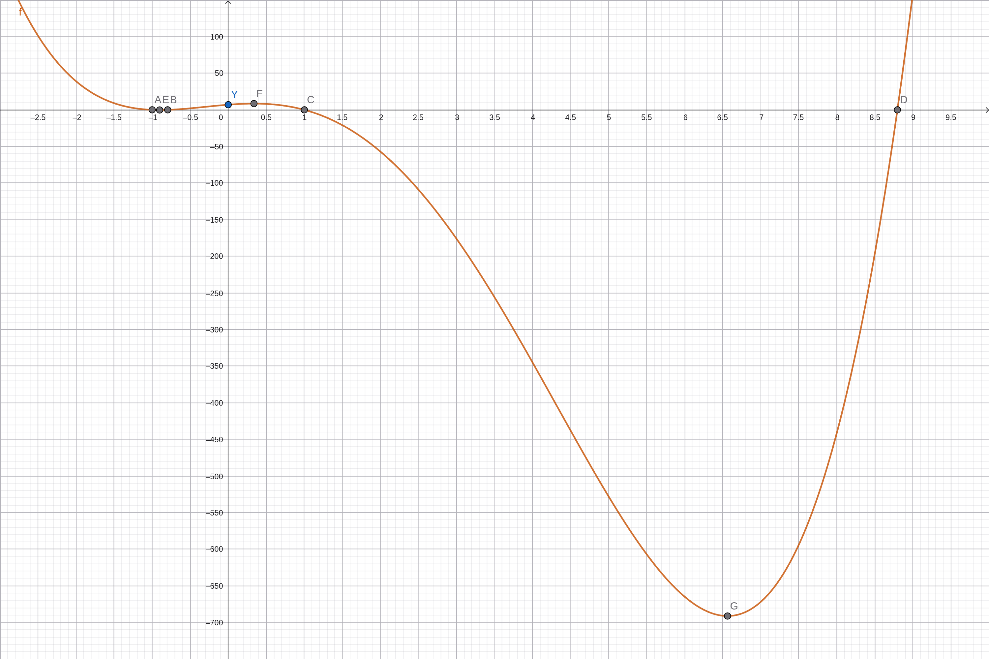
In Figure 1, points A, B, C and D are the zeros, Y is the y-intercept, and E, F and G are the turning points found with GeoGebra's Root and Extremum commands. The graph confirms the algebra. It crosses the x-axis at the four zeros found above, crosses the y-axis at f(0) = 7, and has three turning points: a local minimum near (-0.90, -0.19), a local maximum near (0.34, 8.49), and a deep local minimum near (6.56, -691.30). Three turning points is the most a degree 4 polynomial can have (Abramson, 2023, Section 5.3).

(iii) End Behavior
The end behavior of a polynomial is controlled by its leading term (Abramson, 2023, Section 5.2; Mathispower4u, 2012b). Here the leading term is x⁴: the degree 4 is even and the leading coefficient 1 is positive. So both ends of the graph rise:
• as x → -∞, f(x) → +∞
• as x → +∞, f(x) → +∞
This matches the graph, which climbs upward on the far left and the far right.

Task 3: Asymptotes and Domain of f(x) = (2x² - 5x + 3) / (x² + 5x)

(i) Horizontal and Vertical Asymptotes
Step 1: Factor the numerator and the denominator.
• Numerator: 2x² - 5x + 3. We need two numbers that multiply to 2 × 3 = 6 and add to -5, which are -2 and -3. So 2x² - 2x - 3x + 3 = 2x(x - 1) - 3(x - 1) = (2x - 3)(x - 1).
• Denominator: x² + 5x = x(x + 5).
f(x) = (2x - 3)(x - 1) / [x(x + 5)]
Step 2: Look for common factors. The numerator's factors (2x - 3) and (x - 1) do not match the denominator's factors x and (x + 5), so nothing cancels and the graph has no holes.
Step 3: Vertical asymptotes. Set the denominator equal to zero:
x(x + 5) = 0, so x = 0 or x = -5.
Neither value makes the numerator zero (at x = 0 the numerator is 3, at x = -5 it is 78), so both are vertical asymptotes: x = 0 and x = -5 (Abramson, 2023, Section 5.6).
The behavior near each asymptote, found by checking the sign of each factor:
Approach | Sign of numerator | Sign of denominator | f(x) goes to
x → -5⁻ | + | + | +∞
x → -5⁺ | + | - | -∞
x → 0⁻ | + | - | -∞
x → 0⁺ | + | + | +∞

Step 4: Horizontal asymptote. The numerator and the denominator both have degree 2. When the degrees are equal, the horizontal asymptote is the ratio of the leading coefficients (Abramson, 2023, Section 5.6; Mathispower4u, 2011a):
y = 2/1, so the horizontal asymptote is y = 2.
To see why, divide the top and bottom by x²: f(x) = (2 - 5/x + 3/x²) / (1 + 5/x). As x grows very large in either direction, every term with x in the denominator shrinks toward 0, so f(x) gets closer and closer to 2/1 = 2.
A detail worth noting. A graph can cross its horizontal asymptote in the middle, even though it cannot cross a vertical one. Setting f(x) = 2:
2x² - 5x + 3 = 2(x² + 5x), so 2x² - 5x + 3 = 2x² + 10x, which gives -15x = -3 and x = 1/5.
So the graph crosses y = 2 once, at (0.2, 2), and then approaches y = 2 from below as x → +∞.

(ii) Domain
A rational function is defined everywhere except where its denominator is zero, because division by zero is undefined.
1. Set the denominator equal to zero: x² + 5x = 0.
2. Factor: x(x + 5) = 0.
3. Solve: x = 0 or x = -5.
4. Remove these two values from the real numbers.
Domain: all real numbers except x = -5 and x = 0, which is
{x ∈ ℝ : x ≠ -5, x ≠ 0} = (-∞, -5) ∪ (-5, 0) ∪ (0, ∞)
The function's zeros are x = 1 and x = 3/2 (from the numerator), and it has no y-intercept, because x = 0 is not in the domain. Figure 2 shows the graph with its asymptotes.
Figure 2
GeoGebra Graph of f(x) = (2x² - 5x + 3)/(x² + 5x) With Asymptotes x = -5, x = 0 and y = 2
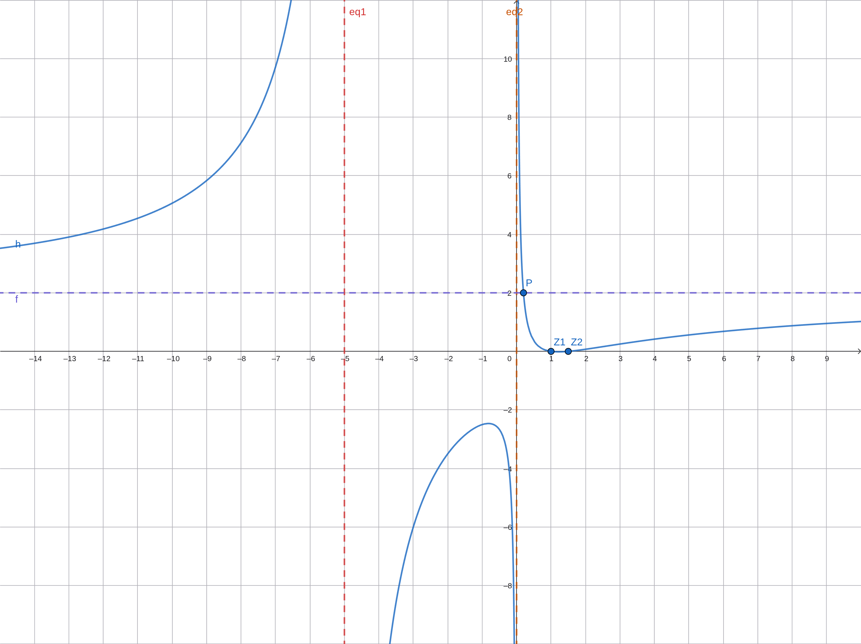

Task 4: Identifying a Rational Function From Its Graph

(i) Asymptotes, and How to Find Them in General
Reading the graph. The graph has two vertical asymptotes, x = 1 and x = 5. Near each of these lines the curve shoots toward +∞ on one side and -∞ on the other and never touches the line. There is no horizontal asymptote: on the far left and far right the curve does not level off toward a constant. Instead it follows a slanted straight line, rising to the right and falling to the left, which is a sign of an oblique (slant) asymptote. After finding the function in part (iii), this slant asymptote is shown to be y = x - 3.
How to find asymptotes of any rational function f(x) = P(x) / Q(x) mathematically (Abramson, 2023, Section 5.6; Mathispower4u, 2011a):
1. Factor the numerator and the denominator completely.
2. Cancel common factors. A factor that cancels creates a hole (a removable discontinuity), not an asymptote.
3. Vertical asymptotes: set the remaining denominator equal to zero. Each real solution x = a gives a vertical asymptote, because the function's values grow without bound as x approaches a.
4. Horizontal asymptote: compare the degree n of the numerator with the degree m of the denominator. - If n < m, the horizontal asymptote is y = 0. - If n = m, it is y = (leading coefficient of P) / (leading coefficient of Q). - If n > m, there is no horizontal asymptote. When n = m + 1, there is a slant asymptote y = mx + b, found by dividing P by Q with long division and ignoring the remainder.

(ii) Zeros
The zeros are the x-intercepts marked on the graph: x = 2, x = 3 and x = 4 (points B, C and D). At each one the graph passes straight through the x-axis, which means each zero has odd multiplicity, and the simplest choice is multiplicity 1.

(iii) The Rational Function
Step 1: Numerator from the zeros. Zeros at 2, 3 and 4 give numerator factors (x - 2), (x - 3) and (x - 4).
Step 2: Denominator from the vertical asymptotes. Asymptotes at x = 1 and x = 5 give denominator factors (x - 1) and (x - 5).
Step 3: Use the y-intercept to find the stretch factor a.
f(x) = a(x - 2)(x - 3)(x - 4) / [(x - 1)(x - 5)]
The graph passes through A = (0, -4.8), so
f(0) = a(-2)(-3)(-4) / [(-1)(-5)] = -24a / 5 = -4.8, which gives a = 1.
The rational function is
f(x) = (x - 2)(x - 3)(x - 4) / [(x - 1)(x - 5)] = (x³ - 9x² + 26x - 24) / (x² - 6x + 5)
Step 4: Check the function against the graph.
• Slant asymptote. The numerator has degree 3 and the denominator degree 2, so there is no horizontal asymptote. Long division gives
x³ - 9x² + 26x - 24 = (x² - 6x + 5)(x - 3) + (3x - 9), so the slant asymptote is y = x - 3, a line with slope 1, which matches the straight-line tails of the graph.
• Behavior at the asymptotes. As x → 1⁻, f(x) → -∞ and as x → 1⁺, f(x) → +∞. As x → 5⁻, f(x) → -∞ and as x → 5⁺, f(x) → +∞. These match the four branches in the graph.
• A point on the right branch. f(6) = (4)(3)(2) / [(5)(1)] = 24/5 = 4.8, which matches the low point of the right-hand branch near (6, 4.8).
• Domain: all real numbers except x = 1 and x = 5, written (-∞, 1) ∪ (1, 5) ∪ (5, ∞).
Figure 3
GeoGebra Check: f(x) With Its Asymptotes x = 1, x = 5 and y = x - 3
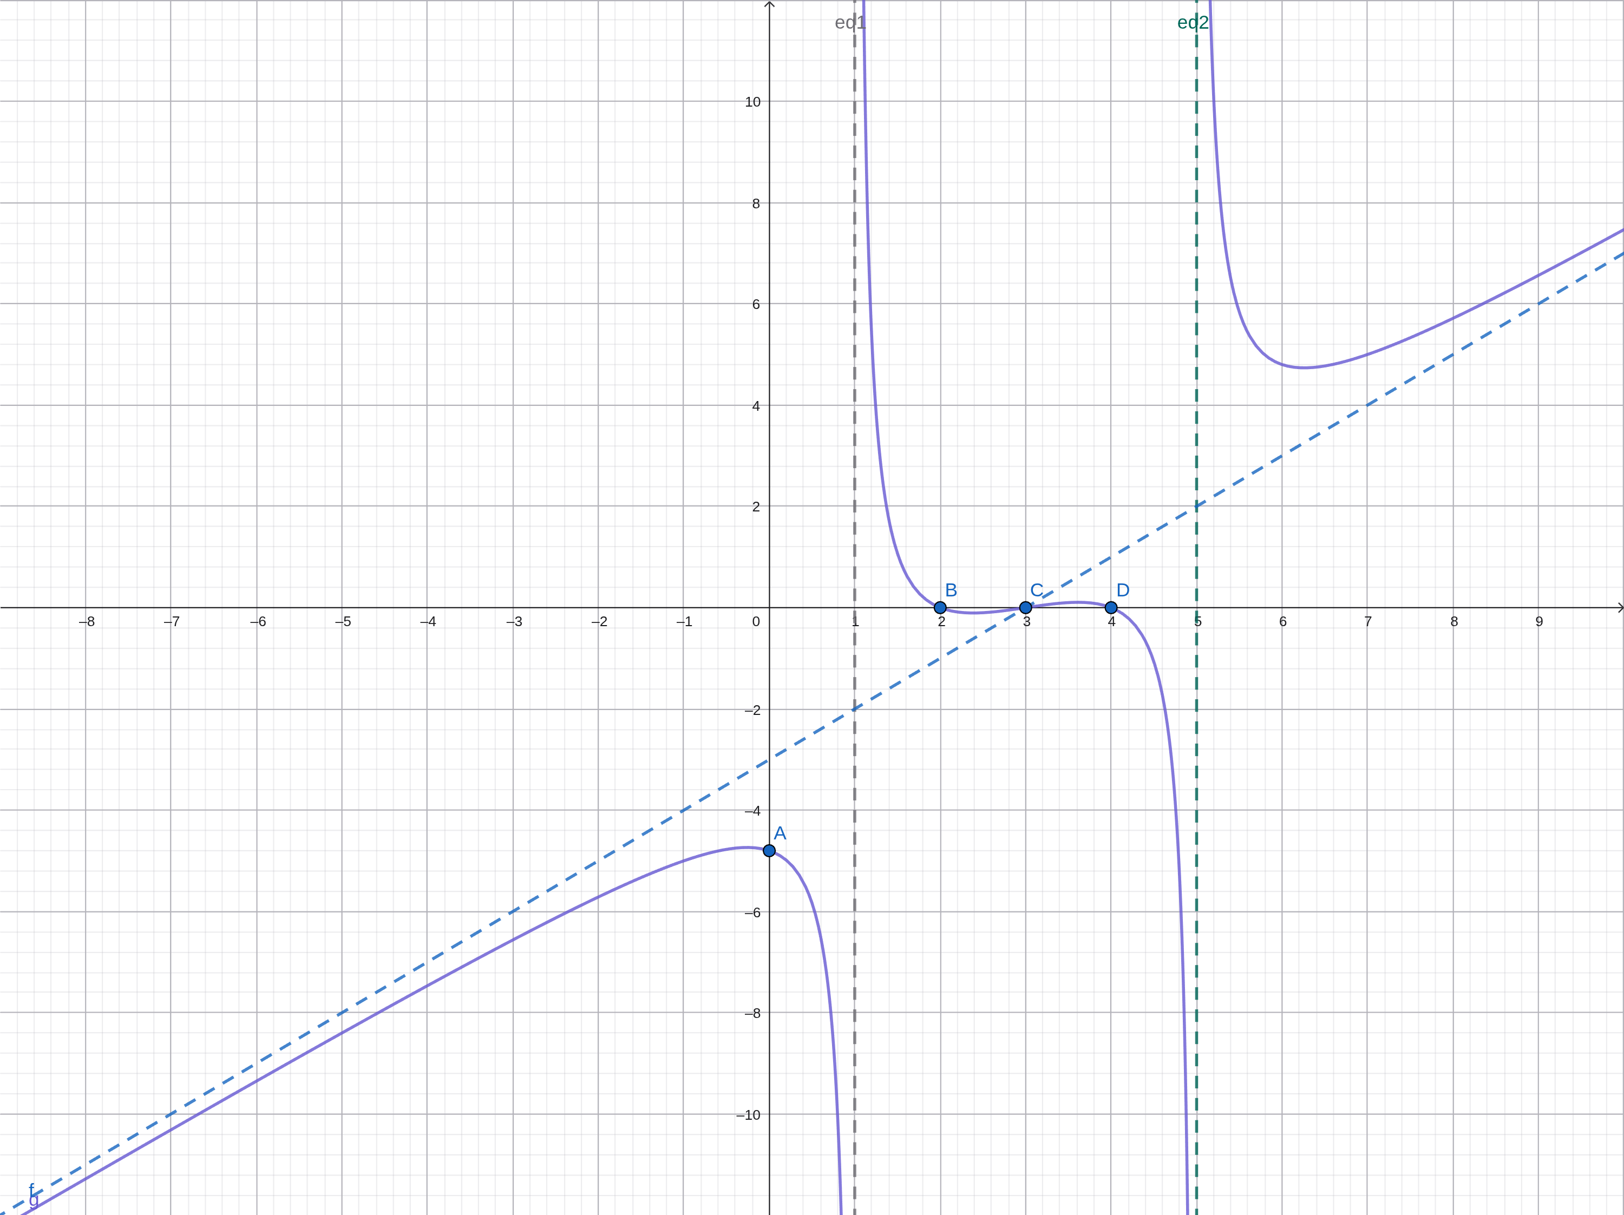

Task 5: Volume of an Open Box

(i) The Volume Function
The cardboard has width x cm and length 3x cm. A 15 cm × 15 cm square is cut from each corner and the sides are folded up. Folding removes 15 cm from each end of both dimensions, so:
• Height of the box: 15 cm (the size of the cut)
• Width of the base: x - 2(15) = x - 30 cm
• Length of the base: 3x - 2(15) = 3x - 30 cm
Volume = length × width × height, so
V(x) = 15(3x - 30)(x - 30)
= 15(3x² - 90x - 30x + 900)
= 15(3x² - 120x + 900)
= 45x² - 1800x + 13500 cubic cm

Is it a polynomial? Yes. V(x) is a sum of terms of the form a·xⁿ with whole-number powers (2, 1 and 0) and real coefficients, so it is a polynomial function. Its degree is 2, so it is a quadratic function with leading coefficient 45. It is not a rational function, because there is no variable in a denominator. This is different from Example 3.1.3 in Stitz and Zeager (2013, p. 238), where the size of the corner cut is the variable, so the height, width, and length all depend on x and the volume is a cubic. Here the cut is fixed at 15 cm, so only two dimensions depend on x, and the volume is one degree lower.

(ii) Domain of the Volume Function
Every dimension of a real box must be positive:
• Height: 15 > 0, always true.
• Width: x - 30 > 0, so x > 30.
• Length: 3x - 30 > 0, so x > 10.
Both conditions hold when x > 30. The domain of V is therefore x > 30, or (30, ∞) in interval notation. At x = 30 the width is 0 and V(30) = 0, so there is no box. The formula V(x) itself is defined for every real x, but values x ≤ 30 do not describe a real box, so they are excluded, which is the same reasoning Stitz and Zeager (2013, p. 238) use for their applied domain. In practice the size of the available cardboard sheet would also give an upper limit.

(iii) Box Dimensions for a Volume of 12,500 Cubic cm
Set the volume equal to 12,500:
45x² - 1800x + 13500 = 12500
45x² - 1800x + 1000 = 0
9x² - 360x + 200 = 0 (dividing both sides by 5)

Quadratic formula with a = 9, b = -360, c = 200:
x = [360 ± √(360² - 4(9)(200))] / (2 · 9)
= [360 ± √(129600 - 7200)] / 18
= [360 ± √122400] / 18
= [360 ± 60√34] / 18
= 20 ± (10/3)√34

This gives x ≈ 39.44 or x ≈ 0.56. The value x ≈ 0.56 is outside the domain x > 30 (it would make the width negative), so it is rejected. Therefore x = 20 + (10/3)√34 ≈ 39.44 cm.
Appropriate dimensions:
Measurement | Expression | Value
Cardboard width | x | ≈ 39.44 cm
Cardboard length | 3x | ≈ 118.31 cm
Box width | x - 30 | ≈ 9.44 cm
Box length | 3x - 30 | ≈ 88.31 cm
Box height | 15 | 15 cm

Check: 9.4365 × 88.3095 × 15 ≈ 12,500 cubic cm, as required.
So the courier should start with a sheet about 39.44 cm by 118.31 cm, which folds into an open box about 88.31 cm long, 9.44 cm wide, and 15 cm high. The box is long and narrow, which suits a flexible item that can bend or stretch to fit. Because V is increasing for every x > 30 (the parabola's vertex is at x = 20, to the left of the domain), each volume matches exactly one cardboard size, so this answer is the only one.
Figure 4
GeoGebra Graph of V(x) on x > 30 Crossing the Line V = 12,500 at x ≈ 39.44
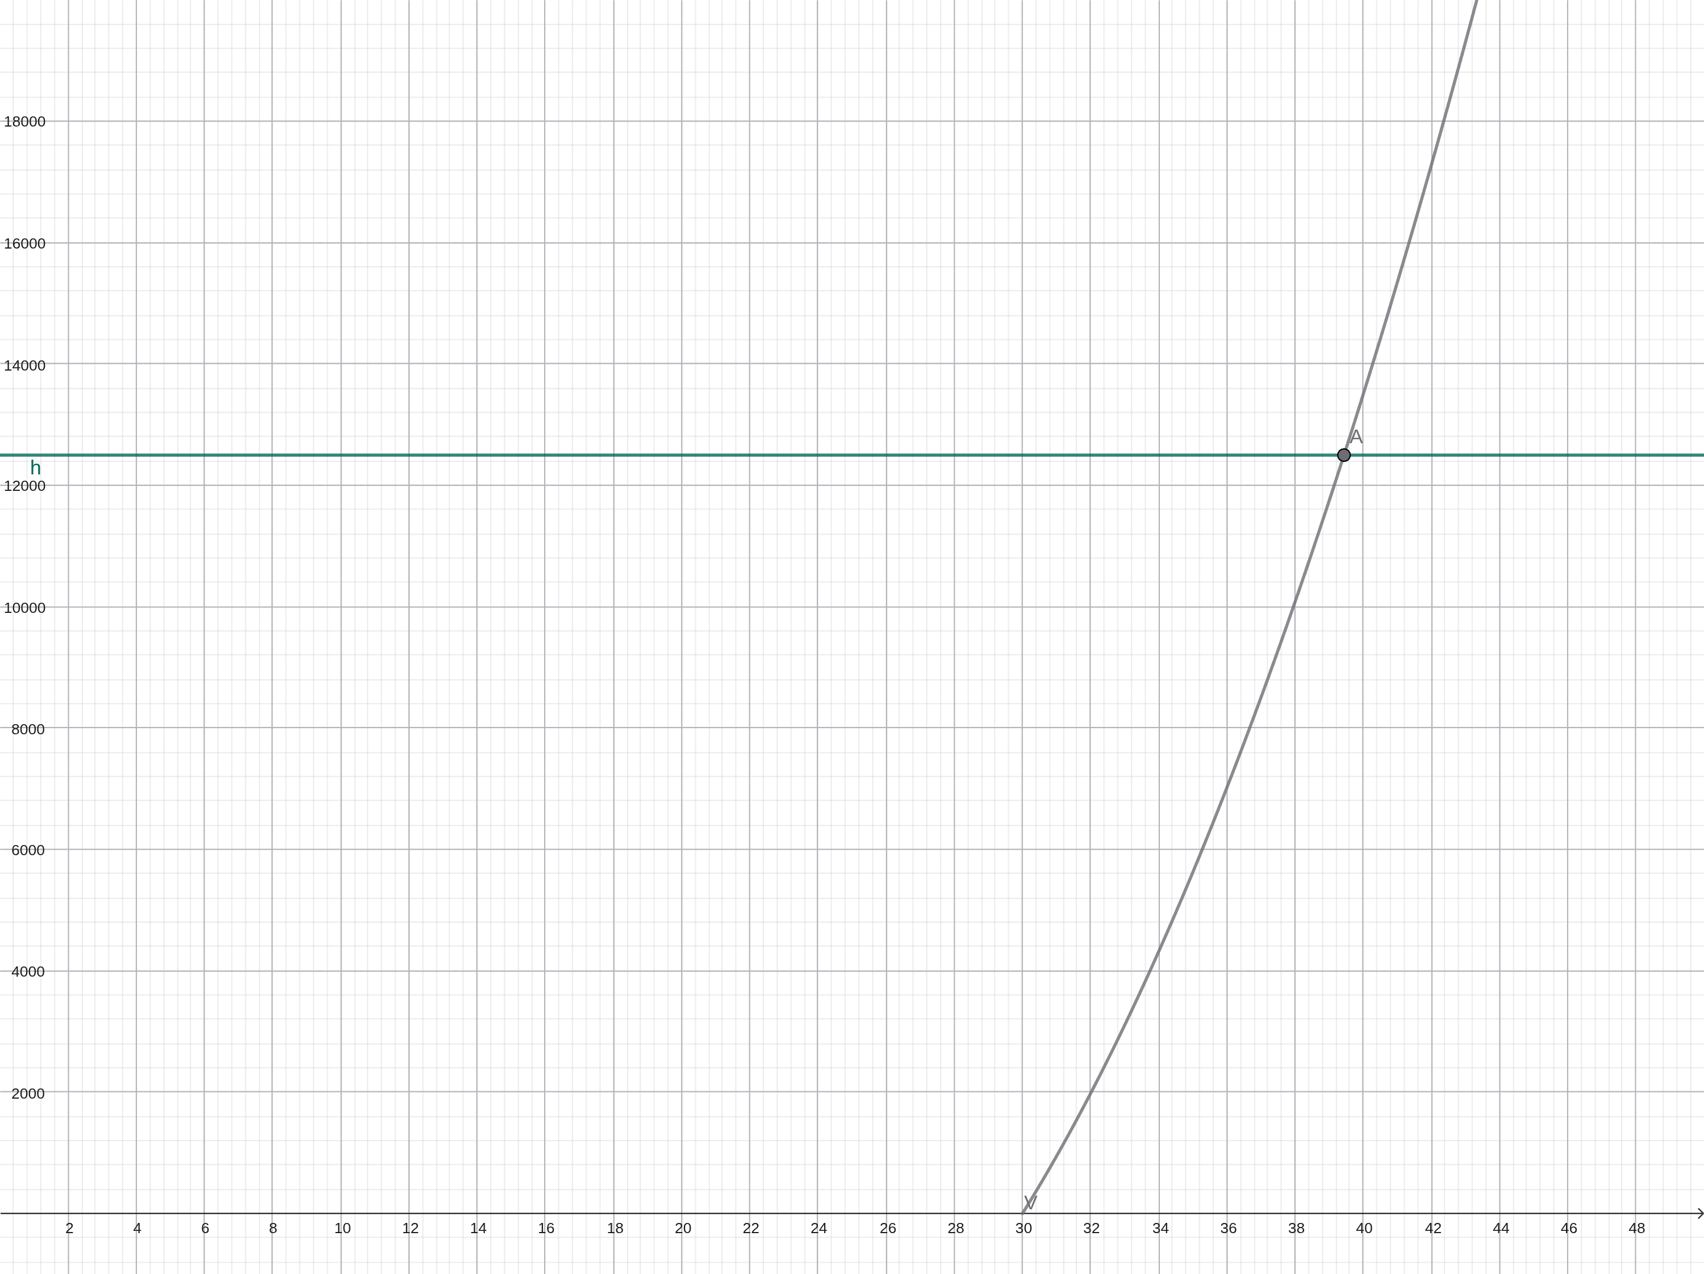

Conclusion
The five tasks show how polynomial and rational functions are read and used. The Rational Zero Theorem and synthetic division turned a quartic into linear and quadratic factors, and its leading term predicted the end behavior shown on the graph. For rational functions, the zeros of the numerator and denominator gave the x-intercepts and vertical asymptotes, and comparing degrees explained the slant asymptote. The open-box model showed how a real situation produces a polynomial and why its domain must be limited to values that make physical sense.

References
Abramson, J. (2023). Algebra and trigonometry (2nd ed.). OpenStax. https://openstax.org/details/books/algebra-and-trigonometry-2e
Mathispower4u. (2011a, March 18). Determining vertical and horizontal asymptotes of rational functions [Video]. YouTube. https://www.youtube.com/watch?v=wBZxVxiJS9I
Mathispower4u. (2011b, October 9). Ex 4: Divide a polynomial by a binomial using synthetic division [Video]. YouTube. https://www.youtube.com/watch?v=bqm4DoznJxo
Mathispower4u. (2012a, June 12). Ex: Determine the least possible degree of a polynomial from the graph [Video]. YouTube. https://www.youtube.com/watch?v=LU1nLawYyH0
Mathispower4u. (2012b, June 11). Summary of end behavior or long run behavior of polynomial functions [Video]. YouTube. https://www.youtube.com/watch?v=y78Dpr9LLN0
Mathispower4u. (2012c, June 12). Turning points and x intercepts of a polynomial function [Video]. YouTube. https://www.youtube.com/watch?v=9WW0EetLD4Q
Mathispower4u. (2013, May 20). Real zeros, factors, and graphs of polynomial functions [Video]. YouTube. https://www.youtube.com/watch?v=e_EttLeQblY
Stitz, C., & Zeager, J. (2013). College algebra. Stitz Zeager Open Source Mathematics. https://stitz-zeager.com/szca07042013.pdf

