Building a Stack in x86 Assembly to Reverse Strings and Check Balanced Brackets

Nicanor Maswili
Department of Computer Science, University of the People
CS 1105: Digital Electronics & Computer Architecture
Instructor: Muhammad Aligohar Bilal
October 21, 2026

Building a Stack in x86 Assembly to Reverse Strings and Check Balanced Brackets

Introduction
A stack is one of the simplest high-level data structures: items are added and removed only at the top, so the last item in is the first item out (LIFO). In a language like Java or Python a stack is one line of code, but the processor has no "stack object". It only has registers, memory addresses, and instructions. For this assignment I built a stack by hand in x86 assembly language and used it to solve three classic problems: reversing a string, testing whether a string is a palindrome, and checking that the brackets ( ), [ ], and { } in a line of text are balanced. The program was written for NASM, the assembler used in the asmtutor.com tutorials from this unit's readings, and runs as a 32-bit Linux program (NASM Assembly Language Tutorials, n.d.).
This paper covers the three parts of the assignment in order. The first part shows the program and the data structure. The second part explains the design and development process and what it taught me about low-level programming. The third part summarizes the benefits of assembly language for building data structures like this one, with real-world examples.

Part 1: The Stack Data Structure and the Program

What the Program Does
The program is one source file, stackapp.asm (the full listing is in the Appendix). Run with no arguments, it processes eight built-in test strings. Run with arguments, for example ./stackapp "(a[b])" "level", it processes the strings the user typed. For every string it prints the reversed string, whether the string is a palindrome, and whether its brackets are balanced. If they are not, it says exactly what went wrong and where.
Table 1
Routines in stackapp.asm
Group | Routine | Job
Stack | stack_init | Empty the stack (set stack_top to 0)
Stack | stack_push | Push the byte in AL; carry flag set on overflow
Stack | stack_pop | Pop the top byte into AL; carry flag set on underflow
Stack | stack_size | Return the number of items in EAX
Problems | reverse | Push every character, then pop them all into outbuf
Problems | is_palindrome | Compare the string with its reversed copy
Problems | check_brackets | Push opening brackets, match each closing bracket with a pop
Output | print_str, print_quoted, print_uint | Write text, a quoted character, or a number using the Linux write system call
Control | process, _start | Run the three problems on each string and print the results

How the Stack Is Stored in Memory
The stack is two variables in the .bss section, the part of memory that holds uninitialized data (Figure 1). stack_data is a block of 64 bytes that holds the items, and stack_top is a 32-bit counter. stack_top does two jobs at once: it is the number of items on the stack, and it is also the index of the next free slot. That one choice keeps every operation short. A push writes to stack_data[stack_top] and then adds 1, and a pop subtracts 1 and then reads stack_data[stack_top]. In x86 this is a single instruction with base plus index addressing: mov [stack_data + ebx], al.
Figure 1
Memory Layout of the Stack After Reading "{[("
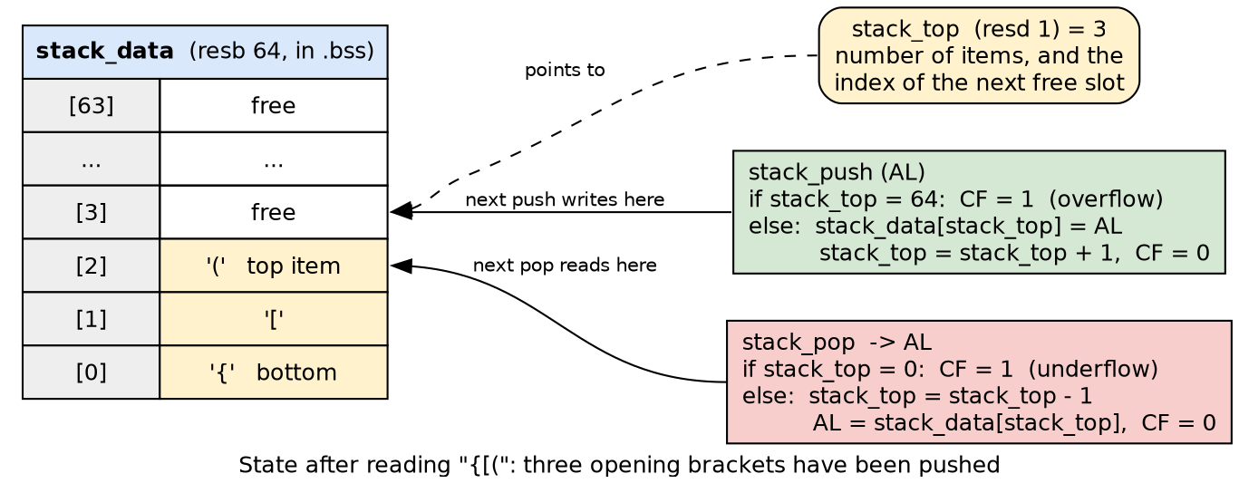

The Stack Operations
Each operation is a small subroutine called with call and left with ret. The table below gives the interface of each, because in assembly there are no parameter lists, so the "contract" has to be written down.
Table 2
Interface of the Stack Operations
Operation | Input | Output | Error handling
stack_init | none | stack_top = 0 | none needed
stack_push | AL = item | item stored, stack_top + 1 | CF = 1 if 64 items already (overflow)
stack_pop | none | AL = top item, stack_top - 1 | CF = 1 if the stack is empty (underflow)
stack_size | none | EAX = number of items | none needed

The heart of the data structure is these two routines:
stack_push:
push ebx
mov ebx, [stack_top]
cmp ebx, STACK_MAX ; is there room for one more item?
jae .full
mov [stack_data + ebx], al ; store the item in the next free slot
inc ebx
mov [stack_top], ebx
clc ; CF = 0: success
pop ebx
ret
.full:
stc ; CF = 1: overflow
pop ebx
ret

stack_pop:
push ebx
mov ebx, [stack_top]
test ebx, ebx ; empty?
jz .empty
dec ebx
mov al, [stack_data + ebx] ; read the most recent item
mov [stack_top], ebx
clc
pop ebx
ret
.empty:
stc ; CF = 1: underflow
pop ebx
ret

Both routines report success or failure in the carry flag (CF), a single bit in the processor's flags register. The caller tests it with one jump instruction (jc for "jump if carry"), so error checking costs almost nothing. Both routines also save and restore EBX, so a caller never loses a value it was keeping in a register.

How the Stack Solves the Three Problems
String reversal. reverse pushes every character of the string and then pops until the stack is empty, writing each popped character into an output buffer. Because the last character pushed is the first one popped, the characters come out in reverse order. "Assembly" becomes "ylbmessA".
Palindrome test. is_palindrome reuses the reversed copy. It compares the original string and the reversed string byte by byte. If they match all the way to the zero byte that ends both strings, the string reads the same in both directions, as "racecar" and "level" do.
Balanced brackets. This is the problem where a stack is really needed, because brackets nest and the most recently opened bracket must be the first one closed (Figure 2). check_brackets reads the string one character at a time. An opening bracket is pushed. For a closing bracket the routine puts the matching opening bracket in AH, pops the top of the stack into AL, and compares the two. Any other character is skipped. There are four ways to fail, and the routine returns a different code for each one so the program can print a precise message: a closing bracket with nothing open (code 1), a closing bracket of the wrong kind (code 2), brackets still open when the string ends (code 3), and more than 64 open brackets (code 4, overflow).
Figure 2
Flowchart of check_brackets
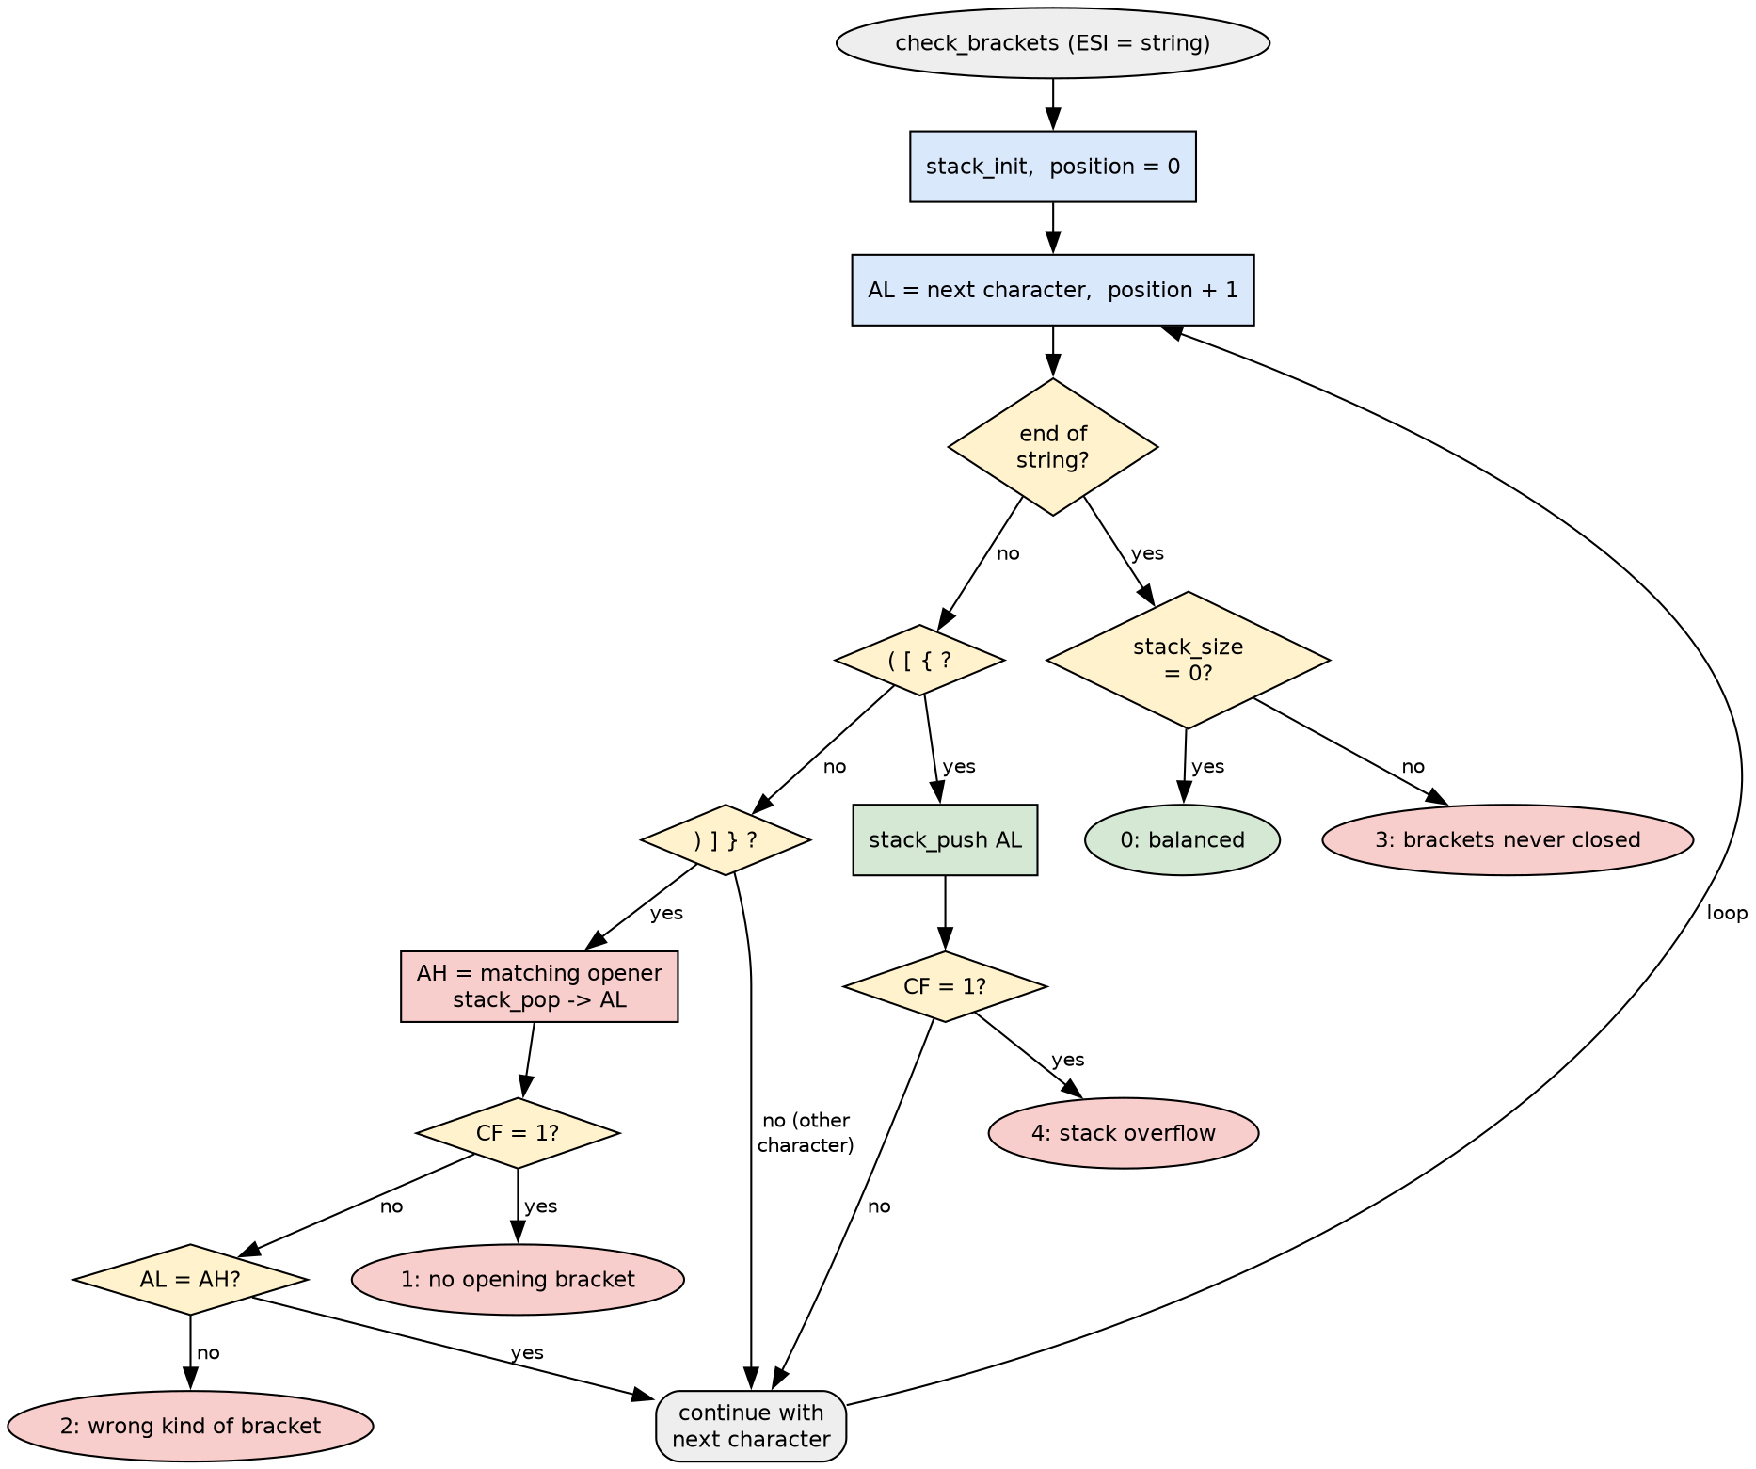
Table 3 traces the stack while checking the balanced string "{[()()]}".
Table 3
Trace of check_brackets for "{[()()]}"
Position | Character | Action | Stack (bottom to top)
1 | { | push | {
2 | [ | push | { [
3 | ( | push | { [ (
4 | ) | pop "(", it matches | { [
5 | ( | push | { [ (
6 | ) | pop "(", it matches | { [
7 | ] | pop "[", it matches | {
8 | } | pop "{", it matches | (empty)
end |  | stack_size = 0 | balanced

For "([)]" the same steps push "(" and "[", but at position 3 the ")" pops "[" instead of "(", so the program prints: NOT balanced: ')' at position 3 does not match '['.

Efficiency of the Design
• Time. Each character is read exactly once, and every push and pop takes constant time. On the success path, stack_push and stack_pop each execute exactly 10 instructions (7 when they report an error), which I confirmed by disassembling the program with objdump. All three problems therefore run in linear time, O(n), in the length of the string.
• Memory. The stack uses a fixed 68 bytes and the reversed copy a fixed 65 bytes. There is no heap allocation, and the input string is never copied.
• Small choices that add up. Loop variables stay in registers (ESI for the string pointer, ECX for the position) instead of memory. Errors are reported in the carry flag, so checking one costs a single jc instruction. The palindrome test reuses the reversed copy instead of running the stack a second time, and check_brackets stops at the first error instead of scanning the rest of the string.

Part 2: Design and Development Process

Step 1: Defining the Problem and Choosing the Structure
I started from the problem, not the code. Reversal and bracket matching both depend on "last in, first out", so a stack was the natural choice. A linked list would also work, but a stack stored in an array needs no pointers and no memory allocation, which matters in assembly, where there is no malloc or new unless you write one yourself. Mahout (2012) presents arrays and stacks as basic structures that an assembly programmer builds directly in memory, and that is the approach I took.

Step 2: Choosing the Tools
I chose NASM on 32-bit x86 Linux because it matches the asmtutor.com lessons in our reading list, which use the same build commands (nasm -f elf, then ld -m elf_i386) and the same int 80h system calls for output and exit (NASM Assembly Language Tutorials, n.d.). The assembler translates each mnemonic, such as mov or cmp, into machine code ("Assembly Language," 2021), and the linker then turns that object file into a program the operating system can run.

Step 3: Designing the Data Layout and the Interfaces
Kann (2021) explains that designing an assembly language comes down to three concerns: moving data between main memory and the registers inside the CPU, the operations the ALU can perform, and branching for program control. I designed my program around the same three concerns:
• Data. The items live in memory (stack_data), and a register (EBX) holds the index while an operation runs. The 64-byte limit is a named constant, STACK_MAX, so it can be changed in one place.
• Operations. Each stack operation is a handful of moves, compares, and increments.
• Control. Every decision is a compare followed by a conditional jump, such as jae for "stack full" or jc for "an error was reported".
Before writing any code I wrote down the interface of every routine (Table 2): which register carries the input, which carries the output, and how errors are reported. I picked the carry flag for errors because one flag is cheaper than a return code and is easy to test.

Step 4: Building and Testing the Stack First
I wrote stack_init, stack_push, and stack_pop before anything else and tested them on their own. Only when push and pop behaved correctly, including on a full and an empty stack, did I build reverse, is_palindrome, and check_brackets on top of them. Building in layers meant that when something went wrong later, I knew the bug was in the new layer and not in the stack.

Step 5: Handling Errors
In assembly nothing stops the program from writing past the end of an array. A push onto a full stack would silently overwrite stack_top, the variable stored right after stack_data in memory, and the stack would lose track of its own size. So stack_push checks the capacity before every write, stack_pop checks for an empty stack before every read, and every caller tests the carry flag. The last built-in test string has 70 "(" characters to prove that both overflow cases are caught and reported instead of corrupting memory.

Step 6: Debugging
Two problems taught me the most. The first was a risk I had to plan around: register clobbering. The output routines call the Linux write system call, which uses EAX, EBX, ECX, and EDX. Without care, printing a message would destroy the position and bracket values that check_brackets had just returned. I avoided this by making every helper save all registers with pushad and restore them with popad. I also learned that popad does not change the flags, so a routine can restore its registers and still return a result in the carry flag. The second was a visible bug in my first full run: when a string was too long, the output read Reversed : "error: ... with a stray quote mark. The label printed an opening quote before I knew whether reversal would succeed. I moved the quote so it is printed only when there is a reversed string to show.

Step 7: Testing
I tested the program in three ways:
1. The built-in tests (Figure 3) cover a normal word, a palindrome, two balanced expressions, and every error: a wrong bracket, an unclosed bracket, a bracket with no opener, and overflow.
2. My own strings on the command line (Figure 4), including a line of C code.
3. An automated check. I wrote a short Python script, verify_stackapp.py, that assembles the program, runs it on 5,014 strings (random strings plus edge cases at exactly 64 and 65 characters), and compares every printed line with a Python version of the same algorithms. All 5,014 matched. To make sure the checker could actually catch mistakes, I planted a bug on purpose in a copy of the program (I skipped the bracket-kind comparison), and the checker flagged 26 failing batches. With the bug removed, it reports no failures.
Table 4
Selected Test Cases and Results
Input | Reversed | Palindrome | Brackets
Assembly | ylbmessA | no | balanced
racecar | racecar | yes | balanced
{[()()]} | }])()([{ | no | balanced
([)] | ])[( | no | ')' at position 3 does not match '['
((x) | )x(( | no | 1 bracket(s) never closed
x)( | ()x | no | ')' at position 2 has no opening bracket
70 "(" characters | overflow error | skipped | overflow error
{(}) | )}({ | no | '}' at position 3 does not match '('

Compile and Run
nasm -f elf stackapp.asm
ld -m elf_i386 stackapp.o -o stackapp
./stackapp (built-in tests)
./stackapp "text" "(a[b]{c})" (your own strings)

The program assembles with no warnings. Its machine code is 748 bytes, and the stack itself uses 68 bytes of memory (64 for the items and 4 for stack_top).
Figure 3
Building the Program and Running the Built-in Tests
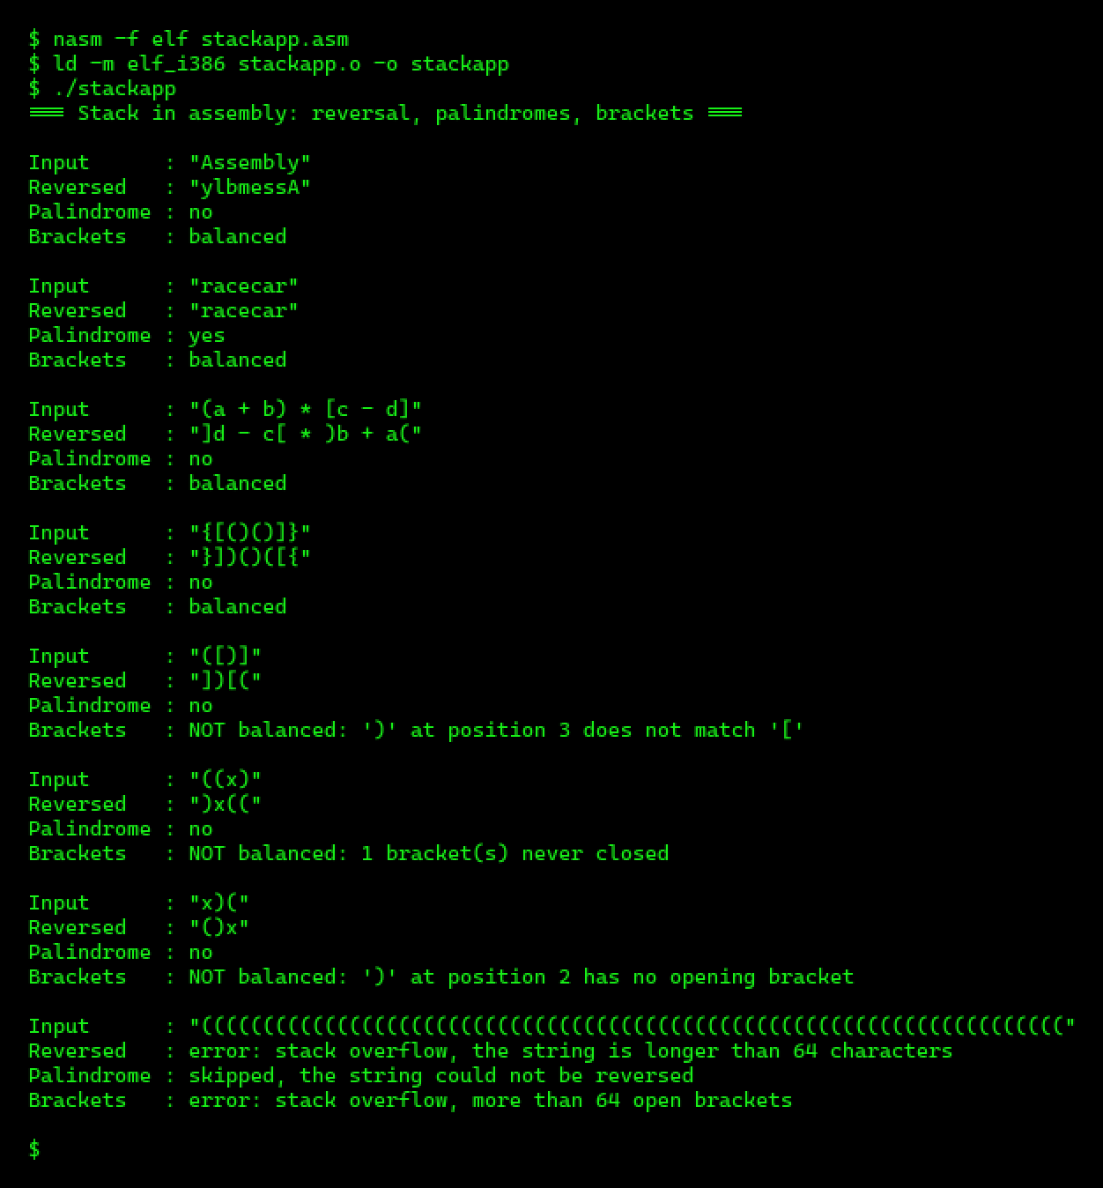
Figure 4
Running the Program on Strings Typed on the Command Line
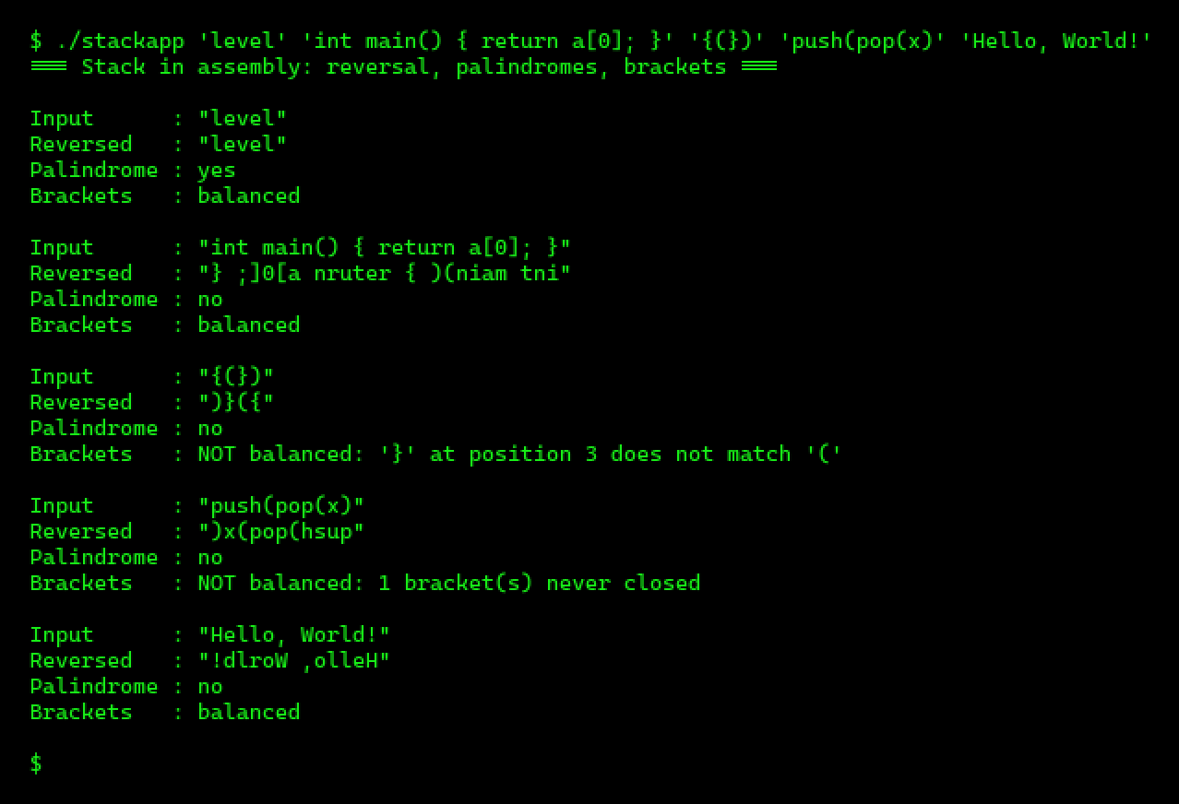

How This Project Deepened My Understanding of Low-Level Programming
• A data structure is just memory plus rules. The "stack" is 64 bytes and a counter. What makes it a stack is the discipline that every access goes through push and pop. High-level languages hide this, but it is exactly what a Stack class does inside.
• Addressing modes do real work. Base plus index addressing, [stack_data + ebx], is what an array access like data[top] becomes in machine code.
• Flags are a communication channel. Returning errors in the carry flag showed me how compare and jump instructions drive every decision a program makes.
• There are two stacks. My data stack is separate from the CPU's own call stack (ESP), which call, ret, push, and pop use behind the scenes to store return addresses and saved registers. Writing both side by side made the hardware stack easy to understand, because it works by the same LIFO rule as mine.
• Programs talk to the operating system through system calls. Printing one line means loading a system call number into EAX, the arguments into EBX, ECX, and EDX, and executing int 80h (NASM Assembly Language Tutorials, n.d.).
• Program translation became concrete. I wrote the same push operation in C and asked GCC to translate it with optimization turned on (gcc -m32 -O2 -S). The compiler produced almost the same compare, store, and increment. This matches the code generation phase, where a compiler maps its optimized intermediate code to the target machine's instructions (Bhumika, 2022). The main differences were that GCC passed the item on the memory stack and returned the status in EAX, because it must follow the standard calling convention, while my version uses a register and the carry flag.

Part 3: Benefits of Assembly Language for High-Level Data Structures
1. Complete control over memory. In assembly I decide exactly where every byte lives and how big the structure is: 64 bytes of items and a 4-byte counter, with no object headers and no hidden allocation. This matters most on small embedded devices. Mahout (2012) teaches these structures on the ARM Cortex-M3, a processor core built for microcontrollers, where memory is small and has to be planned byte by byte.
2. Speed and predictable timing. A push in my program is about ten instructions with no function-call overhead beyond call and ret, and its running time is the same every time. Assembly is still used where timing is critical, such as device drivers, interrupt handlers, and real-time systems, where an interrupt may fire thousands of times per second and must finish in as few cycles as possible ("Assembly Language," 2021). Thakkar (2022) also points out that a few programmers still pick assembly for short programs where every bit of execution speed counts.
3. Smaller code. My hand-written stack_push is 31 bytes of machine code. The same logic written in C and compiled by GCC with -O2 came to 40 bytes, mostly because the compiler has to pass the argument through memory to follow the calling convention. The gap is small, which shows how good modern compilers are, but in boot code or firmware stored in a small ROM those bytes add up. Assembly is still typically used for boot code that runs before the operating system starts ("Assembly Language," 2021).
4. Access to processor features that high-level languages hide. I used the carry flag as a cheap error signal, which C or Java cannot do directly. Real systems use this kind of access too. The Linux kernel's memcpy, the routine that copies blocks of memory for the whole operating system, is written in x86 assembly so it can use the rep movsb string instruction directly (Linux kernel developers, n.d.). Encryption code is another example, because it relies on bit rotation instructions that many compilers do not expose ("Assembly Language," 2021).
5. Understanding what high-level code really does. Even if I never write production code in assembly, I now know what a Stack class, a function call, and an array index cost on real hardware. That helps with debugging, with reading compiler output, and with security work, where attacks such as buffer overflows only make sense at this level.
These benefits come with real costs. My program runs only on x86 processors, because each processor family has its own assembly language (Thakkar, 2022). It took far more lines than the same program in Python, and I had to handle every overflow check and saved register myself. Thakkar (2022) notes that most developers rarely write assembly today for these reasons. In practice, the best use of assembly is for the small, critical parts of a system, such as the core data structure operations, the interrupt handler, or the memory copy routine, while the rest is written in a high-level language.

Conclusion
The project turned a familiar idea, the stack, into something I could see at the level of bytes, registers, and flags. Building it in layers, defining clear register interfaces, checking for overflow and underflow on every operation, and testing against a reference version on more than 5,000 strings gave me a program that is small (748 bytes of code), fast, and correct. It also showed me why assembly is still worth knowing: it gives full control over memory, timing, and processor features, which is exactly what device drivers, embedded systems, and operating system kernels need, even though most software is now written in high-level languages.

Appendix: Full Source Code
stackapp.asm
; ---------------------------------------------------------------------------
; stackapp.asm
; CS 1105 Unit 7: a stack data structure written in x86 assembly language
; Author: Nicanor Maswili
;
; The program builds its own stack (separate from the CPU's call stack) and
; uses it to solve three problems on each input string:
; 1. reverse the string
; 2. test whether the string is a palindrome
; 3. check that the brackets ( ) [ ] { } are balanced
;
; Target: NASM, 32-bit x86, Linux system calls (int 80h), as in asmtutor.com
; Build: nasm -f elf stackapp.asm
; ld -m elf_i386 stackapp.o -o stackapp
; Run: ./stackapp runs the built-in test strings
; ./stackapp "text" "(a[b])" checks your own strings
; ---------------------------------------------------------------------------

STACK_MAX equ 64 ; capacity of the stack, in bytes
SYS_EXIT equ 1
SYS_WRITE equ 4
STDOUT equ 1

SECTION .data
title db '=== Stack in assembly: reversal, palindromes, brackets ===', 0Ah, 0Ah, 0
lbl_input db 'Input : "', 0
lbl_rev db 'Reversed : ', 0
lbl_pal db 'Palindrome : ', 0
lbl_brk db 'Brackets : ', 0
open_quote db '"', 0
quote_nl db '"', 0Ah, 0
newline db 0Ah, 0
msg_yes db 'yes', 0Ah, 0
msg_no db 'no', 0Ah, 0
msg_rev_ovf db 'error: stack overflow, the string is longer than 64 characters', 0Ah, 0
msg_skip db 'skipped, the string could not be reversed', 0Ah, 0
msg_ok db 'balanced', 0Ah, 0
msg_bad db 'NOT balanced: ', 0
msg_at db ' at position ', 0
msg_noopen db ' has no opening bracket', 0Ah, 0
msg_nomatch db ' does not match ', 0
msg_open db ' bracket(s) never closed', 0Ah, 0
msg_brk_ovf db 'error: stack overflow, more than 64 open brackets', 0Ah, 0
quoted db "'x'", 0 ; template used by print_quoted

; Built-in test strings, stored as a zero-terminated table of pointers.
tests dd t1, t2, t3, t4, t5, t6, t7, t8, 0
t1 db 'Assembly', 0
t2 db 'racecar', 0
t3 db '(a + b) * [c - d]', 0
t4 db '{[()()]}', 0
t5 db '([)]', 0
t6 db '((x)', 0
t7 db 'x)(', 0
t8 times 70 db '('
db 0

SECTION .bss
stack_data resb STACK_MAX ; storage for the stack's items
stack_top resd 1 ; number of items = index of the next free slot
outbuf resb STACK_MAX + 1 ; reversed copy of the input
numbuf resb 12 ; digits of a number being printed

SECTION .text
global _start

; ===========================================================================
; Stack operations. The status of push and pop is returned in the carry flag
; (CF = 0 success, CF = 1 error), so callers test it with jc / jnc.
; ===========================================================================

; stack_init: make the stack empty.
stack_init:
mov dword [stack_top], 0
ret

; stack_push: push the byte in AL.
; Out: CF = 1 if the stack is full (overflow), otherwise CF = 0.
stack_push:
push ebx
mov ebx, [stack_top]
cmp ebx, STACK_MAX ; is there room for one more item?
jae .full
mov [stack_data + ebx], al ; store the item in the next free slot
inc ebx
mov [stack_top], ebx
clc ; CF = 0: success
pop ebx
ret
.full:
stc ; CF = 1: overflow
pop ebx
ret

; stack_pop: remove the top byte and return it in AL (AH is not changed).
; Out: CF = 1 if the stack is empty (underflow), otherwise CF = 0.
stack_pop:
push ebx
mov ebx, [stack_top]
test ebx, ebx ; empty? (test also clears CF)
jz .empty
dec ebx
mov al, [stack_data + ebx] ; read the most recent item
mov [stack_top], ebx
clc
pop ebx
ret
.empty:
stc ; CF = 1: underflow
pop ebx
ret

; stack_size: return the number of items in EAX.
stack_size:
mov eax, [stack_top]
ret

; ===========================================================================
; Problem solvers that use the stack
; ===========================================================================

; reverse: copy the zero-terminated string at ESI into outbuf, reversed.
; Every character is pushed, then popped, so the last one in comes out first.
; Out: CF = 1 on overflow (string too long), otherwise CF = 0.
reverse:
pushad
call stack_init
.push_loop:
mov al, [esi]
test al, al ; end of string?
jz .pop_phase
call stack_push
jc .done ; overflow: return with CF = 1
inc esi
jmp .push_loop
.pop_phase:
mov edi, outbuf
.pop_loop:
call stack_pop
jc .finish ; stack empty: every character is copied
mov [edi], al
inc edi
jmp .pop_loop
.finish:
mov byte [edi], 0
clc
.done:
popad ; popad does not change the flags
ret

; is_palindrome: compare the string at ESI with outbuf (its reverse).
; Out: ZF = 1 if they are equal, so the string reads the same both ways.
is_palindrome:
pushad
mov edi, outbuf
.compare:
mov al, [esi]
cmp al, [edi]
jne .done ; ZF = 0: different
test al, al ; both ended together: ZF = 1
jz .done
inc esi
inc edi
jmp .compare
.done:
popad
ret

; check_brackets: check that ( ) [ ] { } in the string at ESI are balanced.
; Opening brackets are pushed. A closing bracket must match the bracket
; popped from the top. Any other character is ignored.
; Out: EAX = 0 balanced
; = 1 closing bracket with no opening bracket (ECX = position, DL = char)
; = 2 closing bracket of the wrong kind (ECX = position, DL = char,
; DH = opening bracket found)
; = 3 opening brackets never closed (ECX = how many)
; = 4 stack overflow
check_brackets:
push esi
call stack_init
xor ecx, ecx ; ECX = position of the current character
.next:
mov al, [esi]
test al, al
jz .end_of_text
inc ecx
inc esi
cmp al, '('
je .open
cmp al, '['
je .open
cmp al, '{'
je .open
mov ah, '(' ; AH = the opening bracket this one needs
cmp al, ')'
je .close
mov ah, '['
cmp al, ']'
je .close
mov ah, '{'
cmp al, '}'
je .close
jmp .next ; not a bracket
.open:
call stack_push
jc .overflow
jmp .next
.close:
mov dl, al ; remember the closing bracket
call stack_pop ; AL = most recent opening bracket
jc .no_opener
cmp al, ah
jne .mismatch
jmp .next
.end_of_text:
call stack_size ; anything left open?
mov ecx, eax
test ecx, ecx
jnz .unclosed
xor eax, eax ; 0 = balanced
jmp .return
.no_opener:
mov eax, 1
jmp .return
.mismatch:
mov dh, al
mov eax, 2
jmp .return
.unclosed:
mov eax, 3
jmp .return
.overflow:
mov eax, 4
.return:
pop esi
ret

; ===========================================================================
; Output helpers (all registers are preserved)
; ===========================================================================

; print_str: write the zero-terminated string at EAX to the screen.
print_str:
pushad
mov ecx, eax ; ECX = address of the text
xor edx, edx ; EDX = length, counted below
.count:
cmp byte [ecx + edx], 0
je .write
inc edx
jmp .count
.write:
mov ebx, STDOUT
mov eax, SYS_WRITE
int 80h
popad
ret

; print_quoted: write the character in AL inside single quotes, e.g. '('.
print_quoted:
pushad
mov [quoted + 1], al ; fill the middle of the 'x' template
mov eax, quoted
call print_str
popad
ret

; print_uint: write the unsigned number in EAX in decimal.
print_uint:
pushad
mov edi, numbuf + 11
mov byte [edi], 0
mov ebx, 10
.digit:
xor edx, edx
div ebx ; EAX = EAX / 10, EDX = remainder
add dl, '0'
dec edi
mov [edi], dl
test eax, eax
jnz .digit
mov eax, edi
call print_str
popad
ret

; ===========================================================================
; process: run all three problems on the string at ESI and print the results.
; ===========================================================================
process:
pushad
mov eax, lbl_input
call print_str
mov eax, esi
call print_str
mov eax, quote_nl
call print_str

; 1. reversal
call reverse
jc .reverse_failed
mov eax, lbl_rev
call print_str
mov eax, open_quote
call print_str
mov eax, outbuf
call print_str
mov eax, quote_nl
call print_str

; 2. palindrome, using the reversed copy
mov eax, lbl_pal
call print_str
call is_palindrome
mov eax, msg_yes
je .print_pal
mov eax, msg_no
.print_pal:
call print_str
jmp .brackets

.reverse_failed:
mov eax, lbl_rev
call print_str
mov eax, msg_rev_ovf
call print_str
mov eax, lbl_pal
call print_str
mov eax, msg_skip
call print_str

; 3. bracket check
.brackets:
mov eax, lbl_brk
call print_str
call check_brackets
cmp eax, 0
je .balanced
cmp eax, 1
je .no_opener
cmp eax, 2
je .mismatch
cmp eax, 3
je .unclosed
mov eax, msg_brk_ovf
call print_str
jmp .end

.balanced:
mov eax, msg_ok
call print_str
jmp .end

.no_opener: ; e.g. ')' at position 2 has no opening bracket
call .bad_bracket_at
mov eax, msg_noopen
call print_str
jmp .end

.mismatch: ; e.g. ')' at position 3 does not match '['
call .bad_bracket_at
mov eax, msg_nomatch
call print_str
mov al, dh
call print_quoted
mov eax, newline
call print_str
jmp .end

.unclosed: ; e.g. 1 bracket(s) never closed
mov eax, msg_bad
call print_str
mov eax, ecx
call print_uint
mov eax, msg_open
call print_str
jmp .end

; shared by the two closing-bracket errors: "NOT balanced: 'c' at position n"
.bad_bracket_at:
mov eax, msg_bad
call print_str
mov al, dl
call print_quoted
mov eax, msg_at
call print_str
mov eax, ecx
call print_uint
ret

.end:
mov eax, newline
call print_str
popad
ret

; ===========================================================================
; Program entry point
; ===========================================================================
_start:
mov eax, title
call print_str

mov ecx, [esp] ; ECX = argc (number of arguments + 1)
lea ebx, [esp + 8] ; EBX -> argv[1], the first user string
dec ecx
jz .run_tests ; no arguments: use the built-in tests

.arg_loop:
mov esi, [ebx]
call process
add ebx, 4
dec ecx
jnz .arg_loop
jmp .exit

.run_tests:
mov ebx, tests
.test_loop:
mov esi, [ebx]
test esi, esi ; a zero pointer ends the table
jz .exit
call process
add ebx, 4
jmp .test_loop

.exit:
mov ebx, 0 ; exit code 0
mov eax, SYS_EXIT
int 80h

References
Assembly language. (2021, June 18). In CodeDocs. https://codedocs.org/what-is/assembly-language
Bhumika. (2022, April 9). What is the phases of compiler? Goseeko. https://web.archive.org/web/20230331094608/https://www.goseeko.com/blog/what-is-the-phases-of-compiler/
Kann, C. W., III. (2021, March 21). 2.5: Designing an assembly language. In Implementing a one-address CPU in Logisim (Kann). LibreTexts Engineering. https://eng.libretexts.org/Bookshelves/Electrical_Engineering/Electronics/Implementing_a_One_Address_CPU_in_Logisim_(Kann)/02%3A_Assembly_Language/2.05%3A_Designing_an_Assembly_Language
Linux kernel developers. (n.d.). memcpy_64.S [Source code]. GitHub. https://github.com/torvalds/linux/blob/master/arch/x86/lib/memcpy_64.S
Mahout, V. (2012). Algorithmic and data structures. In Assembly language programming: ARM Cortex-M3 (pp. 87–118). ISTE; John Wiley & Sons. https://doi.org/10.1002/9781118562123.ch6
NASM assembly language tutorials. (n.d.). asmtutor.com. https://asmtutor.com/
Thakkar, M. (2022, May 3). What is assembly language? A quick overview. InfoSec Insights. https://sectigostore.com/blog/what-is-assembly-language/

