VISVESVARAYA TECHNOLOGICAL UNIVERSITY
BELAGAVI–590018
2026-2027

A Community Project Report
On
“Digital Inventory and Sales Management System”
Submitted in the partial fulfillment of the requirements for the 3rd Semester
A Community Project - 1BCP308 for the award of the degree of
Bachelor of Engineering
In
Department of Computer Science and Engineering
(Artificial Intelligence and Machine Learning)
Submitted By
KEERTHANA P | - | 1GV25CI021
L MOHAMMED FAHAD | - | 1GV25CI023
MEHFUZA KHANUM | - | 1GV25CI026
MOHAMMED SAAD | - | 1GV25CI028

Under the Guidance of
Prof. APOORVA D
Assistant Professor
Dept of CSE (AI & ML)
Dr. TTIT, KGF
Department of Computer Science and Engineering
(Artificial Intelligence and Machine Learning)
Dr. T. THIMMAIAH INSTITUTE OF TECHNOLOGY
Oorgaum, Kolar Gold Fields 563120
Accredited by NBA (CSE, MINING, ECE) and NAAC with 'A' Grade
DR. T. THIMMAIAH INSTITUTE OF TECHNOLOGY
Oorgaum, K.G.F 563120
Accredited by NBA (CSE, Mining, ECE) and NAAC with 'A' Grade
DEPARTMENT OF COMPUTER SCIENCE AND ENGINEERING
(ARTIFICIAL INTELLIGENCE AND MACHINE LEARNING)
CERTIFICATE
This is to certify that the Community Project entitled “Digital Inventory and Sales Management System” is a bonafide work carried out by KEERTHANA P-1GV25CI021, L MOHAMMED FAHAD-1GV25CI023, MEHFUZA KHANUM-1GV25CI026, MOHAMMED SAAD-1GV25CI028 in the partial fulfillment for the completion of 3rd semester of Bachelor of Engineering in Computer Science and Engineering (Artificial Intelligence and Machine Learning) of the Visvesvaraya Technological University, Belagavi during the academic year 2026-2027. It is certified that all corrections/suggestions indicated for the assessment have been incorporated in the Community Project Report deposited in the department library.
The report has been approved as it satisfies the academic requirement in respect of Community Project Report – 1BCP308 prescribed for the Bachelor of Engineering Degree.
……………………………  Signature of Guide  Prof. APOORVA D  Asst. Prof.  Dept. of CSE (AI & ML)  Dr. TTIT, KGF | ……………………………  Signature of H.O.D  Dr. LEELAVATHY S R  Assoc. Prof. & Head  Dept. of CSE (AI & ML),  Dr. TTIT, KGF | ……………………………  Signature of Principal  Dr. SYED ARIFF  Principal  Dr. TTIT, KGF
DECLARATION
We here by declare that the Project work entitled “Digital Inventory and Sales Management System” submitted to Visvesvaraya Technological University, Belagavi during the year 2026-27 in the partial fulfillment for the award of Bachelor of Engineering in Computer Science and Engineering (Artificial Intelligence and Machine Learning) is a record of bonafide work carried out by us under the supervision of Prof. APOORVA D, Asst. Prof Department of Computer Science and Engineering (Artificial Intelligence and Machine Learning), Dr. T Thimmaiah Institute of Technology – KGF.
We further declare that the work reported in this Project report has not been submitted and will not be submitted, either in part or in full, for the award of any other degree or diploma in this institute or any other institute or university.
Place: KGF
Date:
Signature of the Candidate
……………………………………  KEERTHANA P  1GV25CI021 | ……………………………………  L MOHAMMED FAHAD  1GV25CI023
……………………………………  MEHFUZA KHANUM  1GV25CI026 | ……………………………………  MOHAMMED SAAD  1GV25CI028

ACKNOWLEDGEMENT
The successful completion of any task would be incomplete without the mention of the people who made it possible, whose constant guidance and encouragement crown effort with success.
It is with the profound feeling of gratitude we would like to express our sincere thanks to our institution Dr. T. THIMMAIAH INSTITUTE OF TECHNOLOGY, KGF, for providing excellent infrastructure for successful completion of the Community Project.
We wish to express a whole hearted thanks to our Principal, Dr. SYED ARIFF, Dr. TTIT, K.G.F, for being a constant support in carrying out this project.
We would like to extend heartly thanks to our HOD, Dr. LEELAVATHY S R, Associate Professor and Head, Dept. of CSE (AI & ML), Dr. TTIT, K.G.F, for being a constant support of encouragement to carry out the Community Project successfully.
We would like to extend hearty thanks to our guide Prof. APOORVA D, Asst. Professor and our Coordinator Prof. MUKESH M, Asst. Professor, Dept. of CSE (AI & ML), Dr. TTIT, K.G.F, for their valuable suggestions, guidance and support in the completion of this Community Project work.
We would also like to thank all teaching and non-teaching staff of Dept. of CSE (AI&ML), Dr. TTIT, K.G.F who were directly and indirectly supported for carrying out this Community Project successfully.
We extend our hearty thanks to our parents for what we are today and friends who helped us in successful completion of our Community Project report and for the betterment of our career.
KEERTHANA P | - | 1GV25CI021
L MOHAMMED FAHAD | - | 1GV25CI023
MEHFUZA KHANUM | - | 1GV25CI026
MOHAMMED SAAD | - | 1GV25CI028
ABSTRACT
Small and medium retail stores in India still manage a large part of their business with paper stock registers, spreadsheets and stand-alone billing machines. Stock figures drift away from what is actually on the shelf, reorders are decided by guesswork, and preparing GST-compliant invoices and tax summaries takes considerable manual effort. This project presents a Digital Inventory and Sales Management System, a web application that brings the catalogue, stock, purchasing, billing and reporting of a retail store into one place, and adds artificial intelligence to help the owner decide what to reorder and when.
The system is built on the MERN stack with TypeScript: a React single-page application, a REST API on Node.js and Express, and a MongoDB database run as a replica set so that every sale, purchase receipt and stock adjustment is saved as one all-or-nothing transaction. Every change in stock is recorded in a stock ledger, so the stock of a product always equals the sum of its recorded movements and can never become negative. The system follows Indian GST rules: products carry HSN codes and GST rates, supplier GSTINs are verified with their check character, money is stored in paise to avoid rounding errors, and tax is split into CGST and SGST for sales within the state or charged as IGST across states. Access is controlled by roles (admin, manager and cashier) using short-lived JSON Web Tokens and rotating refresh tokens.
Two AI features are designed for the system. The first is a human-in-the-loop restocking agent: a demand-forecasting engine based on Holt-Winters exponential smoothing with weekly seasonality and festival uplift estimates each product's demand over its supplier's lead time, computes a reorder point with safety stock, and prepares a restock plan listing the items and quantities to order. The owner reviews and edits the plan, and purchase orders are placed only after the owner confirms. The second is an "Ask your Inventory" assistant built on Google Gemini, which answers questions about the shop in plain English by calling the system's own services and can prepare restock plans on request, but can never confirm an order by itself.
At the time of this report the user management, catalogue, stock ledger, stock adjustment and purchase order modules are complete and verified by 235 automated tests, all passing. Point-of-sale billing, reports and the AI modules have been designed and are being implemented. A deterministic simulation of one year of trading (11,870 invoices) with weekday, seasonal and festival patterns is used as the demonstration and forecasting dataset.
Keywords: Inventory Management, Point of Sale, GST Invoicing, MERN Stack, MongoDB Transactions, Stock Ledger, Demand Forecasting, Holt-Winters Exponential Smoothing, Reorder Point, Human-in-the-Loop AI, Large Language Models, Google Gemini.
TABLE OF CONTENTS
DETAILS |  | PAGE NO
ACKNOWLEDGEMENT |  | I
ABSTRACT |  | II
CONTENTS |  | III
LIST OF FIGURES |  | IV
LIST OF TABLES |  | V
CHAPTER NO. | DESCRIPTION | PAGE NO.
CHAPTER 1 | INTRODUCTION | 1
 | 1.1 Motivation | 1
 | 1.2 Objectives | 2
 | 1.3 Scope of the Project | 2
 | 1.4 Applications | 3
CHAPTER 2 | LITERATURE SURVEY | 4
 | 2.1 Comparison Table | 7
 | 2.2 Key Findings | 7
CHAPTER 3 | PROPOSED SYSTEM | 9
 | 3.1 Problem Statement | 9
 | 3.2 System Architecture | 9
 | 3.3 Methodology | 11
 | REFERENCES | 15
LIST OF FIGURES
SL. NO | DESCRIPTION | PAGE NO
Fig 3.1 | System Architecture | 10
Fig 3.2 | Development Methodology | 11
Fig 3.3 | AI Restocking Methodology (Human in the Loop) | 12
LIST OF TABLES
SL. NO | DESCRIPTION | PAGE NO
Table 2.1 | Comparison of Existing Approaches and the Proposed System | 7

CHAPTER 1
INTRODUCTION
Retail is one of the largest sources of employment and economic activity in India, and the great majority of retail outlets are small, independently run stores: general and grocery stores, supermarkets, stationery and electronics shops, and similar businesses. Such a store typically stocks a few hundred to a few thousand products, buys from a handful of regular suppliers, and serves walk-in customers at one or two billing counters. Its success depends on having the right goods on the shelf at the right time, without locking up money in stock that does not sell.
In many of these stores, inventory and sales are still managed manually. Stock is recorded in registers or spreadsheets, purchases are ordered by looking at the shelves, and bills are written by hand or produced by a billing machine that is not connected to the stock records. Over time the recorded stock drifts away from what is actually in the store, items run out without warning, slow-moving goods accumulate unnoticed, and the owner has little reliable information on which to base decisions. Since the introduction of the Goods and Services Tax (GST) in 2017 and its rationalisation into fewer slabs in September 2025, stores must also issue tax invoices that show HSN codes, the correct split of CGST and SGST or IGST, and the shop's GSTIN, and must keep records that support their tax filings.
This project develops a Digital Inventory and Sales Management System: a web application that replaces the stock register and stand-alone billing with one integrated system. The owner and staff sign in from any browser according to their role. Managers maintain the product catalogue and suppliers, raise purchase orders and record deliveries; cashiers bill customers at the point of sale; and every movement of goods in or out of the store is recorded in a stock ledger, so that the stock shown on screen always matches the history of what was bought, sold, returned or written off. GST is calculated automatically from each product's rate and the location of the supplier or customer.
On top of this accurate record of sales and stock, the system adds artificial intelligence where it gives the owner the most value: deciding what to reorder and how much. A demand-forecasting engine learns each product's sales pattern, including the weekly cycle, seasons and festivals, and prepares a restock plan before items run out. The owner reviews the suggested items and quantities and confirms the plan before any purchase order is placed. An AI assistant based on Google Gemini lets the owner ask questions such as "What sold most this week?" or "Can you restock based on previous demand?" in plain English.
1.1 MOTIVATION
The motivation for this project comes from the everyday problems of small retail stores. A store owner has to keep track of hundreds of products, each with its own price, tax rate, supplier and rate of sale. When this is done on paper, errors are unavoidable: a sale is not recorded, a delivery is counted twice, damaged goods are thrown away without being written off. The owner discovers the difference only when the shelf is empty or during an annual stock count. Lost sales from out-of-stock items and money tied up in excess stock directly reduce the store's profit.
Commercial retail software exists, but much of it is either expensive, designed for large chains, or limited to billing without real inventory control. Most systems also leave the hardest decision, what to reorder and how much, entirely to the owner's judgement. Recent advances in time-series forecasting and in large language models make it possible to build a system that not only records data accurately but also helps the owner act on it, while leaving the final decision with the owner.
As engineering students of Artificial Intelligence and Machine Learning, we were motivated to build a complete, production-quality system rather than a prototype: one that handles the real rules of Indian retail (GST slabs, HSN codes, GSTIN validation, financial-year invoice numbering, Indian number formatting), keeps data consistent even when several staff use it at the same time, and applies AI responsibly, with a human confirming every order the AI proposes.
1.2 OBJECTIVES
- To design and develop a web-based system that manages the product catalogue, categories, suppliers, stock, purchase orders and sales of a retail store in one place.
- To keep stock accurate by recording every change as an entry in a stock ledger inside a database transaction, so that stock always equals the sum of its movements and can never become negative.
- To produce GST-compliant purchase orders and invoices, with HSN codes, correct CGST/SGST or IGST and validated GSTINs.
- To provide secure, role-based access for the admin (owner), managers and cashiers.
- To forecast product demand from past sales and prepare restock plans that are placed as purchase orders only after the owner confirms them.
- To let the owner query the business in plain English through an AI assistant that uses the system's own data.
- To ensure quality through automated testing, continuous integration and realistic demonstration data.
1.3 SCOPE OF THE PROJECT
The system is intended for a single retail store with one or more billing counters and a small team of staff. It covers the full cycle of goods through the store: setting up products and suppliers, ordering from suppliers, receiving deliveries (including partial deliveries), keeping stock accurate through counts and write-offs, selling to customers at the point of sale, handling returns, and reporting on sales, stock value and GST. It runs in a web browser on a desktop, laptop, tablet or mobile phone, so no special hardware is required; a USB barcode scanner, which behaves like a keyboard, can be used to add products quickly.
The scope includes three roles. The admin (owner) manages staff accounts and has full access. The manager runs the store: catalogue, suppliers, purchasing, stock adjustments, reports and the AI features. The cashier bills customers and processes returns, and cannot see cost prices or change stock directly.
The AI features are designed as decision support. The forecasting engine runs inside the system and needs no external service; the Gemini assistant is optional and is enabled only when an API key is configured. The AI never places an order on its own: confirming a restock plan is a separate action that only a signed-in person with purchasing rights can perform. The project does not cover online sales, multiple branches with stock transfers, or payroll and full accounting, which are noted as future enhancements.
1.4 APPLICATIONS
The system can be applied wherever goods are bought from suppliers and sold to customers in a physical store:
- General and grocery stores (kirana): keep daily essentials such as milk, rice, oil and pulses in stock, with loose goods sold by weight.
- Supermarkets and mini-marts: manage thousands of products across categories with barcode scanning at several counters.
- Stationery and book shops: prepare for the sharp rise in demand when schools reopen.
- Electronics and accessories shops: track higher-value items, costs and margins accurately.
- Dairy, bakery and beverage outlets: reorder fast-moving and seasonal products before they run out.
- Pharmacies and cosmetic stores: record expired and damaged stock with reasons for write-off.
- Wholesale distributors: manage purchase orders, partial deliveries and supplier lead times.
- Training and education: demonstrate inventory control, GST billing and demand forecasting to students of commerce and computer science.
CHAPTER 2
LITERATURE SURVEY
[1] "Development of a Web-Based Platform for Automating an Inventory Management of a Small and Medium Enterprise" was authored by F. F. Agboola, Y. M. Malgwi, M. A. Mahmud and J. P. Oguntoye, and was published in 2022 in the FUDMA Journal of Sciences. The paper observes that many businesses still keep stock records in spreadsheets, a practice the authors describe as labour-intensive, costly and error-prone. To address this, they develop computerised, web-based inventory management software that maintains stock records, tracks employee salaries, and updates sales and transaction data. The system is organised into modules so that it is user-friendly and adaptable, and it uses a MySQL database as its back end. A case study illustrates the approach, and the authors conclude that the software can replace manual stock recording and improve the effectiveness, efficiency and service delivery of the enterprise. The work does not include GST billing, a purchase-order workflow or demand forecasting.
[2] "An Inventory Management System for Small Businesses" was authored by H. Q. Lim, A. R. Rahmat and S. Suban@Ani, and was published in 2025 in the Journal of Digital System Development. The paper presents EzStock, a web-based inventory management system for small businesses that rely either on outdated manual methods or on software too complex for their needs. The system provides real-time visibility of stock levels and automates key inventory processes, and was built with HTML, CSS, JavaScript and PHP on a MySQL database. Requirements were gathered through a survey of 30 participants and a literature review, and development followed an Agile methodology. The evaluation reports an overall user satisfaction of 93.3%, with 90% of respondents finding the interface intuitive. The authors identify better search, reporting and product bundling as future work; forecasting and AI-assisted restocking are not addressed.
[3] "A Point-of-Sale Platform for the Retail Small and Medium Enterprises" was authored by P. Phuthaikampanatpinya and C. Dechsupa, and was published in 2023 in the Academic Journal of Science and Technology, Dhonburi Rajabhat University. The paper presents a web-based point-of-sale platform intended to give smaller retailers capabilities comparable to those of large retail operators, covering inventory management, promotions and sales. Requirements were derived from fresh food and beverage entrepreneurs and electrical appliance stores, and the framework was implemented with PHP and the MySQL database management system. Two entrepreneurs evaluated the platform and rated the overall result as good, and the authors conclude that it is practical and adaptable to other kinds of retail business. The platform does not address Indian GST invoicing, supplier purchase orders or demand forecasting.
[4] "Account + GST Inventory Management ERP System (Using Cloud Storage)" was authored by H. R. Patil, S. R. Kotgire, N. S. Madhekar, P. N. Shelke and I. Raskar, and was published in 2022 in the International Journal for Research in Applied Science and Engineering Technology (IJRASET). The paper addresses the accounting, Goods and Services Tax and inventory management needs of small businesses through an Enterprise Resource Planning (ERP) system that uses cloud storage. The authors note that ERP systems are valuable for integrating business functions but are expensive to deploy and maintain, so they have been adopted mainly by large organisations, leaving small and medium enterprises with limited access. They therefore propose a combined account, GST and inventory management system hosted on cloud storage as an affordable alternative. The work is close to the Indian context of this project but does not include demand forecasting, owner-confirmed restocking or a conversational assistant.
[5] "Applying Machine Learning in Retail Demand Prediction—A Comparison of Tree-Based Ensembles and Long Short-Term Memory-Based Deep Learning" was authored by M. Nasseri, T. Falatouri, P. Brandtner and F. Darbanian, and was published in 2023 in Applied Sciences (MDPI). The paper compares tree-based ensemble models with Long Short-Term Memory (LSTM) networks for retail demand prediction, using more than six years of daily demand data from a retailer covering over 330 products and about 5.2 million records, together with meteorological and COVID-19-related variables. Focusing on perishable product categories, the study compares the Extra Trees Regressor with other ensembles including XGBoost and with LSTM. The results show that the Extra Trees Regressor outperforms LSTM on MAPE, MAE, RMSE and R², with the largest advantage for fresh meat and only a marginal one for fruit. The study indicates that simpler models can match or exceed deep learning for practical retail forecasting, but the forecasts are not integrated into an operational inventory system.
[6] "Enhancing Supply Chain Agility and Sustainability through Machine Learning: Optimization Techniques for Logistics and Inventory Management" was authored by V. Pasupuleti, B. Thuraka, C. S. Kodete and S. Malisetty, and was published in 2024 in Logistics (MDPI). The paper investigates machine-learning techniques for optimising logistics and inventory management with the aim of improving supply chain agility and sustainability. Using historical data from a multinational retail corporation covering sales, inventory levels, order fulfilment rates and operational costs, the authors apply regression, classification, clustering and time-series analysis to demand forecasting, inventory optimisation and customer segmentation. The reported results show better demand forecasting accuracy, fewer overstock and stock-out situations, and accurate prediction of order fulfilment timelines. The work targets a large retailer and does not involve the store owner in confirming replenishment decisions.
[7] "Deep Reinforcement Learning for Inventory Control: A Roadmap" was authored by R. N. Boute, J. Gijsbrechts, W. van Jaarsveld and N. Vanvuchelen, and was published in 2022 in the European Journal of Operational Research. This invited review examines how deep reinforcement learning (DRL) can be applied to inventory control. The authors note that DRL has shown considerable promise for sequential decision-making and that early studies have applied it to inventory replenishment, but that a DRL algorithm involves many design choices whose tuning is computationally expensive, which makes practical use difficult. To help practitioners, they catalogue the key design decisions in implementing DRL for inventory control and discuss their implications, and they outline research directions that build on structural results from classical inventory theory. The roadmap assumes fully automated policies, whereas the proposed system keeps the owner in control of every order.
[8] "A Survey on Employing Large Language Models for Text-to-SQL Tasks" was authored by L. Shi, Z. Tang, N. Zhang, X. Zhang and Z. Yang, and was published in 2025 in ACM Computing Surveys. The paper surveys methods that use large language models (LLMs) to translate natural-language questions into SQL queries over relational databases. The authors observe that the development of LLMs has produced a large range of new Text-to-SQL methods. The survey reviews the benchmark datasets and evaluation metrics used in the field, examines the two mainstream approaches of prompt engineering and fine-tuning with a taxonomy and practical insights for each, and discusses the base models used. It is a useful reference for designing natural-language interfaces to business data, although it is not applied to retail inventory; the proposed assistant instead calls the system's own services as tools rather than generating database queries.
[9] "SiriusBI: A Comprehensive LLM-Powered Solution for Data Analytics in Business Intelligence" was authored by J. Jiang et al., and was published in 2025 in the Proceedings of the VLDB Endowment. The paper presents SiriusBI, an LLM-powered business intelligence system built for practical deployment in industry. The authors identify three limitations of existing BI solutions: outdated legacy functionality, single-round SQL generation that cannot clarify the user's intent over several turns, and the high cost of adapting methods across domains. They propose an end-to-end architecture, a multi-round dialogue mechanism for clarifying queries and a data-conditioned strategy for choosing how SQL is generated. Deployed on Tencent's data platform, the system achieves over 93% accuracy in SQL generation and reduces analysts' query time from minutes to seconds. It is designed for enterprise analysts and is not connected to day-to-day stock, billing or restocking operations.
[10] "Artificial Intelligence in Retail – A Systematic Literature Review" was authored by C. Heins, and was published in 2023 in Foresight (Emerald). The paper presents a systematic literature review of AI research in retail, covering peer-reviewed English-language articles published between 2005 and 2021, analysed by research topic, theoretical characterisation and the AI methods used. The findings show a marked increase in AI-related retail literature in recent years, but the field is described as fragmented in scope and limited in methodology. Eight research topics are identified, of which optimising the retail value chain and meeting customer expectations with AI emerge as the key areas. The review predates LLM-based assistants and does not address small Indian retailers.
2.1 COMPARISON TABLE
Table 2.1: Comparison of Existing Approaches and the Proposed System
Aspect | Existing / Manual Systems | Proposed System
Stock records | Paper registers or spreadsheets updated by hand; stock drifts from reality. | Stock ledger: every change recorded in a database transaction; stock always equals the sum of its movements.
Billing and tax | Hand-written bills or stand-alone billing machines not linked to stock. | GST-compliant invoices with HSN codes and automatic CGST + SGST or IGST.
Purchasing | Orders placed by phone after looking at shelves; deliveries not matched to orders. | Purchase orders with partial deliveries, overdue tracking and weighted-average cost.
Reorder decisions | Owner's guesswork or a fixed reorder level. | AI demand forecasting with seasonality and festivals; restock plans with safety stock.
Control over AI | Fully manual, or fully automatic reordering in large-enterprise systems. | Human in the loop: the owner reviews and confirms every AI restock plan.
Querying data | Fixed reports, or specialist BI tools for analysts. | Plain-English assistant (Google Gemini) that uses the shop's own data.
Access and security | Shared logins or none. | Role-based access with JWT, rotating refresh tokens and audit log.
Platform | Desktop software tied to one computer. | Web application usable on any device; one-command Docker deployment.

2.2 KEY FINDINGS
The survey shows that web-based inventory systems for small businesses [1], [2], [4] and point-of-sale platforms for retail SMEs [3] successfully replace manual records, but they treat stock as a number that is edited directly and generally stop at recording and reporting. Few of them combine purchasing, billing and stock control in one consistent transactional model, and only some address the Indian GST requirements of HSN codes, GSTIN validation and the CGST/SGST/IGST split.
Research on demand forecasting [5], [6] shows that machine-learning and statistical models can predict retail demand accurately and reduce stock-outs and overstock, but these studies are usually carried out on large retailers' data and are not integrated into the day-to-day system a small shop actually uses. Work on reinforcement learning for inventory control [7] aims at fully automatic replenishment policies, which a small store owner is unlikely to trust with real money.
Large language models now make natural-language access to databases practical [8], [9], but existing solutions target enterprise analysts rather than shop owners and are not connected to operational actions such as preparing an order. Reviews of AI in retail [10] identify optimisation of the retail value chain as a key area while noting that the research remains fragmented.
Overall, there is a gap for an affordable, integrated system for small Indian retailers that keeps stock accurate through a transactional ledger, follows GST rules, and uses AI to prepare reorder decisions that the owner confirms, together with a conversational assistant over the shop's own data. The proposed system is designed to fill this gap.
CHAPTER 3
PROPOSED SYSTEM
3.1 PROBLEM STATEMENT
Small and medium retail stores lack an affordable, integrated system that keeps their stock records accurate, produces GST-compliant documents, and helps them decide what to reorder. Manual registers and disconnected billing tools lead to stock figures that do not match the shelves, lost sales from items that run out, money tied up in slow-moving goods, errors in tax calculation, and decisions based on guesswork. Existing software either stops at record-keeping or, at the enterprise level, automates reordering without the owner's control. There is therefore a need for a secure, web-based system that records every stock movement reliably, follows Indian GST rules, forecasts demand from past sales, and prepares restock orders that the owner reviews and confirms.
3.2 SYSTEM ARCHITECTURE
The system follows a three-tier client-server architecture, shown in Fig 3.1. The three tiers are kept in one code repository (a monorepo) with a shared package, so that the rules for money, GST and validation are written once and used by both the browser and the server.
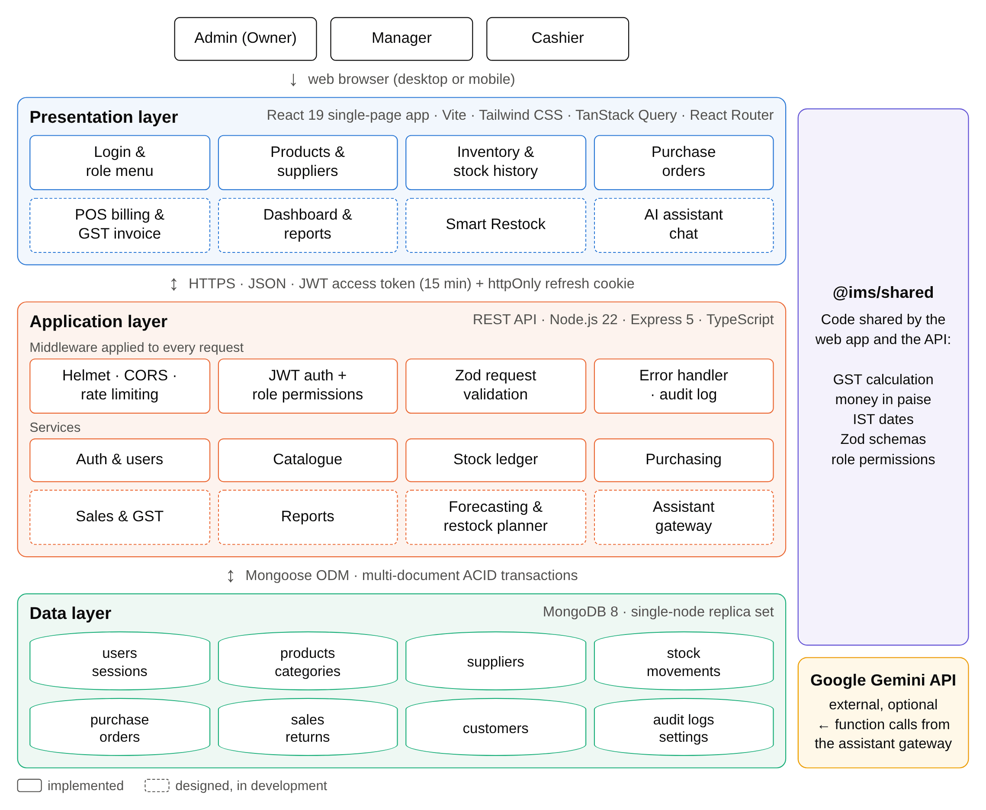
Fig 3.1: System Architecture
- Presentation layer (React single-page application): runs in the browser and provides the screens for each module. It talks to the API over HTTPS with JSON. The short-lived access token is kept only in memory; when it expires, the app silently renews it using an httpOnly refresh cookie. Screens the user is not allowed to use are hidden according to the same permission list the server enforces.
- Application layer (Express REST API): every request passes through security headers, CORS, rate limiting, JWT authentication, role-permission checks and Zod validation before reaching a service. Services contain the business logic: the catalogue, the stock ledger, purchasing, and (in development) sales with GST, reports, the forecasting and restock planner, and the assistant gateway. Important changes are written to an audit log.
- Data layer (MongoDB replica set): stores the users, products, stock movements, purchase orders, sales and other collections. Running MongoDB as a replica set enables multi-document ACID transactions, so a sale, a purchase receipt or a stock adjustment either saves completely or not at all.
- Shared package (@ims/shared): TypeScript code used by both tiers: GST calculation, money in paise, Indian financial-year dates and document numbers, request validation schemas and the role permission matrix.
- Google Gemini (optional external service): used only by the assistant. The model is given tools that call the system's own services, so its answers are based on real figures rather than invented ones.
3.3 METHODOLOGY
The project was planned first and then built in ten iterative steps, one module at a time (Fig 3.2). Each step adds the database models, API endpoints and user interface for one module, together with automated tests. Before a step is considered complete, the module is checked in a real browser against realistic seed data, and the code is pushed to GitHub, where continuous integration runs formatting, linting, type checking, all tests, the production build and the Docker image build.
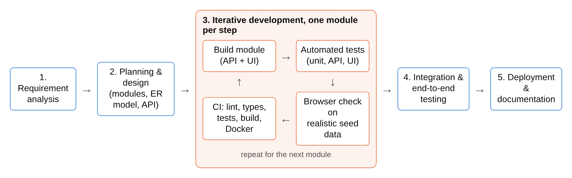
Fig 3.2: Development Methodology
The core of the AI restocking feature is the pipeline shown in Fig 3.3. It is divided into three stages: forecasting demand, deciding what to reorder, and the owner's decision.
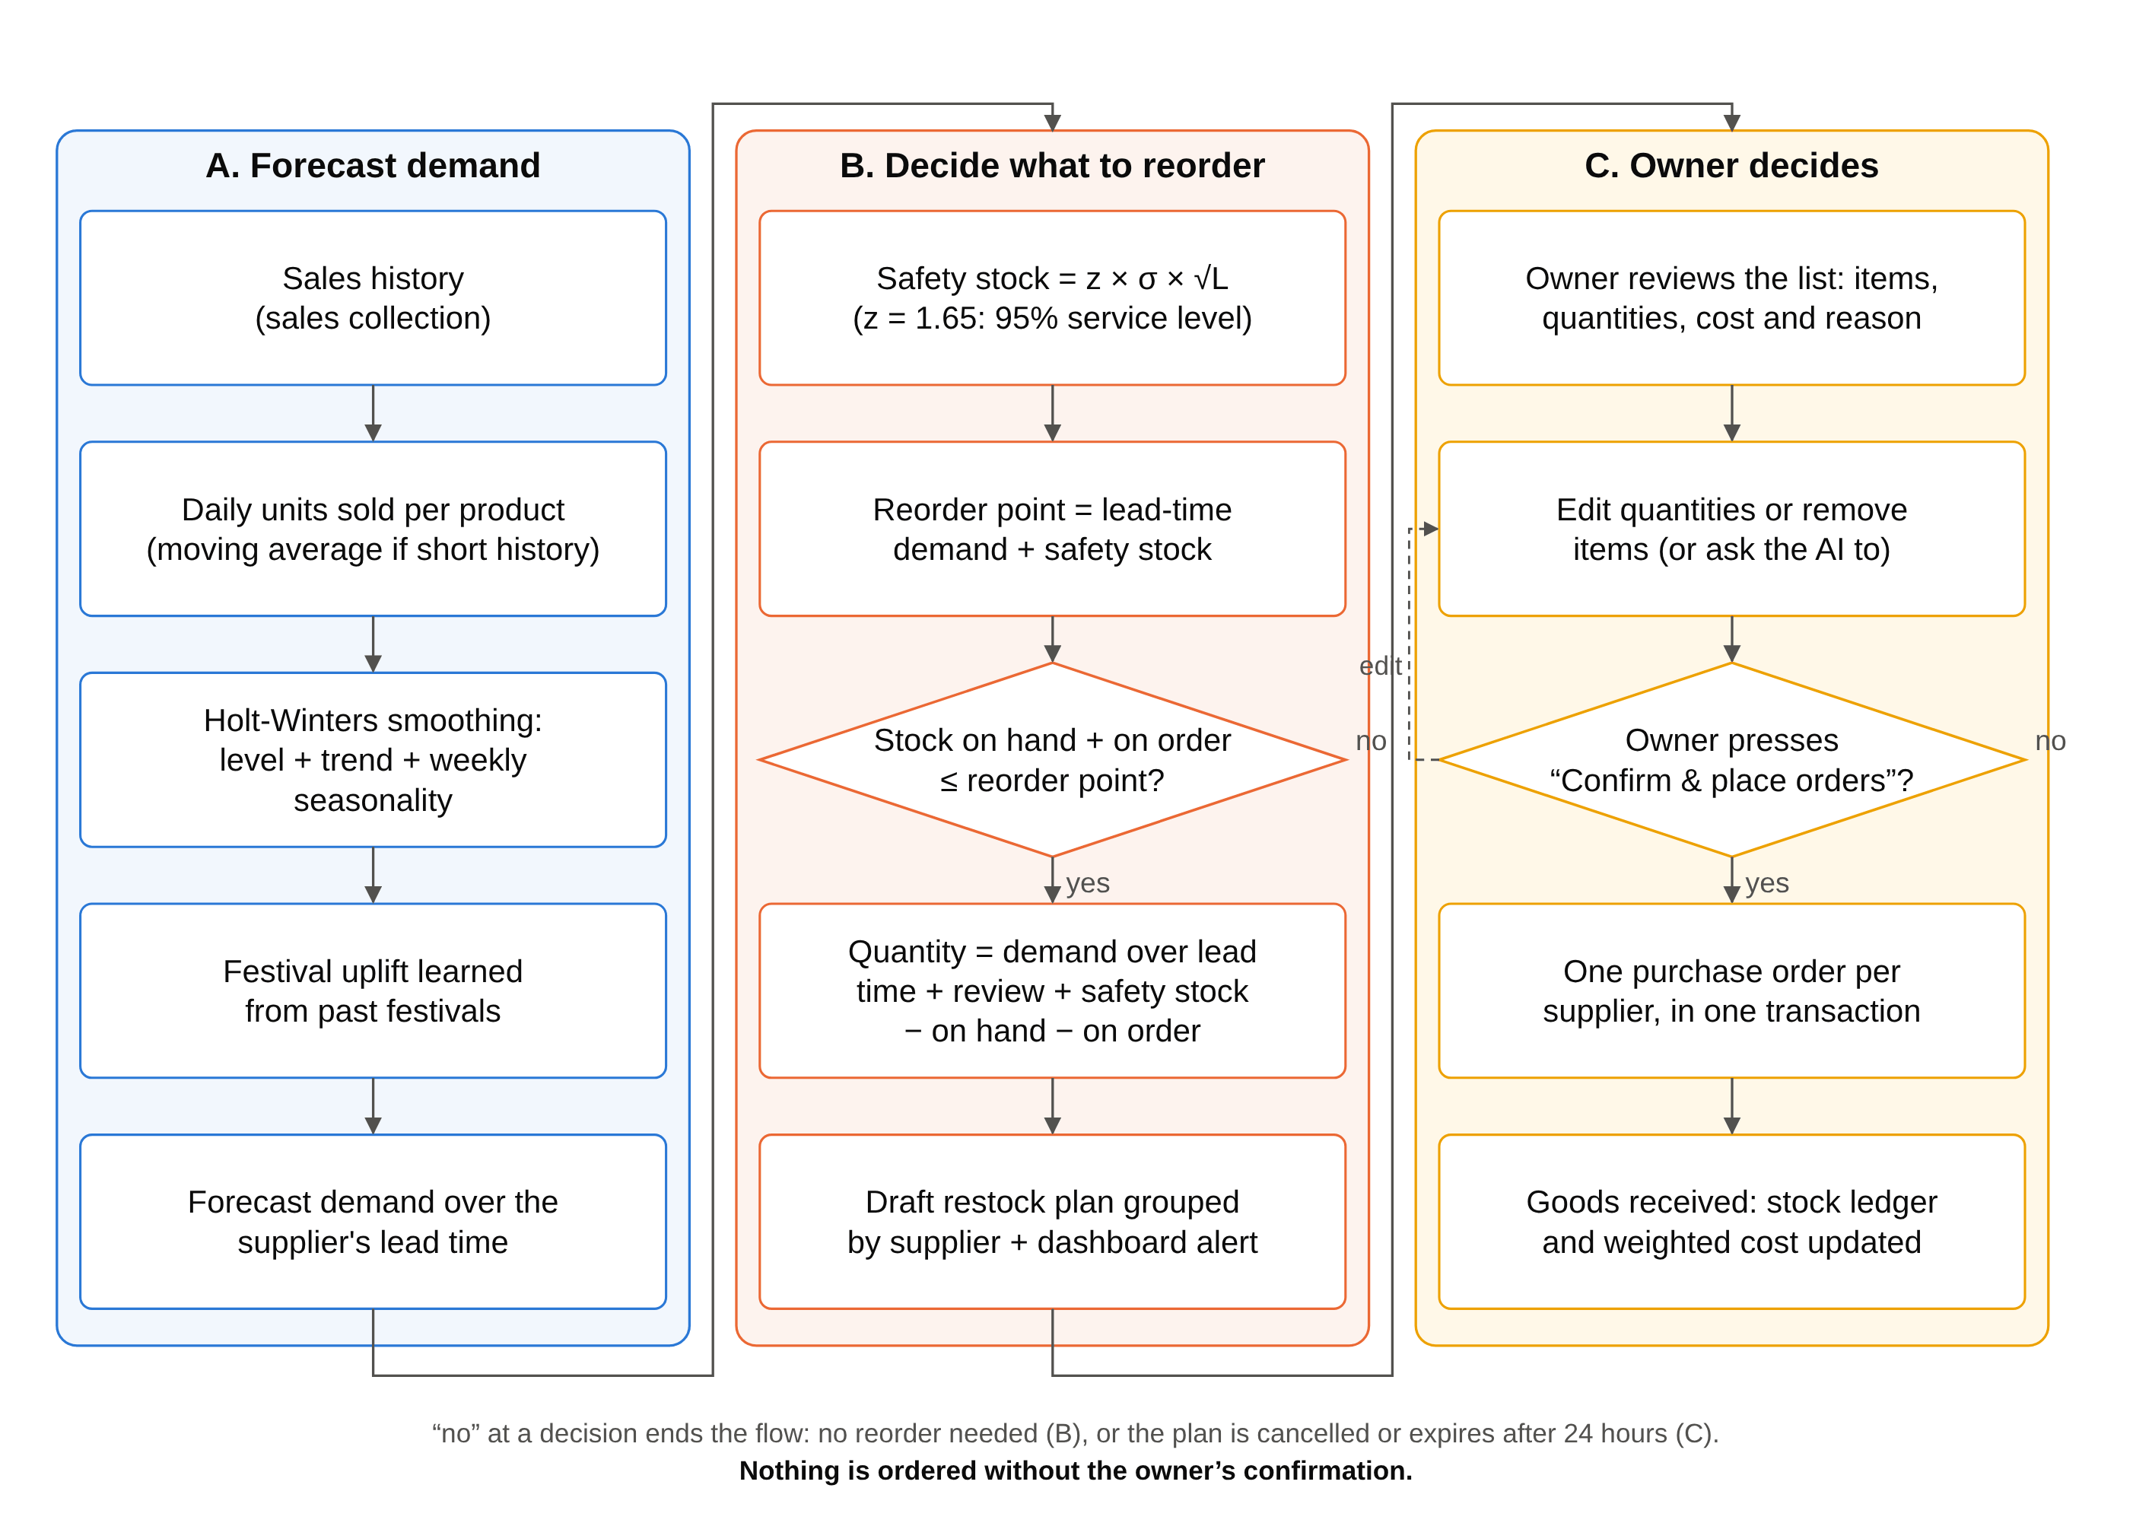
Fig 3.3: AI Restocking Methodology (Human in the Loop)
A. Forecasting demand
Daily units sold are aggregated for each product from the sales records, using Indian Standard Time calendar days. Demand is forecast with Holt-Winters exponential smoothing (triple exponential smoothing), which models three components: the level ℓ, the trend b and a weekly seasonal component s with period m = 7 days, because sales of a store differ strongly between weekdays and weekends. With smoothing constants α, β and γ, the additive form is:
ℓ_{t} = α (y_{t} − s_{t−m}) + (1 − α)(ℓ_{t−1} + b_{t−1}) (3.1)
b_{t} = β (ℓ_{t} − ℓ_{t−1}) + (1 − β) b_{t−1} (3.2)
s_{t} = γ (y_{t} − ℓ_{t}) + (1 − γ) s_{t−m} (3.3)
ŷ_{t+h} = ℓ_{t} + h · b_{t} + s_{t+h−m} (3.4)
where:
- y_{t} is the number of units of the product actually sold on day t.
- ℓ_{t} (level) is the product's normal daily sales with the day-of-the-week effect taken out, as estimated on day t.
- b_{t} (trend) is how much the level is rising per day; it is negative when sales are falling.
- s_{t} (seasonal effect) is how far above or below the level sales usually are on that day of the week, for example +6 units on a Saturday and −4 units on a Monday.
- m = 7 is the length of the season in days (one week), so s_{t−m} is the seasonal effect of the same weekday one week earlier.
- h is the number of days ahead being forecast, and ŷ_{t+h} is the forecast of the units that will be sold on day t + h.
- α, β and γ are smoothing constants between 0 and 1 for the level, the trend and the seasonal effect. A value close to 1 gives the newest day a lot of weight, so the estimate reacts quickly; a value close to 0 keeps the estimate steady.
Equation (3.1) updates the level. The day's sales are first corrected for the day of the week by subtracting the usual effect of that weekday, y_{t} − s_{t−m}, so that a busy Saturday is not mistaken for a real rise in demand. This corrected value is then blended with what the previous level and trend expected for today, ℓ_{t−1} + b_{t−1}: a share α comes from the new day and a share 1 − α from the earlier estimate.
Equation (3.2) updates the trend. The change in level from yesterday to today, ℓ_{t} − ℓ_{t−1}, is blended with the previous trend. With a small β the trend changes only when sales keep rising or falling for some time, not because of one unusual day.
Equation (3.3) updates the seasonal effect of today's weekday. The difference between today's sales and the new level, y_{t} − ℓ_{t}, is blended with the effect the same weekday had a week ago. Each of the seven weekdays keeps its own seasonal effect, refreshed once a week.
Equation (3.4) makes the forecast. It starts from the current level, adds the trend once for each day ahead (h · b_{t}) and adds the seasonal effect of the weekday being forecast, taken from the most recent week (s_{t+h−m}). The demand expected during a supplier's lead time of L days is the sum of the forecasts for h = 1 to L.
The model is started from the first two weeks of sales: the starting level is the average daily sales of the first week, the starting trend is the difference between the averages of the two weeks divided by seven, and each weekday's starting seasonal effect is its sales in the first week minus that week's average. For each product, α, β and γ are chosen by trying values from 0.1 to 0.9 and keeping the combination that gives the smallest forecast error on its past sales.
Worked example. A packet of biscuits normally sells about 20 units a day. Yesterday's estimates were a level ℓ_{t−1} = 20 units and a trend b_{t−1} = 0.5 unit per day, and last Saturday's seasonal effect was s_{t−7} = +6 units. Today is a Saturday and 28 packets were sold. With α = 0.3, β = 0.1 and γ = 0.2:
- Level (3.1): ℓ_{t} = 0.3 × (28 − 6) + 0.7 × (20 + 0.5) = 6.6 + 14.35 = 20.95 units.
- Trend (3.2): b_{t} = 0.1 × (20.95 − 20) + 0.9 × 0.5 = 0.095 + 0.45 = 0.545 unit per day.
- Seasonal effect (3.3): s_{t} = 0.2 × (28 − 20.95) + 0.8 × 6 = 1.41 + 4.8 = 6.21 units.
- Forecast for next Saturday (3.4), with h = 7 so that s_{t+h−m} = s_{t}: ŷ_{t+7} = 20.95 + 7 × 0.545 + 6.21 = 30.975, that is about 31 packets.
The system therefore expects about 31 packets to sell next Saturday: more than on an ordinary day because Saturdays are busy, and slightly more than this Saturday because sales are growing.
For products with too little history, a moving average is used instead. Festivals such as Diwali, Ganesh Chaturthi and Eid cause short, sharp increases in demand for certain goods; an uplift factor for each product is learned from its sales around past festivals and applied to known upcoming festival dates. Forecast accuracy is measured with the Mean Absolute Percentage Error, MAPE = (100/n) Σ |y_{t} − ŷ_{t}| / y_{t}, over n days kept aside from the fitting (a hold-out period); for example, a MAPE of 15% means the forecasts were off by 15% on average.
B. Deciding what to reorder
For each product the expected demand over the supplier's lead time L is computed from the forecast. Safety stock protects against demand being higher than forecast: safety stock = z × σ × √L, where σ is the standard deviation of daily forecast errors and z = 1.65 gives a 95% service level. The reorder point is the lead-time demand plus the safety stock. When the stock on hand plus the quantity already on order falls to or below the reorder point, the product is added to a restock plan with a suggested quantity = demand over the lead time and review period + safety stock − stock on hand − quantity on order, rounded up to the pack size. Each item carries a short reason, for example "sales up 40% this month; supplier takes 3 days".
C. The owner decides
Items are grouped by supplier into a draft restock plan, and the dashboard shows an alert. The owner sees the list of items, quantities, costs and reasons, can change quantities or remove items, and then confirms or cancels the plan. Only on confirmation does the system create one purchase order per supplier, inside a single transaction, after re-checking stock and open orders. A plan that is not confirmed within 24 hours, or whose stock situation has changed, expires.
REFERENCES
[1] F. F. Agboola, Y. M. Malgwi, M. A. Mahmud, and J. P. Oguntoye, "Development of a web-based platform for automating an inventory management of a small and medium enterprise," FUDMA Journal of Sciences, vol. 6, no. 5, pp. 57–65, 2022, doi: 10.33003/fjs-2022-0605-1064.
[2] H. Q. Lim, A. R. Rahmat, and S. Suban@Ani, "An inventory management system for small businesses," Journal of Digital System Development, vol. 3, no. 1, pp. 29–44, 2025, doi: 10.32890/jdsd2025.3.1.3.
[3] P. Phuthaikampanatpinya and C. Dechsupa, "A point-of-sale platform for the retail small and medium enterprises," Academic Journal of Science and Technology, Dhonburi Rajabhat University, vol. 1, no. 1, 2023.
[4] H. R. Patil, S. R. Kotgire, N. S. Madhekar, P. N. Shelke, and I. Raskar, "Account + GST inventory management ERP system (using cloud storage)," International Journal for Research in Applied Science and Engineering Technology (IJRASET), vol. 10, no. 4, 2022, doi: 10.22214/ijraset.2022.41898.
[5] M. Nasseri, T. Falatouri, P. Brandtner, and F. Darbanian, "Applying machine learning in retail demand prediction—A comparison of tree-based ensembles and long short-term memory-based deep learning," Applied Sciences, vol. 13, no. 19, Art. no. 11112, 2023, doi: 10.3390/app131911112.
[6] V. Pasupuleti, B. Thuraka, C. S. Kodete, and S. Malisetty, "Enhancing supply chain agility and sustainability through machine learning: Optimization techniques for logistics and inventory management," Logistics, vol. 8, no. 3, Art. no. 73, 2024, doi: 10.3390/logistics8030073.
[7] R. N. Boute, J. Gijsbrechts, W. van Jaarsveld, and N. Vanvuchelen, "Deep reinforcement learning for inventory control: A roadmap," European Journal of Operational Research, vol. 298, no. 2, pp. 401–412, 2022, doi: 10.1016/j.ejor.2021.07.016.
[8] L. Shi, Z. Tang, N. Zhang, X. Zhang, and Z. Yang, "A survey on employing large language models for text-to-SQL tasks," ACM Computing Surveys, vol. 58, no. 2, Art. no. 54, 2025, doi: 10.1145/3737873.
[9] J. Jiang et al., "SiriusBI: A comprehensive LLM-powered solution for data analytics in business intelligence," Proceedings of the VLDB Endowment, vol. 18, no. 12, pp. 4860–4873, 2025, doi: 10.14778/3750601.3750610.
[10] C. Heins, "Artificial intelligence in retail – a systematic literature review," Foresight, vol. 25, no. 2, pp. 264–286, 2023, doi: 10.1108/FS-10-2021-0210.

