Linear Regression
Optimization Basis:
Learning rate
🔷 1. What is Learning Rate?
👉 Learning rate (α) controls how big a step the model takes while updating weights.
During training:
$$\text{new weight}=\text{old weight}-α×\text{gradient}$$
👉 It decides:
- How fast the model learns
- Whether it converges or fails

🔷 2. What is its Target (Goal)?
👉 The goal of learning rate is:
✅ Reach the minimum loss (best model)
✅ Reach it fast
✅ Reach it stably (without oscillation or divergence)

🎯 So the learning rate tries to balance:
Goal | Meaning
Speed | Reach minimum quickly
Stability | Avoid overshooting
Accuracy | Land exactly near minimum

🔷 3. Visual Intuition (Very Important)
Imagine you are going downhill ⛰️ to reach the lowest point.

🔹 Case 1: Small Learning Rate
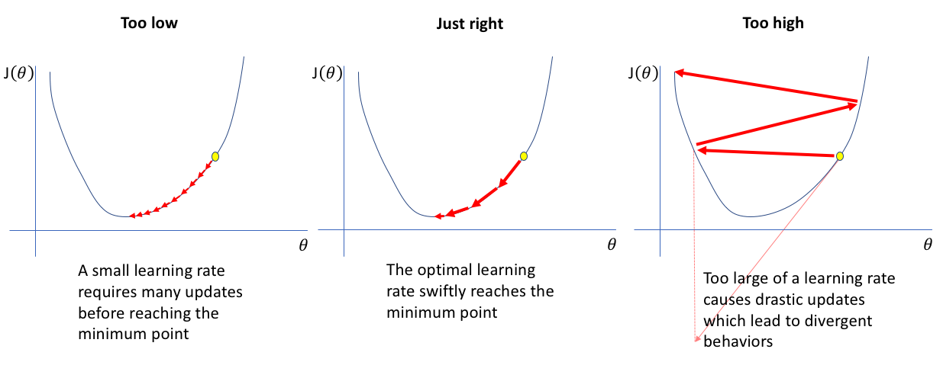

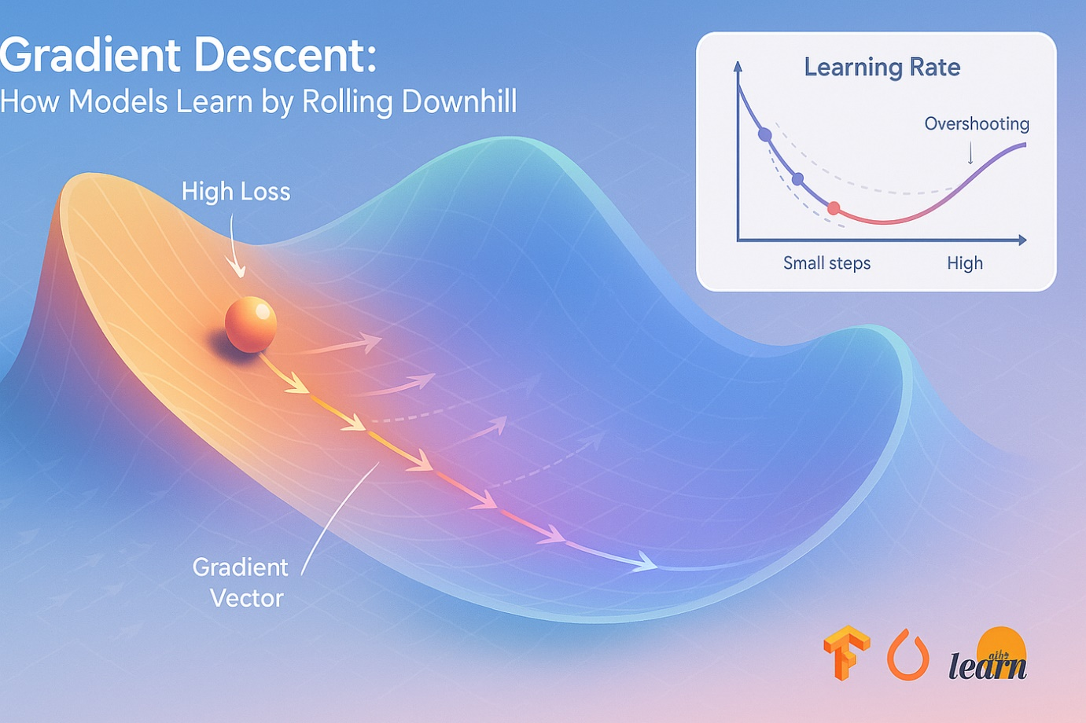
👉 Behavior:
- Takes very small steps
- Moves slowly
✔ Stable
❌ Very slow

🔹 Case 2: Optimal Learning Rate

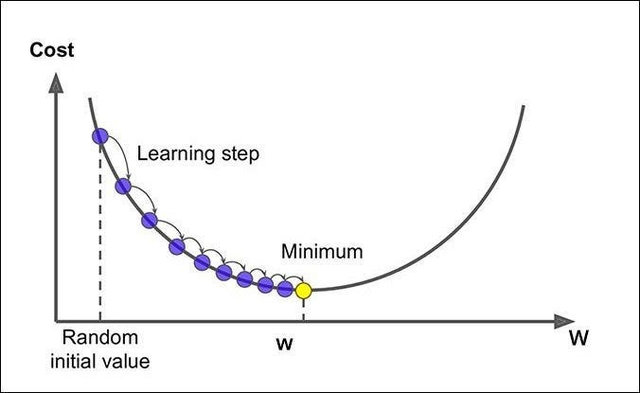
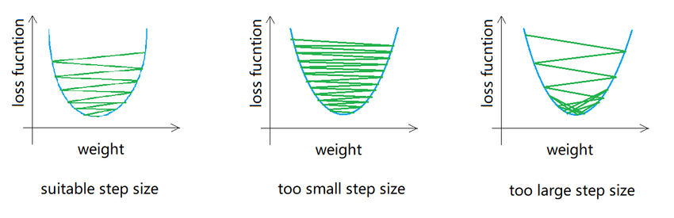
👉 Behavior:
- Reaches minimum quickly
- Smooth convergence
✔ Best case

🔹 Case 3: Large Learning Rate

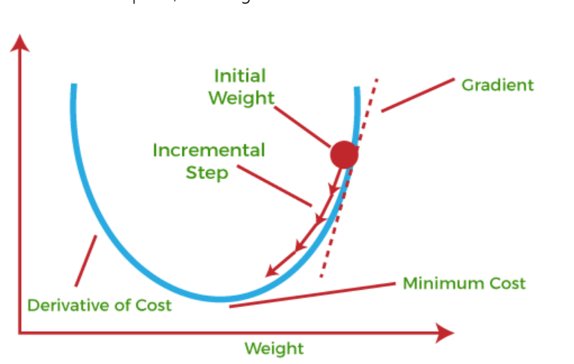
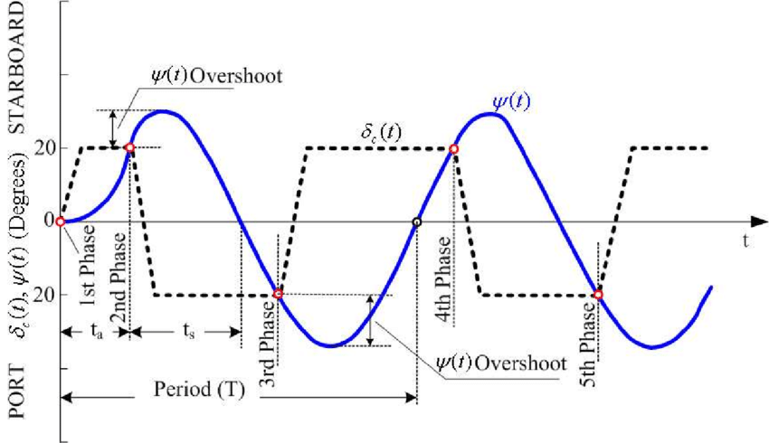
👉 Behavior:
- Jumps across minimum
- Oscillates or diverges
❌ Never converges

🔷 4. Mathematical Understanding
We minimize loss:
$$J(θ)=(y-\hat{y})^{2}$$
Gradient tells:
👉 “which direction to move”
Learning rate tells:
👉 “how far to move”

Example:
Gradient = 50
Learning Rate | Update | Effect
0.001 | 0.05 | very slow
0.1 | 5 | good
1 | 50 | too aggressive

🔷 5. What Happens Without Proper Learning Rate?
❌ Too Small (α → 0)
- Training takes forever
- May stop before reaching minimum
- Looks like model is “not learning”

❌ Too Large (α → ∞)
- Loss increases instead of decreasing
- Model diverges
- Training becomes unstable

❌ No Learning Rate Concept
- You cannot control optimization
- Model won’t converge properly

🔷 6. Real Example (Step-by-Step)
Suppose:
- Initial weight = 10
- Gradient = 20

Case 1: α = 0.1
new weight = 10 - (0.1 × 20) = 8
✔ Smooth update

Case 2: α = 1
new weight = 10 - (1 × 20) = -10
❌ Jumped too far

Case 3: α = 0.001
new weight = 10 - (0.001 × 20) = 9.98
❌ Too slow

🔷 7. Learning Rate vs Loss Curve
👉 Good learning rate:
- Loss decreases steadily
👉 Bad learning rate:
- Loss oscillates or increases

🔷 8. Advanced Concepts
🔹 1. Learning Rate Decay
- Start big → reduce gradually
👉 Why?
- Fast start
- Fine-tune at end

🔹 2. Adaptive Learning Rates
Used in optimizers:
- Adam
- RMSProp
👉 Automatically adjust α per parameter

🔹 3. Learning Rate Scheduling
Examples:
- Step decay
- Exponential decay

🔷 9. Key Insight (Important)
👉 Gradient = direction
👉 Learning rate = step size
Both are needed to reach minimum

🔥 Final Intuition
Think of learning rate like:
🚗 Driving a car:
- Small α → crawling
- Large α → crash
- Perfect α → smooth drive to destination

Number of iterations

🔷 1. What is “Number of Iterations / Epochs”?
👉 Epoch = one full pass over the entire dataset
👉 Iteration = one update step (can be per batch or per sample)

Example:
Dataset = 100 samples
Method | Iterations in 1 epoch
Batch GD | 1
Mini-batch (size=10) | 10
SGD (size=1) | 100

🔷 2. What is its TARGET in a Model?
👉 The goal of epochs is:
✅ To minimize the loss function step by step
For Linear Regression:
$$J(θ)=\frac{1}{n}\sum_{i=1}^{n}{(}y_{i}-{\hat{y}}_{i})^{2}$$
👉 Each epoch:
- Updates weights
- Reduces error
- Moves closer to optimal solution (minimum loss)

🔷 3. What Happens in Each Epoch?
Let’s simulate:
Initial:
- weights = random
- predictions = poor
- loss = high

Epoch 1:
- Model sees all data
- Updates weights slightly
- loss ↓

Epoch 2:
- Better predictions
- loss ↓↓

Epoch 10:
- Near optimal
- loss stabilizes

After many epochs:
- Very tiny improvement
- or starts overfitting

🔷 4. Visualization Intuition
Think of it like going down a hill:
- Top of hill → high error
- Bottom → minimum error
👉 Each epoch = one step downhill

🔷 5. Example (Dry Run)
Dataset:
x = [1,2,3]
y = [2,4,6]

Start:
w = 0

Epoch 1:
- prediction = [0,0,0]
- error = high
- update → w = 0.5

Epoch 2:
- prediction = [0.5,1,1.5]
- update → w = 1.2

Epoch 3:
- prediction closer
- w = 1.8

Epoch 5:
- w ≈ 2 ✅ (optimal)

👉 This gradual improvement = purpose of epochs

🔷 6. What Happens WITHOUT Enough Epochs?
❌ Too Few Epochs
👉 Model stops early
- weights not optimized
- high error
- underfitting

Example:
- Needed: 100 epochs
- Used: 5
👉 Model still “learning” → incomplete

🔷 7. What Happens WITH Too Many Epochs?
❌ Too Many Epochs
👉 Model starts memorizing data
- training error ↓
- validation error ↑
👉 overfitting

🔷 8. Role with Learning Rate
👉 Epochs + Learning Rate work together
Learning Rate | Epoch Behavior
High | fewer epochs needed but unstable
Low | more epochs needed but stable

🔷 9. When to Stop Training?
We don’t just pick random epochs — we use:

🔹 1. Early Stopping
👉 Stop when validation error increases

🔹 2. Convergence (via tolerance)
👉 Stop when:
$$\text{new loss}-\text{old loss}≈0$$

🔹 3. Fixed max_iter
👉 Hard limit (e.g., 1000 epochs)

🔷 10. Real Intuition (Very Important)
👉 Epochs are NOT just loops
They are:
- Optimization steps
- Gradual learning process
- Path to reach best weights

🔷 11. Key Insight
👉 The model’s goal is:
✔ Find weights where:
- Loss is minimum
- Gradient ≈ 0
👉 Epochs help reach that point

🔷 12. Simple Analogy
Think of:
- Studying for exam 📚
👉 1 epoch = revising entire syllabus once
Case | Result
1 revision | poor understanding
5 revisions | good
50 revisions | memorization (overfit 😄)
Tolerence
🔷 1. What is Tolerance (tol)?
👉 Tolerance defines the minimum improvement required to keep training.
In simple terms:
“If the model is not improving enough, stop training.”

🔷 2. What does it measure?
Tolerance checks how much the loss (error) is changing between iterations.
We minimize loss:
$$J(θ)=\frac{1}{n}\sum_{i=1}^{n}{(}y_{i}-{\hat{y}}_{i})^{2}$$
👉 At each step:
$$\text{change}=∣J_{new}-J_{old}∣$$

🔷 3. Stopping Condition
Training stops when:
$$∣J_{new}-J_{old}∣<\text{tol}$$
👉 Meaning:
- Improvement is too small to matter

🔷 4. Intuition (Very Important)
Think like this:
- At the beginning → loss decreases a lot
- Later → improvements become very small
👉 tol decides:
- “Is this small improvement worth continuing?”

🔷 5. Example (Step-by-Step)
Suppose loss values:
Iteration | Loss
1 | 100
2 | 60
3 | 40
4 | 39.5
5 | 39.49

Case 1: tol = 0.01
- Iter 4 → change = 0.5 ✔ continue
- Iter 5 → change = 0.01 ✔ borderline
- Iter 6 → change < 0.01 ❌ stop
👉 Stops early → faster training

Case 2: tol = 0.000001
- Keeps going for many iterations
- Even tiny improvements matter
👉 More precise but slower

🔷 6. What is the Target of tol?
👉 The goal is:
✅ Detect convergence
- When model has almost reached optimal solution
✅ Avoid unnecessary computation
- Stop when improvement is negligible
✅ Prevent over-training
- Especially in iterative solvers

🔷 7. With vs Without Tolerance

🔹 WITH tolerance
✔ Stops automatically
✔ Efficient training
✔ Saves time

🔹 WITHOUT tolerance
👉 You rely only on:
- fixed iterations (max_iter)
Problems:
- May stop too early ❌
- May run unnecessarily long ❌

🔷 8. Interaction with Other Hyperparameters

🔹 tol + learning rate
- Large learning rate → big jumps → tol reached late
- Small learning rate → tiny changes → tol reached early

🔹 tol + max_iter
- tol → soft stop
- max_iter → hard stop
👉 Training stops when:
- either condition is met

🔷 9. Real-world Analogy
Imagine climbing down a hill 🏔️
- At first → big steps
- Near bottom → tiny steps
👉 tol says:
“If your steps are too small, you’ve basically reached the bottom—stop.”

🔷 10. Practical Values
Typical:
tol = 1e-3 # fast, less precise
tol = 1e-5 # balanced
tol = 1e-8 # very precise

🔷 11. Key Insight (Important)
👉 tol does NOT improve model accuracy directly
👉 It controls:
- when to stop training
- how precise the convergence should be

🔷 12. Common Mistakes
❌ Setting tol too high
→ stops too early → underfitting
❌ Setting tol too low
→ wastes time with no real gain

✅ Final Summary
- tol = minimum improvement threshold
- It helps detect convergence
- It balances:
  - speed ⚡
  - precision 🎯
Solver
🔷 What is a Solver in Linear Regression?
👉 A solver is the algorithm used to find the best model parameters (weights) that minimize the loss function.
In simple words:
Solver = “How the model finds the best line”

🔷 What is its Target?
The solver tries to minimize the error (loss):
$$J(θ)=\frac{1}{n}\sum_{i=1}^{n}{(}y_{i}-{\hat{y}}_{i})^{2}$$
👉 Target:
- Find optimal θ (weights)
- So that prediction error is minimum

🔷 Think of it Like This
👉 You are standing on a mountain ⛰️
👉 Goal = reach the lowest point (minimum error)
Solver decides:
- How to move
- How fast to move
- Which path to take

🔷 Types of Solvers (Core Idea)
There are 2 main approaches:

🔶 1. Analytical Solver (Direct Solution)
👉 Solves equation mathematically in one shot
Formula:
$$θ=(X^{T}X)^{-1}X^{T}y$$

✅ Characteristics:
- No iterations
- Exact solution
- Fast for small datasets

❌ Problems:
- Matrix inverse is expensive
- Not scalable for large data

📌 Example
If you have:
X = small dataset (100 rows)
👉 Directly compute θ → done

🔶 2. Iterative Solvers (Optimization Based)
👉 Start with random weights and improve step by step

🔹 (A) Gradient Descent
Update rule:
$$θ=θ-α⋅∇J(θ)$$

✅ What it does:
- Moves in direction of decreasing error

Behavior:
Learning Rate | Result
Small | slow but stable
Large | may diverge

🔹 (B) Stochastic Gradient Descent (SGD)
👉 Uses 1 sample at a time
✅ Advantages:
- Faster for large data
- Works online
❌ Disadvantage:
- Noisy updates

🔹 (C) Mini-batch Gradient Descent
👉 Uses small batches (most practical)

🔹 (D) Advanced Solvers
Used in libraries like sklearn:

1. SVD (Singular Value Decomposition)
👉 Very stable numerical method
- Handles singular matrices
- Used in LinearRegression

2. Cholesky
👉 Faster but needs well-conditioned matrix

3. LSQR
👉 Efficient for large sparse data

4. SAG / SAGA
👉 Faster gradient methods
- Used in large-scale problems
- Converges quickly

🔷 What Happens Without a Proper Solver?
👉 If solver is wrong:
❌ Case 1: No convergence
- Model never reaches minimum

❌ Case 2: Very slow training
- Takes too long

❌ Case 3: Numerical instability
- Matrix inverse fails

🔷 Example to Understand Deeply

Problem:
x = [1,2,3]
y = [2,4,6]

Solver 1: Normal Equation
👉 Directly computes:
y = 2x
✔ Exact solution

Solver 2: Gradient Descent
Start:
θ = 0
Iterations:
Step | θ | Error
1 | 0.5 | high
2 | 1.2 | lower
10 | 2.0 | minimum
✔ Reaches same solution gradually

🔷 When to Use Which Solver?
Situation | Best Solver
Small data | Normal Equation
Large data | Gradient Descent
Sparse data | LSQR
Numerical stability needed | SVD

Regularization Basis:
Alpha
🔷 1. What is Alpha (λ)?
👉 Alpha (λ) is the regularization strength
It controls how much we penalize large weights in a model.

🔷 2. Why Do We Need λ?
Problem without λ:
Linear regression tries to minimize only error:
$$\text{Error}=∑(y-\hat{y})^{2}$$
👉 Model goal:
- Fit data as closely as possible
❌ Problem:
- It may overfit
- Coefficients become very large
- Model memorizes noise

🔷 3. What λ Does (Core Idea)
We modify the loss function:
👉 Instead of only minimizing error:
$$\text{Loss}=\text{Error}+λ⋅\text{Penalty}$$

For Ridge (L2):
$$\text{Loss}=∑(y-\hat{y})^{2}+λ∑w^{2}$$
👉 Now model has two goals:
- Fit the data
- Keep weights small

🔷 4. What is the Target of λ?
👉 The real objective of λ is:
✅ 1. Prevent Overfitting
- Stops model from learning noise
✅ 2. Control Model Complexity
- Keeps weights small → simpler model
✅ 3. Improve Generalization
- Works better on unseen data

🔷 5. Intuition (Very Important)
Think of model training like:
👉 Without λ:
- "Fit data at ANY cost"
👉 With λ:
- "Fit data, BUT keep model simple"

🔷 6. Effect of λ Values
λ Value | Behavior
λ = 0 | Normal Linear Regression
Small λ | Slight control
Medium λ | Balanced model
Large λ | Strong penalty (underfit risk)

🔷 7. Example (Numerical Intuition)
Suppose:
👉 Model 1 (no λ):
y = 10x1 + 15x2
👉 Model 2 (with λ):
y = 3x1 + 4x2

Observation:
- Model 1 → fits training data better
- Model 2 → smaller weights → more stable
👉 Model 2 is usually better on new data

🔷 8. Visual Intuition
Imagine fitting a curve:
- Without λ → very wiggly curve (overfit)
- With λ → smooth curve

🔷 9. Ridge vs Lasso (Role of λ)
🔹 Ridge (L2)
- Shrinks weights
- Never exactly zero
👉 Good when all features matter

🔹 Lasso (L1)
- Makes some weights = 0
👉 Performs feature selection

🔷 10. What Happens Without λ?
❌ Problems:
- Overfitting
- Large coefficients
- High variance
- Poor performance on test data

🔷 11. What Happens With λ?
✅ Benefits:
- Stable model
- Better generalization
- Reduced variance
- Simpler interpretation

L1_ratio

🔷 1. Where does l1_ratio come from?
It is used in Elastic Net Regression, which combines:
- L1 (Lasso) → feature selection
- L2 (Ridge) → weight shrinkage
👉 The loss function becomes:
$$J(θ)=\frac{1}{n}∑(y-\hat{y})^{2}+λ\left[α∑∣θ∣+(1-α)∑θ^{2}\right]$$
👉 Here:
- λ → overall regularization strength
- α = l1_ratio

🔷 2. What exactly is l1_ratio?
👉 It controls how much L1 vs L2 regularization is applied
$$l1_ratio=α∈[0,1]$$

🔷 3. Interpretation (VERY IMPORTANT)
l1_ratio | Meaning | Behavior
0 | Pure Ridge | No feature selection
0.5 | Mix of both | Balanced
1 | Pure Lasso | Feature selection

🔷 4. What is the target of l1_ratio?
👉 The goal is to control sparsity vs stability
🔹 L1 (when l1_ratio → 1)
- Forces some weights = 0
- Removes useless features
✔ Target:
- Feature selection
- Simpler model

🔹 L2 (when l1_ratio → 0)
- Shrinks weights smoothly
- Keeps all features
✔ Target:
- Stability
- Handles multicollinearity

🔹 Elastic Net (0 < l1_ratio < 1)
✔ Target:
- Combine both advantages
- Sparse + stable model

🔷 5. Intuition (Very Simple)
Imagine you have 100 features:
- Lasso → picks only 10 important ones
- Ridge → keeps all but reduces their importance
- Elastic Net → picks important ones but doesn’t completely ignore others
👉 l1_ratio decides:
👉 “How aggressive should feature selection be?”

🔷 6. Example (Practical)
Dataset:
features = [age, salary, experience, random_noise1, random_noise2]

Case 1: l1_ratio = 1 (Lasso)
👉 Result:
age → used
salary → used
experience → used
noise1 → 0
noise2 → 0
✔ Removes noise features

Case 2: l1_ratio = 0 (Ridge)
👉 Result:
age → 0.8
salary → 0.6
experience → 0.7
noise1 → 0.1
noise2 → 0.05
✔ Keeps all features

Case 3: l1_ratio = 0.5
👉 Result:
age → 0.9
salary → 0.7
experience → 0.8
noise1 → 0
noise2 → 0.02
✔ Balanced behavior

🔷 7. What happens WITHOUT l1_ratio?
👉 You are forced to choose:
- Only Lasso ❌ (unstable with correlated features)
- Only Ridge ❌ (no feature selection)
👉 Elastic Net solves this limitation

🔷 8. When should you use what?
🔹 Use l1_ratio close to 1 (Lasso-like)
- Many irrelevant features
- Need feature selection

🔹 Use l1_ratio close to 0 (Ridge-like)
- Features are correlated
- Want stable coefficients

🔹 Use middle values (0.3–0.7)
- Real-world datasets (most common)
- Mix of noise + correlation

