DE_Project Documentation

Title:
End-to-End Medallion Architecture for Olist E-Commerce Analytics

By:
Nidharsan V
INT231

Table of Contents
- Executive Summary
- Project Overview
  - 2.1. Objective / Problem Statement
  - 2.2. Business Use Case
  - 2.3. Expected Outcomes & KPIs
- Architecture Overview
  - 3.1. High-Level Architecture Diagram
  - 3.2. Detailed Data Flow
  - 3.3. Modular Pipeline Design
  - 3.4. Key Platform Components
- Technology Stack
- Data Sources & Ingestion
  - 5.1. Dataset Overview
  - 5.2. Data Source & Secure Connection
  - 5.3. Data Ingestion Method & Flow
- Data Architecture: Medallion Layers
  - 6.1. Setup Layer (Environment Initialization)
  - 6.2. Bronze Layer (Raw Data)
  - 6.3. Silver Layer (Cleaned & Transformed)
  - 6.4. Gold Layer (Analytics Ready)
- Pipeline & Workflow Orchestration
- Data Quality & Validation
- Reporting & Visualization (Power BI)
- Conclusion & Future Scope

1. Executive Summary
This project details the design and implementation of an end-to-end, scalable data analytics platform for the Brazilian e-commerce marketplace, Olist. The primary challenge was transforming fragmented, multi-relational CSV data into a "Single Source of Truth" to drive business intelligence.

By leveraging the Medallion Architecture within Databricks and governed by Unity Catalog, a robust data pipeline was constructed. Data flows from raw ingestion in Amazon S3 through a structured process: the Bronze layer for raw persistence, the Silver layer for cleaning and enrichment, and finally, the Gold layer, which houses a high-performance Star Schema optimized for analytics. The entire pipeline is automated using Databricks Workflows.

The final output is a suite of Power BI dashboards that deliver critical business KPIs, including revenue trends, logistics performance, customer lifetime value, and seller analytics. This architecture provides Olist with a scalable, reliable foundation for data-driven decision-making.

2. Project Overview
2.1. Objective / Problem Statement
The primary objective is to build a scalable and automated data pipeline using Databricks to process the fragmented Brazilian E-Commerce (Olist) dataset. The project addresses the challenge of moving raw, inconsistent, and multi-relational CSV data through a structured Medallion Architecture (Bronze, Silver, Gold). The goal is to ensure data quality, handle complex e-commerce logic (like multiple payments and logistics tracking), and produce a high-performance Star Schema for business intelligence.

2.2. Business Use Case
Olist operates as a marketplace connecting small businesses to larger Brazilian retailers. To stay competitive, the business needs a "Single Source of Truth" to:
- Identify bottlenecks in logistics (monitoring late deliveries).
- Evaluate seller performance and product category trends.
- Understand customer purchasing behavior and lifetime value (CLV).
Category | KPI
Revenue & Value | Total revenue by month, Average Order Value (AOV), Customer Lifetime Value (CLV)
Sales Performance | Top 10 products by revenue, Top 10 sellers by revenue
Customer Insights | Orders by customer city and state (amount and count), New vs returning customers (monthly)
Logistics | Order fulfillment rate, Late delivery percentage, Average delivery time (days) by region
Payments & Reviews | Payment method distribution, Average review score by product category, Average review score by seller, Percentage of low-rated orders (rating < 3)
- Optimize payment processing and marketing spend based on order frequency.

3. Architecture Overview
The project implements a modern Medallion Architecture (Data Lakehouse pattern) powered by Databricks and Unity Catalog. This design ensures that data flows from a raw, chaotic state into a structured, highly optimized format suitable for executive-level business intelligence.

3.1. High-Level Architecture Diagram
The architectural flow is defined by four distinct stages:
- Ingestion: Securely pulling raw CSV files from Amazon S3.
- Storage & Governance: Organizing data within Unity Catalog for fine-grained access control and lineage.
- Transformation: Using PySpark and SQL to move data through Bronze, Silver, and Gold layers.
- Serving: Connecting the final Gold layer to Power BI for KPI visualization.

3.2. Detailed Data Flow
The pipeline follows a layered transformation approach, where each layer increases the data's "cleanliness" and business value.
- Raw Layer (External Volume): Before entering the Delta Lake, data is landed in a Unity Catalog Volume.
  - Path: /Volumes/ecommerce_dev/bronze/raw_volume/
  - Characteristic: Immutable landing zone. Files remain in their original .csv format to provide a historical audit trail.
- Bronze Layer (The Entry Point): Data is loaded into Delta tables with the primary goal of persistence.
  - Transformations: Minimal. Only basic column renaming (to lowercase) and trimming of whitespace.
  - Key Feature: Schema Enforcement is applied here to ensure that malformed CSVs do not corrupt the downstream pipeline.
  - Purpose: To provide a queryable version of the raw data that can be reprocessed without re-fetching from S3.
- Silver Layer (The Quality Zone): This is where the heavy lifting of data engineering occurs.
  - Data Integrity: Implementation of Null Handling (replacing null with defaults) and Deduplication (ensuring unique order_id and customer_id).
  - Standardization: Date strings are cast to TIMESTAMP objects, and currency values are standardized to DOUBLE.
  - Enrichment: Tables are joined (e.g., merging orders and customers) to create broader datasets that represent a business event rather than a raw table.
- Gold Layer (The Analytics Layer): The final stage organizes data into a Star Schema (Facts and Dimensions).
  - Fact Tables: Contain quantitative measures (e.g., payment_value, freight_value).
  - Dimension Tables: Contain descriptive attributes (e.g., product_category, customer_city).

3.3. Modular Pipeline Design
To ensure reliability, the architecture is broken down into modular Databricks Workflows.
- Ingestion Pipeline: Automates the movement of data from S3 to the Bronze Volume.
- Transformation Pipelines: Separate jobs for Bronze-to-Silver and Silver-to-Gold, allowing for independent debugging.
- Master Pipeline: A "parent" workflow that orchestrates the entire end-to-end process. It handles dependencies, ensuring the Silver layer doesn't start until the Bronze layer successfully completes.
- Parallelism: Dimension tables (e.g., dim_product and dim_customer) are processed in parallel to reduce the overall execution time of the Gold pipeline.

3.4. Key Platform Components
- Amazon S3 (Data Source): Acts as the global entry point. By using IAM Roles and Storage Credentials within Unity Catalog, we eliminate the need for hardcoded AWS Access Keys in the notebooks, significantly increasing security.
- Unity Catalog (The Governance Engine):** Unity Catalog is the "brain" of the architecture. It provides centralized metadata and fine-grained access.
- Power BI & Microsoft Fabric: The visualization layer connects to the Gold Schema. Because the data is pre-aggregated into a Data Cube in the Gold layer, Power BI doesn't have to perform complex calculations on the fly, leading to a smoother end-user experience.

4. Technology Stack
This project leverages a modern cloud-based data engineering stack.
Category | Technology | Purpose & Key Responsibilities
Cloud Platform | Amazon Web Services (AWS) | Foundational cloud platform for storage. Amazon S3 is used as the primary, scalable data lake entry point for raw CSV files.
Processing Engine | Databricks (Apache Spark) | Core processing engine. Handles distributed data processing for ingestion, transformation across all Medallion layers, and execution of PySpark/SQL workloads.
Programming Lang. | PySpark & SQL | PySpark for flexible, complex transformations and cleaning. SQL for simple queries, aggregations, and building the final fact/dimension tables.
Storage & Governance | Unity Catalog | Centralized data governance and storage layer. Manages metadata, enforces fine-grained access control, and organizes tables logically under bronze, silver, and gold schemas.
Orchestration | Databricks Workflows | Manages end-to-end pipeline automation. Defines task dependencies, enables parallel execution, and provides monitoring for all jobs (Ingestion, Bronze, Silver, Gold, Master).
Visualization | Microsoft Power BI | Business intelligence and reporting tool. Connects directly to Gold layer tables to build interactive dashboards for all defined KPIs.
Version Control | Git | Manages and tracks code changes for all notebooks and scripts. Ensures reproducibility, collaboration, and code versioning.

5. Data Sources & Ingestion
5.1. Dataset Overview
Table Name | Description
customers | Stores customer information.
orders | Contains order-level details.
order_items | Line items within each order.
products | Product-related information.
sellers | Seller details.
order_payments | Payment transactions per order.
order_reviews | Customer reviews and ratings.
geolocation | Location data based on zip code.
product_category_name_translation | Maps category names from Portuguese to English.
Dataset Name: Olist eCommerce Dataset
This dataset contains real-world Brazilian e-commerce data including 9 CSV files that simulate a typical e-commerce platform's backend.
5.2. Data Source & Secure Connection
The dataset is stored as CSV files in Amazon S3. A secure connection was established between S3 and Databricks using an IAM Role and Storage Credentials within Unity Catalog, eliminating the need for hardcoded access keys.
5.3. Data Ingestion Method & Flow
- Initial Load: A one-time full load of all historical CSV files from S3 into the Unity Catalog Volume.
- Ingestion Flow: Amazon S3 (CSV Files) → Databricks Volume (Raw Layer) → Bronze Tables

6. Data Architecture: Medallion Layers
6.1. Setup Layer (Environment Initialization)
The foundational step where the environment is prepared.
- Catalog & Schema: Created ecommerce_dev catalog with bronze, silver, and gold schemas.
- Volume Creation: Created a Volume, raw_volume, inside the Bronze schema to serve as the raw data landing zone.
- Ingestion: Automated the copying of data from S3 to the Volume using a Databricks Workflow.

6.2. Bronze Layer (Raw Data)
The first stage in the Medallion Architecture where raw data is ingested into structured Delta tables.
- Process: Raw files are read from the Volume using PySpark.
- Minimal Transformations: Column names are converted to lowercase, and spaces are trimmed.
- Tables Created: All 9 raw tables (customers, orders, etc.) are created as Delta tables in the bronze schema.

6.3. Silver Layer (Cleaned & Transformed)
Stage | Notebook | Key Transformations
Basic Cleaning | Basic_Cleaning | Null Handling: Replaced nulls with defaults.  Deduplication: Removed duplicates based on primary keys.  Data Type Casting: Converted strings to timestamps, etc.  Standardization: Trimmed spaces and standardized text to lowercase.
Enhanced Transformation | Enhanced_Transformation | Derived Columns: Created delivery_time, total_order_value.  Joins: Enriched tables (e.g., orders + customers).  Business Logic: Applied logic for order status and delivery delays.  Date Transformations: Extracted year, month, day.

6.4. Gold Layer (Analytics Ready)
The final stage, designed for business intelligence, reporting, and KPI generation.
- Star Schema Design: The layer follows a Star Schema model.
  - Fact Tables: fact_order, fact_order_items, fact_payment, fact_review
  - Dimension Tables: dim_customer, dim_product, dim_seller, dim_date, dim_geography
- Data Cube Generation: A pre-aggregated table, olist_datacube, was created to optimize dashboard performance.
Attributes of DataCube(ecommerce_dev.gold.olist_datacube)
- ecommerce_dev.gold.olist_datacube:
- This table contains order-level data for an e-commerce platform, including order, customer, product, seller, payment, and review details. Key columns are:
- order_id, customer_id, product_id, seller_id: Unique identifiers for orders, customers, products, and sellers.
- order_purchase_timestamp, order_month, order_year: Timestamps and date parts for order placement.
- order_status, is_delivered, is_late_delivery: Order fulfillment status and delivery indicators.
- order_item_id: Item number within the order.
- total_item_value, total_payment_value: Monetary values for items and payments.
- payment_type: Payment method used.
- review_id, review_score, review_category: Customer review information.
- customer_unique_id, customer_city, customer_state: Customer location and unique identifier.
- product_category_name: Product category.
- seller_city, seller_state: Seller location.
- purchase_ts, order_delivered_customer_date, order_estimated_delivery_date: Timestamps for purchase, delivery, and estimated delivery.

- KPI Dataset Generation: A set of KPI-specific tables was generated and stored in a dedicated kpi schema for direct consumption by Power BI.
7. Pipeline & Workflow Orchestration
Databricks Workflows were used to orchestrate the end-to-end data processing.
- Master Pipeline: A single workflow that orchestrates all layer pipelines in sequence: Ingestion → Bronze → Silver → Gold.

- Modular Pipelines: Separate, reusable pipelines for each layer.

- Parallel Processing: In the Gold layer, dim_generation and fact_generation tasks run in parallel to reduce execution time.

- Dependency Management: Dependencies are explicitly defined (e.g., Enhanced_Transformation depends on Basic_Cleaning), ensuring tasks run in the correct order.

8. Data Quality & Validation
Data quality checks were implemented primarily in the Silver Layer to ensure the data is clean and consistent.
- Null Checks: Identified and handled null values in critical columns, using defaults like 0 for numeric fields.

- Duplicate Checks: Duplicate records were identified based on key columns (e.g., order_id) and removed.

- Schema Validation: Data types were explicitly cast (e.g., STRING to TIMESTAMP) to maintain consistency.

- Data Consistency: Standardized formats for text (lowercase, trimmed) and dates to ensure a uniform dataset.

9. Reporting & Visualization (Power BI)
The reporting layer was built using Microsoft Power BI, integrated with Databricks.
- Connection: A secure connection was established between Databricks and the Microsoft Fabric Power BI workspace using a Service Principal (Microsoft Entra ID) and a Databricks Personal Access Token (PAT).
- Semantic Model: A semantic model named ecommerce_dev-kpi was created, directly referencing the KPI tables in the ecommerce_dev.kpi schema.
- Dashboard: A report named kpi_report was built on top of the semantic model, visualizing all 14 KPIs through an interactive dashboard.

10. Conclusion & Future Scope
This project successfully delivered a robust, scalable, and automated data analytics platform for Olist. By implementing a Medallion Architecture in Databricks, the complex raw data was transformed into a high-quality, governed, and analytics-ready dataset. The resulting Power BI dashboards provide Olist's business stakeholders with actionable insights into revenue, customer behavior, logistics, and seller performance.
Future Scope:
- Incremental Loads: Implement Change Data Capture (CDC) or append-only ingestion to handle new incoming data efficiently.
- Real-time Stream Processing: Incorporate a streaming layer (e.g., using Delta Live Tables or Kafka) for near real-time KPI updates.
- Machine Learning: Leverage the Gold layer data for predictive models, such as customer churn prediction or delivery time forecasting.
- Advanced Governance: Implement row-level and column-level security in Unity Catalog for enhanced data access control.

Screenshots:
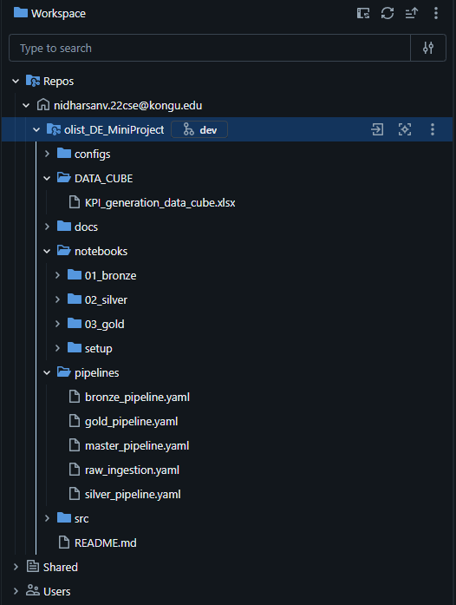
Figure 1:Folder Structure
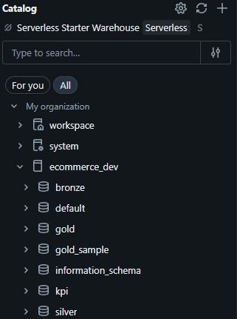
Figure 2:Unity Catalog

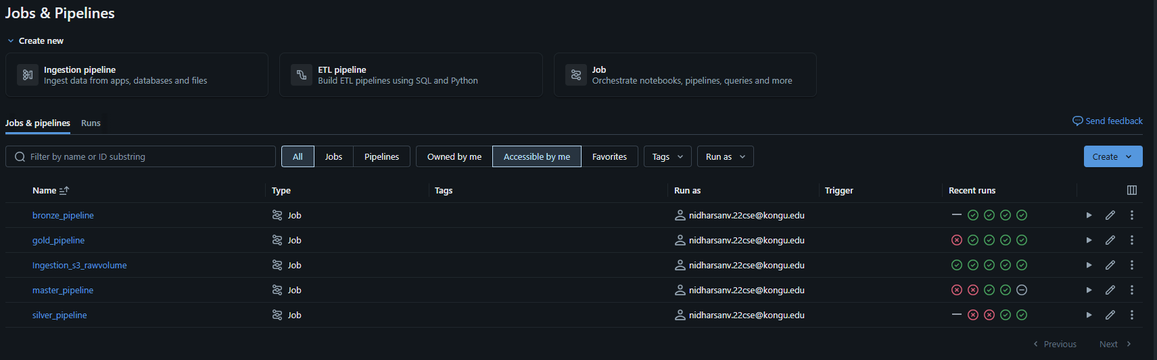
Figure 3:Jobs and Pipelines
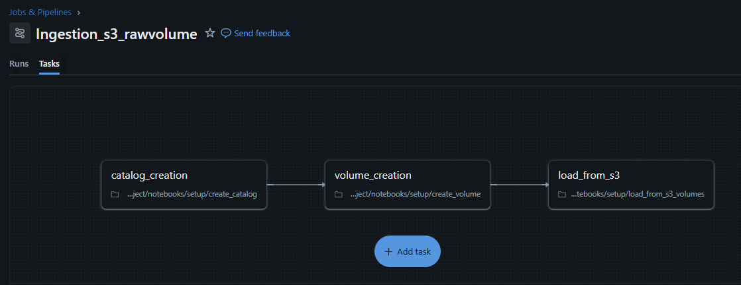
Figure 4 : Ingestion Pipeline
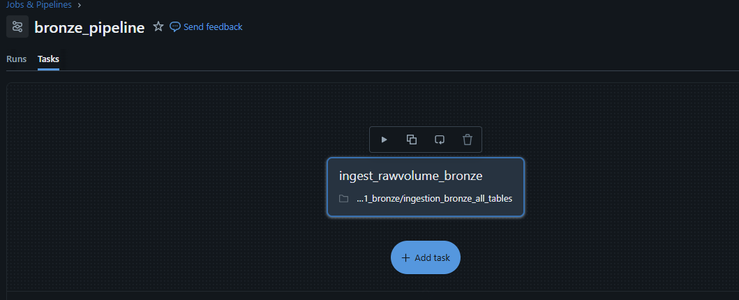
Figure 5:bronze pipeline
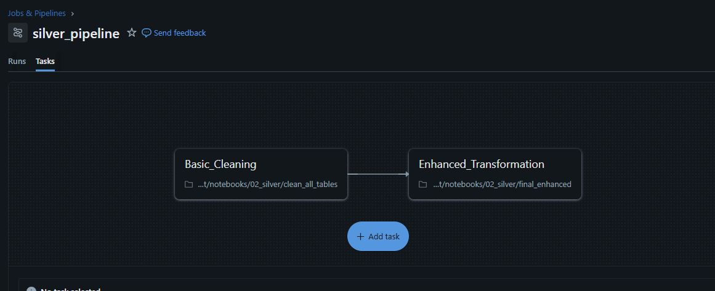
Figure 6:Silver pipeline
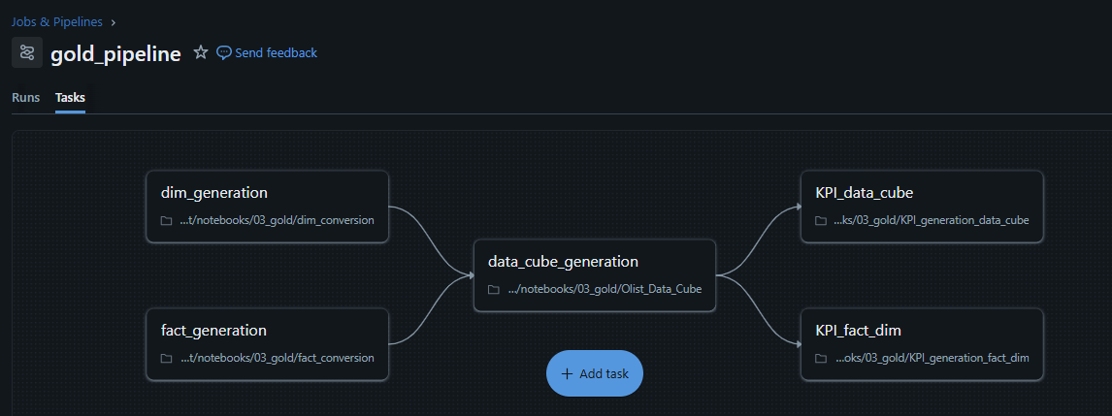
Figure 7:Gold Pipeline
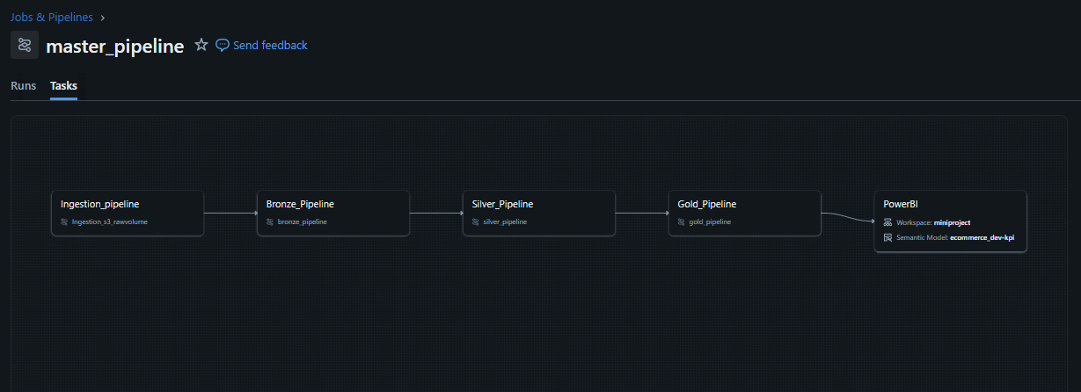
Figure 8:Master pipeline

Figure 9:Master pipeline
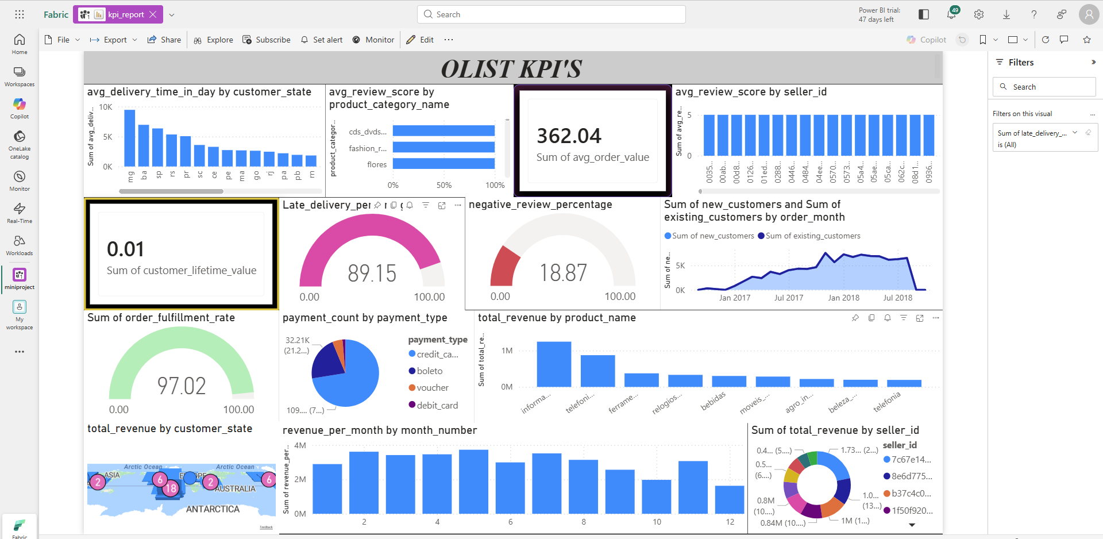
Figure 10:PowerBI dashboard in Fabric

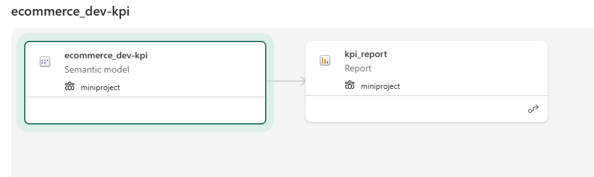
Figure 11:Lineage Reporting

