ABAP
(Advanced Business Application Programming)

Functionalities of ABAP Editor

- The Transaction Code for the ABAP editor is SE38.
- Any customized program must start with Z (Development or testing purpose) or Y (finalized and ready for development to production environment) as the first Alphabet.
- Standard SAP reports name starts with A and X.
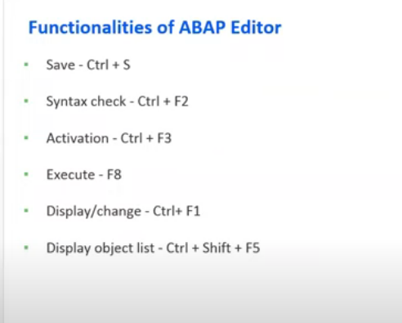
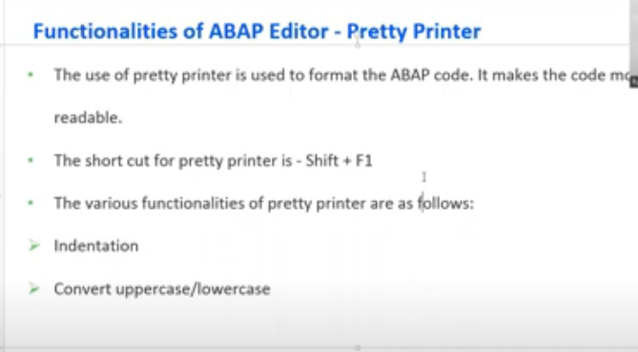
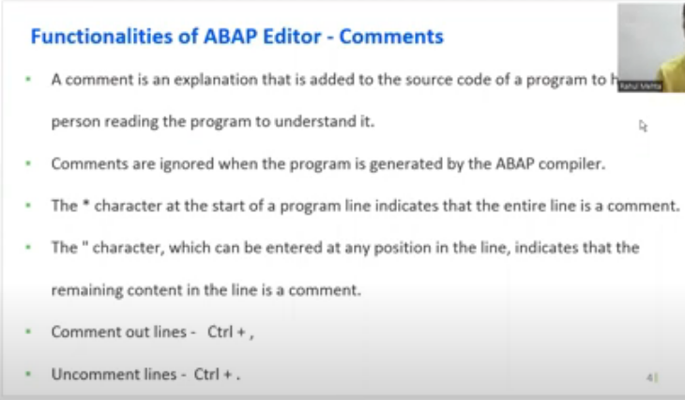

- DATA TYPES are templates for creating data objects.
- It defines the technical attributes of the data object.

DATA Objects

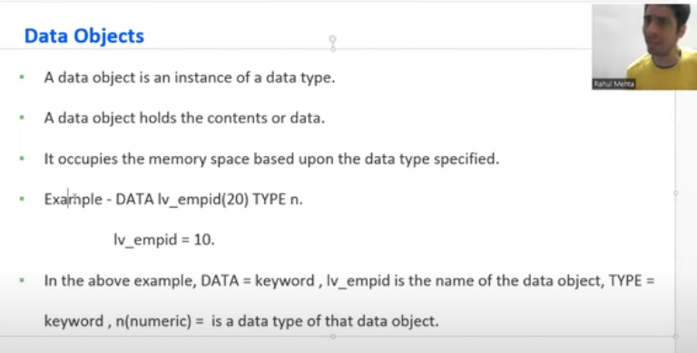
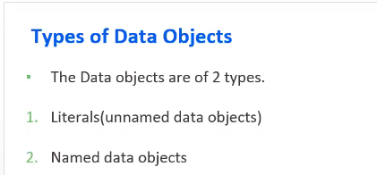
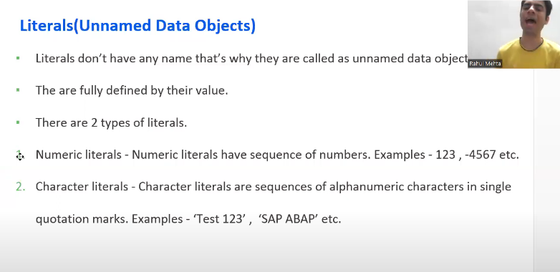
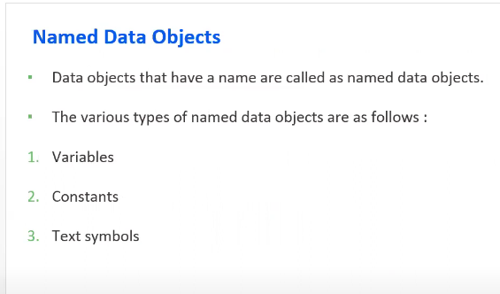

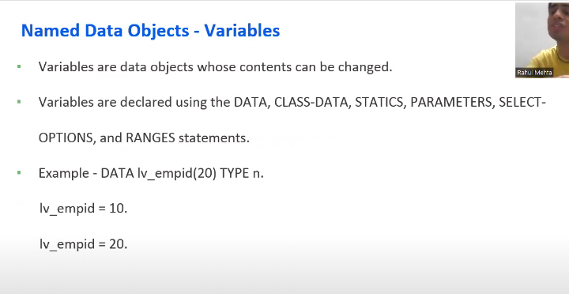
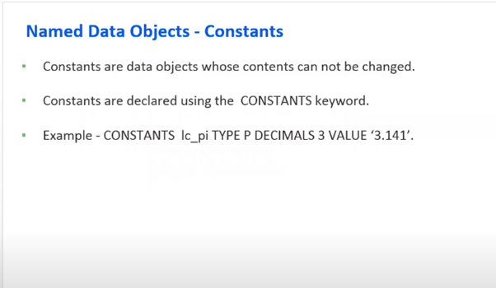
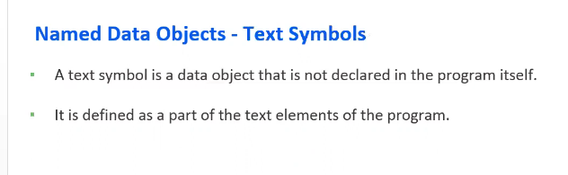

DATA object categories

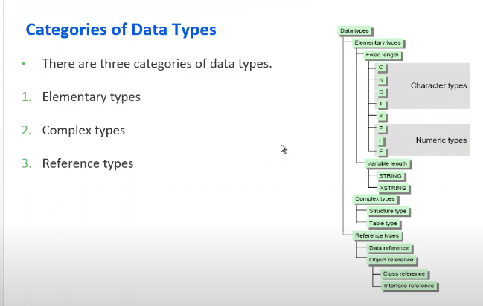

Elementary Data types
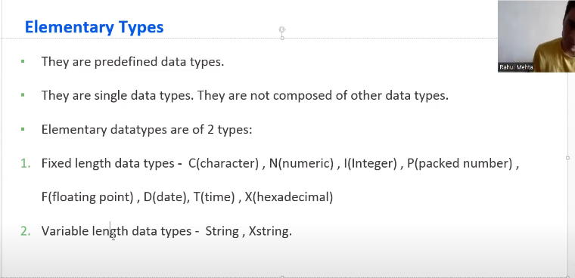

Complex Data types

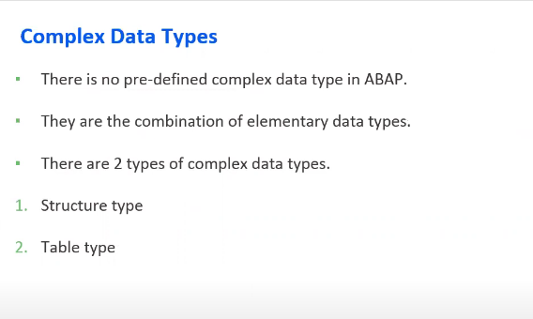

Reference Data Types

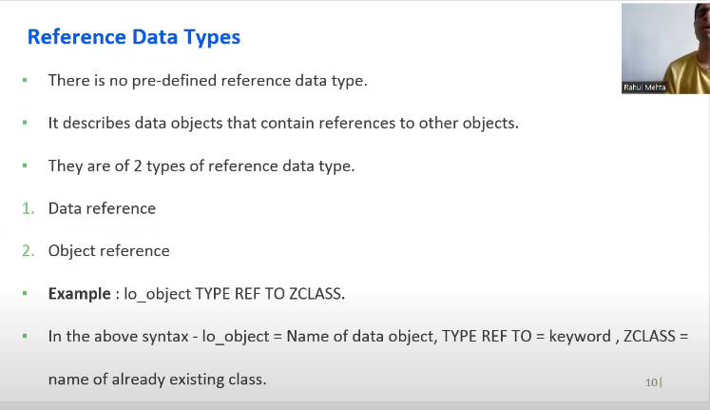

WRITE Statement
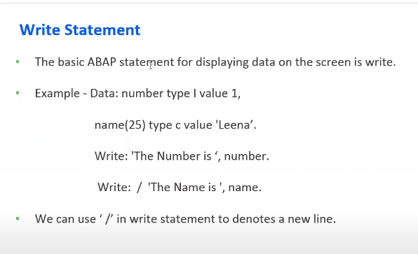

Chain Operator

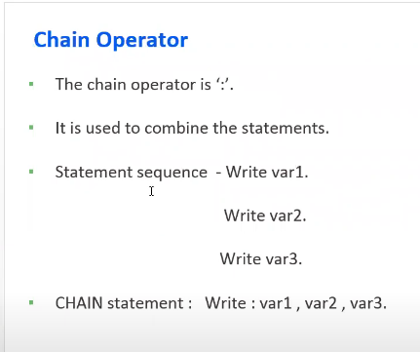

Conditional Statement

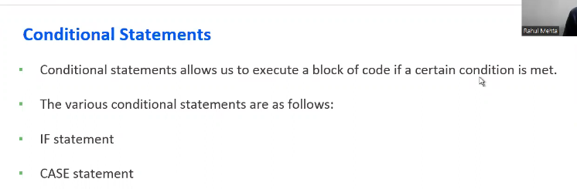

If Statement

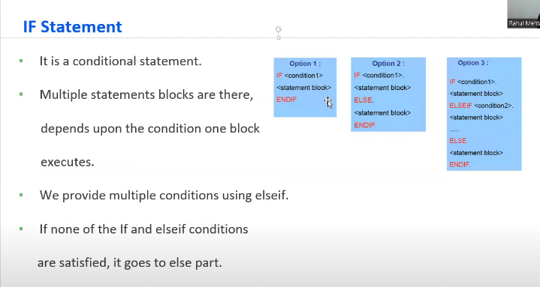

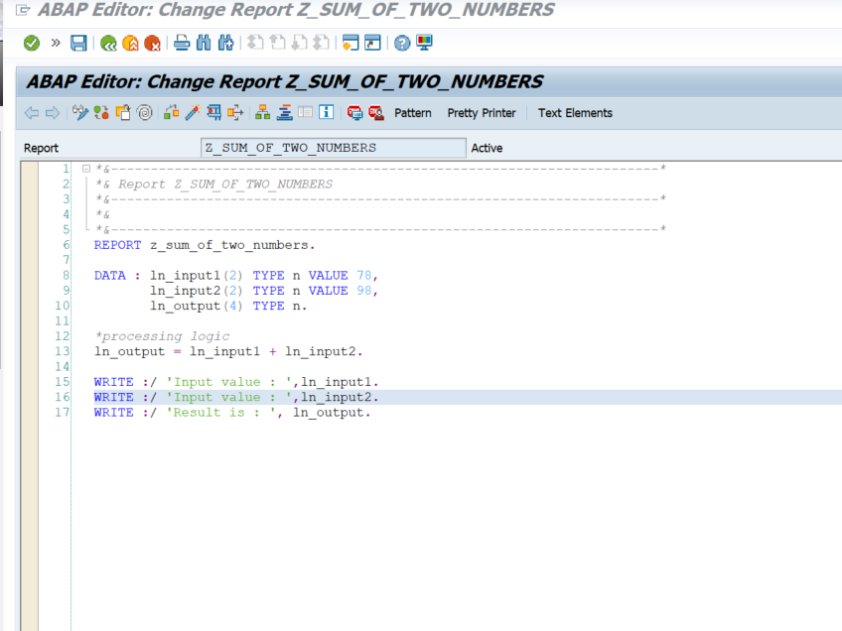
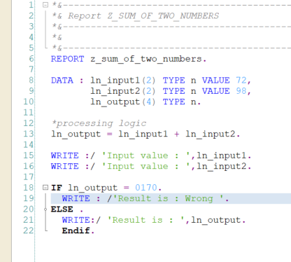

Case Statement
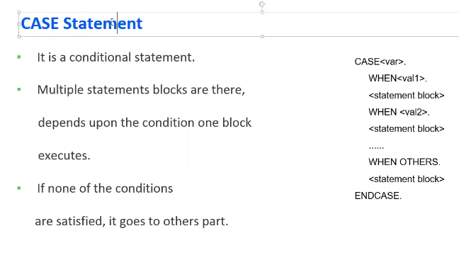
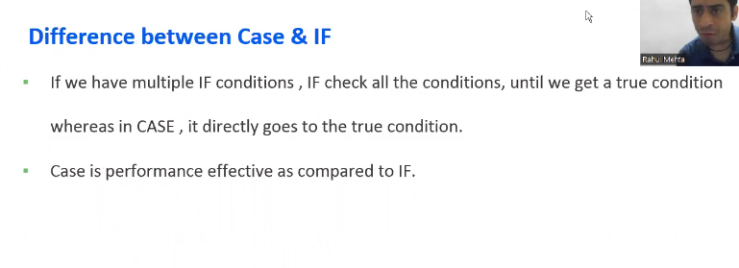

LOOP Statement

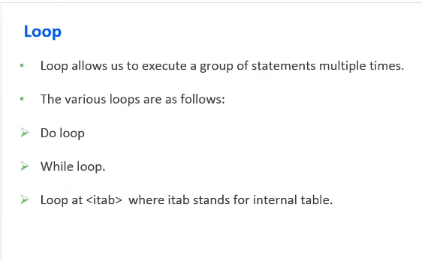

Do Loop Statement

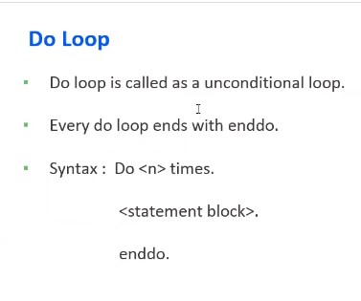

While Loop Statement

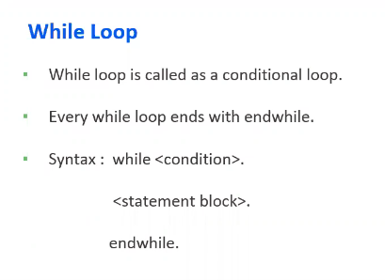

System variables

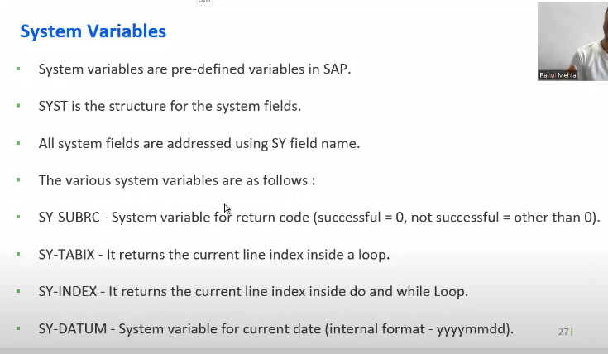
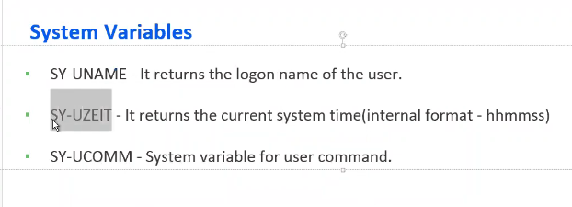
SY-UNAME: returns the username through which the system is logged on.

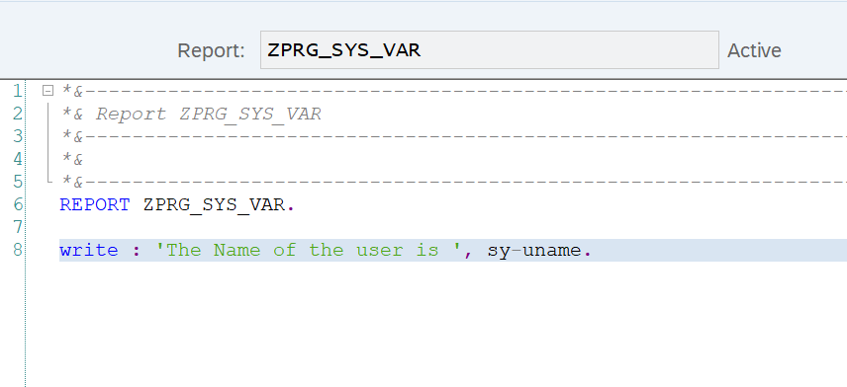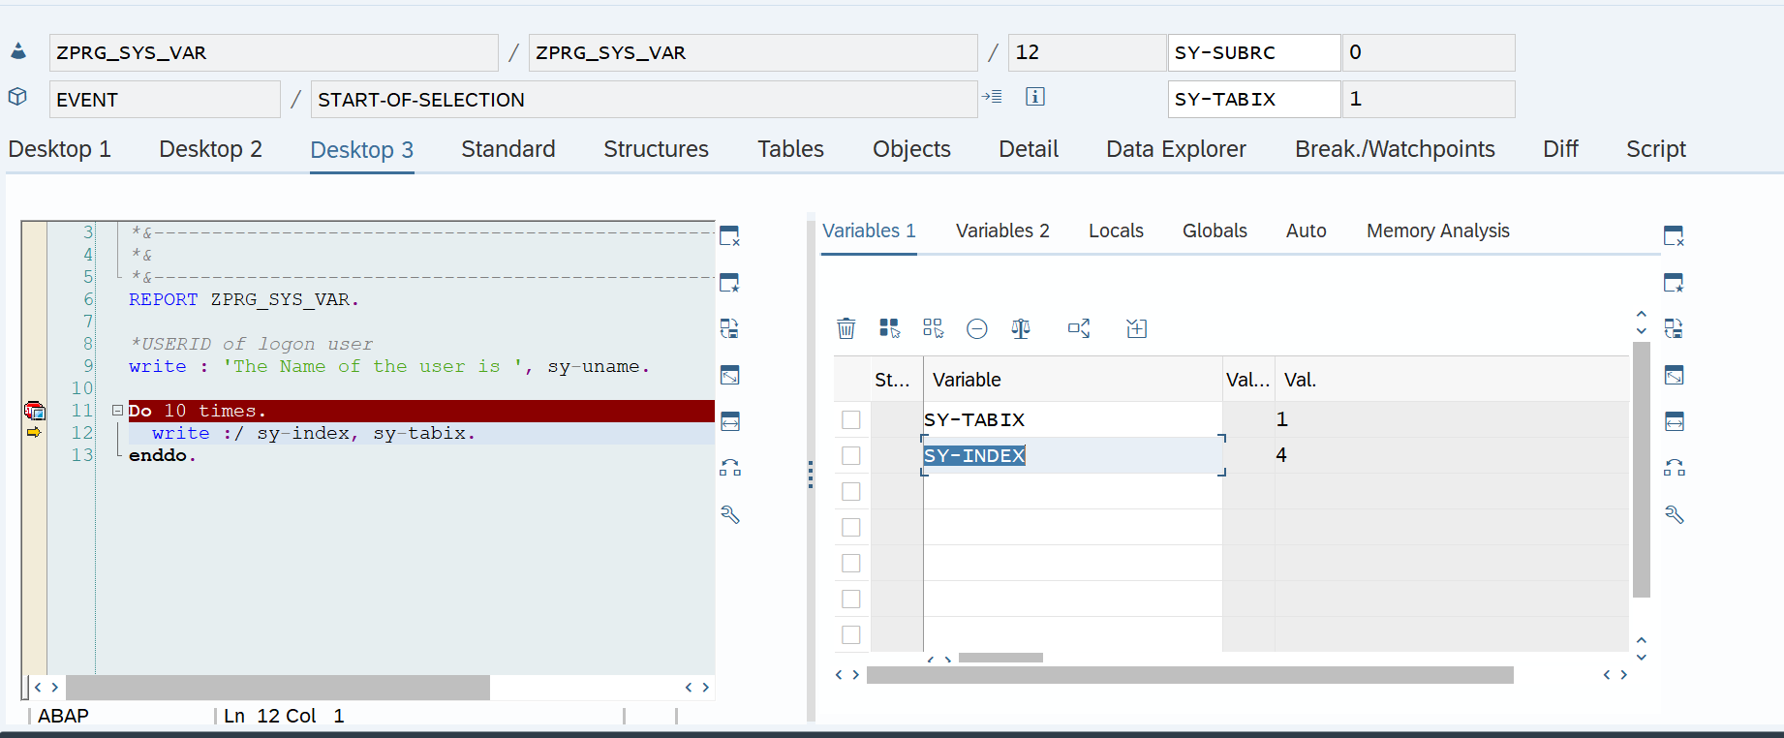
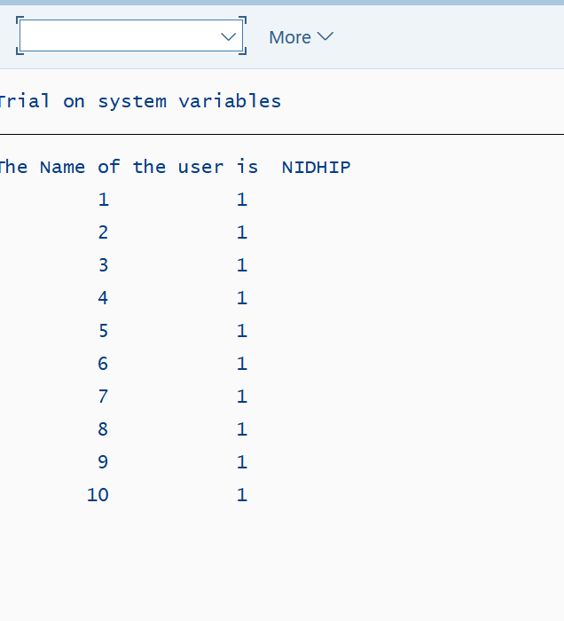
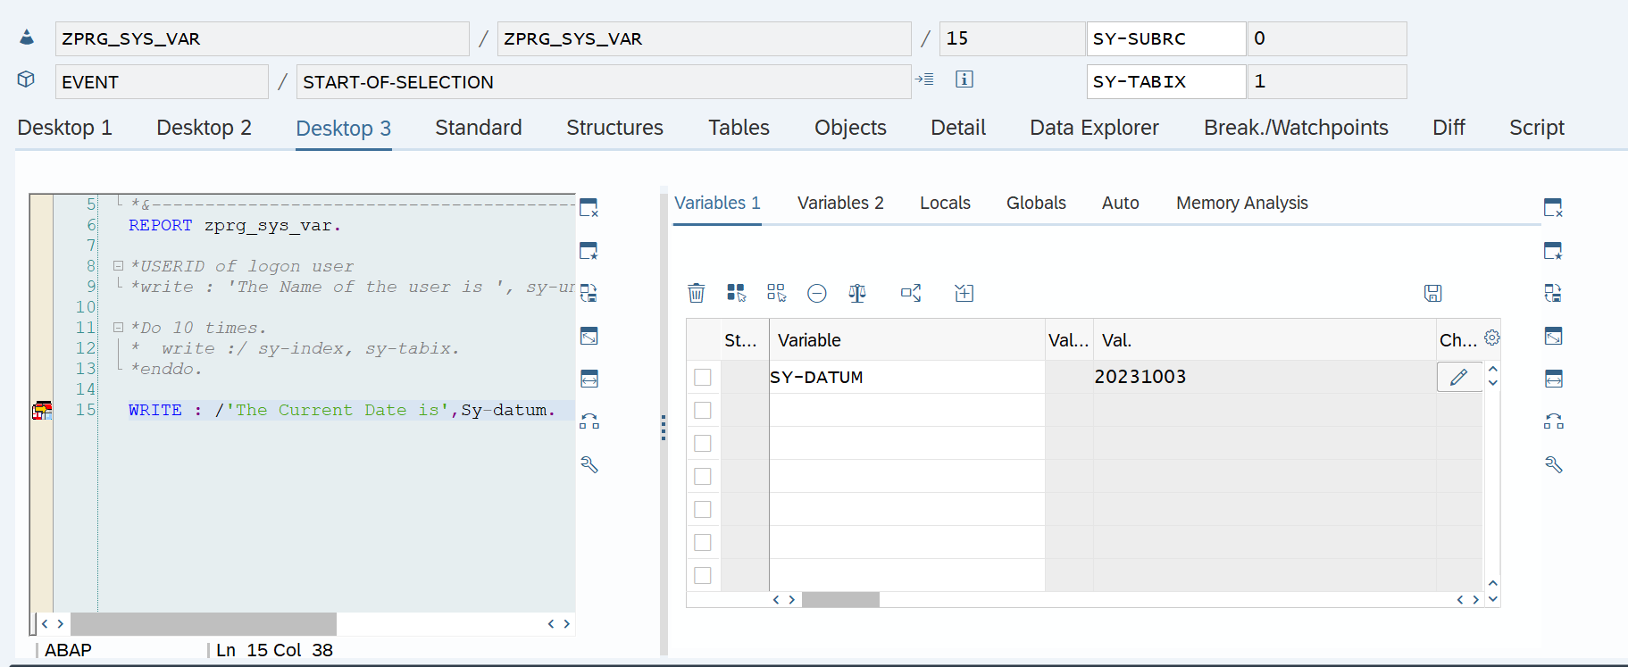
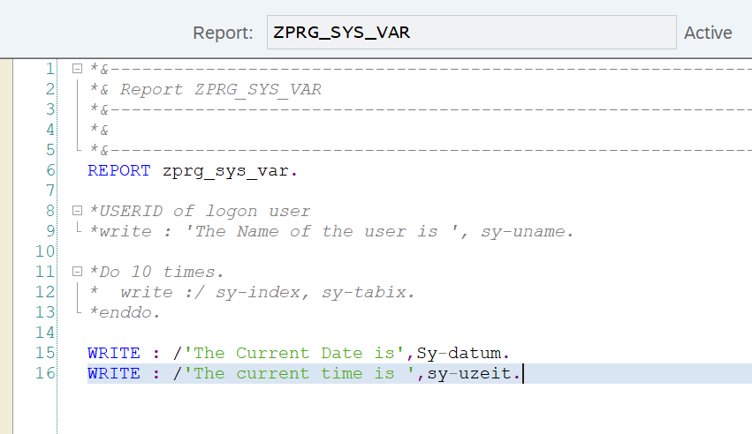
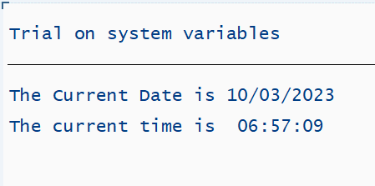

String Operations

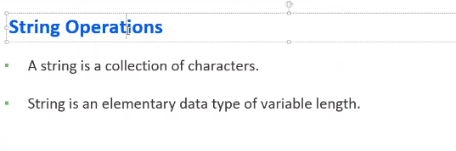

CONCATENATE
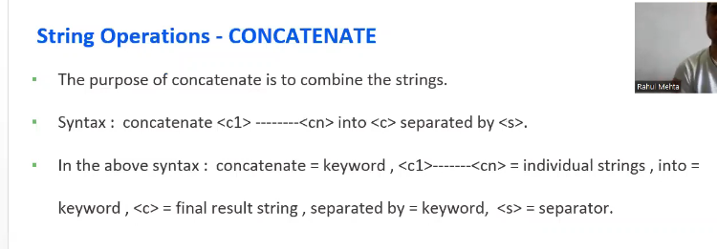
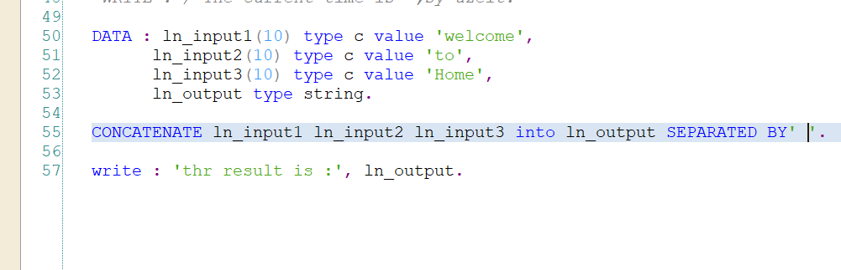

SPLIT

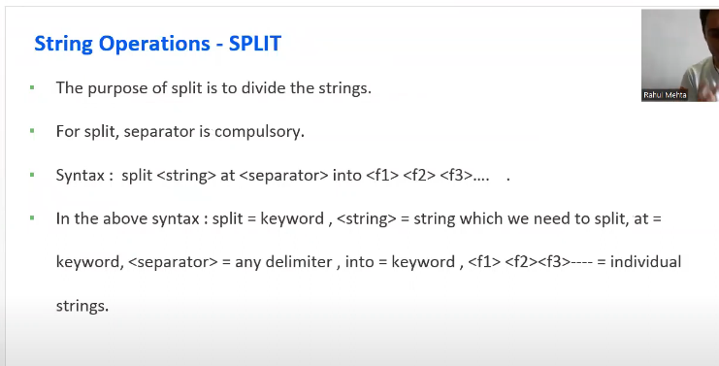
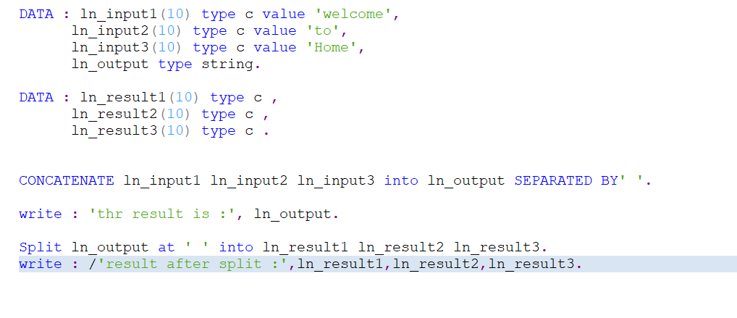

CONDENSE

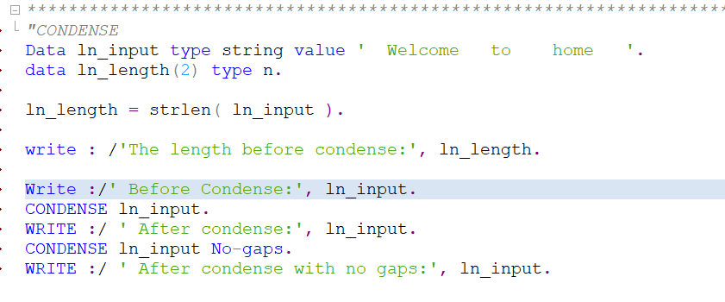

FIND

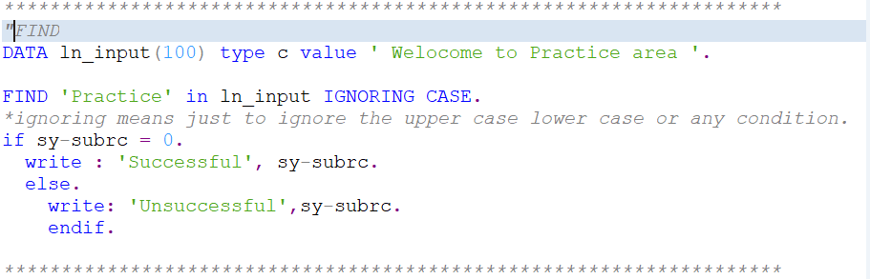

TRANSLATE

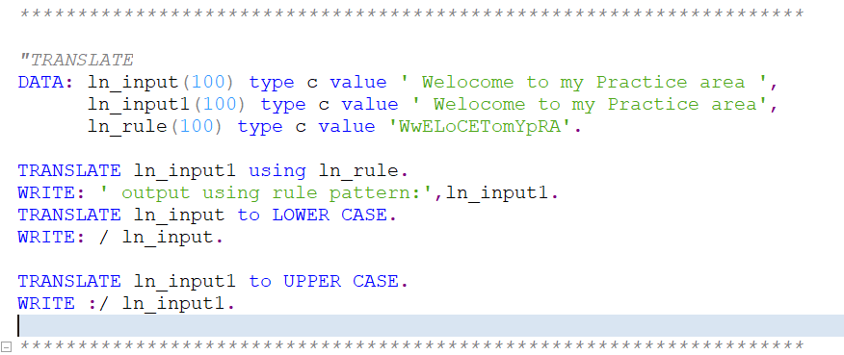

SHIFT

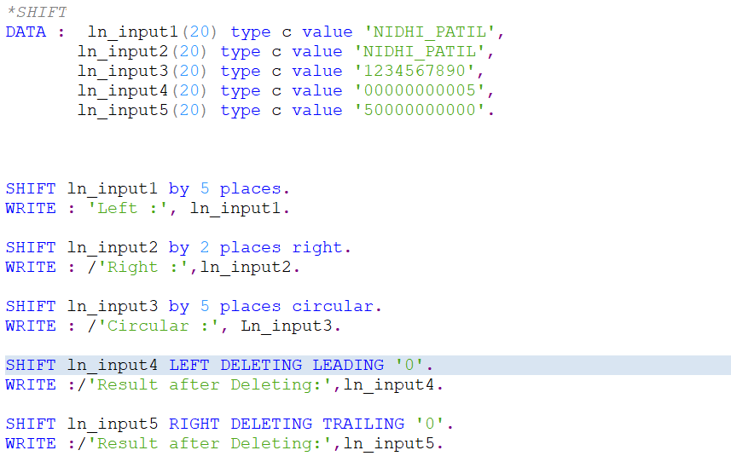

SUBPROCESS

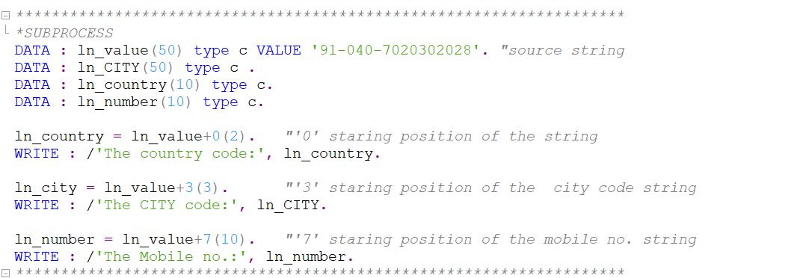

Internal Table
- Internal tables are the temporary storage of data on the application layer.
- It can store any number of records at run time.
- Is used for storing and formatting data from a database table within a program.

Work Area
- Temporary storage of data.
- WA is a single row of data.
- Is used to process data in an internal table, one line at a time.

- Complex Data Type: (SE11)

- Structure:
- Structure should be created with a (best naming convention) standard name “lty – local type”.

- Table Type:
- Table type is always for the internal table.
- It is not for the WA.
- We can define table type for Internal tables only.

Internal Table Operations

APPEND
to insert data into the internal table at last.

DELETE
delete records from the internal table.

MODIFY
use to modify the records in the internal table.

LOOP
used to read the records one by one in the internal table.

READ TABLE:
used to read the 1st matching record from the internal table.

CLEAR, REFRESH
used to clear content.

COLLECT
used to make the sum of amount values based upon unique character values.

- ZPRG_PRAC_INTERNALTABLE Refer to this report for an understanding of the internal table operations.

Types of Internal Table

Standard Internal Table
- They are the default internal table.
- Index-based internal table.
- Both append and insert operations can be used to insert the records into a standard internal table.
- Data is not sorted by default.

Sorted Internal table.
- They are the special type of internal tables in which data is automatically sorted.
- The key needs to be specified while declaring the internal table.
- Sorted internal tables are also index-based internal tables.
- Only the insert operation can be used to insert the records into sorted internal tables.

Hashed internal table.
- A special type of internal table that works on HASH algorithms.
- They are not the index-based internal table.
- Only insert operation can be used to insert the records.
- Highest performance

Internal Table with Header line
- There is an implicit (SAP automatically provides the work area) work area.
- The name of the work area is the same as that of the internal table.

Internal Table without header line.
- There is an explicit (external) work area.
- We can declare an explicit work area.

Data Dictionary

Domain
- Displays the technical characteristics (Data type, length) of a Field/Column.

Data Element
- The label or name that the user can see for the field or columns.

Mandt(Client no of the System)
- Tables having a Mandt field are called client-dependent tables. Means the table will be visible to only the specific client
- Tables that do not have the MANDT field are called client-independent tables.

Data browser/Table view maintenance options
- Display/maintenance allowed
- Display/maintenance allowed with restriction
- Display/maintenance not allowed
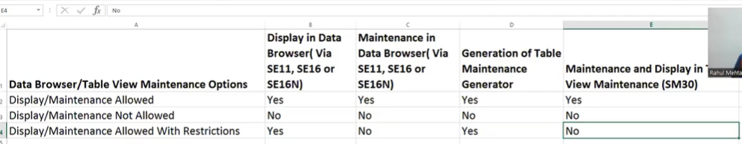

Primary key
- The primary key identifies the record uniquely.
- The primary key of the table should always be at the top of the table.
- The primary key of one table acts as the foreign key in another table.

Data Class
- Defines in which portion of the database the table data will be stored.

Delivery Class
- It is used for controlling the data transport of tables during installation
- Upgrading and transporting between customer systems.

Table maintenance Generator
- Authorization group: &NC& - any user can maintain the data
- Single Step: Only the overview screen is applicable
- Two-step: Both the overview screen and single screen are applicable.
- In the two-step process, we can add a record at a time where whereas in the one-step we can add multiple entries one after the other.
- When the data is to be maintained by SM30, they keep the browser/table view Editing as Display/Maintenance Allowed.
- If we update the column or any other details of the table, then we need to recreate the TMG for that table.

Size category
- A table can store how many records. (Editable)

Types of SAP Data
- Master Data, which is accessed frequently but changes rarely.
- Transaction Data – which is always changing, the number of records re continuously increasing.
- Configuration data- which we can customize, depending on the business scenario and customer requirements.
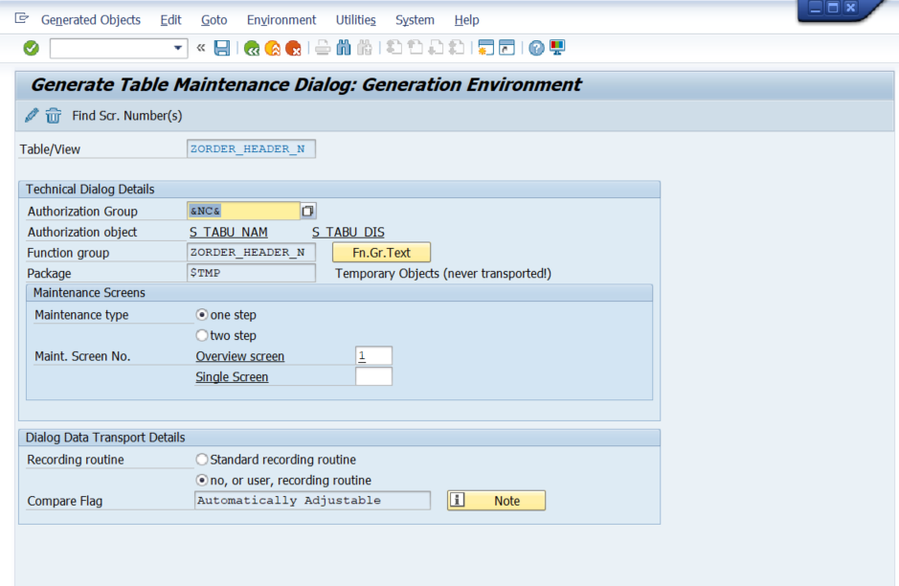

Cardinality:
- The number of records in the key table corresponds to the numbers of records are there in the Secondary/foreign key table.

Structure
- Is a collection of fields, columns of different data types or similar data types.
- The table has data, but the Structure does not have any data.

Include
- It is a reusable structure.
- We can insert the include structure at any point.
- Can be added to the custom table, not to the SAP-specific table.
- SE11>> Data Type (ZINCLUDE_STR_N)- Structure>>>edit>>include>>>insert

Append
- It is not a reusable Structure.
- It always inserts at the last.
- It can be added to both SAP-specific and Custom.

Views
- It is a virtual table, which does not have any data.
- A view is the logical database.
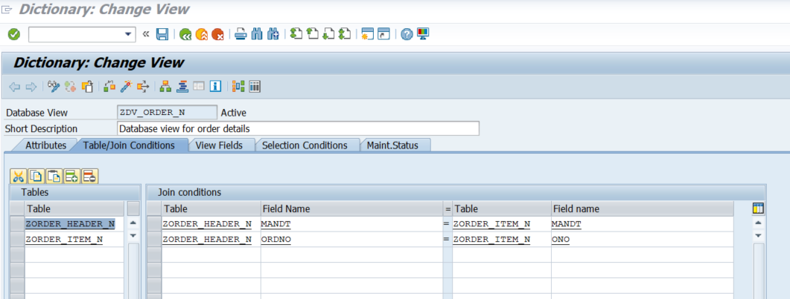

Database View
- It is a collection of one or more database tables.

Projection view
- It is applicable for a single table only.
- We can create a view with the selected fields that are required.

Maintenance View
- Its purpose is to maintain multiple tables.
- The cardinality should be 1:1
- We can generate a single TMG for all the tables included in the maintenance view.

Help views
- It is used in the Search help.
- The cardinality should be 1:1
- The content button is disabled in help view. It gets enable when it is used in search help.
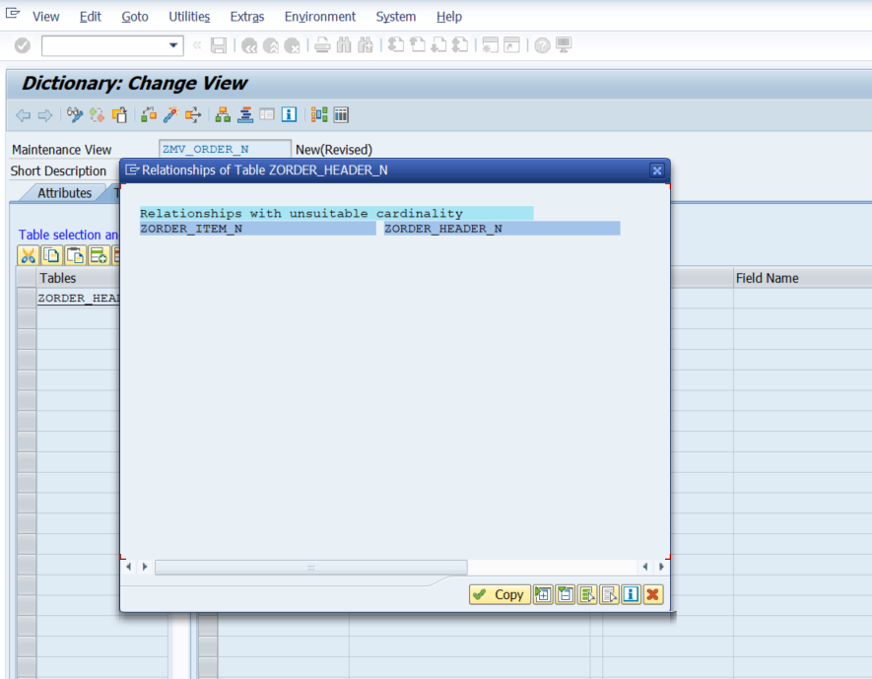

Index
- It increases the high performance
- It stores data in a stored order.
- Disadvantage: it will occupy space on the database layer.
- The index name is 3 characters.
- Index is getting stored in the database with the naming convention of: ZORDER_HEADER_N~ODT
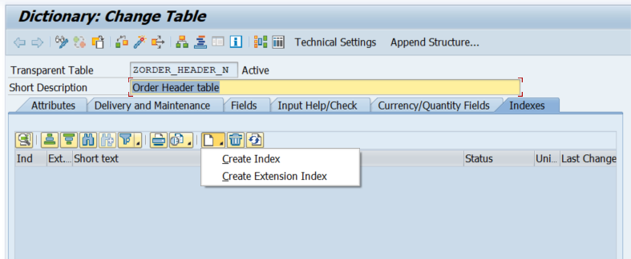

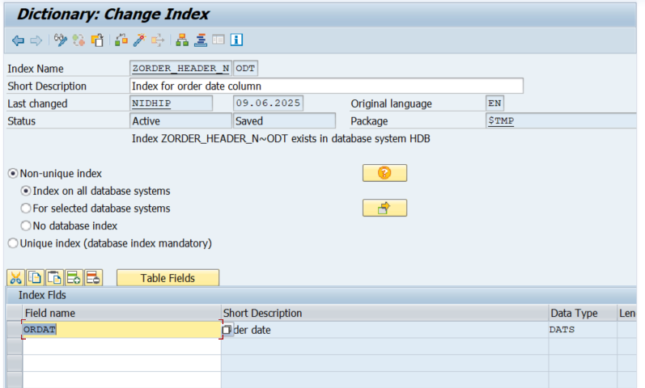

Primary index
- Primary key will act as the primary index

Secondary index
- Based on the requirement, the secondary key is created.
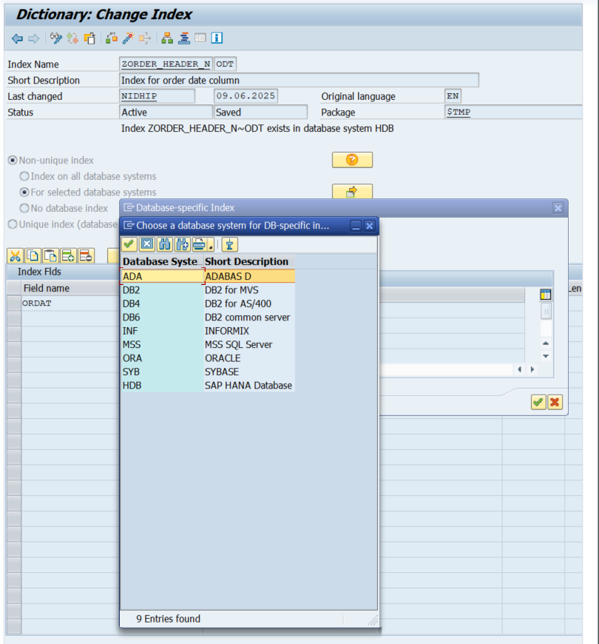
Figure 1 available databases in the System
SYBASE (SAP ASE) | SAP HANA Database | ORACLE | MSS SQL Server | INFORMIX | DB2 for MVS | DB2 for AS/400 | DB2 Common Server | ADABAS D (SAP MaxDB)
Relational Database Management System (RDBMS) | In-Memory, Columnar, Multi-Model Database | Relational Database Management System (RDBMS) | Relational Database Management System (RDBMS) | Relational Database Management System (RDBMS) | Relational Database Management System (RDBMS) | Relational Database Management System (RDBMS) | Relational Database Management System (RDBMS) | Relational Database Management System (RDBMS)
Disk-based | In-memory (main storage), with disk persistence | Disk-based | Disk-based | Disk-based | Disk-based | Disk-based | Disk-based | Disk-based
Yes (with Sybase IQ, a separate product) | Yes (core to its architecture) | No (primarily row-store) | No (primarily row-store) | No (primarily row-store) | No (primarily row-store) | No (primarily row-store) | No (primarily row-store) | No (primarily row-store)
Online Transaction Processing (OLTP) | Real-time OLTP & OLAP (converged) | OLTP, high availability | OLTP, ease of use (especially on Windows) | OLTP, robustness | OLTP, mainframe environments | OLTP, IBM i (AS/400) environments | OLTP & OLAP (distributed) | OLTP, SAP-specific workloads
Supported for SAP Business Suite ECC (older versions of SAP ERP) after SAP acquired Sybase. | Exclusive database for SAP S/4HANA. Also used for SAP Business Warehouse (BW) on HANA, SAP Business Suite on HANA (pre-S/4HANA). | Widely used for SAP Business Suite ECC (older versions), especially in large enterprises. | Widely used for SAP Business Suite ECC (older versions), particularly in Microsoft-centric environments. | Supported for older, legacy SAP ECC versions. Limited or no support for newer SAP products. | Supported for SAP Business Suite ECC on IBM mainframe (z/OS) platforms. | Supported for SAP Business Suite ECC on IBM i (AS/400) platforms | Supported for SAP Business Suite ECC on distributed platforms (Unix/Linux/Windows). | Acquired by SAP and rebranded as SAP MaxDB. Supported for SAP Business Suite ECC, SAP Content Server, and other SAP NetWeaver components.
Scalability, reliability, cost-effectiveness (compared to Oracle) | Unparalleled speed for real-time analytics & transactions, simplified data model, advanced analytics capabilities. | Industry standard, extreme scalability, high availability (RAC, Data Guard), comprehensive features. | Ease of use, strong integration with Microsoft ecosystem, good performance for mid-range SAP deployments | Robustness, reliability, high concurrency. | High reliability, security, scalability for mission-critical mainframe workloads. | Integrated platform, high reliability, ease of management for IBM i. | High performance, scalability, platform flexibility across Unix/Linux/Windows. | SAP-specific optimizations, low TCO, good performance for standard SAP scenarios.
Decreased (focus shifted to HANA) | Highest - the foundational database for SAP's future (S/4HANA) | Decreased (for new S/4HANA deployments), but still prevalent for older ECC systems. | Decreased (for new S/4HANA deployments), but still prevalent for older ECC systems. | Very low, considered legacy. | Decreased (for new S/4HANA deployments), but relevant for existing mainframe SAP ECC. | Decreased (for new S/4HANA deployments), but relevant for existing IBM i SAP ECC. | Decreased (for new S/4HANA deployments), but relevant for existing distributed SAP ECC. | Low (MaxDB is still supported but not the strategic direction).

Search help
- It is also called F4 help(Value help)
- Its purpose is to display the various possible values for any Input field.
- Selection method is the name of the table or the name of the view where we are fetching the data.
- Dialog Types:
- Display Values immediately: Values will display immediately.
- Dialog with value restriction: Before displaying the values, a restriction dialog will appear.
- Dialog depends upon the set of values: If the table has fewer than 100 values, it will switch to displaying values immediately. If the table has more than 100 values, it will switch to a dialog with value restriction.

Elementary help
- Single search help
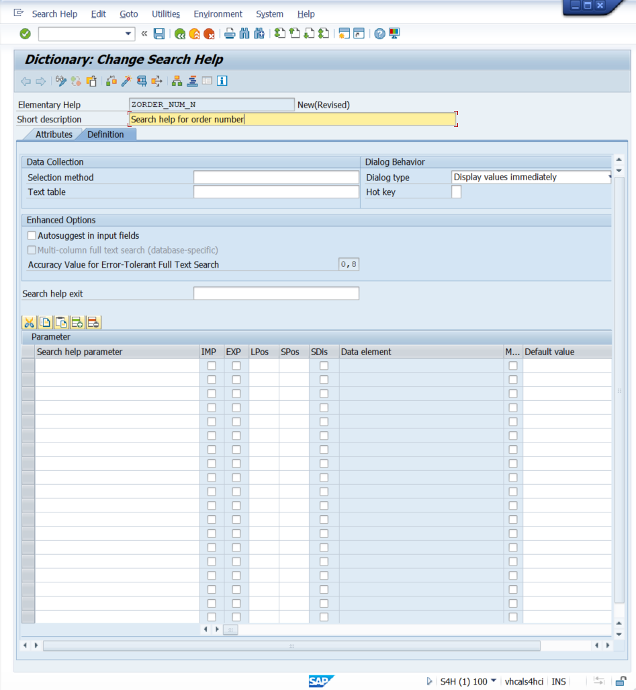
- Selection method: It is the name of the table or the name of the view from which we are fetching the data.
- Dialog type:
- Display values immediately: values<100, values will be displayed immediately.
- Dialog with value restrictions: values>100 to filter/restrict out some of the values.
- Dialog depends on a set of values- if the table has fewer than 100 values, it will switch to display the value immediately.
If the table has greater than 100, it will switch to a dialog with value restriction.
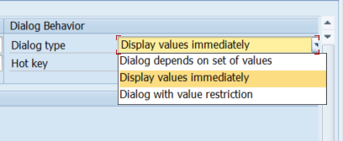

Collective search helps
- It is a combination of elementary search helps. We can include 2 or more elementary search helps in the collective search help.

- Search help parameters: Field of search help
- The import check box should be unticked if the default value is passed to the parameter.
- LPOS: List position (when values got displayed)
- SPOS: Screen position (Before displaying the values)
- Modify: to modify the data element.
- SDIs: to make any field in the read-only mode.
- Import: Input
- Exporting: To export the values from the hit list to the screen fields (Input fields).
- Hot key: the hot key allows the user to select the elementary search help from the collective search help directly in the input field with a short notation.
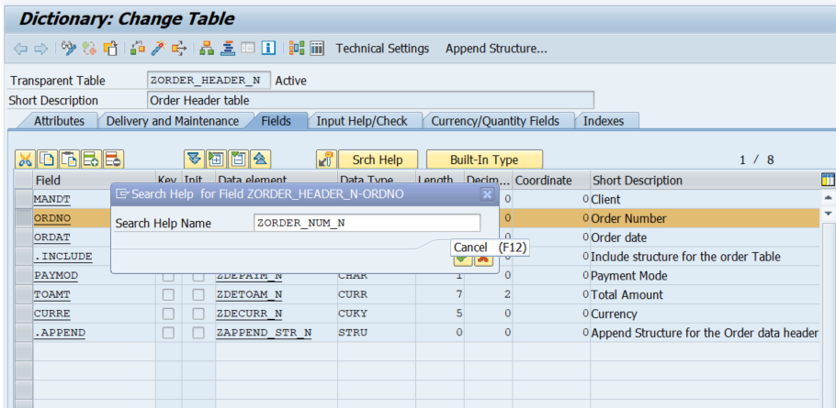
- To assign the search help to the parameter in the report Match code object key is used.
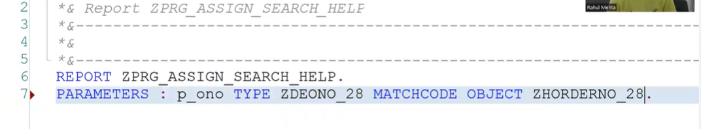

Table Buffering
- Buffer is a temporary storage on the application layer.
- It improves the performance when accessing the contents from the table.
- Buffering is part of the technical settings of the table.
- Buffering should be used for tables, where single records are accessed by specifying the complete key.
- We can check the buffer through the Tcode: AL12.
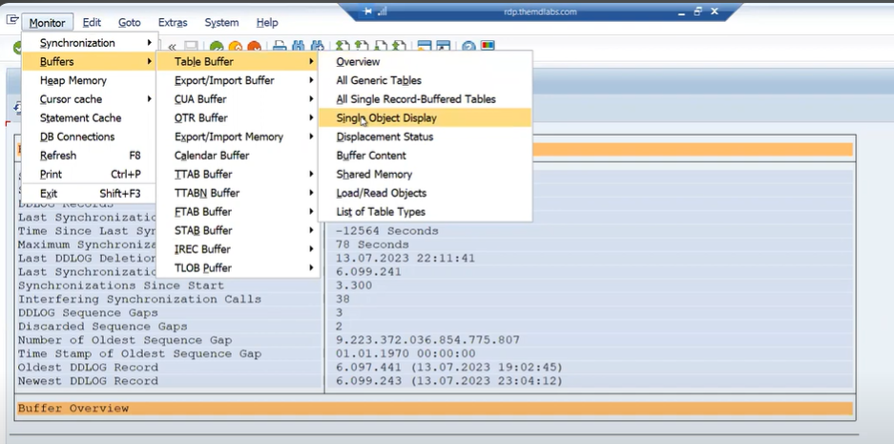

Single record buffering
- Single record buffering, single record loads in the buffer at a time.

Full Record buffering
- Full buffering: full table records are loaded in the buffer.

Generic Area

Types of Database Tables

Transparent table
- There is a 1:1 relationship between the ABAP dictionary and the database.

Pooled table
- There is a N:1 relationship between the ABAP dictionary and the database.
- Primary-foreign key relationship is not required.
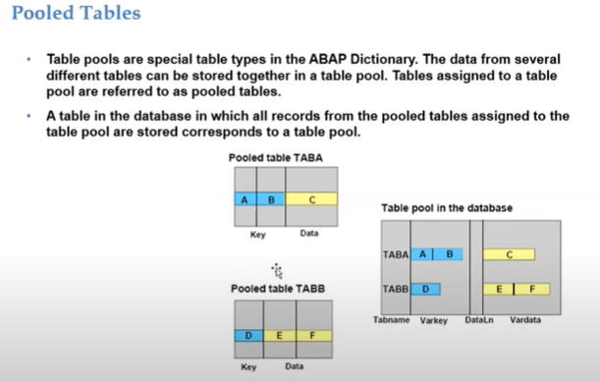

Cluster table
- There is N:1 relationship between the ABAP dictionary and the database.
- A primary-foreign key relationship is required.

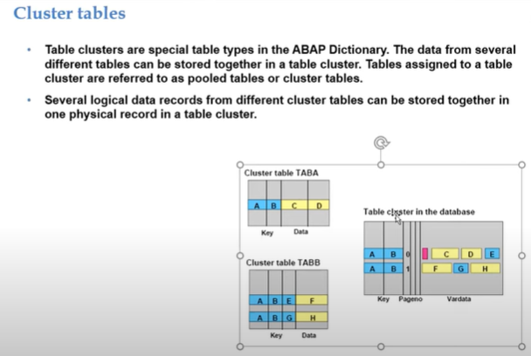

Selection Screen

- The selection screen or input screen always has the no. = 1000.
- With the selection screen user provides input to the program.
- 2 ways to provide input to the program.

Parameters
are used to pass the single input.
PARAMETERS <P>……….DEFAULT<F>………...
PARAMETERS <P>………. OBLIGATORY…………
PARAMETERS <P>……….AS CHECKBOX………...
PARAMETERS <P>………. RADIOBUTTON GROUP <radi>………...

Select-options.
- Select-option is used to pass a range of inputs.
SELECT-OPTIONS <seltab> FOR <f>…DEFAULT<g>[TO<h>]
SELECT-OPTIONS <seltab> FOR <f>…NO-EXTENSION
SELECT-OPTIONS <seltab> FOR <f>…NO INTERVALS
SELECT-OPTIONS <seltab> FOR <f>…OBLIGATORY.

Select-options.
- A text symbol is a data object that is not declared in the program itself.
- It is defined as a part of the text elements of the program.
- Select option is an internal table with a header line.
- A select option has 4 parts.
- Sign – I/E (include/exclude)
- Option – Relational operators (EQ =, BT <>, LT<, etc.)
- Low – low value
- High – high value.
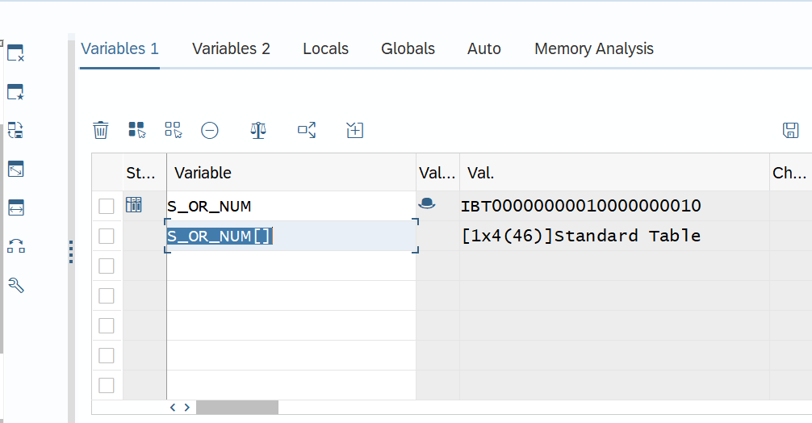
- S_OR_NUM – is work Area.
- S_OR_NUM [] – Internal Table with header line.
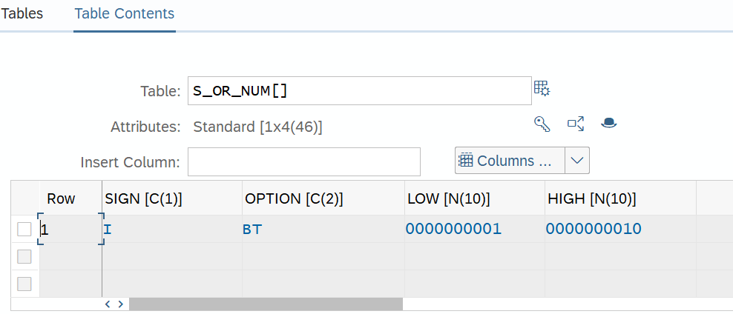

Classical Reports
- Reports are programs that read data from the database, process the data, and display the data in the required format.
- It consists of 2 screens – a selection screen and an output screen.
- In classical reports we displayed the output using a written statement.

Open SQL
- Open SQL is database independent.
- Native SQL is database dependent.

Single database table

Multiple database Tables for All Entries

Multiple Database tables using join.

Column Labels

SY-ULINE and SY-VLINE.
SY-ULINE-> Horizontal line(underline)
SY-VLINE->vertical Line.

Message Class (SE91)
- Types of messages:

A (abort)

E (error)
-> The control comes out of the program.

I (information)
-> The information message comes in the form of a pop-up that executes the rest of the report.
- Lv_flag – ‘X’.
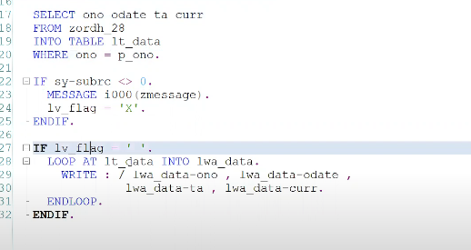
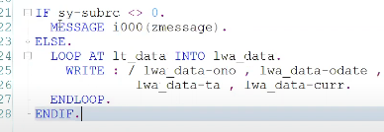

S (success/status)

W (warning)

X (exit)
- Message number length is 3(000-999).
- We can pass values to a message number using &.
- Syntax: MESSAGE E000(<msg class>).

Custom Transaction Code (SE93)
ZNID

Best performance Practices / Guidelines
- Never use * in the query.
- Columns fetching sequence needs to be the same as that of the data dictionary.
- Never use corresponding in the query.
- For traditional databases avoid using JOIN, use FOR ALL ENTRIES IN.
- Traditional database: oracle
- Sybase
- Db2 database
- In the condition of all entries there is only one table is used.
- Where in the case of join there are more than one/multiple tables used.
- Join can be used for the HANA database.
- For fetching data from a foreign key/dependent table always use a sy-subrc or internal table is not an initial condition.
- Use binary search while using READTABLE. As binary search reduces the time.
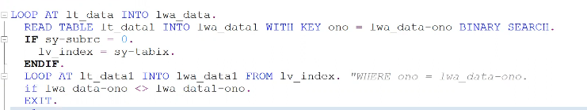
- Use parallel cursor in nested loops.
- For multiple conditions, use case conditional statements rather than if conditional statements.
- Depending upon the requirement, create a secondary index to improve the performance.
- Never right the queries inside the loop.
- For multiple conditions, use a CASE conditional statement rather than IF. It increases the performance of the report. As it is jumping directly on the true condition.

Classical Report Events

- We display the output using the WRITE statement.
- Event is triggered by specific action (mouse click, pressing a key) or occurrence (running out of memory).

Initialization
- This event calls before displaying the selection screen/input screen.
- To initialize the default values.
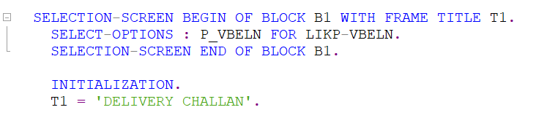

At Selection-screen
- Event calls when the user performs some action (enter, click) on the selection screen.
- Is used to validate the input.

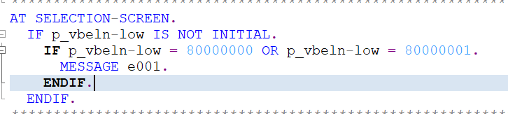

Start-of-selection.
- This event calls when the user clicks the execute button on the selection screen.
- Selection logic is the part of this event.

End-of-Selection.
- This event calls when the selection process ends.
- This event helps to identify the end of data/record.

Top-of-Page.
- Top-of-page event calls when the first write statement occurs in a program.
- It provides a title/header at the beginning of a new page.

End-of-page.

At selection-screen output
- This event calls before the selection screen/input screen.
- The purpose of this event is to modify the selection screen.
- Is equal to PBO (process before output) in module pool.
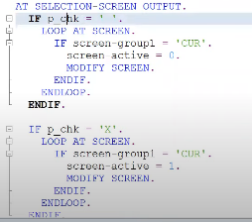

At selection-screen on the value request
- This event calls when the user clicks F4 on a field of the selection screen.
- The purpose of this event is to provide value help for an input field.
- F4 help/value help/Search help.
- F1 help/technical information help.
- STRUCTURE: ‘ZORDH_28’

At selection-screen of the help request

At selection-screen on <field>
- This event calls when the user performs some action on the selection screen.
- Used to validate a particular input field present on the selection screen.
SE11 ->> SCREEN (structure).
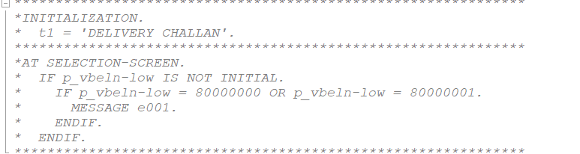

Interactive Classical Report Events
- In classical reports we only display the output on a basic list. There is no interaction with the output.

Interactive report Terminology

Basic List
- When we excite the program and get an output the first list visible to the user is the basic list.
- Generated at first by our ABAP program.
- The number of basic lists in the classical report is 1.

Secondary list
- Secondary lists are generated by further navigation or user selection from the basic list.
- The number of secondary lists in the classical report is 20.

Events in Interactive Classical Report

At Line-selection
- When the user double-clicks on the line or selects a line and presses F2 or selects a line and clicks choose at that time at line-selection event triggers.

At user-command
- When a user clicks on the functions created using pf-status, at that time at user command event triggers.
- The system variable sy-ucomm is used to capture the value of the function code.
- SY-UCOMM -> is a system variable for user command.
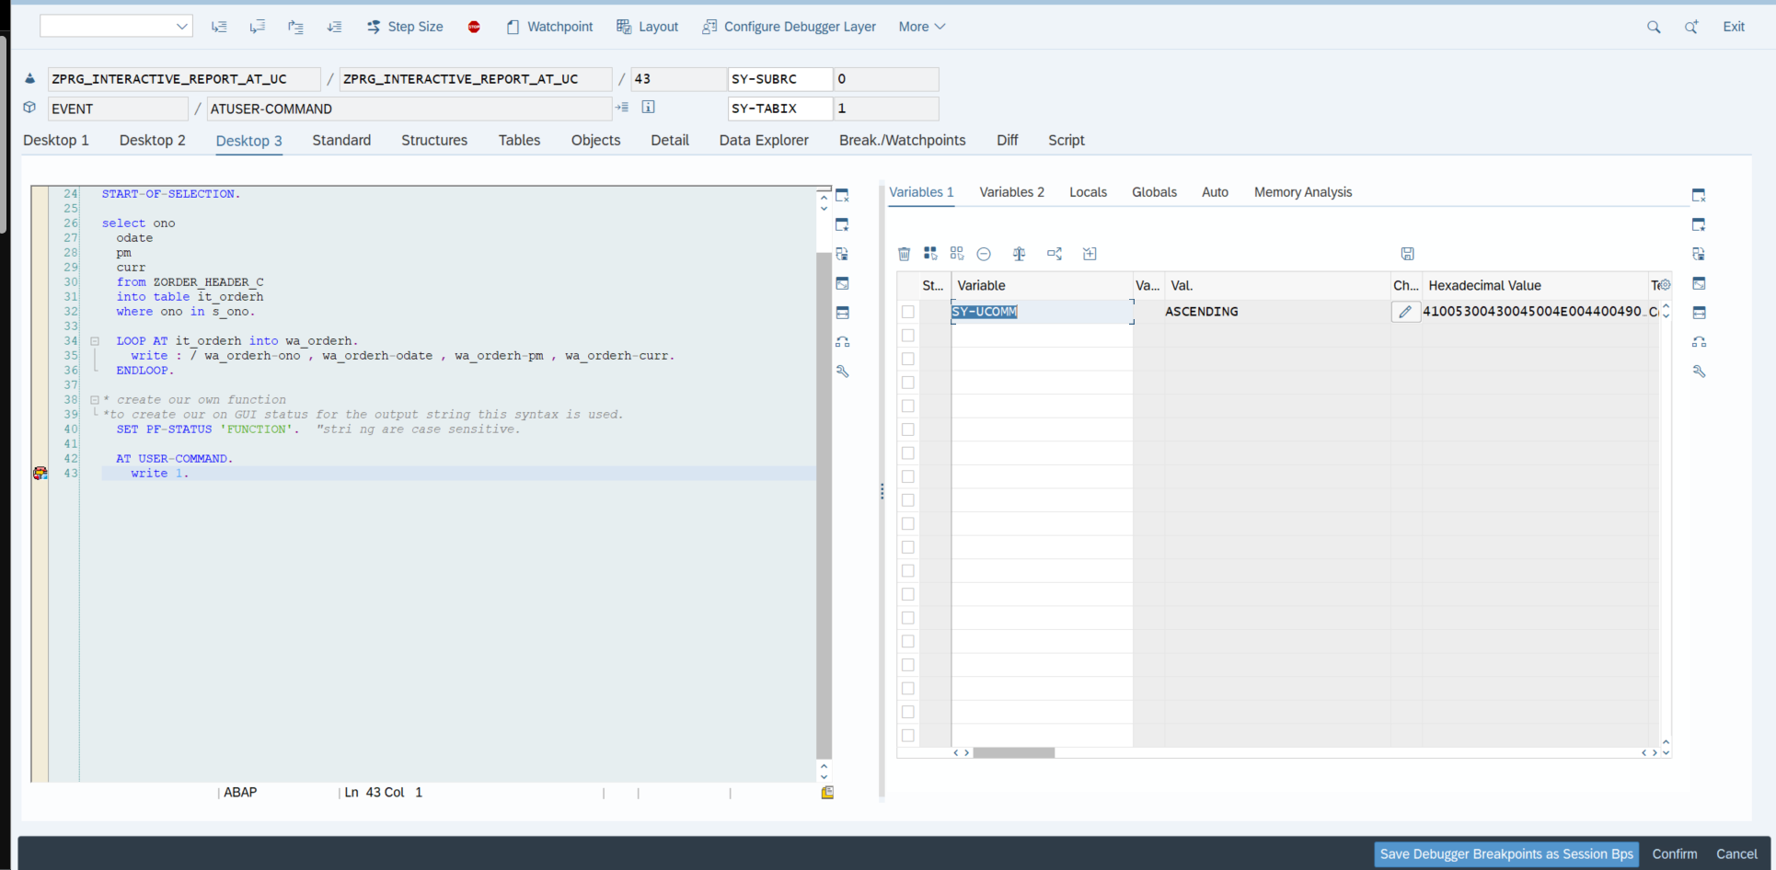
Figure 2 value of the system variable SY-UCOMM.
- To create our own GUI screen for the output.
- “Get PF-STATUS ‘FUNCTION’.” -> syntax.

Custom GUI creation
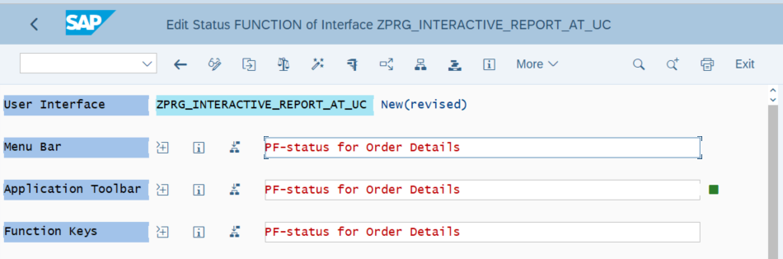
Figure 3 after double clicking the created function.

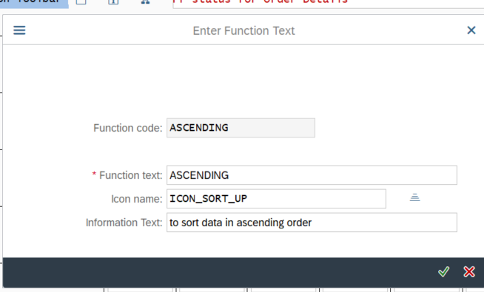
Figure 4 Enter the function text for more understanding.
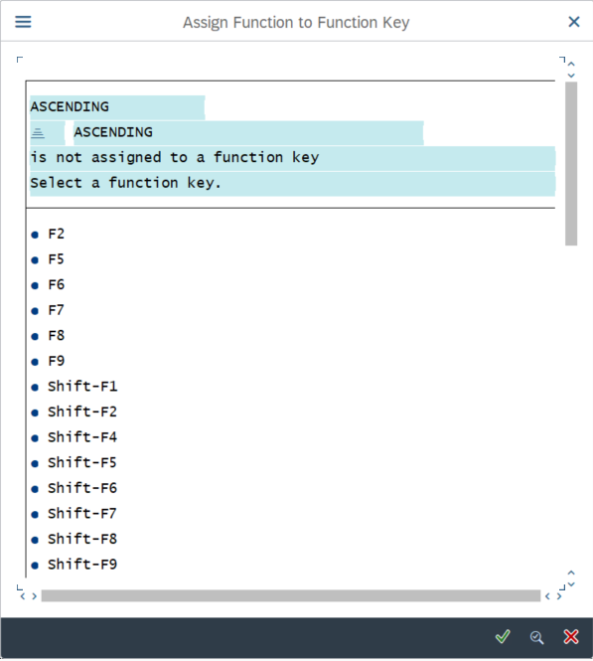
Figure 5 select the shortcut key for the button.
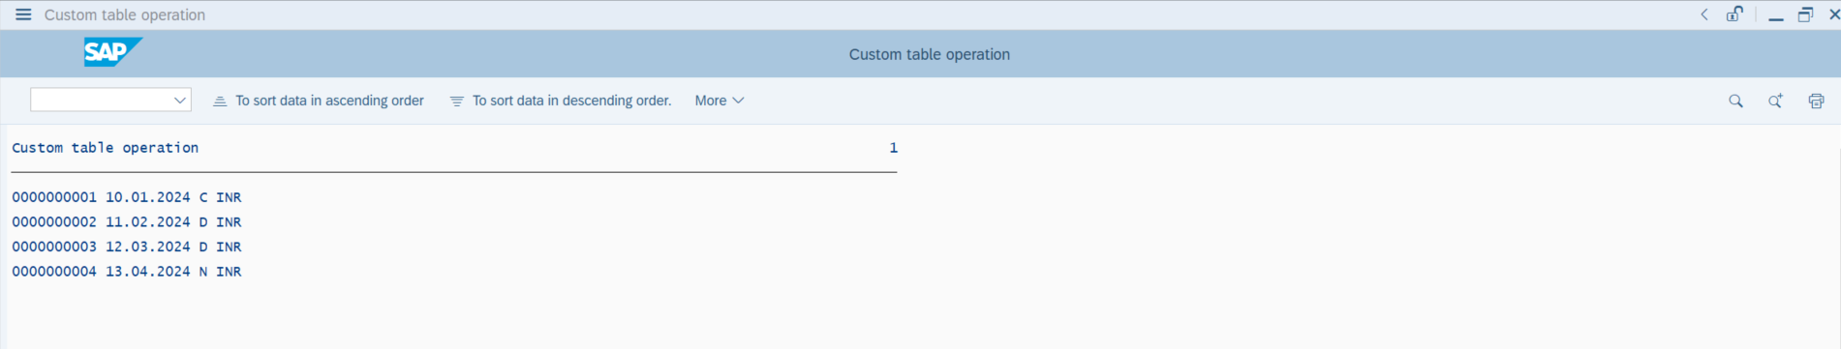
Figure 6 Output of the custom-created GUI screen.

Top-of-page during line-selection.
- This event calls when the first WRITE statement occurs in a program for a page on the secondary list.
- Its purpose is to provide a title/header at the beginning of a new page on a secondary list.
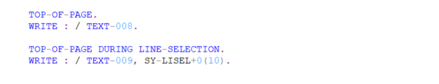
Figure 7 To-of-page event syntax.

System Variable in Interactive Classical report events are as follows:

SY-LISEL.
- It is a system variable that returns the contents of the selected line.

SY-LSIND
- It is a system variable that returns the index of the displayed list.

SY-LILLI
- Absolute number of a selected line in the list displayed.
- It returns the line no. of the selected row.
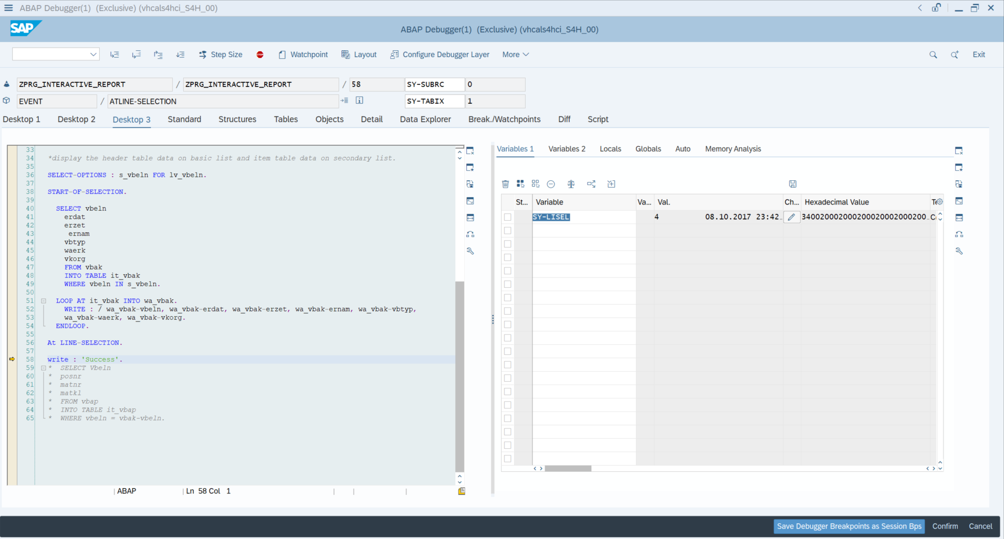
Figure 8 SY-LISEL variable operation.
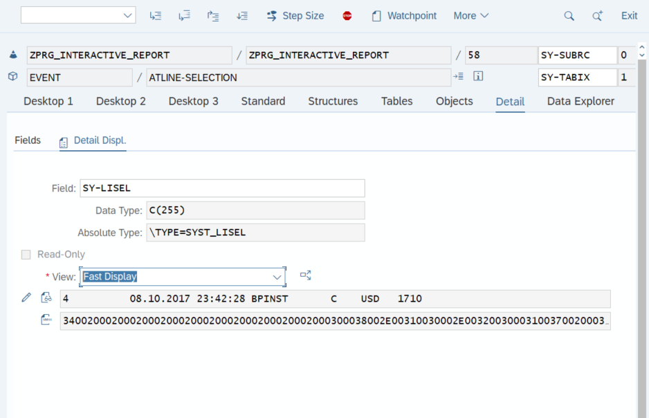
Figure 9 Details of the variable execution.
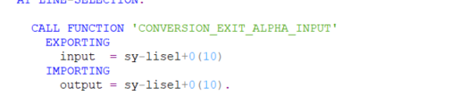
Figure 10 FM to add the Zero for the fields.

Statements in Interactive classical reports

HIDE statement.
- We can use the HIDE statement to store the line-specific information while creating a basic list.
- The stored info can be used while creating a secondary list.
- Syntax: HIDE <f>.
- Field name, field value, and line number from a table can be stored in the Hide area.
- The system variable SY_LILLI determines the selected line.
- When we double-click the selected line then the SY_LILLI system variable returns the selected line.
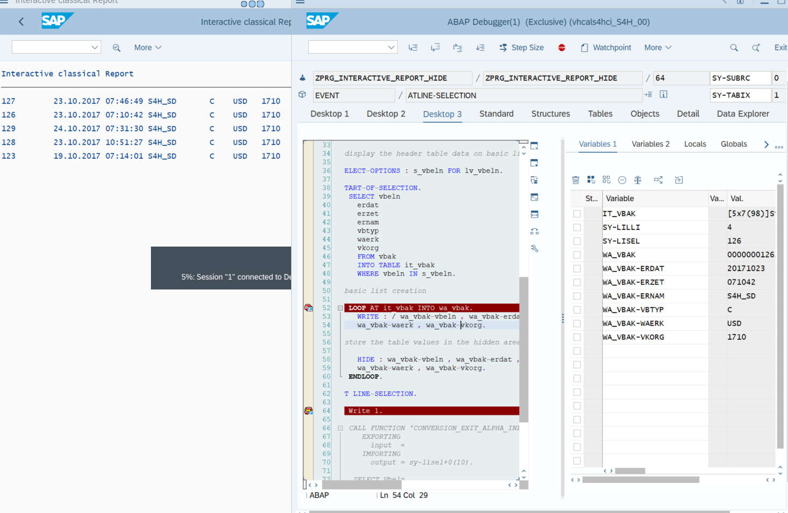
Figure 11 HIDE statement working.
- Pre-requisites for the HIDE statement are as follows:
- Hide statement must be written after the write statement.
- Hide statement must be called inside the loop.

GET CURSOR statement.
- This statement is used to create secondary lists according to the cursor position.
- Syntax: GET CURSOR FIELD <lv_field> VALUE <lv_value>.
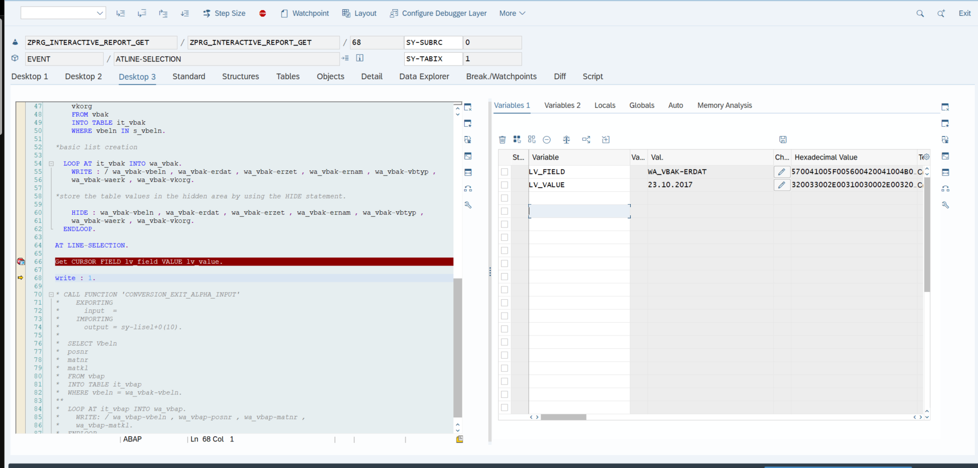
Figure 12 Get Cursor output.

Comparison of HIDE and GET CURSOR statements.

HIDE STATEMENT | GET CURSOR STATEMENT
Respond to a particular line. | Respond for a particular field.
Is used to store the line with the line number. | Is used to store the value of the selected field name.
We cannot display secondary lists based on field name and field value | We can display a secondary list based on the field name and field value.

Control Break Statements/Events.
- Control break statements are used to control the loop, or we can say they are used to control the data flow in the loop.
- They are triggered automatically without doing any action.
- Control break statements start with at and end with end-at.
- Prerequisites to apply control statements.
- Control break statements should be applied inside a loop.
- The Internal Table should be in sorted order.

Types of Control Break Statement

AT FIRST
- It triggers the first row/first record/first iteration of the internal table in the loop.

AT LAST
- It triggers the last row/last record/last iteration of the internal table in the loop.

AT NEW <fieldname>
- It triggers the new/first record of a group having the same value for the specified field name in the loop.

AT END OF <fieldname>
- It triggers for last record of a group having the same value for the specified field name in the loop.

Control Break Statement with SUM Statement.
- SUM statement can only be used in the loop-end loop statement and needs to be applied in control break statements (at and end-at).
- It calculates the sum of all numeric fields to the right of the current group key.
- Sum is for all rows of the current group and assigns it to the corresponding components of the work area.
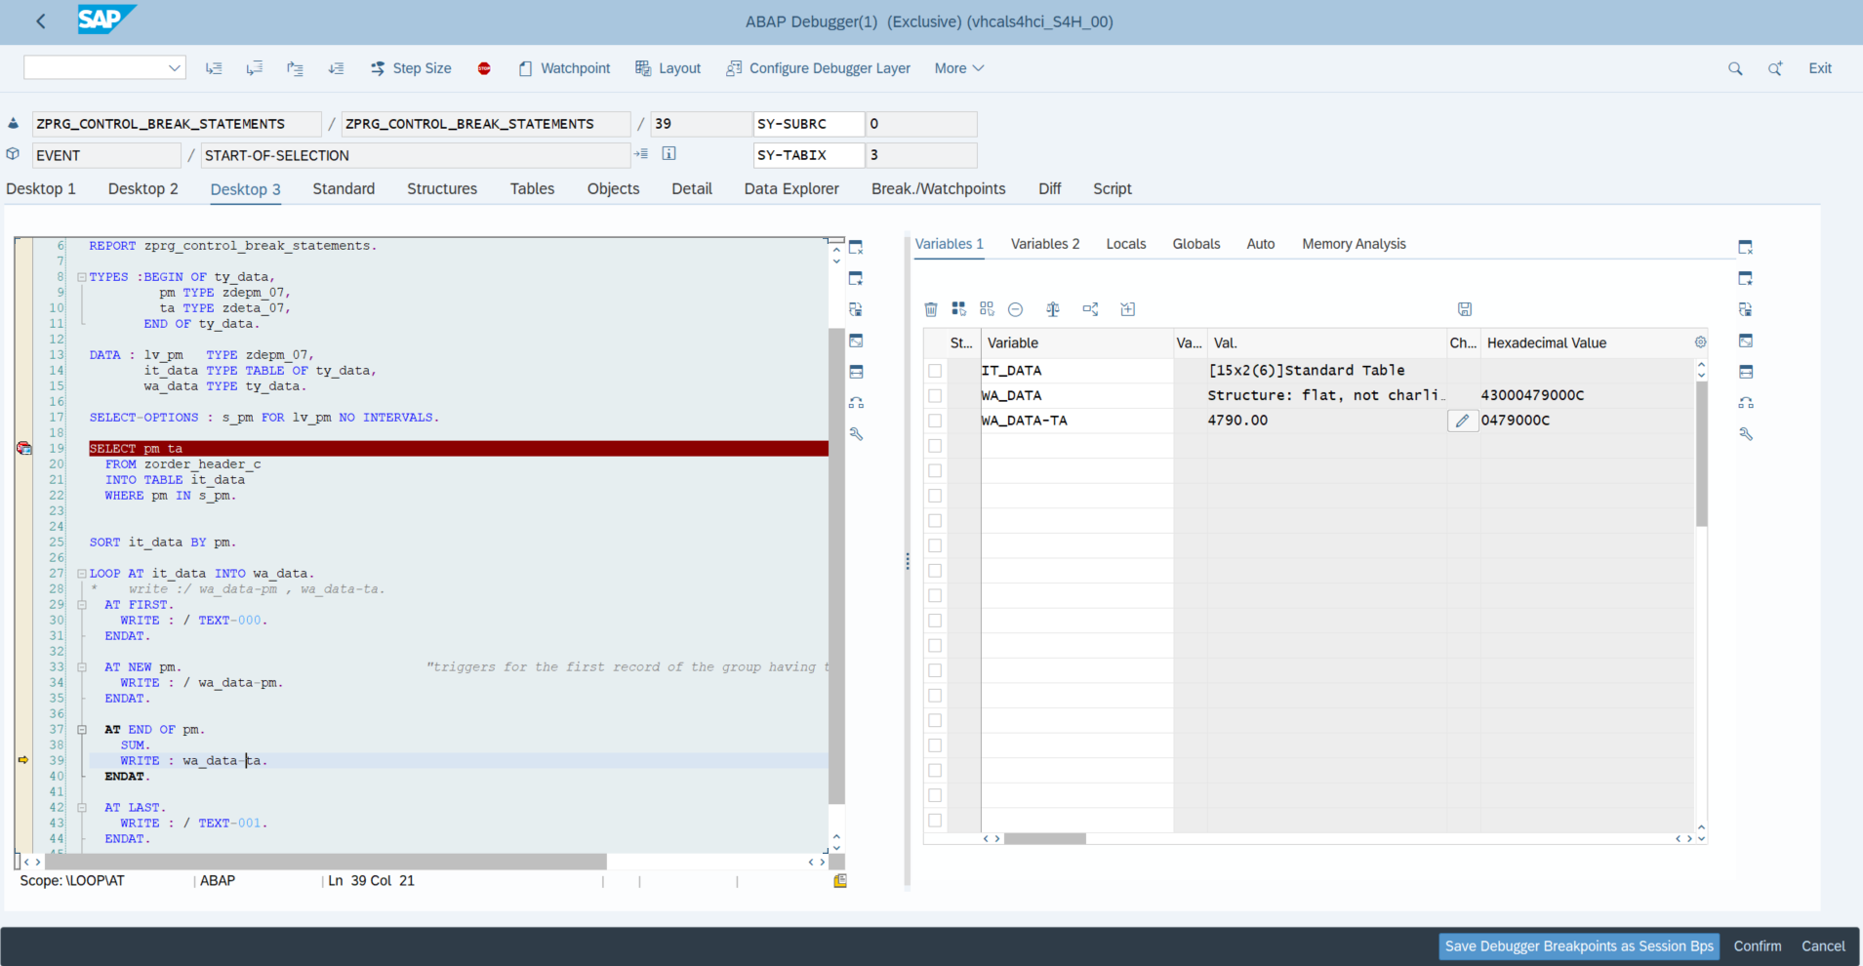
Figure 13 Output of the SUM statement.
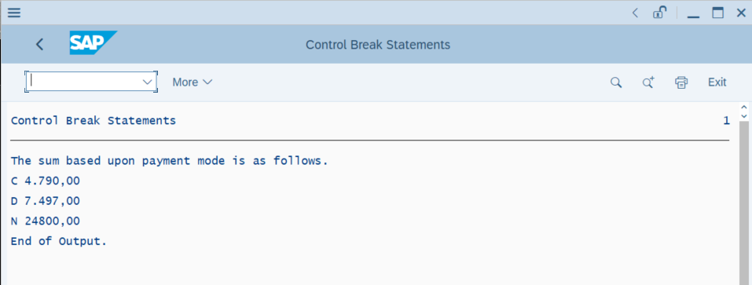
Figure 14 Final Output of the control break statements.
- The event AT NEW <fieldname> and AT END OF <fieldname> also triggers if the value of other fields changes which is present on the left-hand side of the specified fieldname. If we want AT NEW <fieldname> and AT END OF <fieldname> to trigger based on the specified field name only, this can be overcome by taking the specified field name at the 1st position in the internal table.
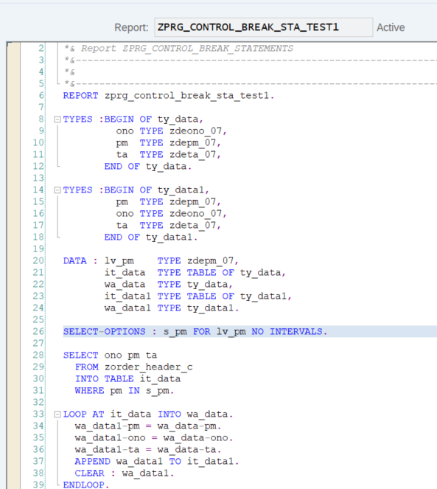
Figure 15 test case 2 if we want to add the extra field. Inside the internal table.
- Whenever AT FIRST and AT LAST control break event triggers all character field values converted to *** and all numeric field values converted to 0. This happens as we don’t specify any field values.

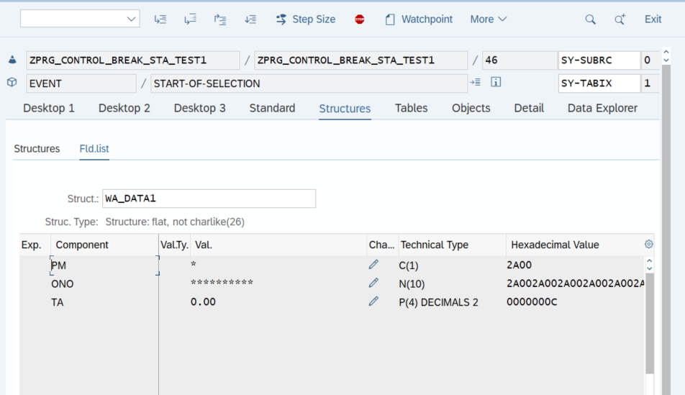
Figure 16 when at first and at last will trigger all character fields and numeric fields become * and 0.
- Whenever AT NEW <fieldname> and AT END OF <fieldname> triggers the value of character fields on the right-hand side of the specified field name converted to *** and numeric field value converted to 0.
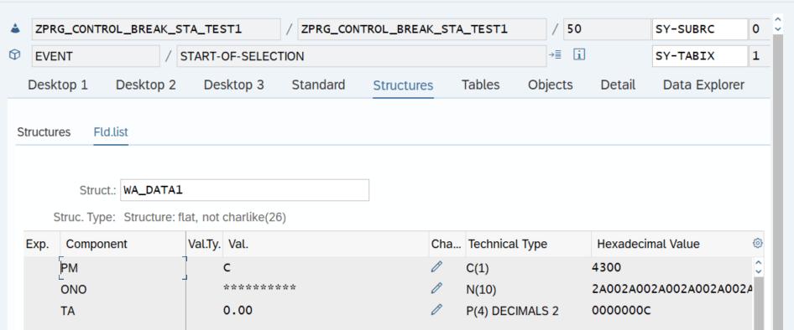
Figure 17 When the AT NEW and AT END statements trigger.
- Solution: store the value in the temporary work area before any of the control break events trigger.
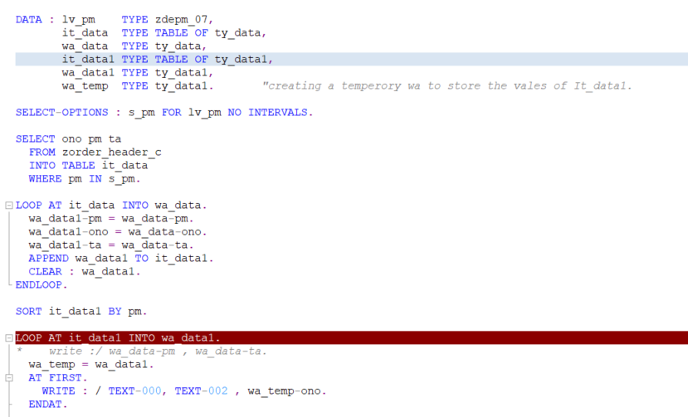
Figure 18 creates a temporary work area to store the values in its original format.
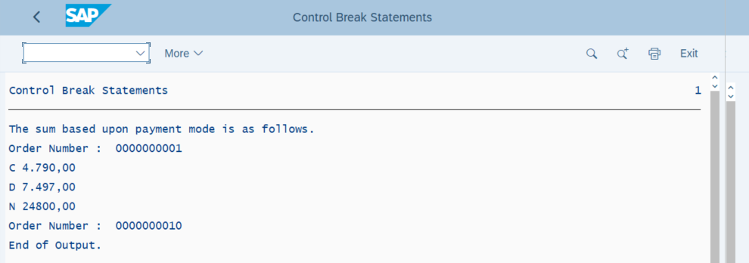
Figure 19 Output After the creation of the temp work area.

Database Operations.
- Database operations deal with database tables.

Types of Database Operations.

Select
- Select is used to fetch data from a database table.

Insert
- Insert is used to insert the records into database tables.

Update
- Update is used to update the existing records in the database tables.

Delete
- Delete is used to delete the existing records from database tables.

Modify
- It works for both – insert + update. For existing records – it acts as an update, for non-existing records – it acts as an insert.

Stages of SAP report

Planning and Requirement Gathering
- This initial stage involves defining the purpose and functionality of the report. You'll need to gather requirements from stakeholders, such as what data the report should display, how it should be formatted, and what selection criteria users will need.

Design and Development
- Designing the report layout using ABAP screen elements.
- Writing the ABAP code to access and process data from SAP tables or other sources.
- Implementing any selection logic or filters for the report.

Testing and unit testing
- Once the basic code is written, it's crucial to test the report thoroughly. This includes unit testing individual components of the program to ensure they function as expected, as well as integration testing to verify the report works correctly with other system elements.

Documentation and User training
- After successful testing, you'll need to document the report. This documentation should explain how to use the report, what its functionalities are, and any limitations to be aware of. You might also need to provide user training depending on the complexity of the report.

Deployment and Release
- The final stage involves deploying the report to the target SAP system, typically a production environment. This might involve transporting the report from a development system to production and making it available to authorized users.

Enhancements and Modifications
- Enhancements – SAP Functionality in Customer namespace (Z or Y).
- Enhancements are the recommended and modern way to extend standard SAP functionality.
- The core idea behind enhancements is to add custom code or functionality without directly altering the original SAP source code.
- Modifications – SAP Functionality in SAP namespace

Types of Enhancements

Implicit Enhancements & Explicit Enhancements

Implicit Enhancement
- Implicit points are available at the start and end (“””””””) of the program, subroutines, and FMs.
- Predefined by SAP at fixed locations (e.g., beginning/end of methods, function modules, subroutines, classes). They exist by default and don't require explicit definition by SAP. You "show" them in the ABAP Editor (Edit -> Enhancement Operations -> Show Implicit Enhancement Options).
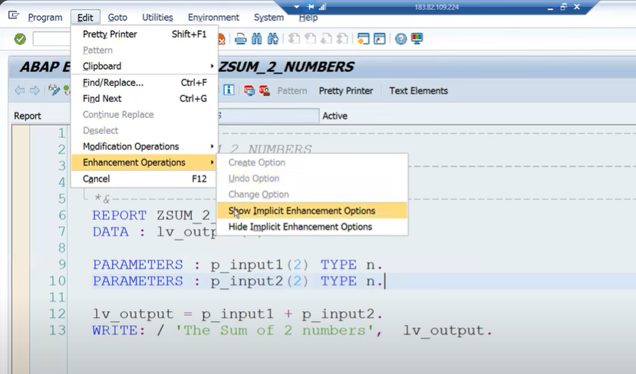
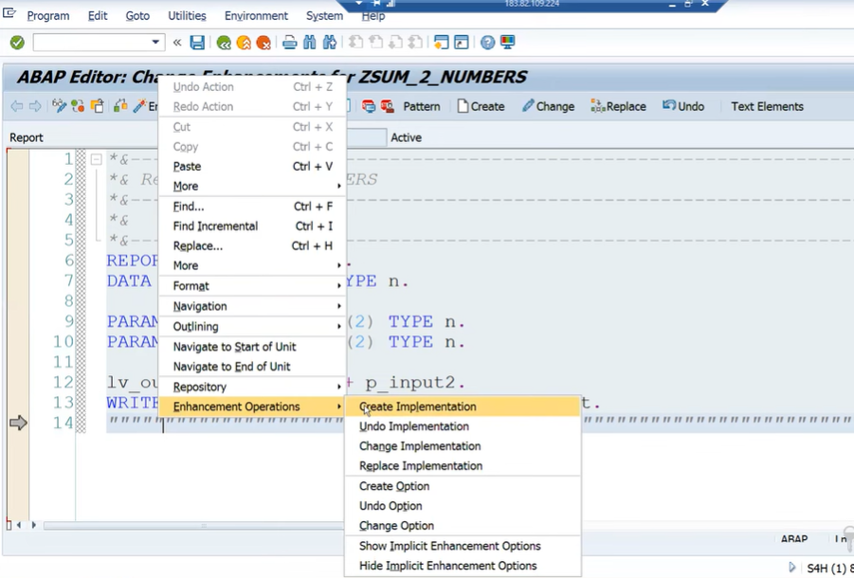

Explicit Enhancement
- Explicit points and sections are available at any line.
- Explicitly defined by SAP developers using ENHANCEMENT-POINT or ENHANCEMENT-SECTION statements in the standard code. ENHANCEMENT-SECTION allows you to replace a block of standard code with your custom code
- How to create a enhancement point and section in the program
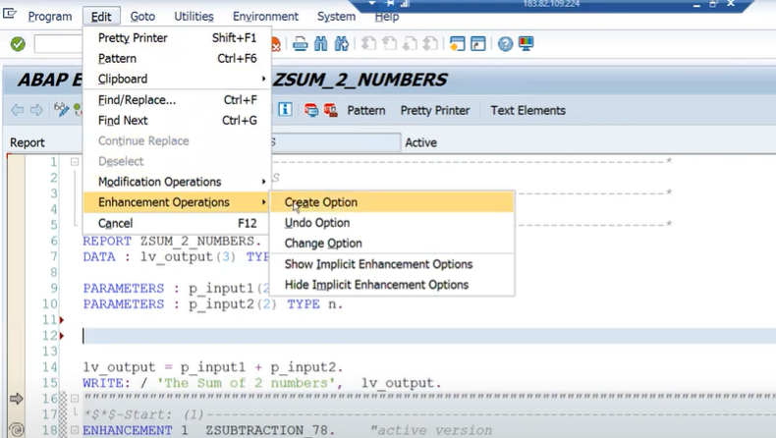

Enhancement – point
- It will not give a default implementation.
- You can only create the explicit implementations using those points and sections.
- In the enhancement point, we can add our logic or edit the logic.

Enhancement – section
- It will give a default implementation.
- We can change the whole logic or replace the completed logic.

Customer Exit
- Applicable to all the modules, as decided by SAP.
- Function module + Include program.
- Doesn’t require the access key.
- CMOD and SMOD Tcodes.
- Types of Customer Exit:

Function Module Exits
- allows us to add our code to SAP programs with the help of FM. {Syntax CALL CUSTOMER-FUNCTION '3-digit number'}
- To find an FM, keep a breakpoint at the statement for the call Customer-function.
- Put the package name of the program in the SMOD transaction code.
- GO to transaction SE84 (Enhancement – Customer exits)
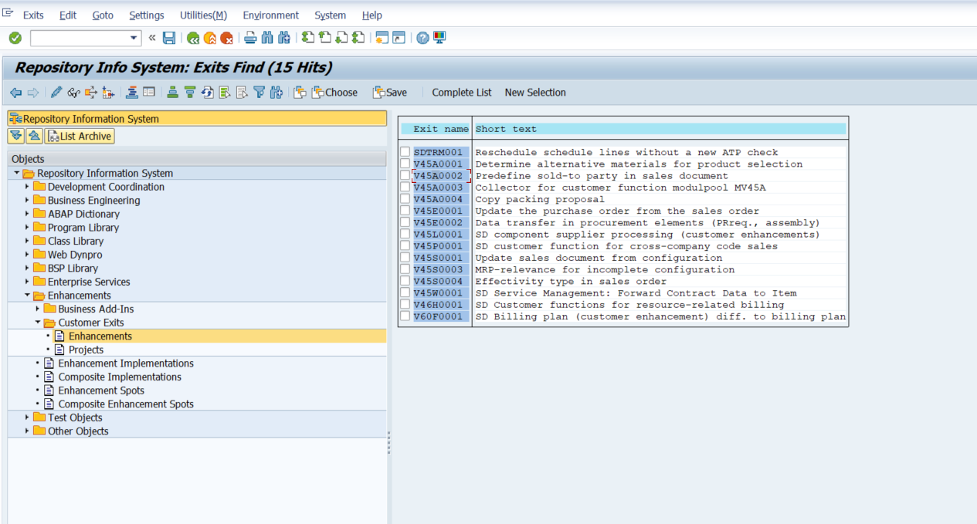

- Steps to implement an FM exit
- Tcode – CMOD
- Provide a project name and create

Screen Exits

Menu Exits
- Menu exits allow us to add menu items to the menu of SAP programs.
- The menu items have function codes that begin with a “+” sign.
- We can perform customer-specific functionalities on these menu items.

Field Exits

BADI
- OO methodology.
- Single, multiple implementations, filter, and custom
- SE18 and SE19 Tcodes.
- Single-use BAdI: Only one implementation can be active at a time. If multiple are created, only one will be picked (often the last one activated, but the order is not guaranteed).
- Multiple-use BAdI: Multiple implementations can be active simultaneously, and all active implementations will be executed. The order of execution is generally not guaranteed and should not be relied upon.

User Exit (Modification)
- These are specific subroutines (FORM...ENDFORM) within standard SAP programs
- Mostly applicable for SD module program
- Need access key to include custom code.

Module Pool Programming

Tabs of Screen

Attributes
- Provides the generic information about the screens

Element list
- It provides the list of elements available on that screen

Flow logic
- Logic place

Module Pool events

PBO (First screen)
- This event is called before displaying a particular screen.

PAI (Second screen)
- This event is called after performing some action on a particular screen.

POV
- This event occurs when we click F4 on a field of a screen.

POH
- This event is called when we click F1 on a field of the screen.

PBO ---> AT SELECTION-SCREEN OUTPUT
PAI ----> AT SELECTION-SCREEN
POV --> AT SELECTION SCREEN ON VALUE-REQUEST
POH ---> AT SELECTION SCREEN ON HELP-REQUEST

Parts of the GUI status

PF-Status

Menu Bar

Function Keys

Title Bar

Application Bar

Table Control
- It is used to display data in the form of a table.
