**Figure legend**

**Figure 1.**  The workflow and application of SEMIPs. The left four rectangles and arrows indicate our hypothesis testing and generation schema. A biological hypothesis is tested in a model animal system (mouse) on relationship between two interacting factors (Fac1 & Fac2) and their endpoints. The hypothesis is translated to another species (i.e. human in our research) via T-score computation and verified with SEM model. This process is accomplished with our shinyapp indicated by two curved arrows. γ11 and γ21 are correlation efficient and ξ are model residuals. The two-class bootstrap analysis is shown in the red rectangle box. Hypothesis generating and exploring steps are explained by the bottom two rectangles.

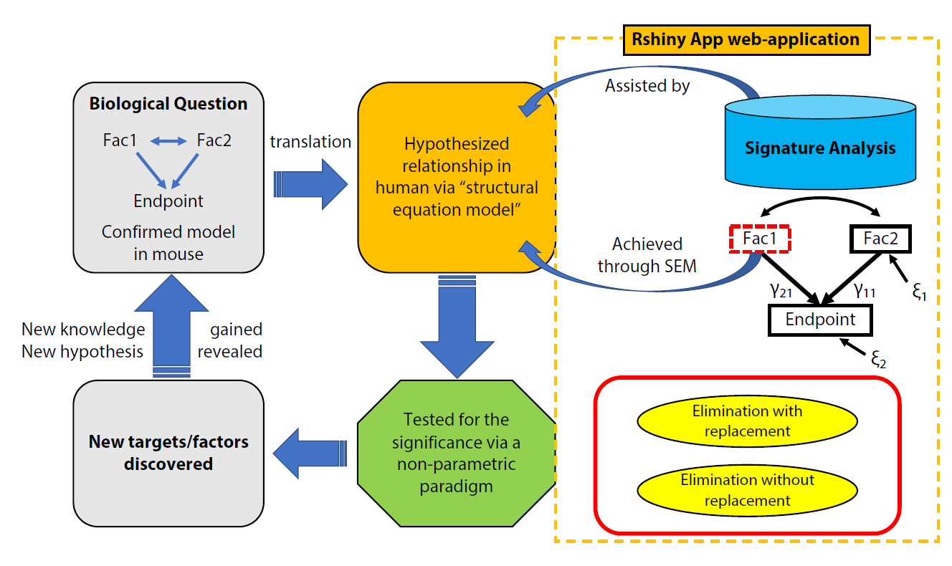

**Figure 2.** The user interface is shown when it is launched. The main panel contains four tabs: “T-Scores”, “SEM”, “Bootstrap”, and “Instruction”. The right panel shows the screen when the “T-scores” is selected and generated. In the left panel, the application accepts two inputs, 1) a list of signatures (in Entrez gene symbol format) and 2) a data matrix of expression measurement with the top lines shown for viewing. The green “Go!” button is clicked to launch the T-score generation and grayed out to denote the process is running. The first 10 rows of the T-scores matrix are shown, which can be downloaded by clicking the “Download T-Scores” button.

