# Changes needed to complete post ASR implementation

This document is intended to provide the steps needed to complete the ASR which is intended to allow workflows be triggered when an anonymous user submits a new term or a new project into NIEM Project Info.

## TERMs list

### Workflow Changes in SharePoint Designer

1. Open SharePoint Designer 2010 against <https://www.niem.gov>
2. You will be prompted for you credentials. Please select the option that allows use to enter in your site collection administrator credentials.

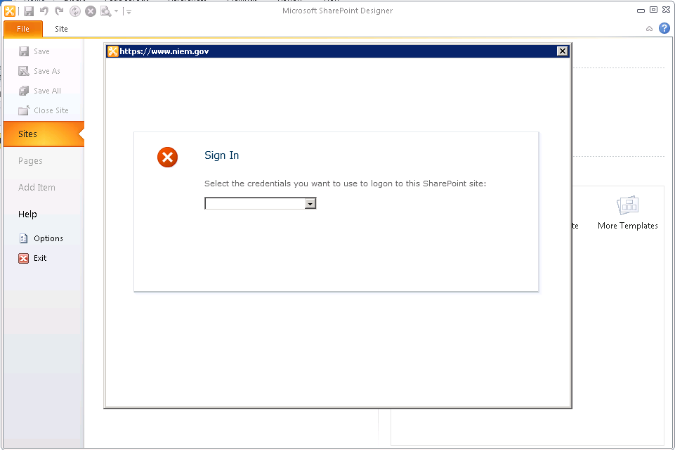

1. Now, click on **Workflows** and **TERMS_approval** workflow

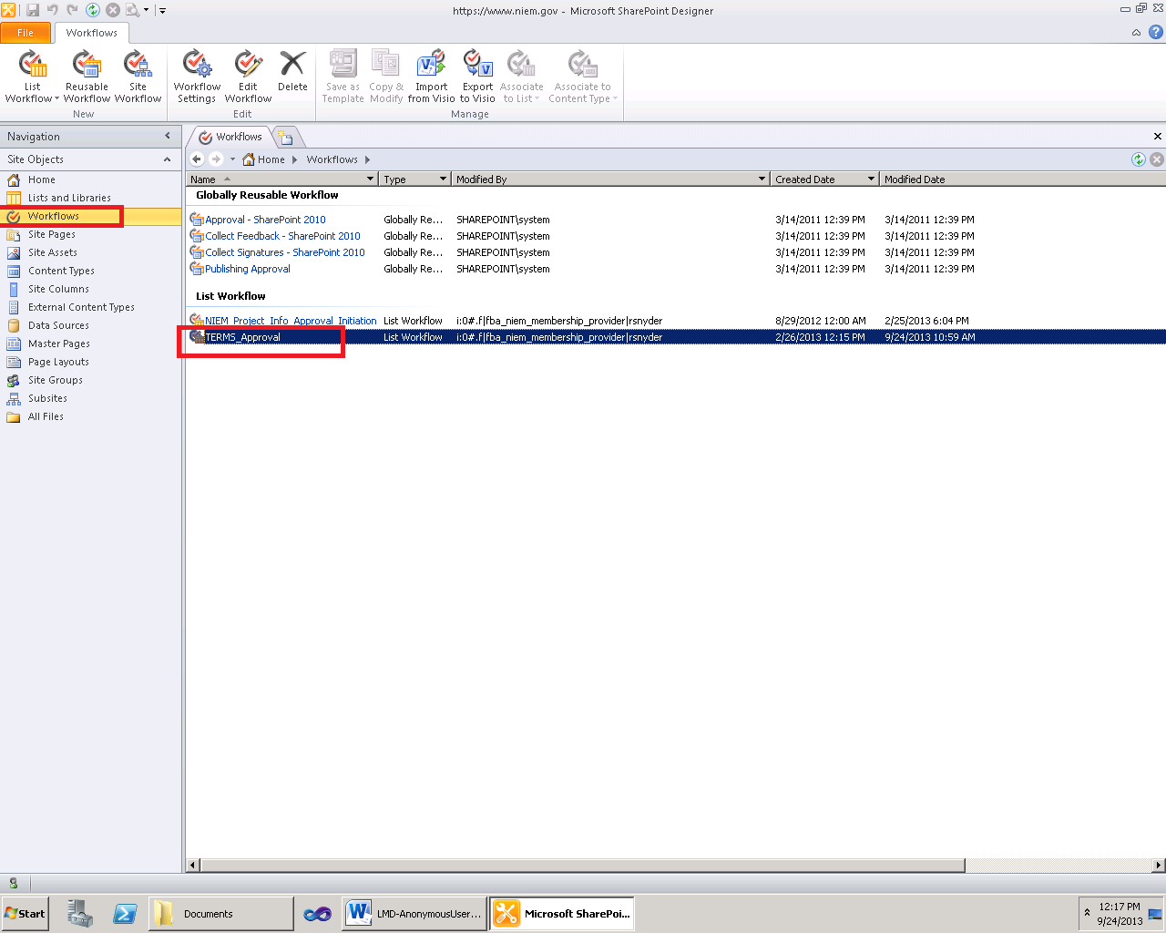

1. You should now be on the TERMS_approval workflow page. Make sure to **uncheck** the **“Start workflow automatically when an item is created”**. Then, click on **Save** and **Publish**  in the ribbon. This functionality will now be done within the ItemAdded event handler on the TERMs list.

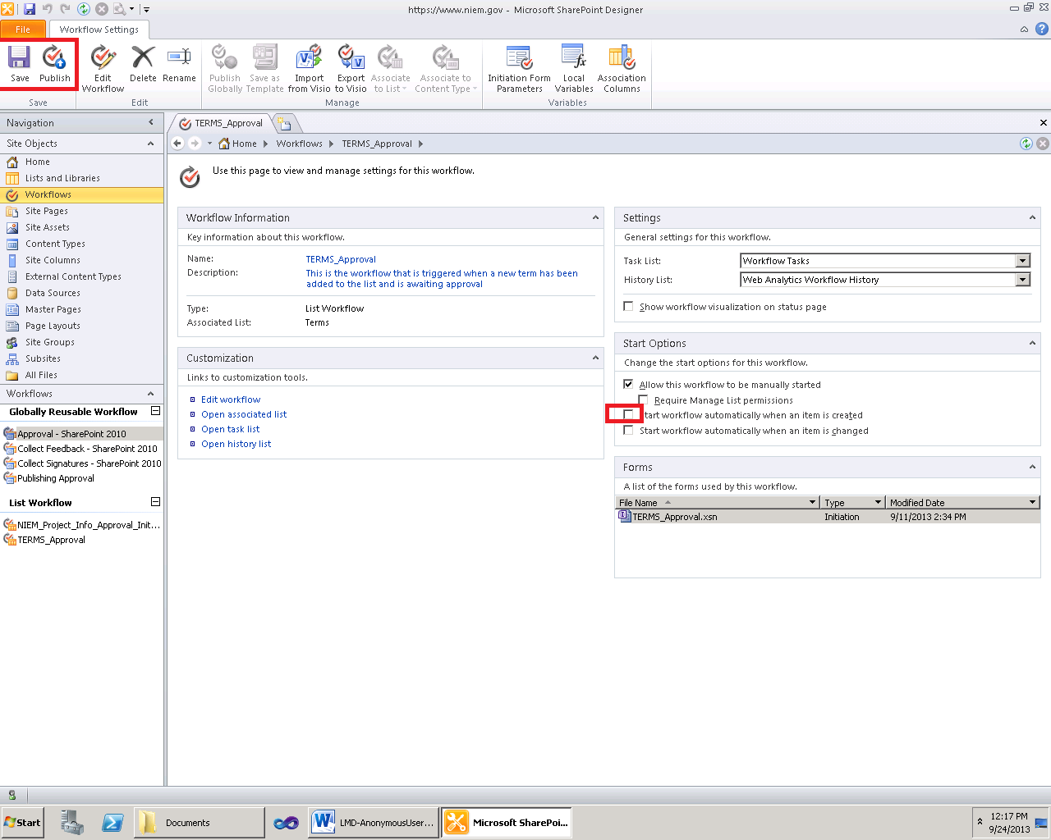

### Activating the feature

1. Open up a browser against <https://www.niem.gov>
2. Log in using an account with site collection administrator permissions.
3. Click on **Site Actions** and **Site Settings**

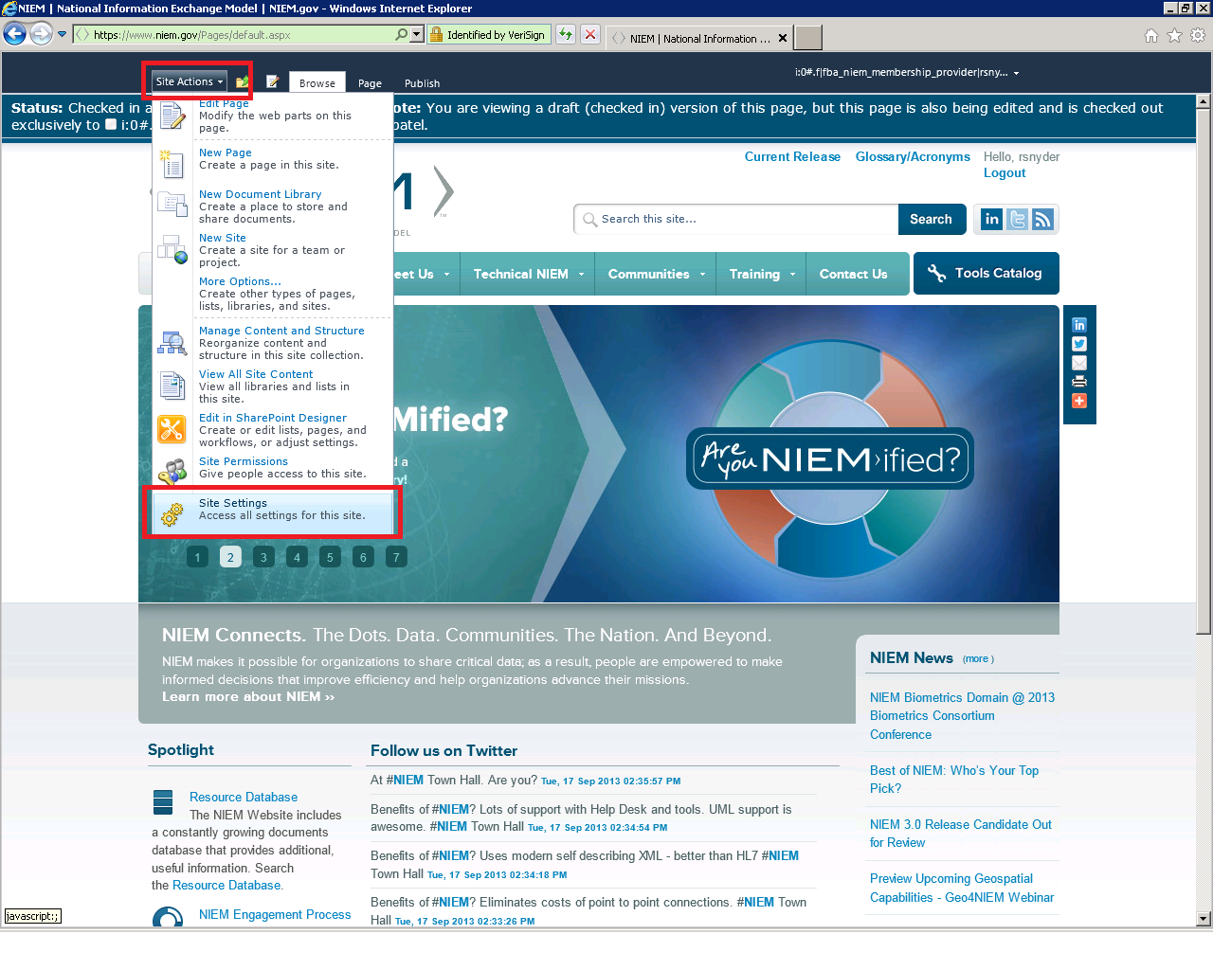

1. On the site settings page, click on the **Manage site features** link

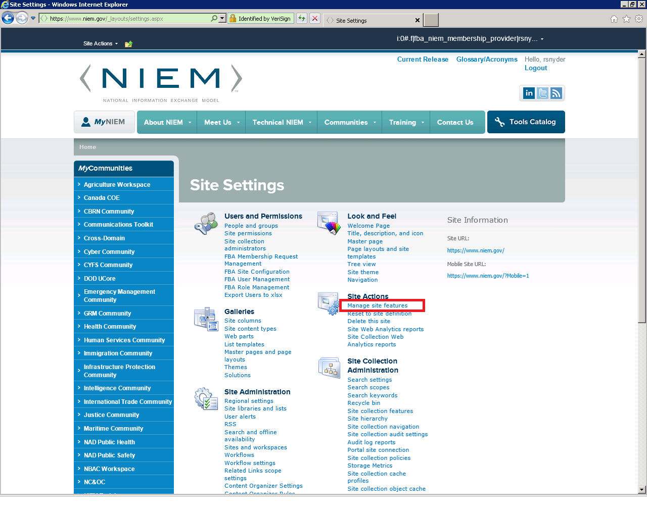

1. Finally, click on the **Activate** button on the **NIEM.Terms ItemAdded EventHandler Feature** . This will bind the ItemAdded event handler to the TERMs list. This will resolve the problem so items added by anonymous users will still trigger the workflow to fire.

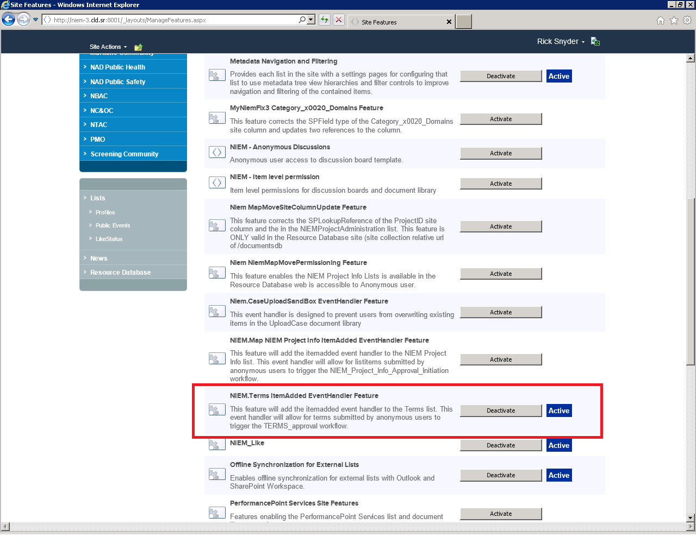

## NIEM Project Info list

### Workflow Changes in SharePoint Designer

1. Open SharePoint Designer 2010 against <https://www.niem.gov/docmentsdb>
2. You will be prompted for you credentials. Please select the option that allows use to enter in your site collection administrator credentials.



1. Now, click on **Workflows** and **NIEM_Project_Info_Approval_Initiation** workflow

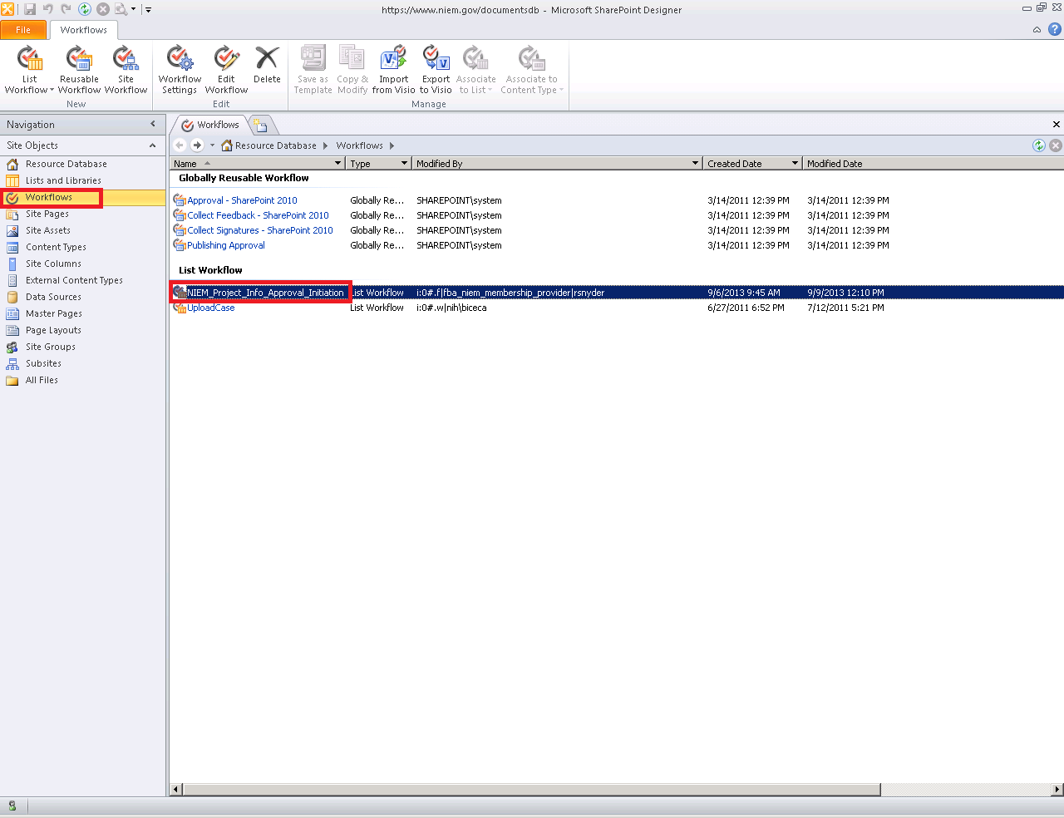

1. You should now be on the NIEM_Project_Info_Approval_Initiation workflow page. Make sure to **uncheck** the **“Start workflow automatically when an item is created”**. Then, click on **Save** and **Publish**  in the ribbon. This functionality will now be done within the ItemAdded event handler on the NIEM Project Info list.

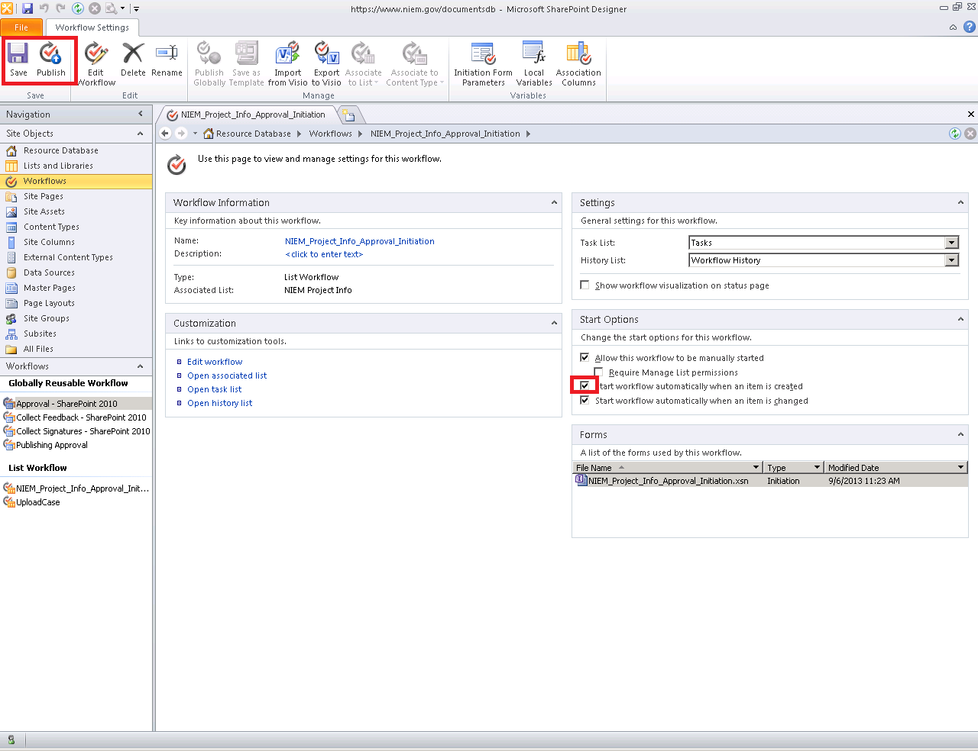

### Activating the feature

1. Open up a browser against <https://www.niem.gov/documentsdb>
2. Log in using an account with site collection administrator permissions.
3. Click on **Site Actions** and **Site Settings**

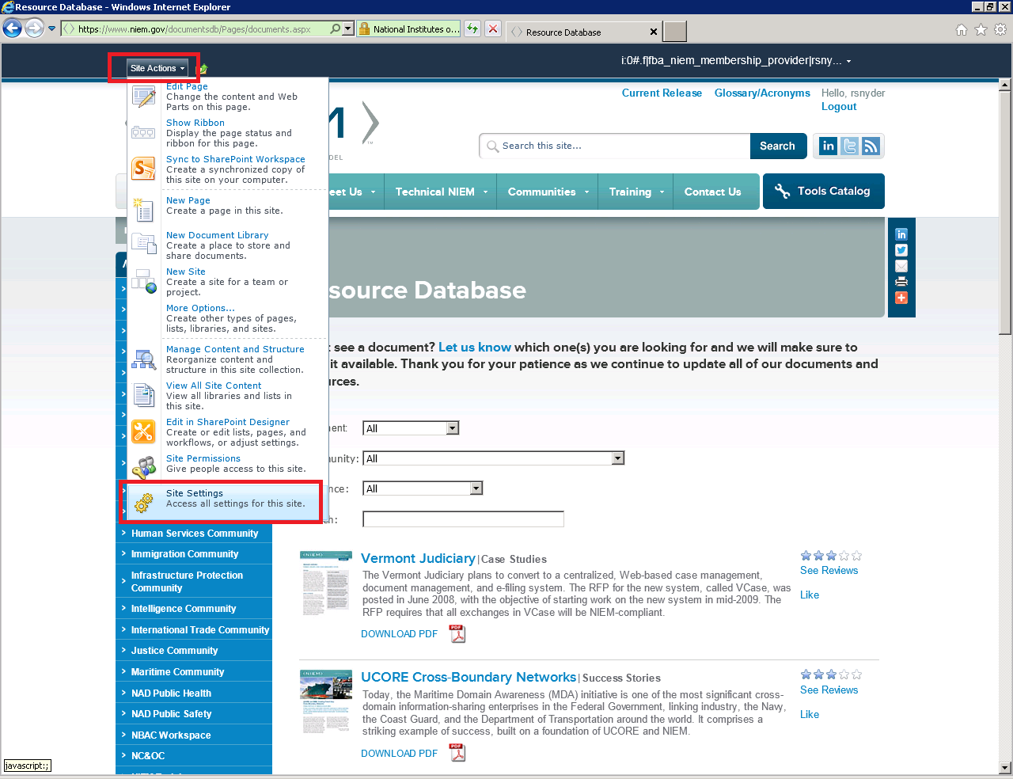

1. On the site settings page, click on the **Manage site features** link

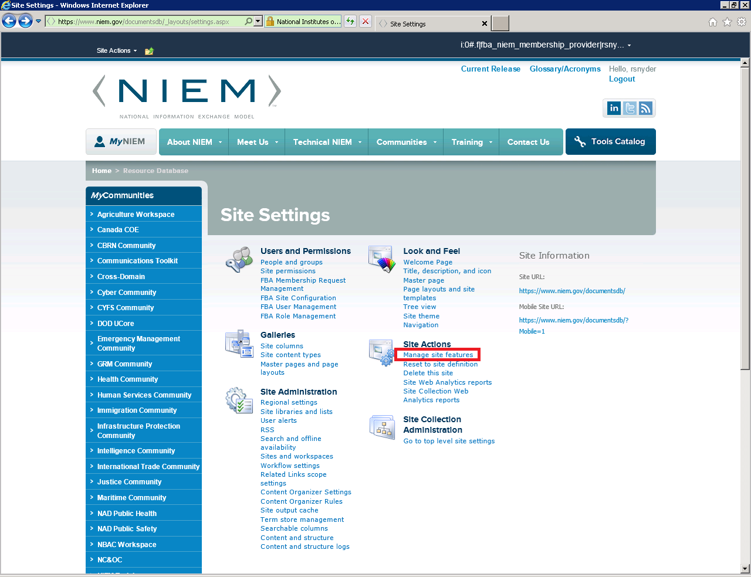

1. Finally, click on the **Activate** button on the **NIEM.Map NIEM Project Info ItemAdded EventHandler Feature** . This will bind the ItemAdded event handler to the TERMs list. This will resolve the problem so items added by anonymous users will still trigger the workflow to fire.

