# How to rename a Dicussion

This document is intended to provide the steps needed to rename a Disussion within a Community Workspace so that a more descriptive discussion title will appear within MyNiem.

1. Navigate into the Community Workspace using an account that has Full Control rights to the workspace site. We will the that [CBRN Workspace](https://www.niem.gov/communities/cbrn/cbrn-community/cbrn-workspace/SitePages/Home.aspx) as an example.
2. Click on the **All Site Content** link in the Quick Launch

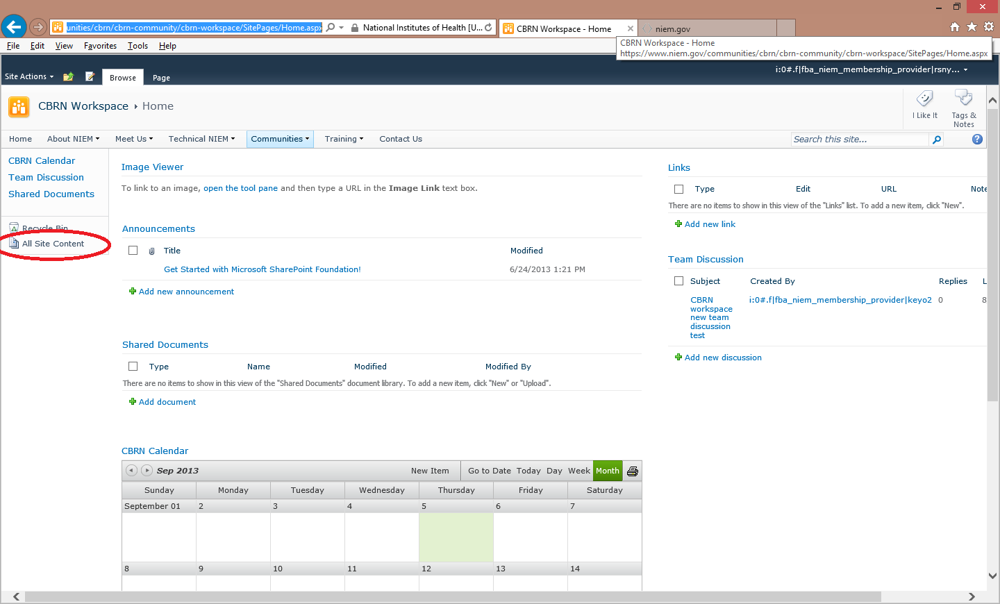

1. On the All Site Content page, click on the discussion board link that you wish to rename. In this example, we are changing the Team Discussion list.

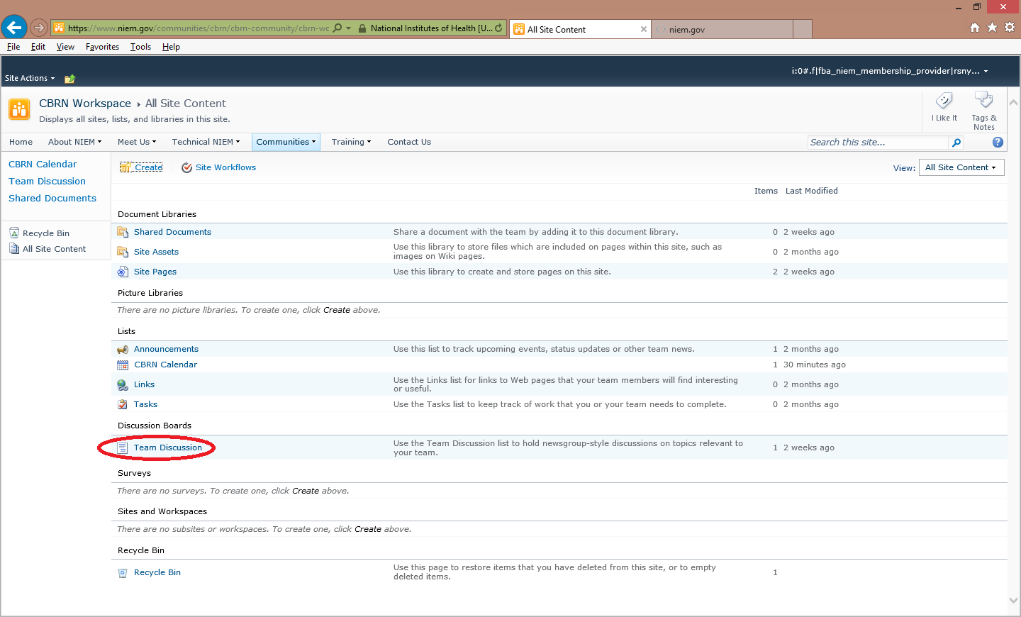

1. On the list page, click on the **List** tab in the ribbon and then the **List Settings** icon in the ribbon.

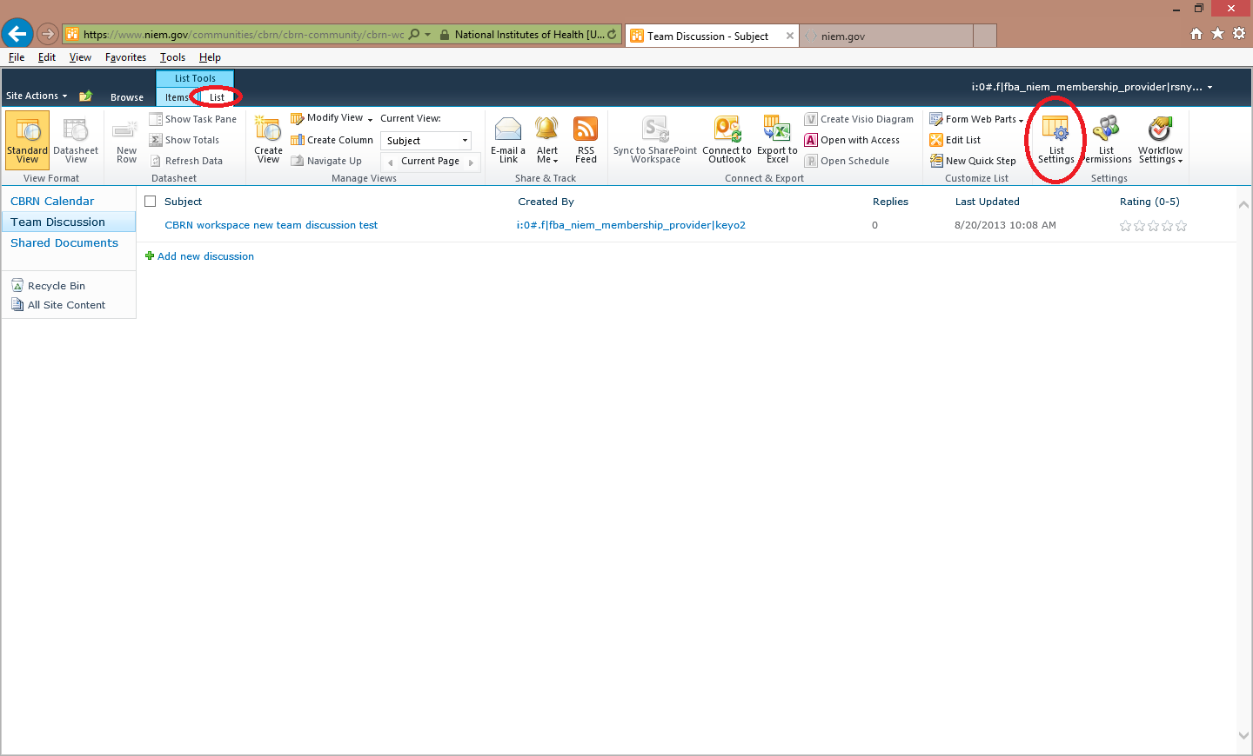

1. On the list settings page, click on the **Title, description, and navigation** link.

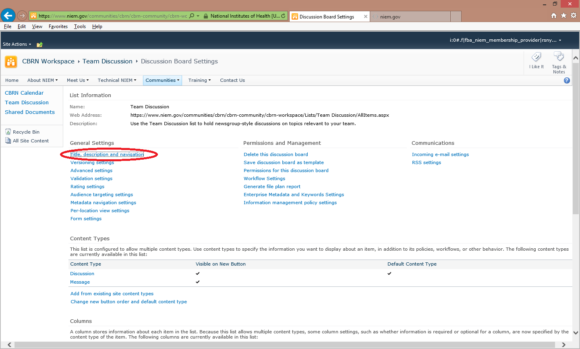

1. On the General Setting page, change the name to be whatever you would like it to be. In this example, we changed the name to CBRN Workspace Forum. Then, click on the **Save** button.

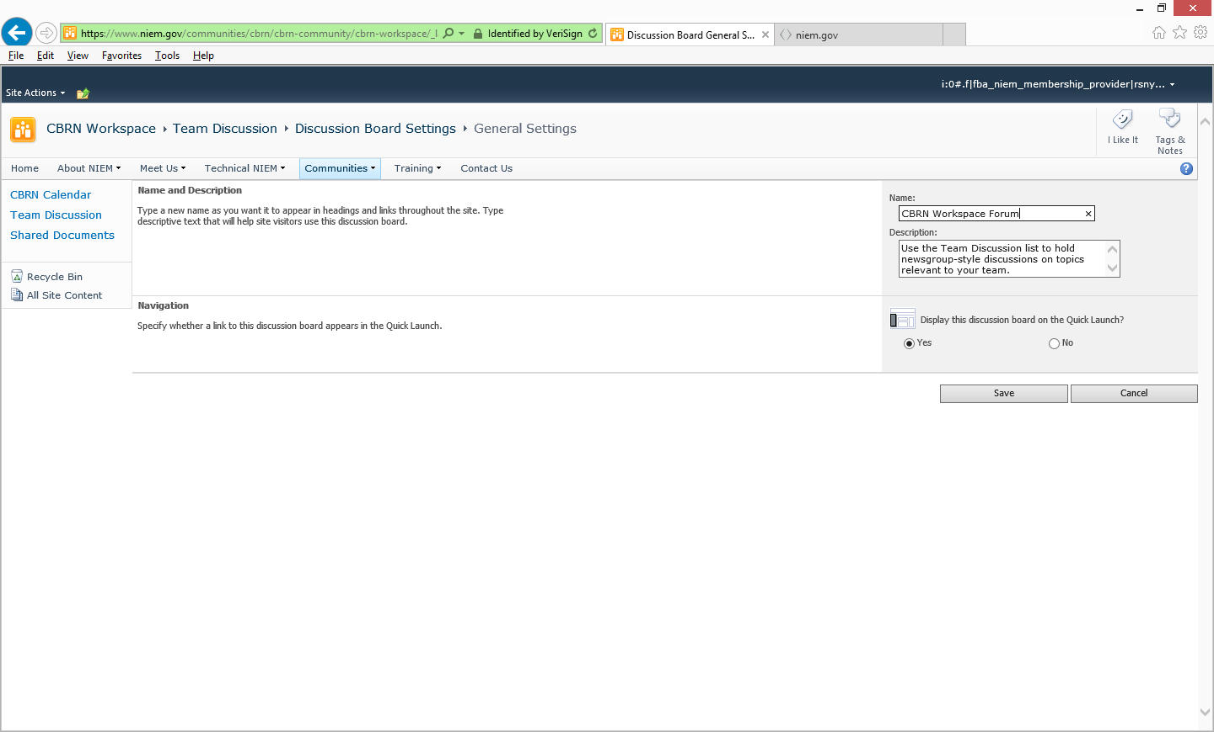

1. Now return, to the workspace home page , [CBRN Workspace](https://www.niem.gov/communities/cbrn/cbrn-community/cbrn-workspace/SitePages/Home.aspx), and you will see your changes reflected.

