## MilOps NIEM Change Request Process

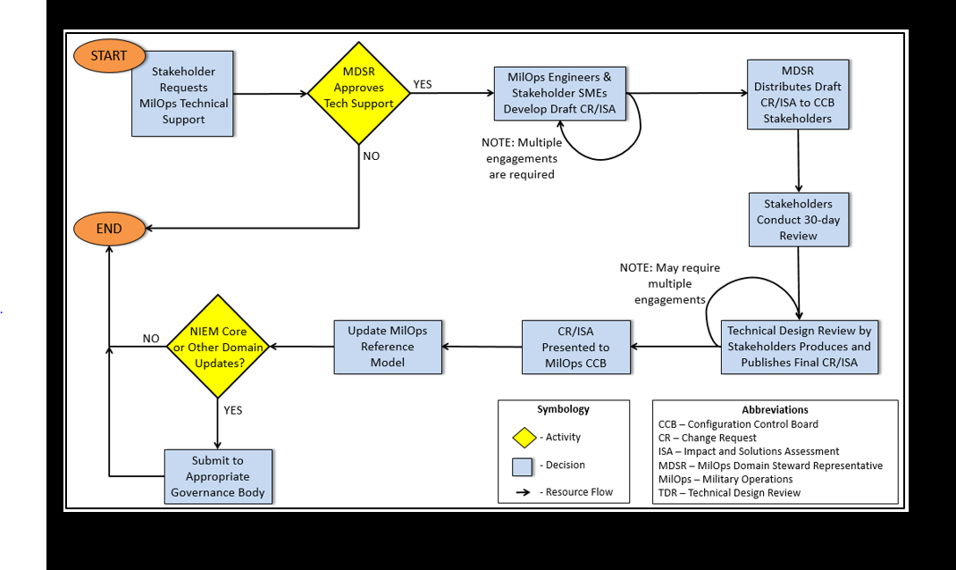

1. Stakeholder requests MilOps tech Support.
2. GTRI develops the Change Request (CR) and Impact Solutions Assessment (ISA).
3. MilOps Tech Lead (Frank Kluznik) reviews the draft CR and ISA w/ requester and update as appropriate.  Once requester approves, MilOps tech will submit it to MilIOps Domain Stewards (Heather/Ralph) on behalf of the requestor.
4. The CR/ISA is then distributed along with supporting artifacts to the MilOps CCB distribution list at a Distro C level, and everyone is provided 30 days to review and comment.
5. At the end of the 30 day period, a Technical Design Review (TDR) is held via TELCON, and MilOps tech lead and GTRI answer any questions.  Sometime there are discussions which result in modifications to the CR.
6. Once everyone agrees to the CR/ISA, it is then presented at the next quarterly MilOps CCB (e.g., Dec) and approved.
7. The changes will then be incorporated into the next NIEM release (e.g., NIEM v4.2).
8. In the future requestor will be notified of any change proposals submitted against their semantic content.
9. It will be important for the requestor to participate during the TDR and the following CCB.