

01 June 2019



Military Operations Domain & Data and Services Division Technical Support Plan

Contents

Purpose 1

Overview 1

Model Management 1

Activity Plan 3

Planned Activities 4

• Configuration Control Board 4

• Change Request/Impact and Solutions Assessment/Technical Design Review Process 5

# Purpose

This document contains a plan of action and milestones for the National Information Exchange Model (NIEM) Military Operations (MilOps) Domain model management and technical support to Joint Staff J6, Deputy Director for C5 Integration, Data and Services Division (JS J6 DDC5I DSD).

# Overview

The material in this document is organized into two sections: model management, and planned activities. This material is generated from a GTRI perspective. As such, the material provided herein was not intended or designed to convey a complete plan of action and milestones (POA&M) for each line of activity. Rather it was designed to convey the NIEM MilOps support to that activity. For more information, please contact the appropriate POC listed for each activity.

# Model Management

Configuration Management (CM) of the MilOps Domain data model is unique because the distributed approach to governance employed by NIEM requires synchronization among multiple governance and CM activities. This coordination demands a familiarity and in-depth technical understanding of NIEM, as well as data and messaging standards used by the Department, and its external partners (e.g., NATO, international, federal, state, local and tribal) organizations.

Like all of the other NIEM Domains, MilOps is independently governed and configuration managed under the broader umbrella of NIEM governance. The MilOps data model is an instantiation of the NIEM technical framework, and its public content is published as a harmonized and integral part of every NIEM release. MilOps non-public content is published to DoD controlled networks along with the public NIEM content immediately following a formal NIEM release.

The key documents describing the MilOps Domain scope, governance and supporting processes include the:

* MilOps Domain Value Proposition
* MilOps Domain Scope Summary
* NIEM MilOps Domain Charter
* NIEM MilOps Domain Operations and Maintenance Plan
* NIEM MilOps Domain Steward Agreement

All of these documents are available on the [NIEM MilOps APAN SharePoint Site](https://wss.apan.org/s/NIEM_MilOps/CCB/default.aspx?RootFolder=%2Fs%2FNIEM%5FMilOps%2FCCB%2FDocument%20Library%2F1%2FMilOps%20Key%20Documents&FolderCTID=0x012000E86D8C230289844EB8AD56E8AD39EF5E&View=%7bF0AD4DEC-DE84-4F56-B654-965280CD4865%7d).

Management of the MilOps Domain involves a reoccurring iterative, process supported by a continuous stream of on demand training, outreach, feedback, automation, software tool development, and technical engineering support (ref Figure 1). The core process involves the development and use of a new NIEM release to develop Information Exchange Package Documentation (IEPD) specifications to define new data exchanges (ref Figure 1, #1). This activity produces new data requirements for the MilOps data model, which are documented in a MilOps Change Request (CR) (ref Figure 1, #2).

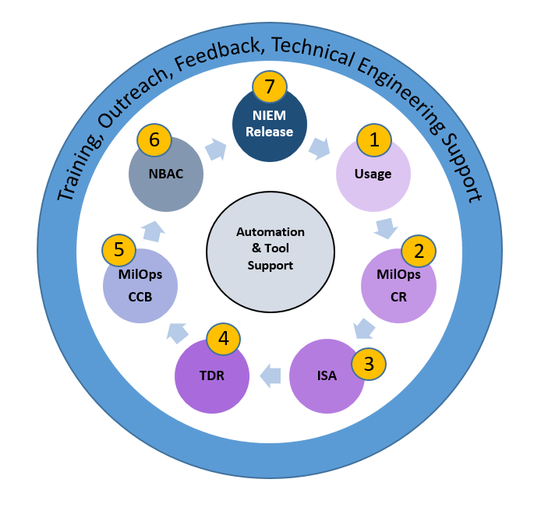Details of the MilOps CR process are well-documented in the MilOps Operations and Maintenance Plan. When a new CR is received, the lead engineer for MilOps works with the sponsoring organization to develop an Impact and Solutions Assessment (ISA) document, which provides a technical analysis of the request, outlines options for implementation and risks associated with the change (ref Figure 1, #3). When the ISA is completed it is distributed to all MilOps stakeholders for a 30-day review. At the end of the review period, all interested stakeholders are afforded an opportunity to discuss the CR and provide additional inputs to the ISA package during an open Technical Design Review (TDR) meeting, during which consensus is achieved on how to proceed forward with the CR (ref Figure 1, #4). When the TDR is completed, a final CR/ISA package is produced and sent to the MilOps Configuration and Control Board (CCB) for review, discussion and final disposition (ref Figure 1, #5). Decisions by the CCB are forwarded to the NIEM Business Architecture Committee (NBAC) in the form of a Domain update, or recommended change to NIEM Core (ref Figure 1, #6). All updates to the NIEM reference model are published in accordance with an annual 3-year release cycle described in the [NIEM High-Level Version Architecture](https://reference.niem.gov/niem/specification/high-level-version-architecture/3.0/high-level-version-architecture-3.0.html) (ref Figure 1, #7). Additional details regarding MilOps CM is available in the [MilOps Operations and Maintenance Plan](https://wss.apan.org/s/NIEM_MilOps/CCB/default.aspx?RootFolder=%2Fs%2FNIEM%5FMilOps%2FCCB%2FDocument%20Library%2F1%2FMilOps%20Key%20Documents&FolderCTID=0x012000E86D8C230289844EB8AD56E8AD39EF5E&View=%7bF0AD4DEC-DE84-4F56-B654-965280CD4865%7d).

Figure 1: NIEM MilOps Process

The figure below provides a high level schedule of the CM activities and associated dependencies over a typical 12-month period. Note that ongoing training, outreach, feedback technical engineering support and tool development provide the foundation for all new semantic content added to NIEM and NIEM MilOps.

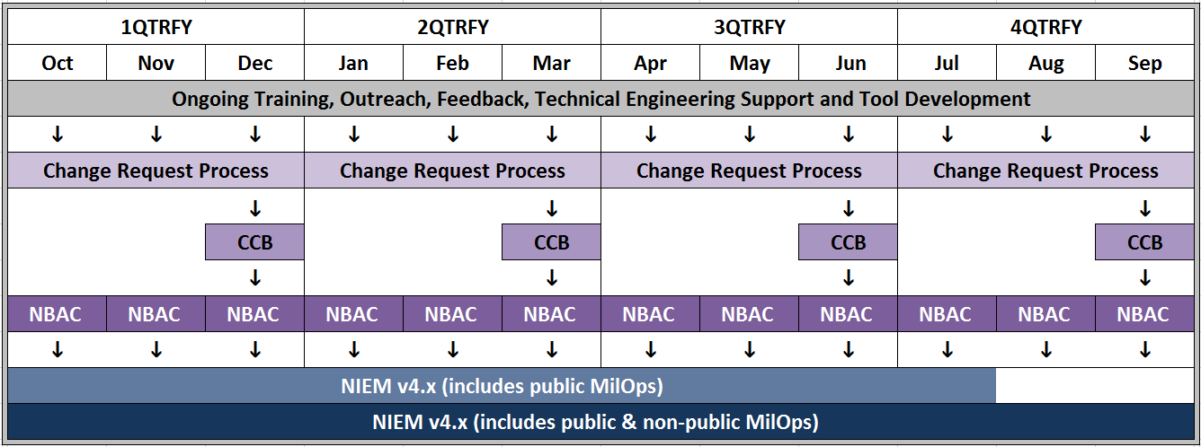

Figure 2: Twelve-Month MilOps Activity Schedule

# Activity Plan

Figure 3 below contains the latest activity plan in support of NIEM MilOps. The “color key” on the following page explains the color and symbols used in the plan. Appendix A of this document provides additional details on each of the activities in the activity plan.

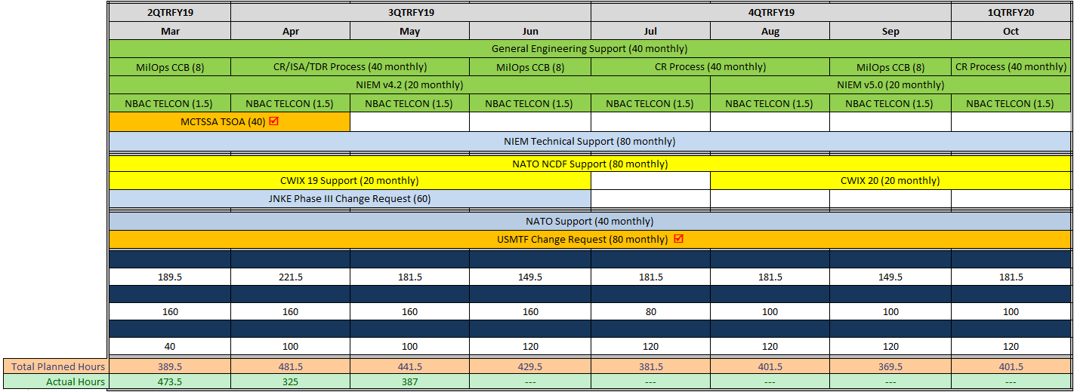  
Figure 3: High-Level NIEM MilOps Activity Plan

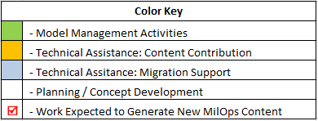  
Figure 4: High-Level NIEM MilOps Activity Plan Key

# Planned Activities

This section provides known details about all active and planned NIEM MilOps Activities.

## Configuration Control Board

LEAD:

* Domain Steward: Mr. Stewart Whitehead ([stuart.a.whitehead.civ@mail.mil](mailto:stuart.a.whitehead.civ@mail.mil))
* Domain Steward Representative: Mr. Ralph O’Connell ([ralph.m.oconnell.civ@mail.mil](mailto:ralph.m.oconnell.civ@mail.mil))
* Government Technical Lead: Mr. Rodney McCoy ([rodney.a.mccoy.civ@mail.mil](mailto:rodney.a.mccoy.civ@mail.mil))
* Secretariat: Mr. Michael Gilman ([michael.t.gilman1.civ@mail.mil](mailto:michael.t.gilman1.civ@mail.mil))
* Contract Technical Lead: GTRI

OBJECTIVES: The configuration control board meets 3-4 times per year at the discretion of the Domain Steward Representative (DSR). CCB meetings are held via TELCON; normally on the last Friday of the month, and typically from 1000-1200. Historical and current supporting materials are available at: O:\DDC5I\DSD\2 NIEM Support\NIEM MilOps Domain\3_MilOps CCBs. The latest email distribution list is v23 and is available at: O:\DDC5I\DSD\2 NIEM Support\NIEM MilOps Domain\3_MilOps CCBs\NIEM_MilOpsCCB_2015-2016_DistroLists.

The NIEM MilOps site on APAN is: <https://wss.apan.org/s/NIEM_MilOps/default.aspx>. The MilOps CCB site on APAN is: <https://wss.apan.org/s/NIEM_MilOps/CCB/default.aspx>.

ACTION PLAN: The 2018 CCB schedule of activities provided in Figure 5 on the next page. Note that Change Requests (CRs) may be submitted at any time regardless of the published schedule, and CCB dates may be changed at the discretion of the Domain Steward Representative to accommodate stakeholder’s schedules.

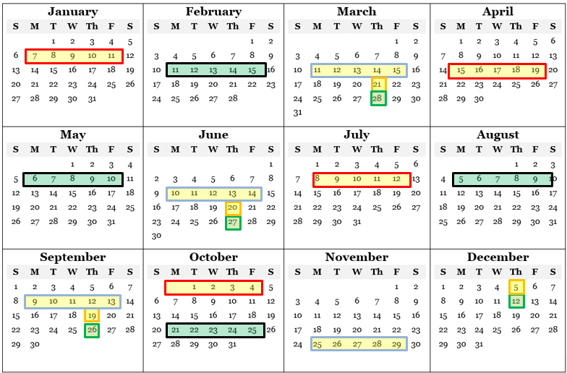

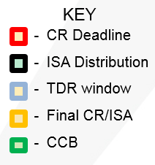

*Figure 5: 2019 NIEM MilOps CCB Activity Schedule*

## Change Request/Impact and Solutions Assessment/Technical Design Review Process

LEAD:

* MilOps Domain Lead Engineer: GTRI

OBJECTIVES: The purpose of the Change Request, Impact and Solutions Assessment and Technical Design Review (CR/ISA/TDR) process is designed to facilitate the collection of MilOps change requests for adding, modifying or deleting data components in the NIEN reference model. The NIEM reference model includes: NIEM Core and all of the NIEM Domain models. The MilOps change request illustrated in Figure 7 is explained in detail in the MilOps Operations and Maintenance Plan. Any changes recommended to NIEM Core or other NIEM Domain will follow the appropriate configuration management process.

The NIEM MilOps site on APAN is: <https://wss.apan.org/s/NIEM_MilOps/default.aspx>. The MilOps CCB site on APAN is: <https://wss.apan.org/s/NIEM_MilOps/CCB/default.aspx>.

Refer to Figure 6 and Figure 7 for supporting activity model diagrams.

ACTION PLAN: Refer to Figure 8 for a timeline and synchronization of CR/ISA/TDR activities scheduled in 2018. Note that Change Requests (CRs) may be submitted at any time regardless of the published schedule. Deadlines listed in the activity schedule are designed for planning purposes. These dates may change to accommodate stakeholder’s schedules.

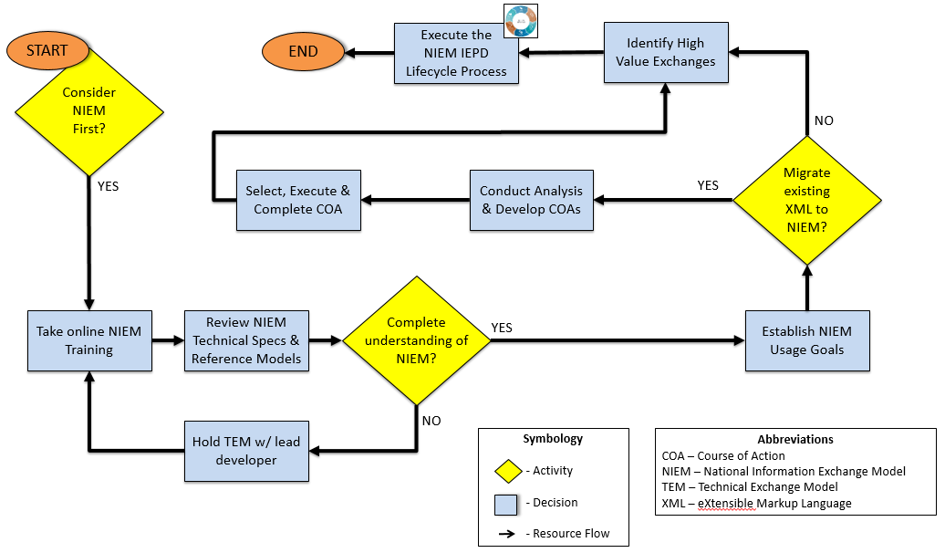Figure 6: NIEM Adoption Process Flow Diagram

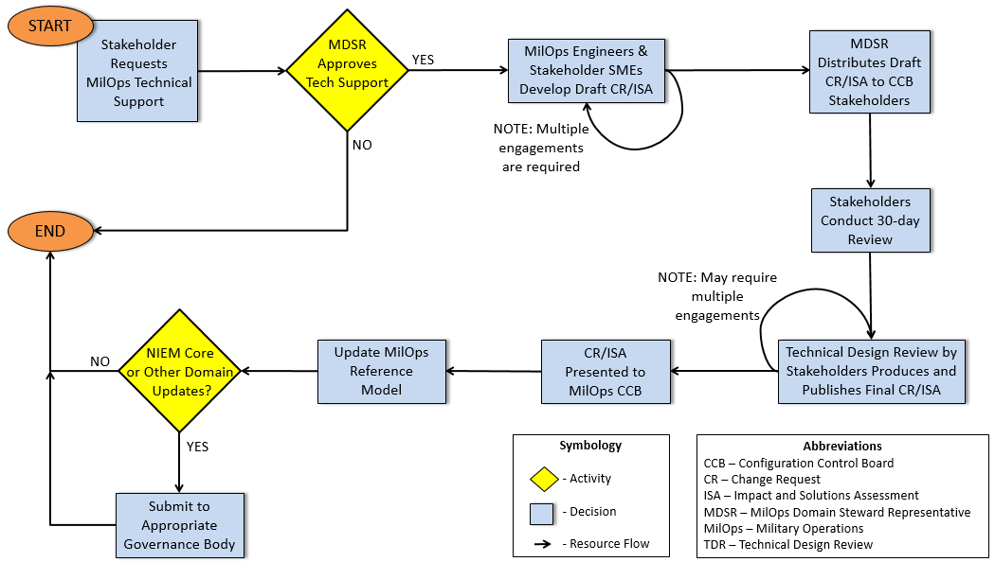

Figure 7: MilOps Change Request Process