

Alpine Map Training
Companion Manual: Levels 1 to 3
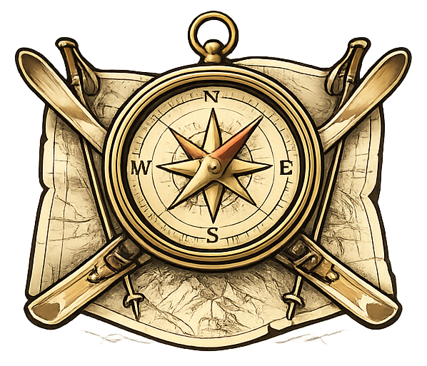
A printable workbook for ski instructors preparing for
BASI Alpine Level 4 ISTD (IMS / EMS module)

Prepared by

Nigel Taylor, CEO
nigel@performos.ai | www.performos.ai
Version 1.0 | May 2026

About this manual
This is the printable companion to the Alpine Map Training Progressive Web App. It mirrors the conceptual content of Levels 1 to 3 so that a learner can read, work through exercises and self-mark on paper, away from a phone or laptop. The two are designed to be used together, not in isolation.

What is in scope
- Levels 1 to 3 learner pages, exercises and self-checks.
- Worked examples and schematic teaching diagrams (Levels 2 and 3).
- Per-level check quizzes and reflection pages.
- Answer keys at the back of each level for self-marking or for use with a trainer.
- Printable templates appendix: route cards, pressure log, day log, interference table, decision-point criteria, escape-route working sheet, and the two mixed-quiz worksheets.

What stays in the field
The manual cannot replace the physical drills that need a real map, a real compass, an altimeter, or a trainer alongside the learner. Compass walking drills, the pole-and-cord technique, the verbal "if I stood here" exercises, and most map-marking work are deliberately referenced here but practised on the ground.

A note on magnetic variation
No fixed declination value is printed in this manual. Always check the current magnetic variation for your map area and date using the map margin and an official calculator (BGS WMM, NOAA / NCEI, or swisstopo).

Default venue
Worked examples reference Courchevel and the IGN TOP25 Les Trois Vallees / Modane 3534OT sheet by default. Substitute your own venue and equivalent map sheet where indicated.

How to use this manual
- Read each level’s introduction page first to set expectations.
- Work through pages in order, attempting every exercise before consulting the answer keys at the back of the level.
- Tick the self-check at the end of each page when you are confident.
- Sit the level’s check quiz under self-test conditions before moving on.
- Use the printable templates in the appendix during real practice in the field.

Contents
A live table of contents that updates with the document. Right-click the contents below and choose "Update field" if numbers ever drift.

Level 1

Map Literacy Foundations
This level builds the essential map-reading habits needed before moving into terrain interpretation. It focuses on understanding how maps work, how to read their structure, how to use scale and grids, and how to orient a printed extract confidently.

What is in this level
- B1 What is a topographic map (B1.1, B1.2)
- B2 Map anatomy (B2.1, B2.2)
- B3 Colours and symbols (B3.1, B3.2, B3.3)
- B4 Scale and distance (B4.1, B4.2, B4.3)
- B5 Grid references (B5.1, B5.2, B5.3)
- B6 Orientation to north (B6.1, B6.2, B6.3)
- Level 1 check quiz
- Level 1 reflection and completion page
- Level 1 answer keys

B1.1 Map Purpose and Perspective
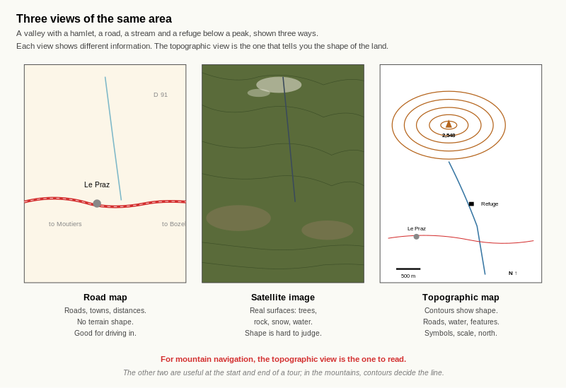
Reference diagram. Three Views of the Same Area. road map shows roads and towns but no terrain shape; satellite image shows real surfaces but is hard to read for slope; topographic map combines symbols, contours and labels so the shape of the land can be read at a glance. For mountain navigation, contours decide the line.

Learning aim
By the end of this page, the learner should be able to explain what a topographic map is, how it differs from a road map or satellite view, and why it is useful for mountain navigation.

What is a topographic map?
A topographic map is a detailed picture of the land seen from above. It shows the shape of the ground, water features, vegetation, buildings, tracks and other important information in a carefully organised visual form.
Unlike a road map, it is not only interested in getting you from one town to another. It is designed to help you understand the land itself.
Unlike a satellite image, it does not simply show what the camera saw. Instead, it selects, simplifies and organises information so that you can read the land clearly and make decisions.

Why this matters in mountain areas
In mountain terrain, the shape of the land matters just as much as distance. A route that looks short on a road map may cross steep ground, cliffs, gullies or ridges. A good mountain map helps the navigator understand:
- Where the high and low ground is.
- Which slopes are steep or gentle.
- Where rivers, huts, tracks and ridges are.
- Which route options are likely to be practical.

Three ways of viewing the same landscape
You can think about maps using three different viewpoints:
- Road map view – useful for roads and settlements, but poor for terrain shape.
- Satellite view – useful for seeing real surfaces and patterns, but not always easy to interpret quickly.
- Topographic map view – useful for understanding the structure of the terrain and navigating through it.

Worked example
Imagine you need to move from a valley hamlet to a mountain hut.
- A road map may show the road to the valley, but not the steepness of the hillside.
- A satellite image may show forest, rock and paths, but it may still be hard to judge the shape of the slope quickly.
- A topographic map helps you see the route, the land shape and the key features together.
That is why topographic maps are the standard tool for mountain navigation.

Exercise 1 — Identify the map type
Write the correct label next to each description:
Options:
- Road map
- Satellite image
- Topographic map
A. Shows roads and settlements clearly, but gives limited information about slope and terrain shape. Answer:
B. Shows the land as it appears from above, using real imagery rather than symbols. Answer:
C. Shows terrain shape, features and navigation detail using symbols, colours and contour lines. Answer:

Exercise 2 — Why use a topographic map?
Write three reasons why a topographic map is more useful than a road map in mountain terrain.

Exercise 3 — Short comparison task
Complete the table.
View type | Best for | Weakness
Road map | __________________ | __________________
Satellite image | __________________ | __________________
Topographic map | __________________ | __________________

Exercise 4 — Short written response
Write 4–5 sentences answering this question:
Why is a topographic map the most useful type of map for mountain navigation?
____________________________________________________ ____________________________________________________ ____________________________________________________ ____________________________________________________

Self-check
Tick the statements you can now do confidently:
☐ I can explain what a topographic map is.
☐ I can explain the difference between a road map, satellite image and topographic map.
☐ I can give at least three reasons why topographic maps matter in mountain areas.

Reflection
Which part still feels unclear?

B1.2 Bird’s-eye View vs Ground View
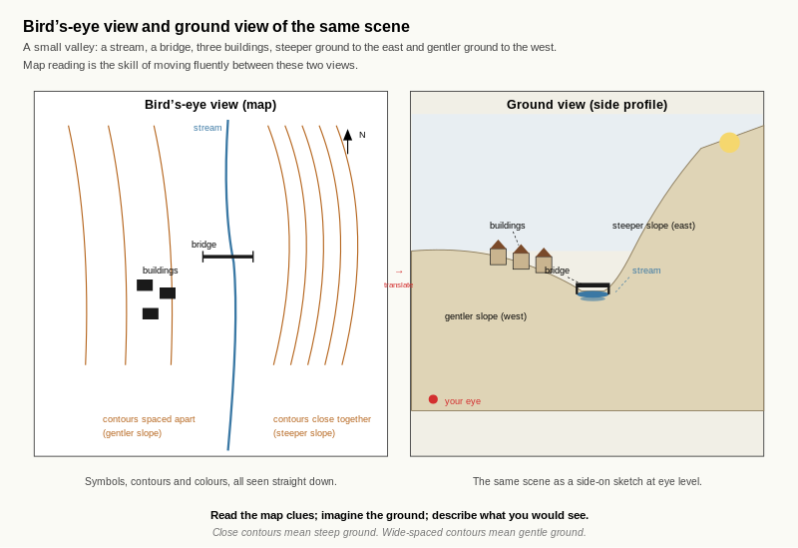
Reference diagram. Bird's-eye and Ground View. the same scene appears twice; the map view uses symbols and contour spacing to encode shape; the ground view shows what those map clues translate to at eye level.

Learning aim
By the end of this page, the learner should understand that a map is a bird’s-eye view of the land and should be able to begin turning simple map information into a mental picture of what the ground might look like.

The key idea
A map shows the landscape from above.
When you stand on the ground, you do not see the world that way. You see it from the side, at eye level. Good map reading depends on learning to translate between these two views.
This is one of the most important skills in mountain navigation.

Bird’s-eye view and ground view
Think of a simple valley with a stream, a bridge, a few buildings and a slope rising on one side.
From above on a map, you may see:
- A blue line for the stream.
- A black crossing for the bridge.
- A cluster of small black shapes for buildings.
- Brown contour lines showing rising ground.
From the ground, you may experience:
- Water at the low point.
- Buildings grouped together near flatter ground.
- Slopes rising away from the valley floor.
- Limited visibility depending on where you stand.

Worked example
Imagine you are standing next to a bridge shown on the map.
If the contour lines are close together to the east of the bridge and further apart to the west, that suggests:
- The ground rises steeply to the east.
- The ground rises more gently to the west.
- The bridge is likely to be near a low point where the stream passes through.
This is the beginning of visualising map data as reality.

How to practise this skill
When looking at a small map area, ask yourself four questions:
- Where is the lowest point?
- Where is the highest ground?
- What man-made or natural features are easy to recognise?
- If I stood here, what would I probably see around me?

Exercise 1 — Simple translation
Read the map description below and write what the ground might look like.
Map description: A blue stream runs north to south. A bridge crosses it. There are three buildings west of the bridge. Brown contour lines lie close together east of the stream.
What might this look like on the ground?
____________________________________________________ ____________________________________________________ ____________________________________________________

Exercise 2 — “If I stood here...”
Use the same description above.
Imagine you are standing on the bridge and facing east. Write 3–4 sentences describing what you would expect to see.
____________________________________________________ ____________________________________________________ ____________________________________________________

Exercise 3 — Feature matching
Match each map clue to the most likely ground meaning.
Map clue | Ground meaning
Blue line at the lowest point | A. Rising slope
Cluster of black rectangles | B. Watercourse
Close brown contour lines | C. Buildings
Write your answers:
- Blue line at the lowest point =
- Cluster of black rectangles =
- Close brown contour lines =

Exercise 4 — Sketch task
On a separate sheet of paper, draw a very simple side view of the scene described in Exercise 1.
Include:
- The stream.
- The bridge.
- The buildings.
- The steeper slope to the east.
- The gentler or flatter area to the west.
After drawing, write one sentence about which part was hardest to imagine.

Self-check
☐ I understand that a map shows the land from above.
☐ I can begin to imagine what a simple map scene might look like from ground level.
☐ I can describe low ground, high ground and obvious features using map clues.

Reflection
Which is harder for you at the moment?
☐ Understanding map symbols.
☐ Imagining the shape of the land.
☐ Turning map view into ground view.
☐ Describing the scene clearly.
Why?

B2.1 Map Anatomy: Title, Legend, Scale, North Arrow, Grid
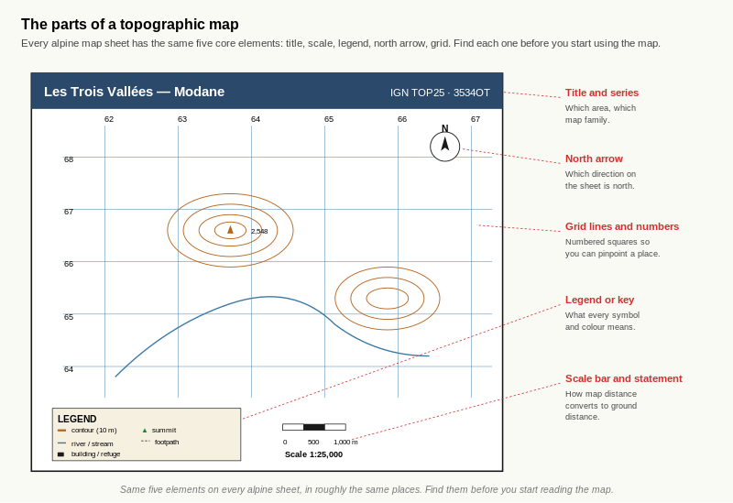
Reference diagram. Map Anatomy Annotated. title and series, north arrow, grid lines and numbers, legend, scale bar plus statement. Same five elements appear on every alpine sheet in roughly the same places.

Learning aim
By the end of this page, the learner should be able to locate and name the main parts of a topographic map: title, legend/key, scale bar, north arrow and grid lines.

The main parts of a map
Most outdoor maps share a common set of structural features:
- Title and series name – tells you which area the map covers and which map family it belongs to.
- Scale bar and scale statement – shows the relationship between map distance and ground distance (for example 1:25,000).
- Legend or key – explains the colours and symbols used on the map.
- North arrow – shows which direction on the map is north.
- Grid lines and grid numbers – divide the map into squares so you can pinpoint locations.
Being able to find these parts quickly is essential. Before using any new map, you should spend a few minutes finding and checking each one.

Worked example
Imagine opening a new 1:25,000 mountain map. Before you do anything else:
- Find the title to confirm you have the right area.
- Find the scale statement and scale bar to check the scale and contour interval.
- Find the legend and scan for key symbols (paths, huts, cliffs, lifts, forests).
- Find the north arrow so you know which way is north on the sheet.
- Look for grid lines and grid numbers around the edges.
This habit means you always know what the map is showing and how to read it.

Exercise 1 — Label the parts
Look at one of your own 1:25,000 or 1:50,000 map sheets.
On the map (or on a photocopy/printout), put a small numbered circle next to each of the following, then write the matching number in the table.
Items to find:
- Title or map name.
- Series name (family of maps).
- Scale statement (for example 1:25,000).
- Scale bar.
- Legend or key.
- North arrow.
- Grid lines.
- Grid numbers.
Number | Item found at (describe corner/position)
1 | ____________________________________________
2 | ____________________________________________
3 | ____________________________________________
4 | ____________________________________________
5 | ____________________________________________
6 | ____________________________________________
7 | ____________________________________________
8 | ____________________________________________

Exercise 2 — Function matching
Match each map part to its main purpose.
Map parts:
A. Title B. Legend/key C. Scale bar D. North arrow E. Grid lines and numbers
Purposes:
- Show the direction of north on the map.
- Let you convert centimetres on the map to distance on the ground.
- Divide the map into squares so you can give precise locations.
- Tell you which area the map covers.
- Explain the meaning of symbols and colours.
Write the correct letter next to each number:
- 1.
- 2.
- 3.
- 4.
- 5.

Exercise 3 — Quick questions
Answer the questions in one short sentence each.
- Why should you always check the scale when you pick up a map?
- Why should you always inspect the legend before using an unfamiliar map?
- Why is it important to know where north is on the map?
- How do grid lines help with navigation?

Self-check
☐ I can find the title, scale bar, legend, north arrow and grid on a map.
☐ I know the main purpose of each part.
☐ I always check these parts before using a new map.

B2.2 "Find It Fast" Drill Page

Learning aim
By the end of this page, the learner should be able to locate key map elements quickly and confidently on any topographic map.

Why speed matters
In real navigation, you will often need to:
- Confirm the scale quickly.
- Check a symbol in the legend.
- Read a grid reference near the edge.
- Glance at the north arrow.
The less time you spend hunting for these basics, the more attention you can give to route choice, hazards and the group.

Exercise 1 — Timed anatomy drill
You will need a stopwatch or phone timer.
Step 1: On your chosen map, time how long it takes to find and touch each of the following in order:
- Title or map name.
- Scale statement.
- Scale bar.
- Legend.
- North arrow.
- A grid line.
- A grid number.
Write your times below.
Item | Time taken (seconds)
Title/map name | ________
Scale statement | ________
Scale bar | ________
Legend | ________
North arrow | ________
Grid line | ________
Grid number | ________
Step 2: Repeat the drill on a second map (for example a different country or map series). Write the times again.
Item | Time taken (seconds)
Title/map name | ________
Scale statement | ________
Scale bar | ________
Legend | ________
North arrow | ________
Grid line | ________
Grid number | ________
Step 3: Circle the items which took you longest to find on each map.

Exercise 2 — Spot the differences
Lay two different map sheets side by side (for example one UK-style map and one Alpine map).
Answer the questions:
- Where is the legend located on each map (corner/edge)? Map 1: ____________________________________________ Map 2:
- How is the scale shown on each map (scale bar, statement, both)? Map 1: ____________________________________________ Map 2:
- Are the north arrows in the same place on both maps? Answer:
- Which map makes it easier for you to find these items quickly? Why? Answer:

Exercise 3 — Quick-fire questions
Without looking back at the previous page, answer:
- Name three essential parts of a topographic map.
- Which map part tells you what symbols mean?
- Which map part allows you to give precise positions using numbers?
- Which map part allows you to convert centimetres on the map into ground distance?

Exercise 4 — Personal checklist
Based on your timings and answers above, write down:
- One map element you can find quickly and confidently.
- One map element you still hunt for more slowly.
- One action you will take when you pick up a new map to improve your speed (for example, "I will always find the legend and scale before starting").

Self-check
☐ I can find key map parts quickly on different map types.
☐ I know which elements I tend to miss or search for slowly.
☐ I have a short personal routine for inspecting a new map.

B3.1 The Five-Colour System
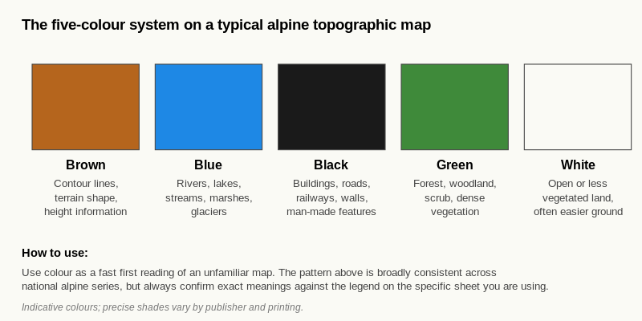
Reference diagram. Five-Colour System. brown for terrain shape and contours; blue for water; black for man-made features; green for vegetation; white for open or less vegetated land. Indicative; learner should always confirm against the legend on the actual sheet.

Learning aim
By the end of this page, the learner should be able to recognise the main colour groups used on outdoor topographic maps and explain what each colour usually represents.

Why colour matters
Topographic maps use colour as a fast visual language. Before reading small symbols or detailed text, a skilled navigator often gets a quick first impression from the map’s colours.
Although different map agencies may vary slightly, the broad pattern is usually consistent enough to be very useful.

The five-colour system
On many outdoor maps, these colours usually suggest the following:
- Brown – terrain shape and height information, especially contour lines.
- Blue – water, such as rivers, lakes, streams, marshes or glaciers.
- Black – man-made features, including buildings, roads, railways, walls and many boundaries.
- Green – vegetation, especially forest, woodland, scrub or areas of thicker plant cover.
- White – open or less vegetated land, often easier to cross than dense woodland (but not always).
The learner should treat these as strong visual clues, then confirm details from the legend.

Worked example
Imagine you open a map and immediately notice:
- a broad white area,
- a narrow blue line,
- a block of green,
- several black shapes,
- and many brown lines.
A quick first interpretation might be:
- open ground,
- a stream or river,
- woodland or dense vegetation,
- buildings or other man-made features,
- and shaped terrain with height information.
This first visual scan helps you understand the area before you read finer detail.

Exercise 1 — Colour matching
Match each colour to its most likely meaning.
Colour | Meaning
Brown | A. Water
Blue | B. Terrain / contours
Black | C. Vegetation / woodland
Green | D. Man-made features
White | E. Open land
Write your answers:
- Brown =
- Blue =
- Black =
- Green =
- White =

Exercise 2 — Colour scan task
Choose one of your map extracts.
Without reading the legend yet, scan the map for 30–60 seconds and then write down:
- Two things the brown tells you about the area.
- Two things the blue tells you about the area.
- Two things the green/white pattern tells you about the likely ground cover.
- Two things the black features tell you about human presence or access.

Exercise 3 — Quick interpretation
Read the description and answer the questions.
Description: The centre of the map is mostly white with many brown contours. A dark green block lies to the west. A blue stream runs north to south. A small cluster of black rectangles sits near the stream.
- What is the white area likely to represent?
- What does the dark green block likely represent?
- What does the blue line represent?
- What do the black rectangles likely represent?
- What do the many brown contours tell you?

Exercise 4 — Legend check
Now look at the actual legend of your map.
Write down one example where the legend confirmed your first guess, and one example where the legend added extra detail.
- Confirmed guess:
- Extra detail from legend:

Self-check
☐ I can recall the usual meaning of the five main map colours.
☐ I can use colour as a quick first reading of the map.
☐ I understand that colour gives clues, but the legend confirms the detail.

B3.2 Symbol Hunt
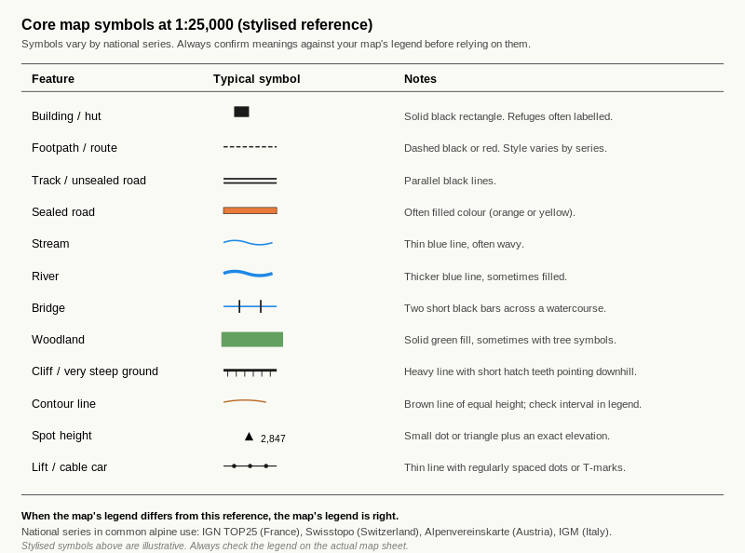
Reference diagram. Core Map Symbols. the typical visual form of each common symbol; conventions vary by national series; the discipline of always checking the legend on the actual map sheet before relying on a symbol.

Learning aim
By the end of this page, the learner should be able to find and interpret common topographic map symbols using the legend and real map extracts.

Why symbols matter
Colour gives a fast overview, but symbols give precision. Small signs on the map may show a hut, bridge, path, wall, cliff, church, road, lift or many other features that matter for route choice.
The key habit is simple: notice the symbol, then confirm it in the legend if needed.

A practical way to learn symbols
Do not try to memorise an entire legend in one sitting. Instead:
- Learn a few high-value symbols first.
- Find them on a real map.
- Say aloud what they mean.
- Revisit them several times across different map types.

Core symbols to start with
Use your own map legend to identify symbols for:
- Building or hut.
- Footpath or walking route.
- Road or track.
- River or stream.
- Bridge.
- Woodland.
- Cliff or very steep ground.

Exercise 1 — Legend lookup
Using your chosen map, find the legend symbol for each of the following and sketch it in the table.
Feature | Sketch the symbol | What it means
Hut / building
Footpath / route
Road / track
Stream / river
Bridge
Woodland
Cliff / steep ground

Exercise 2 — Symbol hunt on the map
Find examples of the following on your actual map and describe where you found them.
- One building or hut. Found at:
- One path or walking route. Found at:
- One water feature. Found at:
- One vegetation feature. Found at:
- One steep or rocky feature. Found at:

Exercise 3 — What does this tell you?
Answer the questions in one or two sentences.
- If you see a bridge symbol crossing a blue line, what does that suggest on the ground?
- If you see a hut symbol near a path junction, why might that be a useful feature for navigation?
- If you see cliff or very steep-ground symbols on your route line, what should that make you think about?

Exercise 4 — Tiny map-square description
Pick a very small area on your map, about 2 cm by 2 cm.
Describe it using colours and symbols only.
Start your answer with:
“This small map area appears to show...”
____________________________________________________ ____________________________________________________ ____________________________________________________

Self-check
☐ I can use the legend to find the meaning of common symbols.
☐ I can locate real examples of symbols on a map.
☐ I can describe a small map area using colour and symbol clues.

B3.3 Legend Comparison Page

Learning aim
By the end of this page, the learner should be able to compare two different map legends, notice similarities and differences, and explain why checking the legend is essential whenever using an unfamiliar map.

Why legend comparison matters
A topographic map is only as useful as your ability to decode it correctly. Even when two maps look broadly similar, the symbols, colours, line styles and labels may vary.
This means a good navigator never assumes. A good navigator checks.

What to compare
When comparing two map legends, look especially for:
- paths and walking routes,
- roads and tracks,
- rivers and streams,
- huts or buildings,
- woodland or vegetation,
- cliffs or steep ground,
- lift systems or mountain infrastructure,
- and any symbols that are unfamiliar.

Worked example
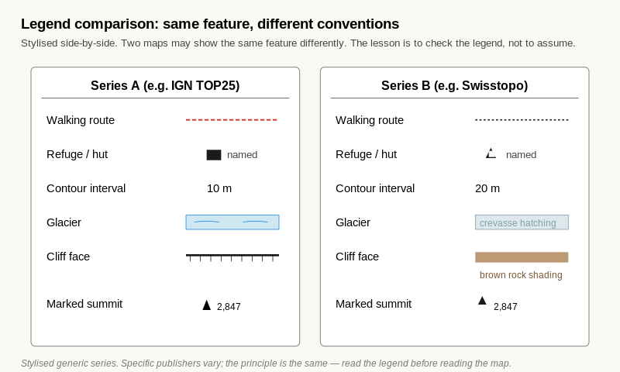
Reference diagram. Legend Comparison Worked Example. the same feature shown with different conventions on two example legends; the discipline of comparing rather than assuming.
Imagine you place two maps side by side.
- On Map A, a walking route may be shown with a red dashed line.
- On Map B, a similar route may be shown with a black dotted line.
- On one map, a hut symbol may be a small black square.
- On another, it may have a different icon or label.
If you rely on assumption instead of checking the legend, you can misread the map.

Exercise 1 — Legend comparison table
Place two different maps side by side and complete the table.
Feature | Map 1 symbol / style | Map 2 symbol / style | Same or different?
Footpath / route
Track / road
Hut / building
Stream / river
Woodland / vegetation
Cliff / steep ground

Exercise 2 — What surprised you?
Write down two differences you noticed between the legends.

Write down one thing that stayed broadly similar.

Exercise 3 — Why does this matter?
Answer in 3–5 sentences:
Why is it risky to assume that symbols mean the same thing on every map?
____________________________________________________ ____________________________________________________ ____________________________________________________

Exercise 4 — Personal rule
Complete this sentence:
Whenever I pick up a new map, before I start navigating I will always...

Self-check
☐ I can compare two legends and notice differences.
☐ I understand why assumptions are risky.
☐ I have formed the habit of checking the legend first.

B4.1 Understanding Scale
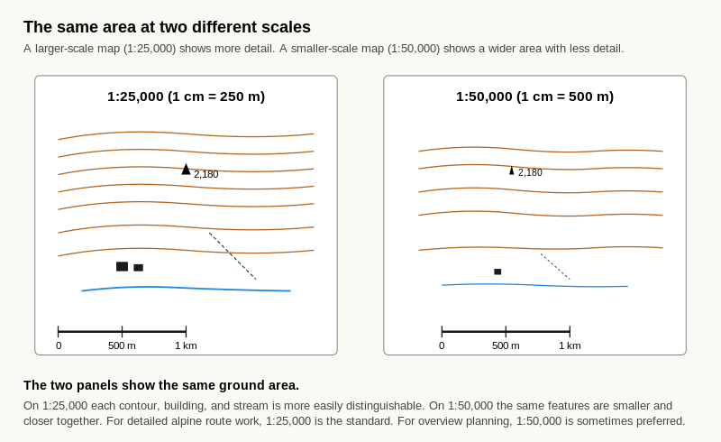
Reference diagram. Scale Comparison. the larger scale (1:25,000) shows more detail in less area; the smaller scale (1:50,000) shows a wider area with less detail; both have their use in alpine planning.

Learning aim
By the end of this page, the learner should understand what map scale means, how to interpret 1:25,000 and 1:50,000, and why scale affects navigation detail.

What scale means
Map scale tells you how much the real world has been reduced to fit on the map.
For example:
- 1:25,000 means 1 unit on the map equals 25,000 of the same units on the ground.
- 1:50,000 means 1 unit on the map equals 50,000 of the same units on the ground.
In practical terms:
- On a 1:25,000 map, 1 cm on the map = 250 metres on the ground.
- On a 1:50,000 map, 1 cm on the map = 500 metres on the ground.

Why scale matters in navigation
A larger-scale map (such as 1:25,000) usually shows more detail. A smaller-scale map (such as 1:50,000) shows a wider area but usually with less detail.
This matters because in mountain navigation you often need both:
- fine detail for precise route choice,
- and wider overview for bigger planning.

Worked example
If two points are 4 cm apart on the map:
- On a 1:25,000 map, the ground distance is 1,000 m (1 km).
- On a 1:50,000 map, the ground distance is 2,000 m (2 km).
The same line on two different maps can therefore represent very different ground distances.

Exercise 1 — Fill in the blanks
- On a 1:25,000 map, 1 cm = __________ metres.
- On a 1:50,000 map, 1 cm = __________ metres.
- On a 1:25,000 map, 4 cm = __________ km.
- On a 1:50,000 map, 2 cm = __________ km.

Exercise 2 — Quick conversions
Complete the table.
Scale | Map distance | Ground distance
1:25,000 | 2 cm | __________________
1:25,000 | 6 cm | __________________
1:50,000 | 3 cm | __________________
1:50,000 | 5 cm | __________________

Exercise 3 — Which map would you choose?
Answer the questions.
- Which scale is usually better for detailed route-finding: 1:25,000 or 1:50,000? Why?
- Which scale is more useful for seeing a wider area quickly? Why?
- Why might a navigator use both types during planning and travel?

Exercise 4 — Explain it simply
Write 3–4 sentences explaining map scale as if you were teaching it to a beginner.
____________________________________________________ ____________________________________________________ ____________________________________________________

Self-check
☐ I understand what 1:25,000 and 1:50,000 mean.
☐ I can convert simple map distances into ground distances.
☐ I know why scale affects the amount of detail I can see.

B4.2 Measuring Simple Route Lengths

Learning aim
By the end of this page, the learner should be able to measure simple route lengths on printed map extracts using a ruler, straight edge or string, and convert those measurements into ground distance.

Why this matters
Knowing scale is useful, but navigation becomes practical when the learner can actually measure a route and turn that into a real-world distance. On printed extracts and PDFs, the learner must always check that the print size is correct before trusting measurements.

Before measuring
Before starting, check three things:
- The printed extract has been printed at the correct size.
- The scale bar or scale statement is visible.
- You know whether the map is 1:25,000 or 1:50,000.
If the print has been resized, use the scale bar rather than assuming the original scale is still exact.

Straight and curved distances
There are two common cases:
- Straight line distance – measure directly with a ruler.
- Curved route distance – use a piece of string, paper edge or flexible strip to follow the bends, then measure that length with a ruler.

Worked example 1 — Straight line
Two points are 5 cm apart on a 1:25,000 printed extract.
- 1 cm = 250 m
- 5 cm = 1,250 m
- So the ground distance is 1.25 km

Worked example 2 — Curved route
A winding path is traced with a piece of string and the string measures 7 cm on a 1:50,000 extract.
- 1 cm = 500 m
- 7 cm = 3,500 m
- So the route length is 3.5 km

Exercise 1 — Straight route conversions
Complete the table.
Scale | Map measurement | Ground distance
1:25,000 | 3 cm | __________________
1:25,000 | 8 cm | __________________
1:50,000 | 4 cm | __________________
1:50,000 | 7 cm | __________________

Exercise 2 — Printed extract practice
Using one of your printed map extracts, choose two obvious points and measure the straight-line distance between them.
- Map scale:
- Map measurement:
- Ground distance:
Now write one sentence explaining how you worked it out.

Exercise 3 — Curved route practice
Using a second printed extract or route line, choose a simple path or track that bends.
Use string, a strip of paper or the edge of a flexible card to follow the route.
- Map scale:
- String / paper measurement:
- Ground distance:
What was harder about measuring the curved route than the straight route?

Exercise 4 — Print-check question
Why is it important to check whether a PDF extract has been printed at the correct size before measuring distance?

Self-check
☐ I can measure a straight-line distance on a printed extract.
☐ I can measure a simple curved route using string or paper.
☐ I know why print scaling can affect accuracy.

B4.3 Scale Fluency Drill

Learning aim
By the end of this page, the learner should be able to convert common map measurements quickly and confidently without having to work everything out from scratch each time.

Quick rules to memorise
Use these fluency rules:
- 1:25,000 → 1 cm = 250 m
- 1:50,000 → 1 cm = 500 m
If these become automatic, route planning becomes much easier.

Exercise 1 — Fast conversions
Write the answer as quickly as you can.

1:25,000 scale
- 1 cm =
- 2 cm =
- 4 cm =
- 6 cm =

1:50,000 scale
- 1 cm =
- 2 cm =
- 4 cm =
- 6 cm =

Exercise 2 — Mixed drill
Complete the table.
Scale | Map distance | Ground distance
1:25,000 | 5 cm | __________________
1:50,000 | 5 cm | __________________
1:25,000 | 10 cm | __________________
1:50,000 | 10 cm | __________________
1:25,000 | 12 cm | __________________
1:50,000 | 12 cm | __________________

Exercise 3 — Which is larger?
Answer the questions.
- On which map scale does 4 cm represent the greater ground distance?
- If two people each measure 6 cm, one on a 1:25,000 map and one on a 1:50,000 map, whose route is longer on the ground?
- Why must you never convert map distance without checking the scale first?

Exercise 4 — Personal memory method
Write down the memory rule you will use for these two scales.

Self-check
☐ I can convert common measurements quickly.
☐ I can tell the difference between 1:25,000 and 1:50,000 at a glance.
☐ I am becoming faster and more accurate with scale.

B5.1 Eastings and Northings
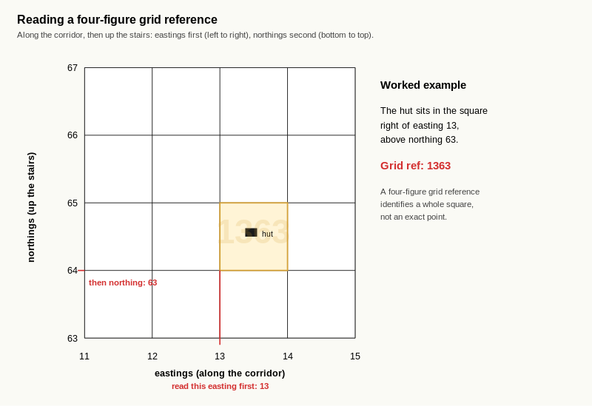
Reference diagram. Grid Square Diagram. the along-the-corridor-then-up-the-stairs reading order; eastings first, northings second; the four-figure reference identifies a square, not an exact point.

Learning aim
By the end of this page, the learner should be able to identify eastings and northings on a map grid and explain the order in which they are read.

The basic idea
Grid lines turn the map into a set of squares. These squares help the navigator describe location clearly.
There are two directions to remember:
- Eastings – the vertical grid lines, read from left to right.
- Northings – the horizontal grid lines, read from bottom to top.
A simple memory phrase is:
Along the corridor, then up the stairs.
That means:
- Read the easting first.
- Read the northing second.

Worked example
Imagine a symbol sits inside the square between easting 23 and 24, and between northing 57 and 58.
To identify the square:
- read the left-hand grid line first → 23
- then read the bottom grid line → 57
So the square is 2357.

Exercise 1 — Name the parts
Complete the sentences.
- Eastings are the __________________ grid lines.
- Northings are the __________________ grid lines.
- Eastings are read from __________________ to __________________.
- Northings are read from __________________ to __________________.

Exercise 2 — Memory rule
Write the memory phrase in your own words.

Exercise 3 — Square identification practice
A feature sits in the square between:
- easting 41 and 42
- northing 76 and 77
Write the four-figure square reference:
Now try these:
- Between easting 18 and 19, and northing 63 and 64 =
- Between easting 52 and 53, and northing 21 and 22 =
- Between easting 07 and 08, and northing 44 and 45 =

Exercise 4 — Why order matters
Why is it important to say eastings first and northings second?

Self-check
☐ I know which lines are eastings and which are northings.
☐ I know the correct reading order.
☐ I can identify a grid square correctly.

B5.2 Four-Figure Grid References

Learning aim
By the end of this page, the learner should be able to give and interpret four-figure grid references using printed map extracts or training grids.

What a four-figure grid reference does
A four-figure grid reference identifies one whole grid square on the map. It does not pinpoint the exact feature inside the square, but it tells you which square to search in.
This is often enough for simple beginner exercises and is the foundation for more precise work later.

How to read it
To give a four-figure grid reference:
- Find the easting of the left-hand grid line of the square.
- Find the northing of the bottom grid line of the square.
- Put them together in that order.

Worked example
A bridge lies in the square:
- right of easting 34
- above northing 62
Its four-figure grid reference is 3462.

Exercise 1 — Write the grid reference
Give the four-figure reference for the following squares.
- Right of easting 11 and above northing 45 =
- Right of easting 26 and above northing 70 =
- Right of easting 53 and above northing 18 =
- Right of easting 08 and above northing 39 =

Exercise 2 — Read the grid reference
Write what each reference means.
- 2741 means the square right of easting ______ and above northing
- 5633 means the square right of easting ______ and above northing
- 1248 means the square right of easting ______ and above northing

Exercise 3 — Spot the mistake
A learner says that a feature in the square right of easting 37 and above northing 52 has the reference 5237.
What has the learner done wrong?

What is the correct answer?

Exercise 4 — Practice on a printed extract
Using one of your printed map extracts, choose three clear features in different squares and record their four-figure grid references.
Feature | Four-figure grid reference

Self-check
☐ I can give a correct four-figure grid reference.
☐ I always say eastings before northings.
☐ I understand that a four-figure reference identifies a square, not an exact point.

B5.3 Grid-Reference Drill

Learning aim
By the end of this page, the learner should be able to give and read four-figure grid references quickly and reliably on simple training grids and printed map extracts.

Why this drill matters
Four-figure grid references are one of the first truly practical map skills. They help the learner move from “I can see the feature” to “I can state where it is”.
The key ideas remain the same each time:
- Find the correct square.
- Read the easting first.
- Read the northing second.

Quick reminder
A four-figure grid reference identifies a grid square, not an exact point. The first two digits come from the left-hand grid line of the square. The second two digits come from the bottom grid line of the square.

Exercise 1 — Fast square drill
Give the correct four-figure reference for each square.
- Right of easting 14 and above northing 62 =
- Right of easting 37 and above northing 45 =
- Right of easting 09 and above northing 28 =
- Right of easting 51 and above northing 73 =
- Right of easting 26 and above northing 19 =
- Right of easting 44 and above northing 56 =

Exercise 2 — Read the reference
Explain what each four-figure reference means.
- 2358 = square right of easting ______ and above northing
- 4172 = square right of easting ______ and above northing
- 0846 = square right of easting ______ and above northing
- 5631 = square right of easting ______ and above northing

Exercise 3 — Spot and correct the mistake
A learner gives these answers:
- A hut in the square right of easting 32 and above northing 61 is written as 6132.
- A bridge in the square right of easting 07 and above northing 43 is written as 0743.
- A wall in the square right of easting 48 and above northing 25 is written as 2548.
For each one, write whether it is correct or incorrect, and if incorrect write the corrected answer.
Example | Correct or incorrect? | Correct answer if needed
Hut
Bridge
Wall

Exercise 4 — Printed extract drill
Using one of your printed extracts, choose four clear features in different squares and record their four-figure references.
Feature | Four-figure grid reference

Self-check
☐ I can give a four-figure grid reference accurately.
☐ I always read eastings before northings.
☐ I can use both training grids and real extracts.

B6.1 Orientation to North
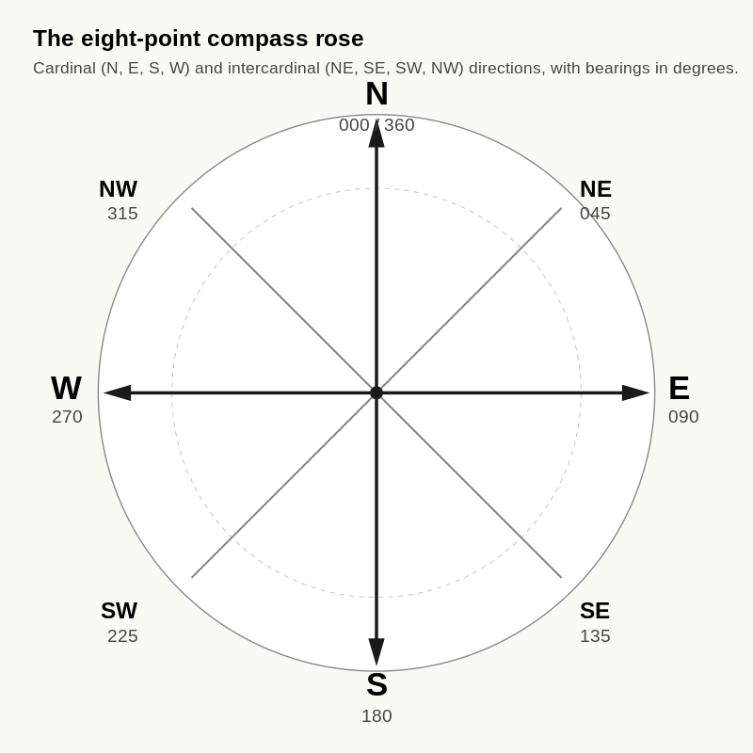
Reference diagram. Eight-Point Compass Rose. N (000 / 360), NE (045), E (090), SE (135), S (180), SW (225), W (270), NW (315); the eight-direction resolution that the workbook uses for aspect reading at IMS / EMS level.

Learning aim
By the end of this page, the learner should understand why north is shown at the top of most maps and should be able to use north, south, east and west correctly on a printed extract.

Why north matters
Maps need a consistent direction system. On most topographic maps, north is at the top of the sheet. Once the learner understands this, they can describe where features lie in relation to each other more clearly.
For example:
- if north is at the top,
- south is at the bottom,
- east is to the right,
- west is to the left.

From paper to ground
When the map is not aligned with the ground, the learner may have to do a mental rotation. That is why good navigators often turn the map so it matches the world around them.
At this stage, the aim is simply to become confident with north and the other main directions.

Exercise 1 — Direction basics
Complete the sentences.
- If north is at the top of the map, south is at the __________.
- If north is at the top of the map, east is to the __________.
- If north is at the top of the map, west is to the __________.
- If a stream lies above a hut on the page, the stream is to the __________ of the hut.

Exercise 2 — Simple feature directions
Imagine a printed extract where:
- a hut is in the centre,
- a stream is above it,
- woodland is to the right,
- a road is below it,
- and open ground is to the left.
Write the direction of each feature from the hut.
- Stream =
- Woodland =
- Road =
- Open ground =

Exercise 3 — Short reasoning task
If you rotate the page 180 degrees in your hands, does north on the actual map content change?
Answer:
Why?

Exercise 4 — Printed extract practice
Look at one printed extract and choose one obvious central feature.
Then write:
- What lies north of it?
- What lies south of it?
- What lies east of it?
- What lies west of it?

Self-check
☐ I know where north, south, east and west are on a map.
☐ I understand that turning the paper does not change the map’s internal directions.
☐ I can describe nearby features using basic directions.

B6.2 Map Rotation
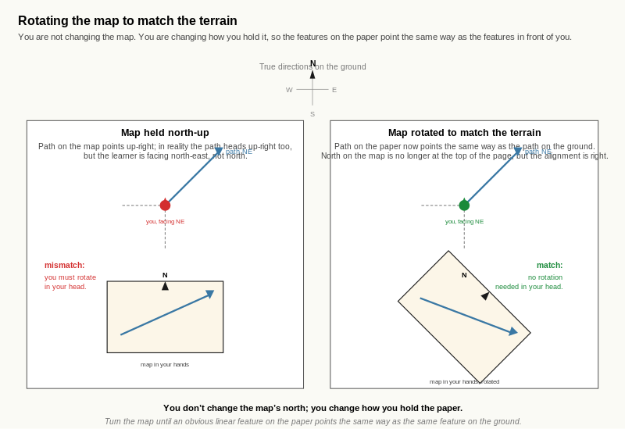
Reference diagram. Map Rotation. turning the paper does not change where north is on the map; it changes how your hands hold the sheet. Mental load drops as soon as linear features on the paper point the same way as the same features on the ground.

Learning aim
By the end of this page, the learner should understand why rotating the map helps reduce confusion and should be able to turn a printed extract so that it better matches the world around them.

Why rotate the map?
A map is easiest to use when the directions on the paper match the directions of the terrain around you. If the map is held at an awkward angle, the learner has to keep translating left/right and forward/backward in their head.
Rotating the map helps reduce that mental effort.

Key idea
You are not changing the map itself. You are changing how you hold it so that the features on the paper point the same way as the features on the ground.

Worked example
Imagine you are standing on a path junction. On the map, the path you want runs away to the north-east. If, in real life, that path heads away in front-right of where you are standing, turning the map so that the path points the same way can make the whole picture easier to understand.

Exercise 1 — True or false
Write true or false.
- Rotating the map changes the real direction of north on the map.
- Rotating the map can make it easier to match paper and terrain.
- Holding the map in one fixed position is always best.
- Rotating the map can reduce mental effort.

Exercise 2 — Why rotate?
Write 3–4 sentences answering this question:
Why does rotating a map often make navigation easier?
____________________________________________________ ____________________________________________________ ____________________________________________________

Exercise 3 — Tabletop practice
Place one printed extract on a table.
- Choose one route line or valley.
- Turn the paper slowly through 90 degrees, then 180 degrees.
- Notice how easy or hard it is to imagine the route when the map is in each position.
Write your observations below.
- Easiest position:
- Hardest position:
- Why?

Exercise 4 — Feature matching
Using a printed extract, choose one obvious linear feature such as a stream, valley, road or ridge.
Complete the sentence:
“I would rotate the map until this feature points in the same direction as...”

Self-check
☐ I understand why rotating the map helps.
☐ I know that rotating the paper does not change the map’s true north.
☐ I can use rotation to make the map easier to read.

B6.3 Simple Orienting Exercises

Learning aim
By the end of this page, the learner should be able to use obvious terrain and feature clues to orient a printed map in a simple situation, without yet relying on advanced compass work.

The basic principle
A map can often be oriented by comparing a few strong clues between the paper and the ground, such as:
- a valley,
- a stream,
- a road,
- a ridge,
- a settlement edge,
- or a junction.
The learner is trying to make the picture on the paper line up with the picture in the landscape.

Worked example
Suppose you are standing near:
- a stream in a shallow valley,
- woodland to one side,
- open ground to the other,
- and a path crossing a bridge.
If the printed extract shows the same arrangement, you can rotate the map until those features line up in the same relative directions.

Exercise 1 — Which way would you turn it?
Imagine the map shows a stream running top to bottom on the page, but in front of you the real stream runs left to right.
What might you need to do to the paper map?

Exercise 2 — Match the scene
Read the scene description:
You are on open ground. A wood is to your right. A stream is ahead. A track runs behind you.
On your printed extract, find a place where those same relationships might fit.
Write one short paragraph explaining how you would turn the map so it matches the scene.
____________________________________________________ ____________________________________________________

Exercise 3 — Valley and ridge thinking
Answer in one or two sentences each.
- Why are obvious linear features like valleys, streams and roads helpful when orienting a map?
- Why is it harder to orient a map in featureless or confusing ground?

Exercise 4 — Personal process
Write your simple orienting routine in four steps.

Self-check
☐ I can use obvious features to help orient a printed map.
☐ I understand that orienting means matching the paper to the ground.
☐ I am beginning to form a simple repeatable process.

Level 1 Check Quiz

Instructions
Answer all questions without looking back at the previous pages if possible. This short check is designed to test the key ideas from Level 1.

Questions
- What is the main purpose of a topographic map?
- What is the difference between a bird’s-eye view and a ground view?
- Name three main structural parts of a map.
- What does the colour blue usually represent on a topographic map?
- Why should you always check the legend on an unfamiliar map?
- On a 1:25,000 map, 1 cm represents how many metres on the ground?
- On a 1:50,000 map, which covers more ground on the sheet: 1 cm or 1 cm on a 1:25,000 map?
- What is the correct order when reading a four-figure grid reference?
- What does a four-figure grid reference identify: an exact point or a grid square?
- Why can rotating the map make navigation easier?
- If north is at the top of the map, which direction is to the right?
- Why must you check print scaling on a PDF extract before trusting measurements?

Self-rating
Tick the statement that best fits your current confidence.
☐ I am ready to move into Level 2.
☐ I understand most of Level 1, but need more drill practice.
☐ I need to revisit several Level 1 sections before moving on.

Level 1 Reflection and Completion Page

Completion check
Tick the statements that are now true.
☐ I understand the purpose of a topographic map.
☐ I can explain bird’s-eye view and ground view.
☐ I can find title, legend, scale, north arrow and grid quickly.
☐ I understand the main map colours.
☐ I can use the legend to interpret symbols.
☐ I can convert simple map distances into ground distances.
☐ I can give four-figure grid references accurately.
☐ I can describe north, south, east and west correctly.
☐ I can rotate and orient a simple printed extract.

Reflection questions
Answer in short notes or full sentences.
- What part of Level 1 now feels strongest for you?
- Which part still feels least confident?
- What mistake do you now make less often than when you started?
- What habit has improved most during this level?
- What should you practise again before moving fully into Level 2?

Readiness decision
Tick one:
☐ I am ready to begin Level 2.
☐ I want one more practice session on Level 1 before moving on.
☐ I need to revisit several Level 1 pages first.

Trainer / self-review note
Write one short note about what should happen next.

Level 1

Answer keys
Self-mark or use these with a trainer alongside. Where exercises ask for short written responses, the keys give "model answer" criteria rather than a single correct sentence; a strong answer covers most of the listed points.

B1.1 Map Purpose and Perspective — Answer Key

Exercise 1 — Identify the map type
- A. Road map
- B. Satellite image
- C. Topographic map

Exercise 2 — Why use a topographic map?
Accept any three valid points, such as:
- It shows the shape of the land.
- It shows steep and gentle ground.
- It helps with route choice in mountain terrain.
- It combines natural and man-made features.
- It is designed for navigation rather than just travel between settlements.

Exercise 3 — Short comparison task
Model answers:
View type | Best for | Weakness
Road map | Roads, towns, route planning by road | Poor for terrain shape
Satellite image | Real-world surface appearance | Harder to judge terrain structure quickly
Topographic map | Navigation and terrain understanding | Requires learning symbols and contours

Exercise 4 — Short written response
A strong answer should mention most of the following:
- A topographic map shows the shape of the land.
- It helps the learner understand high and low ground.
- It shows important natural and man-made features together.
- It is better for judging route practicality in mountain areas.
- It supports navigation decisions more effectively than a simple road map.

B1.2 Bird’s-eye View vs Ground View — Answer Key

Exercise 1 — Simple translation
A strong answer should include:
- A stream in the lowest part of the ground.
- A bridge crossing the stream.
- Buildings grouped on the west side.
- Steeper rising ground to the east.
- Gentler or flatter ground around the buildings to the west.

Exercise 2 — “If I stood here...”
A strong answer should include ideas such as:
- Water below or beside the bridge.
- Buildings behind or to one side on flatter ground.
- The slope rising more steeply to the east.
- The valley floor or lower ground around the stream.

Exercise 3 — Feature matching
- Blue line at the lowest point = B. Watercourse
- Cluster of black rectangles = C. Buildings
- Close brown contour lines = A. Rising slope

Exercise 4 — Sketch task
This is self-assessed, but a good sketch should show:
- Stream at the lowest point.
- Bridge crossing the stream.
- Buildings on the west side.
- Steeper slope to the east.
- Relative ground shape shown from side view rather than from above.

Coaching notes for marking
If the learner struggles, check whether the difficulty is mainly:
- recognising symbols,
- understanding that water lies in low ground,
- understanding that close contours mean steep ground,
- or converting map clues into a side-on mental picture.
If the last point is the main issue, keep using tiny map scenes and ask for short verbal descriptions before asking for sketches.

B2.1 Map Anatomy — Answer Key

Exercise 1 — Label the parts
This exercise is descriptive. Check that the learner has correctly identified positions on their actual map for:
- Title or map name.
- Series name.
- Scale statement.
- Scale bar.
- Legend or key.
- North arrow.
- Grid lines.
- Grid numbers.
Locations will vary by map series, but each item should be present and correctly recognised.

Exercise 2 — Function matching
Correct answers:
- 1. D (North arrow): shows the direction of north on the map.
- 2. C (Scale bar): lets you convert centimetres on the map to distance on the ground.
- 3. E (Grid lines and numbers): divide the map into squares for precise locations.
- 4. A (Title): tells you which area the map covers.
- 5. B (Legend/key): explains the meaning of symbols and colours.

Exercise 3 — Quick questions
- Why should you always check the scale when you pick up a map?
- Model idea: Because the scale tells you how distances on the map relate to real distances, and you may need to switch between 1:25,000 and 1:50,000.
- Why should you always inspect the legend before using an unfamiliar map?
- Model idea: Because different maps use slightly different symbols, and the legend explains what they mean.
- Why is it important to know where north is on the map?
- Model idea: Because orienting the map to north helps you match the map to the real terrain.
- How do grid lines help with navigation?
- Model idea: They allow you to use grid references to give and find precise positions.

B2.2 "Find It Fast" Drill Page — Answer Key

Exercise 1 — Timed anatomy drill
There are no fixed numeric answers here. Look for improvement between the first and second attempts, and check that:
- The learner can find each item without confusion.
- The learner has correctly circled the items which took longest to find.

Exercise 2 — Spot the differences
Answers will vary by map. Strong responses should include points like:
- Legend location: correctly described for each map (for example, bottom-left on Map 1, back cover on Map 2).
- How the scale is shown: both maps show a scale bar, for example, and one also shows a numeric statement like 1:25,000.
- North arrow position: whether it is clearly visible and if its location differs between maps.
- Which map is easier and why: for example, one has a clearer layout or more obvious legend placement.

Exercise 3 — Quick-fire questions
- Name three essential parts of a topographic map.
- Model ideas: Title, legend/key, scale bar, north arrow, grid lines.
- Which map part tells you what symbols mean?
- Legend/key.
- Which map part allows you to give precise positions using numbers?
- Grid lines and grid numbers.
- Which map part allows you to convert centimetres on the map into ground distance?
- Scale bar (and scale statement).

Exercise 4 — Personal checklist
This is reflective. Look for:
- Evidence that the learner has identified something they do well.
- A realistic recognition of a weak area (for example, "I always forget where the legend is on foreign maps").
- A specific habit they will adopt when picking up a new map.

Coaching notes for marking
If the learner struggles to find certain map parts, encourage them to:
- Always locate the title, scale, legend and north arrow as soon as they unfold a new map.
- Practise with different map series so they see how layouts vary.
- Use finger or pen-tracing to reinforce where these items live on each map.

B3.1 The Five-Colour System — Answer Key

Exercise 1 — Colour matching
Correct answers:
- Brown = B (Terrain / contours)
- Blue = A (Water)
- Black = D (Man-made features)
- Green = C (Vegetation / woodland)
- White = E (Open land)

Exercise 2 — Colour scan task
Answers will vary by map. Strong responses should show that the learner can use colour as a first-pass interpretation. Look for ideas such as:
- Brown: steepness, hills, ridges, valleys, terrain complexity.
- Blue: streams, lakes, drainage lines, wet ground, glacier areas.
- Green/white: forest vs open ground, dense vegetation vs clearer land.
- Black: huts, buildings, tracks, roads, boundaries, infrastructure.

Exercise 3 — Quick interpretation
Model answers:
- White area likely represents open ground.
- Dark green block likely represents woodland or dense vegetation.
- Blue line represents a stream or river.
- Black rectangles likely represent buildings or huts.
- Many brown contours tell you the land has shaped terrain and likely changing height.

Exercise 4 — Legend check
This is reflective. Good answers should show:
- one case where the learner correctly guessed the meaning from colour,
- one case where the legend provided more precise information than colour alone.

B3.2 Symbol Hunt — Answer Key

Exercise 1 — Legend lookup
This depends on the learner’s map. Check that each requested feature has been found in the legend and that the learner’s sketch broadly resembles the printed symbol.

Exercise 2 — Symbol hunt on the map
Answers vary. The important check is whether the learner has found real examples of:
- a building or hut,
- a path or route,
- a water feature,
- a vegetation feature,
- and a steep or rocky feature.

Exercise 3 — What does this tell you?
Model answers:
- A bridge symbol crossing a blue line suggests there is a crossing point over a stream or river.
- A hut near a path junction is useful because it is often a distinct feature that can help confirm position.
- Cliff or steep-ground symbols should make the learner think carefully about safety, route choice and whether the line is practical.

Exercise 4 — Tiny map-square description
A strong answer should use multiple clues together, for example:
- open land or woodland,
- a stream or path,
- a building or hut,
- and some sense of terrain from contours or steep-ground symbols.

Coaching notes for marking
If the learner struggles here, check whether the issue is:
- poor recall of colour meanings,
- failure to use the legend,
- weak visual scanning of the map,
- or difficulty combining colours and symbols into one coherent description.
If needed, reduce the task size and work on very small map areas first.

B3.3 Legend Comparison Page — Answer Key

Exercise 1 — Legend comparison table
Answers vary depending on the two maps used. A strong answer should show:
- that the learner has actually compared the two legends,
- that they noticed both similarities and differences,
- and that they are becoming more careful about unfamiliar symbols.

Exercise 2 — What surprised you?
This is reflective. Good responses usually identify:
- at least two genuine differences in symbol style, line type, label or colour,
- and at least one broad similarity, such as blue still representing water or brown still representing contours.

Exercise 3 — Why does this matter?
A strong answer should mention most of the following:
- symbols can vary between map series or countries,
- assumptions can lead to misreading the terrain or route,
- the legend is the reliable source for exact meaning,
- checking the legend reduces navigation errors.

Exercise 4 — Personal rule
A good answer should show that the learner intends to check the legend before trusting unfamiliar symbols.

B4.1 Understanding Scale — Answer Key

Exercise 1 — Fill in the blanks
- On a 1:25,000 map, 1 cm = 250 metres.
- On a 1:50,000 map, 1 cm = 500 metres.
- On a 1:25,000 map, 4 cm = 1 km.
- On a 1:50,000 map, 2 cm = 1 km.

Exercise 2 — Quick conversions
Scale | Map distance | Ground distance
1:25,000 | 2 cm | 500 m
1:25,000 | 6 cm | 1.5 km
1:50,000 | 3 cm | 1.5 km
1:50,000 | 5 cm | 2.5 km

Exercise 3 — Which map would you choose?
Model answers:
- 1:25,000 is usually better for detailed route-finding because it shows more fine detail.
- 1:50,000 is more useful for seeing a wider area quickly because it covers more ground on one sheet.
- A navigator may use both because one gives overview and the other gives detailed local information.

Exercise 4 — Explain it simply
A strong answer should explain that scale means reduction from real world to map, and should correctly describe the practical differences between 1:25,000 and 1:50,000.

Coaching notes for marking
If the learner struggles with scale:
- check whether they understand that the same unit must be used on both sides,
- reinforce the quick rules of thumb,
- and keep conversion questions simple before moving to longer route measurements.

B4.2 Measuring Simple Route Lengths — Answer Key

Exercise 1 — Straight route conversions
Scale | Map measurement | Ground distance
1:25,000 | 3 cm | 750 m
1:25,000 | 8 cm | 2 km
1:50,000 | 4 cm | 2 km
1:50,000 | 7 cm | 3.5 km

Exercise 2 — Printed extract practice
Answers depend on the learner’s chosen extract. Check that:
- the correct scale has been identified,
- the learner has measured sensibly,
- and the conversion matches the scale used.

Exercise 3 — Curved route practice
Again, answers vary. A strong answer should show that the learner understands why curved routes are harder to measure and why string or paper helps follow bends.

Exercise 4 — Print-check question
A strong answer should mention that if a PDF is printed at the wrong size, the original scale may no longer be accurate, so measurements may be wrong unless checked against the scale bar.

B4.3 Scale Fluency Drill — Answer Key

Exercise 1 — Fast conversions

1:25,000 scale
- 1 cm = 250 m
- 2 cm = 500 m
- 4 cm = 1 km
- 6 cm = 1.5 km

1:50,000 scale
- 1 cm = 500 m
- 2 cm = 1 km
- 4 cm = 2 km
- 6 cm = 3 km

Exercise 2 — Mixed drill
Scale | Map distance | Ground distance
1:25,000 | 5 cm | 1.25 km
1:50,000 | 5 cm | 2.5 km
1:25,000 | 10 cm | 2.5 km
1:50,000 | 10 cm | 5 km
1:25,000 | 12 cm | 3 km
1:50,000 | 12 cm | 6 km

Exercise 3 — Which is larger?
- 4 cm represents the greater ground distance on a 1:50,000 map.
- The route on the 1:50,000 map is longer on the ground.
- Because the same map measurement means different real distances on different scales.

Exercise 4 — Personal memory method
Reflective. Accept any clear and correct memory rule.

Coaching notes for marking
If the learner struggles here:
- reduce the number of steps,
- reinforce the two core conversion rules,
- and keep the practice linked to real printed extracts rather than abstract maths alone.

B5.1 Eastings and Northings — Answer Key

Exercise 1 — Name the parts
- Eastings are the vertical grid lines.
- Northings are the horizontal grid lines.
- Eastings are read from left to right.
- Northings are read from bottom to top.

Exercise 2 — Memory rule
Reflective. Accept any correct version of “along the corridor, then up the stairs” or equivalent.

Exercise 3 — Square identification practice
- Example square = 4176
- 1. 1863
- 2. 5221
- 3. 0744

Exercise 4 — Why order matters
A strong answer should explain that if the order is reversed, the reference points to a different square and may locate the wrong place entirely.

B5.2 Four-Figure Grid References — Answer Key

Exercise 1 — Write the grid reference
- 1145
- 2670
- 5318
- 0839

Exercise 2 — Read the grid reference
- 2741 means the square right of easting 27 and above northing 41.
- 5633 means the square right of easting 56 and above northing 33.
- 1248 means the square right of easting 12 and above northing 48.

Exercise 3 — Spot the mistake
The learner has reversed the order and said the northing first instead of the easting first.
Correct answer: 3752.

Exercise 4 — Practice on a printed extract
Answers vary. Check that the learner:
- has chosen real features,
- has identified the correct square,
- and has given eastings before northings.

Coaching notes for marking
If the learner struggles with four-figure references:
- go back to identifying the square first,
- reinforce eastings before northings,
- and use very simple labelled grids before using complex real extracts.

B5.3 Grid-Reference Drill — Answer Key

Exercise 1 — Fast square drill
- 1462
- 3745
- 0928
- 5173
- 2619
- 4456

Exercise 2 — Read the reference
- 2358 = right of easting 23 and above northing 58
- 4172 = right of easting 41 and above northing 72
- 0846 = right of easting 08 and above northing 46
- 5631 = right of easting 56 and above northing 31

Exercise 3 — Spot and correct the mistake
- Hut = incorrect, correct answer 3261
- Bridge = correct, answer 0743
- Wall = incorrect, correct answer 4825

Exercise 4 — Printed extract drill
Answers vary. Check that the learner:
- chose real features,
- identified the correct squares,
- and kept eastings before northings.

B6.1 Orientation to North — Answer Key

Exercise 1 — Direction basics
- bottom
- right
- left
- north

Exercise 2 — Simple feature directions
- Stream = north
- Woodland = east
- Road = south
- Open ground = west

Exercise 3 — Short reasoning task
Model answer: No, the actual internal north of the map does not change. Turning the paper changes how you hold it, not the directional meaning printed on the map.

Exercise 4 — Printed extract practice
Answers vary. Check whether the learner is using directions correctly in relation to the page and chosen feature.

Coaching notes for marking
If the learner struggles:
- return to simple labelled grids,
- reinforce that eastings come first,
- and use very basic directional language before moving into more complex orientation.

B6.2 Map Rotation — Answer Key

Exercise 1 — True or false
- False
- True
- False
- True

Exercise 2 — Why rotate?
A strong answer should explain that rotating the map helps the directions on the paper match the directions of the terrain, which reduces mental effort and makes route understanding easier.

Exercise 3 — Tabletop practice
Answers vary. The learner should show that some positions of the paper make interpretation easier than others.

Exercise 4 — Feature matching
Answers vary. Check that the learner understands they are matching the direction of the map feature to the equivalent feature in the real world.

B6.3 Simple Orienting Exercises — Answer Key

Exercise 1 — Which way would you turn it?
A good answer would say that the learner may need to rotate the map by about 90 degrees so the stream on the page points the same way as the real stream.

Exercise 2 — Match the scene
A strong paragraph should show that the learner is comparing the relative position of the wood, stream, open ground and track, and rotating the map until those relationships line up.

Exercise 3 — Valley and ridge thinking
- Obvious linear features are helpful because they are easy to recognise and compare between map and ground.
- Featureless or confusing ground gives fewer strong clues, so it is harder to line the map up confidently.

Exercise 4 — Personal process
Reflective. A good routine should include:
- choosing obvious features,
- comparing relative positions,
- rotating the map,
- and checking that the overall picture makes sense.

Coaching notes for marking
If the learner struggles here:
- simplify the scene,
- use very obvious features first,
- and focus on matching one or two dominant clues before adding more detail.
- A topographic map is used to understand and navigate the land, including its shape, features and routes.
- A bird’s-eye view shows the land from above, while a ground view is what you see from eye level on the terrain.
- Any three of: title, legend/key, scale bar or scale statement, north arrow, grid lines and numbers.
- Blue usually represents water.
- Because symbols and styles can vary, and the legend confirms the correct meaning.
- 250 metres.
- 1 cm on a 1:50,000 map covers more ground than 1 cm on a 1:25,000 map.
- Eastings first, then northings.
- A grid square.
- Because it helps the map match the terrain and reduces mental rotation.
- East.
- Because if the PDF has been printed at the wrong size, the original scale may no longer be accurate.

Marking guide
- 10–12 correct: secure Level 1 understanding.
- 7–9 correct: mostly secure, but revisit weak areas.
- 0–6 correct: more Level 1 consolidation needed before progressing.
Level 2

Contour Reading and Terrain Shapes
This level builds the contour-reading vocabulary needed to interpret alpine terrain from a printed map. It covers what contours represent, the basic and advanced shapes (peaks, valleys, ridges, cols, bowls, plateaux, cliff bands), aspect-of-slope reading, and the visualisation skill of moving from map view to side profile and back to terrain. Schematic teaching diagrams sit alongside each shape to anchor recognition.

What is in this level
- C1 What contours mean (C1.1, C1.2)
- C2 Basic terrain shapes (C2.1, C2.2, C2.3, C2.4)
- C3 Advanced terrain shapes (C3.1, C3.2, C3.3)
- C4 Aspect and direction of slope (C4.1, C4.2)
- C5 Visualisation and terrain imagination (C5.1, C5.2, C5.3)
- C6 Slope judgement and route thinking (C6.1, C6.2)
- C7 Level 2 consolidation (C7.1 mixed quiz, C7.2 virtual terrain walk)
- Level 2 answer keys

C1.1 What Contour Lines Represent
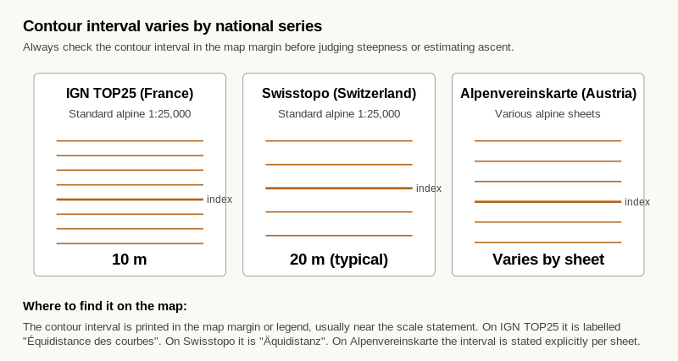
Reference diagram. Contour Interval Reference. the contour interval is printed in the map margin near the scale statement; spacing on the page only translates to slope angle if you also know the interval; the discipline of checking before judging steepness.

Learning aim
By the end of this page, you should understand that contour lines show height and terrain shape, and that each contour joins points of equal elevation above sea level.

Why contours matter
Contour lines are the most important tool in mountain navigation. They take you from reading symbols and map structure into understanding the actual shape of the land.
Without contours it is hard to judge whether a route crosses steep ground, follows a ridge, enters a valley, or climbs gradually. On an alpine map, the contour pattern is what tells you whether ground is travellable, whether a slope is in the avalanche release range, and where natural lines of ascent and descent lie.

The core idea
A contour is a line that joins points of equal height above sea level.
That means:
- every point on the same contour line is at the same elevation,
- different contour lines show different heights,
- and together they build a picture of the land's shape.

Contour interval
The contour interval is the vertical height difference between one contour line and the next. It varies by map type. Always check it from the map legend before using contours to judge anything.
Common alpine values:
- France IGN 1:25,000 — typically 10 m contour interval.
- Switzerland Swisstopo 1:25,000 — typically 20 m contour interval.
- Austria Alpenvereinskarte — varies by sheet; check the legend.

Worked example
Imagine a hillside with contour lines at 100 m, 110 m, 120 m and 130 m. If you walk uphill and cross each line in order, your height is increasing 10 m at a time.
The map is not showing a wall or a path. It is showing levels of height.

Exercise 1 — Core definition
Complete the sentence:
A contour line joins points of equal __________________ above sea level.

Exercise 2 — True or false
Write true or false.
- All points on one contour line are at the same height.
- Contour lines usually show roads and tracks.
- Contours help you understand the shape of the ground.
- The contour interval should be checked on the map you are using.

Exercise 3 — Short explanation
Write three or four sentences answering this question:
Why are contour lines important in mountain navigation?
____________________________________________________ ____________________________________________________ ____________________________________________________

Exercise 4 — Height sequence
A map shows contour lines labelled 200 m, 210 m, 220 m and 230 m.
- What is the contour interval?
- If you cross from 200 m to 230 m uphill, how much height have you gained?

Self-check
☐ I understand that contour lines represent equal height.
☐ I know what contour interval means and why it varies between maps.
☐ I can explain why contours matter in mountain terrain.

Why this matters for IMS
Reading contours is the foundation of every IMS map skill. Without it, route identification, slope angle estimation and aspect reading are not possible. This page is the entry point to the rest of Level 2.

C1.2 Steep vs Gentle Slopes
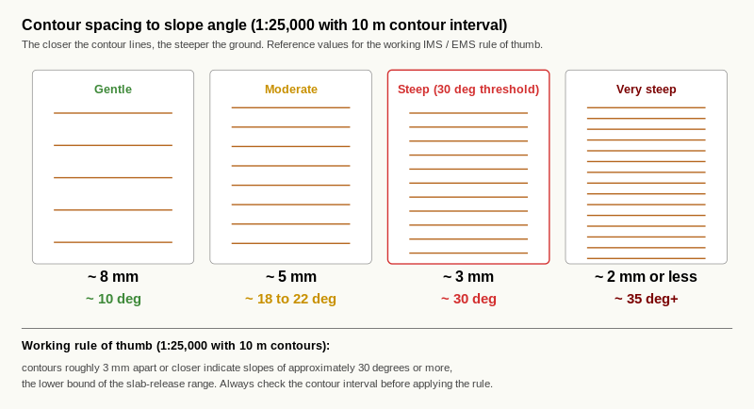
Reference diagram. Slope Spacing to Slope Angle Reference. the working IMS / EMS rule of thumb: 3 mm spacing or closer indicates approximately 30 degrees, the lower bound of the slab-release range; the visual reference the candidate uses to calibrate eye for steepness on any 1:25,000 alpine sheet.

Learning aim
By the end of this page, you should be able to use the spacing between contour lines on a 1:25,000 alpine map to judge whether a slope is gentle, moderate, steep, or very steep, and you should know the rule of thumb for identifying slopes at 30 degrees or more.

Why this matters
Slope steepness is the single biggest factor in alpine route choice. It governs:
- whether ground is safe to cross,
- whether it can be skinned up,
- whether it is in the avalanche release range,
- and whether the ground is travellable at all.
For BASI Level 4 IMS / EMS candidates, the ability to identify slopes at and above 30 degrees from the map alone is a core assessed skill.

The core idea
The closer the contour lines are to one another, the steeper the ground.
To put it more carefully:
- Wide spacing indicates a gentle slope.
- Medium spacing indicates a moderate slope.
- Close spacing indicates a steep slope.
- Merged or near-touching contours indicate a cliff or extremely steep ground. Snow generally cannot hold a slab here, and it is usually too steep to travel.
This spacing-to-steepness link is the foundation of every later contour skill in this workbook.

Why contour interval matters again
Spacing on the page only makes sense if you know the contour interval. Always check the legend before judging steepness.
The same physical 3 mm of spacing on a 1:25,000 map with a 10 m interval represents a steeper slope than the same 3 mm on a 1:50,000 map with a 20 m interval. Make checking the interval a habit.

The 30 degree rule of thumb
On a 1:25,000 alpine map with a 10 m contour interval:
- Contours roughly 3 mm apart or closer indicate a slope of approximately 30 degrees or more.
- This is the threshold at which avalanche slabs commonly release.
- This is the rule of thumb the IMS candidate needs to internalise.
The rule changes with contour interval. On a 1:25,000 map with a 25 m contour interval, the 30 degree threshold sits at roughly 8 mm spacing instead. Always check the legend.

Worked example
A path on the map crosses six contour lines over a 12 mm map distance. With a 10 m contour interval, that is 60 m of height gain over (12 × 25) = 300 m of ground distance. The slope angle is approximately atan(60 / 300) ≈ 11 degrees. Gentle ground.
A second path crosses six contour lines over a 4 mm map distance. That is 60 m of height gain over 100 m of ground distance. The slope angle is approximately atan(60 / 100) ≈ 31 degrees. In the high avalanche risk band.

Exercise 1 — Match the spacing
For each contour spacing description below, write gentle, moderate, steep, or very steep.
- Contours 8 mm apart on a 1:25,000 map with 10 m intervals:
- Contours 2 mm apart on a 1:25,000 map with 10 m intervals:
- Contours 4 mm apart on a 1:25,000 map with 10 m intervals:
- Contours touching or merged:

Exercise 2 — Apply the 30 degree rule
On the Section C1.2 map extract (provided by your trainer; 1:25,000, 10 m contours), three slopes are marked A, B and C.
For each slope, measure the spacing between adjacent contour lines and tick whether the slope is at or above 30 degrees.
Slope | Measured spacing (mm) | At or above 30 degrees?
A |  | Yes / No
B |  | Yes / No
C |  | Yes / No

Exercise 3 — Why the interval matters
Complete the sentence:
The spacing between contour lines only tells you about steepness if you also know the ____________________ , which is shown in the map ____________________.

Exercise 4 — Reflection
In two or three sentences, explain in your own words why "the closer the contours, the steeper the slope" is the most important rule in alpine map reading.
____________________________________________________ ____________________________________________________

Self-check
☐ I can link wider or closer contour spacing to gentler or steeper slopes.
☐ I can describe the rule of thumb for identifying 30 degree slopes on a 1:25,000 map with 10 m contours.
☐ I always check the contour interval before judging steepness.

Why this matters for IMS
This page directly supports the IMS / EMS map reading competency: identify all slopes at or above 30 degrees on any given map extract within five minutes. It also underpins all later route-selection work, where slopes in the 30 to 45 degree band are the prime avalanche release range.

C2.1 Hills and Summits

Learning aim
By the end of this page, you should be able to recognise hills and summits on a 1:25,000 alpine map from their closed-loop contour patterns, distinguish three common summit shapes (sharp peak, rounded summit, plateau-like high), and read summit height accurately from contours and spot heights.

Why this matters
Summits and high points are key reference features in alpine navigation. They are often:
- the turning point on a tour,
- the obvious goal,
- the rendezvous point at the top of a skinned ascent,
- or the unambiguous landmark used to relocate when other features are unclear.
For a BASI Level 4 IMS / EMS candidate, recognising summits quickly from the map is a building block of route identification, which is one of the assessed competencies.

The core idea
A hill or summit shows up on the map as a set of closed contour loops with the highest contour at the centre.
If you imagine pouring water onto the page, water at the centre of a closed loop has nowhere lower to flow to. The centre is the highest point.

Reading height from the map
Two cues confirm the height of a summit:
- The centre contour value. This is the highest contour drawn on the loop set.
- A spot height. This is a small dot or cross with a precise elevation number printed beside it. Spot heights are more accurate than the centre contour because they mark the actual highest point, which usually sits between two contour lines.
On a 1:25,000 alpine map, almost every named summit will carry a spot height. Use the spot height as the precise figure; use the centre contour to confirm the general elevation band.

Three common summit shapes
A summit is not always a sharp peak. Three patterns are worth recognising on sight:
- Sharp peak. Tightly spaced closed loops with a single, clear highest point. Steep on most or all sides. Common in the higher alpine. The contour spacing here will usually trigger your 30 degree alarm from C1.2.
- Rounded summit. Widely spaced loops, often with a broad central area. The high point can feel ambiguous on the ground. Common on grass-covered or weathered tops.
- Plateau-like high. Very widely spaced or even absent contours across a flat area, sometimes with a small spot height marking the actual peak. Common on Austrian Alpine plateaux and broad shoulders.

Worked example
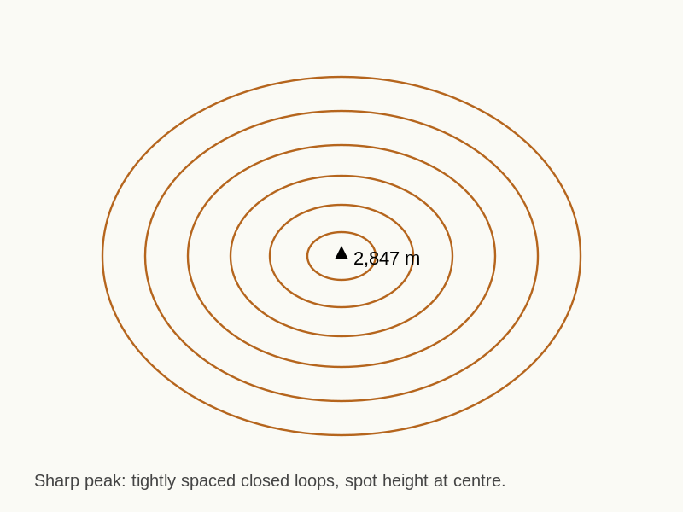
Reference diagram. Sharp Peak Summit. tightly spaced closed loops with a single clear highest point.
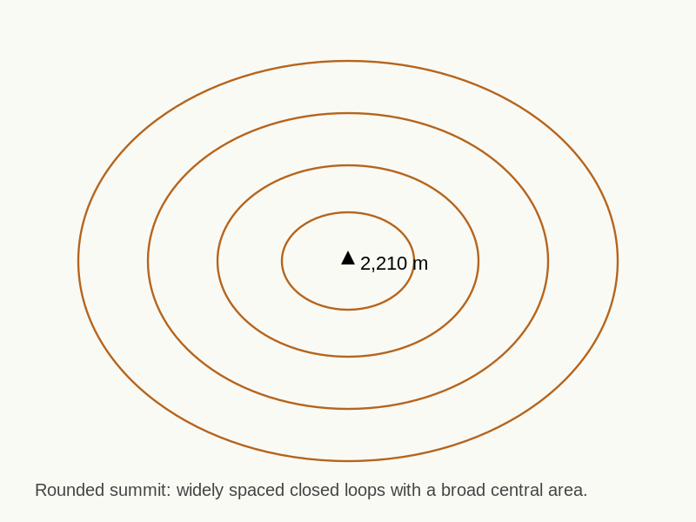
Reference diagram. Rounded Summit. widely spaced closed loops with a broad central area.
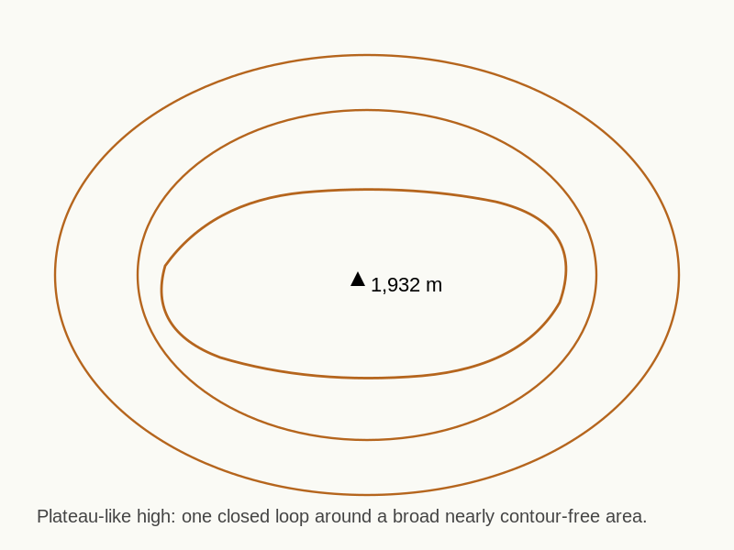
Reference diagram. Plateau-Like High. single closed loop surrounding a contour-free area with a spot height.
On a 1:25,000 alpine map you see three closed-loop patterns near each other:
- Loop set A has loops 1 to 2 mm apart, with the highest contour at 2,840 m and a spot height of 2,847 m. This is a sharp peak.
- Loop set B has loops 6 to 8 mm apart with the highest contour at 2,200 m. This is a rounded summit.
- Loop set C has a single closed loop at 1,920 m surrounding a 0.5 km wide nearly contour-free area, with a spot height of 1,932 m. This is a plateau-like high.

Exercise 1 — Identify the summit
On the Section C2.1 map extract (provided by your trainer), three points are marked A, B and C.
For each point, write summit or not a summit and give a one-line reason.
- Point A: ____________________ Reason:
- Point B: ____________________ Reason:
- Point C: ____________________ Reason:

Exercise 2 — Read the height
Look at the summit closest to point A on the map extract.
- What is the highest contour value?
- Is there a spot height? If so, what is it?
- Which is more precise, and why?

Exercise 3 — Match the summit shape
Three contour patterns are shown on the map extract, labelled D, E and F. For each, write sharp peak, rounded summit, or plateau-like high.
- Pattern D:
- Pattern E:
- Pattern F:

Exercise 4 — Side profile sketch
Pick one of the three summits (D, E or F). In the space below, sketch a simple side profile of that summit as you would expect to see it from the ground, looking towards the peak from a kilometre away. Label the highest point.
[Sketch space - approximately 8 cm by 5 cm]

Exercise 5 — "If I stood here"
Imagine you are standing at the highest point of the summit you sketched. In three sentences, describe what you would expect to see immediately around you. Include:
- whether the ground around you is flat or sloping,
- the direction of any obvious drop,
- and any neighbouring high points.
____________________________________________________ ____________________________________________________

Self-check
☐ I can identify a hill or summit by its closed-loop contour pattern.
☐ I can read summit height from the highest contour and confirm it from a spot height.
☐ I can name the three common summit shapes and recognise each on a map.
☐ I can sketch a side profile of a summit from its contour pattern.

Why this matters for IMS
This page underpins the IMS / EMS competency: identify all key contour features (spur, re-entrant, col, convex roll, concave slope, cliff) on a 1:25,000 topo map. Summit recognition is also a foundation for route identification beyond the ski area boundary, where high points are commonly used as turning points and rendezvous markers on the route card.
These two pages are paired deliberately. Valleys and ridges are the inverses of each other on a contour map, and the fastest way to lock both shapes into your spatial vocabulary is to study them side by side.

C2.2 Valleys and Gullies

Learning aim
By the end of this page, you should be able to recognise valleys and gullies on a 1:25,000 alpine map from their V or U shaped contour patterns, predict the direction of water flow from the contours, distinguish a broad valley from a tight gully, and translate the contour pattern into a side profile and a verbal "if I stood here" description.

Why this matters
Valleys and gullies are the drainage lines of the mountain. On the map they tell you:
- where water and snow naturally collect,
- where ascent and descent lines tend to be funnelled,
- where avalanche debris is most likely to run and stop,
- where you would find a clear linear feature to follow in poor visibility,
- and where a route can be exposed to overhead terrain even when the line itself looks gentle.
Mountaineering Scotland's navigation guidance is explicit on the point that valleys, streams and gullies count as linear features that can be followed even in poor visibility or at night. For an IMS / EMS candidate, that is a working tool, not a piece of trivia.

The core idea
Valleys and gullies show up on the map as contour lines that bend into a V or U shape, with the V or U pointing uphill.
That last word is the one to remember. The point of the V points towards higher ground; the open side of the V points towards lower ground. Water flows from the point of the V outwards, downhill.
This is the inverse of the spur pattern you will meet in C2.3, where the V points downhill.

Reading the drainage direction
To work out which way water flows in a valley:
- Find the contour bend (the V or U).
- Identify the highest contour value at the point of the V.
- Identify the lowest contour value at the open end of the V.
- Water flows from the point of the V towards the open end, from high to low.
If the map shows a blue line running through the contour bends, that is the visible stream and it confirms the direction. On dry ground or ground covered by snow, the contour shape alone tells you the same thing.

Valley vs gully
Valleys and gullies are the same family of feature on different scales:
- Valley. A broad drainage feature, often with a flat or near-flat floor, gentle to moderate side walls, and a stream or river along the bottom. On the map the V or U is wide and the bend covers many millimetres of map distance.
- Gully. A narrow, steep-sided drainage feature, typically with no flat floor and very tight side walls. On the map the V is sharp, the contours that form the V are close together, and the feature often cuts directly across a slope.
In avalanche terms, gullies behave very differently from broad valleys. A gully concentrates moving snow into a narrow channel; a broad valley spreads it across a wide runout. This is why a candidate working at IMS / EMS level needs to read the difference at a glance.

Worked example
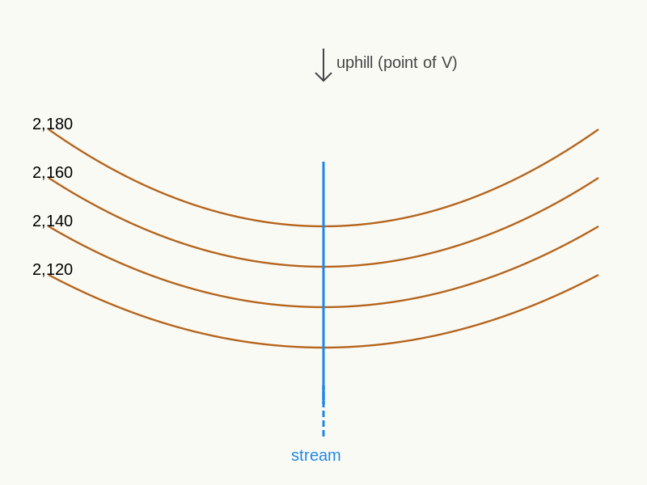
Reference diagram. Valley. broad V-up with stream; floor; moderate side walls.
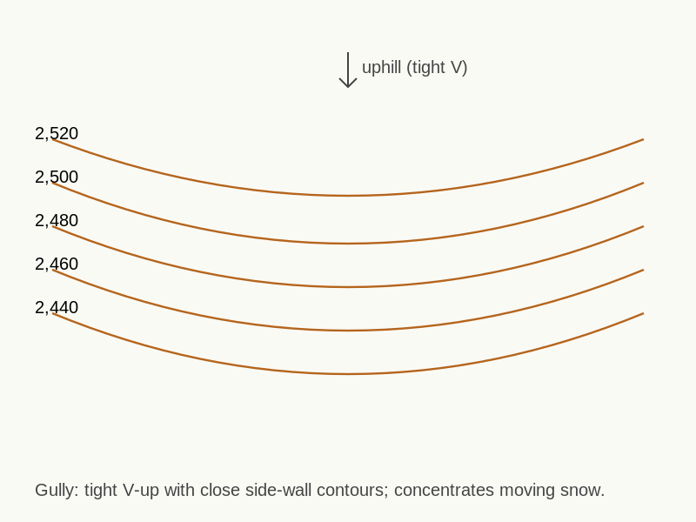
Reference diagram. Gully. tight V-up with close-spaced side walls.
A 1:25,000 IGN sheet with 10 m contours shows a contour pattern in which:
- contours bend into a clear V shape,
- the point of the V is at 2,180 m,
- the open end of the V is at 2,040 m,
- the bend covers about 6 mm of map width,
- and a thin blue line runs through the bend.
That is a valley. Water flows from 2,180 m down towards 2,040 m. The 6 mm width and the blue stream tell you the floor is broad enough to walk along comfortably.
A second pattern on the same sheet shows:
- contours bend into a tight, sharp V,
- the point is at 2,520 m,
- the open end is at 2,460 m,
- the bend covers only 1 to 2 mm of map width,
- and the contours that form the V are 2 mm apart on the side walls.
That is a gully. Water flows from 2,520 m down towards 2,460 m. The narrow width and the close side-wall contours tell you the feature is steep and tight, and that any moving snow on the slope above will be funnelled into it.

Exercise 1 — Valley or gully
On the Section C2.2 map extract (provided by your trainer; 1:25,000, 10 m contours), four features are marked A, B, C and D.
For each feature, write valley or gully and give a one-line reason that refers to the width of the V and the spacing of the side-wall contours.
- Feature A: ____________________ Reason:
- Feature B: ____________________ Reason:
- Feature C: ____________________ Reason:
- Feature D: ____________________ Reason:

Exercise 2 — Drainage direction
For features A and B from Exercise 1:
- Highest contour value at the point of the V (Feature A):
- Lowest contour value at the open end (Feature A):
- Direction of water flow (Feature A): from __________ towards
- Highest contour value at the point of the V (Feature B):
- Lowest contour value at the open end (Feature B):
- Direction of water flow (Feature B): from __________ towards

Exercise 3 — Side profile sketch
Pick one valley and one gully from Exercise 1.
In the spaces below, sketch a simple side profile of each, looking across the feature from one side. Label the floor, the side walls, and the highest point on each side. Mark the approximate width of the feature in metres at the level of the floor.
Valley sketch:
[Sketch space - approximately 8 cm by 5 cm]
Gully sketch:
[Sketch space - approximately 8 cm by 5 cm]

Exercise 4 — "If I stood here"
Imagine you are standing on the floor of the valley you sketched, looking up the valley towards the point of the V.
In four sentences, describe what you would expect to see. Include:
- whether the ground beneath your feet is flat, sloping, or stepped,
- the direction of the stream,
- the steepness of the side walls (gentle, moderate, steep, or very steep),
- and whether anything overhead could affect you in winter conditions.
____________________________________________________ ____________________________________________________ ____________________________________________________

Exercise 5 — Following a linear feature in poor visibility
The IMS / EMS standard expects you to be able to use linear features as handrails when visibility is poor.
In two or three sentences, explain:
- why a valley floor or stream line is a useful linear feature in poor visibility, and
- why a tight gully is not a feature you would deliberately follow on the descent in poor visibility, even though it is also a linear feature.
____________________________________________________ ____________________________________________________

Self-check
☐ I can identify a valley or gully from a V or U shaped contour bend pointing uphill.
☐ I can read the direction of water flow from the contour values alone.
☐ I can distinguish a broad valley from a tight gully on the map.
☐ I can sketch a side profile of either feature from its contour pattern.
☐ I can explain when a linear drainage feature is a useful handrail and when it is a hazard.

Why this matters for IMS
This page directly supports the IMS / EMS map reading competency: identify all key contour features (spur, re-entrant / valley, col, convex roll, concave slope, cliff) on a 1:25,000 topo map. It also supports the route-selection competency, because gully recognition is a building block of avalanche-aware terrain interpretation. The poor-visibility handrail point links to the relocation and contingency-navigation expectations of the EMS assessment.

C2.3 Ridges and Spurs

Learning aim
By the end of this page, you should be able to recognise ridges and spurs on a 1:25,000 alpine map from their V or U shaped contour patterns pointing downhill, distinguish a long ridge from a short spur, identify which side of the crest falls away in which direction, and translate the contour pattern into a side profile and a verbal "if I stood here" description.

Why this matters
Ridges and spurs are the high-ground equivalent of valleys and gullies. They are some of the most useful features on an alpine map because:
- they are linear features that can be followed in poor visibility,
- they are often safer skinning and ascent lines because they shed snow rather than collect it,
- they give you commanding views for relocation,
- they are predictable: if you know the line of the crest, you know which way the ground falls on each side,
- and they let you avoid travelling under or through avalanche-prone slopes.
For the IMS / EMS candidate, fluent ridge and spur reading is what turns a flat map into a viable route choice.

The core idea
Ridges and spurs show up on the map as contour lines that bend into a V or U shape, with the V or U pointing downhill.
This is the direct inverse of the valley pattern in C2.2.
The clearest test is to look at the contour values:
- If the contour values rise as you move towards the point of the V, the V points uphill and the feature is a valley or gully.
- If the contour values fall as you move towards the point of the V, the V points downhill and the feature is a ridge or spur.
This single check resolves almost every confusion between the two shapes. Train yourself to do it before naming the feature.

Ridge vs spur
Ridges and spurs are the same family of feature on different scales:
- Ridge. A long high line connecting high points, often forming the crest between two valleys. On the map a ridge runs across the sheet as a continuous line of paired contour bends, sometimes for several kilometres. The ridge is itself the watershed.
- Spur. A shorter projection of high ground that runs out from a larger mass, often from a summit, a ridge, or the side of a high plateau. On the map a spur is a single V or U pointing downhill from a higher feature, often only a few hundred metres long, ending where the contour bend is no longer recognisable.
Every spur belongs to a parent feature. Every ridge is the parent of multiple spurs. Once you start reading them this way, the high ground on a map organises itself into a small number of named lines instead of a wash of orange contours.

Which side falls where
A ridge or spur is a crest. From the crest, ground falls away on both sides.
To work out which direction the ground falls on each side:
- Stand mentally on the line of the crest, facing along it towards the point of the V (downhill end).
- The contours immediately to your left fall away to the left.
- The contours immediately to your right fall away to the right.
- The aspect of each side is determined by the direction the slope faces, not the direction the crest runs.
This is the foundation of aspect reading, which is treated formally in C4.

Worked example
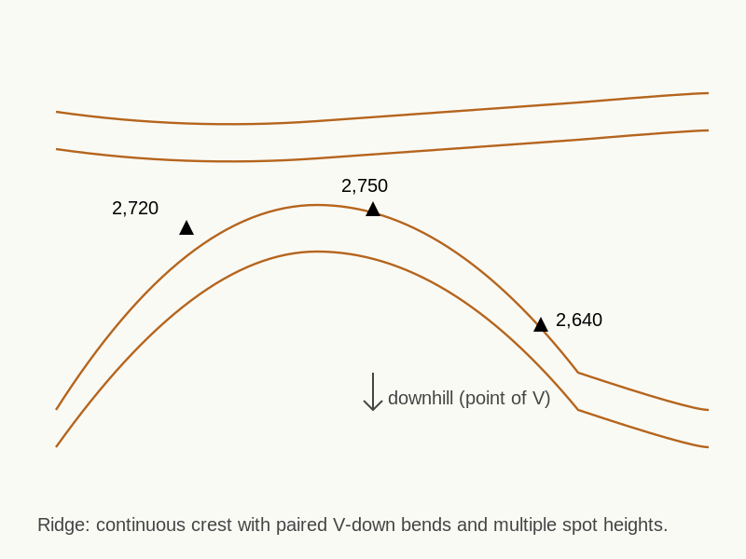
Reference diagram. Ridge. long V-down crest dividing two valleys.
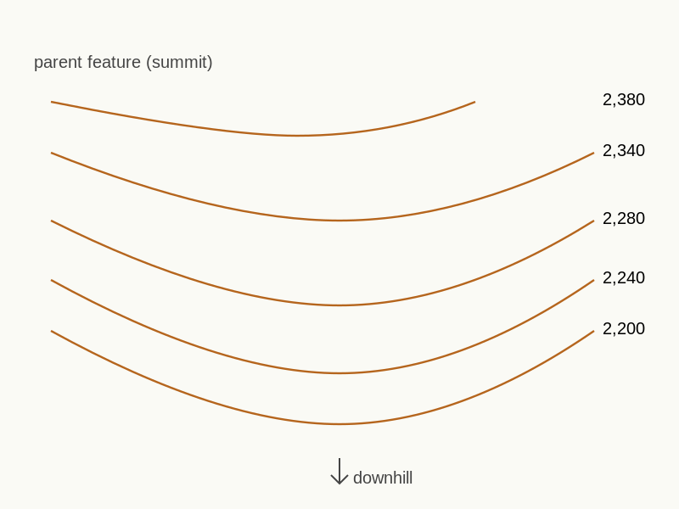
Reference diagram. Spur. short V-down off a parent feature.
A 1:25,000 IGN sheet with 10 m contours shows a contour pattern in which:
- contours bend into a clear V shape,
- the point of the V is at 2,200 m,
- the contours upslope of the bend rise to 2,380 m,
- the bend covers about 5 mm of map width,
- and the V projects out from a larger summit.
That is a spur. The crest line drops from 2,380 m down towards 2,200 m. Standing on the crest and facing the 2,200 m end, the ground falls away on both your left and your right sides; the steepness of each side is given by the contour spacing on each side independently.
A second pattern shows:
- a continuous line of paired contour bends running across most of the map,
- spot heights at intervals along the line,
- the line dividing two large drainage systems,
- and the contour values falling on both sides of the line.
That is a ridge. It is the watershed between the two drainage systems and the natural high-ground line for any route that wants to stay out of the valleys.

Exercise 1 — Ridge, spur or neither
On the Section C2.3 map extract (provided by your trainer; 1:25,000, 10 m contours), four features are marked A, B, C and D.
For each feature, write ridge, spur, or neither and give a one-line reason that refers to the V direction, the contour values, and the length of the feature.
- Feature A: ____________________ Reason:
- Feature B: ____________________ Reason:
- Feature C: ____________________ Reason:
- Feature D: ____________________ Reason:

Exercise 2 — Aspect of each side
Choose the spur from Exercise 1.
- Direction the crest runs (compass):
- Aspect of the slope on the left of the crest (facing downhill):
- Aspect of the slope on the right of the crest (facing downhill):
- Which of the two sides would you expect to hold colder, drier snow in mid-winter, and why?

Exercise 3 — Side profile sketch
Pick one ridge and one spur from Exercise 1.
In the spaces below, sketch a simple side profile of each, looking from one side towards the crest. Label the high point, the low end, and the two flank slopes. Indicate which side is steeper.
Ridge sketch:
[Sketch space - approximately 8 cm by 5 cm]
Spur sketch:
[Sketch space - approximately 8 cm by 5 cm]

Exercise 4 — "If I stood here"
Imagine you are standing on the crest of the spur you sketched, three quarters of the way along it from the high end towards the point of the V.
In four sentences, describe what you would expect to see. Include:
- whether the ground beneath your feet is flat, narrow, or broad,
- which direction the ground falls away on your left,
- which direction the ground falls away on your right,
- and which way you would walk to descend the spur safely.
____________________________________________________ ____________________________________________________ ____________________________________________________

Exercise 5 — Inverse pairing with C2.2
In two sentences, explain in your own words how the valley and gully pattern from C2.2 differs from the ridge and spur pattern in C2.3, in terms of:
- the direction the V points, and
- the way contour values change as you move along the feature.
____________________________________________________

Self-check
☐ I can identify a ridge or spur from a V or U shaped contour bend pointing downhill.
☐ I can use contour values to confirm the direction of the slope.
☐ I can distinguish a long ridge from a shorter spur on the map.
☐ I can identify which side of a crest falls away in which direction, and read the aspect of each side.
☐ I can sketch a side profile of either feature from its contour pattern.

Why this matters for IMS
This page directly supports the IMS / EMS map reading competency: identify all key contour features (spur, re-entrant / valley, col, convex roll, concave slope, cliff) on a 1:25,000 topo map. Spur and ridge recognition also underpins route selection, since they are the safest natural ascent lines in many alpine settings and the primary handrails for poor-visibility navigation. The aspect-of-each-side reading is a foundation for the avalanche-aware terrain interpretation tested at EMS assessment.

C2.4 Section C2 Matching Exercise

Learning aim
By the end of this page, you should be able to look at any of the contour patterns you have met in C2.1, C2.2 and C2.3 and call the feature confidently and quickly. The aim of this page is fluency, not new content. If you find yourself thinking about each pattern for more than a few seconds, return to the relevant earlier page and re-do the exercise that gave you the pattern in the first place.

Why this matters
Recognising a contour shape under time pressure is what separates classroom map reading from real route-choice. On a touring day the assessor will not ask you to define a feature. They will point at a contour pattern and expect a name, a direction of slope and a route-relevant comment within seconds. This page builds towards that fluency.

How to use this page
The exercises on this page draw on three map extracts:
- the Section C2.1 extract (hills and summits),
- the Section C2.2 extract (valleys and gullies),
- the Section C2.3 extract (ridges and spurs).
Use whichever extracts your trainer has given you. If you only have one combined Section C2 extract that contains all the relevant features, use that.
The eight contour snippets in Exercise 1 below are labelled 1 to 8 on your trainer's snippet sheet. Each snippet is a small (roughly 4 cm by 4 cm) extract from a 1:25,000 alpine map with 10 m contour intervals.

Worked example
Imagine a snippet labelled 0 showing closed contour loops, with the highest contour at the centre, loops 6 to 8 mm apart, and a spot height of 2,200 m at the centre.
Working through the C2.1 to C2.3 vocabulary:
- It shows closed loops with a high point at the centre, so it is in the summit family (C2.1).
- The loops are widely spaced (6 to 8 mm), which gives a rounded summit rather than a sharp peak.
- Confirmed by the absence of any V-shaped contour bend that would point to a valley, gully, ridge or spur.
The answer is rounded summit.
This is the level of internal commentary you should be running through for each of the eight snippets in Exercise 1. After a few snippets, the commentary should fall away and the answer should arrive on sight.

Exercise 1 — Match the snippets to the names
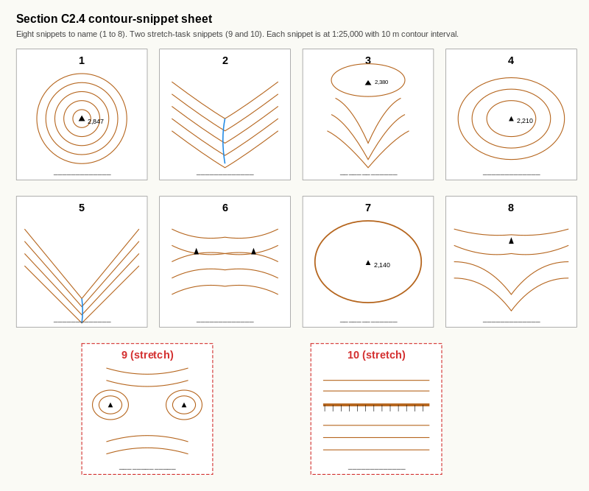
Reference diagram. C2.4 Snippet Sheet (1 to 8 plus 9 to 10 stretch). snippets 1 to 8 cover sharp peak, valley, spur, rounded summit, gully, ridge, plateau-like high, and a second spur on a different parent; snippets 9 and 10 (stretch) preview col / saddle and cliff band; idealised contour patterns chosen for pedagogical clarity.
For each of the eight contour snippets on your trainer's snippet sheet, write the matching name from the list below. Each name may be used more than once or not at all.
Names to choose from:
- sharp peak
- rounded summit
- plateau-like high
- valley
- gully
- ridge
- spur
Snippet | Feature name | One-word reason (loop / V-up / V-down / spacing)
1
2
3
4
5
6
7
8

Exercise 2 — Match the snippets to side-view sketches
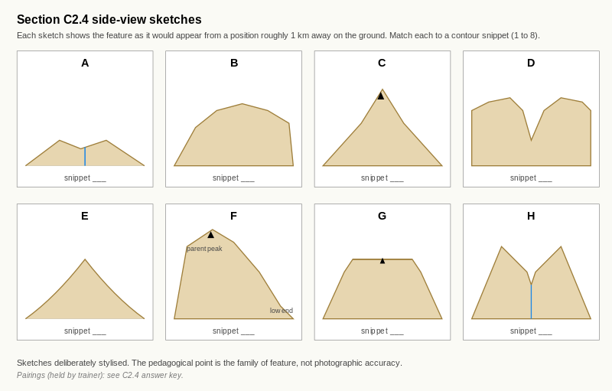
Reference diagram. C2.4 Side-View Sketches (A to H). each sketch shows the feature as it would appear from a position roughly 1 km away on the ground; the matching exercise rehearses 2D contour to 3D ground translation.
Your trainer's snippet sheet also includes eight side-view sketches labelled A to H. Each sketch shows the feature as it would appear from a position roughly one kilometre away on the ground.
Match each contour snippet (1 to 8) to the side-view sketch (A to H) that shows the same feature.
Snippet | Sketch
1
2
3
4
5
6
7
8
If a sketch and a snippet do not feel like an obvious pair, look first at the family of feature (high ground or drainage), then at the sub-type (sharp / rounded / plateau, broad / tight, ridge / spur). The C2.3 inverse-pairing rule is the key check: if the V points downhill on the contour, the sketch should show a crest, not a drainage line.

Exercise 3 — Reflection
In two or three sentences, answer the following:
- Which of the seven feature names above did you call most quickly and confidently?
- Which one did you have to think about hardest, or got wrong on first attempt?
- What will you do to fix the slow or wrong one before C3?
____________________________________________________ ____________________________________________________
A useful answer is specific. "I keep flipping ridge and valley" is more useful than "I'm slow on ridges". Specificity tells you which page to revisit (in this example, C2.3 Exercises 1 and 5, plus the inverse-pairing diagram).

Exercise 4 — Stretch task: preview of Section C3
Two of the snippets on your trainer's sheet (snippets 9 and 10) show features you have not yet met. They are previews of two features taught formally in Section C3.
Without using the formal Section C3 vocabulary, do your best with the following:
- Snippet 9 shows a low point sitting between two high points. The contours form a distinctive saddle shape. Sketch what you think the ground would look like from one of the two high points, looking towards the other.
[Sketch space - approximately 8 cm by 5 cm]
- Snippet 10 shows a section of the map where contours are merged or near-touching across a band 3 to 5 mm wide. Sketch what you think the ground would look like from a position one kilometre away on the slope below the band.
[Sketch space - approximately 8 cm by 5 cm]
Do not worry about getting the names right. The two features are taught in C3.1 (cols and saddles) and C3.3 (cliff bands). The point of this stretch task is to give you a controlled first encounter with the contour pattern before the formal teaching, so that when C3 introduces the names you will already have the visual right.

Self-check
☐ I can call summit, valley, gully, ridge or spur on sight from a 1:25,000 contour snippet within five seconds.
☐ I can distinguish sharp, rounded and plateau-like summits.
☐ I can distinguish broad valleys from tight gullies.
☐ I can distinguish long ridges from shorter spurs.
☐ I can match each snippet to its side-view sketch with confidence.
☐ I have identified at least one feature where my recognition is still slow or unreliable, and I have a specific plan to fix it.

Why this matters for IMS
This page is the first sustained fluency exercise in the workbook. The IMS / EMS map reading competency expects candidates to identify contour features on sight on a 1:25,000 topographic map; a candidate who hesitates over basic shapes during route-card preparation or in-field relocation is a candidate who is not yet at assessment standard. The reflection in Exercise 3 is the diagnostic that turns this page from a quiz into a learning tool: it tells you exactly which earlier page to revisit before Section C3.

C3.1 Cols and Saddles

Learning aim
By the end of this page, you should be able to recognise cols and saddles on a 1:25,000 alpine map from their contour pattern, distinguish a col from a summit and from a valley, read the height of the col accurately, and explain why cols are the natural crossing points between two valleys. You should also be able to translate the contour pattern into a side profile and a verbal "if I stood here" description.

Why this matters
A col is a low point on a ridge, sitting between two summits. In navigation terms it is the doorway between two valleys. In a working alpine route, cols are:
- the natural crossing points from one drainage system to another,
- the easiest place to climb from one side of a ridge to the other,
- a recognisable landmark in poor visibility because of the distinctive saddle shape on the skyline,
- a target for the assessor's "where would you cross this ridge?" question on a route card,
- a feature where wind funnelling and snow build-up are common, with implications for route choice and avalanche awareness.
For a BASI Level 4 IMS / EMS candidate, fluent col reading is what turns a map full of summits and ridges into a map full of route options.

The core idea
A col shows up on the map as a low point on a ridge, with rising contours on both sides leading up to two summits.
The clearest signature is a contour pattern that looks like a saddle:
- on two opposite sides, contours rise to higher ground (the two summits),
- on the other two opposite sides, contours fall away to lower ground (the two valleys the col joins),
- and at the centre, a small open area where neither pattern dominates.
If you imagine pouring water onto the col, water at the centre has two directions it could flow (towards either valley) and two directions it cannot flow (towards either summit). That is the saddle.
The terms "col", "saddle" and "pass" overlap in everyday alpine vocabulary:
- Col is the standard map term for the low point itself.
- Saddle describes the same feature but emphasises the shape rather than the function. The two are interchangeable in most contexts.
- Pass describes the col when it is used as a route. A col becomes a pass when it is the chosen crossing.
For map work, treat col and saddle as the same feature. Use "pass" when the route card has chosen to cross there.

Reading the height of the col
A col has a specific height: the elevation of the lowest contour line that crosses the saddle.
Two cues confirm this:
- The lowest contour value at the centre of the saddle. This is the highest contour you can stand on while still being able to walk in any of the four cardinal directions of the saddle (towards either summit, towards either valley).
- A spot height at the col itself. Many named cols carry a spot height; on French IGN sheets the col is often labelled with its name and elevation alongside the spot.
Use the spot height as the precise figure, and confirm with the surrounding contour pattern. The col height is what goes onto the route card as the high point of the leg if the route crosses there.

Worked example
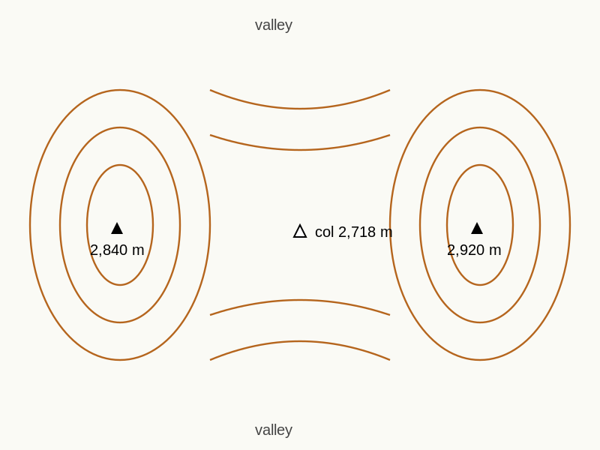
Reference diagram. Col / Saddle. low point on a ridge between two summits.
A 1:25,000 alpine sheet with 10 m contours shows the following pattern:
- a continuous ridge running north to south,
- a summit at the north end at 2,840 m,
- a summit at the south end at 2,920 m,
- between the two summits a clear saddle, with the lowest contour through the saddle at 2,720 m, and a spot height at the centre marked 2,718 m,
- to the west of the saddle, contours fall steadily into a valley with a stream symbol at 2,400 m,
- to the east of the saddle, contours fall less steeply into a different valley at 2,500 m.
That is a col at 2,718 m. The two summits are 122 m and 202 m higher than the col respectively. The col joins the western valley at 2,400 m to the eastern valley at 2,500 m. As a pass, it would be the natural crossing point between those two drainage systems and would save approximately 200 to 300 m of climbing compared with going over either summit.

Exercise 1 — Identify the col
On the Section C3.1 map extract (provided by your trainer; 1:25,000, 10 m contours), four points are marked A, B, C and D.
For each point, write col, summit, or neither, and give a one-line reason that refers to the contour pattern.
- Point A: ____________________ Reason:
- Point B: ____________________ Reason:
- Point C: ____________________ Reason:
- Point D: ____________________ Reason:

Exercise 2 — Read the col height
For the col you identified in Exercise 1:
- Lowest contour value through the saddle:
- Spot height at the col, if shown:
- Height of the summit on the higher side:
- Height of the summit on the lower side:
- Difference between col height and lower summit (this is the climb saved by going over the col rather than over the lower summit):

Exercise 3 — Side profile sketch
In the space below, sketch a side profile of the col looking along the ridge from one summit towards the other.
Label the col, the two summits, and the approximate height of each. Indicate the two valleys falling away on either side of the saddle.
[Sketch space - approximately 8 cm by 5 cm]

Exercise 4 — "If I stood here"
Imagine you are standing at the centre of the col, facing along the ridge towards the higher summit.
In four sentences, describe what you would expect to see. Include:
- whether the ground beneath your feet is flat, slightly hollow, or running level along the ridge,
- the direction the ground rises in front of you,
- the directions in which the ground falls away on your left and right (these should be the two valleys),
- and the wind exposure, given that cols often funnel wind.
____________________________________________________ ____________________________________________________ ____________________________________________________

Exercise 5 — Route choice
Two routes are sketched on the Section C3.1 map extract:
- Route 1 crosses the ridge by climbing over the lower summit (the one at 2,840 m in the worked example, or its equivalent on your extract).
- Route 2 crosses the ridge by going over the col.
In two or three sentences, answer the following:
- Which route is shorter in horizontal distance, Route 1 or Route 2?
- Which route involves less total climbing?
- Which route would you choose for a touring ascent in winter, and why?
____________________________________________________ ____________________________________________________

Self-check
☐ I can identify a col from the saddle pattern of contours rising on two opposite sides and falling on the other two.
☐ I can read col height accurately from the lowest contour and the spot height.
☐ I can distinguish a col from a summit and from a valley.
☐ I can sketch a side profile of a col from its contour pattern.
☐ I can choose a col over a summit in a route-choice exercise and explain my reasoning.

Why this matters for IMS
This page directly supports the IMS / EMS map reading competency: identify all key contour features (spur, re-entrant / valley, col, convex roll, concave slope, cliff) on a 1:25,000 topo map. Cols are also the route-card hinge point on most ski-touring days that involve crossing a ridge; the assessor expects the candidate to choose cols over summits where the climbing budget allows, to read col height accurately for the route card, and to factor wind exposure and snow accumulation at the col into the avalanche-aware terrain interpretation.
The contour pattern you have just learned was previewed in C2.4 Exercise 4 (snippet 9). If you sketched that snippet, look back at your sketch now. The names you didn't have then are the names you have now.
These two pages cover the remaining advanced terrain shapes in Section C3. C3.2 deals with bowls, corries and basins (the enclosed and semi-enclosed hollows that collect snow). C3.3 deals with plateaux and cliff bands (the flattest and steepest extremes of alpine terrain). Both pages assume fluency with the C2 vocabulary; if either feels confusing, return to the relevant C2 page before pressing on.

C3.2 Bowls, Corries and Basins

Learning aim
By the end of this page, you should be able to recognise bowls, corries and basins on a 1:25,000 alpine map from their distinctive contour pattern, distinguish the headwall from the side flanks, predict where snow is likely to accumulate, and translate the contour pattern into a side profile and a verbal "if I stood here" description.

Why this matters
Bowls, corries and basins are some of the most route-significant features in alpine terrain. They are:
- the natural collection points for wind-loaded snow,
- the prime terrain in which avalanches release and run,
- often the most attractive ski lines on the descent (open, sustained, fall-line),
- and a well-known terrain trap when conditions are wrong, because the bowl shape funnels moving snow towards the lower exit and offers few safe lines once you are inside.
For a BASI Level 4 IMS / EMS candidate, the ability to read a bowl from the map and predict its loading and runout is a foundation of avalanche-aware route choice.

The core idea
A bowl shows up on the map as a half-cup or U-shape of contours that opens downhill, with the highest contour forming the back of the bowl and the contours fanning out and falling away as the bowl opens.
A simpler test:
- the back of the bowl (the headwall) is where contours are tightly packed and curved, often arc-shaped,
- the flanks of the bowl (the sides) are where contours run more or less parallel to the fall line,
- the floor and exit of the bowl (the mouth) is where contours space out and the U opens downhill.
The bowl is enclosed on three sides (the headwall and two flanks) and open on the fourth (the mouth, falling away to lower ground).
Three terms describe the same family of feature with slightly different connotations:
- Bowl. The general alpine term, used widely in skiing and ski-touring.
- Corrie. Scottish / Gaelic for the same feature; common in UK navigation literature, including Mountaineering Scotland's terrain vocabulary. The Welsh equivalent is "cwm".
- Cirque. French and standard scientific term, common on IGN maps and in alpine geomorphology. A "cirque glaciaire" is a corrie that has been carved by a former glacier.
- Basin. Broader and shallower than a corrie; often used for larger, less steep enclosed areas higher up.
For map work, treat all four as the same family. Pay attention to size and steepness rather than the name.

Where snow accumulates
Bowls collect snow in two characteristic ways:
- Wind-loading. Snow blown over the headwall lip from the upwind side is deposited on the lee side, building cornices on the rim and a thicker pillow on the upper bowl.
- Gravitational settling. Snow falling on the upper slopes slides or sloughs into the bowl, deepening the snowpack at the back and building a smoother surface in the middle.
The combined effect is that the upper part of the bowl (just below the headwall) is typically deeper, more wind-affected and more avalanche-prone than the lower mouth. This is what makes the bowl a terrain trap: the easiest ski line is also the part of the slope where the snow is most loaded.

Worked example
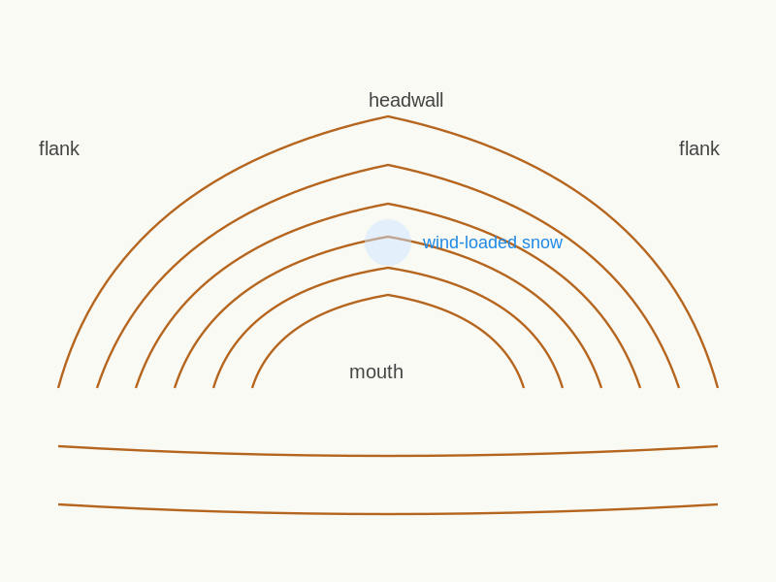
Reference diagram. Bowl / Corrie / Cirque. U-shape opening downhill with tight headwall and wider flanks.
A 1:25,000 alpine sheet with 10 m contours shows the following pattern:
- contours form a clear arc opening to the south,
- the back of the arc (the headwall) sits between 2,800 m and 2,900 m, with contours roughly 1 to 2 mm apart,
- the flanks of the arc fall away on the east and west sides, with contours 4 to 6 mm apart,
- the mouth opens at around 2,500 m onto a broad, gently sloping basin below,
- and the floor of the bowl shows widely spaced contours and no visible water symbol.
That is a bowl (or "corrie", or "cirque", depending on which map and which guide you read). The headwall is steep enough to trigger your 30 degree alarm from C1.2 and likely above the prime release angle. The flanks are moderate. The bowl faces south, which means in the northern hemisphere it receives strong winter sun and may have melt-freeze cycles affecting the snowpack.

Exercise 1 — Identify the bowl
On the Section C3.2 map extract (provided by your trainer; 1:25,000, 10 m contours), four features are marked A, B, C and D.
For each feature, write bowl, valley, or neither, and give a one-line reason that refers to the headwall, the flanks, and which way the feature opens.
- Feature A: ____________________ Reason:
- Feature B: ____________________ Reason:
- Feature C: ____________________ Reason:
- Feature D: ____________________ Reason:

Exercise 2 — Headwall steepness
For the bowl you identified in Exercise 1:
- Spacing of contours on the headwall (mm):
- Approximate slope angle of the headwall (using the C1.2 rule of thumb):
- Is the headwall at or above 30 degrees?
- Spacing of contours on the flanks (mm):
- Approximate slope angle of the flanks:

Exercise 3 — Side profile sketch
In the space below, sketch a side profile of the bowl looking from one flank towards the other.
Label the headwall, the two flanks, the floor, and the mouth. Indicate which side is steeper. Mark approximately where wind-loaded snow would accumulate after a typical winter storm.
[Sketch space - approximately 8 cm by 5 cm]

Exercise 4 — "If I stood here"
Imagine you are standing at the mouth of the bowl, looking up at the headwall.
In four sentences, describe what you would expect to see. Include:
- the ground rising in front of you and how it changes as it rises,
- the two flanks on your left and right and which one is steeper,
- the visible signs of wind-loading at the top (cornice, pillow, snow plume),
- and where you would not want to be standing if a slab released from the headwall.
____________________________________________________ ____________________________________________________ ____________________________________________________

Exercise 5 — Aspect and snow
The bowl in the worked example faces south. Bowl aspect strongly affects snow conditions.
In two or three sentences, answer:
- What aspect would you expect to hold the most consistent winter snow in the northern hemisphere, and why?
- How does that change for a bowl in the southern hemisphere?
____________________________________________________ ____________________________________________________

Self-check
☐ I can identify a bowl, corrie or basin from a U-shape of contours opening downhill.
☐ I can distinguish the headwall (close contours) from the flanks (wider contours).
☐ I can predict where wind-loaded snow accumulates within the bowl.
☐ I can sketch a side profile of a bowl from its contour pattern.
☐ I can read the aspect of a bowl and explain what it means for snow conditions.

Why this matters for IMS
This page directly supports the IMS / EMS competencies in route selection and avalanche-aware terrain interpretation. Bowls are the classic combination of attractive ski terrain and elevated avalanche risk, and the assessor expects the candidate to read bowl shape, headwall steepness and aspect from the map fluently before stepping onto the snow. The 30 degree threshold from C1.2 is most often crossed on the headwall of a bowl.

C3.3 Plateaux and Cliff Bands
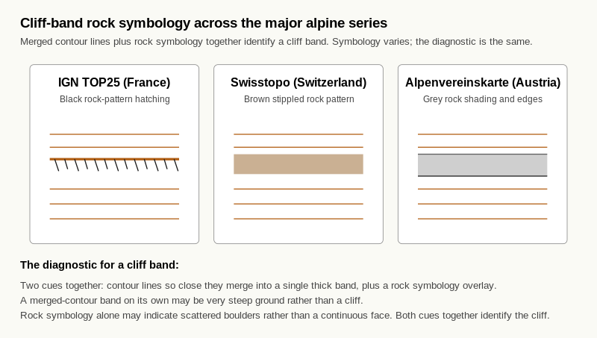
Reference diagram. Cliff Rock Symbology Comparison. the diagnostic for a cliff band is two cues together - merged contour lines plus rock symbology overlay; the symbology varies but the diagnostic is consistent.

Learning aim
By the end of this page, you should be able to recognise plateaux on a 1:25,000 alpine map from their distinctive absence of contours, recognise cliff bands from merged or rock-symbol contours, distinguish the easiest and the hardest ground on an extract at a glance, and translate both patterns into a side profile and a verbal "if I stood here" description.

Why this matters
Plateaux and cliff bands are the two extremes of alpine terrain. Plateaux are the easiest ground to walk on and the hardest to navigate in poor visibility; cliff bands are the easiest to spot and the hardest to descend. Reading both fluently is essential for:
- route planning that uses plateaux as recovery and decision points,
- route planning that avoids cliff bands or commits to known descents,
- relocation in poor visibility, where a plateau can produce dangerously few features and a cliff band can be a hard handrail,
- and avalanche awareness, where cliff bands often mark the boundary between manageable and committing terrain.

The core idea — Plateaux
A plateau shows up on the map as a high area with very widely spaced or absent contours, often bounded by a sudden change in spacing where the ground falls away.
The signature is the contrast: contours close together on the bounding slopes, almost none on the plateau itself. Spot heights are usually present to mark the actual highest point because the broad flat top makes the precise peak ambiguous.
You met one form of this in C2.1 as the "plateau-like high". C3.3 covers it as a feature in its own right: a flat or near-flat alpine area with route-choice and navigation implications.

The core idea — Cliff bands
A cliff band shows up on the map as contours so close together they merge or are drawn as a single thick line, often with rock symbology overlaid.
The signature is the merger: where individual contour lines cannot be picked out separately, the ground is steeper than the contour interval can resolve. On 1:25,000 alpine sheets with 10 m contours, this typically means slopes of 50 degrees or above, which is too steep to ski in most conditions and may be impassable on foot.
Most national mapping agencies overlay rock-feature symbols on cliff bands:
- IGN TOP25 (France): black or dark grey rock-pattern hatching across the merged contours.
- Swisstopo (Switzerland): a brown stippled pattern simulating rock faces.
- Alpenvereinskarte (Austria): grey rock shading with prominent rock-edge symbols.
Always check the map legend for the specific symbol used. The combined cue is unmistakable: merged contours plus rock symbology equals cliff.

Worked example
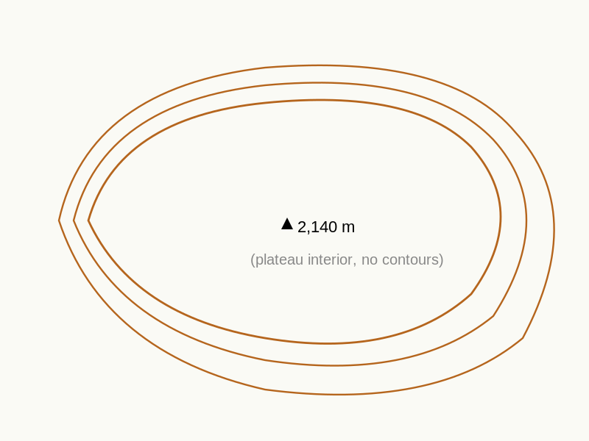
Reference diagram. Plateau. high area with widely spaced or absent contours bounded by close-spaced contours.
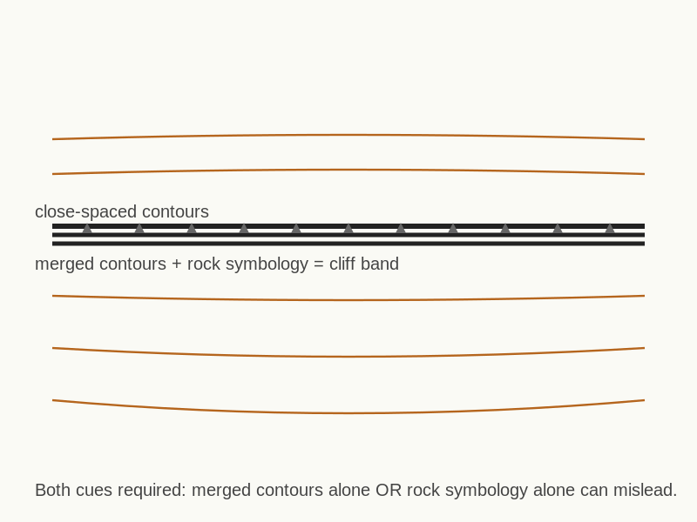
Reference diagram. Cliff Band. merged contours plus rock symbology overlay.
A 1:25,000 alpine sheet with 10 m contours shows two features close together:
- Feature P: a roughly oval area approximately 1.2 km by 0.8 km, with no contour lines drawn within it, surrounded by close-spaced contours falling away on all sides; a single spot height at 2,140 m near the centre.
- Feature Q: a band approximately 200 m long and 30 m wide, where contours are drawn merged into a thick black line with rock-pattern hatching overlaid, sitting on the steepest part of the slope below the plateau.
Feature P is a plateau at 2,140 m. The flat top is bordered by steeper ground on all sides. The plateau itself is easy walking; the bounding slopes are not.
Feature Q is a cliff band. It sits on the slope below the plateau, marking the place where the ground transitions from "very steep" to "impassable on foot in normal conditions". A descent route from the plateau to the valley below would have to navigate around this band.

Exercise 1 — Find the plateau
On the Section C3.3 map extract (provided by your trainer; 1:25,000, 10 m contours), shade the area you would identify as a plateau. Then answer:
- Approximate dimensions of the plateau (km by km):
- Spot height of the plateau, if shown:
- The four cardinal directions: in which one(s) does the plateau drop off most sharply?

Exercise 2 — Mark the cliff bands
On the same Section C3.3 map extract, mark with a pencil line each cliff band you can identify. For each, write:
- Approximate length (m):
- Approximate aspect (the direction the cliff face looks out towards):
- Whether the cliff band is continuous, or has breaks where a route could pass through:

Exercise 3 — Easiest and hardest ground
Looking at the same Section C3.3 map extract:
- Mark with a tick the easiest ground to walk on.
- Mark with a cross the hardest ground to descend.
- In one sentence, explain how the contour pattern told you which was which.

Exercise 4 — Side profile sketch
In the spaces below, sketch a side profile of the plateau and the cliff band as you would see them from the valley below.
Plateau and cliff band sketch:
[Sketch space - approximately 8 cm by 5 cm]
Label the plateau, the bounding slopes, and the cliff band. Indicate where a route from the valley to the plateau would most likely climb (or descend).

Exercise 5 — "If I stood here" (poor visibility)
Imagine you are standing at the centre of the plateau in poor visibility, with cloud cover at ground level and 20 m of useful sight distance.
In three sentences, describe:
- what you would see immediately around you,
- why a plateau is harder to navigate in poor visibility than a ridge or a valley,
- and what one piece of equipment beyond the map and compass you would most want to have with you.
____________________________________________________ ____________________________________________________

Self-check
☐ I can identify a plateau from the absence or wide spacing of contours bounded by close-spaced contours.
☐ I can identify a cliff band from merged contours plus rock symbology, and know to check the map legend for the local convention.
☐ I can pick the easiest and hardest ground on a map at a glance.
☐ I can sketch a plateau and cliff band combination from a contour pattern.
☐ I can articulate why a plateau is hard to navigate in poor visibility.

Why this matters for IMS
This page directly supports the IMS / EMS map reading competency: identify all key contour features (spur, re-entrant / valley, col, convex roll, concave slope, cliff) on a 1:25,000 topo map. Plateaux and cliff bands also drive route planning at IMS / EMS level: plateau navigation is the canonical poor-visibility challenge, and cliff-band recognition is the canonical "what is the safe descent line?" question. The contour pattern for cliff bands you have just learned was previewed in C2.4 Exercise 4 (snippet 10). If you sketched that snippet, look back at your sketch now and compare it with what you have just learned.
These two pages introduce slope direction and aspect formally. They sit between the contour-shape work of Sections C2 and C3 and the visualisation work of Section C5. Sections C2 and C3 have already given you most of what you need; C4 makes the reading explicit and adds the compass-aspect language that the IMS / EMS assessor will expect to hear.

C4.1 High to Low Ground
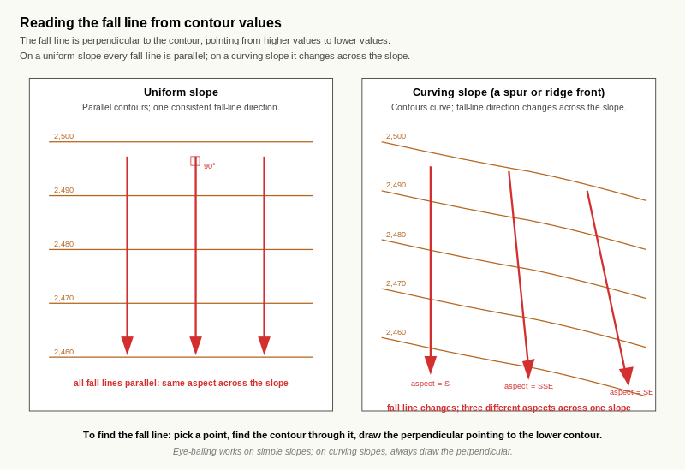
Reference diagram. Fall Line on a Contour Pattern. the perpendicular-to-contour rule is reliable on any slope; on a uniform slope every fall line points the same way; on a curving slope the local fall-line direction (and therefore the aspect) changes across the slope.

Learning aim
By the end of this page, you should be able to look at any contour pattern and identify the direction of the downhill, draw an arrow showing the line of greatest descent (the fall line), and explain how you know.

Why this matters
Reading direction of slope is the foundation of every later route-choice skill. Without it you cannot:
- read aspect (C4.2),
- judge fall-line ski descents,
- predict where water and avalanche debris run,
- choose ascent lines that follow gentler ground,
- or transcribe direction of travel onto a route card.
In Section C2 you read downhill informally as part of valley, gully, ridge and spur recognition. In Section C3 you read downhill again as part of bowl and col recognition. C4.1 takes the implicit skill and makes it the explicit subject of the page.

The core idea
The direction of slope is given by the contour values:
- contours with higher values are uphill,
- contours with lower values are downhill,
- the line at right angles to the contours, pointing from high to low, is the fall line.
The fall line is the steepest line down the slope. It is the line water would take running off the slope. It is also the line a ball would roll down. On a uniform slope, every point has a single fall line.

The fall line in practice
Two practical points to keep in mind:
- The fall line is local. It is the steepest descent at the point you are standing. Two points on the same slope can have slightly different fall-line directions if the slope curves.
- The fall line is at right angles to the contour line. This is the geometric definition. To find the fall line at a point, look at the contour line passing through that point; the fall line points downhill, perpendicular to the contour.
This perpendicular-to-contour rule is what makes the reading reliable. Eye-balling the downhill works on simple slopes; on complex slopes, drop a perpendicular from the contour and you have the right answer.

Worked example
A 1:25,000 alpine sheet with 10 m contours shows three contour lines on a slope, with values 2,500 m at the top, 2,490 m in the middle, and 2,480 m at the bottom of the visible section.
The downhill direction is from 2,500 m towards 2,480 m. At any point on the 2,490 m contour, the fall line runs perpendicular to that contour, pointing towards the 2,480 m contour.
If the contours run east-west across the slope on the page, the fall line runs north-south. Whether it points north or south depends on which side has the higher contour: if 2,500 m is to the north, the fall line points south; if 2,500 m is to the south, the fall line points north.

Exercise 1 — Mark the high and low points
On the Section C4.1 map extract (provided by your trainer; 1:25,000, 10 m contours), four slopes are marked A, B, C and D.
For each slope, write the highest contour value visible and the lowest contour value visible.
Slope | Highest contour (m) | Lowest contour (m)
A
B
C
D

Exercise 2 — Draw the fall-line arrow
For each of the four slopes from Exercise 1, draw an arrow on the map extract showing the fall line. The arrow should:
- start at a point near the centre of the slope,
- run perpendicular to the contour at that point,
- and point downhill (from higher contour to lower).
The arrow does not need to be long. It needs to be in the right direction.

Exercise 3 — Explain how you know
For slope A, write two or three sentences explaining how you determined the fall line. Include:
- which contour is higher and which is lower,
- the rule you used to find the perpendicular,
- and any visible feature that confirms your reading (a stream, a ridge, a spot height).
____________________________________________________ ____________________________________________________

Exercise 4 — Curving slope
On the Section C4.1 extract, slope C is a curving slope: the fall-line direction changes across the slope.
- Pick three points along slope C and draw the fall line at each.
- Note the direction of each fall line in compass terms (no need to be more precise than to the nearest cardinal or intercardinal direction at this stage).
- In one sentence, explain why the three fall lines do not all point the same way.
____________________________________________________

Self-check
☐ I can identify the higher and lower sides of any contour pattern from the values.
☐ I can draw a fall-line arrow that runs perpendicular to the contour and points downhill.
☐ I can explain how I know the direction of slope using the contour values and the perpendicular rule.
☐ I recognise that on curving slopes, the fall line direction changes across the slope.

Why this matters for IMS
Every aspect reading, every route choice, every fall-line ski descent and every avalanche-runout estimate at IMS / EMS level rests on a fluent reading of direction of slope. This page is short because the skill is short, but the IMS / EMS competency depends on it being instinctive.

C4.2 Reading Aspect
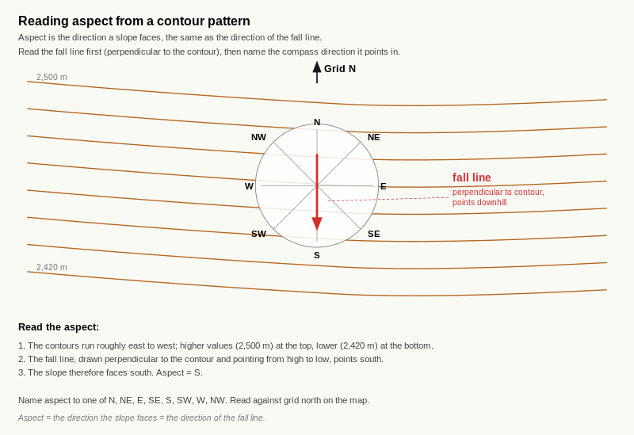
Reference diagram. Aspect Rose on Contour Pattern. aspect equals the direction the slope faces equals the direction of the fall line; aspect named to one of N, NE, E, SE, S, SW, W, NW against grid north.

Learning aim
By the end of this page, you should be able to read the aspect of any slope from a 1:25,000 alpine map in compass terms (N, NE, E, SE, S, SW, W, NW), explain what aspect means and why it matters, and apply aspect reading to map an avalanche bulletin onto the terrain.

Why this matters
Aspect is the single most useful piece of slope information after steepness. It governs:
- snow conditions (cold, dry, wind-loaded, sun-affected, melt-freeze),
- the avalanche bulletin (forecast danger is given by aspect and elevation band),
- the ski quality of a descent at any given time of day or season,
- the safety of a route choice in conditions where some aspects are dangerous and others are not,
- and the route-card translation of the bulletin into "go" and "no-go" terrain.
For a BASI Level 4 IMS / EMS candidate, fluent aspect reading is what turns a generic avalanche bulletin into a specific terrain decision.

The core idea
The aspect of a slope is the direction the slope faces.
Equivalently, it is the direction of the fall line you found in C4.1: the slope faces in the direction it falls towards. A north-facing slope falls towards the north. A south-facing slope falls towards the south.
To read aspect from the map:
- Find the fall line at the point of interest (using C4.1).
- Identify the compass direction the fall line points in, using the map's north arrow.
- Name that direction in cardinal or intercardinal terms.
For IMS / EMS-level work, eight directions are usually enough: N, NE, E, SE, S, SW, W, NW. Finer divisions (NNE, ENE, etc.) are sometimes used in avalanche bulletins; the workbook stays at eight directions for clarity, with a note on the finer divisions where they appear.

Map north and grid north
For aspect reading on a topographic map, you read the fall line against the map's grid. Three norths exist:
- True north. The geographic North Pole. The notional reference for all maps.
- Grid north. The "up" direction of the map's grid lines. Usually within a degree of true north on the alpine sheets used at IMS / EMS.
- Magnetic north. Where a compass needle points. Differs from true north by the magnetic variation, which depends on location and date.
For aspect reading, grid north is the practical reference. Aspect read off the map is given to the nearest of the eight cardinal / intercardinal directions, and the difference between grid and true north is too small to change the answer at this resolution.
For compass bearings (Level 3 onwards), magnetic variation matters. For aspect at IMS / EMS, it does not.
(If your map area or your assessment requires it, check current magnetic variation for your map area and date using the map margin and an official calculator such as BGS WMM, NOAA / NCEI, or swisstopo. Aspect alone does not need this; bearings will.)

Aspect and snow in the northern hemisphere
For a slope in the northern hemisphere:
- North-facing slopes receive the least direct sun in winter. They typically hold colder, drier, longer-lasting snow, with slower melt-freeze cycles and a higher risk of persistent weak layers.
- South-facing slopes receive the most direct sun. They typically have wetter, denser snow, more melt-freeze cycles, and are the first to spring-condition in late season.
- East-facing slopes receive morning sun and afternoon shade. Often the best skiing on a sunny mid-winter day.
- West-facing slopes receive afternoon sun and morning shade. Often more wind-affected because prevailing winter winds in the northern hemisphere alpine are typically from the west or north-west.
In the southern hemisphere (relevant if a candidate is using this workbook for a New Zealand, South American, or Antarctic context) the relationship inverts. South-facing becomes the cold, shaded, snow-holding aspect; north-facing becomes the sun-affected aspect.

Worked example
A 1:25,000 alpine sheet shows a slope in the northern hemisphere where:
- the contour values rise from 2,400 m at the bottom of the slope to 2,700 m at the top,
- the contour lines run roughly east to west across the page,
- the higher contours are on the south side of the page (towards the bottom in the conventional map orientation, but check the north arrow on the actual map),
- and grid north points up the page.
The fall line points from the higher contours towards the lower contours. Higher is south; lower is north. So the fall line points north. The slope faces north. The aspect is north.
Northern-hemisphere implications: this is a cold, shaded slope that holds dry snow. In winter the avalanche bulletin will treat north aspects as a likely persistent-weak-layer aspect.

Exercise 1 — Add the north arrow
On the Section C4.2 map extract (provided by your trainer; 1:25,000, 10 m contours), four slopes are marked A, B, C and D.
If the extract does not already have a north arrow, add one based on the grid lines.

Exercise 2 — Label the aspect
For each of the four slopes, draw a fall-line arrow (using C4.1) and label the slope with its aspect to the nearest cardinal or intercardinal direction.
Slope | Fall-line arrow direction (compass) | Aspect
A
B
C
D

Exercise 3 — Aspect and snow
For two of the four slopes from Exercise 2 (your choice), write a one-sentence prediction of:
- the snow condition you would expect on each slope on a sunny mid-winter day in the northern hemisphere,
- the snow condition you would expect on each slope after a stormy north-westerly,
- and which of the two slopes you would prefer to ski in mid-winter, and why.
Slope ___ :
Slope ___ :
Preferred slope: ___ Reason:

Exercise 4 — Bulletin to terrain
The avalanche bulletin for your area today reads:
> Danger level 3 (Considerable). Persistent weak layer. Heightened danger on north-east through north-west aspects above 2,200 m.
On the Section C4.2 map extract, shade in the slopes that fall within the bulletin's heightened-danger band: aspect between NE and NW (going through N), elevation above 2,200 m.
In two or three sentences, identify a route across the extract that avoids the shaded ground while still reaching a point you have chosen to visit.
____________________________________________________ ____________________________________________________

Exercise 5 — Aspect on a ridge or spur
Pick a ridge or spur from the C2.3 extract, the C3.1 extract, or any ridge or spur visible on the C4.2 extract.
Recall from C2.3 Exercise 2 that the two flanks of a ridge or spur face in different directions. Read the aspect of each flank in compass terms.
- Aspect of left flank (facing along the crest towards the low end):
- Aspect of right flank (facing along the crest towards the low end):
- Which flank would you prefer for a winter ascent in the northern hemisphere, and why?

Self-check
☐ I can read the aspect of any slope on a 1:25,000 alpine map to the nearest of the eight cardinal / intercardinal directions.
☐ I understand that aspect is the direction the slope faces, equivalently the direction of the fall line.
☐ I know that grid north is the practical reference for aspect reading at IMS / EMS level.
☐ I can predict snow conditions on a slope from its aspect, in the appropriate hemisphere.
☐ I can take an avalanche bulletin written in aspect and elevation terms and apply it to a specific map extract.

Why this matters for IMS
This page directly supports the IMS / EMS competency in avalanche-aware terrain interpretation and route selection. The avalanche bulletin is given in aspect-and-elevation terms; the candidate's job at assessment is to map the bulletin onto the specific terrain of the day and produce a route that respects the heightened-danger zones. Exercise 4 is the rehearsal of that move.
The aspect-and-snow link from C3.2 Exercise 5 is treated formally here. The aspect-of-each-side reading from C2.3 Exercise 2 finds its formal home here. After C4 the workbook moves into Section C5 (visualisation), where the aspect language built here will appear in every "if I stood here" prompt.

C5.1 Map View to Side Profile

Learning aim
By the end of this page, you should be able to draw a cross-section line across any contour pattern on a 1:25,000 alpine map, project the contour crossings onto a side-profile sketch beneath the line, choose a sensible vertical scale and vertical exaggeration, and read your finished side profile back as a representation of the actual ground.

Why this matters
The cross-section technique is the most reliable way to convert a contour pattern into a quantitative side view. It is the technique that:
- turns a wash of orange contour lines into a recognisable mountain silhouette,
- lets you compare two route options on the same axis,
- supports route-card preparation for a tour with significant ascent or descent,
- and gives you a piece of paper you can hand to someone else to explain the day's terrain.
For a BASI Level 4 IMS / EMS candidate, the cross-section is the bridge between the contour vocabulary built in Sections C1 to C4 and the route-thinking work that begins in Section C6. It is also the technique that closes the 2D-to-3D gap most directly: there is no eye-balling, no interpretation; the contour data goes onto an axis and a profile emerges.

The core idea
A cross-section is the side view you would see if you cut the mountain along a chosen line and looked at the cut face.
To build one from a map:
- Draw a straight line on the map between two points (the section line).
- Note where the section line crosses each contour.
- Below the map, draw a horizontal axis the same length as the section line on the map.
- Above that axis, draw a vertical axis with elevation marked at the contour interval (10 m for most IGN sheets).
- For each contour crossing on the section line, drop a vertical line down to the matching elevation on the vertical axis.
- Connect the points smoothly to produce the side profile.
That is the technique. The principle is just that of plotting (distance, height) points and joining them up.

Horizontal scale
The horizontal scale of a cross-section should match the map. On a 1:25,000 map, 1 cm on the section line equals 250 m on the ground, so 1 cm on the cross-section's horizontal axis also equals 250 m. Keep the two scales locked.
A common error is to draw the cross-section at a different horizontal scale and then misread the slope angles. Always use the same horizontal scale as the map.

Vertical scale and vertical exaggeration
The vertical axis is where most learners make a choice. Two standard options:
- True scale (1:25,000 vertically as well as horizontally). Mathematically honest, but produces a cross-section that looks almost flat because alpine relief is small relative to horizontal distance. A 600 m climb over 2 km looks like a gentle ramp at true scale.
- Vertically exaggerated (typically 2:1 or 3:1). The vertical scale is multiplied by 2 or 3 relative to the horizontal. The cross-section looks more like the mountain feels. Standard practice in mountain navigation; almost universal in topographic atlases.
Both are valid. For workbook practice, use 2:1 vertical exaggeration as the default. If you need a true-scale cross-section for a specific calculation (route gradient, sight lines), draw a true-scale version separately.
When you label your axes, write the scale and the vertical exaggeration explicitly. A cross-section without these labels can be misread.

Slope angle from a cross-section
The slope angle on a cross-section is governed by the contour spacing along the section line. The C1.2 rule of thumb still applies:
- if the contour crossings on the section line are 3 mm apart or closer (on a 1:25,000 map with 10 m contours), the cross-section section there shows a slope at or above 30 degrees,
- if they are 8 mm or wider, the slope is gentle,
- and so on.
If you draw the cross-section at 2:1 vertical exaggeration, the angles on the page will look steeper than the real slope angles. This is the trade-off: visible relief at the cost of angular accuracy. Read steepness from the map (contour spacing on the section line), not from the angle of the line on the cross-section.

Worked example
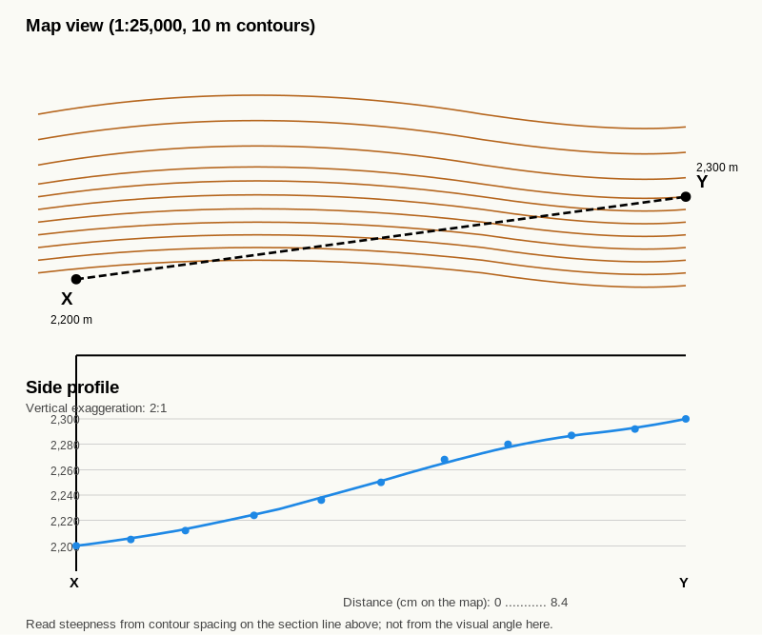
Reference diagram. Cross-Section Worked Example. section line; eleven contour crossings; 2:1 vertical exaggeration.
A 1:25,000 alpine sheet with 10 m contours shows a slope crossed by a section line 8 cm long. The line crosses contours at the following positions along its length:
Distance along line (cm) | Contour value (m)
0.0 | 2,200
0.5 | 2,210
1.5 | 2,220
2.8 | 2,230
4.2 | 2,240
6.0 | 2,250
8.0 | 2,260
The section is 8 cm = 2,000 m on the ground (1:25,000), with a height gain of 60 m from start to end. The cross-section drawn at 2:1 vertical exaggeration would show the contour crossings at the listed distances along the horizontal axis, with the height plotted on a vertical axis where 1 cm represents 5 m of elevation (so 60 m of total ascent occupies 12 cm vertically, and the slope reads visually as much steeper than the true 1.7 degrees).
This is a gentle slope: 60 m gain over 2,000 m horizontal distance is approximately 1.7 degrees. The cross-section shows a smooth concave line, with the line pulling away from level slightly more towards the start (closer-spaced contours at the bottom) and flattening towards the end.

Exercise 1 — Draw the section line
On the Section C5.1 map extract (provided by your trainer; 1:25,000, 10 m contours), draw a section line connecting two named points marked X and Y.
Use a ruler. The line must be straight.
- Length of the section line on the map (cm):
- Equivalent ground distance (m): __________ (multiply by 250 for 1:25,000)

Exercise 2 — Note the contour crossings
Working along the section line from X to Y, record each contour crossing in the table below. The first contour crossed is at the start of the line; the last is at the end. Note the distance from X (in cm) and the contour value (in m).
Crossing # | Distance from X (cm) | Contour value (m)
1
2
3
4
5
6
7
8
(Add or remove rows as needed.)

Exercise 3 — Build the cross-section
Below the section line on a separate sheet of grid paper or in the space below, draw a horizontal axis the same length as the section line. Mark distance in cm or in km.
Above the axis, draw a vertical axis with elevation marked at 10 m intervals, starting from the lowest contour value and going up to the highest, plus one interval of margin at top and bottom.
Choose vertical exaggeration 2:1 unless your trainer instructs otherwise. Label both axes with the scale and the vertical exaggeration.
For each contour crossing from Exercise 2, drop a vertical line from the horizontal axis up to the matching elevation, place a small dot, and then connect the dots smoothly.
[Sketch space - approximately 14 cm by 8 cm]

Exercise 4 — Read the cross-section
With the cross-section drawn, answer:
- What is the highest point along the section line, and at what distance from X?
- What is the lowest point, and at what distance?
- Where along the section is the slope steepest (closest contour spacing)?
- Where is the slope gentlest (widest contour spacing)?
- Identify any feature you can name on the cross-section: a summit, a col, a valley, a ridge crest, a bowl rim, a cliff band.

Exercise 5 — Compare with a model
Your trainer has a model cross-section of the same X-to-Y line. Place your cross-section alongside the model and answer:
- Where is your cross-section too steep compared with the model?
- Where is your cross-section too flat?
- What is the most likely cause of each error (missed contour crossing, wrong vertical scale, line drawn slightly off, smoothing too much, smoothing too little)?
- If you were drawing this cross-section again, what would you do differently?

Self-check
☐ I can draw a section line on a map and note every contour crossing along it.
☐ I can build a cross-section with horizontal scale matched to the map and vertical scale at 2:1 exaggeration.
☐ I can label the axes with scale and vertical exaggeration.
☐ I can read the highest point, lowest point, steepest section and gentlest section from a finished cross-section.
☐ I can name terrain features on the cross-section using the C2 to C4 vocabulary.
☐ I can compare my cross-section with a model and diagnose my own errors.

Why this matters for IMS
Cross-section thinking sits behind every route-card decision the IMS / EMS assessor expects to see: total ascent, total descent, the steepest section of the day, the location of cols and bowls along the line of travel. The candidate does not have to draw a formal cross-section for every leg of every tour, but the cross-section technique is what makes the mental version reliable. After C5.1 the workbook moves to less formal visualisation (C5.2 with images, C5.3 with verbal description); the cross-section is the technical anchor underneath both.
These two pages complete the visualisation block. C5.2 calibrates your contour reading against real images. C5.3 removes the external image and asks you to do the visualisation entirely from the map. The progression is deliberate: scaffolded first, then unscaffolded. By the end of C5.3 you should be able to produce a sustained, structured verbal description of any point on a 1:25,000 alpine map without external help.

C5.2 Map to Real Landscape Matching

Learning aim
By the end of this page, you should be able to look at a contour pattern and an aerial or oblique photograph of the same area, identify which photograph matches which contour pattern, and articulate the visual cues you used. You should also be able to identify recurring patterns where your visualisation differs from the real image so you can correct the bias.

Why this matters
Maps are abstractions. A skilled candidate at IMS / EMS level reads the abstraction back into the real world automatically. C5.2 is the calibration page that turns the contour vocabulary you have built in Sections C2 to C4 into a reliable mental imagery generator.
The exercise here is also the antidote to a common over-confidence: most learners think their mental picture of a contour pattern is more accurate than it actually is. Comparing the mental picture with a real photograph reveals the systematic biases (most people draw mountains too steep and bowls too symmetrical, for example), and the comparison drives correction.

How to use this page
The exercises on this page draw on the Section C5.2 photo-matching set, prepared by your trainer. The set contains:
- six contour snippets (numbered 1 to 6) at 1:25,000 with 10 m contours,
- six aerial or oblique photographs (lettered A to F) of the same areas,
- and a key, held by the trainer, showing the correct pairings.
Each photograph is taken from a known position, with the camera roughly horizontal. Aerial photographs are vertical (looking straight down); oblique photographs are taken from a known altitude with the camera tilted so the horizon is visible.

Exercise 1 — Match the contour snippet to the photograph
For each of the six contour snippets, choose the matching photograph from A to F. Each photograph matches exactly one snippet.
Contour snippet | Matching photograph
1
2
3
4
5
6

Exercise 2 — Articulate the cues
Pick three of the six pairs above. For each, write a single sentence naming the visual cue that confirmed the match. The cue should refer to a specific contour-pattern feature (closed loops, V-up, V-down, headwall, plateau, cliff band, fall line, aspect) and to the corresponding feature visible in the photograph.
Pair ___ :
Pair ___ :
Pair ___ :

Exercise 3 — Where the picture surprised you
Pick the pair where the photograph surprised you most: where the real ground looked different from what you had pictured.
In two or three sentences, answer:
- What did you expect to see?
- What was actually there?
- What does that tell you about how to read this kind of contour pattern in future?
____________________________________________________ ____________________________________________________

Exercise 4 — Sketch from the photograph back to a contour
Pick one of the six photographs. Without looking at the matching contour snippet, sketch the contour pattern you would expect a 1:25,000 map of that area to show.
[Sketch space - approximately 8 cm by 5 cm]
Then compare your sketch with the actual contour snippet. Note any differences.

Self-check
☐ I can match contour snippets to aerial or oblique photographs of the same area.
☐ I can name the visual cue I used for each match in contour-vocabulary terms.
☐ I have noticed at least one place where my mental image differed from the real ground, and I can articulate what to change.
☐ I can work backwards from a photograph to a sketch of the expected contour pattern.

Why this matters for IMS
Calibrating mental imagery against real images is what produces a route-choice instinct. The IMS / EMS assessor will not test photo-matching directly, but candidates who have practised it produce more accurate route-card descriptions and more reliable in-field route adjustments. The skill is invisible at assessment but visible in everything the candidate does on the day.

C5.3 "If I Stood Here" Sustained Practice

Learning aim
By the end of this page, you should be able to mark any point on a 1:25,000 alpine map and produce a sustained four-to-six-sentence description of what you would expect to see standing at that point, without external scaffolding. The description should cover steepness, aspect, neighbouring high and low ground, and the direction of the main slope, in the vocabulary built across Sections C1 to C4.

Why this matters
This page is the consolidated form of the "if I stood here" prompt that has appeared on every named-feature page since C2.1. There it was a short three-sentence prompt embedded in a longer exercise. Here it is the entire exercise, sustained and unscaffolded.
The point is not to produce creative writing. It is to produce a structured, accurate, repeatable description that:
- could be transcribed into a route-card description column,
- could be read out to a second person as a position fix,
- and could be checked against the ground when you arrive.
This is the working speech of an IMS / EMS candidate on the move. C5.3 is where it becomes sustained.

Structure for the description
Use the following four-part structure. Each description should cover all four:
- Underfoot. The ground immediately around you (flat, sloping, narrow, broad, snow surface, rock, vegetation if visible from the map).
- Slope and aspect. The direction the ground falls, expressed in compass terms; the steepness in the C1.2 vocabulary (gentle, moderate, steep, very steep).
- Near features. What you would see within a few hundred metres: the nearest summit, ridge, valley, col, bowl, cliff band, or other named feature.
- Far features. What you would see in the wider view: a distant skyline, a recognisable peak, a major valley, a town or hut visible on the map.
Four sentences is the minimum; six sentences gives you room for two near features or a more nuanced steepness description.

Worked example
Imagine you are standing at a point on a 1:25,000 alpine sheet marked at 2,300 m, on the northern flank of a spur projecting east-north-east from a 2,650 m summit. The contours around you are spaced at approximately 5 mm. To the south the ground rises towards the summit; to the north it falls away into a broad valley with a stream at 1,950 m. About 800 m to the north-east, a ridge rises again to 2,500 m; beyond that ridge, on the far horizon, the spot height for a major peak at 3,250 m is just visible.
A four-sentence description in the structured form:
- Underfoot. I am standing on a moderate snow slope on the northern flank of a spur, with the ground falling away below me and rising up to my left.
- Slope and aspect. The slope falls north, at approximately 18 to 22 degrees on the C1.2 rule of thumb, well below the 30 degree avalanche threshold.
- Near features. The spur crest is about 60 m above me to the south; the broad valley with the stream is 350 m below me to the north.
- Far features. Across the valley, a ridge rises to 2,500 m; on the horizon beyond, a peak at 3,250 m is just visible.
That is the working voice the workbook is building towards.

Exercise 1 — First description
On the Section C5.3 map extract (provided by your trainer; 1:25,000, 10 m contours), your trainer has marked a point labelled P1.
Write a four-sentence description of what you would expect to see standing at P1, using the four-part structure above.
- Underfoot:
- Slope and aspect:
- Near features:
- Far features:

Exercise 2 — Second description, on a different feature type
A second point P2 is marked on the same extract, on a different family of feature (if P1 was on a slope, P2 is on a summit; if P1 was in a valley, P2 is on a ridge; and so on).
Write a four-sentence description of P2, using the same structure.
- Underfoot:
- Slope and aspect:
- Near features:
- Far features:

Exercise 3 — Third description, with poor visibility added
A third point P3 is marked on the same extract, with the additional condition that you are standing there in poor visibility with 30 m of useful sight distance.
Write a four-sentence description for P3 in poor visibility. Some of your sentences (especially the far features) will become "I cannot see X but the map tells me X is at..." statements. That phrasing is correct and is what the IMS / EMS assessor expects to hear.
- Underfoot:
- Slope and aspect:
- Near features (visible or inferred from the map):
- Far features (inferred from the map):

Exercise 4 — Self-criticism
Read back your three descriptions from Exercises 1 to 3.
- Which description is the strongest, and why?
- Which description has the weakest "underfoot" sentence, and what would you change?
- Which description has the weakest "far features" sentence, and what would you change?
- Across the three descriptions, what one habit do you want to make automatic before Section C6?
____________________________________________________ ____________________________________________________ ____________________________________________________

Self-check
☐ I can produce a structured four-to-six-sentence description for any point on a 1:25,000 alpine map.
☐ I can use compass-aspect terms (eight directions) consistently in the description.
☐ I can use the C1.2 steepness vocabulary consistently.
☐ I can adapt the description for poor visibility, distinguishing what I can see from what I infer from the map.
☐ I can read back my own descriptions and identify their weaknesses.

Why this matters for IMS
The IMS / EMS assessor's most common in-field test is "describe what you see from here". The candidate who replies in the structured four-part form sounds professional, is hard to catch out, and produces a response the assessor can actually check against the ground. The candidate who replies "there's a slope and some mountains over there" sounds untrained and is.
C5.3 is where the workbook builds the structured voice. The page is the consolidated form of every "if I stood here" prompt back to C2.1 and is the bridge into Section C6's route-thinking work.
These two pages turn the contour vocabulary built across Sections C2 to C5 into route thinking. C6.1 is constructive: choose the best line up a slope. C6.2 is critical: identify the terrain that deserves extra caution and route around it. The two skills are paired because they are the two halves of the same on-the-day decision: where to go and where not to.
Section C6 stays inside the map-reading scope of the workbook. It does not teach formal avalanche curriculum, snow profiling, or rescue. It teaches the route-relevant reading of terrain features that any IMS / EMS candidate has to do before stepping onto the snow.

C6.1 Which Line Looks Easier?
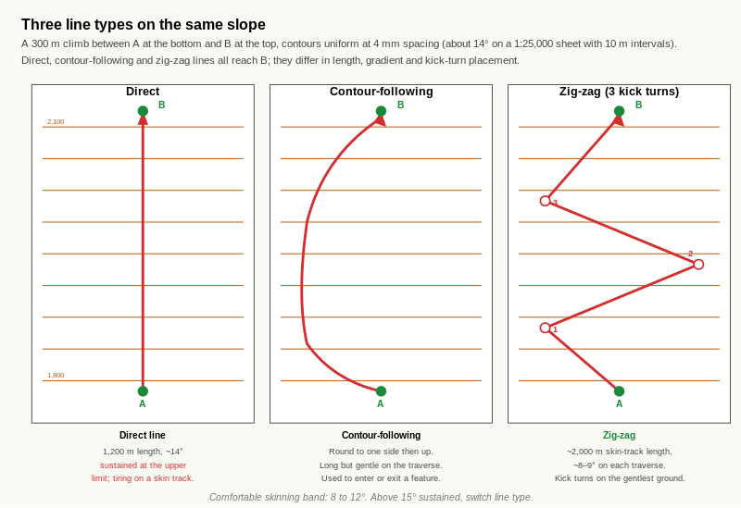
Reference diagram. Three Line Types on the Same Slope. direct line is shortest but holds full gradient throughout; contour-following adds the most distance but is gentlest; zig-zag splits the climb across traverses inside the comfortable skinning band, with kick turns on the gentlest available ground.

Learning aim
By the end of this page, you should be able to look at any slope on a 1:25,000 alpine map, sketch two or three possible lines up or down it, justify your choice of preferred line using contour spacing and terrain shape, and explain why a touring skin track typically sits in a specific gradient band rather than following the direct fall line.

Why this matters
Route choice on a slope is the most common decision on a touring day. It is the decision the IMS / EMS assessor watches most closely. The candidate who picks lines well:
- skins efficiently up gradients that hold grip,
- spaces kick turns to manage steep transitions,
- avoids unnecessary exposure to avalanche-prone aspects,
- arrives at cols and summits with energy left,
- and produces a route card that reads as deliberate rather than improvised.
The candidate who picks lines badly does the opposite. The map-reading work in Sections C2 to C5 is the foundation; C6.1 is where the foundation becomes a decision.

The core idea
A route line is not just a line. It is a series of choices about gradient, exposure, distance and terrain features. Three line types appear in almost every touring day:
- Direct line. The straightest path between two points. Shortest distance. Often the steepest gradient. Useful for short legs or descents on safe ground; rarely the right ascent line on a sustained slope.
- Contour-following line. A line that traverses across the slope rather than climbing it. Long but gentle. Useful for entering or exiting a feature without losing or gaining height.
- Zig-zag line. The standard skinning-track shape on sustained slopes. A series of traverses linked by kick turns. Manages gradient on the traverse legs; concentrates the steep moments at the kick turns themselves, where the skis are stationary.
Most touring lines are a mix of all three. The art of route choice is choosing which type to use where.

Skin-track gradient
A skinned skin track holds best in a specific gradient band. Typical figures across published touring guidance are:
- Comfortable skinning gradient: 8 to 12 degrees. Most efficient for sustained climbing.
- Acceptable upper limit: around 15 degrees on a single traverse leg, with kick turns to break the gradient.
- Above 15 degrees on a sustained line: skin grip becomes unreliable, edge engagement increases, the track tires the legs faster.
These figures are guides, not rules. Snow conditions, ski-skin combination, and the carry weight all shift the bands. But for map work the take-away is: a skin track that climbs at more than 15 degrees in a sustained way is the wrong line. The route choice problem is to find a line that holds the gradient inside the band.
On a 1:25,000 alpine map with 10 m contours, the C1.2 rule of thumb gives:
- 8 to 12 mm contour spacing: comfortable skinning gradient,
- 6 to 8 mm contour spacing: at the upper end of comfortable,
- 5 mm or closer: too steep for a sustained skin track; needs zig-zags or a different line.

The zig-zag and the kick turn
A zig-zag line trades length for gradient. By traversing across the slope rather than up it, the skinner adds horizontal distance and reduces gradient. The kick turn is the manoeuvre that changes direction at the end of each traverse leg.
Two quality criteria for a zig-zag line:
- Each traverse leg should sit inside the comfortable gradient band. A zig-zag that traverses at 20 degrees is barely better than a direct line; the point is a sub-15-degree leg.
- Kick turns should sit on the gentlest available ground. A kick turn on a steep concave roll is awkward and slow; on a gentle bench it is quick. Map-reading lets you place the kick turns deliberately.
The kick-turn placement decision is the one BASI / EMS materials specifically call out as a route-card-relevant skill. Practice it deliberately.

Worked example
A 1:25,000 alpine sheet with 10 m contours shows a slope between two points: A at 1,800 m at the bottom and B at 2,100 m at the top. The horizontal distance from A to B is approximately 1,200 m. The slope is uniformly steep, with contours at approximately 4 mm spacing throughout.
A direct line from A to B would climb 300 m over 1,200 m horizontal distance: an average gradient of approximately 14 degrees. That is at the upper end of the comfortable skinning band. The line would also be very long-feeling because the gradient is sustained.
A zig-zag line with three traverses would convert the 1,200 m horizontal distance into approximately 2,000 m of skin-track distance, but each traverse leg would climb only 100 m over approximately 670 m of skin-track length: an average gradient of approximately 8 to 9 degrees. Three kick turns would be needed; placing them on the gentlest sections of the slope (where contour spacing is locally wider) keeps them efficient.
The right choice is the zig-zag. The total horizontal distance is the same; the energy cost is much lower because the gradient is in the comfortable band throughout.

Exercise 1 — Compare three lines
On the Section C6.1 map extract (provided by your trainer; 1:25,000, 10 m contours), three possible lines are sketched between points A at the bottom and B at the top:
- Line 1: direct.
- Line 2: contour-following round one side of the slope.
- Line 3: zig-zag with three kick turns.
For each line, complete the table:
Line | Total length (m) | Average gradient | Steepest section gradient | Kick turns?
1 |  |  |  | No
2 |  |  |  | No
3 |  |  |  | Yes (3)

Exercise 2 — Choose the preferred line
Choose your preferred line for a touring ascent of the Section C6.1 slope on a stable winter day, and write three or four sentences justifying your choice. Reference:
- the gradient of each line against the comfortable skinning band,
- the total length and the consequent energy cost,
- any terrain features along each line that affect the choice (rolls, benches, gullies, exposure to overhead terrain),
- and the placement of any kick turns.
____________________________________________________ ____________________________________________________ ____________________________________________________

Exercise 3 — Place the kick turns
For the zig-zag line (Line 3), look closely at the contour pattern along the line. Three kick turns are needed.
- Mark on the map where you would place each kick turn. Number them 1, 2 and 3.
- For each, write a single sentence explaining why you chose that location (gentlest ground, recognisable feature, handover point between two traverse legs of similar length).
Kick turn 1:
Kick turn 2:
Kick turn 3:

Exercise 4 — Conditions change the choice
Your preferred line in Exercise 2 was for a stable winter day. Two scenarios change the conditions:
- Heavy fresh snow on a wind-loaded north aspect, avalanche danger level 3. Which of the three lines do you choose now, and what changes in your reasoning?
- Spring conditions, firm refrozen surface, low temperature. Which line do you choose, and why?
Scenario 1 line: __________ Reason:
Scenario 2 line: __________ Reason:

Exercise 5 — Descent vs ascent
The same slope can be approached differently on the descent than on the ascent.
Pick a descent line from B back to A and answer:
- Is your descent line the same as your ascent line, or different?
- If different, what makes the descent line right that would not have worked on the way up?
- What single feature on this slope would change your descent line decisively (a cliff band, a narrow gully, a windward / leeward aspect change)?
____________________________________________________

Self-check
☐ I can sketch direct, contour-following, and zig-zag lines on a contour pattern.
☐ I can read each line's gradient from contour spacing and judge it against the comfortable skinning band.
☐ I can place kick turns on the gentlest available ground.
☐ I can adjust my preferred line for changing snow and avalanche conditions.
☐ I can recognise that the right ascent line and the right descent line on the same slope can differ.

Why this matters for IMS
Setting a skinning track and executing kick turns is a named skill on the BASI EMS training course content. Choosing route lines that respect the comfortable skinning band, place kick turns deliberately, and adapt to conditions is the working substance of the IMS / EMS route-card preparation. After this page, the candidate has the contour-reading vocabulary plus a deliberate process for turning that vocabulary into a route choice.

C6.2 Spot the Terrain Trap
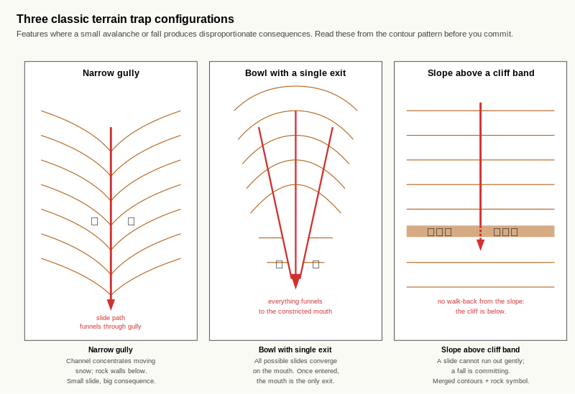
Reference diagram. Three Terrain Trap Configurations. all three are recognisable from the contour pattern alone. Reading these from the map gives you the chance to plan around them.

Learning aim
By the end of this page, you should be able to look at any contour pattern on a 1:25,000 alpine map and identify terrain that deserves extra caution: terrain traps, committing terrain, runout zones, and configurations where a small problem can become a large one. You should also be able to suggest a safer alternative line where one is available, or recognise when no safe line exists.

Why this matters
The map-reading skill is not only "where to go". It is also "where not to go", and "where the ground will not let you back out if it goes wrong". The IMS / EMS assessor expects candidates to read the second skill as fluently as the first, especially on the descent and especially in conditions where the avalanche bulletin or the local snowpack is uncertain.
This page does not teach formal avalanche curriculum. It teaches the map-reading interpretation of terrain features that have route-relevant safety significance. Formal avalanche education (slab structure, weak layers, rescue) sits outside this workbook.

Terrain traps
A terrain trap is a piece of ground where a small avalanche or fall produces disproportionate consequences. Three classic patterns:
- Narrow gully. Already met in C2.2. The narrow channel concentrates moving snow; the gully often ends in a terminal cone or a cliff. A small slide that would be inconsequential on an open slope can be life-threatening in a tight gully.
- Bowl with a single exit. Already met in C3.2. A bowl that opens onto a narrow mouth funnels everything (skiers and snow) towards a single point. If the mouth is constricted by rock or a cliff band, a slide that runs the bowl produces a terminal cone with no outflow.
- Slope above a cliff band. Already met in C3.3. A slope that ends in merged contours plus rock symbology is committing: a slide on the slope cannot run out gently. The same applies to a slide on the slope above a tight gully or above a bowl with a constricted exit.
Each of these has been named individually in earlier sections. C6.2 is where they are read as terrain traps, that is, as features whose consequence is greater than their size suggests.

Committing terrain
Committing terrain is ground that cannot be reversed once entered. Classic patterns:
- Slope above a cliff. Once you ski onto the slope, the cliff below means you cannot stop and walk back up. The slope must be skied through.
- Bowl with a single mouth. Once you ski into the bowl, the mouth is the only exit. If conditions change inside the bowl, you have to ski out through the mouth.
- Tight gully on the descent. Once you commit to the line, exiting laterally may be impossible. The gully has to be skied through.
Committing terrain is not necessarily dangerous. A clean cliff with a known exit and stable snow is committing but skiable. The point is to recognise the commitment so you can decide consciously whether you accept it, rather than discovering it halfway through.

Runout zones
A runout zone is the area where avalanche debris from above would come to rest. On a 1:25,000 map, runout zones are predictable from the contour pattern:
- below a steep avalanche-prone slope, where the gradient eases out (look for the contour spacing widening below a tight band),
- in the floor of a bowl, where the mouth opens onto a flatter basin,
- in the lower part of a gully where it widens onto a debris fan,
- and in any location where a slide from above could reach the ground you are standing on, including across a flat traverse below a steep slope.
A learner standing in a runout zone is at risk from terrain they are not on. This is why the bulletin-to-terrain mapping in C4.2 included aspect-and-elevation: heightened danger on a 35-degree north slope above 2,200 m affects you even on the 5-degree flat below it.

Convex rolls and slope transitions
A convex roll is a slope shape where the gradient increases as you descend. On the map, contour spacing tightens going downhill across the roll. Convex rolls concentrate stress at the steepest section and are common avalanche-trigger points.
The opposite shape, a concave slope, has gradient decreasing as you descend. Concave slopes spread stress and tend to be less reactive.
Reading slope transitions on a map is the same skill as reading contour spacing. Where the spacing tightens or widens going downhill, the slope shape changes.
For route choice, the take-away is: a convex roll above a terrain trap is a configuration that deserves explicit caution, even on a stable day. Reading the configuration from the map gives you the chance to plan around it.

Worked example
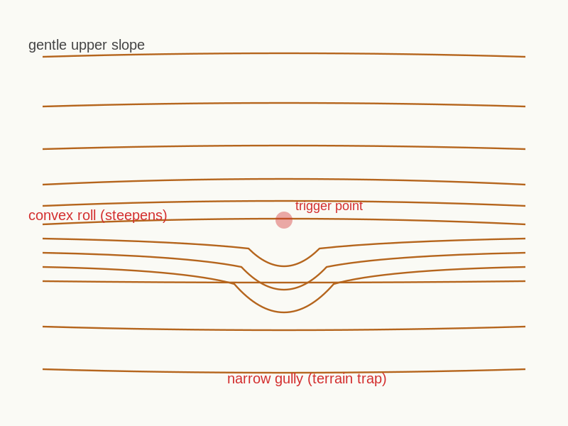
Reference diagram. Convex Roll into Terrain Trap. stress concentration plus moving-snow channel.
A 1:25,000 alpine sheet with 10 m contours shows the following pattern:
- a slope at approximately 30 degrees descending from 2,400 m to 2,200 m,
- below 2,200 m the contour spacing tightens further, indicating a steeper section to 2,150 m,
- below 2,150 m a 20 m wide gully with merged side-wall contours runs for 300 m down to 1,900 m,
- the gully narrows further at 2,000 m where rock symbology appears on both walls,
- and the gully terminates at 1,900 m on a flat basin with a stream symbol.
That configuration is a textbook terrain trap. From top to bottom:
- The 30-degree slope at the top is in the avalanche release range.
- The slope steepens below 2,200 m (a convex roll), concentrating stress at the transition.
- The slope drops into a tight gully with rock walls.
- The gully narrows further before the runout.
- The runout is the basin at 1,900 m.
Even on a stable day, a skier on the upper slope is committing to a line that ends in the gully. On an unstable day, the configuration is the kind a candidate should avoid by choosing a different line entirely. A safer alternative might be a line down a wider open slope with a flat runout, even at the cost of extra skinning to access it.

Exercise 1 — Identify the terrain traps
On the Section C6.2 map extract (provided by your trainer; 1:25,000, 10 m contours), shade or circle each terrain trap you can identify. Below the extract, list each in the form "feature type, location":

Exercise 2 — Identify the committing terrain
On the same extract, mark each piece of committing terrain (ground that cannot be reversed once entered). Below the extract, list each:

Exercise 3 — Identify a runout zone
On the same extract, identify a runout zone you would not stand or rest in even on a stable day, and explain why in one sentence.

Exercise 4 — Find a convex roll
On the same extract, find one convex roll where the gradient increases as you descend.
- Mark the location.
- Note the contour spacing immediately above the roll:
- Note the contour spacing immediately below the roll:
- In one sentence, explain why this shape is route-relevant.

Exercise 5 — Plan a safer alternative
For one of the terrain traps you identified in Exercise 1, sketch a safer alternative line that achieves the same general goal (descending to the same valley, reaching the same hut) without committing to the trap.
In two or three sentences, explain:
- What is the trade-off (extra distance, extra ascent, exposure to a different slope)?
- Why does the alternative line still meet the day's objective?
- Are there any conditions under which the alternative would also be unsuitable?
____________________________________________________ ____________________________________________________

Self-check
☐ I can identify narrow gullies, single-exit bowls and slopes above cliffs as terrain traps from a 1:25,000 contour pattern.
☐ I can recognise committing terrain and explain what makes it committing.
☐ I can identify runout zones and explain why standing in one is a risk even on a stable day.
☐ I can read convex rolls and slope transitions from contour spacing.
☐ I can sketch a safer alternative line and articulate the trade-off.

Why this matters for IMS
Identifying terrain traps and committing terrain from the map is the prerequisite for the avalanche-aware route choice that the BASI EMS assessment expects. The page deliberately stops short of formal avalanche curriculum (snow profiling, rescue, slab analysis) because that content is taught elsewhere on the EMS pathway and falls outside the map-reading scope of this workbook. What this page does is build the map-reading half of the conversation: the candidate looks at the terrain on paper and recognises where the consequences are greater than the slope angle alone would suggest.
After C6.2 the workbook moves to Section C7 (consolidation), where the route-choice and terrain-trap skills built here are integrated with everything that came before.
These two pages close Level 2. C7.1 is a mixed quiz that samples the full Level 2 vocabulary in a fast, low-stakes format. C7.2 is a sustained virtual terrain walk that integrates everything you have learned into a single multi-leg narrative.
Together they are the diagnostic for Level 3 readiness. The point is not to score well; the point is to find out where you are still slow or unsure, so you can revisit the right pages before moving on.

C7.1 Mixed Contour Quiz

Learning aim
By the end of this page, you should have a clear, honest picture of which Level 2 skills are fluent, which are slow, and which are unreliable. The quiz is not graded for the workbook record; it is graded for your own progression decision.

How to use this page
The quiz has fifteen short questions, drawn from across Sections C1 to C6. Work through them in order at a comfortable pace.
After you finish, your trainer will mark with you. Use the error log at the end of the page to record:
- which questions you got wrong,
- which questions you got right but slowly,
- which Level 2 page each weak question relates to,
- and what you will do about it before C7.2.

The quiz
Working materials: the Section C7.1 map extract (provided by your trainer; 1:25,000, 10 m contours) plus the Section C7.1 snippet sheet for the matching question.

Question 1 — Contour intervals
The Section C7.1 extract has a 10 m contour interval. If you walk along the map from a contour at 2,180 m to one at 2,260 m, how many contour lines have you crossed and how much height have you gained?
Crossings: __________ Height gained:

Question 2 — Steepness from spacing
On the same extract, point Q1 sits on a slope where contours are 2 mm apart. Using the C1.2 rule of thumb (1:25,000 with 10 m contours), is this slope at or above 30 degrees?

Question 3 — Identify the feature
On the snippet sheet, snippet A shows a contour pattern. Name the feature:

Question 4 — Identify the feature
Snippet B on the snippet sheet. Name the feature:

Question 5 — Identify the feature
Snippet C on the snippet sheet. Name the feature:

Question 6 — Aspect to eight directions
On the Section C7.1 extract, the slope at point Q2 falls towards the lower-right corner of the page. Grid north points up the page. The aspect is: __________ (give to one of N, NE, E, SE, S, SW, W, NW).

Question 7 — Fall line
At point Q2, sketch the fall-line arrow on the extract. (No written answer needed; the arrow is the answer.)

Question 8 — Inverse pairing
A V-shape of contours points downhill. The feature is a (circle one):
valley / gully / ridge / spur / col / cliff band

Question 9 — Col vs summit
In one short sentence, name the contour-pattern difference between a summit and a col.

Question 10 — Bowl reading
A bowl shows what contour pattern, and where on that pattern would you expect wind-loaded snow to accumulate?
Pattern:
Wind-loaded snow accumulates:

Question 11 — Cliff band
Two cues together identify a cliff band on most national alpine 1:25,000 series. Name them.

Question 12 — Skinning gradient
The comfortable skinning gradient band is approximately what range, and what contour spacing on a 1:25,000 map with 10 m contours corresponds to the upper end of that band?
Gradient range: __________ Upper-end contour spacing:

Question 13 — Terrain trap
In one sentence, give the simplest definition of a terrain trap that a Level 2 candidate should be able to apply.

Question 14 — Sketch task
On the working space below, sketch the side profile of a sharp peak with two spurs running out from it on different aspects. Label the summit and the two spurs.
[Sketch space - approximately 10 cm by 5 cm]

Question 15 — Written description
Pick any point on the Section C7.1 extract that your trainer marks as Q3. Write a four-sentence description of what you would see standing at Q3, using the four-part structure from C5.3 (underfoot, slope and aspect, near features, far features).
- Underfoot:
- Slope and aspect:
- Near features:
- Far features:

Confidence score
For each of the six skill areas below, mark your confidence after the quiz on a scale of 1 (not at all confident) to 5 (fully confident).
Skill area | Confidence (1 to 5)
Steepness reading from contour spacing
Feature recognition (summits, valleys, gullies, ridges, spurs)
Cols, bowls, plateaux, cliff bands
Aspect reading to eight directions
Visualisation (cross-section, photo-matching, sustained description)
Route choice and terrain-trap reading

Error log
For each question you got wrong or were slow on, record:
Question # | Skill area | Page to revisit | What to do before C7.2

Self-check
☐ I have an honest score for the fifteen questions.
☐ I have an honest confidence score for each of the six skill areas.
☐ I have a specific list of pages to revisit before C7.2.
☐ I have a specific plan for what I will do before C7.2.

Why this matters for IMS
C7.1 is the first sustained mixed-skills check in the workbook. It is not the IMS / EMS assessment, but it is the first time the learner has to switch fluently between skills under light time pressure, which is what the assessor will require in the field. The error log is the page's most useful artefact: it identifies exactly which earlier pages need a second pass before Level 3.

C7.2 Virtual Terrain Walk

Learning aim
By the end of this page, you should be able to follow a route across a 1:25,000 alpine map and produce a sustained narrative of the terrain at each stop, the route choice between stops, and the changes in conditions or hazards along the way. This is the closing exercise of Level 2 and the bridge into Level 3.

Why this matters
The virtual terrain walk is the closest the workbook gets to a full route narration. It integrates:
- contour-shape recognition (Sections C2 to C3),
- steepness reading (C1.2),
- aspect reading (C4),
- visualisation (C5),
- route choice (C6.1),
- terrain-trap reading (C6.2),
- and the four-part description structure (C5.3).
The IMS / EMS assessor's most demanding in-field test is to ask the candidate to narrate a tour while moving across it. C7.2 is the rehearsal, on paper, with the trainer alongside.

How to use this page
Working materials: the Section C7.2 map extract (provided by your trainer; 1:25,000, 10 m contours), with four points marked A, B, C and D, plus pre-sketched route lines connecting them.
The route runs A → B → C → D. You will narrate the terrain at each stop and the route choice between each pair of stops. The narration is in your own words; use the four-part description structure (underfoot, slope and aspect, near features, far features) for the stops, and the C6.1 line-comparison vocabulary for the legs.
Pace the exercise like a real tour: short narrations at each stop (3 to 5 sentences), short route-choice notes between stops (2 to 3 sentences each).

Stop A

A.1 — Where are you?
Identify the feature at point A. Name it in one phrase, with the contour pattern that confirms it.
Feature: ____________________ Confirmation:

A.2 — Standing description
Using the four-part structure, describe what you would see standing at A.
- Underfoot:
- Slope and aspect:
- Near features:
- Far features:

Leg A → B

A→B.1 — The line
The pre-sketched line from A to B is one of three types from C6.1 (direct, contour-following, zig-zag with kick turns). Identify the type, and give the average gradient using contour spacing.
Line type: __________ Average gradient:

A→B.2 — The choice
Is the pre-sketched line the right choice for this leg? In two or three sentences, justify or argue against, referencing the comfortable skinning band, terrain features along the line, and any exposure to overhead terrain.
____________________________________________________ ____________________________________________________

Stop B

B.1 — Where are you?
Feature: ____________________ Confirmation:

B.2 — Standing description
- Underfoot:
- Slope and aspect:
- Near features:
- Far features:

Leg B → C

B→C.1 — The line
Line type: __________ Average gradient:

B→C.2 — Conditions change
The avalanche bulletin for the day reads: "Danger level 3. Heightened danger on N through E aspects above 2,200 m." Does this leg pass through any heightened-danger ground? In one sentence, state the answer and what you would do about it.
____________________________________________________

Stop C

C.1 — Where are you?
Feature: ____________________ Confirmation:

C.2 — Standing description
- Underfoot:
- Slope and aspect:
- Near features:
- Far features:

Leg C → D

C→D.1 — The line
Line type: __________ Average gradient:

C→D.2 — Terrain trap check
Does the leg cross or pass close to any terrain trap (narrow gully, single-exit bowl, slope-above-cliff, runout zone, convex roll)? In one or two sentences, state what you find and how it affects the line choice.
____________________________________________________

Stop D

D.1 — Where are you?
Feature: ____________________ Confirmation:

D.2 — Standing description
- Underfoot:
- Slope and aspect:
- Near features:
- Far features:

Closing reflection
Look back at the full A → B → C → D narration.

R1 — Hardest section to picture
In two or three sentences, identify which stop or leg was hardest to picture in your head. Be specific about why: was it the contour pattern, the aspect reading, the route-choice reasoning, or the terrain-trap recognition?
____________________________________________________ ____________________________________________________

R2 — Strongest moment
In two or three sentences, identify the stop or leg where your narration was strongest. What did you do well that you want to keep?
____________________________________________________ ____________________________________________________

R3 — Level 3 readiness
Looking at the full picture (the C7.1 quiz, the C7.2 walk, and your error log), are you ready for Level 3? Mark one of:
☐ Yes, I am ready. The weak spots I have identified are minor and I can address them in parallel with starting Level 3.
☐ Not quite. I need to revisit specific Level 2 pages before starting Level 3. List them: ________________________________________
☐ No. I want to redo a substantial part of Level 2 before progressing.

Why this matters for IMS
C7.2 is the closing rehearsal of Level 2. Every component skill the IMS / EMS assessor will probe in the field has appeared somewhere in the walk, and the sustained narration is the form the assessor will hear it in. After C7.2 the workbook hands the learner over to Level 3 (compass bearings, altimeter, route card preparation, and beyond), confident that the contour-reading foundation is in place.
If the readiness check at R3 returns "not quite" or "no", that is the workbook working as intended. The error log from C7.1 plus the closing reflection here gives a clear list of what to do. Do that work before starting Level 3.
Level 2

Answer keys
Self-mark or use these with a trainer alongside. Where exercises ask for short written responses, the keys give "model answer" criteria rather than a single correct sentence; a strong answer covers most of the listed points.

C1.1 What Contour Lines Represent — Answer Key

Exercise 1 — Core definition
A contour line joins points of equal height above sea level.

Exercise 2 — True or false
- True. All points on one contour line are at the same elevation.
- False. Roads and tracks are shown by their own line styles and colours, not by contour lines.
- True. Reading contours is what reveals the shape of the ground.
- True. The contour interval varies between maps and must always be checked from the legend.

Exercise 3 — Short explanation
A strong answer should mention most of the following:
- contours show height,
- contours show the shape of the land,
- contours reveal steepness, valleys, ridges and climbs,
- contours are essential to mountain route choice and IMS-level navigation.

Exercise 4 — Height sequence
- Contour interval = 10 m.
- Height gained from 200 m to 230 m = 30 m.

C1.2 Steep vs Gentle Slopes — Answer Key

Exercise 1 — Match the spacing
- Contours 8 mm apart on a 1:25,000 map with 10 m intervals: gentle (approximately 8 to 10 degrees).
- Contours 2 mm apart on a 1:25,000 map with 10 m intervals: steep / very steep (approximately 38 to 45 degrees; in the prime avalanche release range and above).
- Contours 4 mm apart on a 1:25,000 map with 10 m intervals: moderate to steep (approximately 22 to 25 degrees, just below the 30 degree threshold).
- Contours touching or merged: very steep / cliff (approximately 45 degrees and above; usually too steep for slab formation).

Exercise 2 — Apply the 30 degree rule
Answers depend on the specific Section C1.2 map extract. Mark by checking that the learner has:
- measured spacing in millimetres rather than estimating by eye,
- correctly applied the rule "3 mm or closer at 1:25,000 with 10 m contours = 30 degrees or more",
- ticked Yes for slopes where measured spacing is 3 mm or closer, and No for slopes where it is wider.
For trainer reference, the standard Section C1.2 extract is configured as:
Slope | Spacing | At or above 30 degrees?
A | approximately 5 mm | No (around 18 degrees)
B | approximately 2 mm | Yes (around 38 degrees)
C | approximately 3 mm | Yes (right at the threshold)

Exercise 3 — Why the interval matters
The spacing between contour lines only tells you about steepness if you also know the contour interval, which is shown in the map legend.

Exercise 4 — Reflection
A strong answer should capture two or three of the following:
- contour spacing is the visual cue that translates a flat map into a 3D sense of the ground,
- it is the core link between contour reading and route choice,
- it underpins the 30 degree avalanche threshold,
- it works on any topographic map regardless of country or scale, provided you know the interval.

Coaching notes for marking
If a learner struggles with the 30 degree rule, return to the worked example and walk through the maths once together: rise over run, atan, and the practical rule of thumb. The maths is not memorised in the assessment; the rule of thumb is.
If a learner forgets to check the contour interval and applies the 3 mm rule to a 1:50,000 map or a 25 m interval Swisstopo sheet, treat that as the most important error to correct. It is the trap that catches most candidates.

C2.1 Hills and Summits — Answer Key
Note for trainer: model answers are illustrative. Where exercises depend on the Section C2.1 map extract, use the trainer reference below if you are using the standard extract; otherwise mark for the underlying understanding rather than the specific figures.

Exercise 1 — Identify the summit
Mark by checking that the learner has:
- recognised that a closed-loop pattern with the highest contour at the centre indicates a summit,
- and given a one-line reason that refers to the loop pattern, the contour pattern, or the position of the spot height.
For trainer reference, the standard Section C2.1 extract is configured as:
Point | Answer | Model reason
A | Summit | Closed contour loops with the highest value at the centre and a spot height marking the top.
B | Not a summit | Contours run across the map without forming a closed loop; this is a slope, not a high point.
C | Summit | Smaller closed-loop pattern with rising height towards the centre; identifiable as a secondary peak.

Exercise 2 — Read the height
For the standard extract (summit at point A):
- Highest contour value: 2,650 m (accept any reading consistent with the trainer's print of the extract).
- Spot height: 2,658 m (accept any reading consistent with the trainer's print of the extract).
- The spot height is more precise. The centre contour shows the highest contour line drawn on the map, but the actual top sits between two contours. The spot height marks the actual highest point with metre-level precision.

Exercise 3 — Match the summit shape
For the standard extract:
- Pattern D: sharp peak
- Pattern E: rounded summit
- Pattern F: plateau-like high
Mark by checking the learner has used the spacing of the loops as the cue, not the absolute height. A 2,200 m rounded summit and a 4,000 m sharp peak both follow the pattern rules.

Exercise 4 — Side profile sketch
A strong sketch should:
- show ground rising to a single highest point,
- match the chosen summit type:
- sharp peak: a narrow, pointed top with steep flanks,
- rounded summit: a broad, gently curved top,
- plateau-like high: a flat top with a small bump or spot height marking the actual peak,
- and label the highest point.
The sketch does not need to be artistic. It needs to show that the learner has translated the contour pattern into a 3D mental picture.

Exercise 5 — "If I stood here"
A strong answer should include:
- a description of the ground immediately around the learner that matches the summit shape (flat for plateau, sloping away on all sides for a sharp peak, broad gentle slope for a rounded summit),
- a clear direction of any obvious drop, expressed in compass terms or as a feature direction (for example "the ground falls away steeply to the south-east"),
- and at least one neighbouring high point or recognisable feature.
Coach learners who slip into describing the symbol rather than the imagined view. The point of this exercise is to build the 2D-to-3D translation habit that Level 4 IMS will rely on.

Coaching notes for marking
If a learner struggles to identify summits, return to the closed-loop / water-running-downhill mental model from C1.1 and C1.2. The conceptual step from "lines of equal height" to "closed loop equals high point" is small but easy to miss.
If a learner reads only the contour value and ignores the spot height, treat that as a notable error to correct. On the IMS log book and route cards, learners are expected to record spot height altitudes for waypoints, not contour values.
Note for trainer: model answers are illustrative. Where exercises depend on the Section C2.2 or C2.3 map extracts, use the trainer reference tables below if you are using the standard extracts; otherwise mark for the underlying understanding rather than the specific figures.

C2.2 Valleys and Gullies — Answer Key

Exercise 1 — Valley or gully
Mark by checking that the learner has:
- recognised that the V or U shape of the contour bend points uphill,
- distinguished a broad bend (valley) from a narrow, sharp bend (gully),
- referred to both the width of the V and the spacing of the side-wall contours in their reason.
For trainer reference, the standard Section C2.2 extract is configured as:
Feature | Answer | Model reason
A | Valley | Wide V shape with a broad floor; side-wall contours moderately spaced; visible blue stream line through the bend.
B | Gully | Sharp, narrow V; side-wall contours close together (around 2 mm); cuts across a steeper slope.
C | Valley | Broad U shape with a near-flat floor; side-wall contours wider apart; classic glacial valley profile.
D | Gully | Tight V with merged or near-merged side-wall contours indicating very steep walls; no flat floor.

Exercise 2 — Drainage direction
For the standard extract:
Question | Feature A (valley) | Feature B (gully)
Highest contour value at point of V | 2,180 m | 2,520 m
Lowest contour value at open end | 2,040 m | 2,460 m
Direction of water flow | from 2,180 m towards 2,040 m | from 2,520 m towards 2,460 m
Mark by checking the learner has used the contour values, not the visible blue line, as the primary cue. Some real maps will not show a stream line where one exists, especially in karst terrain or on north-facing winter slopes. The contour pattern is the reliable cue.

Exercise 3 — Side profile sketch
A strong valley sketch should:
- show a flat or near-flat floor,
- show two side walls rising at moderate angles,
- mark the stream or water flow on the floor,
- and label the floor width in metres (broadly consistent with the map width × scale calculation).
A strong gully sketch should:
- show no flat floor (V-shaped cross-section),
- show steep, close side walls,
- mark the line of the gully along the bottom of the V,
- and label the floor width as small (typically 5 to 15 m for an alpine gully).
The sketch does not need to be artistic. It needs to show that the learner has translated the contour pattern into a 3D mental picture and can quantify the width.

Exercise 4 — "If I stood here"
A strong answer should include:
- a clear description of the floor surface (gravel, stream-bed, snow-filled bowl, broad meadow) consistent with the contour width,
- the direction of the stream stated as upstream / downstream or in compass terms,
- the steepness of the side walls expressed in the C1.2 vocabulary (gentle, moderate, steep, very steep),
- and an awareness of overhead exposure (for a valley, this is usually low; for a gully, this is the central winter hazard).
Coach learners who slip into describing the symbol rather than the imagined view. The point is the 2D-to-3D drill.

Exercise 5 — Following a linear feature in poor visibility
A strong answer should capture both points:
- Why a valley floor or stream is useful: it is a continuous linear feature, it falls in one direction, and it is unambiguous to follow even when visibility is poor. Mountaineering Scotland's navigation guidance lists valley floors and water features as standard handrails for poor-visibility navigation.
- Why a tight gully is not: even though it is also a linear feature, a gully on the descent in winter concentrates moving snow into a narrow channel, often has no safe exit point, and may end in a cliff band, terrain trap or terminal cone. Following one in poor visibility means committing to an unknown line in the most exposed part of the slope. The IMS / EMS expectation is to use linear features as handrails when they reduce risk, not when they increase it.
If a learner says "because gullies are dangerous", push for the specific reason. The teaching point is that linear-feature thinking is conditional, not automatic.

C2.3 Ridges and Spurs — Answer Key

Exercise 1 — Ridge, spur or neither
Mark by checking that the learner has:
- recognised that the V or U shape of the contour bend points downhill,
- used the contour values (falling towards the point of the V) as the confirming check,
- distinguished a long, continuous crest (ridge) from a shorter projection (spur),
- and given a reason that draws on at least two of: V direction, contour values, length of the feature.
For trainer reference, the standard Section C2.3 extract is configured as:
Feature | Answer | Model reason
A | Spur | V points downhill from a parent summit; values fall from 2,380 m at the high end to 2,200 m at the point of the V; feature is short (around 600 m).
B | Ridge | Continuous line of paired contour bends running across the sheet; spot heights along the crest; divides two drainage systems.
C | Spur | Short downhill projection from a ridge; tight V; values clearly falling towards the point.
D | Neither | A high point that does not form a V shape; closed-loop summit (treat as a C2.1 feature, not a ridge or spur).

Exercise 2 — Aspect of each side
For the standard extract spur (Feature A from Exercise 1):
- Crest direction: north-east to south-west (running from 2,380 m down to 2,200 m).
- Aspect of slope on the left of the crest (facing downhill from 2,380 m towards 2,200 m): roughly north-west facing.
- Aspect of slope on the right of the crest: roughly south-east facing.
- The north-west facing side would be expected to hold colder, drier snow in mid-winter because it receives less direct sun in the northern hemisphere. The opposite side warms more, and is more prone to melt-freeze cycles.
Accept any answer where the two named aspects are 180 degrees apart and the candidate's reasoning links sun exposure to snow condition correctly.

Exercise 3 — Side profile sketch
A strong ridge sketch should:
- show a long high line with multiple high points along it,
- show two flank slopes falling away on either side,
- label the highest point on the crest,
- and indicate clearly which flank is steeper if the contour spacing differs.
A strong spur sketch should:
- show a single high point at one end and a falling line extending out from it,
- show two flank slopes converging at the point of the V,
- label the high end and the low end,
- and indicate which flank is steeper.
The sketch should make the inverse-of-valley relationship visually obvious. If the learner sketches a spur that looks like a valley, return to Exercise 1's contour-value check.

Exercise 4 — "If I stood here"
A strong answer should include:
- a description of the ground underfoot consistent with a spur crest (typically narrow, sometimes broad on a rounded spur, occasionally rocky on a sharp spur),
- the aspect or direction of the slope falling on the left, expressed in compass terms,
- the aspect or direction of the slope falling on the right, expressed in compass terms,
- and a stated descent direction along the crest itself (towards the low end of the spur, or back the way they came towards the parent feature).
Coach learners who describe both flanks as the same direction; that is a sign they are reading the spur as a valley.

Exercise 5 — Inverse pairing with C2.2
A strong answer should capture both points:
- V direction. In a valley or gully the V points uphill (towards higher contour values); in a ridge or spur the V points downhill (towards lower contour values).
- Contour values. As you move along the feature towards the point of the V, contour values rise in a valley and fall in a ridge or spur.
If the learner gives only one of the two points, prompt for the other. Both checks together are what makes the rule robust on awkward map extracts where the V direction alone can be ambiguous.

Coaching notes for marking
If a learner confidently calls every V shape a valley regardless of contour direction, that is the single most important error to correct. Return them to Exercise 1 and have them annotate the contour values on the page before naming each feature.
If a learner sketches valleys and spurs as the same shape, work through the worked example again on the board. Drawing the inverse pairing on the same diagram is more effective than re-explaining either alone.
If a learner skips Exercise 4 because "I can't picture it", that is the exact developmental need the workbook is built around. Coach them through the imagine-describe-sketch sequence used in C2.1 rather than letting them substitute a written description for the visualisation.
For the IMS / EMS connection: at assessment, the candidate is expected to read these features fluently from the map, give the aspect of each side of a crest in compass terms, and use the result in route selection. The exercises here are pitched at that fluency, so mark for both correctness and speed of recognition.
Note for trainer: model answers are illustrative. The eight contour snippets and eight side-view sketches are produced from the trainer's standard snippet sheet, which should pair with this answer key. If you are using a different snippet sheet, mark for the underlying recognition rather than the specific snippet numbering.

C2.4 Section C2 Matching Exercise — Answer Key

Exercise 1 — Match the snippets to the names
For trainer reference, the standard C2.4 snippet sheet is configured as below. The mix is deliberate: each of the seven feature names is represented at least once, with two summit sub-types and two ridge / spur examples to test the sub-type discrimination established in C2.1 and C2.3.
Snippet | Feature name | One-word reason
1 | Sharp peak | Loop, tight
2 | Valley | V-up, broad
3 | Spur | V-down, short
4 | Rounded summit | Loop, wide
5 | Gully | V-up, tight
6 | Ridge | V-down, long
7 | Plateau-like high | Loop, flat
8 | Spur | V-down, short (off a different parent feature from snippet 3)
Mark by checking that the learner has:
- placed the snippet in the correct family (closed loop = summit; V-up = drainage; V-down = high-ground crest),
- correctly named the sub-type within the family (sharp / rounded / plateau, broad / tight, ridge / spur),
- and given a single-word reason that is consistent with the answer.
If the learner has the family right but the sub-type wrong, treat that as a partial pass and recycle the relevant earlier exercise (C2.1 for summit sub-types, C2.2 for valley vs gully, C2.3 for ridge vs spur).
If the learner has the family wrong (for example, calling a spur a valley), that is a sign the V-direction or contour-value check is not yet automatic. Return to the inverse-pairing diagram in C2.3 before moving on.

Exercise 2 — Match the snippets to side-view sketches
For the standard snippet sheet:
Snippet | Sketch
1 | C
2 | A
3 | F
4 | E
5 | H
6 | B
7 | G
8 | D
Mark by checking that the learner has paired contour family with sketch family first (high ground sketches show a crest or peak; drainage sketches show a floor and side walls). Sub-type errors within the correct family are minor; family errors are the ones to correct.
If the standard snippet sheet uses a different lettering, accept any pairing that matches the same feature on both sides. The point of the exercise is the contour-to-3D-view link, not the lettering.

Exercise 3 — Reflection
There is no model answer for this exercise. Mark by checking that the learner has:
- named a specific feature (not just "contours" or "the hard ones"),
- identified a specific source of confusion (V-direction, sub-type, scale, spacing),
- and named a specific page or exercise to revisit.
A weak answer ("I'll do more practice") should be coached towards specificity. Ask the learner: which feature, which page, which exercise, by when?
This exercise is the diagnostic that closes Section C2. Treat it as a learning tool, not a quiz question. The trainer should record the learner's answer in the trainer manual's progress log so it can be checked against improvement at the start of Section C3.

Exercise 4 — Stretch task: preview of Section C3
This is a deliberately unscored exercise. The learner has not yet been taught the formal vocabulary for cols / saddles or cliff bands.
For snippet 9 (col / saddle): a strong sketch should show two high points with a clear low point between them. Some learners will sketch the col as a smooth dip; some will sketch it as a sharp notch. Either is fine at this stage. Coach learners who draw two unrelated peaks (without the linking low point) towards looking again at the connected nature of the feature.
For snippet 10 (cliff band): a strong sketch should show a sudden steep face running across the slope, with gentler ground above and below. Some learners will sketch the cliff face square-on; some will draw it foreshortened. Either is fine. Coach learners who draw the cliff as merely "very steep ground" towards recognising that merged contours indicate ground too steep to walk on, not just steep ground.
Do not introduce the names "col" or "cliff band" formally during marking. Save the formal teaching for C3.1 and C3.3 respectively. The point here is the visual seed.

Coaching notes for marking
The fastest way to read a learner's level on this page is to time them through Exercise 1 with the answer table covered. A C2-fluent learner should complete the eight snippets in under three minutes with at most one sub-type error. A learner taking longer than five minutes, or making family-level errors, is not yet ready for Section C3.
If a learner is borderline, do not push on to C3 prematurely. Recycle the exercises that exposed the weakness. The cumulative effect of C2.1 to C2.4 is what makes Section C3 manageable; rushing the foundation makes the advanced features harder to learn, not easier.
The progression test for readiness to start C3 is:
- correct family on every snippet in Exercise 1,
- correct sub-type on at least six of the eight snippets,
- correct sketch pairing on at least six of the eight snippets in Exercise 2,
- a specific, actionable answer in Exercise 3,
- and an honest engagement with the stretch task in Exercise 4.
If all five hold, the learner is ready for C3.
Note for trainer: model answers are illustrative. Where exercises depend on the Section C3.1 map extract, use the trainer reference below if you are using the standard extract; otherwise mark for the underlying understanding rather than the specific figures.

C3.1 Cols and Saddles — Answer Key

Exercise 1 — Identify the col
Mark by checking that the learner has:
- recognised that a col shows a low point on a ridge with rising contours on two opposite sides (the summits) and falling contours on the other two opposite sides (the valleys),
- distinguished a col from both a summit (closed loops, no falling contours on either side) and a valley (V-up but no rising contours on opposite sides),
- and given a one-line reason that refers to the saddle pattern.
For trainer reference, the standard Section C3.1 extract is configured as:
Point | Answer | Model reason
A | Col | Low point on the main ridge with two summits visible to north and south; saddle pattern with valleys falling east and west.
B | Summit | Closed contour loops with the highest contour at the centre; no saddle.
C | Col | Smaller secondary col on a side ridge; clear rising contours on two opposite sides.
D | Neither | A bend in the ridge crest that has not formed a clear low point; ground continues to rise on both sides.

Exercise 2 — Read the col height
For the standard extract, with point A as the col:
- Lowest contour value through the saddle: 2,720 m (accept any reading consistent with the trainer's print of the extract).
- Spot height: 2,718 m (accept any reading consistent with the trainer's print).
- Higher summit: 2,920 m.
- Lower summit: 2,840 m.
- Climb saved by going over the col rather than over the lower summit: 122 m (2,840 m minus 2,718 m).
Mark by checking the learner has used the spot height where present, has identified both summits correctly, and has done the subtraction in the right direction (col is below summit; the saving is positive).

Exercise 3 — Side profile sketch
A strong sketch should:
- show two summits at different heights with a saddle between them,
- show the saddle as a clearly lower point, not just a flat ridge,
- label both summits and the col,
- mark approximate heights or relative heights,
- and indicate the two valleys falling away on either side of the saddle.
The sketch does not need to be artistic. It does need to make the inverse-of-summit relationship visible: a col is the local minimum on the ridge, the same way a summit is the local maximum.

Exercise 4 — "If I stood here"
A strong answer should include:
- a description of the ground at the col itself, which on most maps is slightly hollow rather than truly flat (the saddle dips between the two summits),
- the direction of rising ground in front of the learner, identified by compass aspect or by a feature reference,
- the two falling directions on left and right, given as the two valleys with their compass aspects,
- and an awareness of wind exposure: cols funnel wind because they are the low point in the ridge, and learners should expect stronger wind at the col than at either summit.
If the learner describes the col as "flat ground", coach them: it is locally flat in the sense that the saddle bottoms out, but it is shaped by the rising summits on either side. The descriptive precision matters at IMS / EMS assessment.

Exercise 5 — Route choice
A strong answer should include:
- Horizontal distance. Route 1 (over the summit) is usually slightly shorter in horizontal distance than Route 2 (over the col), because the col is offset from the direct line. On the standard extract, accept either answer with a sound reason.
- Total climbing. Route 2 (over the col) involves less total climbing in almost every case, because the col is by definition lower than either summit. On the standard extract, the saving is 122 m on the lower summit and 202 m on the higher summit.
- Touring choice. A strong answer should choose Route 2 (the col) for a winter touring ascent and explain at least one of:
- the climbing saving,
- the lower exposure compared with a summit traverse,
- the wind protection of the col flanks vs. the summit ridge,
- or the route-card simplicity of crossing at the col.
If the learner chooses Route 1 (over the summit), accept it only with a strong justification (for example, summit visit as the day's objective, or summit weather window). The default IMS / EMS instinct is to cross at the col when the climbing budget allows.

Coaching notes for marking
The most common error on this page is confusion between cols and the bottom of a re-entrant or valley head. The check is the two opposite directions rule: a col rises on two opposite sides and falls on the other two; a re-entrant or valley head rises on three sides and falls on only one. If a learner is unsure, ask them to mark all four directions of slope on the page.
The route-choice exercise is the IMS / EMS-relevant skill on the page. Do not let learners answer it abstractly. Push for a specific direction, a specific climbing saving, and a specific reason. On the assessor's route card, a col choice has a number against it (the col's elevation), a saved-climbing figure against it, and a reason in plain English.
The C2.4 stretch task (snippet 9) was a deliberate first encounter with this contour pattern. If the learner sketched snippet 9, return to that sketch with them now and run a before-and-after comparison. The sketch they produced before they had the vocabulary is usually a better learning artefact than they expect; reinforcing what they already saw correctly (and gently noting what they missed) is more durable than re-teaching from scratch.
Note for trainer: model answers are illustrative. Where exercises depend on the Section C3.2 or C3.3 map extracts, use the trainer reference below if you are using the standard extracts; otherwise mark for the underlying understanding rather than the specific figures.

C3.2 Bowls, Corries and Basins — Answer Key

Exercise 1 — Identify the bowl
Mark by checking that the learner has:
- recognised that a bowl shows a U or arc-shaped pattern of contours opening downhill,
- distinguished the headwall (close-spaced contours at the back) from the flanks (wider-spaced contours on the sides),
- distinguished a bowl from a valley by checking that the bowl is enclosed on three sides whereas a valley runs through with high ground on only two sides,
- and given a one-line reason that refers to at least two of: the U-shape, the headwall, the flanks, the open mouth.
For trainer reference, the standard Section C3.2 extract is configured as:
Feature | Answer | Model reason
A | Bowl | Clear U opening south; tight headwall contours at 2,800 to 2,900 m; wider-spaced flanks; mouth opens onto a basin at 2,500 m.
B | Valley | V-up pattern with stream symbol; runs through, not enclosed at the head.
C | Bowl | Smaller corrie pattern; tight arc-shaped headwall on the north-east side; open mouth to the south-west.
D | Neither | A simple slope with no enclosing pattern; contours run uniformly without a U or arc.

Exercise 2 — Headwall steepness
For the bowl identified at point A in Exercise 1:
- Headwall contour spacing: approximately 1 to 2 mm.
- Headwall slope angle (using the C1.2 rule): approximately 40 to 50 degrees.
- At or above 30 degrees: Yes, comfortably above the avalanche-release threshold.
- Flank contour spacing: approximately 4 to 6 mm.
- Flank slope angle: approximately 15 to 20 degrees.
Mark by checking the learner has applied the C1.2 rule of thumb correctly (3 mm or closer at 1:25,000 with 10 m contours indicates 30 degrees or more) and has read both the headwall and the flanks rather than treating the bowl as a single uniform slope.

Exercise 3 — Side profile sketch
A strong sketch should:
- show a steep headwall at the back (steep curve or near-vertical line on the sketch, depending on the actual angle),
- show the two flanks meeting the headwall and opening out into the floor of the bowl,
- show the floor as comparatively flat or gently sloping, with the mouth opening downhill,
- label all four parts (headwall, two flanks, floor / mouth),
- and mark wind-loaded snow accumulation in the upper bowl, just below the headwall.
The wind-loading mark is the IMS / EMS-relevant detail. A bowl sketch that shows even snow distribution misses the most important point about why bowls are terrain traps.

Exercise 4 — "If I stood here"
A strong answer should include:
- a description of the headwall rising in front of the learner, with steepness expressed in the C1.2 vocabulary (steep or very steep),
- the two flanks on left and right with at least one of them named as steeper or more wind-affected,
- a description of visible wind-loading signs (cornice on the rim, snow pillow on the upper headwall, snow plume blowing over the lip),
- and an explicit statement that standing at the mouth puts the learner in the runout zone if a slab releases from the headwall.
The runout-zone awareness is what turns this from a description exercise into a route-choice exercise. Coach learners who omit it.

Exercise 5 — Aspect and snow
A strong answer should include:
- Northern hemisphere. A north-facing bowl typically holds the most consistent winter snow. Reasons: less direct sun in winter, slower melt-freeze cycles, longer-lasting cold dry snow. Accept also "north-east" or "north-north-west" with sound reasoning.
- Southern hemisphere. The relationship inverts: a south-facing bowl holds the most consistent winter snow there.
If the learner gives the wrong direction without reasoning, mark as wrong. If they give the right direction with weak reasoning ("because it's colder"), prompt for the specific mechanism (low sun angle in winter, less radiation, slower snowpack metamorphosis).

C3.3 Plateaux and Cliff Bands — Answer Key

Exercise 1 — Find the plateau
For the standard Section C3.3 extract:
- Plateau dimensions: approximately 1.2 km by 0.8 km.
- Plateau spot height: 2,140 m.
- Sharpest drop-off: east (the plateau falls steeply onto the cliff band on the eastern side; the other three sides drop more moderately).
Mark by checking the learner has shaded an area where contours are absent or widely spaced, and has correctly identified the cardinal direction(s) of the steepest drop-off. Accept any reading consistent with the trainer's print of the extract.

Exercise 2 — Mark the cliff bands
For the standard extract, expect the learner to identify two cliff bands:
Cliff band | Length | Aspect | Continuity
Main band below the plateau | approximately 200 m | east-facing | continuous (no break)
Secondary band south of the plateau | approximately 80 m | south-east-facing | broken (one gully cuts through it)
Mark by checking the learner has used the merged-contours-plus-rock-symbology cue, and has noted whether each band is continuous or has a break. The break is the route-relevant detail: a continuous cliff band has to be avoided; a broken cliff band may be navigable through the gap.

Exercise 3 — Easiest and hardest ground
For the standard extract:
- Easiest ground (tick): the plateau itself; widely spaced or absent contours, no rock symbology, gentle gradient.
- Hardest ground to descend (cross): the cliff band immediately east of the plateau; merged contours and rock symbology indicate impassable terrain in normal conditions.
- Reason: contour spacing alone gives the answer. Wide spacing equals easy ground; merged contours equal cliff. The rock symbology confirms the cliff reading and excludes the alternative interpretation that the merger is just a printing artefact.

Exercise 4 — Side profile sketch
A strong sketch should:
- show the plateau as a flat or near-flat top,
- show the bounding slopes falling away from the plateau,
- show the cliff band as a sharp vertical or near-vertical face on the steepest side,
- label the plateau, the bounding slopes, and the cliff band,
- and indicate at least one route from the valley to the plateau, marked on the side that does not have the cliff band, or through the gap in a broken cliff band.
If the learner draws the cliff band as merely "very steep ground", coach them: a cliff is a sudden vertical break. The sketch should show that break as a distinct line, not as a steeper version of a normal slope.

Exercise 5 — "If I stood here" (poor visibility)
A strong answer should include:
- a description of the immediate surroundings dominated by the absence of features (flat ground, no obvious lines, low visibility removes any distant landmark),
- a clear explanation of why a plateau is hard to navigate in poor visibility: there are no linear handrails (no streams, ridges, or spurs), so the learner cannot use the standard contour-feature handrails from C2.2 and C2.3,
- and a piece of equipment beyond map and compass. Acceptable answers include altimeter (essential for verifying height when no contour features are visible), GPS, pacing in combination with a bearing, or a known timing for the leg.
If the learner names "phone" or "watch" without specifying the function (altimeter or GPS), prompt for the specific feature being relied on.

Coaching notes for marking
For C3.2, the diagnostic is whether the learner reads the bowl as a single feature or as a structured one (headwall plus flanks plus floor). The structured reading is what supports avalanche-aware route choice; the single-feature reading does not.
For C3.3, the diagnostic is whether the learner reads contour spacing as a continuum (gentle to steep) or as containing two qualitatively different categories (walkable, including very steep, vs. impassable cliff). The qualitative break at merged contours plus rock symbology is the IMS / EMS-relevant distinction.
The C2.4 stretch task (snippet 10) was a deliberate first encounter with the cliff-band contour pattern. If the learner sketched snippet 10, return to that sketch with them now. Compare what they drew before they had the vocabulary with what they have just learned. As with the C3.1 col preview, this before-and-after comparison is more durable than re-teaching from scratch.
If the learner is borderline on either page, hold them at C3 before moving on to C4 (Aspect). Aspect reading depends on fluent terrain-shape recognition; weak shape recognition produces compounding errors at C4.
Note for trainer: model answers are illustrative. Where exercises depend on the Section C4.1 or C4.2 map extracts, use the trainer reference below if you are using the standard extracts; otherwise mark for the underlying understanding rather than the specific figures.

C4.1 High to Low Ground — Answer Key

Exercise 1 — Mark the high and low points
Mark by checking that the learner has read the contour values directly from the map rather than guessing. The exact values depend on the standard extract.
For trainer reference, the standard Section C4.1 extract is configured as:
Slope | Highest contour (m) | Lowest contour (m)
A | 2,500 | 2,440
B | 2,720 | 2,640
C | 2,310 | 2,180 (range; slope curves and lowest point varies)
D | 1,950 | 1,860
If the learner reads only the values without identifying which is higher and which is lower, that is the marking point to coach: knowing the values is not the same as knowing the direction of slope.

Exercise 2 — Draw the fall-line arrow
A correct fall-line arrow:
- runs perpendicular to the contour at the chosen point,
- points from the higher contour towards the lower contour,
- and is positioned near the centre of the named slope, not at the edge.
Common errors to mark down:
- arrow runs parallel to the contour (often a sign the learner confused contour direction with downhill direction),
- arrow points uphill (sign that the contour values were not checked),
- arrow drawn on a curved slope at a single point rather than at the point of greatest representative steepness.
For the standard extract, the fall lines run:
Slope | Fall-line direction (compass, approx.)
A | South-east
B | South
C | West (varies; see Exercise 4)
D | North-east

Exercise 3 — Explain how you know
A strong answer should include:
- a specific contour-value reading (which contour is at what height),
- the perpendicular-to-contour rule explicitly named,
- and a confirming feature (a stream symbol pointing towards the open end of the V, a spur with the V pointing downhill, a spot height at the upper end).
If a learner answers "because it looks downhill", coach into specificity. The IMS / EMS-relevant skill is the explicit reading; the visual intuition is a useful confirmation but not the diagnostic.

Exercise 4 — Curving slope
For the standard extract, slope C is configured as a curving slope where the fall line rotates approximately 60 degrees across the slope width:
Point on slope C | Fall-line direction
Left point | South-west
Centre point | West
Right point | North-west
A strong one-sentence answer should explain that the contour lines themselves curve across the slope, so the perpendicular at each point also rotates, producing different fall-line directions at different points. If the learner says "because the slope is curved", coach into the explicit perpendicular-rotation reasoning.
This exercise sets up the aspect-on-a-spur reading at C4.2 Exercise 5: spurs and ridges are inherently curving features in the same way.

C4.2 Reading Aspect — Answer Key

Exercise 1 — Add the north arrow
Mark by checking that the north arrow has been drawn parallel to the eastings (the vertical grid lines), pointing up the page if the map is in conventional orientation. If the map has a printed north arrow already, the learner should have copied it accurately.
If the learner draws the arrow towards a corner of the page or in the direction of a named feature, coach: the north arrow is geometric, not local. It always points up the grid.

Exercise 2 — Label the aspect
For the standard Section C4.2 extract:
Slope | Fall-line arrow direction | Aspect
A | South-east | South-east
B | South | South
C | West | West
D | North-east | North-east
The fall-line direction and the aspect are the same: the slope faces in the direction it falls.
Mark by checking the learner has used eight directions (N, NE, E, SE, S, SW, W, NW) rather than four (N, E, S, W). The four-direction reading is too coarse for IMS / EMS work and the avalanche bulletin will use eight. Accept finer divisions (NNE, ENE, etc.) without penalty if the learner volunteers them.

Exercise 3 — Aspect and snow
Model answer for two slopes from the standard extract:
Slope A (south-east):
- Sunny mid-winter day: morning sun, warming through the day; snow can become wind-glazed or melt-affected by mid-afternoon depending on temperature. Lower-quality skiing in the afternoon.
- After a stormy north-westerly: this slope is on the lee side of the prevailing wind, so it accumulates wind-loaded snow. The combination of sun and wind-loading is unfavourable; potential cornice build-up.
- Skiing preference depends on the time. Early morning before sun-affect: acceptable. Mid-afternoon: not preferred.
Slope D (north-east):
- Sunny mid-winter day: morning sun then afternoon shade; snow stays drier and longer-lasting through the day. Often the best mid-winter aspect.
- After a stormy north-westerly: also on the lee side of the prevailing wind, so it accumulates wind-loaded snow. The combination of cold shade and wind-loading is the classic persistent-weak-layer aspect.
- Skiing preference: better than slope A on a cold day; less attractive than slope A in late season because it stays cold and unforgiving.
A strong learner answer does not need to match the model exactly. Mark for:
- the right hemisphere reasoning (north-facing cold and snow-holding in the northern hemisphere),
- recognition that wind-loading depends on the prevailing wind direction not the aspect alone,
- and a specific reason for the preferred-slope choice rather than "because I prefer powder".

Exercise 4 — Bulletin to terrain
For the standard extract, the heightened-danger band (aspect NE through NW going through N, elevation above 2,200 m) covers approximately:
- the upper north-facing flank in the north of the extract,
- the upper north-east bowl below the main summit,
- the north-west spur of the secondary ridge.
A strong route answer should:
- name a specific destination point on the extract (a col, a hut, a junction),
- describe a route that stays on aspects from E to W going through S, or below 2,200 m, or both,
- and acknowledge a place where the route gets close to the heightened-danger band and what they do about it (descend, traverse below, choose an alternative).
If the learner shades the extract correctly but cannot find a viable route, that is information about the extract, not about the learner. Some extracts will be heavily shaded; the right answer in that case is to choose a different objective for the day. Coach this point: the bulletin's role is to direct the route, not just to inform it.

Exercise 5 — Aspect on a ridge or spur
For trainer reference, using the C2.3 standard extract spur (Feature A in C2.3 Exercise 1):
- Left flank (facing along the crest from 2,380 m towards 2,200 m): north-west.
- Right flank: south-east.
- Northern hemisphere winter ascent preference: the north-west flank holds colder, drier snow and is less affected by sun. It is also more likely to hold consistent snow cover where the south-east flank may have bare patches or melt-freeze surfaces. Strong learners may also note that the prevailing wind direction can complicate this default; if the prevailing wind is from the north-west, the south-east flank may be wind-loaded and the north-west flank scoured.
Accept either flank as the answer if the reasoning is sound. The IMS / EMS-relevant skill is the explicit aspect reading and the snow reasoning, not the specific choice.

Coaching notes for marking
The single most common error on C4.1 is treating the fall line as parallel to the contour rather than perpendicular. The fix is the right-angle drill: hold a pencil at right angles to the contour line, and the pencil shows the fall line. Make this a habit before moving to C4.2.
On C4.2, the most common error is reading aspect at four directions (N, E, S, W) rather than eight. The avalanche bulletin uses eight, and so does the IMS / EMS assessor. Hold the eight-direction standard from the start.
The aspect-and-snow exercise (Exercise 3) is the page's most assessable IMS / EMS skill. A learner who can name the aspect but cannot reason about the snow has done half the work. Hold both halves.
The bulletin-to-terrain exercise (Exercise 4) is the integration. If a learner can do this exercise fluently they can do the route-card-thinking work that comes in Section C6.
If a learner is still wobbly at the end of these pages on either fall-line reading or aspect reading, recycle. Section C5 (visualisation) builds on aspect; weak aspect makes weak visualisation.
Note for trainer: model answers are illustrative. Where exercises depend on the Section C5.1 map extract, use the trainer reference below if you are using the standard extract; otherwise mark for the underlying technique rather than the specific figures.

C5.1 Map View to Side Profile — Answer Key

Exercise 1 — Draw the section line
For the standard extract:
- Section line length on the map: 8.4 cm.
- Equivalent ground distance: 2,100 m (8.4 × 250).
Mark by checking that the learner has drawn a straight line between X and Y using a ruler. A wobbly or freehand line will produce wrong contour-crossing readings later. Insist on the ruler.

Exercise 2 — Note the contour crossings
For the standard extract, the section line from X to Y crosses contours as follows:
Crossing # | Distance from X (cm) | Contour value (m)
1 | 0.0 | 2,200
2 | 0.4 | 2,210
3 | 1.0 | 2,220
4 | 1.8 | 2,230
5 | 2.7 | 2,240
6 | 3.7 | 2,250
7 | 4.6 | 2,260
8 | 5.4 | 2,270
9 | 6.4 | 2,280
10 | 7.4 | 2,290
11 | 8.4 | 2,300
Mark by checking that the learner has noted every contour crossing rather than skipping ones that look close together, and that the recorded distance increases monotonically along the line. Skipped crossings are the most common cause of incorrectly steep or flat sections later.

Exercise 3 — Build the cross-section
A correct cross-section will show:
- a horizontal axis 8.4 cm long (matching the section line),
- a vertical axis covering 2,190 m to 2,310 m (one 10 m margin top and bottom),
- vertical exaggeration 2:1, with the page distance per metre of elevation set to 20 mm per 100 m (giving 100 m of elevation = 2 cm on the page, which is twice what 100 m would occupy at true 1:25,000 scale of 4 mm per 100 m),
- both axes labelled with scale and the vertical-exaggeration figure (2:1),
- and 11 plotted points joined by a smooth line that is convex upwards in places and concave in others, depending on the standard extract.
For the standard extract, the cross-section between X and Y reads as a slope that steepens slightly past the halfway point and then eases back towards Y, with no major breaks. The line is approximately concave upwards from X to crossing 6, then approximately straight from crossing 6 to Y.
Common errors to mark down:
- Vertical scale not labelled.
- Vertical exaggeration not stated.
- Contour crossings plotted at uniform spacing along the horizontal axis instead of at their actual distances from X (a common simplification that destroys the shape).
- Smoothing through important breaks (a plateau read as a continuous slope, for example).

Exercise 4 — Read the cross-section
For the standard extract:
- Highest point: 2,300 m at 8.4 cm from X (point Y).
- Lowest point: 2,200 m at 0.0 cm from X (point X).
- Steepest section: between crossings 1 and 2 (0.0 to 0.4 cm from X), where contour spacing on the section line is approximately 0.4 cm. On a 1:25,000 map with 10 m contours, 0.4 cm = 4 mm spacing, which puts that section in the moderate-to-steep range (around 22 to 25 degrees).
- Gentlest section: between crossings 6 and 11, where spacing is approximately 1 cm per contour (10 mm). That puts the section at gentle ground (around 9 degrees).
- Named features the learner can identify: the cross-section shape suggests a slope with a slight steepening near the bottom, easing as the slope rises. No closed loops on the section, no V-shape: the section is a single flank rather than a feature in its own right.
Mark by checking the learner has read steepness from contour spacing on the section line (not from the visual angle of the cross-section drawing, which is exaggerated). The C1.2 rule of thumb still governs.

Exercise 5 — Compare with a model
There is no fixed answer. Mark by checking that the learner has:
- produced a comparison rather than a generic "looks similar",
- identified at least one specific section where their cross-section deviates from the model,
- attributed the deviation to a specific cause (missed crossing, wrong scale, ruler off the X-Y line, smoothing),
- and stated what they would change next time.
The single most common cause of error is a missed contour crossing in a steep section. The second most common is a vertical-scale labelling slip. Both are easy to fix once named.

Coaching notes for marking
The cross-section technique has a steep first attempt and a gentle second attempt: most learners find their first cross-section frustrating and their second much easier. Build that into the session shape: do C5.1 once for marking, then run a fresh section line and have the learner do it a second time as a self-check. The improvement is the learning artefact.
If a learner refuses to label the vertical exaggeration ("does it matter?"), insist. The IMS / EMS assessor expects to see the labelling. A cross-section without it can be misread by a third party and is not a reliable handover document.
If a learner reads slope angles off the visual angle of the cross-section drawing rather than off the contour spacing on the section line, that is the most important error to correct. The C1.2 rule of thumb is the angular truth; the cross-section is a visualisation of relief.
The cross-section is not the only way to visualise terrain (C5.2 and C5.3 cover the other approaches), but it is the technical anchor. After C5.1 the learner has a reliable, repeatable procedure for converting any contour pattern into a side view. That confidence should carry through the rest of Section C5 and into Section C6.
Note for trainer: model answers are illustrative. The Section C5.2 photo-matching set and the Section C5.3 map extract are produced by the trainer; if you are using a different set, mark for the underlying skill rather than the specific letter or feature.

C5.2 Map to Real Landscape Matching — Answer Key

Exercise 1 — Match the contour snippet to the photograph
For the standard photo-matching set, the correct pairings are:
Contour snippet | Matching photograph
1 | C
2 | A
3 | F
4 | E
5 | B
6 | D
Mark by family first (high ground photograph paired with closed-loop snippet; valley photograph paired with V-up snippet; bowl photograph paired with arc-shape snippet). A learner who pairs by family but mismatches within a family has a calibration problem, not a vocabulary problem; a learner who pairs by family wrongly has a vocabulary problem. Treat the two errors differently.
For the standard set, snippets 1 and 4 are deliberately similar (both summit families), as are snippets 2 and 5 (both drainage families). The within-family discrimination is the test.

Exercise 2 — Articulate the cues
A strong cue answer will:
- name a specific contour feature in the snippet (closed loops, V-up, V-down, arc with tight headwall, merged contours, etc.),
- name the corresponding feature visible in the photograph,
- and link the two with a short explanation.
Examples of strong answers:
- "Pair 3 (snippet 3, photo F): the snippet has tight closed loops with a spot height at the centre, indicating a sharp peak. Photo F shows a recognisable rock summit with steep flanks falling away on all sides."
- "Pair 4 (snippet 4, photo E): the snippet shows widely spaced closed loops with a broad central spot height, indicating a rounded summit or plateau-like high. Photo E shows a broad flat-topped hill with no obvious sharp peak."
Examples of weak answers to coach:
- "Pair 3: it just looks similar." (No cue named.)
- "Pair 3: I picked the most obvious one." (No reasoning.)
If a learner produces three weak answers, recycle. The cue articulation is what makes the calibration durable; without it the matching is guess-work.

Exercise 3 — Where the picture surprised you
There is no fixed answer. Mark by checking that the learner has:
- named a specific surprise rather than a generic "I didn't expect that",
- identified the contour feature that produced the wrong expectation,
- and stated what they will change in their reading of similar features in future.
Common surprises in the standard set:
- learners draw cliff bands as dramatically vertical when the actual ground in photo D shows the cliff band as a rough rock face that looks less geometric and more broken than the merged-contours-plus-rock-symbology image suggests,
- learners picture rounded summits as gentle when photo E shows a rounded summit with surprisingly strong flank slopes,
- learners picture bowls as more symmetrical than reality (photo B in the standard set).
If the learner cannot identify a surprise, prompt them: "look at the photograph for a feature you would not have drawn that way". Most learners can produce one with a small nudge.

Exercise 4 — Sketch from the photograph back to a contour
There is no single correct sketch. Mark by checking that the learner has:
- drawn contours, not a side profile (the exercise is photograph-to-map, not photograph-to-sketch),
- represented the family of feature correctly (closed loops for a summit, V-up for a valley, arc for a bowl, etc.),
- represented the relative steepness using contour spacing,
- and produced something that resembles the actual contour snippet when compared.
If the learner produces a side-profile sketch by accident, return to the exercise wording and have them redo. The reverse direction (image to map) is a different cognitive skill from the forward direction (map to image) and is worth practising in its own right.

C5.3 "If I Stood Here" Sustained Practice — Answer Key

Exercise 1 — First description
There is no fixed answer; the model depends on the trainer's chosen point P1. Mark by checking that the learner has:
- used all four parts of the structure (underfoot, slope and aspect, near features, far features),
- written at least one sentence per part,
- used compass-aspect terms (eight directions, not four),
- used the C1.2 steepness vocabulary (gentle, moderate, steep, very steep),
- referred to specific features visible from the chosen point on the map (named summit, named col, named valley if labelled, otherwise contour-shape features),
- and avoided describing the symbol rather than the imagined view (a common slip is "there are lots of contours" rather than "the ground is steep").
A strong description will read like the worked example: a point of view in plain English, structured by the four parts, accurate to the map.
For trainer reference, the standard P1 in the standard extract is on the eastern flank of a 2,650 m summit at approximately 2,300 m. A model description for P1:
- Underfoot. I am standing on a moderate east-facing snow slope, with the ground rising steeply to my west and falling to my east into a broad valley.
- Slope and aspect. The slope falls east at approximately 22 to 25 degrees on the C1.2 rule of thumb, just below the 30 degree avalanche threshold.
- Near features. The summit is about 350 m above me to the west; the valley floor with a stream is approximately 600 m below me to the east.
- Far features. Across the valley, a continuous ridge runs north to south at approximately 2,500 m; on the horizon to the north-east, the spot height of a peak at 3,150 m is just visible.

Exercise 2 — Second description, on a different feature type
Mark on the same criteria as Exercise 1. The point P2 is set on a different feature type by design; the test is whether the learner adapts the structure to the new feature without the structure breaking down.
Common errors when the feature changes:
- on a summit, learners forget the four-part structure because "I'd just see lots of mountains";
- on a ridge, learners describe only one side rather than both flanks;
- in a valley, learners forget the far-features sentence because the surrounding high ground blocks the distant view.
The structure should adapt rather than collapse. Coach the adaptation explicitly.

Exercise 3 — Third description, with poor visibility added
Mark on the same criteria as Exercises 1 and 2, plus the poor-visibility adaptation:
- the underfoot sentence becomes more important (the learner can still feel the ground),
- the slope and aspect sentence becomes a map-derived statement,
- near features may or may not be visible at 30 m (a contour feature within 30 m might be visible; one further away is inferred from the map),
- far features are entirely inferred from the map and should be phrased "I cannot see X but the map tells me X is at...".
A learner who writes the same description for poor visibility as for clear visibility has not engaged with the visibility constraint. Coach this explicitly.

Exercise 4 — Self-criticism
There is no fixed answer. Mark by checking that the learner has:
- engaged with the self-criticism honestly rather than declaring all three descriptions equally good,
- identified a specific weakness in the underfoot sentence and a specific weakness in the far features sentence,
- and named one specific habit they want to make automatic before Section C6.
The self-criticism is the diagnostic that closes Section C5. If a learner cannot identify a weakness, ask them to read aloud and listen for repetitive language ("there is", "you can see") or for missing parts of the structure. The act of reading aloud usually surfaces the problem.

Coaching notes for marking
The C5.2 photo-matching is fastest to mark; the C5.3 sustained descriptions take longest. Build the time budget accordingly.
For C5.2, the trainer should aim to identify the learner's calibration biases. Common ones:
- mountains drawn too steep,
- bowls drawn too symmetrical,
- cliff bands drawn too geometric,
- ridges drawn too sharp.
These biases are predictable and persistent; once named they can be corrected on the next photograph the learner sees. Keep a brief note for each learner so the bias can be revisited.
For C5.3, the trainer should aim to build the structured voice as a habit. Some learners will resist the four-part structure as artificial; insist on it for the workbook even if the natural voice is freer. The structure is what the IMS / EMS assessor expects to hear in the field, and a learner who sounds structured under pressure is a learner who can pass the assessment.
If a learner's C5.3 descriptions are weak across all three exercises, do not move on to Section C6 until the structure is reliable. The route-thinking work in C6 builds on the structured-description voice; weak descriptions produce weak route narratives.
Note for trainer: model answers are illustrative. Where exercises depend on the Section C6.1 or C6.2 map extracts, use the trainer reference below if you are using the standard extracts; otherwise mark for the underlying reasoning rather than the specific figures.

C6.1 Which Line Looks Easier? — Answer Key

Exercise 1 — Compare three lines
For the standard Section C6.1 extract (300 m climb from A at 1,800 m to B at 2,100 m, with the slope uniformly steep at approximately 4 mm contour spacing):
Line | Total length (m) | Average gradient | Steepest section gradient | Kick turns?
1 (direct) | approximately 1,200 | approximately 14° | approximately 14° (uniform) | No
2 (contour-following) | approximately 1,800 | approximately 9° | approximately 12° (where the line crosses a steeper micro-roll) | No
3 (zig-zag, 3 kick turns) | approximately 2,000 | approximately 9° | approximately 10° on the kick-turn approach | Yes (3)
Mark by checking that the learner has:
- read line length from the map using the scale (1:25,000),
- read gradients from contour spacing using the C1.2 rule of thumb,
- distinguished average gradient from steepest-section gradient,
- and noted the kick-turn count for line 3.
A learner who reads gradient by eye-balling the line on the map rather than by contour spacing has slipped to a less reliable method. Coach back to the contour reading.

Exercise 2 — Choose the preferred line
For a stable winter day, the preferred line is line 3 (zig-zag with kick turns). A strong justification will include:
- the average gradient (9°) sits inside the comfortable skinning band (8 to 12°),
- the total length (2,000 m) is longer but the energy cost is lower because the gradient is sustained at the comfortable level,
- the kick turns are placed deliberately on the gentlest sections,
- and the line avoids any features that would force a steeper section.
Accept line 2 (contour-following) as a defensible alternative if the learner argues that the absence of kick turns simplifies the line for a tired group, the gradient is still in band, and the trade-off in length is acceptable.
Line 1 (direct) should be rejected with a sound reason. If a learner picks line 1 because "it's shortest", coach: shortest distance is not the same as easiest. The IMS / EMS expectation is energy-efficient route choice, not distance-minimisation.

Exercise 3 — Place the kick turns
For the standard extract, the three kick turns should be placed:
Kick turn | Standard placement | Reason
1 | At a small bench at approximately 1,890 m | Gentlest ground on the lower part of the slope; contour spacing locally widens to approximately 6 mm.
2 | At a slope-crest transition at approximately 1,975 m | Bench-like transition where contour spacing widens before the next steeper section.
3 | At a near-flat shoulder at approximately 2,065 m | Wide contour spacing immediately below the final pitch to B.
Mark by checking that each placement sits on locally wider contour spacing rather than in the middle of a steep section. A kick turn placed in the middle of tight contours is awkward to execute and slow to recover from.

Exercise 4 — Conditions change the choice
Scenario 1 (heavy fresh snow on wind-loaded north aspect, danger 3):
- Line 3 may still be the preferred line only if the slope itself is not on the heightened-danger north aspect at heightened-danger elevation; if it is, none of the three lines on this slope is the right line and the right answer is to abandon the slope.
- Line 2 (contour-following) may become the preferred line if it crosses to a less-loaded aspect.
- Line 1 (direct) is not appropriate in any reading; the direct line maximises exposure on the avalanche-loaded slope.
A strong answer should note the bulletin-driven aspect and elevation question and treat slope choice as the upstream decision.
Scenario 2 (spring conditions, firm refrozen surface):
- Line 3 is still preferred for the gradient, but on a firm refrozen surface skin grip is reduced and the comfortable gradient band contracts (8 to 10° rather than 8 to 12°). The traverse legs of line 3 should be checked against the contracted band.
- Line 1 is firmly out: skin grip cannot hold a 14° direct line on refrozen snow.
- Line 2 may become preferable because its average gradient sits below the contracted band.
Mark for the surface-conditions awareness, not for a specific line choice.

Exercise 5 — Descent vs ascent
A strong answer should recognise that:
- The preferred descent line is often different from the ascent line because the gradient that is too steep for skinning may be ideal for skiing.
- A direct or near-direct line that was rejected for the ascent may be the right descent line.
- Specific features that change the descent choice include cliff bands (which may force the descent away from the direct line entirely), narrow gullies (which become terrain traps on the descent), and aspect transitions that change snow quality.
If the learner answers that the descent line is the same as the ascent line without engaging with these factors, coach the gradient asymmetry: skin tracks favour gentle gradients, ski lines favour steeper ones.

C6.2 Spot the Terrain Trap — Answer Key

Exercise 1 — Identify the terrain traps
For the standard Section C6.2 extract, the terrain traps are:
# | Feature type | Location
1 | Narrow gully | Central north-east section, running from approximately 2,150 m down to 1,900 m, with rock-walled lower section
2 | Bowl with single exit | Upper west bowl, opening to the south through a constricted mouth at approximately 2,200 m
3 | Slope-above-cliff | Open slope at 2,400 m feeding directly onto the cliff band on the eastern flank
4 | Convex-roll-into-gully | Slope steepening from 2,300 m down to the head of the central gully
Mark by checking that the learner has:
- named the feature type (gully, bowl, slope-above-cliff, convex roll),
- given a location reference (a contour value, a compass bearing, a named feature),
- and recognised at least three of the four configurations on the standard extract.
A learner who identifies only one or two has not yet read the extract critically. Coach to look for combinations: a steep slope alone is not a trap; a steep slope above a cliff is.

Exercise 2 — Identify the committing terrain
For the standard extract:
- The slope-above-cliff on the eastern flank. Once entered, the cliff below means the line cannot be reversed by skinning back up.
- The mouth of the western bowl. Once skied into, the constricted mouth is the only exit.
Accept also the upper section of the central gully, if the learner argues that lateral exit becomes impossible once the gully narrows below 2,000 m.

Exercise 3 — Identify a runout zone
For the standard extract, the runout zone of the central gully is the basin at 1,900 m where the gully terminates. A learner crossing this basin during skinning is at risk from any slide that releases on the upper slope or in the gully above, even if they themselves are on flat ground.
A strong one-sentence answer should identify the runout zone and link the risk to the upstream slope rather than to the basin itself. If the learner says "the basin is safe because it's flat", coach: the basin is the runout for the slope above; flat does not mean safe.

Exercise 4 — Find a convex roll
For the standard extract, the most prominent convex roll is between 2,300 m and 2,200 m on the slope above the central gully:
- Location: above the gully head on the central flank.
- Contour spacing immediately above the roll: approximately 6 mm.
- Contour spacing immediately below the roll: approximately 3 mm.
- Route relevance: the slope steepens going down, concentrating stress at the steep transition. A skier crossing the roll will be heaviest exactly where the slope is steepest, which is where avalanche-trigger forces are highest. The convex shape combined with the gully below produces a textbook trigger-and-funnel configuration.
Accept any convex roll the learner identifies on the extract, with the same three pieces of information.

Exercise 5 — Plan a safer alternative
For the standard extract, a safer alternative to the central gully descent is a line down the western shoulder, descending the broader open slope to the basin at 1,900 m. The trade-offs:
- Extra distance. The shoulder line is approximately 400 m longer than the gully line.
- Extra ascent on the day's overall route, because the shoulder requires a brief contour-following traverse to reach.
- Different aspect. The shoulder is a south-east aspect; the gully line was on a north-east aspect. The aspect change has snow-quality implications.
A strong answer will explain that the alternative still meets the day's objective (reaching the basin at 1,900 m) and will name a condition under which even the alternative would be unsuitable (for example, danger level 4 across all aspects, or a heightened-danger band that extends to the shoulder aspect at the relevant elevation).
If the learner cannot find a safer alternative, accept the answer "no safer alternative exists on this extract" if it is supported by an explicit reading of the extract. The right IMS / EMS response to that finding is to abandon the day's objective.

Coaching notes for marking
The C6.1 / C6.2 pair is the closest the workbook gets to a real IMS / EMS in-field decision. Mark accordingly: the reasoning is the assessable skill, not the specific line.
For C6.1, the diagnostic is whether the learner can hold gradient inside the comfortable skinning band as a deliberate constraint rather than as an afterthought. A learner who picks line 3 because "zig-zags are how skinning works" has not internalised the constraint; a learner who picks line 3 because the average gradient is 9° has.
For C6.2, the diagnostic is whether the learner reads terrain configurations rather than individual features. A 30° slope is not a terrain trap; a 30° slope above a cliff band is. The combination is what produces consequence. A learner who identifies individual steep slopes without naming the configuration has done half the work.
If a learner is borderline on either page, do not move on to Section C7. The C7 virtual terrain walk integrates the C6 skills with everything earlier; weak C6 produces weak C7.
Note for trainer: model answers are illustrative. Where exercises depend on the Section C7.1 or C7.2 map extracts and snippet sheet, use the trainer reference below if you are using the standard set; otherwise mark for the underlying skill rather than the specific figures.

C7.1 Mixed Contour Quiz — Answer Key

Question 1 — Contour intervals
Crossings: 8. Height gained: 80 m.
(2,180 m to 2,260 m is 80 m of climb at a 10 m contour interval, which is 8 contour-line crossings.)
If the learner answers "9" for crossings, the most likely error is counting both the start and the end contour as crossings. Coach: a crossing is a transition from one contour band to the next; the eight crossings between 2,180 m and 2,260 m correspond to the eight transitions, not to the nine contour lines.

Question 2 — Steepness from spacing
Yes, this slope is at or above 30 degrees. 2 mm contour spacing on a 1:25,000 map with 10 m contours sits well inside the C1.2 30-degree threshold (which sits at approximately 3 mm spacing on these parameters).

Question 3 to 5 — Identify the feature
For the standard snippet sheet:
Snippet | Feature
A | Spur (V-down)
B | Bowl
C | Plateau
Mark by checking the family is right. Sub-type errors within the correct family are less serious; family errors are the ones to recycle.

Question 6 — Aspect to eight directions
For the standard extract with grid north up the page and Q2 falling towards the lower-right corner: aspect is SE (south-east).
If the learner answers "south" or "east" alone, the four-direction default has crept back in. Recycle C4.2.

Question 7 — Fall line
A correct fall-line arrow at Q2 runs perpendicular to the contour at Q2, pointing from the higher contour towards the lower contour, in the south-east direction.
Mark by checking the perpendicular rule was applied (not parallel to the contour).

Question 8 — Inverse pairing
A V-shape of contours pointing downhill is a spur (or a ridge if the feature is long enough; both answers are accepted, since the test of family vs sub-type is on the matching questions, not here).
If the learner answers "valley" or "gully", the C2.3 inverse-pairing rule has not stuck. Recycle C2.3.

Question 9 — Col vs summit
A strong answer captures one of:
- A summit shows closed contour loops with the highest contour at the centre; a col shows two opposite sides of contours rising (towards two summits) and two opposite sides falling (towards two valleys).
- The summit is the local maximum on a ridge; the col is the local minimum on a ridge between two summits.
If the learner answers "a summit is high, a col is low", coach for specificity. Both features are "high" relative to the surrounding valleys; the difference is the contour pattern, not the elevation.

Question 10 — Bowl reading
Pattern: a U-shape or arc of contours opening downhill, with tightly spaced contours at the back (the headwall) and wider-spaced contours on the flanks.
Wind-loaded snow accumulates: in the upper part of the bowl, just below the headwall, on the lee side of the prevailing wind; cornices may build on the rim above.

Question 11 — Cliff band
The two cues are:
- Merged or near-merged contours drawn as a single thick line.
- Rock symbology overlaid (hatching on IGN, stippling on Swisstopo, rock-face shading on Alpenvereinskarte).
Either cue alone can mislead. Both together are diagnostic.

Question 12 — Skinning gradient
Gradient range: 8 to 12 degrees comfortable; up to 15 degrees as the upper sustained limit.
Upper-end contour spacing: 5 to 6 mm on a 1:25,000 map with 10 m contours (using the C1.2 rule).
If the learner answers "8 to 15" without the comfortable / upper-limit distinction, coach: the comfortable band and the upper limit are different concepts. The 8 to 12 figure is where the skin track works without effort; up to 15 is acceptable on a single traverse leg with kick turns.

Question 13 — Terrain trap
A strong answer captures: a piece of ground where a small avalanche or fall produces disproportionate consequences, often because the configuration concentrates moving snow (gully), removes the exit (single-mouth bowl), or adds a vertical drop (cliff band below the slope).
If the learner answers "a steep slope" or "a dangerous slope", coach: terrain trap is about the consequence, not just the slope angle. A 30-degree slope is not a terrain trap; a 30-degree slope above a cliff is.

Question 14 — Sketch task
A strong sketch should:
- show a sharp peak (narrow, pointed, steep flanks),
- show two spurs running out from the peak in different directions,
- label the summit and the two spurs,
- and indicate that the two spurs face in different aspects (a brief direction note for each is helpful).
Mark for the relationship between the features (spurs as projections from a parent peak) more than for the artistry. A sketch that shows two summits with no obvious spur projection has missed the structural point.

Question 15 — Written description
Mark on the same criteria as C5.3 Exercise 1:
- all four parts of the structure used,
- compass-aspect terms (eight directions),
- C1.2 steepness vocabulary,
- specific feature references rather than generic ones,
- imagined view rather than symbol description.
For trainer reference, the standard Q3 in the standard extract is configured on a moderate north-east-facing slope at approximately 2,250 m, with a summit at 2,500 m to the south-west and a broad valley with a stream at 1,950 m to the north-east. A model description is in the same form as the C5.3 Exercise 1 model answer; adapt to the trainer's actual Q3.

Confidence score
There is no fixed answer. Mark by checking that the learner has scored each of the six skill areas honestly and that the scores correlate with their performance on the relevant questions. A learner who scores 5 across the board after several wrong answers has not engaged with the self-assessment honestly; coach.

Error log
There is no fixed answer. The error log is the page's most useful artefact. Mark by checking that:
- every wrong answer is logged,
- every slow-but-right answer is logged,
- each entry names a specific page to revisit,
- and each entry names a specific action.
A vague entry ("review contours") is not enough. Push for "redo C2.3 Exercise 1 with a fresh extract by Friday".

C7.2 Virtual Terrain Walk — Answer Key
Note: model answers depend on the trainer's choice of A, B, C, D points and pre-sketched lines. The marking framework below applies to any standard configuration.

Stops A, B, C, D — feature identification and standing description
For each stop, mark by checking that the learner has:
- Identified the feature correctly in one phrase, with a contour-pattern reason.
- Used the four-part description structure (underfoot, slope and aspect, near features, far features).
- Used eight-direction aspect language consistently.
- Used C1.2 steepness vocabulary consistently.
- Referred to specific features visible from the stop (named summit, valley, col, spur), not generic ones.
A learner who produces a strong description at A but lets the structure collapse by B or C has lost discipline under length. Coach back to the structure each time it slips.
For trainer reference, the standard A → B → C → D route is configured to span four feature families:
Stop | Standard feature type
A | Col or saddle (start of the day, on a ridge between two valleys)
B | Bowl (mid-route, on a slope facing into a corrie)
C | Spur (descending towards a valley floor)
D | Valley floor with stream (end of the day, near a hut or junction)
The four families test different aspects of the description structure. The col tests aspect on a saddle; the bowl tests structured reading (headwall, flanks); the spur tests two-flank aspect; the valley floor tests the underfoot detail and overhead-exposure awareness.

Legs A→B, B→C, C→D — line type, gradient, and additional checks
Mark by checking that the learner has:
- Identified the line type (direct, contour-following, zig-zag).
- Read the average gradient from contour spacing using the C1.2 rule.
- Applied the additional check for that leg (the comfortable skinning band on A→B, the bulletin on B→C, the terrain-trap reading on C→D).
For the standard configuration:
Leg | Standard line type | Standard gradient
A → B | Contour-following round the side of the bowl | Approximately 8 to 9 degrees
B → C | Zig-zag with kick turns down the spur head | Approximately 10 to 12 degrees on the kick-turn approaches
C → D | Direct down the spur to the valley | Approximately 12 to 15 degrees, depending on where the line meets the lower flank
The bulletin check on B → C asks whether the leg passes through heightened-danger ground (N through E aspects above 2,200 m). For the standard extract, the leg passes briefly through the upper part of the bowl on a north-east aspect at 2,250 m, which is inside the heightened-danger band. A strong answer notes this and proposes one of: avoid the bowl entirely, traverse below 2,200 m, or accept the brief crossing as a calculated risk with stated mitigations (timing, group spacing, terrain selection within the band).
The terrain-trap check on C → D asks whether the leg passes near a terrain trap. For the standard extract, the lower spur runs above a small cliff band that would catch a slide from above. A strong answer identifies the slope-above-cliff configuration and proposes either a slightly different line (further along the spur to a gap in the cliff) or a stated awareness that the line is safe only if the upper slope is stable.

Closing reflection — R1, R2, R3
There are no fixed answers; the reflection is the diagnostic.
For R1 (hardest section to picture), mark by checking that the learner has:
- named a specific stop or leg, not "all of it",
- named the specific component skill that was hard (contour pattern, aspect, route choice, terrain trap),
- and articulated the difficulty in their own words.
For R2 (strongest moment), mark by checking that the learner has named a specific moment and a specific habit they want to keep. Vague "I did well at the col" is less useful than "the four-part structure held at the col because I had used it twice already and it had become automatic".
For R3 (Level 3 readiness), the answer is the learner's, not the trainer's. The trainer's role is to verify the answer is honest:
- A "yes" answer should be supported by a clean C7.1 quiz, a strong C7.2 narration, and an error log of minor items only.
- A "not quite" answer should name specific pages.
- A "no" answer should name a specific section or block of sections to redo.
If the learner's R3 answer disagrees with the evidence (a "yes" with five wrong answers in C7.1, for example), coach the discrepancy openly rather than override the answer. The honesty of the readiness check is what makes it useful.

Coaching notes for marking
C7.1 marks fastest as a quiz; C7.2 takes the time. Build the time budget accordingly.
The error log from C7.1 should drive the action between sessions. After marking, sit with the learner and translate each error-log entry into a specific commitment ("redo C2.3 Exercise 1 by Tuesday"; "do five fall-line readings on a fresh extract before next session"). The commitment is what makes the log useful.
C7.2 is the closing rehearsal of Level 2. Treat it as such: the learner who narrates fluently and self-criticises honestly is ready for Level 3. The learner who narrates well but cannot identify any weakness is ready for Level 3 with a small caveat (genuinely strong learners do exist; check that the lack of weakness is real and not over-confidence). The learner who narrates poorly but feels ready is the one to slow down. Hold the readiness standard.
Level 3 readiness criteria, in summary:
- C7.1 quiz at 12 or more correct out of 15, with no family-level errors on the feature-identification questions.
- C7.2 narration with the four-part structure intact at all four stops, and route-choice reasoning at all three legs that references the comfortable skinning band, the bulletin, and the terrain-trap configuration where relevant.
- Honest reflection in R1, R2 and R3.
- An error log that the learner has acted on, or has a specific plan to act on.
If all four hold, the learner is ready. If any are weak, recycle the relevant material before progressing.
Level 3

Compass, Bearings and Instruments
This level moves from map reading into instrument navigation: compass anatomy and bearings, magnetic variation, walking on a bearing, back-bearings and resection, practical accuracy and aiming off, the altimeter as a primary navigation tool, barometric trends and weather, integrated bearing-plus-altimeter techniques, navigation in flat light and whiteout, and route-card preparation with explicit decision points and escape routes. Schematic teaching diagrams sit alongside the key technique pages.

What is in this level
- D1 The compass (D1.1, D1.2)
- D2 Bearings from the map (D2.1, D2.2, D2.3)
- D3 Bearings on the ground (D3.1, D3.2, D3.3)
- D4 Practical accuracy (D4.1, D4.2, D4.3)
- D5 The altimeter (D5.1, D5.2, D5.3, D5.4)
- D6 Barometer and weather (D6.1, D6.2)
- D7 Putting it together (D7.1, D7.2, D7.3)
- D8 Poor visibility (D8.1, D8.2, D8.3)
- D9 Route cards (D9.1, D9.2, D9.3, D9.4)
- D10 Level 3 consolidation (D10.1 mixed quiz, D10.2 virtual day on a tour)
- Level 3 answer keys
These two pages introduce the compass as an instrument before the technique pages in D2 ask the candidate to use it. D1.1 covers the parts of the compass and what each does. D1.2 covers reading a bearing from the bezel and holding the compass correctly. By the end of D1.2 the candidate should be able to handle the compass confidently before applying it to the map in D2.1.

D1.1 Parts of the Compass
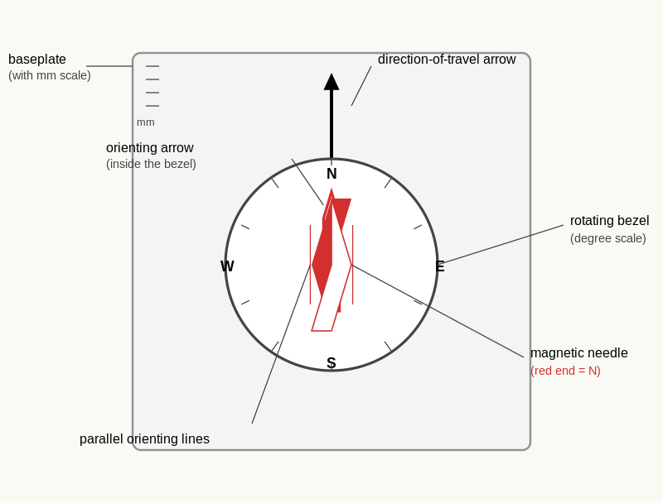
Reference diagram. Compass Anatomy (Labelled). the orienting arrow and the direction-of-travel arrow as the two most-confused parts.
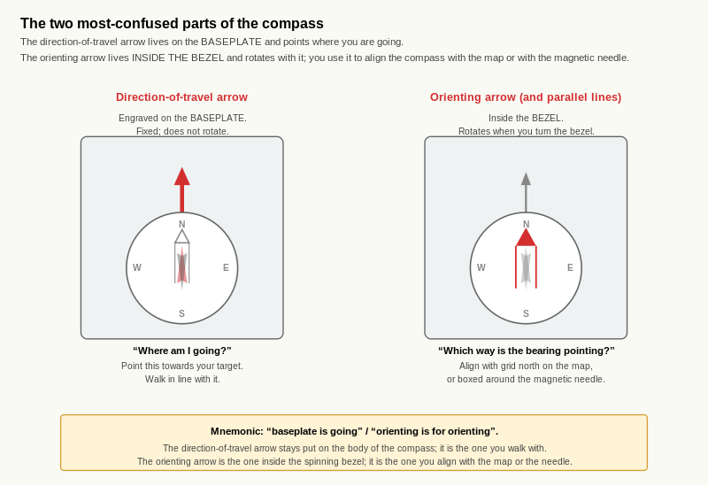
Reference diagram. Two Most-Confused Parts of the Compass. the direction-of-travel arrow is the one you walk with; the orienting arrow is the one you align with grid north on the map or box around the magnetic needle. Confusing the two is the most common cause of 180-degree errors on bearings.

Learning aim
By the end of this page, you should be able to identify the six main parts of a baseplate compass on sight, explain what each part does, and recognise the two parts that are most commonly confused with each other.

Why this matters
The compass is the primary instrument for converting a map bearing into a direction of travel in the field. At IMS / EMS level the candidate is expected to handle the compass without thinking about its parts; the assessor will not pause for the candidate to inspect the instrument before taking a bearing. Familiarity with the parts is the prerequisite for the speed and accuracy that come later.

The six main parts
A baseplate compass is built around six functional parts. Most beginners can name three or four; the assessor will expect all six.
- Baseplate. The flat transparent body of the compass. The edges are usually marked in millimetres or centimetres so the baseplate doubles as a ruler for map work. The baseplate is the working surface that lies on the map when a bearing is taken.
- Direction-of-travel arrow. The arrow printed permanently on the baseplate, pointing forward (away from the user when the compass is held in the standard orientation). This is the arrow that points where you are going.
- Rotating bezel. The dial that turns around the compass body, marked in degrees from 0 to 360. The bezel is what you set to a specific bearing.
- Orienting arrow. The arrow printed on the floor of the rotating bezel (visible through the transparent base). When the bezel is turned, the orienting arrow turns with it. This is the arrow you align with the magnetic needle when walking on a bearing.
- Magnetic needle. The free-floating needle that always points to magnetic north (the red end). The needle is what makes the compass a compass.
- Parallel orienting lines. The lines printed on the floor of the rotating bezel, parallel to the orienting arrow. These are what you align with the grid lines on the map when taking a bearing from the map.
A handful of compasses also include a clinometer (for slope angle measurement) and a sighting mirror (for high-precision bearings on distant features). Both are useful but neither is essential at IMS / EMS level.

The two most-confused parts
The single most common error among new compass users is confusing the direction-of-travel arrow with the orienting arrow. Both are arrows on the same instrument; both point. The distinction matters and is worth memorising:
- The direction-of-travel arrow is on the baseplate and is fixed. It points where you are going.
- The orienting arrow is on the floor of the rotating bezel and turns with the bezel. It is the alignment target for the magnetic needle.
When a bearing is set on the bezel, the direction-of-travel arrow shows the heading and the orienting arrow shows where the magnetic needle should sit. The needle goes into the orienting arrow, like a thumb into a glove. The body then rotates until both align with the direction-of-travel arrow. At that point the compass is set to the bearing and the user faces the right way.
The other common confusion is between the red end and the white end of the magnetic needle. The red end points to magnetic north. A useful mnemonic is red to shed: red points north, where in the northern hemisphere the shed (or any reference object known to be north) sits. Get into the habit of confirming the red end early; on a poorly-lit map at dusk the colour can be hard to read.

Worked example
A candidate picks up a baseplate compass for the first time and is asked to identify the parts. A correct identification names:
- The transparent flat body as the baseplate, with the millimetre scale on its edge.
- The arrow printed permanently on the baseplate (pointing forward) as the direction-of-travel arrow.
- The numbered dial as the rotating bezel, currently set with 0 (north) at the top.
- The arrow inside the dial floor as the orienting arrow.
- The free-floating needle as the magnetic needle, with the red end pointing north (verified by asking which way is north in the room).
- The lines printed inside the dial floor, parallel to the orienting arrow, as the parallel orienting lines.
If the candidate names "the arrow" without specifying which arrow, return them to the orienting-vs-direction-of-travel distinction.

Exercise 1 - Label the compass
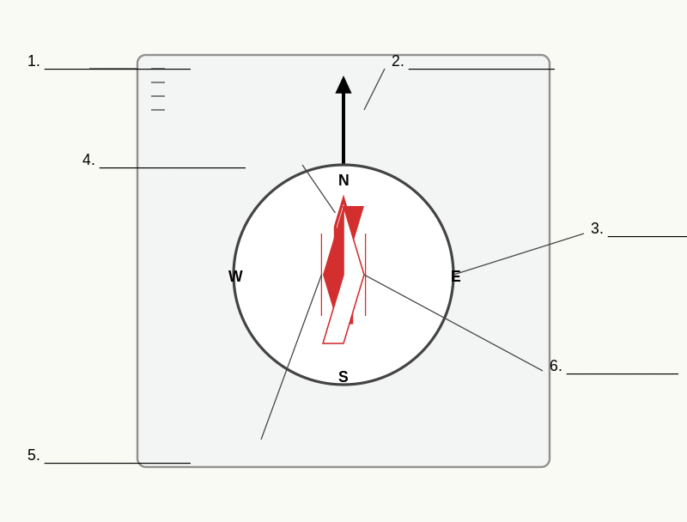
Reference diagram. Compass Anatomy (Unlabelled). answer key is the labelled version above.
Your trainer has provided a labelled diagram of a baseplate compass. The labels have been removed. Re-label all six main parts.
[Diagram space - approximately 12 cm by 8 cm, with the six parts unlabelled]

Exercise 2 - Match each part to its function
Match each part to its function by writing the letter (a to f) next to the part name.
Part | Function letter
Baseplate
Direction-of-travel arrow
Rotating bezel
Orienting arrow
Magnetic needle
Parallel orienting lines
Functions:
- (a) Aligns with the magnetic needle when walking on a bearing.
- (b) The flat working surface that lies on the map; doubles as a ruler.
- (c) Points permanently forward; shows the heading.
- (d) Turns around the body; marked in degrees from 0 to 360.
- (e) Always points to magnetic north (red end).
- (f) Aligns with the grid lines on the map when taking a bearing from the map.

Exercise 3 - The two most-confused parts
In two or three sentences, explain in your own words why the direction-of-travel arrow and the orienting arrow are commonly confused, and what the consequence would be of treating one as the other while taking a bearing.
____________________________________________________ ____________________________________________________

Exercise 4 - Quick check
A compass is placed on a table in front of you. The bezel is set to 90. The magnetic needle is sitting freely.
- Which way does the direction-of-travel arrow point relative to the needle?
- To set the compass to 90 degrees and walk on it, what would you rotate next - the bezel, the body, or the compass position on the table?
- What angular position does the bezel need to show for a bearing of 270 degrees?

Self-check
☐ I can name the six main parts of a baseplate compass on sight.
☐ I can explain what each part does.
☐ I can distinguish the direction-of-travel arrow from the orienting arrow without thinking about it.
☐ I know which end of the magnetic needle points to magnetic north.

Why this matters for IMS
Compass familiarity is the prerequisite for every D2 technique that follows. The assessor expects the candidate to handle the compass fluidly during route narration, position fixing, and poor-visibility navigation. A candidate who fumbles for the orienting arrow under stress sounds untrained. After D1.1 the parts should be invisible: you reach for the compass and set the bearing without thinking about which arrow is which.

D1.2 Reading a Bearing from the Compass

Learning aim
By the end of this page, you should be able to read a bearing in degrees from a set compass to within 2 degrees, hold the compass correctly (flat, away from steel objects), and recognise when the magnetic needle is sluggish or settling rather than reading the figure.

Why this matters
A bearing is only useful if it has been read accurately. The assessor will accept a bearing read within about 2 degrees of the correct value at IMS / EMS level; further than that, errors compound rapidly over the length of a leg. A bearing that is 3 degrees off produces approximately 26 m of lateral drift over a 500 m leg, which is enough to miss a col, a hut, or a critical waypoint.
The reading itself is simple; the discipline around the reading is what makes it reliable.

Reading the bearing
The bearing is shown by the angular position of the direction-of-travel arrow against the bezel scale. To read:
- Hold the compass flat in front of you.
- Identify the line on the bezel that aligns with the direction-of-travel arrow. (Most compasses have a small index mark at this point.)
- Read the bearing in degrees from the bezel scale at that line.
A bearing is always a number between 0 and 360 degrees. Cardinal directions correspond to:
- North: 0 (or 360, equivalently).
- East: 90.
- South: 180.
- West: 270.
Intercardinal directions sit between: NE = 45, SE = 135, SW = 225, NW = 315.
The C4.2 eight-direction aspect vocabulary maps onto these figures directly. A north-facing slope from C4.2 has an aspect bearing of 0 (or 360). A slope falling to the south-east has an aspect bearing of 135.

Holding the compass correctly
Three habits make compass readings reliable:
- Hold the compass flat. A tilted compass floor lets the magnetic needle drag against the bezel, producing slow or sticky readings. Use the back of one hand as a working surface, or rest the compass on a glove or notebook.
- Hold the compass away from steel. Ski bindings, ice axes, mobile phones and radio handsets all create magnetic fields that deflect the needle. Minimum safe distance: 30 cm from a phone or radio; 50 cm from steel objects. (D4.3 covers magnetic interference in detail.)
- Wait for the needle to settle. A freshly-handled compass needle takes several seconds to come to rest. Reading the figure before the needle has stopped moving produces a wrong bearing. In cold conditions, settling can take longer than usual; allow up to 10 seconds in temperatures well below freezing.

Recognising a sluggish needle
A magnetic needle that swings sluggishly, fails to settle, or settles in different positions on repeated readings is telling you something. Three causes worth knowing:
- Cold temperature. Compass damping fluid thickens in cold. Allow extra settling time; if the needle is so sluggish that the compass is unusable, warm it inside a glove for a minute.
- Magnetic interference. A nearby steel or electronic object is deflecting the needle. Move the compass away from the suspect source and re-read; if the bearing changes, the source is confirmed.
- Damaged compass. A compass that has been dropped, sat on, or pierced may have a damaged needle pivot or compromised damping fluid. A compass that no longer settles reliably should be replaced.
The quick-check before any field use is to set a known direction (a building edge, a road, a ridge crest you can see) and confirm the compass agrees. Disagreement is the cue to investigate before the bearing matters.

Worked example
A candidate sets their compass to take a bearing in still air at room temperature. The bezel is rotated until the needle settles inside the orienting arrow. The direction-of-travel arrow now points to the index mark on the bezel.
- The candidate reads the bezel value at the index mark: 142 degrees.
- The candidate cross-checks against a sighting on a wall feature known to be roughly south-east. 142 degrees is consistent with south-east (135 degrees), so the reading is plausible.
- The candidate re-takes the bearing from the same position to confirm it falls within 2 degrees of the first reading: 143 degrees on the second take. Acceptable.
The bearing is recorded as 142 degrees, with the second-take confirmation noted in the candidate's working.

Exercise 1 - Read the bearing
Your trainer has provided three compass photographs, each showing a needle settled inside an orienting arrow on a different bezel setting.
For each photograph, read the bearing in degrees. Write your answer to the nearest degree.
Photograph | Bearing
A
B
C

Exercise 2 - Cardinal cross-check
For each of your three readings from Exercise 1, name the closest cardinal or intercardinal direction (N, NE, E, SE, S, SW, W, NW) and note the angular difference between your reading and that exact cardinal value.
Photograph | Closest cardinal | Angular difference
A
B
C

Exercise 3 - Holding the compass
In two or three sentences, describe in your own words the three habits for holding the compass correctly. For each habit, give one example of what could go wrong if the habit is broken.
____________________________________________________ ____________________________________________________

Exercise 4 - Quick-check drill
Practical drill at home. Set the compass to a bearing that should align with a known direction (for example, east, looking out of an east-facing window).
- Read the bearing the compass shows when the needle is settled and aligned.
- Note the difference (if any) from the expected value.
- Identify any object or condition near the compass that might explain the difference.

Exercise 5 - When the needle is sluggish
In one sentence each, name the three causes of sluggish needle behaviour and the action the candidate should take in each case.

Self-check
☐ I can read a compass bearing in degrees to within 2 degrees of the correct value.
☐ I hold the compass flat and away from steel by habit.
☐ I wait for the needle to settle before reading.
☐ I run a known-direction quick-check before relying on the compass for the day.
☐ I can recognise the three causes of sluggish needle behaviour and respond to each.

Why this matters for IMS
A bearing read within 2 degrees in under 60 seconds is the working standard at IMS / EMS level. The reading discipline (flat, away from steel, settled needle, quick-check) is what produces that standard reliably. After D1.2 the candidate is ready to apply the compass to the map in D2.1, where the bearing is no longer an arbitrary figure but a route-relevant direction between two named points.
These three pages teach a single integrated technique: take a bearing from the map, apply magnetic variation to convert it to a magnetic bearing usable in the field, and walk on it accurately. They are paired in one file because they form a sequence; the bearing taken in D2.1 is the bearing converted in D2.2 and walked in D2.3. A candidate who is fluent on all three has the foundational compass-and-map technique that all subsequent Level 3 work builds on.

D2.1 Taking a Bearing from the Map
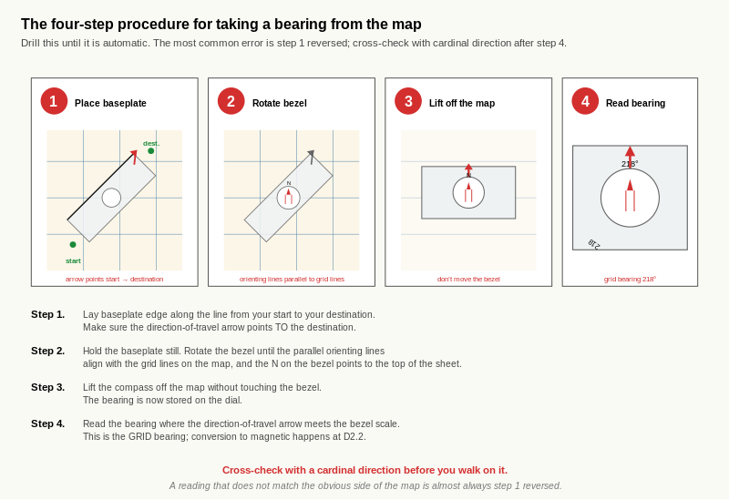
Reference diagram. Four-Step Procedure for a Map Bearing. step 1 reversed is the most common error and produces a bearing 180 degrees off. The cardinal cross-check in step 4 catches it before it becomes a leg in the field.

Learning aim
By the end of this page, you should be able to take a grid bearing accurately from a 1:25,000 alpine map between two named points using the four-step procedure, and you should be able to write that bearing on a route-card-style entry within 60 seconds.

Why this matters
A bearing taken from the map is the route-card backbone of every poor-visibility leg you will ever walk or ski. The IMS / EMS assessor expects every leg of the day to have a written bearing on the route card before departure. The map bearing is what converts a planned line on the map into a heading you can hold in the field.
The four-step procedure is not difficult, but it has to be drilled until it is automatic. A candidate who has to stop and think about which arrow goes where during a route briefing has not yet internalised it.

The four-step procedure
Take the compass and lay it on the map. Then:
- Place the baseplate edge along the line from your start point to your destination. The direction-of-travel arrow must point from start to destination, not the other way. This step alone is the most common error: a baseplate placed correctly but with the direction-of-travel arrow pointing the wrong way produces a bearing that is exactly 180 degrees wrong.
- Rotate the bezel until the parallel orienting lines are aligned with the grid lines on the map, with the orienting arrow (and the N on the bezel) pointing to the top of the map (which is grid north on most alpine sheets). The compass body itself does not move; only the bezel rotates.
- Take the compass off the map. The bearing is now set on the bezel.
- Read the bearing from the direction-of-travel arrow against the bezel scale. This is the grid bearing from your start point to your destination.
The bearing read at step 4 is a grid bearing, not yet a magnetic bearing. D2.2 covers the conversion to magnetic. D2.3 covers walking on it.

Worked example
A candidate plans a leg from a col at 2,720 m to a hut at 2,450 m on a 1:25,000 alpine sheet. Working through the procedure:
- Place the baseplate edge along the line from the col (start) to the hut (destination). Direction-of-travel arrow points towards the hut.
- Rotate the bezel until the parallel orienting lines align with the grid lines on the sheet. N on the bezel points to the top of the map.
- Take the compass off the map.
- Read the bearing: 218 degrees.
The leg's grid bearing is 218 degrees. Cross-check: 218 degrees is south-south-west. The hut sits to the south-west of the col on the sheet, which is consistent. The bearing is plausible.
The bearing is recorded on the route card as "Grid bearing 218 degrees". The conversion to magnetic happens in D2.2.

Exercise 1 - Take five bearings
On the Section D2.1 map extract (provided by your trainer; 1:25,000, 10 m contours), five legs are pre-drawn between named features.
For each leg, take the grid bearing using the four-step procedure. Write the bearing in the table below.
Leg | From | To | Grid bearing
1
2
3
4
5

Exercise 2 - Cardinal cross-check
For each of the five bearings from Exercise 1, name the closest cardinal or intercardinal direction (N, NE, E, SE, S, SW, W, NW). The cross-check is the discipline that catches the 180-degree error early.
Leg | Grid bearing | Closest cardinal
1
2
3
4
5

Exercise 3 - Diagnose the error
A candidate takes a bearing from a col at the top of a slope down to a hut at the bottom, and reads 042 degrees. Looking at the map, the hut is clearly to the south-west of the col.
- Is the bearing correct?
- If not, what is the most likely error?
- What is the correct bearing?

Exercise 4 - Speed drill
Take three more bearings on the same Section D2.1 extract under time pressure. The target is 60 seconds per bearing.
Leg | Grid bearing | Time taken
6
7
8

Self-check
☐ I can take a grid bearing from a 1:25,000 alpine map using the four-step procedure.
☐ I always check that the direction-of-travel arrow points from start to destination, not the reverse.
☐ I cross-check every bearing against the closest cardinal direction.
☐ I can take a bearing in under 60 seconds with practice.

Why this matters for IMS
The map-bearing skill is the foundation of every route card and every poor-visibility navigation leg. The 60-seconds-per-bearing speed is the working standard for completing a six-leg route card inside the 20 minutes the IMS Nav Training Programme assessment-checklist allows. The cardinal cross-check is the safety net against the 180-degree error, which is the most common compass error and the most consequential.

D2.2 The Three Norths Revisited and Magnetic Variation
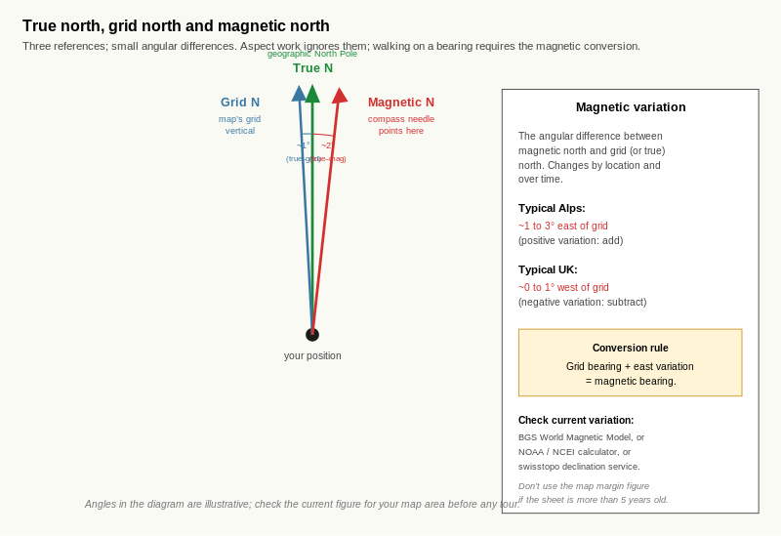
Reference diagram. True, Grid and Magnetic North. angles in the schematic are illustrative; the actual current variation must be looked up from BGS, NOAA / NCEI, or swisstopo. In the Alps east variation is added to the grid bearing; in the UK west variation is subtracted.

Learning aim
By the end of this page, you should be able to distinguish the three norths (true, grid and magnetic), explain magnetic variation, look up the current variation for your map area and date using a recognised official source, and convert a grid bearing into a magnetic bearing for use in the field.

Why this matters
A grid bearing taken from the map and a magnetic bearing read on the compass in the field are not the same number. The difference is magnetic variation, which depends on where you are and when. A candidate who walks on a grid bearing without applying the variation will drift off the intended line; the further they go, the more they drift.
For aspect reading at C4.2 the variation was small enough to ignore. For walking on a bearing, it is not. The IMS / EMS assessor expects every leg's bearing on the route card to have variation applied correctly, with the variation figure documented.

The three norths
Three different "norths" exist on a map and in the field:
- True north. The geographic North Pole. The fixed astronomical reference. Lines of longitude meet at true north.
- Grid north. The "up" direction of the map's grid lines. On most alpine 1:25,000 sheets, grid north is within a degree of true north and the difference can be ignored at IMS / EMS resolution.
- Magnetic north. Where a compass needle points. The location of the magnetic north pole drifts over time and currently sits in the Canadian Arctic. The angular difference between magnetic north and grid (or true) north is the magnetic variation.
For practical IMS / EMS work:
- Aspect reading uses grid north (per C4.2). The eight-direction resolution makes the variation negligible.
- Walking on a bearing requires the conversion to magnetic. The 1- to 3-degree variation typical in the Alps is enough to matter on a leg of more than a few hundred metres.

Looking up current variation
Magnetic variation changes by location and over time. The workbook does not bake in a fixed figure because the figure that was correct in the map margin three years ago may be wrong this year.
Three official sources for current variation:
- British Geological Survey (BGS) World Magnetic Model calculator. The standard UK source. Enter coordinates and date; returns variation. URL in `00_Research_Inputs/Sources.md`.
- NOAA / NCEI declination calculator. The standard US source, equivalent precision.
- swisstopo magnetic declination geoservice. The standard Swiss source, particularly convenient for European Alps work.
The map margin will also show a variation figure with a date and an annual rate of change. If the map is recent (within five years), the margin figure is usable. If the map is older or the candidate is uncertain, look up the current value online before the tour.
For the worked examples below, a variation of +2 degrees east is used. This figure is illustrative; check current variation for your map area and date using one of the sources above.

Converting grid to magnetic
The conversion rule depends on whether the variation is east or west of grid north:
- Variation is east (positive, common in the Alps): add the variation to the grid bearing to get the magnetic bearing.
- Variation is west (negative, common in the UK): subtract the variation from the grid bearing to get the magnetic bearing.
Two mnemonics that some candidates find useful:
- "Grid to mag, add" (when variation is east). "Mag to grid, get rid" (subtract when going the other way).
- More general: "the magnetic needle leans towards the variation, so the magnetic bearing leans the same way relative to grid".
Both work. Pick one and stick with it. The key is to apply the conversion automatically, not to derive it from first principles each time.

Worked example
A candidate has taken five grid bearings from D2.1. The current magnetic variation for the map area and date is +2 degrees east (verified using the BGS WMM calculator).
Leg | Grid bearing | Variation | Magnetic bearing
1 | 218 | +2E | 220
2 | 045 | +2E | 047
3 | 312 | +2E | 314
4 | 178 | +2E | 180
5 | 003 | +2E | 005
Note that on leg 1 the magnetic bearing of 220 degrees would be set on the compass bezel and walked. The grid bearing of 218 stays on the route card as the original figure; the magnetic bearing is what the candidate uses in the field.

Exercise 1 - Look up the variation
For the map area you are working with, look up the current magnetic variation using one of the three official sources (BGS WMM, NOAA / NCEI, or swisstopo).
- Source used:
- Coordinates entered:
- Date entered:
- Magnetic variation returned (degrees east or west):

Exercise 2 - Convert grid to magnetic
For the five grid bearings you took in D2.1 Exercise 1, apply the variation from D2.2 Exercise 1 to convert each to a magnetic bearing.
Leg | Grid bearing (D2.1) | Variation (D2.2 Ex 1) | Magnetic bearing
1
2
3
4
5

Exercise 3 - Reflect on the consequence
In two or three sentences, calculate or estimate the lateral drift you would experience over a 1,500 m leg if you walked on the grid bearing without applying the variation. Use the variation figure from Exercise 1.
(Reference figure: at a typical Alpine variation of around 2 degrees, the lateral drift over 1,500 m would be approximately 1,500 m times the tangent of 2 degrees, which is approximately 52 m. Adjust for the actual variation you looked up.)
____________________________________________________ ____________________________________________________

Exercise 4 - Variation in different parts of the world
The variation is not the same everywhere. Look up (or recall) typical variation for two of the following:
Location | Approximate variation
Scottish Highlands (UK)
French Alps
Swiss Alps
Pacific Northwest (Cascades, US)
Southern Alps (New Zealand)
In one sentence, explain why a candidate using the workbook in a non-Alpine location must look up the variation rather than assume the Alpine figure.

Self-check
☐ I can name the three norths and explain how each differs.
☐ I can look up current magnetic variation for any location and date using BGS WMM, NOAA / NCEI, or swisstopo.
☐ I can convert a grid bearing to a magnetic bearing using the right addition or subtraction rule for the local variation.
☐ I record both the grid bearing and the magnetic bearing on my route card.
☐ I do not bake a fixed variation into my workbook practice; I look it up for the date and area.

Why this matters for IMS
The variation conversion is one of the most assessable habits in the IMS / EMS skill set: small, repeated, easy to skip under pressure, and consequential when skipped. The candidate who applies it automatically and documents it on the route card has built one of the foundational instructor habits.

D2.3 Walking on a Bearing
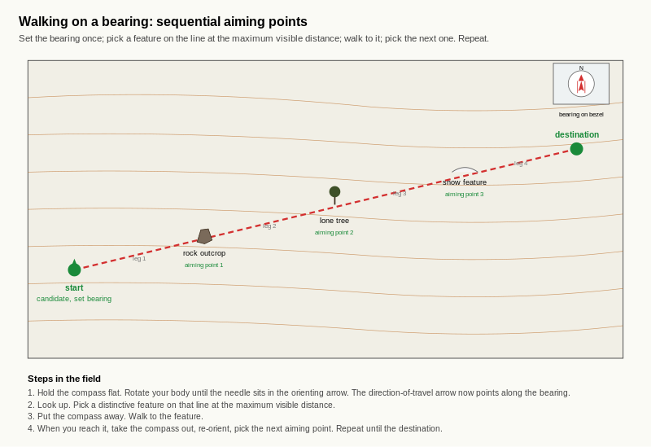
Reference diagram. Walking on a Bearing with Aiming Points. the candidate's body tracks the eyes, so the eyes go on a feature, not on the compass. Each leg ends at a distinctive, stable feature; the bearing is reset before the next leg.

Learning aim
By the end of this page, you should be able to walk on a magnetic bearing in the field accurately, using intermediate aiming points, with a working drift target of less than 15 m per 100 m of travel.

Why this matters
A bearing taken from the map and converted to magnetic is only useful if the candidate can hold it on the ground. The walking technique is what turns the bearing on the bezel into a route. Two habits make the technique reliable; without them, even an accurate bearing produces drift.
For an IMS / EMS candidate, the working accuracy target is 15 m of lateral drift per 100 m of travel. A 500 m leg should land within 75 m of the intended point. Better is achievable with practice; worse than this and the bearing was effectively useless.

Holding the bearing
To walk on a magnetic bearing already set on the compass:
- Hold the compass flat in front of you, at chest or waist height.
- Rotate your whole body until the magnetic needle sits inside the orienting arrow on the bezel.
- Read the direction the direction-of-travel arrow now points in the field.
- Identify a feature (a rock, a tree, a snow feature, a cloud break) at the maximum visible distance in that direction.
- Put the compass away.
- Walk to that feature.
- Repeat from step 1.
The "intermediate aiming point" technique is the single most important habit on this page. Walking with the eyes on the compass is unreliable because the body drifts whenever the eyes leave the path. Walking with the eyes on a fixed feature ahead is reliable because the body tracks the target naturally.

Picking the aiming point
A good aiming point is:
- on the bearing,
- at the maximum visible distance,
- distinctive enough to recognise on approach (not "that grey rock among many grey rocks"),
- and stable (a cloud break is a poor aiming point because it moves; a rock is a good one because it does not).
In open snow with no features, the candidate's options are reduced. Two backup strategies:
- A partner sent forward on the bearing as a moving aiming point. Useful in poor visibility (and is the basis of the pole-and-cord technique covered in D8.2).
- Tracks in the snow if the candidate is following a known line; not always available, and not always reliable in fresh snow or wind.

Common drift causes
Three causes of drift are worth recognising:
- Tilted compass. A compass held off-flat lets the needle drag against the bezel and produces a wrong reading. Hold flat.
- Body off-axis. A candidate who reads the compass correctly but turns at the moment of stepping forward will drift. The body should square up before walking.
- Leaning into the slope. On a side-slope the candidate naturally leans uphill, which rotates the compass against the slope and shifts the needle. Hold the compass square to the horizontal, not square to the slope.

Worked example
A candidate sets a magnetic bearing of 220 degrees on the compass (from D2.2 worked example, leg 1). On the ground at the col:
- Holds compass flat at waist height.
- Rotates body until the needle sits inside the orienting arrow.
- Identifies a rock outcrop on the slope ahead at approximately 200 m distance, on the bearing.
- Puts the compass away.
- Walks to the rock outcrop.
- At the rock, takes out the compass again.
- Re-takes the bearing using the same procedure; identifies a new aiming point a further 200 m along the bearing.
- Continues.
The candidate arrives at the planned destination (the hut at 2,450 m) approximately 30 m east of the intended point on a 1,500 m leg. Lateral drift: 30 m / 1,500 m = 2 percent, or approximately 2 m per 100 m. Well inside the 15 m per 100 m target.

Exercise 1 - Practical drill in any open space
In any open space (a park, a beach, a flat field) at home, with a partner if possible:
- Set a magnetic bearing on the compass (any bearing; for variety, use a bearing that is not a cardinal direction).
- Mark your starting point.
- Pick an aiming point at maximum visible distance on the bearing.
- Walk 100 paces along the bearing using the intermediate-aiming-point technique.
- Mark your end point.
- With your partner (or by re-tracing), measure the lateral drift from the intended line.
Record:
- Starting bearing:
- Number of paces: 100
- Intended distance covered (estimate using your pace length):
- Lateral drift from the intended line (metres):
- Drift expressed as metres per 100 m:

Exercise 2 - Repeat with a deliberate offset
Repeat Exercise 1, but this time set the compass bezel deliberately 5 degrees off the intended bearing. Walk 100 paces.
- Lateral drift this time:
- Difference from Exercise 1:
- Reflect: was the drift you measured consistent with what 5 degrees would predict over the distance walked? (The trigonometric prediction is approximately tan(5 degrees) times the distance, or about 8.7 m per 100 m.)

Exercise 3 - Diagnose the drift
If your Exercise 1 drift was outside the 15 m per 100 m target, work through the three common causes and identify which is the most likely culprit.
Cause | Was this present in your drill? | Likely culprit?
Tilted compass
Body off-axis
Leaning into a slope
Other (name it)

Exercise 4 - The intermediate aiming point
In two or three sentences, explain in your own words why walking with the eyes on a fixed feature ahead is more reliable than walking with the eyes on the compass.
____________________________________________________ ____________________________________________________

Exercise 5 - When there is no aiming point
In one or two sentences each, describe the two backup strategies for walking on a bearing when no fixed aiming point is visible.

Self-check
☐ I can hold a compass flat and rotate my body to align the needle with the orienting arrow.
☐ I pick a distinctive, stable aiming point at maximum visible distance and walk to it.
☐ I do not walk with my eyes on the compass.
☐ I can recognise the three common causes of drift and adjust for each.
☐ My typical drift on a 100 m leg is inside the 15 m per 100 m target.

Why this matters for IMS
The 15 m per 100 m drift target is the working standard for IMS / EMS poor-visibility navigation. A candidate who can hold a bearing to that accuracy can navigate to a col, a hut, or a known waypoint in flat light. The intermediate-aiming-point technique is what the assessor will watch for during route narration; a candidate who walks with eyes on the compass loses points even if they happen to land in the right place.
After D2.3 the candidate has the integrated technique: take the bearing from the map (D2.1), convert it to magnetic (D2.2), walk on it (D2.3). The remaining D3 and D4 pages refine this with on-the-ground bearings, back bearings, resection, bearing shapes drills, and aiming off.
These three pages teach the inverse direction of the D2 work. In D2 the candidate took bearings from the map and applied them in the field. In D3 the candidate takes bearings from the field (looking at visible features) and applies them to the map. Together D2 and D3 give the candidate the full map-and-field bearing skill set.
D3.1 is the foundational technique (taking a bearing to a feature). D3.2 covers back bearings as a confirmation tool. D3.3 covers resection, the two-feature position fix that requires good visibility.

D3.1 Taking a Bearing to a Feature

Learning aim
By the end of this page, you should be able to take a magnetic bearing in the field from your current position to any visible feature, convert it to a grid bearing using magnetic variation, and use that grid bearing to identify the feature on the map.

Why this matters
Taking a bearing to a feature is the inverse of taking a bearing from the map. It is what the candidate does when:
- standing at a known position and trying to identify an unfamiliar feature on the skyline,
- confirming that a visible feature is the one they expected from the route card,
- or providing the inputs to a resection (D3.3) for a position fix.
For an IMS / EMS candidate, this is the field-side complement of the route-card preparation skill. The route card has the bearing on it before the day; the field check has the bearing taken on the day.

The procedure
Standing on the ground, looking at the feature:
- Hold the compass flat in front of you.
- Point the direction-of-travel arrow at the feature. Sight along the baseplate edge and align the arrow with the feature.
- Rotate the bezel until the orienting arrow aligns with the magnetic needle. The needle goes into the orienting arrow; the bezel rotates around it.
- Read the bearing from the direction-of-travel arrow against the bezel scale. This is the magnetic bearing from your position to the feature.
To convert this magnetic bearing to a grid bearing for use on the map, apply the variation in the opposite direction from D2.2:
- Variation is east: subtract the variation from the magnetic bearing to get the grid bearing.
- Variation is west: add the variation to the magnetic bearing to get the grid bearing.
The mnemonic from D2.2 ("grid to mag, add" when east) reverses for the inverse direction ("mag to grid, get rid" when east means subtract).

Common error: parallax
The single most common D3.1 error is parallax: the candidate's eye is not aligned with the feature when they sight along the baseplate edge. The result is a bearing that is several degrees off, with no obvious cause.
The fix is a sighting habit: hold the compass at chest height with both hands, square to the body, and look along the baseplate edge with one eye closed. A sighting compass (with a built-in mirror) makes this easier but is not essential.

Worked example
A candidate stands at a col at 2,720 m on a 1:25,000 alpine sheet. A distinctive rock outcrop is visible to the south-west. The current magnetic variation for the area is +2 degrees east (verified using BGS WMM).
Working through the procedure:
- Holds the compass flat, points the direction-of-travel arrow at the rock outcrop.
- Rotates the bezel until the orienting arrow is aligned with the magnetic needle.
- Reads the magnetic bearing: 222 degrees.
- Converts to grid: 222 - 2 = 220 degrees grid bearing from the col to the rock outcrop.
The candidate then takes the compass to the map. Placing the baseplate edge from the col with the direction-of-travel arrow on the 220 grid bearing, the rock outcrop on the map should lie along that line. Confirms: yes, a rock outcrop is marked on the map at approximately 1.4 km from the col on the 220 line.
The unidentified feature on the skyline is now identified.

Exercise 1 - Take three field bearings
Practical drill. At any high point with a clear view (ideally three or more identifiable features visible), take a magnetic bearing to each.
Feature | Magnetic bearing | Variation | Grid bearing
1
2
3

Exercise 2 - Identify the feature on the map
For each of the three features from Exercise 1, use the grid bearing and your current position on the map to identify the feature.
Feature | Identified on map as
1
2
3

Exercise 3 - When more than one feature lies on the bearing
For one of the three features from Exercise 1, look along the same grid bearing on the map and note any other feature that also lies on that line, beyond or short of the one you identified.
- Other feature on the line:
- How would you distinguish the intended feature from this other one in the field?

Exercise 4 - Diagnose the parallax error
A candidate takes a bearing to a distinctive summit and reads 087 magnetic. The candidate then walks 50 m to the side and re-takes the bearing to the same summit. The new reading is 092 magnetic.
- Has the bearing genuinely changed?
- What is the most likely cause of the discrepancy?
- What would you do differently to avoid the error?

Self-check
☐ I can take a magnetic bearing to a visible feature using the four-step ground procedure.
☐ I can convert magnetic to grid using the right rule for my local variation.
☐ I can use the grid bearing and my current position to identify a feature on the map.
☐ I recognise the parallax error and use a sighting habit to avoid it.
☐ I can distinguish two features on the same bearing line.

Why this matters for IMS
Field-bearing reading is the IMS / EMS-relevant skill for confirming that visible features match the route card. The assessor may point at a distant ridge and ask the candidate to identify it; a candidate who can take a bearing, convert to grid, and identify on the map within a minute is at the working standard. After D3.1 the candidate has the inverse-of-D2 technique; D3.2 adds back bearings as a sanity check.

D3.2 Back Bearings

Learning aim
By the end of this page, you should be able to convert any forward bearing into a back bearing (forward bearing plus or minus 180 degrees), use back bearings to confirm direction or to relocate from a known feature behind you, and recognise the IMS / EMS use of back bearings as a routine sanity check in poor visibility.

Why this matters
A back bearing is the bearing from where you are now back to where you came from. If your forward bearing was correct and you have walked it correctly, the back bearing should align with your starting feature. If it does not, you have drifted.
Back bearings are useful in three IMS / EMS-relevant ways:
- Confirming direction. Take a back bearing every five to ten minutes in poor visibility; if the back bearing aligns with where you came from, you are still on the line.
- Relocating using a known feature behind you. When the feature ahead is invisible, the feature behind may not be; take a bearing to it and apply the back-bearing rule.
- Confirming you have not drifted. A simple sanity check that takes 30 seconds and catches a slow drift before it becomes a long one.

The 180-degree rule
A back bearing is the forward bearing plus or minus 180 degrees:
- If the forward bearing is less than 180 degrees, add 180 to get the back bearing.
- If the forward bearing is 180 or more, subtract 180 to get the back bearing.
The rule keeps the back bearing in the 0 to 360 range. Both add-180 and subtract-180 produce mathematically equivalent results; the rule above is just the cleaner way to express it.
The rule applies equally to grid bearings and to magnetic bearings, as long as you do not mix them. A grid forward bearing produces a grid back bearing; a magnetic forward bearing produces a magnetic back bearing.

Worked example
A candidate has set off on a leg from a col with a magnetic bearing of 220 degrees (from the D3.1 worked example). After 200 m of walking, they stop to confirm direction.
The back bearing from their current position to the col is:
- forward bearing 220 is greater than 180, so subtract 180 to get back bearing.
- 220 - 180 = 040 degrees magnetic.
The candidate turns around (mentally; they do not need to physically face the col), takes a magnetic bearing to the col itself, and reads 041 degrees. Within 2 degrees of the predicted 040; they have not drifted.
If the candidate had read, for example, 055 magnetic, that would tell them they had drifted approximately 15 degrees off the intended line. At that point they would take a corrective heading rather than continuing on the original 220 forward bearing.

Exercise 1 - Convert forward to back
For each forward bearing, calculate the back bearing.
Forward bearing | Back bearing
045
090
178
220
312
003

Exercise 2 - Practical drill
Practical drill. From a marked starting point in any open space, set a forward bearing on the compass and walk 200 paces along it. Stop, calculate the back bearing, and take a back bearing to the starting feature.
- Forward bearing set:
- Calculated back bearing:
- Actual back bearing read to the starting feature:
- Difference (degrees):
- Approximate lateral drift implied (use the D2.3 angular-to-linear relationship): __________ m

Exercise 3 - The poor-visibility sanity check
In two or three sentences, explain in your own words why an IMS / EMS candidate would take a back bearing every five to ten minutes in poor visibility, and what action they would take if the back bearing did not align with where they came from.
____________________________________________________ ____________________________________________________

Exercise 4 - Back bearing for relocation
A candidate is uncertain of position on a broad slope in flat light. The col they came from is still visible behind them as a dark notch on the skyline.
- What bearing would they take to the col? __________ (forward to a feature behind = same as a back bearing relative to their original direction of travel)
- How would they use this bearing to confirm or correct their position?
- Why is this approach more reliable than estimating distance walked from the col?

Self-check
☐ I can calculate any back bearing from a forward bearing using the plus-or-minus 180-degree rule.
☐ I can take a back bearing in the field to a visible feature behind me.
☐ I use back bearings as a routine direction check in poor visibility.
☐ I can use a back bearing to relocate from a known feature behind me.

Why this matters for IMS
The back-bearing sanity check is the IMS / EMS-relevant habit for poor-visibility navigation. A candidate who takes back bearings every five to ten minutes is the candidate who catches drift early and corrects before it becomes a problem. The skill is small but the habit is what counts; the assessor will watch for it during route narration in flat light or whiteout simulation.

D3.3 Resection (Position Fix from Two Visible Features)

Learning aim
By the end of this page, you should be able to fix your position on the map by taking compass bearings to two identifiable features, plotting the back bearings on the map, and reading the position where the lines cross. You should also be able to explain why resection works only in good visibility and what alternatives exist for poor-visibility relocation.

Why this matters
Resection is the standard map-and-compass position fix when the candidate is uncertain of where they are but can see at least two named features. It is taught at every level of mountain navigation from Mountain Leader to BASI EMS.
The IMS / EMS candidate is expected to know resection and to perform it accurately in good visibility. It is not the primary alpine relocation technique because alpine poor visibility makes the two-features-visible condition hard to meet; for poor-visibility relocation, the aspect-of-slope technique (D7.2) is the alpine-specific alternative. Both are part of the toolkit.

The four-step procedure
Standing in an unknown position with two identifiable features visible on the ground and the map:
- Take a compass bearing to feature A using the D3.1 ground procedure. Convert from magnetic to grid.
- Take a compass bearing to feature B, also using the D3.1 procedure. Convert from magnetic to grid.
- Calculate back bearings for both using the D3.2 plus-or-minus 180-degree rule.
- Plot each back bearing on the map as a line drawn from the corresponding feature, using the compass baseplate as a straight edge:
- Place the baseplate edge against the feature on the map.
- Rotate the bezel until the back bearing reads at the index mark.
- Rotate the whole compass (with the bezel held) until the parallel orienting lines align with the map's grid lines.
- Draw a line from the feature along the baseplate edge, in the direction the back bearing points.
The two lines drawn from features A and B will cross at a single point. That point is your position.

Why two bearings, not one
A single bearing tells you that your position is somewhere along a line; it does not tell you where on the line. Two bearings produce two lines, and where they cross is the unique point that satisfies both bearings. That point is your position.
For best accuracy:
- The two features should be roughly 90 degrees apart as seen from your position. Two features at 90 degrees produce lines that cross at a sharp angle, giving a clean fix. Two features close together (or close to opposite each other) produce lines that cross at a shallow angle, and small bearing errors translate into large position errors.
- The two features should be clearly identified on both the ground and the map. A feature you cannot uniquely identify on the map cannot be used.
A third bearing (to a third feature) produces three lines that should cross at the same point. They almost never do exactly; instead they form a small triangle (a "cocked hat") whose centre is the best estimate of position. A cocked hat with sides longer than about 100 m at 1:25,000 indicates a bearing error worth investigating.

Why resection fails in poor visibility
Resection requires the candidate to see at least two features at known positions. In poor visibility (whiteout, fog, low cloud) this condition rarely holds:
- A single visible feature is not enough.
- Three features visible in fog at unknown distances may be hard to identify on the map.
- Local visibility (a rock at 50 m) does not produce features identifiable on a 1:25,000 map.
The alpine relocation technique for poor visibility is the aspect-of-slope relocation (D7.2), which uses the slope itself as one of the position references and the altimeter as the second. It substitutes the unavailable second feature with two pieces of information that are always available on a slope (its aspect and the candidate's altitude).

Worked example
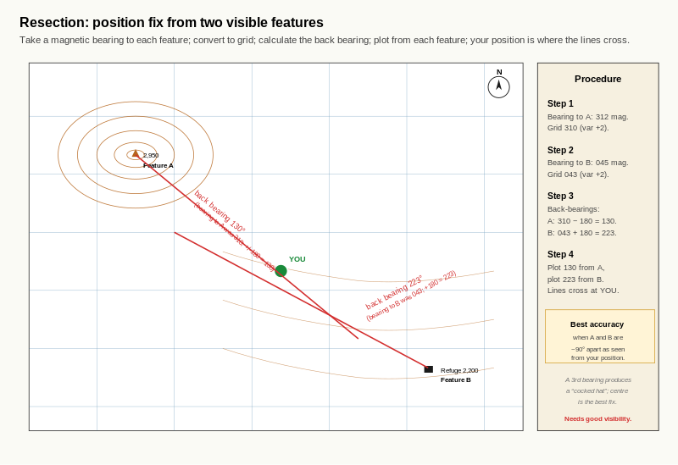
Reference diagram. Resection Plot Worked Example. the lines cross at a single point; the angle of crossing is sharpest when the two features are about 90 degrees apart. The procedure works only when at least two map-identifiable features are visible on the ground.
A candidate is uncertain of position on a broad upper slope. Two features are clearly visible:
- Feature A: a sharp rock summit at 2,950 m, identified on the map by its spot height.
- Feature B: a hut at 2,200 m in the valley below, identified on the map by its symbol and label.
Working through the procedure:
- Bearing to A: 312 magnetic. Variation +2 east. Grid bearing = 310.
- Bearing to B: 045 magnetic. Variation +2 east. Grid bearing = 043.
- Back bearings: A back = 310 - 180 = 130. B back = 043 + 180 = 223.
- Plot back bearing 130 from feature A on the map; plot back bearing 223 from feature B on the map. The two lines cross at approximately 2,500 m on the upper east-facing slope.
The candidate's position is at the intersection. Cross-check: the contour at the intersection reads 2,500 m, which the altimeter (set at the morning's reference point) confirms within 20 m.

Exercise 1 - Plot a back bearing
For practice on the map, take the worked-example back bearing 130 from a named feature on the Section D3.3 map extract. Draw the line on the extract using the compass baseplate as a straight edge.
- Feature you used:
- Length of line drawn:
- Cross-checking the line: does it pass through the kind of terrain you would expect?

Exercise 2 - Practical resection
Practical drill. From a known position with at least two named features visible:
- Identify two features visible on both the ground and the map: ____________________ and
- Take magnetic bearings to each: __________ and
- Convert to grid bearings: __________ and
- Calculate back bearings: __________ and
- Plot the back bearings on the map.
- Where do the lines cross?
- How does this compare with your known position?

Exercise 3 - The 90-degree rule
In two or three sentences, explain in your own words why two features roughly 90 degrees apart from your position give a more accurate resection than two features close together.
____________________________________________________ ____________________________________________________

Exercise 4 - When resection does not work
For each of the following scenarios, state whether resection is a viable position-fix technique. If not, name the alpine-specific alternative covered in D7.2.
Scenario | Resection viable? | Alternative if not
Clear day, summit visible to the north and hut visible to the east | Yes | n/a
Whiteout on a broad slope; no features visible beyond 30 m
Flat light; one ridge visible to the south but no second feature
Clear day on a wide plateau; nearest features all on the same skyline 5 km away

Self-check
☐ I can take two compass bearings to identifiable features and convert them to grid back bearings.
☐ I can plot back bearings on a map using the compass baseplate as a straight edge.
☐ I can read my position from the intersection of two plotted lines.
☐ I know that two features roughly 90 degrees apart give the most accurate resection.
☐ I recognise the conditions in which resection does not work and know that aspect-of-slope relocation is the alpine alternative.

Why this matters for IMS
Resection is a foundational map-and-compass skill expected at IMS / EMS level and is consistent with Mountain Leader and Mountaineering Scotland's published guidance. The IMS / EMS-specific point is the recognition of when resection fails and the readiness to switch to aspect-of-slope relocation (D7.2). A candidate who knows both techniques and can choose between them is at the working assessment standard.
After D3.3 the candidate has the full bearings-from-the-ground skill set. D4 covers practical accuracy: the bearing shapes drill, aiming off, and magnetic interference.
These three pages refine the practical accuracy of compass-and-bearing work. D4.1 is a calibration drill that tells the candidate how accurate they actually are. D4.2 is the aiming-off technique that makes a small bearing error work in your favour. D4.3 is instrument hygiene: the magnetic interference sources that quietly degrade compass readings if not managed.
Together D2, D3 and D4 close out the compass section of Level 3. After D4 the candidate has a fully drilled compass-and-bearing skill set; D5 introduces the altimeter as the second instrument.

D4.1 Bearing Shapes Drill
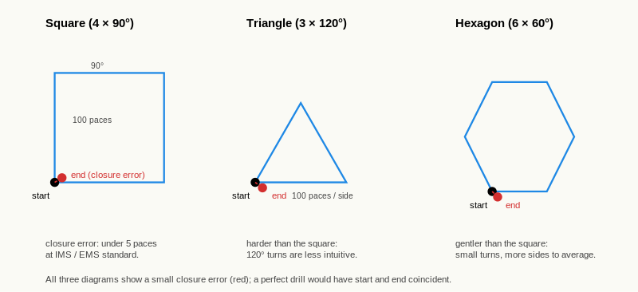
Reference diagram. Bearing-Shapes Drill. each shape closes back to the starting point if compass and pacing are accurate.

Learning aim
By the end of this page, you should be able to walk closed shapes (square, triangle, hexagon) using compass bearings only, measure your closure error, and use that error to assess your practical compass-and-pacing accuracy. You should also be able to interpret the closure error in terms of the IMS / EMS 15-m-per-100-m drift target from D2.3.

Why this matters
A closed shape walked on bearings is a self-test. If the candidate's compass and pacing are accurate, the shape closes back on the starting point. The gap between where the candidate finishes and where they started is the closure error: the cumulative effect of every bearing inaccuracy and every pacing inconsistency over the four (or three, or six) sides.
For an IMS / EMS candidate, the bearing-shapes drill is the calibration tool. It gives a single number (closure error) that can be tracked across sessions. A candidate whose closure error is improving is becoming more accurate; a candidate whose closure error is stuck has a habit to fix.

The square drill
The standard drill is a square: four sides of 100 paces each, with 90-degree turns at each corner.
Procedure:
- Mark a starting point.
- Set any bearing on the compass (for variety, use a bearing that is not a cardinal direction, for example 137 degrees).
- Walk 100 paces along that bearing using the D2.3 walking technique.
- At the corner, add 90 degrees to the bezel (137 + 90 = 227).
- Walk 100 paces along the new bearing.
- Repeat steps 4 and 5 twice more (227 + 90 = 317; 317 + 90 = 047 or equivalently 047, the original bearing minus 90 since 137 - 90 = 047 wraps).
- After the fourth side, you should be back at the starting point.
Measure the closure error: the distance from the actual end point to the starting point.

Standards for closure error
For 100-pace sides on a square (about 70 to 100 m of ground):
- Less than 5 paces of closure error indicates excellent practical accuracy. The candidate is at IMS / EMS working standard.
- 5 to 10 paces indicates good accuracy. Identify which leg contributed most to the error and refine.
- 10 to 20 paces indicates a habit to fix. Run the diagnostic from D2.3 (tilted compass, body off-axis, leaning into slope) and re-attempt.
- More than 20 paces indicates a bearing or pacing problem. Recycle D1.2 (compass holding) and D2.3 (walking technique) before trying again.
A pace is the distance covered by one foot in normal walking. Pace length varies by candidate (typically 70 to 90 cm for adults). A candidate's pace length should be calibrated separately by walking a known 100 m and counting paces; the figure is then used to convert pace counts into metres.

The triangle and hexagon drills
The square drill uses 90-degree turns. The triangle uses 120-degree turns (3 × 120 = 360); the hexagon uses 60-degree turns (6 × 60 = 360). Each is a different turning rhythm and a different test.
For the triangle:
- Three sides of 100 paces.
- Turn 120 degrees at each corner.
- Should close on the starting point.
For the hexagon:
- Six sides of 100 paces.
- Turn 60 degrees at each corner.
- Should close on the starting point.
The triangle is the harder drill because the 120-degree turn is less intuitive than 90 degrees and small errors compound faster over fewer, longer-feeling legs. The hexagon is the gentler drill because each turn is small and there are more legs to average over. Run all three to see which turn rhythm exposes your specific error pattern.

The deliberate-offset variation
To see what a 3-degree compass error looks like in practical drift, run the square drill with the bezel deliberately set 3 degrees off the calculated bearing on every side. Compare the closure error with your accurate-bezel run.
Predicted drift from a 3-degree error over a 100-pace side: approximately tan(3 degrees) × 100 paces = approximately 5 paces of lateral drift per side. Over a four-sided square the errors compound, but they also partially cancel; the closure error from a uniform 3-degree offset is typically 10 to 15 paces.

Worked example
A candidate walks a square with sides of 100 paces, starting on bearing 137 degrees:
- Side 1: 137 degrees, 100 paces.
- Side 2: 227 degrees, 100 paces.
- Side 3: 317 degrees, 100 paces.
- Side 4: 047 degrees, 100 paces.
End point: 7 paces south-east of the starting point. Closure error: 7 paces.
Interpretation: in the 5-to-10-paces band. Good but not excellent. The candidate notes which corner contributed most (visibly side 2 had the most awkward feel) and resolves to focus on the body-square-up habit at corner turns next time.

Exercise 1 - Walk a square
Practical drill in any open space.
- Starting bearing:
- Closure error after the four sides (in paces):
- Closure error in metres (using your pace length):
- Which side contributed most to the error?
- Likely cause (using D2.3 diagnostic):

Exercise 2 - Walk a triangle
Practical drill, same space.
- Starting bearing:
- Closure error after three sides (in paces):
- How does the triangle compare with your square in Exercise 1?

Exercise 3 - Walk a hexagon
Practical drill, same space.
- Starting bearing:
- Closure error after six sides (in paces):
- How does the hexagon compare with your square and triangle?

Exercise 4 - Deliberate offset
Repeat Exercise 1 with the bezel set 3 degrees off on every side.
- Closure error this time (in paces):
- Difference from Exercise 1:
- Reflect: was the difference consistent with what 3 degrees would predict over the four sides?

Exercise 5 - Implications for tour legs
Using the closure error from Exercise 1 (in metres), estimate the lateral drift you would expect on a 500 m tour leg if the same compounding errors were at play.

Self-check
☐ I can walk a closed square using bearings only, with a closure error inside the IMS / EMS standard for my level.
☐ I can walk a triangle and a hexagon and identify which turn rhythm exposes my error pattern.
☐ I can run the deliberate-offset variation and compare the result with the predicted compounding error.
☐ I can convert pace closure into metres using my calibrated pace length.
☐ I track my closure error across sessions to see whether my accuracy is improving.

Why this matters for IMS
The bearing-shapes drill is the assessable practical-accuracy standard from the IMS Nav Training Programme. A candidate at less than 5 paces closure error on a 100-pace square is at the IMS / EMS working level. A candidate at 20 paces or more is not yet at working level; the route-card bearings will not produce a route in the field that matches the route on paper. The drill is the diagnostic that tells the candidate whether their compass-and-bearing skill is good enough to rely on.

D4.2 Aiming Off

Learning aim
By the end of this page, you should be able to apply the aiming-off technique to reach a known target by deliberately offsetting your bearing, ensuring you hit a known linear feature on a known side and turn towards the target. You should also be able to choose the safe side of the offset and articulate the trade-off between offset distance and total distance walked.

Why this matters
A direct bearing to a small target (a hut, a col, a junction) is fragile. A small bearing error or a small pacing error means you arrive close to the target but cannot tell which side you are on. Without that information you cannot reliably correct.
The aiming-off technique solves this by deliberately offsetting the bearing so you arrive at a known linear feature (a ridge, a stream, a track, a cliff base, a contour line) on a known side of the target. Once you arrive at the linear feature, you know which direction to turn.
For an IMS / EMS candidate, aiming off is one of the small habits that turns a fragile route card into a robust one. It is also one of the assessor's favourite questions: "how would you reach this hut in poor visibility?"

The technique
Three components:
- Identify a linear feature through (or close to) the target. The linear feature should be unmistakable when you reach it: a ridge crest, a stream, a track, a cliff base, a contour line at a specific altitude.
- Choose which side of the target to aim for. This is the safe side: the side without a hazard between you and the target.
- Calculate the aim-off bearing. Take the direct bearing to the target and adjust by the angle that places your line on the chosen side. A typical offset is 5 to 10 degrees, equivalent to a lateral offset of about 10 to 20 m per 100 m of travel.
When you arrive at the linear feature, you turn towards the target along the linear feature. The feature is your handrail to the destination.

Choosing the safe side
The safe side is the side without a hazard. Examples:
- For a hut at the top of a steep slope below a cliff band: aim off to the side of the cliff band that has a walkable approach. Hitting the cliff band is the wrong side.
- For a col on a ridge: aim off along the ridge, not into either of the two valleys.
- For a junction in a stream: aim off upstream of the junction, so when you hit the stream you walk downstream to the junction. Aiming downstream of the junction means you walk upstream to find it, which is harder.
The safe-side choice is route-specific. There is no general rule beyond "the side with no hazard". The candidate should think it through for every aim-off they plan.

The trade-off
Aiming off adds distance. A 10-degree offset over a 1 km leg adds approximately 1.5 percent to the total distance walked (about 15 m). The cost is small.
The benefit is reliability. A direct bearing that misses the target by 50 m to an unknown side leaves the candidate guessing. An aim-off that hits the linear feature 50 m from the target on the known side is a clean handrail walk to the destination.
The trade-off is almost always worth it for poor-visibility legs. For good-visibility legs where the target is visible from a distance, the trade-off is less compelling and a direct bearing is fine.

Worked example
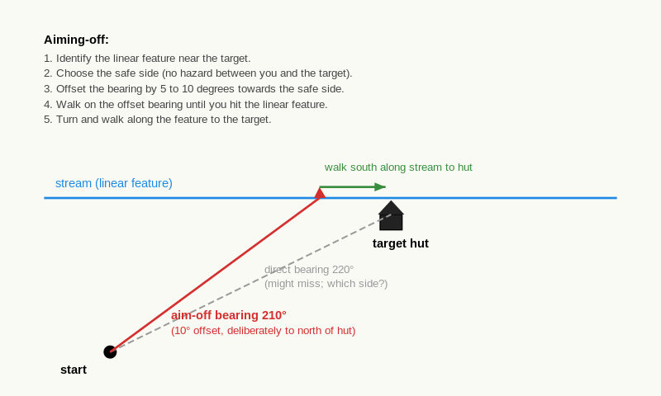
Reference diagram. Aiming Off. the aim-off line is offset from the direct line by a few degrees, hitting the linear feature on the safe side of the target.
A candidate is planning a leg from a col at 2,720 m to a hut at 2,450 m. The hut sits on a flat shoulder; a stream runs roughly east-west across the shoulder, passing about 50 m north of the hut.
The direct bearing from the col to the hut is 220 degrees grid (from D2.1). The candidate decides to aim off to the north (so when they hit the stream they walk south along it, downhill, towards the hut).
Aim-off calculation:
- Direct bearing 220 degrees.
- Offset 10 degrees to the north (which on this bearing means subtracting 10): 220 - 10 = 210 degrees.
- The candidate sets 210 grid (212 magnetic with +2 east variation) on the compass and walks the leg.
Arrival: the candidate hits the stream approximately 100 m north of the hut. They turn left along the stream and walk downhill until they reach the hut.
If they had walked the direct 220 grid bearing and arrived 50 m north of the hut, they would have to guess which side to walk along. The aim-off removes the guess.

Exercise 1 - Identify the linear features
For three named targets on the Section D4.2 map extract, identify the linear feature that would be the candidate's aim-off handrail.
Target | Linear feature for aim-off
Target 1
Target 2
Target 3

Exercise 2 - Choose the safe side
For each of the three targets from Exercise 1, identify which side of the target would be the safe side to aim off to, and explain why in one sentence.
Target | Safe side | Reason
Target 1
Target 2
Target 3

Exercise 3 - Calculate the aim-off bearing
For each target, calculate:
- the direct grid bearing,
- the aim-off offset (5 to 10 degrees, in the appropriate direction),
- the aim-off grid bearing.
Target | Direct grid | Offset | Aim-off grid
Target 1
Target 2
Target 3

Exercise 4 - Aim-off in poor visibility
In two or three sentences, explain in your own words why aim-off is more important in poor visibility than in good visibility, and why the safe-side choice becomes more critical.
____________________________________________________ ____________________________________________________

Self-check
☐ I can identify a usable linear feature for aim-off near any named target on the map.
☐ I can choose the safe side based on terrain hazards.
☐ I can calculate an aim-off bearing from the direct bearing.
☐ I understand the small distance cost of aim-off and the large reliability benefit in poor visibility.

Why this matters for IMS
Aim-off is one of the IMS / EMS habits that distinguishes a candidate from a strong candidate. The route card with aim-off bearings on the poor-visibility legs is the route card that produces a robust day. The assessor will probe with "how would you reach this hut in flat light?" and the answer that names the linear feature, the safe side, and the offset is the answer at working standard.

D4.3 Magnetic Interference and Instrument Hygiene
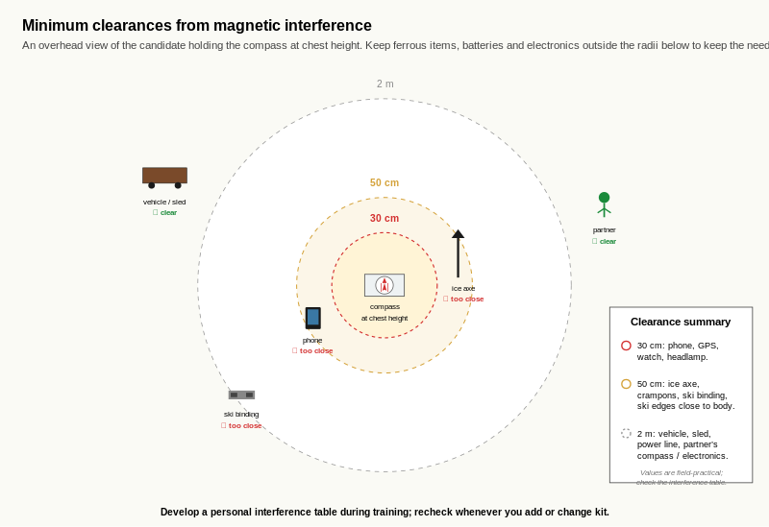
Reference diagram. Magnetic Interference Clearances. distances are typical working figures; the candidate's own interference table records measured values for their actual kit. Phones and GPS sit in the tightest zone; vehicles and partners take the widest clearance.

Learning aim
By the end of this page, you should be able to identify the common sources of magnetic interference on a ski tour, know the minimum safe distance from each, and produce a personal interference table for the equipment you carry. You should also know the basic instrument-hygiene checks to keep your compass reliable.

Why this matters
A compass is a magnetic instrument. Anything magnetic nearby pulls the needle off true magnetic north. The pull may be small but it is consistent: a 5-degree deflection from a phone in a chest pocket affects every bearing the candidate takes that day until the phone is moved.
For an IMS / EMS candidate, magnetic interference is one of the silent error sources. A bearing read with a compass next to a steel ski binding produces drift on every leg, and the candidate may not notice until the cumulative effect is large.

Common interference sources
The four most common interference sources on a ski tour:
- Steel ski bindings. The largest interference source most candidates encounter. Bindings are within 50 cm of the compass when the compass is held at chest height with skis on. Minimum safe distance: 50 cm.
- Ice axes. Steel head and shaft. Minimum safe distance: 50 cm.
- Mobile phones. The internal magnets of the speaker and camera produce a small but consistent field. Minimum safe distance: 30 cm.
- Radio handsets. The internal antenna magnets produce a similar field to phones. Minimum safe distance: 30 cm.
Other interference sources to be aware of:
- Avalanche transceivers in transmit mode. (In search mode they are designed to detect signals and are even more sensitive to interference; never use a compass alongside a transceiver in active search.)
- Electronic watches and altimeters. Generally negligible at the wrist when the compass is held at chest height.
- Vehicles. Steel chassis and engine. Minimum safe distance: 2 m when standing next to a parked car.
- Reinforced concrete buildings. Reinforcement bars produce local fields; useful to know when calibrating a compass at a hut or visitor centre.

The test
The test for interference is simple: with the compass set to a known direction, move the suspect object closer. If the needle deflects as the object approaches, the object is the source.
For a personal interference table, run the test for every piece of equipment you routinely carry. Note the distance at which deflection becomes detectable. Add a margin (typically 20 to 30 cm) for safety.

Instrument hygiene
The compass itself needs occasional checks:
- Crack in the baseplate. A cracked baseplate may flex and tilt the compass when held flat. Replace.
- Cloudy or pierced damping fluid. A compass with a damaged needle pivot or compromised damping fluid will not settle reliably. Replace.
- Stuck or sluggish bezel. A bezel that does not turn smoothly will produce inconsistent bearings. Try cleaning gently; if the problem persists, replace.
- Confirmation against a known direction. Run the D1.2 quick-check at the start of every tour. A compass that disagrees with a known direction on the quick-check is a compass that should be inspected before being relied on.

Worked example
A candidate runs the interference test at home. With the compass set to a known direction (a bearing taken to a building edge known to be due south, so the compass should read 180 degrees magnetic):
Object tested | Distance at first deflection | Personal safe distance
Mobile phone | 25 cm | 50 cm (with margin)
Ski binding (held in hand) | 40 cm | 70 cm (with margin)
Ice axe | 35 cm | 60 cm (with margin)
Avalanche transceiver (transmit) | 15 cm | 40 cm (with margin)
Avalanche transceiver (search) | not tested (do not test in active search mode) | n/a
The candidate notes that the steel ski binding has the largest interference range. On tour the candidate keeps the compass at chest height (50 cm above the binding tops when standing) and is careful not to place the compass on the snow next to the skis when removing them.

Exercise 1 - Run the interference test
Practical drill at home or at any safe location.
For each piece of equipment you routinely carry on tour, run the test. Note the distance at which the compass needle first deflects from the known direction. Add a 20 cm margin for the personal safe distance.
Equipment | First-deflection distance | Personal safe distance
Mobile phone
Ski bindings
Ice axe
Other (name it)

Exercise 2 - Identify the highest-risk source
From your table in Exercise 1, identify the equipment with the largest interference range. In one sentence, explain how you will manage this source on tour.
____________________________________________________

Exercise 3 - Quick-check habit
In one or two sentences each, describe the four instrument-hygiene checks you will run on your compass.

Exercise 4 - When the compass disagrees with a known direction
A candidate runs the morning quick-check at the start of a tour. The compass reads 178 degrees magnetic when set to a known due-south bearing (which should read 180 degrees with negligible variation in the local area).
- Is this 2-degree discrepancy acceptable?
- What would you do before using the compass for the day?
- At what level of discrepancy would you not use the compass at all?

Self-check
☐ I can name the four common magnetic interference sources on a ski tour.
☐ I have produced a personal interference table for my own equipment.
☐ I know the minimum safe distances I personally use.
☐ I run the four instrument-hygiene checks on my compass before any tour.
☐ I know how to interpret a quick-check disagreement and when to trust the compass.

Why this matters for IMS
Magnetic interference management is one of the small habits the IMS / EMS assessor expects without prompting. A candidate who places the compass on a steel ski binding while taking a bearing has not internalised the discipline. The personal interference table is the working tool that turns generic guidance into a specific habit; the candidate carries the table mentally and adjusts compass placement accordingly.
After D4 the candidate has the full compass-and-bearings skill set: parts and reading (D1), bearings from the map (D2), bearings from the ground (D3), and practical accuracy plus instrument hygiene (D4). D5 introduces the second instrument: the altimeter.
These two pages introduce the altimeter as the second navigation instrument. D5.1 covers the mechanism (how a barometric altimeter measures altitude through atmospheric pressure) and the distinction from GPS altimeters. D5.2 covers the practical setup (calibration at known reference points) and the recalibration habit that keeps the altimeter useful through a touring day.
D5.3 and D5.4 then cover drift management and altimeter-as-primary-tool. Together the four D5 pages give the candidate the full altimeter skill set.

D5.1 How an Altimeter Works
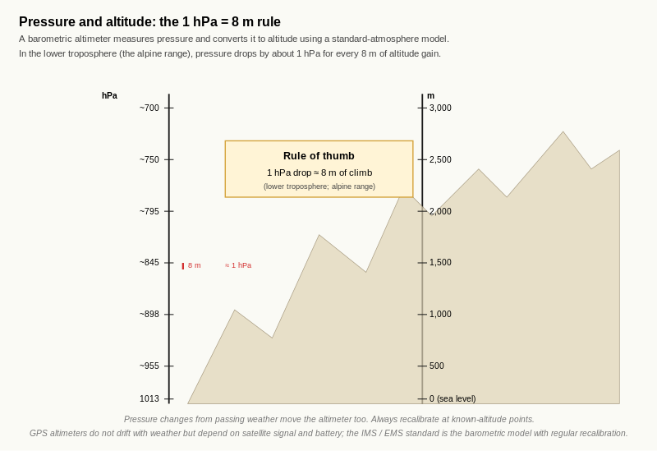
Reference diagram. Pressure and Altitude: the 1 hPa = 8 m Rule. the relationship is approximately linear over the alpine range; the rule of thumb is reliable for IMS / EMS work. Drift comes from weather pressure changes, not from the rule itself.

Learning aim
By the end of this page, you should understand that a barometric altimeter measures atmospheric pressure and converts it to altitude using a standard atmosphere model, distinguish a barometric altimeter from a GPS altimeter, and recognise that altimeter readings drift with weather changes.

Why this matters
The altimeter is the second navigation instrument in the IMS / EMS toolkit. Where the compass tells you direction, the altimeter tells you height. Together they form the position-fixing pair that does not require visible features, which is what makes them the alpine-specific alternative to resection.
Understanding how the altimeter works is the prerequisite for using it well. A candidate who treats the altimeter as a magic box will be confused by drift; a candidate who understands the pressure-to-altitude conversion will read drift as information.

The barometric altimeter mechanism
A barometric altimeter measures atmospheric pressure with a small aneroid capsule (a flexible metal chamber that expands and contracts with pressure changes). The altimeter then converts the measured pressure into an altitude figure using a standard atmosphere model.
The standard model assumes:
- pressure decreases predictably with altitude,
- the rate of decrease is approximately 1 hectopascal (hPa) per 8 metres of altitude gain in the lower troposphere (the relevant range for alpine work),
- and the conversion is calibrated to a sea-level reference pressure of 1013.25 hPa under standard temperature.
The mechanism is mechanical and reliable. It does not require batteries (in mechanical altimeters) or satellite signal. It is the same technology used in aircraft altimeters at lower altitudes.

Why altimeters drift
The conversion from pressure to altitude assumes stable weather. Real weather is not stable. Two factors produce drift:
- Weather pressure changes. A passing weather system changes atmospheric pressure independent of the candidate's altitude. A falling barometer (incoming low pressure) makes the altimeter over-read; a rising barometer (high pressure building) makes it under-read.
- Temperature. The standard atmosphere model assumes a specific temperature profile. In very cold conditions the air is denser at altitude than the model assumes, so the altimeter may under-read. The error is small (typically less than 1 percent) and rarely matters for IMS / EMS work, but it is present.
For practical IMS / EMS work, weather pressure drift is the dominant error source. D5.3 covers it in detail. The take-away here is that an altimeter reading at any given moment depends on both your altitude and the current weather pressure; if either changes, the reading changes.

GPS altimeters
A GPS altimeter measures altitude directly using satellite signals. It does not depend on atmospheric pressure and does not drift with weather.
The trade-offs:
- GPS altimeters are typically less accurate than barometric altimeters in stable conditions (often 10 to 20 m error vs 1 to 3 m for a properly calibrated barometric).
- GPS altimeters require satellite signal, which can be poor in steep terrain, dense forest, or under low cloud.
- GPS altimeters are generally more battery-dependent.
The IMS / EMS recommendation is to use both:
- Barometric altimeter as the primary tool because it is more accurate when calibrated and works in any weather.
- GPS altimeter as a backup for cross-check and for use when the barometric has drifted significantly without the opportunity to recalibrate.

Worked example
A candidate sets a barometric altimeter at home in the morning. The reading at 8am is 90 m above sea level (the candidate's known home elevation).
The candidate does not move from home all day. Readings:
- 8am: 90 m
- noon: 95 m
- 4pm: 105 m
- 8pm: 115 m
The altimeter has not moved, but the reading has changed by 25 m over 12 hours. This implies a barometric pressure change of approximately 25 m / 8 m per hPa = approximately 3 hPa drop over the period.
The candidate cross-checks against a weather forecast or a separate barometer. A 3 hPa drop in 12 hours is consistent with a slowly approaching weather system.
The point of the exercise is to demonstrate that the altimeter is doing its job correctly: the reading change accurately reflects the pressure change. The error appears only if the candidate assumes the reading is altitude when the pressure has shifted.

Exercise 1 - 24-hour stationary drill
Practical drill at home. Set the altimeter to your known home elevation in the morning. Record the reading every few hours over a 24-hour period without moving the altimeter.
Time | Altimeter reading | Apparent altitude change from start
Morning |  | 0 (start)
Midday
Evening
Next morning

Exercise 2 - Calculate the implied pressure change
For your largest apparent altitude change between two readings in Exercise 1, calculate the implied pressure change using the rule of thumb (1 hPa = 8 m).
- Apparent altitude change: __________ m
- Implied pressure change: __________ hPa
- Direction (rising or falling pressure):
- Weather expected from this trend (improving, stable, deteriorating):

Exercise 3 - Distinguish barometric from GPS
In two or three sentences, explain in your own words the key differences between a barometric altimeter and a GPS altimeter, and state which the IMS / EMS-relevant primary tool is and why.
____________________________________________________ ____________________________________________________

Exercise 4 - When the altimeter is preferred over GPS
In two or three sentences, give one specific scenario in which the barometric altimeter would be preferred over a GPS altimeter for navigation, even if both are working.
____________________________________________________

Self-check
☐ I understand that a barometric altimeter measures pressure and converts it to altitude.
☐ I know the standard rule of thumb (1 hPa pressure change = approximately 8 m of apparent altitude change).
☐ I can distinguish a barometric altimeter from a GPS altimeter and explain the trade-offs.
☐ I recognise that altimeter readings drift with weather pressure changes, even when stationary.
☐ I know the IMS / EMS-recommended pairing: barometric primary, GPS backup.

Why this matters for IMS
The altimeter is the second navigation instrument in the IMS / EMS toolkit, paired with the compass. Together they enable the alpine-specific aspect-of-slope relocation technique (D7.2) that does not require visible features. Understanding how the altimeter works is the prerequisite for using it well; a candidate who treats it as a magic box will misread drift as altitude error and lose confidence in the instrument when they should be reading the weather.

D5.2 Setting and Calibrating the Altimeter

Learning aim
By the end of this page, you should be able to set the altimeter to a known elevation reference at a known position, recognise the need to recalibrate at every reliable known point on a tour, and identify the kinds of points that are reliable for calibration.

Why this matters
An altimeter that has not been calibrated recently is unreliable. Weather pressure has drifted; the altimeter reading has drifted with it; the candidate is reading the wrong altitude.
The recalibration habit is the discipline that keeps the altimeter useful through a touring day. Best practice is to recalibrate at every reliable known point. The cost is small (15 seconds per calibration); the benefit is large (the altimeter stays accurate to within a few metres throughout the day).
For an IMS / EMS candidate, the recalibration habit is one of the small habits the assessor will watch for. A candidate who calibrates at the morning lift station and never again is using a tool that is correct at 9am and wrong by 5pm.

Setting the altimeter
Most altimeters have a manual altitude-set function. The procedure varies slightly by model but the principle is the same:
- Stand at a position where you know the altitude precisely (a marked spot height on the map, a lift station, a hut with a published elevation).
- Note the known altitude.
- Use the altimeter's set function to enter the known altitude.
- The altimeter is now calibrated to that pressure-to-altitude relationship for the current weather.
For digital altimeters, the set function is usually a button sequence; for mechanical (analogue) altimeters, the set function is usually a small adjustment screw or knob. Either way, the procedure is fast (10 to 15 seconds) and should become automatic.

What makes a known point "reliable"
Not all points on a map are equally reliable for calibration. A reliable known point is one where:
- the altitude is precisely known (within 1 to 2 m), not estimated,
- the candidate is physically standing on the marked altitude (not approximately near it),
- the candidate has high confidence they have correctly identified the point on both the ground and the map.
Examples of reliable known points on a typical tour:
- Lift stations. Altitude usually published; the candidate is physically at the published level.
- Huts and refuges. Altitude marked on the map; the candidate is at the hut level.
- Summit spot heights. Marked spot height; the candidate is at the highest point.
- Col spot heights. Marked spot height; the candidate is at the lowest point of the saddle.
- Valley junctions with marked altitudes (less common; usually less reliable than the above).
Examples of unreliable points:
- Approximately at a contour line. The candidate may be 5 m above or below the contour; calibrating to the contour value introduces a systematic error.
- A general high point that is not a marked spot height. The candidate may be at the wrong sub-peak.
- A path junction without an altitude marker. Easy to misidentify on the map.
The discipline is to recalibrate only at reliable points. A poor calibration is worse than no calibration because it introduces an error the candidate trusts.

How often to recalibrate
The IMS Nav Training Programme recommends recalibrating at every reliable known point on the tour. In practice this typically means:
- Morning calibration at the start point (lift station, car park, hut).
- One or two recalibrations at named features during the ascent (a col, a summit, a hut at lunch).
- Final calibration if returning to a known point (lift station for descent).
In stable weather (high pressure), drift between calibrations is small and the habit is mostly precautionary. In active weather (falling barometer, fronts moving through), drift can be 20 to 50 m over a few hours and the habit becomes essential. Either way, the discipline is the same: when you reach a reliable known point, take 15 seconds and reset.

Worked example
A candidate plans a tour:
- Start at lift station at 1,850 m (morning calibration).
- Climb to col at 2,720 m (recalibration at the col spot height).
- Continue to summit at 2,980 m (recalibration at the summit spot height).
- Descend to hut at 2,450 m (recalibration at the hut elevation).
- Return to lift station at 1,850 m (final calibration cross-check).
Five calibration moments through the day. Each takes 15 seconds. Total time cost: under 90 seconds for the full day.
Between calibrations, the candidate uses the altimeter knowing the reading is accurate to within a few metres (in stable weather) or potentially within 10 to 20 m (in active weather). The recalibration at each known point catches and corrects whatever drift has accumulated.
If the candidate notices that the altimeter reads, for example, 35 m higher than the col spot height when they reach the col, they have learned two things:
- The altimeter has drifted by 35 m since the morning calibration.
- The pressure has fallen (35 m apparent gain implies approximately 4 hPa drop), suggesting weather is deteriorating.
Both pieces of information are now on the route card.

Exercise 1 - Calibration drill at home
Practical drill. Set the altimeter to your known home elevation. Walk a known route (a flight of stairs, a hill near home, a known route to a known point).
- Starting elevation set: __________ m
- Ending elevation expected (from your knowledge of the route): __________ m
- Ending elevation read on the altimeter: __________ m
- Discrepancy: __________ m
- Likely explanation for the discrepancy (drift, calibration error, route uncertainty):

Exercise 2 - Identify reliable known points
For your exam-area map, list five reliable known points where you would recalibrate the altimeter on a typical tour.
# | Reliable known point | Altitude
1
2
3
4
5

Exercise 3 - Distinguish reliable from unreliable
For each of the following, state whether it is a reliable or unreliable point for altimeter calibration, and give a one-line reason.
Point | Reliable? | Reason
A marked summit at 2,847 m, candidate at the spot height marker
A col labelled with a spot height of 2,718 m
A junction of two paths at approximately 2,400 m (no marker)
A hut labelled "Refuge des Ecrins, 2,340 m"
A point on a slope where the altimeter happens to read 2,500 m

Exercise 4 - Why recalibrate so often
In two or three sentences, explain in your own words why the IMS Nav Training Programme recommends recalibrating at every reliable known point rather than just once at the start of the tour.
____________________________________________________ ____________________________________________________

Self-check
☐ I can set the altimeter to a known elevation at a known position.
☐ I can identify reliable known points for calibration on a 1:25,000 alpine map.
☐ I know that approximate-altitude points and unmarked junctions are not reliable for calibration.
☐ I have built the habit of recalibrating at every reliable known point on a tour.
☐ I treat a discrepancy at a recalibration as both an altimeter correction and a weather observation.

Why this matters for IMS
The recalibration habit is one of the small habits the IMS / EMS assessor will watch for during route narration. A candidate who recalibrates at the col without prompting and notes the discrepancy as a weather observation is at the working assessment standard. A candidate who calibrates only at the start and is then surprised by altimeter readings later in the day has the wrong habit.
After D5.2 the candidate has the calibration discipline that makes the altimeter useful. D5.3 covers the drift behaviour between calibrations and how to read it as weather information. D5.4 covers using the altimeter as the primary navigation tool on featureless terrain.
These two pages complete the altimeter section of Level 3. D5.3 covers the drift behaviour of the altimeter between calibrations and how to read it as weather information. D5.4 covers using the altimeter as the primary navigation tool on featureless terrain where lateral features are unreliable. Together they take the calibrated altimeter from D5.2 and turn it into a working navigation instrument.
After D5 the candidate has the full altimeter skill set. D6 covers the barometer (often the same physical instrument), and D7 brings compass and altimeter together for the integrated alpine techniques.

D5.3 Pressure Drift and Weather Effects

Learning aim
By the end of this page, you should understand that altimeter readings drift with weather pressure changes even when the candidate is stationary, run a 7-day altimeter day log to build the instinct for trusting or distrusting the altimeter, and read altimeter behaviour as a weather signal alongside its use as an altitude reference.

Why this matters
The altimeter drift discussed in D5.1 is not just an error to be corrected at calibration; it is information about the weather. A falling barometer makes the altimeter over-read, which means the apparent altitude is rising when the candidate is stationary or descending. A rising barometer makes it under-read, so the apparent altitude is falling.
For an IMS / EMS candidate, the altimeter is therefore two instruments in one: an altitude reference (when calibrated and read against known points) and a weather indicator (when its drift is noticed and interpreted). The route card should reflect both uses.

The pressure-altitude relationship
The standard rule of thumb from D5.1: 1 hectopascal (hPa) of pressure change is equivalent to approximately 8 metres of apparent altitude change.
The relationship is most accurate in the lower troposphere (the relevant range for alpine work). At very high altitudes the relationship changes because air density falls; at very low altitudes the rule is also slightly off. For 1,000 m to 3,500 m alpine work, 1 hPa = 8 m is reliable.
The direction of the relationship:
- Falling pressure (incoming low pressure, deteriorating weather): altimeter reads higher than the true altitude. A stationary altimeter shows apparent altitude gain.
- Rising pressure (high pressure building, improving weather): altimeter reads lower than the true altitude. A stationary altimeter shows apparent altitude loss.
The mnemonic is: the altimeter overstates altitude when the weather understates the pressure. Or more memorably: weather going down, altimeter going up.

Reading the altimeter as weather
The IMS / EMS-relevant use is to notice altimeter drift and apply it. Three patterns:
- Stationary candidate noticing apparent altitude gain. Pressure is falling. Weather is deteriorating. Note the rate (m per hour) and apply the IMS Nav Programme decision framework (covered formally in D6.2).
- Recalibration showing the altimeter reads higher than the known point. Same diagnosis: pressure has fallen since the last calibration; weather is deteriorating.
- Apparent altitude rising during a known descent. Pressure is falling fast enough to overcome the descent. Significant weather event in progress.
The rate of drift is the diagnostic. A 5 m drift over an hour is unremarkable. A 20 m drift over an hour is significant. A 50 m drift over an hour is a fast-moving system; consider an early descent or shelter.

The 7-day altimeter day log
The day log is the calibration of trust. The candidate sets the altimeter to home elevation each morning for 7 days and records the reading. Over the week, the candidate sees:
- which days the altimeter was steady (stable weather: trust the altimeter heavily on tour),
- which days the altimeter drifted significantly (active weather: recalibrate frequently on tour),
- and what kinds of weather correlate with what kinds of drift.
The candidate emerges from the 7-day log with an instinct for when to trust the altimeter as an altitude reference and when to read it primarily as a weather signal.

Worked example
A candidate is at a hut overnight at a known elevation of 2,340 m. The candidate sets the altimeter to 2,340 m at 6pm.
The next morning at 6am, before leaving the hut, the candidate reads the altimeter: 2,395 m.
The candidate has not moved. The apparent altitude gain of 55 m implies a pressure drop of approximately 55 / 8 = nearly 7 hPa over 12 hours. That is a significant drop; weather is deteriorating, possibly substantially.
Three responses:
- Recalibrate the altimeter to 2,340 m before departing.
- Update the route card with the weather observation. The day's plan may need to change.
- Apply the decision framework (D6.2): a 7 hPa drop in 12 hours is a moderate-to-fast deterioration; consider an early turn-around criterion or an alternative day plan.
The candidate now has both the corrected altimeter (for the day's altitude readings) and the weather observation (for the day's route decisions).

Exercise 1 - 7-day altimeter day log
Practical drill over 7 consecutive days. Set the altimeter to your known home elevation each morning. Record the reading and note the weather observation.
Day | Morning reading | Apparent change from known elevation | Weather observation
1
2
3
4
5
6
7

Exercise 2 - Identify the pattern
After 7 days, look at your data:
- Average apparent change (m):
- Largest single-day apparent change (m):
- Day with the largest change had what weather?
- Days with the smallest change had what weather?

Exercise 3 - Calculate implied pressure changes
For three days from your log, calculate the implied pressure change using the rule of thumb (1 hPa = 8 m).
Day | Apparent altitude change (m) | Implied pressure change (hPa) | Direction (rising / falling)

Exercise 4 - Worked weather scenario
A candidate at a hut at 2,340 m sets the altimeter at 6pm. At midnight the candidate is woken by wind and checks the altimeter: it reads 2,420 m. The candidate has not moved.
- Apparent altitude change: __________ m
- Implied pressure change: __________ hPa
- Time period: __________ hours
- Rate: __________ hPa per hour
- What does this rate indicate about the weather (use the IMS Nav Programme bands: less than 0.5 hPa/hr = mild; 0.5 to 1 hPa/hr = moderate; more than 1 hPa/hr = rapid)?
- What would you do at midnight as the trip leader?

Exercise 5 - Reflect on trust
In two or three sentences, explain in your own words how the 7-day day log changes the way you would use the altimeter on a tour. Be specific about what you would trust the altimeter for and when you would treat its readings with extra caution.
____________________________________________________ ____________________________________________________

Self-check
☐ I have completed the 7-day altimeter day log and reviewed the pattern.
☐ I can apply the rule of thumb (1 hPa = 8 m) to convert apparent altitude change into implied pressure change.
☐ I can read altimeter drift as a weather signal alongside its use as an altitude reference.
☐ I know the rate bands for pressure change (mild, moderate, rapid) and the action implication of each.
☐ I have an honest sense of when to trust the altimeter heavily and when to treat its readings with extra caution.

Why this matters for IMS
The altimeter as a weather signal is one of the IMS / EMS-relevant integration moments: a single instrument provides both an altitude reading and a weather observation, and the candidate uses both on the route card. A candidate who notices a 50 m apparent gain at the morning hut without responding has not internalised the dual use. The 7-day day log builds the instinct that turns the abstract knowledge into a working habit.

D5.4 Altimeter as Primary Navigation Tool
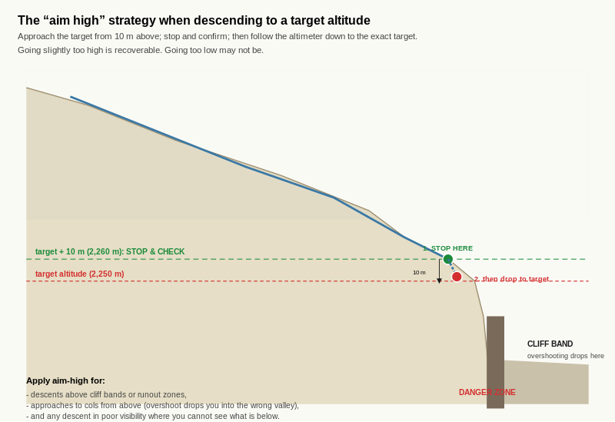
Reference diagram. Aim-High Strategy for Altitude Targets. the 10 m buffer is the asymmetry. Going slightly too high costs you the buffer climb back. Going too low can drop you into committing terrain.

Learning aim
By the end of this page, you should be able to use the altimeter as the primary navigation reference on a contour traverse where lateral features are not reliable, apply the "aim high" strategy for descending to a target altitude safely, and identify on the map the kinds of traverses where altimeter is the primary tool rather than the supporting tool.

Why this matters
Most route legs use the compass for direction and the altimeter for confirmation. A subset of legs invert the relationship: the altimeter becomes the primary tool, and the compass plays a supporting role. These are legs where lateral features (named summits, ridges, rivers) are not visible or not reliable, but the candidate's altitude is still meaningful.
Examples:
- A contour traverse across a uniform north-facing slope, holding 2,250 m to reach a known waypoint at the same elevation.
- A descent into a featureless basin where the candidate must stop at a specific altitude to avoid a cliff band below.
- A poor-visibility leg across a wide plateau where the altimeter is the only available cross-check on position.
For an IMS / EMS candidate, the ability to flip between compass-primary and altimeter-primary modes is one of the assessable competencies. The route card should make the choice explicit for each leg.

The contour traverse
A contour traverse is a route leg where the candidate maintains a constant altitude while moving across a slope. The altimeter is the primary tool because:
- the slope itself provides no lateral landmarks (one stretch of north-facing slope looks much like another at the same altitude),
- the candidate's gradient is the diagnostic: if the altimeter reading rises, the candidate is climbing; if it falls, the candidate is descending,
- the compass provides only the rough direction; the altimeter provides the precise contour.
The procedure:
- Note the target altitude from the map (the contour you intend to follow).
- Set the compass to the rough bearing of the traverse (the direction the contour runs).
- Walk on the bearing while watching the altimeter.
- If the altimeter rises, turn slightly downhill to drop back to the target.
- If the altimeter falls, turn slightly uphill to climb back to the target.
- The actual line followed is a slight zig-zag that hovers around the target altitude.
In practice the line stays within plus or minus 5 m of the target altitude with attention. That is more accurate than the candidate could achieve by visual contouring on an unfamiliar slope.

The "aim high" strategy
When descending to a target altitude, the candidate may overshoot if they do not stop at the right point. Overshoot can be inconvenient (extra climbing back) or dangerous (overshooting onto committing terrain below).
The "aim high" strategy:
- Identify the target altitude from the map.
- Approach the target from slightly above (target + 10 m typically).
- Stop at target + 10 m and confirm position (look around, cross-check with any visible features).
- Then follow the altimeter down to the exact target.
- Stop precisely at the target.
The strategy works because going slightly too high is recoverable (drop the extra 10 m) but going too low may not be (cliff band, terminal cone, runout zone). The 10 m buffer is small enough not to add much effort and large enough to give a safe stop.
Apply the aim-high strategy especially for:
- descents above cliff bands or runout zones,
- approaches to cols from above (overshoot drops the candidate into the wrong valley),
- and descents in poor visibility where the candidate cannot see what is below.

Worked example
A candidate plans a leg across the upper east-facing flank of a summit at 2,650 m. The contour at 2,250 m runs roughly north-south across the flank for approximately 1.5 km. The candidate's destination is a cairn at 2,250 m at the south end of the contour.
The leg:
- Target altitude: 2,250 m. Set on the route card.
- Bearing for the traverse: roughly south, let's say 175 grid (177 magnetic with +2 east variation).
- Calibration before starting: at the col at the north end of the flank, calibrate the altimeter to the col spot height (let's say 2,310 m).
- Walk south on the bearing. Drop the 60 m from 2,310 m to 2,250 m in the first few minutes; then maintain 2,250 m for the rest of the traverse.
- Hovering around 2,250 m: if the altimeter reads 2,255 m, turn slightly downhill to drop 5 m; if it reads 2,245 m, turn slightly uphill to climb 5 m.
- Approach the cairn: in the last 100 m, watch for the cairn visually. The altimeter should still read approximately 2,250 m when the cairn comes into view.
If the cairn is not at exactly 2,250 m on the candidate's altimeter when reached, the discrepancy is information: either the altimeter has drifted (recalibrate at the cairn if the cairn altitude is marked) or the cairn is at a slightly different altitude than the candidate expected (cross-check the map).

Exercise 1 - Identify three altimeter-primary traverses
On your exam-area map, identify three legs where the altimeter would be the primary navigation tool rather than the supporting tool. For each, name:
# | From | To | Target altitude | Why altimeter is primary
1
2
3

Exercise 2 - Plan a contour traverse
For one of the three traverses from Exercise 1, write the route-card-style entry:
- Start point and altitude:
- End point and altitude:
- Target altitude (the contour to maintain): __________ m
- Approximate bearing of traverse:
- Approximate distance: __________ m
- Calibration point before starting:
- Notes (any features along the line that confirm position; any hazards if altitude drifts):

Exercise 3 - Apply the aim-high strategy
A candidate is descending in poor visibility from a col at 2,720 m to a hut at 2,450 m. Below the hut at approximately 2,400 m is a cliff band.
- Target altitude for the hut: __________ m
- Aim-high approach altitude: __________ m
- What would the candidate do at the aim-high altitude before continuing down to the target?
- Why is the aim-high strategy especially important on this leg?

Exercise 4 - Compare with the compass-primary mode
In two or three sentences, explain in your own words the difference between a compass-primary leg and an altimeter-primary leg, and how the route card should reflect the difference.
____________________________________________________ ____________________________________________________

Self-check
☐ I can identify on the map the kinds of traverses where altimeter is the primary navigation tool.
☐ I can plan a contour traverse with target altitude, bearing, and calibration point.
☐ I can hover around a target altitude using small uphill / downhill corrections.
☐ I can apply the aim-high strategy when descending to a target above committing terrain.
☐ I can write a route-card entry that makes the compass-primary or altimeter-primary mode explicit.

Why this matters for IMS
The altimeter-as-primary-tool framing is the alpine-specific application that distinguishes the candidate from a non-alpine navigator. On open snow, in featureless basins, and on poor-visibility plateaux, the altimeter is what makes the navigation work. The aim-high strategy is the discipline that turns a routine descent into a controlled approach, especially above terrain hazards.
After D5 the candidate has the full altimeter skill set: theory (D5.1), calibration (D5.2), drift management (D5.3), and primary-tool use (D5.4). D6 covers the barometer, often the same physical instrument as the altimeter but used as a weather indicator rather than an altitude reference. D7 brings compass and altimeter together for the integrated alpine techniques.
These two pages cover the barometer, often the same physical instrument as the altimeter from D5. D6.1 covers reading and classifying the barometric trend. D6.2 covers the IMS Nav Programme decision framework that converts the trend into route-relevant action.
The barometer is the formal weather-instrument application of the altimeter-as-weather-signal use established in D5.3. Where D5.3 noticed pressure drift through altimeter behaviour, D6 reads pressure directly and applies pre-agreed criteria.

D6.1 Reading a Barometric Trend
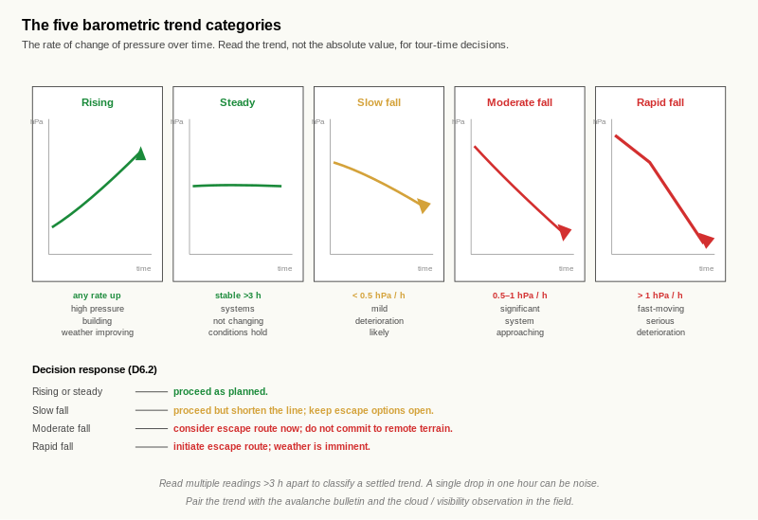
Reference diagram. Five Barometric Trend Categories. the rate (slope of the line) is the diagnostic, not the absolute pressure. The shift from amber to red between slow fall and moderate fall is also the shift from proceed with caution to actively planning the escape route.

Learning aim
By the end of this page, you should be able to record barometric pressure readings over time, classify the trend into one of five categories (rising, steady, slow fall, moderate fall, rapid fall), and explain the weather meaning of each category.

Why this matters
The barometer is the standard short-term weather-forecasting instrument. The trend (rate of change over time) matters more than the absolute value for any practical decision. A pressure reading of 1010 hPa means little on its own; the same reading falling at 1 hPa per hour means a fast-moving weather system is approaching.
For an IMS / EMS candidate, the barometer trend feeds directly into the route-card decision criteria. A rising trend means proceed; a rapid fall means initiate an escape route. The trend is the input; the decision framework in D6.2 is the output.

Pressure units
Barometric pressure is measured in hectopascals (hPa) or equivalently millibars (mb). The two units are interchangeable; 1 hPa = 1 mb. Most modern altimeters and weather forecasts use hPa.
The standard sea-level reference pressure is 1013.25 hPa. Real readings vary around this value depending on weather and altitude. A reading of 950 hPa at sea level indicates very low pressure (a deep depression); 1030 hPa indicates high pressure (a stable anticyclone).
For trend reading, the absolute value is less important than the direction and rate of change.

The five trend categories
The IMS Nav Training Programme classifies trends into five categories:
Trend | Rate | Meaning
Rising | Any rate | High pressure building; weather improving.
Steady | Stable for more than 3 hours | Stable conditions; pressure systems not changing fast.
Slow fall | Less than 0.5 hPa per hour | Mild deterioration likely.
Moderate fall | 0.5 to 1 hPa per hour | Significant system approaching.
Rapid fall | More than 1 hPa per hour | Fast-moving system; serious deterioration imminent.
The rate is what matters. A 6 hPa fall over 12 hours (0.5 hPa per hour) is moderate; the same 6 hPa fall over 3 hours (2 hPa per hour) is rapid. The decision response to each is very different.

Reading the trend
To read the trend, the candidate needs at least two pressure readings separated by enough time to detect a change. Practical guidance:
- At least 1 hour between readings to detect any change at all.
- 3 hours of consistent direction before classifying as a settled trend.
- Multiple readings over 6 to 12 hours to confirm the rate.
A single reading is a snapshot; a trend requires sequence.
For practical IMS / EMS work, the typical reading cadence is:
- a baseline reading the evening before a tour,
- a reading at departure in the morning,
- hourly readings during the tour at major waypoints (cols, lunch stops, decision points),
- a final reading at the end of the tour for the next-day baseline.

Worked example
A candidate records the following barometric readings on the day of a tour:
Time | Pressure (hPa) | Change since previous
6am (departure) | 1018 | (baseline)
9am (col) | 1016 | -2 hPa over 3 hours
Noon (summit) | 1014 | -2 hPa over 3 hours
3pm (hut) | 1012 | -2 hPa over 3 hours
Each 3-hour window shows a 2 hPa drop, which is approximately 0.67 hPa per hour. That sits in the moderate fall band.
The candidate has been seeing significant deterioration through the day. The IMS Nav Programme decision framework (D6.2) recommends "consider early descent; assess escape routes" for moderate fall. By 3pm the candidate has already arrived at the hut, but if the trend continues into the evening it will be the input for tomorrow's go / no-go decision.

Exercise 1 - Three-day pressure log
Practical drill at home over a three-day period. Record barometric pressure every two hours during waking hours.
Time | Day 1 | Day 2 | Day 3
8am
10am
Noon
2pm
4pm
6pm
8pm

Exercise 2 - Plot the readings
On a separate sheet of grid paper, plot the readings from Exercise 1 as a line graph (time on the horizontal axis, pressure on the vertical axis). Use the same scale for all three days so the comparison is visual.
[Sketch space - approximately 14 cm by 8 cm]

Exercise 3 - Classify the trends
For each of the three days, classify the dominant trend using the five categories.
Day | Dominant trend | Approximate rate (hPa/hr)
Day 1
Day 2
Day 3

Exercise 4 - Predict the next 12 hours
Based on the latest trend at the end of Day 3, predict the weather for the next 12 hours.
____________________________________________________

Exercise 5 - Cross-check with a forecast
Look up an actual weather forecast for your area for the same three-day period (a forecast covering Days 1 to 3 made before Day 1).
- What did the forecast predict?
- How well did the forecast match what your barometer recorded?
- Where did your barometer reading lead the forecast (give earlier warning)? Where did it lag?

Self-check
☐ I can record barometric pressure readings systematically over time.
☐ I can plot pressure readings as a trend graph.
☐ I can classify a trend into one of the five IMS Nav Programme categories using the rate.
☐ I can predict the next 12 hours of weather from the latest trend.
☐ I can cross-check my barometer reading against an external forecast.

Why this matters for IMS
Barometric trend reading is the input to the IMS / EMS-relevant decision framework in D6.2. A candidate who can classify a trend rapidly and reliably has the input for the framework; a candidate who cannot has nothing to feed the framework with. The three-day log is the practical drill that builds the trend-reading instinct.

D6.2 Pressure-to-Weather Decision Framework

Learning aim
By the end of this page, you should be able to convert a barometric trend into a route-relevant decision using the IMS Nav Programme decision framework, apply the framework to hypothetical scenarios, and write decision criteria into a route card template that make the framework objective and pre-agreed.

Why this matters
A trend without a decision is just a number. The IMS Nav Training Programme provides a framework that converts each trend category into a specific route action. The framework is not a rule; it is a decision aid that makes the action objective rather than subjective.
For an IMS / EMS candidate, pre-agreed decision criteria are the IMS / EMS-relevant habit. A criterion written before departure is a decision made calmly with full information; a criterion improvised under pressure during deteriorating weather is a decision made by adrenaline.

The framework
The IMS Nav Training Programme decision framework (Quick Reference Card 4):
Trend | Rate | Meaning | IMS action
Rising | Any | High pressure building; weather improving | Proceed with plan
Steady | More than 3 hours stable | Stable conditions | Proceed with plan
Slow fall | Less than 0.5 hPa/hr | Mild deterioration likely | Note time. Monitor. Brief group.
Moderate fall | 0.5 to 1 hPa/hr | Significant system approaching | Consider early descent. Assess escape routes.
Rapid fall | More than 1 hPa/hr | Fast-moving system; serious deterioration imminent | Initiate escape route or shelter immediately.
The framework does not say "always abort on a moderate fall". It says "consider early descent and assess escape routes". The decision is still the candidate's; the framework provides the structured input.

Pre-agreed criteria
A pre-agreed criterion is a decision condition written into the route card before departure. Examples:
- "Turn around at the col if barometric pressure has fallen by more than 2 hPa since departure."
- "Skip the summit attempt if the rate of pressure fall is moderate or worse at the col."
- "Initiate the southern escape route if pressure falls by more than 5 hPa during the day."
A pre-agreed criterion has three components:
- A specific trigger (a measurable condition).
- A specific action (turn around, skip summit, initiate escape).
- A named decision point (where on the route the criterion is checked).
The criterion is set before the day and is non-negotiable on the day. The point is to take the decision out of the moment, where pressure (group expectation, sunk effort, weather optimism) distorts judgement.

Worked example
A candidate is planning a tour with the following decision points:
- Decision point 1: at the col at 2,720 m. Pre-agreed criteria:
- Pressure has fallen by less than 2 hPa since departure: continue to the summit.
- Pressure has fallen by 2 to 5 hPa: proceed to the summit only if the rate is in the slow fall band; otherwise descend via the south route.
- Pressure has fallen by more than 5 hPa: descend via the south route regardless of rate.
- Decision point 2: at the summit at 2,980 m. Pre-agreed criteria:
- Pressure trend rising or steady: descend by the planned north route.
- Pressure trend in slow or moderate fall: descend by the south route (which has more reliable bailout points).
- Pressure trend in rapid fall: descend by the south route immediately.
The candidate carries this on the route card. At each decision point, the criteria are checked against the actual barometer reading and the actual time elapsed. The decision is then automatic.
If the trend at the col is moderate fall and pressure has fallen by 3 hPa, the criteria say: descend via the south route. The candidate does not need to think about it in the moment; the thinking was done before departure.

Exercise 1 - Apply the framework to three scenarios
For each scenario, identify the trend category and the IMS Nav Programme action.
Scenario | Trend category | IMS action
Pressure has been rising at 0.3 hPa per hour for the last 4 hours
Pressure has fallen 4 hPa over the last 5 hours; rate fairly constant
Pressure has fallen 5 hPa in the last 2 hours; still falling

Exercise 2 - Write three pre-agreed criteria
For a tour you might plan from your exam-area map, write three pre-agreed criteria. Each must have a specific trigger, a specific action, and a named decision point.

Exercise 3 - Tour duration and the framework
In two or three sentences, explain in your own words how the decision framework changes (if at all) for:
- A short half-day tour with multiple bailout options.
- A longer full-day tour with a committing mid-section.
____________________________________________________ ____________________________________________________ ____________________________________________________

Exercise 4 - Decision criteria on the route card
For one leg of a tour from your exam-area map, draft a route-card-style entry that includes:
Field | Your entry
Leg description
Decision point
Pre-agreed criterion 1
Pre-agreed criterion 2
Pre-agreed criterion 3
Escape route reference

Exercise 5 - When the criterion says abort but you do not want to
In two or three sentences, explain why pre-agreed criteria matter most exactly when the candidate does not want to abort. Reference the typical pressures on a candidate to continue (group expectations, sunk effort, weather optimism, summit attractiveness).
____________________________________________________ ____________________________________________________

Self-check
☐ I can apply the IMS Nav Programme decision framework to any classified barometric trend.
☐ I can write a pre-agreed criterion with a specific trigger, action, and decision point.
☐ I understand that the framework provides structured input but the decision remains the candidate's.
☐ I can adjust criteria for tour duration and committing-terrain considerations.
☐ I understand why pre-agreed criteria matter most when the candidate does not want to abort.

Why this matters for IMS
The IMS / EMS assessor will probe with weather-deterioration scenarios during route narration. A candidate who refers to pre-agreed criteria from the route card and applies them calmly is at the working assessment standard; a candidate who improvises under pressure is not.
The criteria themselves are workbook-specific examples; the real ones are written for each tour with the specific terrain, escape routes, and weather context in mind. The point of D6.2 is the habit of writing them, not the specific numbers.
After D6 the candidate has the barometer skill set complete. D7 brings compass and altimeter together for the integrated alpine techniques.
These three pages bring compass and altimeter together for the integrated alpine techniques. D7.1 covers bearing-plus-altimeter combined navigation. D7.2 covers the four-stage aspect-of-slope relocation, the alpine-specific alternative to resection. D7.3 covers inclinometer use in the field, the direct-measurement counterpart to the contour-spacing rule of thumb from C1.2.
After D7 the candidate has the full instrument toolkit. D8 covers poor-visibility navigation; D9 covers route cards as the integrative artefact.

D7.1 Bearing Plus Altimeter Combined

Learning aim
By the end of this page, you should be able to navigate to a known waypoint using compass bearing and altimeter together, where neither alone would be sufficient. You should be able to plan a route leg with both inputs and write a route-card entry that makes both explicit.

Why this matters
Most poor-visibility legs in alpine terrain require both a direction and an altitude. The bearing keeps the candidate on the right line; the altimeter tells the candidate when to stop. Either tool alone leaves the candidate guessing.
For an IMS / EMS candidate, the combined technique is the standard for any leg to a waypoint that cannot be visually identified at a distance. The route card should record both the bearing and the target altitude for each such leg.

The technique
To navigate to a known waypoint using both instruments:
- Note the target altitude from the map. This is the altitude the candidate expects to be at when they reach the waypoint.
- Set the compass bearing for the leg. Use the four-step procedure from D2.1, then convert to magnetic for the field.
- Walk on the bearing using the D2.3 walking technique with intermediate aiming points.
- Watch the altimeter at intervals. The reading should rise (or fall) consistently as the candidate progresses.
- Stop when the altimeter reaches the target altitude. The candidate should now be at the waypoint.
- Confirm with a terrain feature if possible. The waypoint may have a recognisable feature (a cairn, a junction, a named landmark) that confirms arrival.
This is the IMS-standard technique for navigating to a col, a hut, or any named waypoint in poor visibility. The bearing handles the direction; the altimeter handles the distance (in altitude terms, which is more reliable than horizontal-distance estimation on snow).

Why both are needed
- Bearing alone tells the candidate the direction but not the distance. On a uniform slope, the candidate could walk past the waypoint without knowing.
- Altimeter alone tells the candidate when they have reached the right altitude but not which point on the contour. The candidate could be at the right altitude but on the wrong slope.
- Bearing plus altimeter uniquely identifies the waypoint: the right line at the right height.
The technique scales to any waypoint with a known altitude and a known direction from a known starting point. The bearing and the target altitude are written on the route card before departure; the field execution is then mechanical.

Worked example
A candidate plans a leg from a hut at 2,340 m to a col at 2,720 m. The grid bearing from the hut to the col (taken using the D2.1 procedure) is 045 degrees. The current magnetic variation is +2 degrees east, so the magnetic bearing is 047 degrees.
The route-card entry for the leg:
Field | Entry
Start | Hut, 2,340 m
End | Col, 2,720 m
Grid bearing | 045
Magnetic bearing | 047
Target altitude | 2,720 m
Distance | approximately 1.4 km
Estimated time | 60 minutes (typical alpine ascent rate)
Notes | Watch for the col's distinctive saddle shape; cornice possible on the lee side
In the field:
- Calibrate the altimeter at the hut (set to 2,340 m).
- Set the compass to the magnetic bearing 047.
- Walk on the bearing using intermediate aiming points.
- Check the altimeter every 5 to 10 minutes. After 30 minutes, the altimeter should read approximately 2,500 m (mid-leg); after 60 minutes, approximately 2,700 m.
- Stop when the altimeter reaches 2,720 m.
- Look for the col's saddle pattern; if visible, confirmed arrival.
If the altimeter reads 2,720 m but no col is visible, the candidate is either drifting off the bearing (compass error) or the altimeter has drifted (recalibration overdue). Both are recoverable; the action is to take a fresh bearing back to the last known feature and re-orient.

Exercise 1 - Plan a three-leg route
On your exam-area map, plan a three-leg route where each leg uses both bearing and altimeter as the primary inputs. For each leg, complete the table.
Leg | From | To | Grid bearing | Magnetic bearing | Target altitude | Distance
1
2
3

Exercise 2 - The deviation question
For your three legs from Exercise 1, identify the leg where a deviation in only one of the two tools (bearing alone, or altimeter alone) would be most dangerous.
- Most dangerous deviation leg:
- Which tool error would be most dangerous?
- Why?

Exercise 3 - Walk through the field execution
For Leg 1 from Exercise 1, write a step-by-step description of how you would execute the leg in poor visibility.
____________________________________________________ ____________________________________________________ ____________________________________________________

Exercise 4 - When the altimeter and the bearing disagree
A candidate is following a leg with bearing 047 magnetic and target altitude 2,720 m. After 50 minutes the altimeter reads 2,720 m but no waypoint is visible.
- What are the two most likely causes?
- What is the immediate action?
- How would the candidate distinguish between the two causes?

Self-check
☐ I can plan a route leg using both bearing and altimeter as the primary inputs.
☐ I can write a route-card entry that makes both inputs explicit.
☐ I understand why bearing alone or altimeter alone is insufficient on a featureless leg.
☐ I can execute the combined technique in the field.
☐ I can diagnose and recover from a bearing-altimeter disagreement.

Why this matters for IMS
The bearing-plus-altimeter technique is the IMS standard for poor-visibility waypoint navigation. The IMS Nav Training Programme cards explicitly call this out as the standard sequence: target altitude noted, compass bearing set, walk on bearing, stop at target altitude, confirm with terrain feature. A candidate who can execute this in the field with both tools, and who can diagnose a disagreement when one occurs, is at the working assessment standard.

D7.2 Aspect-of-Slope Relocation

Learning aim
By the end of this page, you should be able to use the four-stage aspect-of-slope relocation technique to fix your position when no features are visible, recognise the conditions under which the technique works (and the conditions under which it fails), and explain why it is the alpine-specific alternative to resection in poor visibility.

Why this matters
Resection (D3.3) requires two visible features. In alpine poor visibility (whiteout, fog, low cloud) this condition rarely holds. The aspect-of-slope technique substitutes the unavailable second feature with two pieces of information that are always available on a slope: the slope's aspect (which you can measure with a compass) and your altitude (which you can read from a calibrated altimeter).
For an IMS / EMS candidate, this is the canonical alpine relocation technique. It is the assessor's standard answer to the question "what do you do when resection does not work?" Without it the candidate has no reliable position-fix in poor visibility on a featureless slope; with it the candidate can fix position to within a few tens of metres in conditions where resection would fail completely.

The four-stage procedure
The technique is verified at primary source on Mountaineering Scotland and Alpine Guides. The four stages:
- Take a compass bearing directly down the fall line of the slope you are standing on. This is a bearing taken at right angles to the contour lines, perpendicular to the slope. Use the D3.1 ground-bearing procedure (point the direction-of-travel arrow down the slope, rotate the bezel, read the bearing). The bearing is the aspect bearing for the slope.
- Subtract the magnetic variation to get a grid bearing. The aspect bearing as measured is magnetic; the work on the map is in grid. Apply the D2.2 conversion in the inverse direction (magnetic to grid).
- Place the compass on the map over the area you believe you are in. Rotate the compass (with the bezel held at the aspect bearing from stage 2) until the parallel orienting lines align with the map's grid lines. The direction-of-travel arrow now points in the direction of the aspect bearing on the map. Find a place on the map where this direction is perpendicular to the contours. There may be many such places; you are now constrained to a line of possible positions.
- Cross-reference with your altimeter. Read the altimeter. Your position is the unique point where the perpendicular-to-contour direction (from stage 3) crosses the contour at your altimeter altitude.
The technique gives a single position fix using only the slope you are standing on and the altimeter. No visible distant feature is needed.

Why it works
A slope has two pieces of information that can be measured locally:
- Aspect (the direction the slope faces). Different slopes face different directions; identifying which slope you are on narrows the possibilities.
- Altitude (your height above sea level). On any given slope, altitude pins down the contour you are on.
Together, aspect (the slope) and altitude (the contour) uniquely identify the position. The map already encodes both: the contours show altitude bands, and the contour pattern shows which way each slope faces. The technique is just the procedure for using both to find the unique point on the map that matches both.

When it works and when it does not
The technique works well when:
- the slope is uniform enough to give a single, clear aspect bearing (the fall line is consistent across the area you can see),
- the slope is distinctive enough that not many other slopes on the map have the same aspect at the same altitude,
- and the altimeter is recently calibrated so the altitude reading is reliable.
The technique fails when:
- the slope is curving (the fall line points different directions at different points; no single aspect bearing exists),
- many slopes in the area have the same aspect at the same altitude (the technique returns multiple possible positions),
- the ground is very flat (no meaningful fall line; aspect is ambiguous),
- or the altimeter is uncalibrated (the altitude reading is wrong, so the position fix is wrong).
For an IMS / EMS candidate, recognising when the technique works and when it does not is part of the skill. On a curving slope the candidate falls back to other techniques (a partner moved on a bearing, waiting for visibility, sheltering until conditions improve).

Worked example
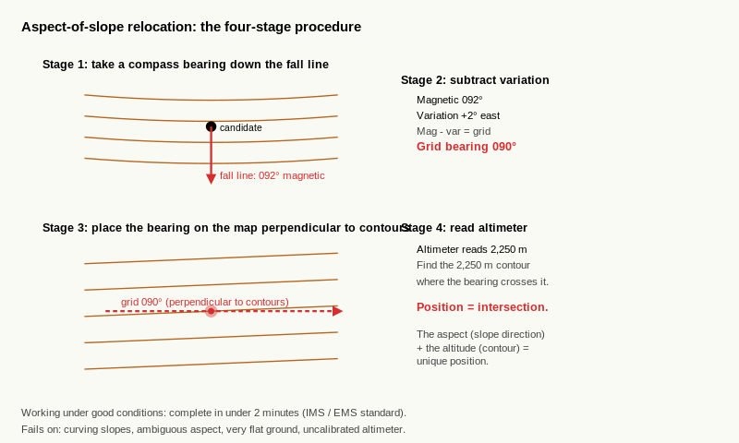
Reference diagram. Aspect-of-Slope Relocation. four-stage procedure visualised on a contour pattern.
A candidate is on the upper east-facing flank of a summit in flat light. Visibility is approximately 30 m. No distant features are visible. Two known features (a col to the north, a hut to the south) cannot be seen. Resection is not possible.
Working through the four-stage procedure:
- The candidate takes a bearing directly down the fall line. The compass reads 092 magnetic (roughly east).
- The current magnetic variation is +2 degrees east. Magnetic to grid = subtract for east = 092 - 2 = 090 grid. The aspect bearing in grid is 090 degrees, which means the slope faces east.
- The candidate places the compass on the map over the upper east-facing flank of the summit. Holding the bezel at 090, rotates the compass until the parallel orienting lines align with the map's grid lines. The direction-of-travel arrow now points east on the map. Looking at the contours: the east-facing flank of the summit is the area where the contours run roughly north-south and the perpendicular-to-contour direction is east. The candidate is somewhere on this flank, constrained to a line.
- The candidate reads the altimeter: 2,250 m. On the map, the 2,250 m contour crosses the upper east-facing flank at approximately (using the standard extract) the position labelled X.
The candidate's position is X, on the upper east-facing flank at 2,250 m. The fix is good to within approximately 20 to 30 m at 1:25,000.
The candidate now has a position fix and can plan the next leg from there.

Exercise 1 - Walk through the technique at a known starting point
On your exam-area map, choose a known position on a uniform slope. Without telling yourself the position, work through the four-stage procedure:
- Determine the aspect bearing the slope would have. (For this exercise, you can read the aspect from the contour pattern using C4.2; in the field the candidate would measure with the compass.)
- Convert magnetic to grid (using a typical Alpine variation; for the exercise use the figure looked up in D2.2 Exercise 1).
- Place the compass on the map and identify all positions where the aspect bearing is perpendicular to contours.
- Use a chosen altitude (consistent with the slope) to pin down the unique position.
Stage | Your work
1. Aspect bearing (magnetic)
2. Grid bearing after variation
3. Possible positions on the map
4. Position fix from altimeter

Exercise 2 - When the technique works
In two or three sentences, explain in your own words the conditions under which the aspect-of-slope technique gives a reliable position fix.
____________________________________________________ ____________________________________________________

Exercise 3 - When the technique fails
For each of the following scenarios, state whether the aspect-of-slope technique would give a reliable fix, and explain why or why not.
Scenario | Reliable? | Reason
Whiteout on a uniform north-facing slope, altimeter calibrated 30 minutes ago
Whiteout in the bottom of a curving valley, with the fall line pointing different directions at different points
Flat light on a wide plateau where the ground is essentially flat
Whiteout on a north-facing slope, but the altimeter has not been calibrated for 4 hours and weather has been actively deteriorating
Whiteout on a north-facing slope of a long ridge, where many points on the ridge have the same north aspect at the same altitude

Exercise 4 - Time the procedure
Practical drill at home or with the trainer. With the candidate's exam-area map and a real compass and altimeter, time the candidate working through the four stages on a known position they have not seen before.
- Time taken: __________ seconds
- Was the position fix accurate (within 50 m of the known position)?
- If no, what stage of the procedure went wrong?
The IMS / EMS working target is under two minutes for the full procedure on a slope where the technique is appropriate.

Self-check
☐ I can execute the four-stage aspect-of-slope relocation technique on a known slope.
☐ I understand the technique uses aspect (from the slope) and altitude (from the altimeter) as the two position references.
☐ I can recognise the conditions under which the technique gives a reliable fix.
☐ I can recognise the conditions under which it fails (curving slope, ambiguous aspect, very flat ground, uncalibrated altimeter).
☐ I can complete the procedure in under two minutes on a slope where it is appropriate.

Why this matters for IMS
Aspect-of-slope relocation is the alpine-specific position-fix technique that the IMS / EMS assessor will expect the candidate to know. The technique is referenced explicitly in Mountaineering Scotland's "when navigation goes wrong" page and in Alpine Guides' altimeter-navigation guide; both treat it as the standard alpine alternative to resection in poor visibility.
The candidate who can execute the four stages reliably and who can recognise when the technique works (and when it does not) has the answer to the assessor's "what do you do when resection does not work?" question. After D7.2 the candidate has the alpine relocation toolkit complete: resection (D3.3) for good visibility, aspect-of-slope (D7.2) for poor visibility on appropriate terrain.

D7.3 Inclinometer Use in the Field

Learning aim
By the end of this page, you should be able to measure slope angle directly with an inclinometer, cross-reference the measurement with the contour-spacing estimate from C1.2, and recognise the systematic differences between map-derived and field-measured slope angles.

Why this matters
The C1.2 contour-spacing rule of thumb gives an estimate of slope angle from the map. The inclinometer gives a direct measurement in the field. Both have their place; both have their limits.
For an IMS / EMS candidate, inclinometer use is the field cross-check on the map estimate. The map says the slope is approximately 30 degrees; the inclinometer at the top of the slope confirms (or contradicts). The discrepancy is information: either the map estimate was wrong, or the slope is non-uniform, or the inclinometer measurement is at an unrepresentative point.
The IMS / EMS-relevant use is avalanche-aware terrain interpretation. A slope at 30 degrees or above is in the avalanche release range; the inclinometer is the field instrument that confirms this for the specific slope the candidate is about to commit to.

The inclinometer
An inclinometer measures slope angle directly. Most baseplate compasses sold for mountain use have a built-in inclinometer; standalone inclinometers also exist.
Two common designs:
- Pendulum inclinometer. A small pendulum suspended inside the compass capsule. When the compass is held edge-on to the slope, the pendulum reads the slope angle against a scale.
- Bubble inclinometer. A small bubble in a curved tube. When the compass is tilted to match the slope, the bubble reads the angle.
Both work the same way in principle: the inclinometer measures the angle between the compass body and the horizontal.
To use:
- Hold the compass edge-on to the slope, with one edge on the slope surface and the body pointing in the direction of greatest descent (the fall line).
- Read the slope angle from the inclinometer scale.
Some compasses require the candidate to sight along the inclinometer towards a distant point on the slope; others use a built-in pendulum that gives the reading directly.

Cross-referencing with the C1.2 rule of thumb
The C1.2 rule of thumb (3 mm contour spacing on a 1:25,000 map with 10 m contours indicates approximately 30 degrees) gives a map-derived estimate. The inclinometer gives a field measurement. For most slopes the two should agree within a few degrees.
When they disagree, three explanations:
- The map estimate was averaged over a longer slope that includes both gentler and steeper sections. The inclinometer measures the specific point; the map averages.
- The slope is non-uniform. The inclinometer reading at one point may be different from the average for the whole slope.
- The measurement is at a poor point. A measurement at a small bump or hollow gives an unrepresentative reading. Take three or four measurements at different points and average.
A discrepancy of more than 5 degrees between the map estimate and a representative inclinometer measurement is worth investigating. Check the contour-spacing measurement against the legend; check the inclinometer reading at a different point.

The 30-degree threshold
The C1.2 30-degree threshold (the lower bound of the slab-release range) is one of the most assessable boundaries in alpine navigation. The inclinometer is the field instrument that confirms whether a specific slope is at, above, or below this threshold.
For practical IMS / EMS work:
- A slope estimated at less than 25 degrees on the map: the inclinometer should confirm. If it reads above 30, the map estimate was wrong; recheck.
- A slope estimated at 25 to 30 degrees on the map: inclinometer measurement is the deciding figure. If above 30, treat as avalanche-prone; if below, treat as safer.
- A slope estimated at 30 degrees or above: the inclinometer is a confirmation rather than a diagnosis. The candidate already knows the slope is in the release range.
The inclinometer is also useful for convex roll detection. A convex roll has the steepest gradient at the rollover point. The inclinometer at the top of the roll may read 25 degrees; at the rollover, 35 degrees; below the rollover, 30 degrees. Three measurements identify the convex-roll pattern that the map shows as tightening contours.

Worked example
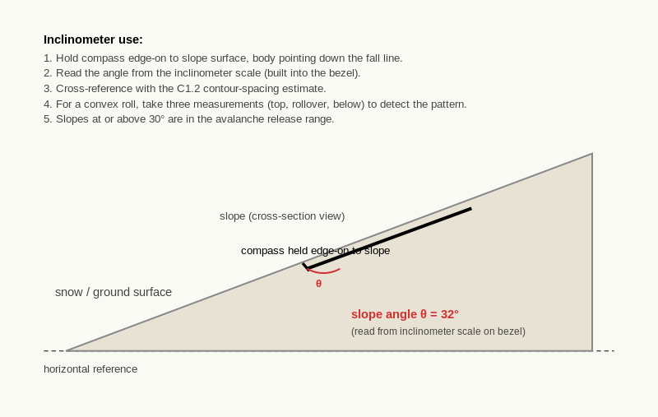
Reference diagram. Inclinometer Use. compass body held flat against slope; reads angle between slope and horizontal.
A candidate is at the top of a slope that the map suggests is approximately 32 degrees (contour spacing approximately 2.5 mm on a 1:25,000 with 10 m contours).
The candidate takes inclinometer readings at three points:
- At the top of the slope: 28 degrees.
- 50 m down the slope: 35 degrees.
- 100 m down the slope: 33 degrees.
Average: 32 degrees. Map estimate: 32 degrees. Agreement.
The variation across the three readings (28 to 35) tells the candidate the slope is non-uniform: gentler at the top, steepening into a roll, then settling to a moderate-steep gradient. The 35-degree mid-slope reading is in the prime avalanche release range; the 28-degree top is not.
The inclinometer has added information beyond the map: the candidate now knows where the steepest section is and can plan the route accordingly.

Exercise 1 - Practical inclinometer drill
On any accessible slopes (a hill near home, a slope on a local walk, a snow slope if available), measure slope angle on five different slopes.
Slope | Inclinometer reading
1
2
3
4
5

Exercise 2 - Cross-check with the map
For each slope from Exercise 1 (where the slope appears on a 1:25,000 map you have access to), estimate the slope angle from the contour spacing using the C1.2 rule of thumb.
Slope | Inclinometer reading | Map estimate (C1.2) | Discrepancy
1
2
3
4
5

Exercise 3 - Diagnose the discrepancy
For the slope in Exercise 2 with the largest discrepancy, identify the most likely cause from the three explanations on this page.
- Slope:
- Discrepancy: __________ degrees
- Most likely cause:
- How would you verify the cause?

Exercise 4 - The 30-degree threshold
For each of three slopes you might encounter on your exam-area map:
Slope | Map estimate (degrees) | Above or below 30? | Inclinometer action
For the inclinometer action column, write what you would do at the slope (skip the measurement; take a confirming measurement; take multiple measurements to find the steepest section).

Exercise 5 - Convex roll detection
For a convex roll on your exam-area map (a slope where contour spacing tightens going downhill):
- Estimated angle at the top of the roll (from map):
- Estimated angle at the rollover (from map):
- Estimated angle below the rollover (from map):
- Where would you take inclinometer measurements to confirm the convex-roll pattern?

Self-check
☐ I can use my compass's inclinometer (or a standalone inclinometer) to measure slope angle.
☐ I can cross-reference inclinometer measurements with the C1.2 contour-spacing estimate.
☐ I can identify the three causes of disagreement between map estimate and field measurement.
☐ I use the inclinometer to confirm whether a specific slope is at, above, or below the 30-degree threshold.
☐ I can detect convex rolls in the field by taking multiple inclinometer measurements across a slope.

Why this matters for IMS
Inclinometer use is the field cross-check on the map estimate. The IMS / EMS-relevant use is avalanche-aware terrain interpretation: the candidate confirms (or contradicts) the map estimate before committing to a slope in the release range. The convex-roll detection is the most route-relevant application; rolls are classic avalanche-trigger points and the inclinometer pattern (gentle / steeper / moderate) is the field signature.
After D7 the candidate has the full instrument toolkit: compass (D1 to D4), altimeter (D5), barometer (D6), and the integrated techniques (D7) that bring all three together. D8 covers the application of the toolkit to poor-visibility navigation.
These three pages cover poor-visibility navigation. D8.1 covers the IMS Nav Programme whiteout sequence: the standard procedure when visibility drops mid-tour. D8.2 covers the pole-and-cord technique for extreme low visibility with terrain hazards. D8.3 covers Mountaineering Scotland's calm systematic relocation procedure for when the candidate becomes uncertain of position.
A note on scope: the BASI EMS / IMS scope explicitly excludes "setting out with the intention of leading in poor visibility". The candidate must be ready to manage poor visibility encountered en route but must not deliberately set out in poor conditions. The distinction matters for both planning and assessment.

D8.1 Navigating in Flat Light and Whiteout
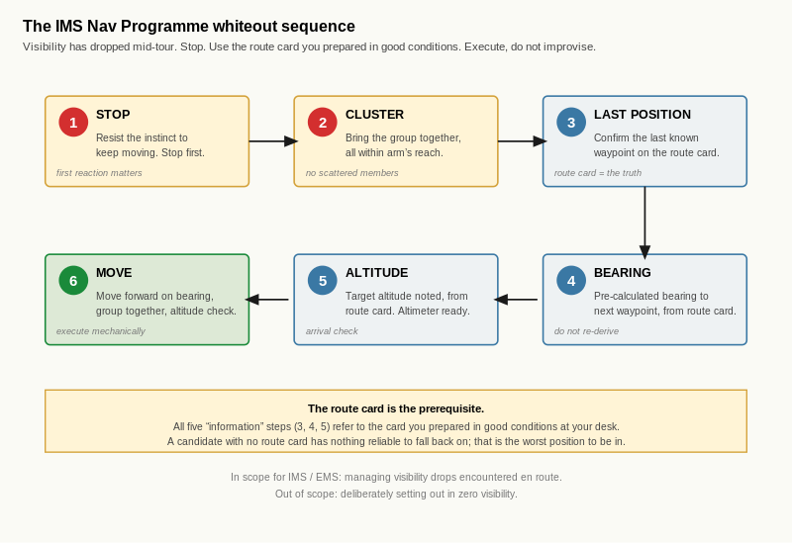
Reference diagram. Whiteout Sequence Flow. steps 1 and 2 are behaviour (stop, cluster); steps 3 to 5 are information (all from the route card); step 6 is execution. The diagram makes the route-card dependency explicit.

Learning aim
By the end of this page, you should be able to apply the IMS Nav Programme whiteout sequence when visibility drops during a tour, distinguish between deliberate setting-out in poor visibility (out of IMS scope) and managing poor visibility encountered en route (in IMS scope), and explain why a pre-prepared route card is the prerequisite for poor-visibility navigation.

Why this matters
Poor visibility is the alpine reality the candidate must be ready for. Snow, cloud, fog and flat light are common features of mountain weather, especially on long days when the morning forecast no longer matches the afternoon conditions. The IMS / EMS candidate is expected to handle visibility drops without losing the day or the group.
The scope distinction is important. The IMS / EMS pathway does not test the candidate's willingness to set out in deliberately bad conditions; it tests the candidate's ability to manage conditions that develop unexpectedly. A candidate who plans a tour to be skied in zero visibility has misunderstood the scope. A candidate who plans a tour for good conditions and handles a sudden white-down at the col has understood the scope and the test.

The IMS Nav Programme whiteout sequence
When visibility drops mid-tour, the IMS Nav Training Programme prescribes a six-step sequence:
- Stop. Do not continue navigating without confirming position. The first reaction to a visibility drop is to keep moving on the assumption that things will improve; this is the wrong reaction. Stop first.
- Get the group in a tight cluster. A scattered group in poor visibility loses members quickly. Bring the group together and keep them together.
- Confirm the last known position on the route card. The route card was prepared in good conditions before the day; it is the trusted reference. Identify the last waypoint the group passed through.
- Take the bearing to the next waypoint from the route card. The bearing was calculated and written before departure; it is reliable. The candidate sets the compass to that bearing now.
- Note the target altitude from the route card. Same principle: the target altitude was determined before the day. The altimeter is the arrival check.
- Move forward on the bearing, with the group moving together. Use intermediate aiming points where any features are visible at all; use the pole-and-cord technique (D8.2) for extreme low visibility with terrain hazards.
The sequence works because the route card was prepared in advance. A candidate who has not prepared a route card has nothing reliable to fall back on; the in-the-moment improvisation that follows is the worst possible response to a visibility drop.

The pre-prepared route card as the foundation
The candidate's route card is the foundation of poor-visibility navigation. Before the day, in good light at the desk, the candidate has:
- identified each leg of the tour,
- calculated the grid and magnetic bearing for each leg,
- noted the target altitude for each waypoint,
- recorded the distance and estimated time for each leg,
- identified key terrain features along each leg,
- and noted decision-point criteria.
In poor visibility on the day, the candidate refers to the route card and follows it. The bearings are pre-calculated; the target altitudes are pre-noted; the candidate's job is to execute, not to plan.
A candidate who tries to take a fresh bearing from the map in poor visibility, with cold fingers and a panicked group, will produce a bearing that is wrong. The pre-prepared route card removes this failure mode entirely.
D9 (route cards) covers the pre-preparation in detail. D8.1 assumes the route card exists.

Worked example
A candidate is leading a group on a tour. The morning forecast was for clear conditions until late afternoon. At 2pm, mid-tour, cloud descends rapidly and visibility drops to approximately 30 m.
The candidate applies the whiteout sequence:
- Stop. Calls the group together at the current position.
- Group in a tight cluster. All four members within arm's reach of each other.
- Last known position confirmed. The group passed the col at 2,720 m approximately 15 minutes ago. Current position is approximately 200 m past the col on the bearing for the next leg.
- Bearing to next waypoint from the route card. The next waypoint is the hut at 2,450 m. The route card has the bearing as 218 grid, 220 magnetic.
- Target altitude noted. 2,450 m. The current altimeter reads 2,650 m, so approximately 200 m of descent remaining.
- Move forward. The group sets off on the 220 magnetic bearing. The candidate uses the second group member as an intermediate aiming point at 20 m visibility distance. Pace count maintained for distance estimation. Altimeter checked every 50 m of altitude descent.
The group reaches the hut after approximately 35 minutes. The altimeter at arrival reads 2,455 m (within 5 m of the target; within calibration tolerance). The hut is identified visually at approximately 15 m range. Leg complete.
The IMS / EMS-relevant detail: at no point did the candidate attempt to take a fresh bearing or re-plan the route. The route card was the reference; the field execution was mechanical.

Exercise 1 - Walk through the whiteout sequence
For a tour leg from your exam-area map (use one of the legs from D7.1 Exercise 1), walk through the whiteout sequence as if visibility had just dropped at the start of the leg.
Step | What you would do for this specific leg
1. Stop
2. Group in tight cluster
3. Confirm last known position
4. Bearing to next waypoint from route card
5. Target altitude from route card
6. Move forward

Exercise 2 - The in-scope / out-of-scope distinction
In two or three sentences, explain in your own words the difference between deliberately setting out in poor visibility (out of IMS scope) and managing poor visibility encountered en route (in IMS scope). Give one example of each.
____________________________________________________ ____________________________________________________

Exercise 3 - Why a pre-prepared route card matters
In two or three sentences, explain why a candidate who tries to take a fresh bearing from the map in poor visibility is more likely to produce a wrong bearing than a candidate who refers to the route card.
____________________________________________________ ____________________________________________________

Exercise 4 - The most-skipped step under stress
In two or three sentences, identify which step of the whiteout sequence you think is most likely to be skipped under stress, and what the consequence would be of skipping it.
____________________________________________________ ____________________________________________________

Self-check
☐ I can apply the IMS Nav Programme whiteout sequence step by step.
☐ I understand that the pre-prepared route card is the foundation of the sequence.
☐ I can distinguish between deliberate setting-out in poor visibility (out of scope) and managing poor visibility encountered en route (in scope).
☐ I recognise that the in-the-moment improvisation is the worst response to a visibility drop.
☐ I have identified the step of the sequence I am most likely to skip under stress.

Why this matters for IMS
The whiteout sequence is the IMS / EMS-relevant standard for poor-visibility management. The assessor will probe with weather-deterioration scenarios; the candidate who refers to the pre-prepared route card and applies the sequence is at the working assessment standard. The candidate who improvises under pressure is not.
The route card is the artefact that makes the sequence work. D9 covers route cards in detail; D8.1 assumes the candidate is moving towards the discipline of writing them.

D8.2 The Pole-and-Cord Technique

Learning aim
By the end of this page, you should be able to deploy the pole-and-cord technique for navigating in extreme low visibility (less than 5 to 10 m) with terrain hazards, identify the scenarios where the technique adds value beyond a partner used as an intermediate aiming point, and recognise the BASI / IMS framing of this as a technique to know but rarely deliberately use.

Why this matters
In extreme low visibility (whiteout, dense fog, flat light on a featureless snow slope) the candidate may not have any visible feature within walking distance. A partner sent forward becomes the aiming point, but the partner can only be sent as far as they remain visible.
Where the terrain has hidden hazards (a drop, a cornice margin, a crevasse - though crevasse risk is out of IMS scope, the technique transfers), sending a partner forward alone is risky. The pole-and-cord technique provides a physical extension that confirms direction and helps detect the hazard before the partner steps into it.
This is an IMS-specific technique. The IMS Nav Training Programme references it explicitly. The Glenmore Lodge YouTube material demonstrates it on snow. The technique is one to know even if the candidate rarely uses it; the assessor may probe.

The technique
The setup:
- Tie 5 to 6 m of thin cord to the end of a ski pole.
- The lead navigator holds the pole; one group member (the "scout") holds the other end of the cord.
The procedure:
- The lead navigator sets the bearing on the compass.
- The scout walks forward on the bearing, paying out the cord as they go.
- The cord lies on the snow in the direction of travel; this provides a physical confirmation that the scout is walking on the correct line.
- At the end of the cord (5 to 6 m), the scout stops.
- The lead navigator walks forward to join the scout, picking up the cord as they go.
- From the new position, the procedure repeats.
The cord on the snow serves three functions:
- Direction confirmation: the cord lies on the bearing, visually confirming the scout's line.
- Physical extension: the scout is at the end of the cord, not at the end of the partner's reach. The cord allows the scout to test the ground forward of their position before the lead navigator arrives.
- Drop detection: if the scout steps onto a sudden drop or cornice margin, the cord tension changes; the lead navigator can pull the scout back.
The technique is slow (5 to 6 m at a time over potentially hundreds of metres) but it is reliable in conditions where no other technique works.

When to use it
The pole-and-cord technique is appropriate when all three of the following hold:
- visibility is less than 5 to 10 m (the partner is not visible at the standard intermediate-aiming-point distance),
- the terrain has hidden hazards (drops, cornices, crevasse margins, sudden steepening),
- and a bearing-walked approach is the only available navigation option (no GPS available; aspect-of-slope relocation has fixed position but the next leg requires walking on a bearing).
If any of these conditions does not hold, simpler techniques are usually preferable:
- If visibility allows a partner to be seen at 20 m or more, use the partner as an intermediate aiming point (D2.3).
- If the terrain is benign (no hidden hazards), the cord adds no value over a partner alone.
- If the candidate can avoid moving entirely (shelter and wait for visibility), that is often the better choice.
The IMS Nav Training Programme treats this technique as one to know but rarely deliberately use. The assessor may ask about it; the candidate's answer should reflect the conditional use.

Worked example
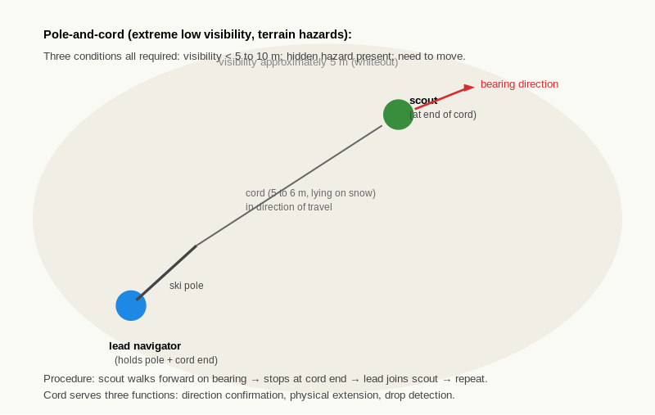
Reference diagram. Pole-and-Cord Technique. lead navigator and scout linked by cord; physical confirmation of direction.
A candidate is leading a group on a descent in flat light. Visibility drops to approximately 5 m. The map shows a cornice along the ridge crest the group is crossing, with steep ground to the east.
The candidate stops the group and assesses. The bearing for the next leg (away from the cornice and into a safer descent line) is 195 magnetic. The visibility is too low for a partner to walk safely as an aiming point; the cornice risk means stepping forward without verification could put the scout into the cornice or onto the steep slope.
The candidate deploys the pole-and-cord technique:
- The pole is tied to the cord end; a group member is briefed as the scout.
- The scout sets off on the 195 bearing, paying out the cord. After 5 m the scout stops.
- The candidate verifies the cord lies on the bearing (visual confirmation in the few metres of visibility available).
- The scout probes the snow ahead with their pole before stepping. The cord margin gives the lead navigator time to react if the scout finds a drop.
- The candidate walks forward to join the scout.
- The procedure repeats for the next 5 m.
After approximately 30 m of progress (six iterations), the group reaches a position where the visibility allows a partner to be seen at 20 m. The technique is wound up; the group continues with intermediate aiming points.
Total time for the 30 m: approximately 10 minutes. Slow, but the cornice was successfully avoided and no member was at risk of stepping into it.

Exercise 1 - When the pole-and-cord adds value
In two or three sentences, identify a scenario from your exam-area map where the pole-and-cord technique would add value beyond a partner used as a standard intermediate aiming point.
____________________________________________________ ____________________________________________________

Exercise 2 - When simpler techniques would be preferable
For each scenario, state whether you would use the pole-and-cord technique or a simpler approach. Give a one-sentence reason.
Scenario | Pole-and-cord, or simpler? | Reason
Visibility 30 m, group of three on a broad gentle snow slope
Visibility 5 m, group on a ridge with cornice on one side
Visibility zero, group at a hut, waiting for conditions to improve
Visibility 8 m, group descending from a col with a known cliff band 200 m below

Exercise 3 - Practical drill on snow
If snow is available, practise the technique with a partner over a 10 m and then a 30 m leg.
- Was the cord lying clearly on the bearing?
- Did the scout stop reliably at the end of the cord?
- How long did the 30 m leg take?
- Reflect: what would change if you were doing this in real flat light rather than in good visibility?

Exercise 4 - The "know it even if you never use it" framing
In two or three sentences, explain in your own words why the IMS Nav Training Programme treats the pole-and-cord technique as one to know but rarely deliberately use, and what the candidate's answer should be if the assessor asks "how would you handle a whiteout descent above a cornice?"
____________________________________________________ ____________________________________________________

Self-check
☐ I can describe the pole-and-cord setup and the six-step procedure.
☐ I know the three conditions that all need to hold for the technique to be appropriate.
☐ I can identify when simpler techniques (intermediate aiming points, sheltering and waiting) would be preferable.
☐ I have practised the technique on snow at least once (or have a clear plan to do so).
☐ I can articulate the IMS / EMS framing of the technique as one to know but rarely use.

Why this matters for IMS
The pole-and-cord technique is the IMS-specific technique that the assessor may probe with a "how would you handle X" question. A candidate who knows the technique, knows when it is appropriate, and knows when it is not, has the working assessment-standard response. A candidate who has never heard of it cannot answer the question; a candidate who would use it for every poor-visibility leg has misunderstood the conditional use.

D8.3 When Navigation Goes Wrong
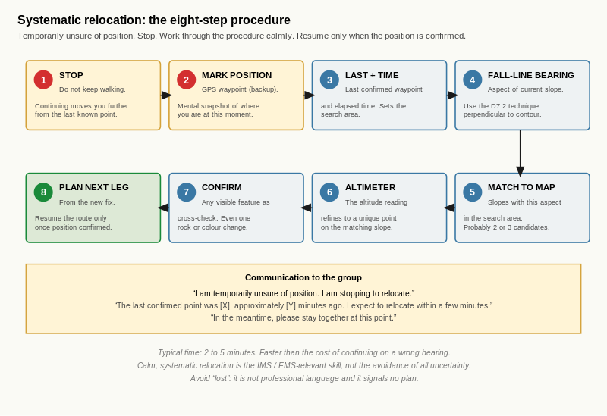
Reference diagram. Systematic Relocation Procedure. steps 1 and 2 are behaviour and backup; steps 3 to 7 are the fix itself (aspect, altitude, feature); step 8 is the resume. The right communication runs in parallel with the procedure.

Learning aim
By the end of this page, you should be able to apply Mountaineering Scotland's calm, systematic relocation procedure when you become uncertain of position, communicate "temporarily unsure of position" to a group without losing their confidence, and recognise that calm systematic relocation is the IMS / EMS-relevant skill rather than the avoidance of all uncertainty.

Why this matters
Becoming temporarily unsure of position is normal in mountain navigation. It happens to experienced navigators in good visibility; it happens more often in poor visibility. The IMS / EMS skill is not avoiding uncertainty entirely; it is responding to uncertainty calmly and systematically.
The candidate who never admits to being uncertain is a candidate who continues on a wrong bearing for ten minutes longer than they should. The candidate who panics in front of the group is a candidate the group loses confidence in. The candidate who stops, communicates calmly, and works through a relocation procedure is the candidate the assessor is looking for.
Mountaineering Scotland's "when navigation goes wrong" page is the published source for the procedure. It is consistent with general navigation pedagogy at Mountain Leader and IMS / EMS levels.

The systematic relocation procedure
When uncertain of position:
- Stop. Do not continue walking. Continuing means moving further from the last known position, making relocation harder.
- Mark the position mentally and (if available) with a GPS waypoint. The GPS waypoint is for backup, not for primary use; the relocation should be possible with map and compass alone.
- Note the last confirmed position and the elapsed time since that position. This is the search starting point: the candidate is somewhere within the area reachable from the last confirmed position in the elapsed time.
- Take a fall-line bearing of the slope. This is the aspect-of-slope technique from D7.2. The aspect bearing constrains the position to a specific kind of slope.
- Match to the map using the compass perpendicular to contours (the D7.2 procedure). This identifies the possible positions consistent with the aspect.
- Check the altimeter. The altitude reading refines the position fix to a unique point on the matching slope.
- Confirm with any visible feature. If even one feature is visible (a small rock, a colour change in the snow, a distant ridge), use it as a cross-check.
- Plan the next leg from the new fix. Once the position is established, the route resumes from the new known point.
The procedure typically takes 2 to 5 minutes. It is slower than continuing on the assumption that everything is fine, but it is the only way to recover when "everything is fine" turns out not to be true.

The leadership dimension
A trip leader's response to uncertainty affects the whole group. A panicked leader produces a panicked group; a calm leader produces a calm group, even when the situation is genuinely uncertain.
Useful language patterns:
- "I am temporarily unsure of position. I am stopping to relocate." This is the professional formulation. It admits the uncertainty (which builds trust) and states the action (which builds confidence).
- "The last confirmed position was [X], approximately [Y] minutes ago. I expect to relocate within a few minutes." This frames the situation as a managed problem, not a crisis.
- "In the meantime, please stay together at this point." This gives the group a clear instruction and prevents them from wandering.
Avoid:
- "I think we might be lost." "Lost" is not professional language; it suggests there is no plan. "Temporarily unsure" suggests a known process is underway.
- "Let me just check the map." Vague; does not communicate the action.
- Continuing to walk while consulting the map. Suggests the candidate is hoping the situation will resolve itself.
The IMS / EMS assessor will watch for the leadership dimension during route narration. A candidate who can communicate "temporarily unsure" calmly is at the working assessment standard.

Worked example
A candidate is leading a tour. After approximately 40 minutes of walking on a bearing in moderate visibility (approximately 100 m), the candidate notices that the expected col is not visible at the expected time. The altimeter reads 2,650 m; the col was expected at 2,720 m at this point.
The candidate applies the procedure:
- Stop. Calls the group together.
- GPS waypoint marked as a backup. (The candidate does not consult the GPS for the relocation; it is a backup if all else fails.)
- Last confirmed position: the bench at 2,540 m, 40 minutes ago.
- Fall-line bearing of the current slope: 095 magnetic. Variation +2 east; grid bearing = 093 (east-facing).
- Match to the map. The east-facing slope below the col is the candidate-set; the perpendicular-to-contour bearing of 093 grid is consistent with that slope.
- Altimeter reads 2,650 m. On the east-facing slope below the col, 2,650 m is the contour the candidate is on.
- Confirm with visible feature. A small rock outcrop is visible at approximately 80 m to the south. The candidate identifies it on the map: a marked rock at 2,640 m on the east-facing slope. Cross-check confirms the position.
- Plan the next leg. The col is approximately 250 m to the north-west, climbing 70 m. The candidate sets a new bearing to the col and continues.
The relocation took approximately 4 minutes. The candidate's communication to the group was: "I am temporarily unsure of position. The last confirmed point was the bench at 2,540 m. I am stopping to relocate; expect a few minutes." After the fix, the candidate confirmed: "We are at 2,650 m on the slope below the col. The col is approximately 250 m to the north-west. We continue."
The group remained calm throughout. The candidate's confidence after the fix was higher than before because the fresh position was now confirmed rather than assumed.

Exercise 1 - Walk through the procedure
For a worked scenario of your choice (use a position on your exam-area map; pick a position you have not been to in the workbook before), walk through the eight-step procedure as if you had just become uncertain of position there.
Step | Your work for this scenario
1. Stop
2. Mark position
3. Last confirmed position and elapsed time
4. Fall-line bearing
5. Match to map
6. Altimeter
7. Confirm with visible feature
8. Plan next leg

Exercise 2 - The leadership communication
For each candidate communication, state whether it is acceptable IMS / EMS-level language or not. If not, give a better alternative.
Candidate communication | Acceptable? | Better alternative if not
"We're a bit lost."
"I am temporarily unsure of position. I am stopping to relocate."
"Hold on, let me check the map while we walk."
"The last confirmed position was the col 20 minutes ago. I expect to relocate within a few minutes."
"I think we should keep going and we'll figure it out."

Exercise 3 - Why "temporarily unsure" works
In two or three sentences, explain in your own words why "temporarily unsure of position" is more useful language than "lost", both for the candidate's own thinking and for the group's confidence.
____________________________________________________ ____________________________________________________

Exercise 4 - The most common error
In two or three sentences, identify what you think is the most common error in this procedure (across all candidates, not specifically your own), and explain what the consequence is.
____________________________________________________ ____________________________________________________

Self-check
☐ I can apply the eight-step systematic relocation procedure on a worked scenario.
☐ I can communicate "temporarily unsure of position" to a group calmly and clearly.
☐ I avoid the language patterns that suggest there is no plan ("lost", "let me check while we walk").
☐ I recognise that becoming temporarily unsure is normal in alpine navigation.
☐ I treat calm systematic relocation as the IMS / EMS-relevant skill rather than the avoidance of uncertainty.

Why this matters for IMS
The leadership dimension of poor-visibility navigation is one of the IMS / EMS-relevant moments the assessor will watch for. A candidate who can communicate "temporarily unsure" calmly, run the systematic procedure, and resume the route with confidence is at the working assessment standard. A candidate who panics in front of the group, or who continues walking on a wrong bearing rather than admit uncertainty, is not.
After D8 the candidate has the poor-visibility navigation toolkit complete. D9 covers route cards as the integrative artefact that makes D8 work; D10 closes Level 3 with consolidation.
These two pages cover the basic route card. D9.1 covers the standard fields and what each one is for. D9.2 covers writing a complete route card for a six-leg tour, applying the techniques and conventions built across D2 to D8.
D9.3 and D9.4 then add the contingency layer: decision points and go / no-go criteria (D9.3); escape routes and contingency planning (D9.4). Together the four D9 pages give the candidate the full route-card skill set.
The route card is the integrative artefact of Level 3. Every previous instrument and technique feeds into it. The IMS / EMS assessor reviews route cards as evidence that the candidate can plan; the route card on the day is the candidate's working reference for the whiteout sequence and the relocation procedure from D8.

D9.1 Anatomy of a Route Card
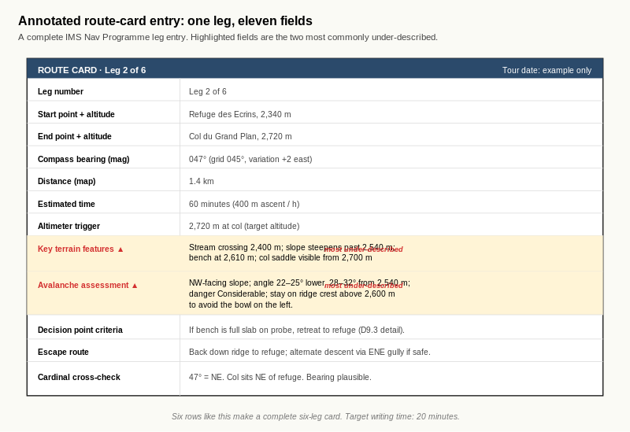
Reference diagram. Annotated Route-Card Entry. the eleven fields appear in a fixed order so the writer can populate them mechanically. The two highlighted rows are where assessor scrutiny is highest; a one-phrase entry there is a fail.

Learning aim
By the end of this page, you should be able to identify the standard fields of an IMS-style route card, explain the function of each field, and recognise the two fields that most commonly get under-described in candidate route cards.

Why this matters
A route card is only useful if it captures the right information in the right form. A card with vague entries (or with key fields missing) is no better than no card at all in poor visibility. A card with complete, specific entries is the foundation of every subsequent IMS / EMS-relevant practice from D8 onwards.
For the candidate, knowing the fields makes the writing in D9.2 efficient. The writing time in D9.2 is targeted at 20 minutes for a six-leg card; that target only works if the candidate knows which fields go where without thinking about them.

The standard fields
The IMS Nav Training Programme route card template (Quick Reference Card 3) uses the following per-leg fields:
- Leg number. The position of the leg in the day's tour (Leg 1 of 6, Leg 2 of 6, etc.).
- Start point and altitude. The named feature where the leg begins and its elevation.
- End point and altitude. The named feature where the leg ends and its elevation.
- Compass bearing (magnetic). The bearing the candidate sets on the compass to walk the leg. This is the magnetic bearing; the underlying grid bearing may also be recorded for cross-check.
- Distance (map). The horizontal distance of the leg as measured on the map.
- Estimated time. The expected duration of the leg in minutes.
- Altimeter trigger height. The altimeter reading at which the candidate stops or changes action. For a leg ending at a waypoint, this is the target altitude. For a leg with an intermediate trigger (descend to 2,500 m then bear right), this is the trigger altitude.
- Key terrain features. The recognisable features the candidate expects to encounter or pass; used for confirmation in good visibility and for orientation in poor.
- Avalanche assessment. The slope angle, aspect, and avalanche-relevant terrain considerations for the leg. Built using the C1.2, C4.2, and C6.1 / C6.2 vocabulary.
- Decision point criteria. The pre-agreed criteria for go / no-go decisions during the leg. Covered in D9.3.
- Escape route. The contingency route if the leg cannot be completed as planned. Covered in D9.4.
A complete card has all eleven fields populated for every leg. A six-leg tour produces six rows of eleven entries each.

Two most commonly under-described fields
Across most candidates' route cards, two fields are typically under-described:
- Key terrain features. Many candidates note one obvious feature (the col, the summit) and skip the smaller features that would actually confirm position en route (a stream crossing at 2,400 m, a slope-angle change at 2,650 m, a forest edge below the col). The fix is to walk the leg in imagination and note every feature the candidate would expect to see.
- Avalanche assessment. Many candidates write a single phrase ("30 degrees north-facing") and skip the route-relevant detail (where on the leg the slope is steepest; whether the leg crosses a runout zone; whether the line is above or below a cornice-prone ridge). The fix is to apply the C6.2 terrain-trap reading to the leg explicitly.
These two fields are also the ones the IMS / EMS assessor scrutinises most carefully. A candidate whose key-terrain field reads "col at 2,720 m" has done one tenth of the work; a candidate whose field reads "stream crossing at 2,400 m, bench at 2,540 m, slope steepens past 2,600 m, col at 2,720 m" has done the work the assessor expects.

Worked example
A candidate plans a leg from a hut at 2,340 m to a col at 2,720 m. Distance approximately 1.4 km; expected ascent rate 400 m per hour for a moderate ski-touring pace. Bearing 047 magnetic.
A complete route-card entry for the leg:
Field | Entry
Leg number | Leg 2 of 6
Start | Refuge des Ecrins, 2,340 m
End | Col du Grand Plan, 2,720 m
Compass bearing (magnetic) | 047
Distance | 1.4 km
Estimated time | 60 minutes
Altimeter trigger height | 2,720 m (target altitude at col)
Key terrain features | Stream crossing at 2,400 m; slope steepens past 2,540 m; bench at 2,610 m; col saddle visible from 2,700 m
Avalanche assessment | NW-facing slope; angle 22 to 25 degrees on lower section, 28 to 32 degrees from 2,540 m; danger Considerable; stay on ridge crest above 2,600 m to avoid the bowl on the left
Decision point criteria | (covered in D9.3)
Escape route | (covered in D9.4)
The eleven fields are populated; the candidate has a working entry for one leg. Six such entries make the card.

Exercise 1 - Label a blank route card template
Your trainer has provided a blank route-card template with the field labels removed. Re-label all eleven fields for one leg.
[Sketch space - approximately 12 cm by 10 cm]

Exercise 2 - Function-matching
Match each field to its function by writing the letter (a to k) next to the field name.
Field | Function letter
Leg number
Start point and altitude
End point and altitude
Compass bearing (magnetic)
Distance
Estimated time
Altimeter trigger height
Key terrain features
Avalanche assessment
Decision point criteria
Escape route
Functions:
- (a) The named feature where the leg begins and its elevation.
- (b) The named feature where the leg ends and its elevation.
- (c) The contingency route if the leg cannot be completed as planned.
- (d) The position of the leg in the day's tour.
- (e) The recognisable features the candidate expects to encounter or pass.
- (f) The horizontal distance of the leg as measured on the map.
- (g) The bearing the candidate sets on the compass to walk the leg.
- (h) The expected duration of the leg in minutes.
- (i) The slope angle, aspect, and avalanche-relevant terrain considerations.
- (j) The pre-agreed criteria for go / no-go decisions during the leg.
- (k) The altimeter reading at which the candidate stops or changes action.

Exercise 3 - Fill in one leg
For one leg of a tour from your exam-area map, fill in the eleven fields completely. The leg should be one you have not previously used in the workbook.
Field | Entry
Leg number
Start
End
Compass bearing (magnetic)
Distance
Estimated time
Altimeter trigger height
Key terrain features
Avalanche assessment
Decision point criteria | (D9.3)
Escape route | (D9.4)

Exercise 4 - Identify the typically under-described fields
In two or three sentences, identify the two fields that most commonly get under-described in candidate route cards, and explain what an under-described entry looks like for each. Use your own Exercise 3 entry as a reference if it shows the pattern.
____________________________________________________ ____________________________________________________

Self-check
☐ I can name the eleven standard fields of an IMS-style route card.
☐ I can match each field to its function without thinking about it.
☐ I can fill in a complete entry for one leg.
☐ I recognise that the key-terrain and avalanche-assessment fields are typically under-described.
☐ I can identify the under-description in my own entries and improve them.

Why this matters for IMS
The route card is the IMS / EMS assessor's primary planning artefact. A candidate whose card has all eleven fields populated for every leg is at the working assessment standard; a candidate whose card has gaps or vague entries is not. After D9.1 the candidate has the field vocabulary; D9.2 covers using it under speed pressure.

D9.2 Writing a Route Card

Learning aim
By the end of this page, you should be able to write a complete route card for a six-leg tour from your exam-area map within the IMS Nav Programme target of 20 minutes, self-mark against a reference card written by an experienced navigator (or by your trainer), and identify the three slowest legs and what made them slow.

Why this matters
The route card writing speed is one of the IMS Nav Programme assessment-checklist standards: complete a full tour route card within 20 minutes total. The 20-minute target works out to approximately 200 seconds per leg for a six-leg tour, which is achievable with practice but not without it.
For the IMS / EMS candidate, the speed standard matters because route cards are written under time pressure on real tour days (the morning of the tour, the evening before, sometimes during a brief stop mid-tour to revise the plan). A candidate who needs an hour to write a card has a card that is often unfinished; a candidate who needs 20 minutes has a card that is reliably complete.

The procedure
Writing a complete route card for a six-leg tour:
- Identify the legs. Decide where the tour starts, where it ends, and the meaningful waypoints in between. Six legs is a typical full-day tour; some are shorter, some longer.
- For each leg, take the bearing using the D2.1 four-step procedure. Apply the variation (D2.2). Record both grid and magnetic if the candidate's card has space; magnetic is what the candidate uses in the field.
- Record the target altitude for each leg. This is the altimeter trigger height for arrival at the next waypoint.
- Estimate distance and time. Distance is measured on the map at the map's scale; time is calculated using the candidate's typical ski-touring pace (often 300 to 400 m per hour ascent rate; 1 to 2 km per hour horizontal on snow).
- Note key terrain features. Walk the leg in imagination and list every feature the candidate would expect to see, in order from start to end.
- Write the avalanche assessment. Apply C6.2 terrain-trap reading to the leg explicitly.
- Identify decision points (D9.3).
- Identify escape routes (D9.4).
- Self-check the card. Read through every leg; confirm all eleven fields are populated; confirm the bearings and altitudes are consistent with the start and end points.
The procedure is deliberate; the speed comes from familiarity. A candidate who has written a dozen route cards can run the procedure on autopilot; a candidate writing their first card will find every step takes longer than they expected.

The 20-minute target
The IMS Nav Programme assessment-checklist target is to complete a full tour route card within 20 minutes. For a six-leg card, this is approximately 200 seconds per leg.
Within the 200 seconds, time breaks down approximately:
- Identify start and end points: 20 seconds.
- Take bearing using D2.1: 60 seconds.
- Apply variation: 10 seconds.
- Record target altitude, distance, time: 30 seconds.
- Write key terrain features: 40 seconds.
- Write avalanche assessment: 30 seconds.
- (Decision points and escape routes added separately, in D9.3 and D9.4.)
The 20-minute target is the working IMS / EMS standard. A candidate consistently above 30 minutes is not yet at standard; one consistently above 45 minutes has serious procedural inefficiencies and should recycle the underlying skills.

Worked example
A candidate plans a six-leg tour from a lift station at 1,850 m through a col at 2,720 m, a summit at 2,980 m, a hut at 2,450 m, a second col at 2,610 m, and back to the lift station via a different descent line.
The candidate sets a 20-minute timer and works through the procedure:
- Minute 0 to 3: identifies the six legs and writes start / end points and altitudes for each.
- Minute 3 to 11: takes six bearings using the D2.1 procedure; applies variation; records target altitudes.
- Minute 11 to 15: estimates distances and times for each leg.
- Minute 15 to 19: writes key terrain features and avalanche assessments.
- Minute 19 to 20: self-checks the card.
Total: 20 minutes. The card has six entries with the nine basic fields populated. Decision points and escape routes are added in D9.3 and D9.4.
If the candidate runs over 20 minutes, the slowest sections are usually the bearing-taking (if D2.1 is not yet automatic) and the avalanche-assessment writing (if C6.2 is not yet fluent). Recycle the underlying skill rather than just trying to write faster.

Exercise 1 - Speed-test exercise
Set a 20-minute timer. Write a complete route card for a six-leg tour from your exam-area map. Use the table format from D9.1 Exercise 3 (eleven fields per leg; decision points and escape routes can be filled in later in D9.3 and D9.4).
The card should have six entries. Time yourself.
- Time taken: __________ minutes
- Number of legs completed within the 20 minutes:
- Were all nine basic fields (excluding decision points and escape routes) populated for each completed leg?

Exercise 2 - Self-mark against a reference
Compare your card with a reference card for the same tour, written by an experienced navigator or by your trainer.
Comparison criterion | Result
Bearings within 2 degrees of the reference | __ legs out of __
Target altitudes match reference | __ legs out of __
Distance estimates within 10% of the reference | __ legs out of __
Time estimates within 15% of the reference | __ legs out of __
Key-terrain features at least as detailed as the reference | __ legs out of __
Avalanche assessment at least as detailed as the reference | __ legs out of __

Exercise 3 - Identify the three slowest legs
For your card from Exercise 1, identify the three legs that took the longest to write.
- Slowest leg: __________ Reason:
- Second-slowest leg: __________ Reason:
- Third-slowest leg: __________ Reason:
For each, identify the underlying skill that needs to improve (D1.1 compass parts? D2.1 bearing procedure? D2.2 variation conversion? C6.2 terrain-trap reading? D5.2 calibration logic?).

Exercise 4 - The under-description test
Read your card from Exercise 1 against the under-description criteria from D9.1 (key-terrain features and avalanche assessment).
- Did your key-terrain entries name multiple features per leg, or only the obvious one?
- Did your avalanche entries reference the C6.2 terrain-trap reading, or only the slope angle?
- What two improvements will you make to the next route card you write?

Self-check
☐ I can write a complete route card for a six-leg tour within 20 minutes (or have a clear plan to reach the standard with practice).
☐ I can self-mark my card against a reference card and identify specific differences.
☐ I can identify which legs took the longest to write and trace the slowness to a specific underlying skill.
☐ I have read my card against the under-description criteria and identified at least two improvements.
☐ I treat the 20-minute target as a working IMS / EMS standard rather than as an aspirational goal.

Why this matters for IMS
The 20-minute speed standard is one of the IMS / EMS assessable benchmarks from the IMS Nav Programme. A candidate who can produce a complete card within 20 minutes has the planning fluency the assessor expects; a candidate who needs an hour will not finish cards on real tour days and will operate without the route-card foundation that D8 depends on.
After D9.2 the candidate has the basic route card. D9.3 adds decision points and go / no-go criteria; D9.4 adds escape routes and contingency planning. Together these complete the route card as the integrative artefact of Level 3.
These two pages add the contingency layer to the route card. D9.3 covers decision points and go / no-go criteria: where on the route the candidate stops to decide, and what conditions trigger which decision. D9.4 covers escape routes and contingency planning: the alternative route if the planned route cannot be completed.
D9.3 builds on D6.2 (the pressure-to-weather decision framework) and applies it to the full route. D9.4 builds on C6.2 (terrain traps and committing terrain) and applies the alternative-route thinking from there to every leg.
After D9 the candidate has the route card complete: basic fields (D9.1), full writing technique (D9.2), decision points with criteria (D9.3), and escape routes with contingency thinking (D9.4). D10 then closes Level 3 with consolidation.

D9.3 Decision Points and Go / No-Go Criteria

Learning aim
By the end of this page, you should be able to place decision points on a route card at meaningful locations, write go / no-go criteria that meet the three-component standard from D6.2 (specific trigger, specific action, named decision point), and recognise the typical decision-point locations on an alpine route card.

Why this matters
A route card without decision points is a one-way commitment: the candidate plans to complete the tour and has no structured way to abort. A route card with decision points is a managed plan: the candidate plans to complete the tour but has pre-agreed criteria for stopping or changing course at specific places.
For an IMS / EMS candidate, decision points are the discipline that turns a route card from a plan into a managed plan. The assessor will look for them; their absence is a meaningful gap.

Where to place decision points
Decision points are placed at specific kinds of locations:
- Cols and ridges where committing terrain begins below. Once the candidate descends from the col, the descent commits them; the col is the last pre-commitment decision point.
- Points of no return. A traverse above a cliff band, a couloir entry, a gully descent. The decision is made before entering the committing terrain, not during.
- Major slope crossings. Where the route crosses a slope that is in the avalanche release range, the decision point is at the slope edge before crossing.
- Time / weather checkpoints. Specific points on the route where the candidate has agreed to assess time elapsed, weather trend (D6.2), and group condition before continuing.
For a typical six-leg full-day tour, the candidate places three to five decision points. Fewer than three suggests the candidate has not engaged with the contingency thinking; more than five suggests the candidate is over-engineering the card.

The three-component criteria standard
From D6.2: every pre-agreed criterion has three components:
- A specific trigger (a measurable condition).
- A specific action (turn around, take the alternative line, abort, etc.).
- A named decision point (the specific location where the criterion is checked).
Examples of strong criteria:
- "If the barometer has fallen by more than 2 hPa since departure when checked at the col at 2,720 m, descend by the morning route."
- "If the time of arrival at the col exceeds 10:30am, skip the summit and traverse via the south col instead."
- "If any group member is unable to maintain the planned pace at the bench at 2,540 m, turn around and descend to the hut."
Examples of weak criteria (coach for specificity):
- "If the weather looks bad, turn around." No measurable trigger; no specific action; no decision point.
- "Watch the weather." Not a criterion at all.
- "If we are running late, decide what to do." No specific trigger; no specific action.
The three-component standard is non-negotiable for IMS / EMS assessment. A candidate's route card with vague criteria signals incomplete planning thinking.

Worked example
A candidate's tour from D9.2 (lift station at 1,850 m through col at 2,720 m, summit at 2,980 m, hut at 2,450 m, second col at 2,610 m, back to lift station) has four natural decision points:
- Decision Point 1: at the col at 2,720 m. The col is the gateway to the summit attempt; the descent from the col commits to the summit-and-hut sequence.
- Decision Point 2: at the summit at 2,980 m. The descent route choice (planned north line vs alternative south line) is made here.
- Decision Point 3: at the hut at 2,450 m. The afternoon decision: continue to the second col, or stop here for the day.
- Decision Point 4: at the second col at 2,610 m. The final descent line choice: planned line vs alternative.
Pre-agreed criteria for each:
- DP1 (col at 2,720 m):
- If the time is past 10:30am: skip summit; traverse via south col.
- If the barometer has fallen more than 2 hPa since departure: descend by the morning route.
- If any group member is struggling: descend by the morning route.
- DP2 (summit at 2,980 m):
- If the weather is rising or steady: descend by the planned north route.
- If the weather trend is in slow or moderate fall: descend by the south route (more reliable bailout).
- If the weather trend is in rapid fall: descend by the south route immediately.
- DP3 (hut at 2,450 m):
- If the time is before 2pm and conditions are stable: continue to the second col.
- If the time is between 2pm and 3pm and conditions are stable: continue but use the shorter alternative route from the second col.
- If the time is after 3pm or conditions are deteriorating: stop at the hut for the day.
- DP4 (second col at 2,610 m):
- If conditions allow: descend by the planned route.
- If conditions have deteriorated since the hut: descend by the alternative route (longer but more sheltered).
The card now has decision points named, located, and equipped with criteria. The plan is no longer a one-way commitment; it is a managed plan with structured fall-back at four specific moments.

Exercise 1 - Identify decision points on your tour
For the tour from D9.2 Exercise 1 (or a fresh tour from your exam-area map), identify all the decision points you would place. Aim for three to five.
# | Decision point location | Why this location
1
2
3
4
5

Exercise 2 - Write criteria for each decision point
For each decision point from Exercise 1, write at least one go / no-go criterion that meets the three-component standard.
Decision point | Criterion (trigger / action / location)
1
2
3
4
5

Exercise 3 - Recognise the weak criteria
For each of the following criteria, state whether it meets the three-component standard. If not, identify the missing component(s) and rewrite to make it acceptable.
Criterion | Standard met? | Missing components / rewrite
If the weather looks bad at the col, turn around.
If the barometer has fallen more than 2 hPa since departure when checked at the col at 2,720 m, descend by the morning route.
Watch the weather.
If a group member needs more than 5 minutes' rest at the bench at 2,540 m, turn around and descend to the hut.
If we are running late, decide what to do.

Exercise 4 - The "want to continue" test
In two or three sentences, explain in your own words why a pre-agreed criterion at a decision point is more useful than a fresh decision in the moment, especially when the candidate (or the group) wants to continue.
____________________________________________________ ____________________________________________________

Self-check
☐ I can identify three to five decision points on a typical six-leg full-day tour.
☐ I can place decision points at the meaningful locations (cols, points of no return, major slope crossings, time / weather checkpoints).
☐ I can write go / no-go criteria that meet the three-component standard.
☐ I can recognise weak criteria and rewrite them to acceptable standard.
☐ I understand that pre-agreed criteria override the in-the-moment pressure to continue.

Why this matters for IMS
The decision points and pre-agreed criteria are one of the IMS / EMS-relevant route card features the assessor will look for. A card without them is a one-way commitment; a card with them is a managed plan. The candidate who has the discipline to write the criteria and the discipline to apply them on the day is at the working assessment standard.

D9.4 Escape Routes and Contingency Planning

Learning aim
By the end of this page, you should be able to plan one or more escape routes for each leg of a route card, identify a generic safe-line strategy, and recognise when no viable escape route exists and what that implies for the route choice.

Why this matters
An escape route is the alternative line when the planned route cannot be completed. Every committing decision should have one. The route card with escape routes is a card with options; the route card without them is a card with one path and one outcome.
For an IMS / EMS candidate, escape routes are the contingency layer that closes the route card. The assessor reviews them as evidence that the candidate has thought about what could go wrong, not just what should go right.
The most important escape-route insight is the negative case: when the candidate cannot identify a viable escape route for a leg, the route choice itself may be wrong. A leg with no escape route is a committing decision; the candidate should know that before committing.

What an escape route is
An escape route is a different route from the planned route, used when the planned route fails. "Different route" means:
- a different bearing or direction of travel,
- a different waypoint or destination,
- or both.
Examples:
- Planned route: ascend via the north ridge to the summit. Escape: descend via the morning route to the lift station.
- Planned route: traverse the upper bowl. Escape: drop into the bowl floor and descend via the safer south flank.
- Planned route: cross the col and descend the west slope. Escape: turn back at the col and descend via the south slope.
A "different route" does not mean "the same route in reverse" unless reversing is meaningfully safer. A reversal is sometimes the right escape (when the candidate has come up a safe line and is now committing to a less safe descent), but often it is not (when the safe line on the way up was via a slope that is now wind-loaded and avalanche-prone for the descent).

Where to plan escape routes
For each leg of the route card, the candidate identifies:
- The escape route from the leg's start. If the candidate stops at the start of the leg and does not commit, where do they go?
- The escape route from the leg's end. If the candidate completes the leg and conditions then change, where do they go from the leg's destination?
- The escape route from any committing point within the leg. If the leg has a point of no return mid-way, where does the candidate go from there?
For most legs, the escape route from the start and the escape route from the end are different routes; the within-leg escape route may be the same as one of the others or distinct.

When no escape route exists
A leg with no viable escape route is a committing leg. Examples:
- A traverse below a cornice with steep ground to one side and a cliff to the other: there is no safe alternative line.
- A couloir descent: once the candidate enters, the only way out is down the couloir.
- A long contour at high altitude with no safe descent in either direction for several kilometres.
When the candidate identifies a leg with no escape route, two responses are appropriate:
- Recognise the commitment explicitly. The route card notes "no viable escape; committing leg" and the decision-point criteria for entering the leg are tightened accordingly.
- Reconsider the route choice. A committing leg in stable conditions may be acceptable; a committing leg in marginal conditions is usually not. The "no viable escape" finding is a flag that the route may need to be revised.
The IMS / EMS-relevant insight: a route with multiple legs flagged "no viable escape" is a route that will not work in any conditions short of perfect. The candidate's response to this finding is part of the planning skill the assessor tests.

Worked example
The candidate's tour from D9.2 / D9.3 has four decision points. Escape routes for each leg:
- Leg 1: Lift station to col at 2,720 m. Escape: turn back along the ascent line to the lift station. Always available; the ascent line is on a broad shoulder with no committing terrain.
- Leg 2: Col to summit at 2,980 m. Escape: turn back at any point along the leg to the col, then descend via the morning route. Available unless conditions make the col itself dangerous.
- Leg 3: Summit to hut at 2,450 m. Two routes exist: the planned north route (steeper, faster, exposed) and the alternative south route (longer, more sheltered, more bailout opportunities). The south route is the escape from the north.
- Leg 4: Hut to second col at 2,610 m. Escape: stop at the hut and shelter. The leg is optional; the candidate is not committed to it.
- Leg 5: Second col back to lift station via planned line. Two routes exist: the planned line and the alternative line. The alternative line is longer but more sheltered; it is the escape from the planned line.
For each leg the candidate has named at least one escape. No leg is flagged "no viable escape", which suggests the route choice is reasonable for the conditions assumed.

Exercise 1 - Identify escape routes for each leg
For your tour from D9.2 / D9.3, identify the escape route(s) for each leg.
Leg | Planned route | Escape route(s)
1
2
3
4
5
6

Exercise 2 - Identify escape routes that would not work in worsening conditions
On the map, mark at least one escape route from Exercise 1 that would not work in worsening conditions (deteriorating weather, fresh avalanche, group member injured).
- Escape route that becomes unavailable in worsening conditions:
- Conditions under which it becomes unavailable:
- Alternative escape if this one fails:

Exercise 3 - The no-viable-escape recognition
For your tour, do any legs have no viable escape route? If yes, list them and explain.
- Legs with no viable escape:
- For each, what would you do at the planning stage?
If no legs are flagged, your route choice is reasonable for the conditions assumed. If multiple legs are flagged, consider whether the route should be revised.

Exercise 4 - The contingency-and-decision-point connection
In two or three sentences, explain in your own words how the escape routes from D9.4 connect to the decision points from D9.3. (Hint: the decision-point criteria are the conditions under which the escape route is taken.)
____________________________________________________ ____________________________________________________

Exercise 5 - Complete route card
For your tour from D9.2, add the decision-point and escape-route fields to your existing card. Each leg should now have all eleven fields populated.
Leg | Decision point criteria | Escape route
1
2
3
4
5
6

Self-check
☐ I can identify escape routes for every leg of a route card.
☐ I can recognise escape routes that would not work in worsening conditions and identify alternatives.
☐ I can recognise when no viable escape route exists and what that implies.
☐ I understand that decision-point criteria are the triggers for taking the escape route.
☐ I have a route card with all eleven fields populated for every leg.

Why this matters for IMS
Escape routes and contingency planning are the closing layer of the route card. A complete card with escape routes is the artefact that demonstrates the candidate has done the full planning thinking. The IMS / EMS assessor scrutinises the contingency layer carefully; a card without it signals that the candidate has planned a one-way commitment.
After D9 the route card is the integrative artefact of Level 3. Every previous instrument and technique feeds into it; the route card on the day is the candidate's working reference for the whiteout sequence (D8.1) and the relocation procedure (D8.3).
D10 closes Level 3 with consolidation: a mixed quiz (D10.1) and a virtual day on a tour (D10.2) that exercises the full route card and instrument toolkit in a sustained narration.
These two pages close Level 3. D10.1 is a mixed quiz that samples the full Level 3 vocabulary in a fast, low-stakes format. D10.2 is a sustained virtual day on a tour that integrates everything into a single multi-leg narration.
Together they are the diagnostic for Level 4 readiness, mirroring the role of C7.1 and C7.2 at the close of Level 2. The point is not to score well; the point is to find out where you are still slow or unsure, so you can revisit the right pages before moving on.
After D10 the candidate has the full Level 3 skill set: compass and bearings (D1 to D4), altimeter and barometer (D5 to D6), combined techniques (D7), poor-visibility navigation (D8), and route cards (D9). Level 3 closes with the candidate ready to move into the next phase of the IMS / EMS pathway: scenario response, full assessment-style narration, and the practical drill days that follow.

D10.1 Mixed Quiz

Learning aim
By the end of this page, you should have a clear, honest picture of which Level 3 skills are fluent, which are slow, and which are unreliable. The quiz is not graded for the workbook record; it is graded for your own progression decision.

How to use this page
The quiz has fifteen short questions, drawn from across Sections D1 to D9. Work through them in order at a comfortable pace.
After you finish, your trainer will mark with you. Use the error log at the end of the page to record:
- which questions you got wrong,
- which questions you got right but slowly,
- which Level 3 page each weak question relates to,
- and what you will do about it before D10.2.

The quiz

Question 1 - Compass parts
Name the two parts of a baseplate compass that are most commonly confused with each other, and give a one-sentence distinction.
____________________________________________________

Question 2 - Reading a bearing
The IMS / EMS-relevant working standard for reading a bearing from a set compass is what accuracy and what time?
Accuracy: __________ Time:

Question 3 - The four-step procedure
Name the four steps of the procedure for taking a bearing from the map. (Single phrase per step.)

Question 4 - Magnetic variation
The current magnetic variation for your map area is +2 degrees east. The grid bearing for a leg is 178 degrees. What is the magnetic bearing?
Magnetic bearing:

Question 5 - Walking on a bearing
The IMS / EMS-relevant working standard for drift while walking on a bearing is what figure?
Drift target: __________ m per __________ m of travel

Question 6 - Back bearing
The forward bearing for a leg is 220 magnetic. What is the back bearing?
Back bearing:

Question 7 - Resection
Resection requires what minimum number of visible features, and what angular separation between them produces the most accurate fix?
Minimum features: __________ Optimal angular separation: __________ degrees

Question 8 - Bearing shapes drill
The IMS / EMS-relevant working closure error standard for a 100-pace square bearing-shapes drill is approximately what figure?
Closure error standard: less than __________ paces

Question 9 - Magnetic interference
Name the four most common magnetic interference sources on a ski tour and give the workbook's minimum safe distance for each.
Source | Minimum safe distance
1.
2.
3.
4.

Question 10 - Altimeter and pressure
The rule of thumb for converting altimeter drift to implied pressure change is approximately what figure?
Rule of thumb: 1 hPa = __________ m of apparent altitude change.

Question 11 - Barometric trend bands
Name the five IMS Nav Programme barometric trend categories with the rate threshold for each.
Trend | Rate threshold
1.
2.
3.
4.
5.

Question 12 - Aspect-of-slope relocation
The four-stage aspect-of-slope relocation procedure starts with what action, and the IMS / EMS-relevant target time for the full procedure on a known slope is what figure?
Stage 1 action:
Target time: under __________ minutes

Question 13 - Pole-and-cord conditional use
The pole-and-cord technique is appropriate when all three of which conditions hold?

Question 14 - Route card fields
Name the eleven standard fields of an IMS-style route card.

Question 15 - Pre-agreed criteria standard
The three-component standard for a pre-agreed go / no-go criterion requires what three things?

Confidence score
For each of the seven skill areas below, mark your confidence after the quiz on a scale of 1 (not at all confident) to 5 (fully confident).
Skill area | Confidence (1 to 5)
Compass parts and reading (D1)
Bearings from the map and variation (D2)
Bearings on the ground and resection (D3)
Practical accuracy and instrument hygiene (D4)
Altimeter and barometer (D5, D6)
Combined techniques (D7) including aspect-of-slope relocation
Poor visibility (D8) and route cards (D9)

Error log
For each question you got wrong or were slow on, record:
Question # | Skill area | Page to revisit | What to do before D10.2

Self-check
☐ I have an honest score for the fifteen questions.
☐ I have an honest confidence score for each of the seven skill areas.
☐ I have a specific list of pages to revisit before D10.2.
☐ I have a specific plan for what I will do before D10.2.

Why this matters for IMS
D10.1 is the first sustained mixed-skills check of Level 3 (mirroring the role of C7.1 in Level 2). It is not the IMS / EMS assessment, but it is the first time the candidate has to switch fluently between Level 3 skills under light time pressure, which is what the assessor will require in the field. The error log is the page's most useful artefact: it identifies exactly which earlier pages need a second pass before D10.2.

D10.2 Virtual Day on a Tour

Learning aim
By the end of this page, you should be able to follow a six-leg route across a 1:25,000 alpine map and produce a sustained narrative of the planning thinking, the instrument use at each leg, the decision points and escape routes, and the response to one "what if" scenario per leg. This is the closing exercise of Level 3 and the bridge into the next phase of the IMS / EMS pathway.

Why this matters
The virtual day on a tour is the closest the workbook gets to a full assessment-style narration. It integrates:
- the route card (D9) as the planning artefact,
- the compass and altimeter (D1 to D7) as the navigation instruments,
- the barometer (D6) as the weather indicator,
- the poor-visibility procedures (D8) as the contingency response,
- the leadership communication patterns (D8.3) as the working voice.
The IMS / EMS assessor's most demanding test is to ask the candidate to lead a tour while narrating each decision. D10.2 is the rehearsal, on paper, with the trainer alongside.

How to use this page
Working materials: the Section D10.2 map extract (provided by your trainer; 1:25,000, 10 m contours), with a six-leg route pre-marked. The route should span the kinds of terrain the candidate met in Section D9.2 (col, summit, hut, alternative descent).
For each leg, the candidate narrates:
- the route card entry (using the eleven-field structure from D9.1),
- the instrument plan (which instruments are primary, which are secondary, calibration timing),
- the decision-point criteria (using the three-component standard),
- the escape route (with worsening-conditions check),
- and the response to a "what if" scenario injected by the trainer.
The narration is sustained: each leg should run to roughly five minutes of spoken or written content, with all five elements addressed. A six-leg tour produces 30 minutes of structured narration.

Pre-departure briefing
Before the legs begin, the candidate gives a pre-departure briefing covering:
- The day's objective in one sentence:
- The forecast (in one sentence; assume the trainer has provided):
- The barometer reading at departure: __________ hPa
- The altimeter calibration point:
- The expected duration: __________ hours
- The group composition (assumed):
- The headline contingency criteria for the day:

Leg 1 - Lift station to first waypoint

Route card entry
Use the eleven-field structure from D9.1. Note all eleven fields.
____________________________________________________

Instrument plan
Which instruments are primary for this leg, and which are secondary? When and where will you recalibrate the altimeter?

Decision-point criteria
If this leg has a decision point, write at least one criterion meeting the three-component standard.

Escape route
Identify the escape route and note one condition under which it would not work.

"What if" scenario
The trainer injects a scenario at this leg. Examples: weather deterioration; a group member tiring; an unexpected steep slope; visibility drop. Respond in three to four sentences.
Scenario:
Response: ____________________________________________________

Leg 2 - First waypoint to summit
(Use the same five-element structure as Leg 1.)

Route card entry

Instrument plan

Decision-point criteria

Escape route

"What if" scenario
Scenario:
Response: ____________________________________________________

Leg 3 - Summit descent

Route card entry

Instrument plan

Decision-point criteria

Escape route

"What if" scenario
Scenario:
Response: ____________________________________________________

Leg 4 - Mid-tour traverse

Route card entry

Instrument plan

Decision-point criteria

Escape route

"What if" scenario
Scenario:
Response: ____________________________________________________

Leg 5 - Second col

Route card entry

Instrument plan

Decision-point criteria

Escape route

"What if" scenario
Scenario:
Response: ____________________________________________________

Leg 6 - Final descent to lift station

Route card entry

Instrument plan

Decision-point criteria

Escape route

"What if" scenario
Scenario:
Response: ____________________________________________________

Closing reflection
Look back at the full six-leg narration.

R1 - Strongest leg
In two or three sentences, identify the leg you narrated most strongly and what you did well there.
____________________________________________________ ____________________________________________________

R2 - Weakest leg
In two or three sentences, identify the leg you narrated most weakly and what specifically was missing or vague.
____________________________________________________ ____________________________________________________

R3 - The hardest "what if"
Of the six "what if" scenarios, which one was hardest to respond to, and why?
____________________________________________________ ____________________________________________________

R4 - Level 4 readiness check
Looking at the full picture (the D10.1 quiz, the D10.2 narration, and your error log), are you ready for the next phase of the IMS / EMS pathway? Mark one of:
☐ Yes, I am ready. The weak spots I have identified are minor and I can address them through practice on real tours.
☐ Not quite. I need to revisit specific Level 3 pages before moving on. List them: ________________________________________
☐ No. I want to redo a substantial part of Level 3 before progressing.

R5 - The two-instruments-in-one habit
Across all six legs, how often did you reference the altimeter as both an altitude reference and a weather signal (the dual-use habit from D5.3)? In one or two sentences, reflect on whether the dual use is becoming automatic or whether it is still effortful.
____________________________________________________

Why this matters for IMS
D10.2 is the closing rehearsal of Level 3. Every component skill the IMS / EMS assessor will probe in the field has appeared somewhere in the narration, and the sustained format is the form the assessor will hear it in. After D10.2 the workbook hands the candidate over to the next phase of the IMS / EMS pathway: real-tour practice, scenario response with a real group, and the practical drill days that lead to the assessment.
If the readiness check at R4 returns "not quite" or "no", that is the workbook working as intended. The error log from D10.1 plus the closing reflection here gives a clear list of what to do. Do that work before moving on.
Level 3

Answer keys
Self-mark or use these with a trainer alongside. Where exercises ask for short written responses, the keys give "model answer" criteria rather than a single correct sentence; a strong answer covers most of the listed points.
Note for trainer: model answers are illustrative. Where exercises depend on the trainer's compass photographs or labelled diagram, mark for the underlying skill rather than the specific figures.

D1.1 Parts of the Compass — Answer Key

Exercise 1 - Label the compass
A correct labelling identifies all six parts:
- baseplate (the transparent flat body),
- direction-of-travel arrow (the fixed arrow on the baseplate, pointing forward),
- rotating bezel (the dial marked 0 to 360),
- orienting arrow (the arrow on the bezel floor),
- magnetic needle (the floating needle, red end to magnetic north),
- parallel orienting lines (the lines on the bezel floor, parallel to the orienting arrow).
Mark by checking that each label points to the correct part. If a label is on the right part but uses the wrong name (for example "north arrow" instead of "orienting arrow"), accept the labelling but note the correct vocabulary.

Exercise 2 - Match each part to its function
Correct matches:
Part | Function letter
Baseplate | b
Direction-of-travel arrow | c
Rotating bezel | d
Orienting arrow | a
Magnetic needle | e
Parallel orienting lines | f
Mark any wrong match. The most common error is swapping the orienting arrow (a) and the parallel orienting lines (f); the orienting arrow aligns with the magnetic needle in the field, while the orienting lines align with the grid lines on the map.

Exercise 3 - The two most-confused parts
A strong answer should:
- name the direction-of-travel arrow and the orienting arrow as the two parts,
- explain that both are arrows on the same compass and both point,
- distinguish the function of each (direction-of-travel = where you are going; orienting = the alignment target for the needle),
- and state the consequence of confusing them (a bearing that is wrong, often by 90 degrees or more depending on the bezel position; in the worst case, a candidate walks the wrong direction).
If a learner gives a vague answer ("they look similar"), coach for the specific functional distinction.

Exercise 4 - Quick check
For a compass with the bezel set to 90 and the magnetic needle sitting freely:
- The direction-of-travel arrow points 90 degrees away from where the needle is currently sitting (because the bezel has rotated the orienting arrow 90 degrees from where the needle is, but the direction-of-travel arrow on the baseplate is fixed). In practical terms: the direction-of-travel arrow points where the user is currently facing; the needle still points to magnetic north.
- To set the compass to 90 degrees and walk on it, rotate the body until the needle sits inside the orienting arrow on the bezel. The bezel has already been set to 90; rotating the body brings the needle into alignment.
- To show a bearing of 270 degrees, the bezel must show 270 at the index mark (where the direction-of-travel arrow meets the bezel scale).
Mark by checking the candidate has not confused which thing rotates at which step. The bezel is set first (to the bearing), then the body rotates (to align the needle).

D1.2 Reading a Bearing from the Compass — Answer Key

Exercise 1 - Read the bearing
Answers depend on the trainer's photographs. For trainer reference, the standard photographs are configured as:
Photograph | Bearing
A | 047 degrees
B | 192 degrees
C | 318 degrees
Mark within 2 degrees of the correct value. A candidate who reads to within 2 degrees has met the IMS / EMS working standard for reading accuracy. A candidate consistently 5 degrees or more off is reading the wrong index mark or has the compass tilted; coach the holding habits.

Exercise 2 - Cardinal cross-check
For the standard photographs:
Photograph | Closest cardinal | Angular difference
A | NE (045) | 2 degrees
B | S (180) | 12 degrees
C | NW (315) | 3 degrees
Mark for the correct cardinal identification, not the angular arithmetic (the arithmetic is just a sanity check). A candidate who calls 192 degrees "south-west" has a four-direction-vs-eight-direction slip from C4.2; recycle that page if persistent.

Exercise 3 - Holding the compass
A strong answer should name all three habits and give one concrete example of failure for each:
- Hold the compass flat. Failure example: a tilted compass lets the needle drag against the bezel; the bearing reads slow or sticks at the wrong figure.
- Hold away from steel. Failure example: a compass next to a phone reads several degrees off; the candidate walks on the wrong line.
- Wait for the needle to settle. Failure example: a candidate reads the bezel before the needle has stopped swinging and gets a different figure on the next reading.
Mark for the explicit pairing of habit and failure; a vague answer ("hold it properly") is not enough.

Exercise 4 - Quick-check drill
There is no fixed answer; the drill produces the candidate's own reading. Mark by checking that:
- the candidate has stated the expected bearing for the known direction (for example, due east = 90 degrees),
- the candidate has noted the actual reading,
- and the candidate has identified at least one nearby object or condition that might explain any difference.
If the difference is more than 10 degrees and no source is identified, the compass itself may be faulty; suggest a re-test in a different location.

Exercise 5 - When the needle is sluggish
Correct answers:
- Cold temperature. Action: allow extra settling time (up to 10 seconds in temperatures well below freezing); warm the compass inside a glove if the needle is unusable.
- Magnetic interference. Action: move the compass away from the suspect source (phone, ice axe, ski binding); re-read; if the bearing changes, the source is confirmed.
- Damaged compass. Action: check for visible damage to the pivot or bezel; if the compass no longer settles reliably, replace it.
Mark by checking each cause is paired with the correct action. A candidate who names the cause but gives the wrong action ("cold temperature: replace the compass") has not internalised the troubleshooting hierarchy.

Coaching notes for marking
The compass-as-instrument pages are about familiarity, not technique. The technique pages start at D2.1. If a candidate is fast and confident on D1.1 and D1.2 they will move smoothly into D2; if they are still confused about which arrow is which, the D2 procedures will compound the confusion.
If a candidate names the parts correctly but cannot read a bearing within 2 degrees, the issue is usually compass-holding rather than knowledge. Run the Exercise 4 drill in person and watch the candidate's grip, tilt, and proximity to interference sources.
The 2-degrees-in-60-seconds standard is the IMS / EMS working target referenced in the IMS Nav Training Programme. Hold it from the start; a candidate who reads at 5 degrees of error in D1.2 will not meet the standard at D2.1, and the corrective work compounds the further into Level 3 the slip persists.
Note for trainer: model answers are illustrative. Where exercises depend on the Section D2.1 map extract or on the variation looked up by the candidate, mark for the underlying procedure rather than the specific figures.

D2.1 Taking a Bearing from the Map — Answer Key

Exercise 1 - Take five bearings
For trainer reference, the standard Section D2.1 extract is configured with five legs as follows:
Leg | From | To | Grid bearing
1 | Col du Grand Plan (2,720 m) | Refuge des Ecrins (2,450 m) | 218
2 | Refuge des Ecrins (2,450 m) | Lac Bleu (2,210 m) | 045
3 | Lac Bleu (2,210 m) | Pointe Sud (2,580 m) | 312
4 | Pointe Sud (2,580 m) | Col Nord (2,640 m) | 178
5 | Col Nord (2,640 m) | Cabane Vieille (2,300 m) | 003
(The named features are placeholders for the trainer's actual extract; substitute the equivalent named features for whatever venue the trainer is using.)
Mark each bearing within 2 degrees of the correct value. A candidate consistently more than 5 degrees off has slipped on the four-step procedure; identify which step is wrong by watching them take a bearing in person.

Exercise 2 - Cardinal cross-check
For the standard extract:
Leg | Grid bearing | Closest cardinal
1 | 218 | SW
2 | 045 | NE
3 | 312 | NW
4 | 178 | S
5 | 003 | N
Mark for the cardinal correctness. A candidate who calls 218 "SSW" or "south-west" is both acceptable; the cross-check is about the rough direction, not the exact label. A candidate who calls 218 "NE" has the 180-degree error and the bearing was probably taken with the direction-of-travel arrow pointing the wrong way.

Exercise 3 - Diagnose the error
For the worked scenario (col at the top, hut at the south-west, candidate reads 042 degrees):
- No, the bearing is not correct. A south-west direction is approximately 225 degrees, not 042.
- Most likely error: the direction-of-travel arrow was pointing from the hut to the col (uphill), not from the col to the hut (downhill). 042 + 180 = 222, which is close to the expected 225, confirming the 180-degree flip.
- Correct bearing: approximately 222 degrees (or whatever the candidate measures correctly with the direction-of-travel arrow pointing the right way).
Mark for the diagnosis (the 180-degree flip), not just for the corrected number. A candidate who notices the discrepancy but cannot diagnose the cause has not internalised the four-step procedure properly.

Exercise 4 - Speed drill
For trainer reference, the standard speed-drill bearings are:
Leg | Grid bearing | Target time
6 | 094 | under 60 seconds
7 | 271 | under 60 seconds
8 | 156 | under 60 seconds
Mark bearings within 2 degrees and times under 60 seconds as fully successful. A candidate at 90 seconds with correct bearings is on track; one at 60 seconds with bearings 5 degrees off has prioritised speed over accuracy and is not yet at the standard. The IMS / EMS target is both inside the limits, not one or the other.

D2.2 The Three Norths Revisited and Magnetic Variation — Answer Key

Exercise 1 - Look up the variation
There is no fixed answer; the variation depends on the candidate's chosen map area and date. Mark by checking that:
- the source named is one of the three official sources (BGS WMM, NOAA / NCEI, or swisstopo),
- the coordinates entered match the candidate's map area,
- the date entered is current (within a few months of the workbook session),
- the variation returned is reasonable for the area (1 to 3 degrees east in the Alps; 0 to 3 degrees west in the UK; up to 15 degrees east or west in some North American locations).
A candidate who copies a figure from an old map margin without checking the date has slipped the discipline. Coach the look-up habit.

Exercise 2 - Convert grid to magnetic
There is no fixed answer; the magnetic bearings depend on the candidate's variation lookup from Exercise 1 and the grid bearings from D2.1.
Mark by checking the arithmetic. For an east variation (positive), each magnetic bearing should equal the grid bearing plus the variation. For a west variation (negative), each magnetic bearing should equal the grid bearing minus the variation.
For trainer reference, with grid bearings from the standard D2.1 extract and a variation of +2 degrees east:
Leg | Grid bearing | +2E | Magnetic bearing
1 | 218 |  | 220
2 | 045 |  | 047
3 | 312 |  | 314
4 | 178 |  | 180
5 | 003 |  | 005
A candidate who subtracts the variation when they should add (or vice versa) has the rule wrong. Drill the chosen mnemonic until it is automatic.

Exercise 3 - Reflect on the consequence
For a 1,500 m leg with a 2-degree variation:
- Lateral drift = 1,500 × tan(2 degrees) ≈ 1,500 × 0.0349 ≈ 52 metres.
Mark for the right order of magnitude (40 to 60 m is acceptable for a 2-degree variation). Adjust for the candidate's actual variation:
- 1 degree → approximately 26 m drift over 1,500 m.
- 3 degrees → approximately 79 m drift over 1,500 m.
- 5 degrees → approximately 131 m drift over 1,500 m.
The point of the exercise is for the candidate to see that the variation is not a small detail. A 50 m drift is enough to miss a col, a hut, or a critical waypoint.

Exercise 4 - Variation in different parts of the world
For trainer reference, approximate current variation figures (May 2026):
Location | Approximate variation
Scottish Highlands (UK) | 0 to 1 degree W (currently small; was 2 W a decade ago)
French Alps | 1 to 3 degrees E
Swiss Alps | 1 to 3 degrees E
Pacific Northwest (Cascades, US) | 13 to 16 degrees E
Southern Alps (New Zealand) | 22 to 24 degrees E
The numbers will drift over time; the workbook does not bake them in. Mark for the candidate having used a recent source rather than for matching the figures above exactly.
The one-sentence reflection should make the point that a candidate using the workbook outside the European Alps must look up the local variation because Alpine figures are unrepresentative of variation elsewhere. A candidate who applies +2 degrees east in the Cascades is more than 10 degrees wrong on every bearing.

D2.3 Walking on a Bearing — Answer Key

Exercise 1 - Practical drill in any open space
There is no fixed answer; the drill produces the candidate's own measurement. Mark by checking that:
- the candidate has stated the bearing they set,
- the candidate has paced 100 paces (roughly 70 to 100 m of ground depending on pace length),
- the candidate has measured lateral drift at the end of the leg,
- and the drift is expressed as metres per 100 m of travel.
The IMS / EMS target is less than 15 m of lateral drift per 100 m of travel. A candidate inside this target on the first attempt is at working level. A candidate consistently outside it should run Exercise 3 to diagnose the cause and re-attempt.
For comparison, the IMS Nav Training Programme PDF gives 15 m per 100 m vertical as the target on a snow drill (Exercise 6 of the Programme). The horizontal-on-flat-ground figure used here is the same number applied to horizontal distance.

Exercise 2 - Repeat with a deliberate offset
For a deliberate 5-degree offset over 100 paces:
- Predicted drift = 100 × tan(5 degrees) ≈ 100 × 0.0875 ≈ 8.7 m.
Mark for the right order of magnitude. A candidate measuring drift well in excess of 10 m has compounded the deliberate offset with their own drift causes; coach the diagnostic from Exercise 3.
The point of the exercise is for the candidate to see that small bearing errors produce predictable, calculable drift. A 3-degree variation slip would produce approximately 5 m drift per 100 m, which is inside the IMS / EMS target but builds up over a longer leg.

Exercise 3 - Diagnose the drift
There is no fixed answer; the diagnosis depends on the candidate's own drill. Mark by checking that the candidate has worked through the three causes systematically and identified at least one as the most likely culprit.
Common patterns:
- Tilted compass: drift is consistently to one side (the side the compass tilted to). Often present in candidates new to the technique.
- Body off-axis: drift is variable and unpredictable. Often present in candidates who turn at the moment of stepping forward.
- Leaning into a slope: drift is uphill (away from the intended line on the downhill side). Most relevant on snow rather than on flat ground; flag for the snow drill in D8.1.
If the candidate identifies an "other" cause, mark for the candidate naming a specific mechanism (for example, gusty wind, soft ground producing pace-length variation, distraction). Vague "other" answers are coaching opportunities.

Exercise 4 - The intermediate aiming point
A strong answer should make two points:
- Walking with the eyes on the compass produces drift because the body does not naturally walk in a straight line without an external reference; the compass needle is too small a reference to track at walking pace.
- Walking with the eyes on a fixed feature ahead is reliable because the feature is large and external; the body tracks the target naturally and the candidate corrects automatically for minor side-step errors.
If the learner answers only "because looking at the compass is awkward", coach for the body-tracking-target mechanism.

Exercise 5 - When there is no aiming point
Correct backup strategies:
- A partner sent forward on the bearing. The partner becomes a moving aiming point. Used in poor visibility; basis of the pole-and-cord technique covered in D8.2.
- Tracks in the snow. If the candidate is following a known line, the tracks themselves are the aiming reference. Not always available; not reliable in fresh snow or wind that may have erased or obscured the track.
Mark for the explicit naming of both. A learner who only names one has half the toolkit.

Coaching notes for marking
The D2 triplet is the foundational technique block of Level 3. Every later technique builds on it. If a candidate is wobbly on D2.1 (taking from the map), or D2.2 (variation), or D2.3 (walking), do not move on to D3 until the wobbly page is solid.
The most common compounded error is grid-bearing-correct, variation-correct, but walking-on-magnetic-bearing-with-grid-bearing in the field. The candidate has done the conversion on paper but has set the compass bezel to the grid bearing rather than the magnetic bearing. A useful check: before walking, ask the candidate "what bearing is on the bezel right now?" The right answer is always the magnetic bearing for that leg.
The 60-seconds-per-bearing target on D2.1 is the assessable speed standard from the IMS Nav Training Programme. The 15 m per 100 m drift target on D2.3 is the assessable accuracy standard. Both should be in the candidate's working repertoire by the end of Batch 11; the rest of Level 3 assumes them.
If a candidate cannot meet either standard after several attempts, recycle D1.2 (compass holding) and D2.1 (the four-step procedure). Most accuracy problems trace back to compass-holding habits rather than to the bearing technique itself.
Note for trainer: model answers are illustrative. Where exercises depend on the candidate's chosen position or the trainer's chosen extract, mark for the underlying technique rather than the specific figures.

D3.1 Taking a Bearing to a Feature — Answer Key

Exercise 1 - Take three field bearings
There is no fixed answer; the bearings depend on the candidate's position and chosen features. Mark by checking that:
- the candidate took bearings to features that are uniquely identifiable on the map,
- the magnetic-to-grid conversion uses the right rule for the candidate's local variation (subtract for east; add for west),
- and the bearings are within 2 degrees of the correct value (the candidate can verify by re-taking from the same position).
If the candidate consistently takes bearings to features they cannot uniquely identify on the map, the exercise has not surfaced the parallax test. Coach the choice of identifiable features.

Exercise 2 - Identify the feature on the map
There is no fixed answer; the identifications depend on the candidate's bearings and position. Mark by checking that:
- each feature on the map lies along the grid bearing from the candidate's position,
- the feature identified matches the feature observed in the field (cross-check by description, not just by bearing),
- and the candidate has verified the identification by checking that the feature looks right from the position.
A candidate who identifies the wrong feature on the map (a feature that lies on the bearing but is not the feature they were looking at) has fallen for the multiple-feature trap. Exercise 3 surfaces this.

Exercise 3 - When more than one feature lies on the bearing
A strong answer should:
- Name the other feature on the line. This depends on the candidate's chosen feature and bearing.
- Distinguish using a second source of information. Acceptable distinguishing factors include:
- estimated distance (the closer feature looks larger; the further one is harder to see clearly),
- elevation (the candidate can estimate elevation from the visible terrain and cross-check against the spot height on the map),
- shape and surrounding features (a summit with two neighbouring spurs is different from a summit on its own),
- or a third bearing taken to a different feature, which would intersect with the first bearing only at the candidate's position.
If the candidate names only one distinguishing factor, accept it; if no factor is named, prompt for at least one.

Exercise 4 - Diagnose the parallax error
For the worked scenario (87 magnetic from one position, 92 magnetic after walking 50 m to the side):
- No, the bearing has not genuinely changed by 5 degrees over 50 m. A genuine bearing change of 5 degrees over 50 m would imply the feature is at very close range; for a distant feature (a ridge, a summit) the bearing should be approximately constant over a 50 m base.
- Most likely cause: parallax. The candidate's eye was not aligned with the feature when sighting along the baseplate edge on at least one of the two readings. The 5-degree difference is a sighting error rather than a real bearing change.
- What to do differently: establish a consistent sighting habit. Hold the compass at chest height with both hands, square to the body. Look along the baseplate edge with one eye closed. A sighting compass with a built-in mirror makes this easier.
If the candidate identifies the cause as drift or compass damage rather than parallax, coach: the controlled experiment (same compass, same operator, two consecutive readings) rules out compass-side causes. The variable is the sighting position.

D3.2 Back Bearings — Answer Key

Exercise 1 - Convert forward to back
Forward bearing | Back bearing
045 | 225
090 | 270
178 | 358
220 | 040
312 | 132
003 | 183
Mark for the arithmetic. The single most common error is failing to wrap (for example, 045 + 180 = 225 is correct; 312 + 180 = 492, which should wrap to 132 by subtracting 360). Drill the rule: less than 180, add 180; 180 or more, subtract 180.

Exercise 2 - Practical drill
There is no fixed answer; the drill produces the candidate's own measurement. Mark by checking that:
- the candidate has stated their forward bearing,
- the calculated back bearing matches the forward bearing plus or minus 180 (with wrap if needed),
- the actual back bearing read in the field is close to the calculated back bearing (within 5 degrees if the walking was straight),
- and the candidate has used the angular-to-linear relationship from D2.3 to estimate the implied lateral drift.
If the actual back bearing is more than 10 degrees off the calculated, the candidate has drifted significantly during the walk; coach the D2.3 walking habits.

Exercise 3 - The poor-visibility sanity check
A strong answer should make two points:
- Why every 5 to 10 minutes: at typical walking speeds (3 to 5 km per hour), 5 to 10 minutes is 250 to 800 m of travel. A drift accumulating over that distance is still small enough to correct. A drift accumulated over an hour is large enough to be lost.
- What action if the back bearing does not align: stop, take a fresh forward bearing (not the original one), and re-orient. The corrective action is not to "push harder on the original bearing"; it is to recognise the drift, accept the new position, and recalculate from there.
If the candidate answers only "to check direction", coach the explicit timing (5 to 10 minutes, not arbitrary) and the explicit action (re-orient, not push harder).

Exercise 4 - Back bearing for relocation
For the scenario (col visible behind, candidate uncertain of position on a broad slope):
- The candidate would take a forward bearing to the col itself. From the candidate's current position, the col is the visible feature; the bearing is taken using the D3.1 procedure.
- The bearing identifies the line on which the candidate's position lies. From the col, drawing the back bearing on the map produces a line; the candidate is somewhere on that line. To find where on the line, cross-reference with altimeter (D7.2) or with a second bearing to another visible feature (D3.3 resection).
- More reliable than estimating distance walked: distance estimation on snow is unreliable (pacing does not work; time is affected by surface conditions and gradient). A bearing to a visible feature is exact in direction even if the distance is unknown.
A candidate who suggests pacing or timing as the alternative has the right idea but the wrong tool for snow. Coach the why-distance-fails point.

D3.3 Resection — Answer Key

Exercise 1 - Plot a back bearing
There is no fixed answer; the line plotted depends on the candidate's chosen feature and back bearing. Mark by checking that:
- the back bearing is correctly drawn from the named feature on the map,
- the parallel orienting lines on the bezel are aligned with the map's grid lines when the line is drawn,
- the line is drawn in the correct direction (away from the feature, on the back-bearing heading),
- and the line passes through plausible terrain (not, for example, ending in mid-air or running through a cliff face that is not on the candidate's likely route).
A candidate who draws the line in the wrong direction has the bearing-on-map procedure inverted. Recycle D2.1 and D3.2.

Exercise 2 - Practical resection
There is no fixed answer; the resection depends on the candidate's chosen position and visible features. Mark by checking that:
- two features were chosen that are uniquely identifiable on the ground and the map,
- the magnetic-to-grid conversions are correct,
- the back bearings are correctly calculated,
- the two lines are correctly plotted on the map,
- the intersection point is identified as the candidate's position,
- and the candidate has compared the resection result with their known position.
A resection within 100 m of the known position at 1:25,000 is at IMS / EMS working standard. A resection more than 200 m off indicates a bearing error worth investigating; check the chosen-features step (one feature may have been mis-identified on the map) and re-attempt.

Exercise 3 - The 90-degree rule
A strong answer should explain that:
- two features at 90 degrees produce two lines that cross at a sharp angle, giving a clean and unambiguous intersection point,
- two features at less than 30 degrees apart (or more than 150 degrees) produce two lines that cross at a shallow angle, where small bearing errors translate into large position errors,
- the candidate should choose features that are roughly 90 degrees apart from their position whenever possible.
If the candidate's answer is geometric without naming the IMS / EMS-relevant consequence (small bearing error causing large position error), coach for the practical implication.

Exercise 4 - When resection does not work
Scenario | Resection viable? | Alternative if not
Clear day, summit visible to the north and hut visible to the east | Yes (90 degrees apart, both identifiable). | n/a
Whiteout on a broad slope; no features visible beyond 30 m | No (no distant features visible). | Aspect-of-slope relocation (D7.2) using compass and altimeter.
Flat light; one ridge visible to the south but no second feature | No (only one feature; resection requires two). | Aspect-of-slope relocation, or wait for visibility to improve and retry.
Clear day on a wide plateau; nearest features all on the same skyline 5 km away | No (features are too close together angularly; the resection is geometrically poor). | Aspect-of-slope relocation, or use altimeter alone with the known plateau elevation.
Mark for the candidate having identified the failure mode in each "no" case (no features, only one feature, features too close together angularly). The aspect-of-slope alternative should be named; if the candidate has not yet read D7.2, accept "altimeter and compass technique we will cover in D7.2" or similar.

Coaching notes for marking
The D3 triplet is the field-side complement of the D2 triplet. A candidate who is fluent on D2 but slow on D3 has not yet internalised the inverse-direction skill (compass-on-ground, then to map, rather than compass-on-map, then to ground). Drill the inverse direction explicitly; both directions matter at IMS / EMS level.
Resection is taught at every level of mountain navigation but is the technique most commonly forgotten by candidates working in alpine environments, because alpine poor visibility makes it impractical so often. Hold the resection skill anyway; it is part of the IMS / EMS toolkit and the assessor will probe.
The aspect-of-slope alternative covered in D7.2 is the alpine-specific answer to "what do you do when resection does not work?" Make sure the candidate knows both techniques and can choose between them based on conditions.
Note for trainer: model answers are illustrative. The bearing-shapes drill, aiming-off exercises, and interference-test exercises are practical drills that produce candidate-specific results; mark for the underlying technique and the working interpretation rather than for specific numbers.

D4.1 Bearing Shapes Drill — Answer Key

Exercise 1 - Walk a square
There is no fixed answer; the closure error depends on the candidate's compass-and-pacing accuracy. Mark by checking that:
- the candidate has stated their starting bearing,
- the four sides walked correspond to bearings of 90, 180 and 270 degrees added to the starting bearing (with wrap),
- the closure error is measured (in paces) and converted to metres using the candidate's calibrated pace length,
- and the candidate has identified the side that contributed most to the error.
Working interpretation:
Closure error | Standard | Trainer action
Less than 5 paces | IMS / EMS working standard. | Confirm. Move on to the triangle and hexagon.
5 to 10 paces | Good but not excellent. | Identify the problem side; refine.
10 to 20 paces | A habit to fix. | Run the D2.3 diagnostic. Re-attempt.
More than 20 paces | A bearing or pacing problem. | Recycle D1.2 (compass holding) and D2.3 (walking technique).
A candidate who reports closure error in metres without stating their pace length has skipped the calibration. Make sure the pace length is recorded.

Exercise 2 - Walk a triangle
There is no fixed answer; the closure error depends on the candidate's accuracy. Mark on the same criteria as Exercise 1.
The triangle is typically harder than the square because:
- the 120-degree turns are less intuitive than 90-degree turns,
- there are only three sides over which errors can average out,
- and small bearing errors at the turns compound faster.
A candidate whose triangle closure is markedly worse than their square closure has a turn-discipline issue. Watch the candidate at the corners during the next drill; the body-square-up habit at the moment of changing direction is the fix.

Exercise 3 - Walk a hexagon
There is no fixed answer; the closure error depends on the candidate's accuracy. Mark on the same criteria as Exercise 1.
The hexagon is typically gentler than the square because:
- the 60-degree turns are small,
- there are six sides over which errors can average out,
- and the longer total distance means the closure error is a smaller fraction of the path length.
A candidate whose hexagon closure is markedly worse than their square closure has a pacing-consistency issue (errors accumulate over the longer total distance). Coach the consistent-stride habit.

Exercise 4 - Deliberate offset
A 3-degree deliberate offset on every side of a 100-pace square produces approximately:
- per-side lateral drift = tan(3 degrees) × 100 paces ≈ 5 paces.
- four sides with the same offset: errors compound but partially cancel; closure error typically 10 to 15 paces.
The exact closure error depends on the geometry of the offset (whether the offset is consistently to the right or to the left). For a uniform 3-degree offset, the four corners of the "square" are not at the intended right angles; the shape becomes a slight parallelogram. The closure error reflects the parallelogram's diagonal misalignment.
Mark by checking:
- the candidate has compared the deliberate-offset closure with their accurate-bezel closure from Exercise 1,
- the difference is in the order of magnitude predicted (10 to 15 paces of additional closure error),
- and the candidate has reflected on the consistency of the prediction.
A candidate who finds the deliberate-offset closure is much smaller than predicted may have not actually maintained the 3-degree offset on every side; coach the discipline of setting the bezel at the new value before each side.

Exercise 5 - Implications for tour legs
The lateral drift on a 500 m tour leg with the same compounding errors is approximately the closure error from Exercise 1 scaled to 500 m. For example:
- closure error 7 paces over 100-pace sides (about 70 m sides, total path 280 m): drift rate is approximately 7 / 280 = 2.5 percent.
- on a 500 m tour leg: implied drift is approximately 12.5 m.
Mark for the right order of magnitude and the right scaling. A candidate who does not scale (and reports the same closure-error figure for the longer leg) has missed the proportional relationship.
The point of the exercise is to make the bearing-shapes drill numbers feel relevant to actual route legs. A candidate at 5-paces closure error on a 100-pace square is at approximately 1 percent drift, which is excellent on any tour leg.

D4.2 Aiming Off — Answer Key

Exercise 1 - Identify the linear features
There is no fixed answer; the linear features depend on the trainer's chosen targets on the Section D4.2 extract. For trainer reference, the standard extract is configured with:
Target | Standard linear feature for aim-off
Target 1: hut at 2,450 m | Stream running east-west across the shoulder, 50 m north of the hut
Target 2: col at 2,720 m | The ridge crest itself, running roughly north-south through the col
Target 3: junction at 2,180 m | Forest edge running roughly east-west, 100 m above the junction
Mark by checking the candidate has identified a feature that:
- is unmistakable when the candidate reaches it (a stream is unmistakable; "the slope eases" is not),
- runs through or close to the target,
- and is in a position that allows a clear handrail walk to the target.

Exercise 2 - Choose the safe side
For the standard extract:
Target | Standard safe side | Reason
Target 1 | North of the hut (so when the candidate hits the stream they walk south, downhill, towards the hut) | Walking downhill on the stream is easier than walking uphill; the south side of the hut is open ground with no hazard
Target 2 | Along the ridge to the south of the col | The ridge crest is the safe handrail; aiming into either valley puts the candidate below the col with no easy way to climb back up
Target 3 | Above the junction (so when the candidate hits the forest edge they walk down to the junction) | The forest edge is unmistakable; aiming below the junction means walking up a steeper slope to find it
Mark for the candidate having considered the practical handrail walk from the linear feature to the target, not just for naming a safe side abstractly.

Exercise 3 - Calculate the aim-off bearing
There is no fixed answer; the bearings depend on the candidate's chosen targets and offsets. Mark by checking:
- the direct grid bearing is taken correctly (using the D2.1 procedure),
- the offset is in the correct direction (towards the chosen safe side, away from the hazard),
- the offset is reasonable (5 to 10 degrees is typical; more produces a longer walk, less produces less reliability),
- and the aim-off grid bearing is correctly calculated.
For Target 1 (hut at 2,450 m, direct bearing 220 grid, aim off 10 degrees north):
- offset direction: north of the direct line. North of bearing 220 is towards 220 - 90 = 130, which is the perpendicular direction. Subtracting from 220 moves the bearing towards north. So 220 - 10 = 210 grid is the aim-off bearing.
Mark the arithmetic and the direction. A candidate who adds when they should subtract has the offset direction inverted.

Exercise 4 - Aim-off in poor visibility
A strong answer should make two points:
- Aim-off matters more in poor visibility because visual confirmation is unavailable. In good visibility the candidate sees the target as they approach and can correct; in poor visibility they cannot. The aim-off provides the certainty that visual confirmation would otherwise provide.
- The safe-side choice becomes more critical in poor visibility because the candidate cannot see hazards on the wrong side. A wrong-side aim-off in good visibility is recoverable; in poor visibility it may put the candidate on a hazard before they realise.
If the candidate answers only with the first point, prompt for the safe-side implication.

D4.3 Magnetic Interference and Instrument Hygiene — Answer Key

Exercise 1 - Run the interference test
There is no fixed answer; the distances depend on the candidate's specific equipment. Mark by checking that:
- each piece of equipment listed is something the candidate routinely carries,
- the first-deflection distance is measured (not estimated),
- a 20 cm margin is added for the personal safe distance,
- and the personal safe distance is at least the workbook-recommended figure (50 cm for steel objects, 30 cm for electronics).
For trainer reference, typical first-deflection distances:
Equipment | Typical first-deflection distance
Mobile phone | 15 to 25 cm
Steel ski binding | 25 to 40 cm
Ice axe | 25 to 35 cm
Avalanche transceiver (transmit) | 10 to 20 cm
A candidate whose figures are markedly different from these may have a particularly strong (or weak) magnet in their specific equipment, or may have measured at an unusual angle. Re-test if the figure looks anomalous.

Exercise 2 - Identify the highest-risk source
There is no fixed answer; the highest-risk source depends on the candidate's equipment. Most candidates find that steel ski bindings are the highest-risk source because they are physically close to the compass when the candidate is wearing skis and using the compass at chest height.
A strong management plan should include at least one of:
- holding the compass at chest height (well above the binding),
- removing skis when taking a precise bearing if practical,
- noting that on-ski bearings are slightly less accurate and accepting the trade-off,
- or using the compass on a flat surface (a notebook on the snow) rather than near the bindings when taking critical bearings.
Mark for the candidate having a specific management action, not just an awareness statement.

Exercise 3 - Quick-check habit
The four instrument-hygiene checks:
- Inspect the baseplate for cracks. A cracked baseplate flexes when held flat and tilts the compass. Replace if cracked.
- Check the damping fluid. A clouded or pierced compass capsule means the needle will not settle reliably. Replace.
- Check the bezel turns smoothly. A stuck or sluggish bezel produces inconsistent bearings. Try cleaning gently; replace if persistent.
- Run a quick-check against a known direction. Set the compass to a known direction (a building edge, a road, a ridge crest) at the start of every tour and confirm it agrees. Disagreement is the cue to investigate.
Mark for all four named with a one-sentence action for each. A candidate who names only the quick-check has missed the equipment-condition checks.

Exercise 4 - When the compass disagrees with a known direction
For the worked scenario (compass reads 178 when expected 180):
- Yes, a 2-degree discrepancy is acceptable. It is at the boundary of the IMS / EMS reading-accuracy standard. Note the discrepancy and proceed.
- Action before using the compass for the day: re-check in a different location, confirm no nearby interference source. If the discrepancy persists in interference-free conditions, accept the 2-degree offset as the compass's calibration and apply it consistently to all bearings for the day.
- Do not use the compass at all if the discrepancy is more than approximately 5 degrees in interference-free conditions. The compass is then sufficiently inaccurate to produce bearings that cannot be trusted; use the candidate's backup compass or postpone the tour.
Mark for:
- the right judgement on the 2-degree case (acceptable; proceed),
- the right diagnostic (re-check in interference-free conditions before accepting),
- and the right threshold for "do not use" (around 5 degrees).
A candidate who would not use the compass at all on a 2-degree discrepancy is over-cautious; coach the working standard. A candidate who would use the compass on a 10-degree discrepancy without troubleshooting is under-cautious; coach the limit.

Coaching notes for marking
The D4 triplet is about practical accuracy, not new technique. The bearing-shapes drill is the calibration test; aiming off is the practical-accuracy enhancer; magnetic interference is the silent error source.
Across all three pages, the IMS / EMS-relevant question is: "is the candidate's compass-and-bearing skill accurate enough to produce a route in the field that matches the route on paper?" The bearing-shapes drill answers this directly with a single number (closure error). Aiming off and magnetic interference management are the habits that make the drill answer hold up in real conditions.
If a candidate is borderline on D4.1 (closure error in the 10-to-20-paces range), do not move on to D5 until the closure improves. The altimeter work in D5 introduces the second navigation tool; without a reliable compass-and-bearing first tool, the combined techniques in D7 will not be reliable either.
The personal interference table from D4.3 is a tool the candidate carries mentally on every tour. Make sure the table is recorded somewhere the candidate can refer to (the front of their route-card pad, for example) until the figures are committed to memory.
Note for trainer: model answers are illustrative. Several D5 exercises are practical drills that produce candidate-specific results; mark for the underlying technique and the working interpretation rather than for specific numbers.

D5.1 How an Altimeter Works — Answer Key

Exercise 1 - 24-hour stationary drill
There is no fixed answer; the readings depend on the candidate's altimeter and local weather. Mark by checking that:
- the candidate has set the altimeter to their known home elevation as the start,
- four (or more) readings are recorded at meaningful intervals,
- the apparent altitude change from start is calculated for each reading,
- and the readings vary across the 24-hour period (any altimeter on a normal day shows some drift; complete consistency suggests the altimeter has not been read carefully).
For trainer reference, typical patterns:
- Stable high pressure: total drift over 24 hours under 5 m. Altimeter behaves as a reliable altitude reference.
- Approaching weather system (falling pressure): drift of 20 to 50 m, all in the same direction (apparent altitude rising).
- Passing front (variable pressure): drift of 30 m or more with direction change during the period.
A candidate whose readings show no drift may have been reading the same digit each time without checking; coach the careful re-read.

Exercise 2 - Calculate the implied pressure change
There is no fixed answer; the calculation depends on the candidate's largest apparent change. Mark by checking the arithmetic.
For example: a 24 m apparent altitude change implies a pressure change of approximately 24 / 8 = 3 hPa.
For the direction:
- Apparent altitude rising (altimeter reading higher than start): implies pressure falling. Weather expected: deteriorating.
- Apparent altitude falling (altimeter reading lower than start): implies pressure rising. Weather expected: improving.
A candidate who reverses the direction has the relationship inverted. Drill the mnemonic: "weather going down, altimeter going up".

Exercise 3 - Distinguish barometric from GPS
A strong answer should:
- name barometric altimeter as measuring atmospheric pressure (mechanical, drifts with weather, more accurate when calibrated),
- name GPS altimeter as measuring altitude via satellite signals (electronic, does not drift with weather, less accurate, requires satellite signal),
- and identify the IMS / EMS-relevant primary tool as the barometric altimeter, with GPS as backup.
The reason for the primary-tool choice should mention either the accuracy advantage when calibrated, or the no-satellite-signal-needed advantage in steep terrain or under cloud, or both.
If the candidate names GPS as the primary tool, coach: GPS altimeters are useful but their lower accuracy and signal dependency make them backup rather than primary in the IMS / EMS toolkit.

Exercise 4 - When the altimeter is preferred over GPS
Acceptable scenarios include:
- Steep terrain or under cloud where satellite signal is poor or unavailable.
- Battery management on long tours where GPS battery life is a concern.
- High accuracy required for a specific task (such as the aspect-of-slope relocation in D7.2, where the altimeter's 1-to-3 m accuracy is part of the technique).
- Cross-check when the GPS altimeter is showing a reading that does not match expectations.
Mark for any specific scenario with a clear reason. A vague "the altimeter is more reliable" is coaching opportunity; push for the specific situation.

D5.2 Setting and Calibrating the Altimeter — Answer Key

Exercise 1 - Calibration drill at home
There is no fixed answer; the discrepancy depends on the candidate's altimeter, route, and the day's weather. Mark by checking that:
- the candidate set the altimeter to their known home elevation,
- the candidate walked a route of known elevation change,
- the discrepancy between expected and read elevation is recorded,
- and the candidate has named a likely explanation (drift since calibration, calibration error, route uncertainty).
A discrepancy of less than 5 m indicates the altimeter is performing well in stable conditions. A discrepancy of 10 to 20 m indicates moderate drift, common in active weather. A discrepancy of more than 30 m suggests calibration error or a significantly active weather system.
If the candidate cannot identify a plausible explanation for the discrepancy, prompt for the three options on the page (drift, calibration error, route uncertainty).

Exercise 2 - Identify reliable known points
There is no fixed answer; the points depend on the candidate's exam-area map. Mark by checking that:
- five points are listed,
- each point has a precisely known altitude (a marked spot height, a hut elevation, a lift station altitude),
- and each point is something the candidate would physically stand on (not just be near).
For trainer reference, typical reliable known points on an alpine map:
- The morning lift station with its published altitude.
- A summit spot height at the top of the day's main ascent.
- A col spot height where the day's tour crosses a ridge.
- A hut or refuge with its marked elevation, used as a lunch stop or overnight.
- The afternoon lift station for the descent.
A candidate who lists "the col" without naming an altitude is using an unreliable point; the col may be 10 m above or below a marked spot height.

Exercise 3 - Distinguish reliable from unreliable
Point | Reliable? | Reason
Marked summit at 2,847 m, candidate at the spot height marker | Yes | Precisely known altitude; candidate physically at the point.
Col labelled with a spot height of 2,718 m | Yes | Spot height is precisely known; col is a clearly identifiable point.
Junction of two paths at approximately 2,400 m (no marker) | No | "Approximately" is not a precisely known altitude; the candidate may be 5 m above or below.
Hut labelled "Refuge des Ecrins, 2,340 m" | Yes | Hut elevation is published; candidate is physically at the hut level.
A point on a slope where the altimeter happens to read 2,500 m | No | Calibrating to whatever the altimeter currently reads is circular; no independent reference.
Mark for the right yes/no judgements and for reasons that name the specific failure mode (approximate altitude, no independent reference, etc.).

Exercise 4 - Why recalibrate so often
A strong answer should make two points:
- Drift between calibrations is unavoidable because weather pressure changes during the day; an altimeter calibrated only at the start is wrong by mid-afternoon in active weather.
- The cost of recalibrating is small (15 seconds at each known point) and the benefit is large (the altimeter stays accurate to within a few metres throughout the day).
A bonus point: the recalibration moment is also a weather observation. The discrepancy between the altimeter and the known point at recalibration tells the candidate how much pressure has changed since the last calibration, which is information about how the weather is evolving.
If the candidate answers only "to keep the altimeter accurate", coach the explicit pressure-drift mechanism and the discrepancy-as-weather-observation use.

Coaching notes for marking
The D5.1 / D5.2 pair is about understanding the altimeter as an instrument and building the calibration habit. Both are foundational; D5.3 (drift management) and D5.4 (primary-tool use) assume the candidate has both.
The 24-hour stationary drill in D5.1 Exercise 1 is the experiment that lands the drift concept. A candidate who has not done the drill cannot really feel that an altimeter reading "altitude" can change while the altimeter is still on the desk. Insist on the drill before moving to D5.3.
The reliable-known-points discipline in D5.2 Exercise 3 is the working tool. A candidate who calibrates at unreliable points is introducing systematic errors; the recalibration habit becomes the source of the problem rather than its solution. Drill the discipline.
If a candidate is borderline at the end of D5.2 (unsure about reliable points or about the recalibration cadence), do not push on to D5.3. The drift-as-weather-signal use in D5.3 assumes a confident calibration habit; without it the drift signal becomes noise.
Note for trainer: model answers are illustrative. The 7-day day log and the contour-traverse identification are practical drills that produce candidate-specific results; mark for the underlying technique and the working interpretation rather than for specific numbers.

D5.3 Pressure Drift and Weather Effects — Answer Key

Exercise 1 - 7-day altimeter day log
There is no fixed answer; the readings depend on the candidate's altimeter and the local weather over the seven days. Mark by checking that:
- the candidate has set the altimeter to their known home elevation each morning,
- the apparent change from known elevation is calculated each day,
- a weather observation is recorded for each day (a single descriptive word or phrase is enough: "stable high", "incoming front", "windy and clearing"),
- and seven days of data are present.
A candidate whose log shows no apparent change on any day (all entries reading the home elevation exactly) has either had seven consecutive days of perfectly stable pressure (rare) or has not been reading the altimeter carefully each morning (more likely). Coach the careful-read habit if the data looks suspicious.

Exercise 2 - Identify the pattern
There is no fixed answer; the pattern depends on the candidate's data. For trainer reference, typical patterns from a 7-day log:
- Average apparent change: typically 5 to 15 m (the altimeter is rarely at zero drift across multiple days).
- Largest single-day apparent change: typically 20 to 50 m on an active-weather day; 5 to 10 m on a stable day.
- Days with the largest change typically correlate with active weather (front passing through, deep low pressure, stormy conditions).
- Days with the smallest change typically correlate with stable high pressure.
Mark for the candidate having identified a meaningful pattern. A vague "weather affects the altimeter" is not enough; push for the specific correlation between weather type and apparent change.

Exercise 3 - Calculate implied pressure changes
There is no fixed answer; the calculations depend on the candidate's data. Mark by checking that:
- the rule of thumb (1 hPa = 8 m) is applied correctly,
- the direction is correctly identified (apparent altitude rising = pressure falling; apparent altitude falling = pressure rising),
- and the arithmetic is right.
For example: a 24 m apparent gain implies a 3 hPa pressure drop. A 16 m apparent loss implies a 2 hPa pressure gain.

Exercise 4 - Worked weather scenario
For the scenario (hut at 2,340 m, altimeter set at 6pm, midnight reading 2,420 m):
- Apparent altitude change: 80 m (2,420 - 2,340).
- Implied pressure change: 80 / 8 = 10 hPa drop.
- Time period: 6 hours (6pm to midnight).
- Rate: 10 hPa / 6 hours = approximately 1.7 hPa per hour.
- Weather indication: more than 1 hPa per hour falls into the rapid band on the IMS Nav Programme decision framework. Fast-moving system; serious deterioration imminent.
- Action at midnight: wake the group, assess the weather conditions outside (wind, snow, temperature), apply pre-agreed go/no-go criteria, consider abandoning the planned tour for the next day in favour of an early descent or shelter. Recalibrate the altimeter (if you can leave the hut and return to a known point) or accept that the morning altimeter readings will need careful cross-checking.
A strong answer to point 6 should not be "panic" or "do nothing". The IMS / EMS-relevant response is calm assessment and pre-agreed criteria. If the candidate proposes only one action, prompt for the wider response (group, conditions check, criteria, decision).

Exercise 5 - Reflect on trust
A strong answer should make at least two of the following points:
- In stable weather (small daily drifts in the log), the candidate would trust the altimeter heavily as an altitude reference and recalibrate at the standard known points without urgency.
- In active weather (large daily drifts in the log), the candidate would trust the altimeter less as an altitude reference and recalibrate at every available reliable point. The altimeter would also be read more often as a weather signal.
- The 7-day log gives the candidate the instinct for which kind of day they are on, even before they look at a forecast.
If the candidate answers only "trust it less in bad weather", coach the specific behaviours (more frequent recalibration; reading drift as weather rather than as altitude error).

D5.4 Altimeter as Primary Navigation Tool — Answer Key

Exercise 1 - Identify three altimeter-primary traverses
There is no fixed answer; the traverses depend on the candidate's exam-area map. For trainer reference, typical altimeter-primary traverses on an alpine map:
- A contour traverse across a uniform north-facing slope between two cols at the same altitude.
- A traverse across the back wall of a cirque at a specific altitude to reach a known col on the opposite side.
- A descent into a featureless basin with a target altitude that puts the candidate at a known waypoint.
- A high-level traverse on a wide plateau where lateral features are far apart but the altitude (the plateau elevation) is known.
A candidate who lists three slopes that all have abundant lateral features (named summits, ridges, streams) has not understood the altimeter-primary concept. Coach the featureless-terrain criterion.

Exercise 2 - Plan a contour traverse
There is no fixed answer; the entry depends on the candidate's chosen traverse. Mark by checking that all seven fields are populated and consistent:
- start point and altitude match the calibration point and the target altitude (or are within a known relationship to them),
- end point and altitude are reasonable for the leg,
- target altitude is a single contour value,
- approximate bearing is plausible for the chosen line,
- approximate distance is consistent with the map scale,
- calibration point is a reliable known point (per D5.2),
- and notes name at least one feature for cross-check or one hazard to manage.
A weak entry leaves the notes field blank; coach the candidate to think about what would tell them they are on the right line and what would tell them they have drifted off it.

Exercise 3 - Apply the aim-high strategy
For the scenario (descent from 2,720 m col to 2,450 m hut, with cliff band at approximately 2,400 m below the hut):
- Target altitude for the hut: 2,450 m.
- Aim-high approach altitude: 2,460 m (10 m above target).
- Action at aim-high altitude: stop, confirm position (look around for any visible features; the hut may now be visible at close range), then follow the altimeter down the remaining 10 m to the exact target.
- Why the aim-high strategy is especially important on this leg: below the hut at 2,400 m is a cliff band. Overshooting the hut by 50 m would put the candidate on or near the cliff band, which is committing terrain. The aim-high strategy prevents the overshoot.
A candidate who proposes aim-high without referencing the cliff band has not engaged with the specific hazard; coach the always-know-what-is-below-your-target principle.

Exercise 4 - Compare with the compass-primary mode
A strong answer should make two points:
- Compass-primary leg: the candidate uses the bearing to find the destination; the altimeter is a confirmation tool. Typical for legs to a recognisable destination (a hut, a junction, a named feature) where the destination provides the visual confirmation on arrival.
- Altimeter-primary leg: the candidate uses the altitude to stay on the right contour or to stop at the right point; the bearing provides only the rough direction. Typical for traverses on uniform slopes, descents to specific altitudes, and poor-visibility legs across featureless terrain.
The route card should reflect the difference by:
- noting the primary tool for each leg explicitly (this could be a column on the route card),
- listing the target altitude prominently for altimeter-primary legs,
- and making the calibration plan explicit (when and where to recalibrate before each altimeter-primary leg).
A candidate who treats every leg as compass-primary has missed the altimeter-primary mode. Coach the explicit choice for each leg.

Coaching notes for marking
The D5.3 / D5.4 pair completes the altimeter section. After D5 the candidate has the full altimeter skill set: theory (D5.1), calibration (D5.2), drift management (D5.3), and primary-tool use (D5.4).
The 7-day day log in D5.3 Exercise 1 is the most valuable practical drill in the D5 section. It cannot be done in a single session; it is genuinely 7 days of small daily observations. If the candidate has not done the drill, the trust calibration in Exercise 5 will be abstract rather than personal. Insist on the drill, even if it means delaying D5.3 marking by a week.
The altimeter-primary concept in D5.4 is the alpine-specific framing that distinguishes the IMS / EMS skill set from generic land navigation. A candidate who can flip between compass-primary and altimeter-primary modes and articulate the choice on the route card is at the working assessment standard.
If a candidate is borderline at the end of D5.4 (unsure about which legs are altimeter-primary, or unsure about the aim-high strategy), do not push on to D6. The barometer work in D6 builds on the altimeter-as-weather-signal use established in D5.3; the integrated D7 techniques assume confident D5 fluency.
Note for trainer: model answers are illustrative. Several D6 exercises are practical drills (the three-day pressure log) or planning drills (decision criteria) that produce candidate-specific results; mark for the underlying technique and the working interpretation rather than for specific numbers.

D6.1 Reading a Barometric Trend — Answer Key

Exercise 1 - Three-day pressure log
There is no fixed answer; the readings depend on the candidate's barometer and the local weather. Mark by checking that:
- the candidate recorded readings every two hours during waking hours,
- three full days of data are present,
- and the readings vary across the period (any barometer shows some change over three days; complete consistency suggests careless reading).
If the candidate cannot record at every two-hour interval, accept four readings per day as a minimum (8am, noon, 4pm, 8pm) provided the rate calculations in Exercise 3 still work.

Exercise 2 - Plot the readings
Mark by checking that the plot:
- has time on the horizontal axis and pressure on the vertical axis,
- uses a sensible vertical scale (typically 5 to 20 hPa range covers most weather variation),
- shows three distinct day-curves (or one continuous curve over the three days),
- and is readable at a glance.
A candidate who plots the data correctly but with no scale or labels has missed the point of the plot. Coach the labelling.

Exercise 3 - Classify the trends
There is no fixed answer; the trend depends on the candidate's data. For trainer reference, the classification rules:
- Rising: any positive rate sustained for at least 3 hours.
- Steady: less than 0.1 hPa/hr change sustained for at least 3 hours.
- Slow fall: rate between -0.1 and -0.5 hPa/hr.
- Moderate fall: rate between -0.5 and -1.0 hPa/hr.
- Rapid fall: rate steeper than -1.0 hPa/hr.
If a day shows mixed trends (rising in the morning, falling in the afternoon), classify the dominant trend (the longer or steeper section) and note the variation.

Exercise 4 - Predict the next 12 hours
There is no fixed answer; the prediction depends on the candidate's data. Mark by checking:
- the prediction is consistent with the trend at the end of Day 3,
- the prediction names a specific weather expectation (improving / stable / deteriorating; possibly with intensity),
- and the prediction includes a time element (the next 12 hours, with possible deterioration starting in 6 to 8 hours, for example).
A vague "weather might change" is not enough; push for specificity.

Exercise 5 - Cross-check with a forecast
There is no fixed answer; the comparison depends on the candidate's data and the forecast they look up. Mark by checking:
- the forecast is from a reputable source (national weather service, established mountain weather service, not a generic phone weather app),
- the forecast covers the same three-day period as the candidate's data,
- the candidate has identified specific points where their barometer led or lagged the forecast,
- and the candidate has reflected on what the comparison tells them about the value of the barometer for short-term forecasting.
A typical pattern: the barometer leads the forecast for short-term events (an unexpected pressure drop at midday gives 1 to 2 hours of warning that a local forecast may not capture), but the forecast leads for longer-term events (a system 24 hours away is forecast accurately but is not yet visible in the barometer).
If the candidate concludes the barometer is "more accurate than the forecast" or "less accurate than the forecast", coach the both-have-their-uses framing.

D6.2 Pressure-to-Weather Decision Framework — Answer Key

Exercise 1 - Apply the framework to three scenarios
Scenario | Trend category | IMS action
Pressure rising at 0.3 hPa/hr for 4 hours | Rising | Proceed with plan
Pressure fallen 4 hPa in 5 hours, rate constant | Moderate fall (rate = 0.8 hPa/hr) | Consider early descent. Assess escape routes.
Pressure fallen 5 hPa in 2 hours, still falling | Rapid fall (rate = 2.5 hPa/hr) | Initiate escape route or shelter immediately.
Mark for the right rate calculation and the right band classification. The most common error is misclassifying a moderate fall as rapid (or vice versa); drill the band thresholds.
A candidate who classifies the second scenario as rapid (because 4 hPa sounds large) has missed the rate calculation. The 5-hour timescale puts the rate in the moderate band.

Exercise 2 - Write three pre-agreed criteria
There is no fixed answer; the criteria depend on the candidate's chosen tour. Mark by checking that each criterion has all three components:
- a specific trigger (a measurable condition, not a vague feeling),
- a specific action (turn around, skip summit, initiate escape, etc.),
- a named decision point (a specific location on the route).
Examples of strong criteria:
- "If pressure has fallen by more than 2 hPa since departure when checked at the col at 2,720 m, turn around and descend by the morning route."
- "If the rate of pressure fall at the col is moderate or worse, skip the summit and traverse via the south col instead."
- "If pressure falls by more than 5 hPa during the day at any waypoint, initiate the southern escape route immediately regardless of progress."
Examples of weak criteria (coach for specificity):
- "If the weather looks bad, turn around." (no measurable trigger)
- "Pay attention to the barometer." (no action)
- "If the weather worsens, do something about it." (no trigger, no action, no decision point)

Exercise 3 - Tour duration and the framework
A strong answer should make at least two of the following points:
- Half-day tour with bailout options: the framework can be applied less aggressively because the consequences of staying out are smaller. A slow fall might trigger only "monitor" rather than "early descent" because there is less time at risk and more bailout availability.
- Full-day committing tour: the framework should be applied more conservatively because the consequences of staying out are larger. A slow fall might trigger early descent because there is no easy bailout from the committing mid-section.
- The committing-terrain consideration is the critical variable. The framework's standard responses assume bailout is reasonably available; on a tour where bailout is not available from the mid-section, criteria should be tighter.
Mark for the engagement with the duration-and-commitment trade-off, not for a specific framework adjustment.

Exercise 4 - Decision criteria on the route card
There is no fixed answer; the entry depends on the candidate's chosen tour. Mark by checking:
- the leg description is specific (start, end, and what makes it a meaningful leg),
- the decision point is named (a specific location, not a vague time of day),
- each criterion has the three components (trigger, action, decision point),
- the escape route is referenced (named, with a brief description of how to access it).
A candidate who writes only one criterion or who omits the escape route reference has not engaged with the route-card practice; coach the full entry.

Exercise 5 - When the criterion says abort but you do not want to
A strong answer should name at least two of the following pressures:
- Group expectations: the group came for the summit; turning back disappoints them.
- Sunk effort: the candidate has already invested significant effort getting this far; turning back feels like wasted effort.
- Weather optimism: the candidate hopes the deteriorating trend will reverse; the natural human bias is to wait one more hour to see.
- Summit attractiveness: the summit (or destination) is visible and close; the goal proximity creates a "just one more push" pressure.
The point of pre-agreed criteria is precisely to override these pressures with a calm pre-departure decision. A criterion written before the day is unaffected by the in-the-moment pressures; a decision improvised under pressure typically yields to them.
A candidate who answers "yes I would abort if the criterion said so" without engaging with the pressures has not internalised why the criteria matter. Push for the explicit recognition of the pressures.

Coaching notes for marking
The D6 pair is short on technique and heavy on judgement. The technique (reading pressure, classifying trend) is straightforward; the judgement (writing criteria, applying the framework) is where the IMS / EMS-relevant skill lies.
The three-day pressure log in D6.1 Exercise 1 is the practical drill that builds the trend-reading instinct. A candidate who has not done it will be guessing at trend classification rather than measuring; insist on the drill.
The pre-agreed criteria habit in D6.2 is one of the IMS / EMS-relevant habits that distinguishes a candidate from a strong candidate. The route card with explicit criteria is the artefact; the practice of writing them is the discipline. Mark Exercise 2 carefully and coach for specificity at every weak criterion.
If a candidate is borderline at the end of D6 (vague trend classifications or vague criteria), do not push on to D7. The combined techniques in D7 are technical and assume the judgement framework from D6 is in place; without it, the candidate has techniques but no decision discipline.
Note for trainer: model answers are illustrative. The route-planning, aspect-of-slope, and inclinometer exercises produce candidate-specific results; mark for the underlying technique and the working interpretation rather than for specific numbers.

D7.1 Bearing Plus Altimeter Combined — Answer Key

Exercise 1 - Plan a three-leg route
There is no fixed answer; the legs depend on the candidate's exam-area map. Mark by checking that:
- each leg has a named start and named end,
- the grid bearing is taken correctly using the D2.1 procedure,
- the magnetic bearing applies the variation correctly,
- the target altitude is the altitude at the end point,
- the distance is plausible (consistent with the map scale),
- and each leg genuinely uses both bearing and altimeter as primary inputs (rather than being a leg where the destination is visible from the start).
A candidate whose three legs all have visible destinations has missed the page's pedagogical intent (which is poor-visibility waypoint navigation). Coach for legs where the destination would not be visible at a distance.

Exercise 2 - The deviation question
There is no fixed answer; the most dangerous deviation depends on the candidate's chosen legs. Common patterns:
- Bearing error most dangerous when the leg crosses terrain where a wrong heading puts the candidate over a cliff band, into a terrain trap, or onto an avalanche-loaded slope. Bearing accuracy is critical for terrain selection.
- Altimeter error most dangerous when the leg ends at a waypoint above a cliff (the candidate continues past the waypoint and onto committing terrain) or in a basin with limited bailout (the candidate stops at the wrong elevation and is on the wrong contour).
A strong answer should name a specific terrain consequence, not just "bearing wrong = lost".

Exercise 3 - Walk through the field execution
A strong answer should describe:
- Calibration of the altimeter at the start point.
- Setting the compass to the magnetic bearing for the leg.
- Walking on the bearing using the D2.3 walking technique.
- Checking the altimeter at intervals.
- Stopping when the altimeter reaches the target altitude.
- Confirming with a terrain feature if possible.
A candidate who omits any step has not internalised the integrated technique. Mark for the complete sequence.

Exercise 4 - When the altimeter and the bearing disagree
For the worked scenario (50 minutes elapsed, altimeter at target, no waypoint visible):
- Two most likely causes:
- Bearing drift: the candidate has wandered off the bearing during the walk, so they are at the right altitude but the wrong line.
- Altimeter drift: the altimeter has drifted (weather pressure changing) since the start calibration, so the altimeter shows the target but the candidate is not at that altitude.
- Immediate action: stop, do not continue forward. The combined-instrument technique has surfaced a problem; continuing without diagnosing it makes the problem worse.
- Distinguishing between the two:
- Take a back bearing to the start point. If the back bearing aligns with the start, the candidate has not drifted off the bearing; the cause is altimeter drift. If the back bearing does not align, the candidate has drifted off the bearing.
- Cross-check altimeter against any visible feature with a known altitude (a contour line crossed earlier, a recognisable terrain shape).
- If neither check resolves the ambiguity, treat both causes as possible and re-orient using the aspect-of-slope technique (D7.2) if conditions allow.
A candidate who proposes "just keep walking" or "trust the bearing more than the altimeter" has missed the diagnostic-first principle. Drill the stop-and-diagnose habit.

D7.2 Aspect-of-Slope Relocation — Answer Key

Exercise 1 - Walk through the technique at a known starting point
There is no fixed answer; the work depends on the candidate's chosen position. Mark by checking that all four stages are completed:
Stage | What to check
1. Aspect bearing (magnetic) | Should match the slope's aspect read from the contour pattern (perpendicular to contours, pointing downhill)
2. Grid bearing after variation | Magnetic minus variation for east; magnetic plus variation for west
3. Possible positions on the map | Should identify all places where the grid bearing is perpendicular to contours; usually a small number on a typical alpine extract
4. Position fix from altimeter | Should identify the unique point where the perpendicular-to-contour direction crosses the contour at the chosen altitude
A candidate who skips the magnetic-to-grid conversion in stage 2 will work entirely in magnetic on the map, which is an error if the map is gridded in true / grid north. Drill the conversion as part of the procedure.
A candidate whose position fix in stage 4 is more than 100 m from the actual position has had an error somewhere in the four stages; identify which stage by re-running the procedure with the candidate alongside.

Exercise 2 - When the technique works
A strong answer should make at least three of the following points:
- The slope is uniform enough to give a single, clear aspect bearing (the fall line is consistent across the area visible to the candidate).
- The slope is distinctive enough that not many other slopes in the area have the same aspect at the same altitude (the technique returns a unique position rather than a list of candidates).
- The altimeter is recently calibrated so the altitude reading is reliable to within a few metres.
- Variation has been correctly applied in the magnetic-to-grid conversion.
If the candidate names only "you can take a clear bearing", coach for the additional conditions.

Exercise 3 - When the technique fails
Scenario | Reliable? | Reason
Whiteout, uniform north-facing slope, altimeter calibrated 30 minutes ago | Yes | All conditions met: uniform slope, recent calibration.
Whiteout, bottom of a curving valley, fall line varies | No | No single aspect bearing exists; the technique requires a uniform fall line.
Flat light, wide plateau, ground essentially flat | No | No meaningful fall line; aspect is ambiguous on flat ground.
Whiteout, north-facing slope, altimeter not calibrated for 4 hours, weather actively deteriorating | No | Altimeter has likely drifted; the altitude reading is unreliable, so the position fix is unreliable.
Whiteout, north-facing slope of a long ridge, many points have same north aspect at same altitude | No | Technique returns multiple possible positions; cannot give a unique fix.
Mark for the right yes/no judgements and for reasons that name the specific failure mode. The fifth scenario is subtle (the technique works in the local sense but does not give a unique position); coach the recognition.

Exercise 4 - Time the procedure
There is no fixed answer; the time and accuracy depend on the candidate's practice. Mark by checking:
- the time is recorded,
- the position-fix accuracy is checked against the known position,
- and any error is traced to a specific stage of the procedure.
The IMS / EMS working target is under two minutes. A candidate consistently above three minutes has not yet automated the procedure; drill the four stages individually until each is fast.
A candidate whose position fix is consistently wrong despite reasonable timing has a procedural error (commonly: forgetting the magnetic-to-grid conversion in stage 2, or aligning the wrong lines in stage 3). Identify the stage and recycle.

D7.3 Inclinometer Use in the Field — Answer Key

Exercise 1 - Practical inclinometer drill
There is no fixed answer; the readings depend on the candidate's chosen slopes. Mark by checking that:
- the candidate measured five different slopes,
- the slopes span a meaningful range (not all similar gradients),
- the inclinometer was held edge-on to the slope in the direction of greatest descent,
- and the readings are recorded in degrees.
A candidate whose five readings are all within a few degrees of each other has chosen unrepresentative slopes; coach for the range.

Exercise 2 - Cross-check with the map
There is no fixed answer; the discrepancies depend on the candidate's slopes and map. For trainer reference, typical patterns:
- Most slopes show map-and-field agreement within 3 to 5 degrees.
- Convex rolls show field measurements that vary across the slope but average close to the map estimate.
- Concave slopes show the same pattern with the variation in the opposite direction.
- Heavily averaged slopes (steep at the top, gentle at the bottom) may show a larger discrepancy if the inclinometer is taken at one point only.
Mark for the candidate having computed the discrepancy for each slope and noted any pattern.

Exercise 3 - Diagnose the discrepancy
There is no fixed answer; the diagnosis depends on the candidate's largest-discrepancy slope. The three causes from the page:
- Map estimate averaged over a longer slope (the map shows the average; the inclinometer measures the specific point).
- Slope is non-uniform (the inclinometer reading at one point is unrepresentative).
- Measurement at a poor point (a small bump or hollow gives an unrepresentative reading).
To verify: take three or four inclinometer measurements at different points on the slope and average. If the average matches the map estimate, the slope is non-uniform. If a single re-measurement matches the map estimate, the original measurement was at a poor point. If the average still differs significantly from the map, the map estimate was based on contour spacing that was misread.
A candidate who proposes only one verification action has missed the systematic diagnosis. Coach the multiple-measurement approach.

Exercise 4 - The 30-degree threshold
There is no fixed answer; the slopes depend on the candidate's exam-area map. For the inclinometer-action column:
- For slopes well below 30 degrees (under 25): inclinometer measurement is informative but not critical; can be skipped if time-pressed.
- For slopes near the 30-degree threshold (25 to 30): inclinometer measurement is the deciding figure; take it.
- For slopes well above 30 (over 35): inclinometer measurement confirms the obvious; take it as confirmation but treat the slope as in the release range regardless.
- For convex rolls: take multiple measurements to find the steepest section.
Mark for the candidate having matched the action to the map estimate sensibly.

Exercise 5 - Convex roll detection
There is no fixed answer; the figures depend on the candidate's chosen convex roll. For trainer reference, typical pattern:
- Top of the roll: estimated at perhaps 20 to 25 degrees from contour spacing.
- Rollover (steepest section): estimated at perhaps 35 to 40 degrees from contour spacing.
- Below the rollover: estimated at perhaps 30 degrees from contour spacing.
The inclinometer measurements should be taken at three points: top, rollover, and below. The pattern of measurements (gentle, steeper, moderate) confirms the convex-roll diagnosis.
A candidate who proposes only one inclinometer measurement on a convex roll has missed the multi-measurement detection technique. Coach the three-point pattern.

Coaching notes for marking
The D7 triplet is the integration block. After D7 the candidate has the full instrument toolkit (compass, altimeter, barometer, inclinometer) and knows how to use them in combination.
D7.1 (bearing plus altimeter) is the most commonly used integration on real tours. A candidate who is fluent on D7.1 has the standard poor-visibility waypoint technique.
D7.2 (aspect-of-slope) is the IMS / EMS-relevant alpine-specific technique. The four-stage procedure is the assessor's expected answer to "what do you do when resection does not work?" A candidate who can execute the procedure in under two minutes on a known slope, and who can recognise when it works (and when it does not), is at the working assessment standard.
D7.3 (inclinometer) is the field cross-check on the map estimate. The convex-roll detection is the most route-relevant application; a candidate who can identify a convex roll from a multi-measurement inclinometer pattern has the avalanche-aware terrain reading skill.
If a candidate is borderline at the end of D7, do not push on to D8. The poor-visibility navigation in D8 assumes confident integrated-techniques fluency; without it, the D8 sequence becomes a list of techniques rather than an integrated response.
Note for trainer: model answers are illustrative. The whiteout-sequence walk-throughs and the systematic-relocation walk-throughs produce candidate-specific results; mark for the underlying procedure and the working interpretation rather than for specific numbers.

D8.1 Navigating in Flat Light and Whiteout — Answer Key

Exercise 1 - Walk through the whiteout sequence
There is no fixed answer; the work depends on the candidate's chosen leg from D7.1. Mark by checking that:
- the candidate has applied all six steps in order,
- step 3 (last known position) references a specific named feature, not a vague "where we just were",
- step 4 (bearing) references the route card explicitly (rather than calculating a fresh bearing in the field),
- step 5 (target altitude) references the route card explicitly,
- and step 6 (move forward) references the appropriate technique for the visibility (intermediate aiming points if visibility allows; pole-and-cord with terrain hazard).
A candidate who tries to take a fresh bearing from the map in step 4 has missed the point of the sequence; coach the route-card-as-foundation principle.

Exercise 2 - The in-scope / out-of-scope distinction
A strong answer should make two points:
- Out of IMS scope: setting out at the start of the day with the intention of leading a group in poor visibility. Example: forecast for whiteout all day, candidate plans to lead a group on a tour anyway. This is not an IMS-level decision.
- In IMS scope: managing poor visibility encountered en route. Example: morning forecast was good, conditions deteriorate at midday, candidate must lead the group safely back to a known point. This is the IMS-relevant test.
The distinction matters because it affects the candidate's planning thinking. A pre-departure forecast of poor visibility is grounds for not setting out; a mid-tour visibility drop is a managed problem with a procedure.
If the learner answers vaguely ("you should not navigate in poor visibility"), coach the explicit distinction. The IMS / EMS expectation is competent management, not avoidance.

Exercise 3 - Why a pre-prepared route card matters
A strong answer should make two points:
- The pre-prepared bearings are calculated calmly, in good light, with full attention. Bearings calculated in the field in poor visibility, with cold fingers and a panicked group, are produced under conditions that compromise the four-step procedure (D2.1) and almost certainly produce errors.
- The route card is the trusted reference. A candidate who refers to the card is following a known good plan. A candidate who improvises is making a fresh plan under the worst possible conditions.
Bonus point: a candidate who has prepared the route card has thought through the route in advance and knows it well; this familiarity helps even before the candidate consults the written card.

Exercise 4 - The most-skipped step under stress
There is no fixed correct answer; the most-skipped step varies by candidate. Common patterns:
- Step 1 (Stop). Many candidates keep walking on instinct; the visibility drop feels like a momentary blip and they assume it will improve. The consequence is moving away from the last known position, making relocation harder.
- Step 2 (Group together). A scattered group is easy to miss in poor visibility; the candidate may not notice they have lost a member until after the next leg.
- Step 6 (Use intermediate aiming points / pole-and-cord). The candidate executes the bearing without the technique discipline and drifts off line.
Mark for the candidate's specific identification and the consequence reasoning. A vague "the candidate might forget to do something" is not enough.

D8.2 The Pole-and-Cord Technique — Answer Key

Exercise 1 - When the pole-and-cord adds value
There is no fixed answer; the scenario depends on the candidate's exam-area map. Mark by checking that the scenario:
- has visibility low enough that a partner cannot serve as a standard intermediate aiming point (typically less than 10 m),
- has a hidden terrain hazard (drop, cornice, sudden steepening) that simple partner-walking would not detect,
- and is one where the candidate would actually need to move (rather than shelter and wait).
A scenario that meets only one or two of the three conditions is not the right scenario for the pole-and-cord technique. Coach the conditional use.

Exercise 2 - When simpler techniques would be preferable
Scenario | Pole-and-cord, or simpler? | Reason
Visibility 30 m, broad gentle snow slope | Simpler (intermediate aiming points) | Visibility allows a partner at 20 m to be visible; no hidden hazards on a gentle slope.
Visibility 5 m, ridge with cornice on one side | Pole-and-cord | Low visibility plus terrain hazard plus need to move. All three conditions met.
Visibility zero, group at a hut | Simpler (shelter and wait) | If the candidate can avoid moving, that is preferable to any navigation technique.
Visibility 8 m, descending from a col with cliff band 200 m below | Pole-and-cord | Low visibility plus terrain hazard (cliff band) plus need to descend. All three conditions met.
Mark for the right judgement on each. A candidate who uses pole-and-cord for the gentle slope has missed the conditional use; coach the simpler-when-possible principle.

Exercise 3 - Practical drill on snow
There is no fixed answer; the drill produces the candidate's own measurements. Mark by checking that:
- the candidate practised the technique with a partner,
- the cord was visibly on the bearing during the drill,
- the scout stopped reliably at the cord end,
- the time for the 30 m leg is recorded (typically 8 to 12 minutes),
- and the candidate has reflected on what would change in real flat light (the drill in good visibility is much faster and easier than the same procedure in actual whiteout).
If the practical drill is not possible, the trainer should demonstrate or show the Glenmore Lodge YouTube reference (linked from the IMS Nav Programme PDF source list). The technique is hard to fully grasp without seeing it.

Exercise 4 - The "know it even if you never use it" framing
A strong answer should make two points:
- Why "know it": the assessor may probe with "how would you handle X" and the candidate needs the technique in their answer. The technique is also the right answer in the rare conditions where it applies.
- Why "rarely use": the conditions for appropriate use are narrow (very low visibility plus hidden hazard plus need to move). In most conditions, simpler techniques (intermediate aiming points; shelter and wait) are preferable.
The candidate's answer to the assessor's "how would you handle a whiteout descent above a cornice?" should reference the conditional logic: assess whether all three conditions hold; if yes, deploy pole-and-cord; if not, use the appropriate simpler technique.
A candidate who answers "I would use pole-and-cord for any whiteout" has missed the conditional. A candidate who answers "I would never use pole-and-cord" has missed the appropriate use.

D8.3 When Navigation Goes Wrong — Answer Key

Exercise 1 - Walk through the procedure
There is no fixed answer; the work depends on the candidate's chosen scenario. Mark by checking that:
- all eight steps are applied in order,
- step 3 (last confirmed position and elapsed time) is specific (a named feature and a specific minute count, not a vague "a while ago"),
- step 4 (fall-line bearing) uses the D7.2 aspect-of-slope procedure correctly,
- step 5 (match to map) constrains the position to a specific slope using the perpendicular-to-contour direction,
- step 6 (altimeter) refines to a unique point on that slope,
- step 7 (visible feature) cross-checks if any feature is available,
- and step 8 (next leg plan) resumes the route from the new fix.
A candidate who skips steps or executes them in the wrong order has not internalised the procedure. Coach the systematic execution.

Exercise 2 - The leadership communication
Candidate communication | Acceptable? | Better alternative if not
"We're a bit lost." | No | "I am temporarily unsure of position. I am stopping to relocate."
"I am temporarily unsure of position. I am stopping to relocate." | Yes | n/a
"Hold on, let me check the map while we walk." | No | "Stop. I am checking position. Please stay together at this point."
"The last confirmed position was the col 20 minutes ago. I expect to relocate within a few minutes." | Yes | n/a
"I think we should keep going and we'll figure it out." | No | "I am stopping to confirm position. I will not move further until I have a fix."
Mark for the right judgement on each. A candidate who accepts the unprofessional communications has not internalised the leadership dimension; coach the language patterns.

Exercise 3 - Why "temporarily unsure" works
A strong answer should make two points:
- For the candidate's own thinking: "temporarily unsure" frames the situation as a managed problem with a known process. "Lost" frames it as a crisis with no plan. The mental framing affects the response.
- For the group's confidence: "temporarily unsure" plus a stated action ("I am stopping to relocate") tells the group that the leader has a plan. "Lost" tells the group that there is no plan.
Bonus point: "temporarily unsure" is also more accurate. A candidate who knows the last confirmed position and has the tools to relocate is not "lost"; they are temporarily uncertain about a specific question (where am I now?) for which they have a procedure.

Exercise 4 - The most common error
There is no fixed correct answer; common errors include:
- Continuing to walk while consulting the map. The most common error. Walking moves the candidate further from the last known position and makes relocation harder. The fix is the explicit "stop" instruction at step 1.
- Avoiding the relocation entirely by hoping the next feature will resolve the uncertainty. Sometimes this works (the next feature is recognisable); often it does not (the candidate continues on a wrong bearing for another 20 minutes before admitting the uncertainty).
- Skipping the leadership communication. The candidate runs the procedure silently and the group becomes anxious; the procedure works but the leadership impression is poor.
- Trusting the GPS over the map-and-compass procedure. The candidate skips the systematic relocation and just reads the GPS coordinates. This works in the moment but does not build the skill.
Mark for the candidate's specific identification and consequence reasoning.

Coaching notes for marking
The D8 triplet is the application of all the prior Level 3 instruments to the specific challenge of poor visibility. After D8 the candidate has the poor-visibility toolkit complete: the whiteout sequence (D8.1), the pole-and-cord for hazardous extremes (D8.2), and the systematic relocation procedure (D8.3).
The IMS / EMS-relevant moments across the triplet:
- D8.1: the whiteout sequence is the standard procedure; the route card is the foundation.
- D8.2: the pole-and-cord is the technique to know but rarely deliberately use; conditional logic.
- D8.3: "temporarily unsure" is the leadership language; the systematic procedure is the skill.
If a candidate is borderline at the end of D8, the typical pattern is:
- Strong on D8.1 but weak on D8.3: the candidate can execute the whiteout sequence but cannot recover when something goes wrong. Recycle D8.3.
- Strong on D8.3 but weak on D8.1: the candidate knows what to do when uncertain but has not internalised the prevention discipline of using the route card during a visibility drop. Recycle D8.1.
- Knows D8.2 too well: the candidate over-applies pole-and-cord when simpler techniques would be preferable. Coach the conditional use.
Do not push on to D9 (route cards) until D8 is solid. D9 will assume that the candidate sees the route card as the foundation of poor-visibility navigation; without that foundation, D9 becomes paperwork rather than the integrative artefact it is meant to be.
Note for trainer: model answers are illustrative. Many D9 exercises produce candidate-specific route cards; mark for the underlying procedure and the working interpretation rather than for specific numbers.

D9.1 Anatomy of a Route Card — Answer Key

Exercise 1 - Label a blank route card template
Mark by checking that the candidate has labelled all eleven fields correctly:
- Leg number
- Start point and altitude
- End point and altitude
- Compass bearing (magnetic)
- Distance (map)
- Estimated time
- Altimeter trigger height
- Key terrain features
- Avalanche assessment
- Decision point criteria
- Escape route
A candidate who labels nine or ten fields correctly is at working level. A candidate missing two or more fields has not internalised the full anatomy; recycle the field listing.
The most commonly missed fields in labelling exercises are altimeter trigger height (often confused with target altitude or end altitude; in fact it can be either) and avalanche assessment (often labelled as "hazard notes" or similar).

Exercise 2 - Function-matching
Correct matches:
Field | Function letter
Leg number | d
Start point and altitude | a
End point and altitude | b
Compass bearing (magnetic) | g
Distance | f
Estimated time | h
Altimeter trigger height | k
Key terrain features | e
Avalanche assessment | i
Decision point criteria | j
Escape route | c
Mark each match. The most common errors:
- Swapping start and end points (a and b): both refer to a feature with an altitude; the candidate may not have internalised which is the start and which is the end. Drill the convention.
- Confusing key terrain features (e) with avalanche assessment (i): both refer to features along the leg; the distinction is descriptive (terrain) vs assessable (avalanche). Coach the distinction.

Exercise 3 - Fill in one leg
There is no fixed answer; the entry depends on the candidate's chosen leg from their exam-area map. Mark by checking that:
- all nine basic fields (excluding decision points and escape routes, which come in D9.3 and D9.4) are populated,
- the start and end altitudes are precisely known (per D5.2 reliable-known-points discipline),
- the bearing has been taken using the D2.1 procedure and converted using the D2.2 variation,
- the target altitude is the end altitude,
- the distance is measured at the map's scale,
- the estimated time is consistent with the candidate's typical ascent or descent rate,
- the key terrain features list multiple specific features (not just the obvious one),
- and the avalanche assessment uses the C1.2 / C4.2 / C6.2 vocabulary.
A candidate whose entry is missing fields or has vague entries should recycle D9.1 before moving to D9.2.

Exercise 4 - Identify the typically under-described fields
A strong answer should:
- name key terrain features as one of the two under-described fields, with an example of an under-described entry (one obvious feature only) vs a complete entry (multiple features in order along the leg),
- name avalanche assessment as the other under-described field, with an example of an under-described entry (slope angle only) vs a complete entry (slope angle, aspect, runout, terrain traps, all referenced to the C6.2 vocabulary),
- and reference the candidate's own Exercise 3 entry for whether it shows the under-description pattern.
If the candidate names other fields as the typically under-described, that is acceptable as long as the explanation is sound. The key-terrain and avalanche fields are the most common in the trainer's experience but other fields can be problematic for specific candidates.

D9.2 Writing a Route Card — Answer Key

Exercise 1 - Speed-test exercise
There is no fixed answer; the result depends on the candidate's writing speed and the chosen tour. Mark by checking:
- the candidate set a 20-minute timer and recorded the actual time taken,
- the number of legs completed within the 20 minutes is honestly recorded,
- and the nine basic fields are populated for each completed leg.
Standards:
- All six legs completed within 20 minutes: at IMS / EMS working standard. The candidate is ready to layer in decision points and escape routes (D9.3 and D9.4).
- Four or five legs completed within 20 minutes: approaching standard. Identify which fields took longest and recycle the underlying skill.
- Three or fewer legs completed: not yet at standard. Recycle the underlying skills (D2.1 bearing procedure, D2.2 variation, C6.2 terrain-trap reading) before re-attempting.
A candidate who completes all six legs but skips the under-described fields (vague key-terrain entries, single-phrase avalanche assessments) has met the speed but failed the quality standard. Coach the quality before the next attempt.

Exercise 2 - Self-mark against a reference
There is no fixed answer; the comparison depends on the candidate's card and the reference card. Mark by checking that:
- the candidate has compared their card field-by-field against the reference,
- the comparison is honest (not just "looks similar"),
- and specific differences are noted for each criterion.
Working standards:
- Bearings within 2 degrees of reference: at least 5 of 6 legs.
- Target altitudes match: 6 of 6 legs (these are read directly from the map; no excuse for variation).
- Distance estimates within 10% of reference: at least 5 of 6 legs.
- Time estimates within 15% of reference: at least 4 of 6 legs (more variation acceptable here because of pace differences between candidates).
- Key-terrain features at least as detailed as reference: at least 4 of 6 legs (this is the under-description test).
- Avalanche assessment at least as detailed as reference: at least 4 of 6 legs (same).
A candidate consistently below the working standards on multiple criteria has produced a card that is not yet ready to use on a real tour. Identify the weakest criterion and recycle.

Exercise 3 - Identify the three slowest legs
There is no fixed answer; the slow legs depend on the candidate's writing. Mark by checking:
- three legs are identified,
- a specific reason is named for each (not just "it was hard"),
- and the underlying skill is identified (D1.1 compass parts? D2.1 bearing procedure? D2.2 variation? C6.2 terrain-trap reading? D5.2 calibration logic?).
The trainer should recognise the typical patterns:
- Slow on bearing-taking: D2.1 not yet automatic. Recycle.
- Slow on variation: D2.2 mnemonic not yet automatic. Drill.
- Slow on key-terrain features: the candidate has not walked the leg in imagination; coach the feature-identification habit.
- Slow on avalanche assessment: C6.2 vocabulary not yet fluent. Recycle Section C6.
A candidate who cannot identify which underlying skill is slowing them is a candidate who has not yet learned to self-diagnose; coach the diagnostic approach.

Exercise 4 - The under-description test
There is no fixed answer; the result depends on the candidate's card. Mark by checking:
- the candidate has read their card against the under-description criteria,
- they have honestly identified whether their entries are detailed enough,
- and they have named two specific improvements for the next card.
The two improvements should be specific (not "write more"). Examples of specific improvements:
- "I will list at least three key-terrain features per leg in order from start to end."
- "I will reference the C6.2 terrain-trap reading explicitly in every avalanche assessment."
- "I will note the runout zone for any leg that crosses below a steep slope."
If the candidate names vague improvements ("be more detailed"), coach for specificity.

Coaching notes for marking
The D9.1 / D9.2 pair is about route-card production. After this pair the candidate has the basic card; D9.3 and D9.4 add the contingency layer.
The 20-minute speed standard is non-negotiable for IMS / EMS-level work. A candidate consistently above 30 minutes will not produce route cards on real tour days; they will set out without a card or with an incomplete card, which compromises every subsequent practice from D8 onwards.
If a candidate is borderline at the end of D9.2 (slow but accurate; or fast but vague), do not push on to D9.3 and D9.4. Recycle the underlying skill that is slowing them or recycle the under-description discipline. The contingency layer in D9.3 and D9.4 assumes the candidate can produce a complete card reliably; without that, the contingency layer becomes paperwork rather than the integrative discipline it is meant to be.
The under-description issue (vague key-terrain and avalanche-assessment entries) is the single most common D9.2 failure mode. Coach for specificity at every weak entry; vague cards are worse than no cards because they create false confidence.
Note for trainer: model answers are illustrative. The decision-point and escape-route exercises produce candidate-specific results; mark for the underlying procedure and the working interpretation rather than for specific answers.

D9.3 Decision Points and Go / No-Go Criteria — Answer Key

Exercise 1 - Identify decision points on your tour
There is no fixed answer; the decision points depend on the candidate's chosen tour. Mark by checking:
- between three and five decision points are identified,
- each is at a meaningful location (col, point of no return, major slope crossing, time / weather checkpoint),
- and each "why this location" reason names a specific terrain or operational factor (not just "good place to stop").
For trainer reference, typical decision points on a six-leg tour:
- The first significant col (gateway to committing terrain below).
- The summit or main objective (descent route choice).
- An afternoon waypoint (time / weather checkpoint).
- A final col before the descent (final committing decision).
A candidate with fewer than three decision points has not engaged with the contingency thinking; coach for additional points. A candidate with more than five may be over-engineering; coach for prioritisation.

Exercise 2 - Write criteria for each decision point
There is no fixed answer; the criteria depend on the candidate's decision points. Mark by checking that each criterion has all three components:
- a specific trigger (a measurable condition: time of day, barometer change, group fitness, snow observation),
- a specific action (turn around, take alternative line, abort, etc.),
- a named decision point (which point on the route the criterion applies at).
A candidate whose criteria all use the same trigger (typically time of day) has a one-dimensional contingency plan. Coach for trigger variety: time, weather (barometer trend from D6.2), group condition, snow observation, terrain-trap concern.
For trainer reference, examples of strong criteria using different trigger types:
- Time: "If arrival at the col exceeds 10:30am, skip the summit and traverse via the south col."
- Weather: "If the barometer has fallen more than 2 hPa since departure when checked at the col, descend by the morning route."
- Group condition: "If any group member needs more than 5 minutes' rest at the bench at 2,540 m, turn around."
- Snow observation: "If fresh wind-loaded snow is found above 2,600 m, do not enter the upper bowl; descend by the south spur instead."
- Terrain-trap concern: "If the slope above the gully has visibly cracked overnight, do not cross the gully; reverse to the col."

Exercise 3 - Recognise the weak criteria
Criterion | Standard met? | Missing components / rewrite
If the weather looks bad at the col, turn around. | No | Trigger is not measurable ("looks bad"); rewrite: "If the barometer has fallen more than 2 hPa since departure when checked at the col at 2,720 m, turn around and descend by the morning route."
If the barometer has fallen more than 2 hPa since departure when checked at the col at 2,720 m, descend by the morning route. | Yes | All three components present; specific, measurable, located.
Watch the weather. | No | No trigger, no action, no decision point. Not a criterion at all. Rewrite as a specific criterion at a named point.
If a group member needs more than 5 minutes' rest at the bench at 2,540 m, turn around and descend to the hut. | Yes | All three components present.
If we are running late, decide what to do. | No | Trigger is vague ("running late"); action is undefined ("decide what to do"). Rewrite: "If arrival at the col exceeds 10:30am, skip the summit and traverse directly to the south col."
Mark for the right yes/no judgements and for rewrites that include all three components.

Exercise 4 - The "want to continue" test
A strong answer should make at least two of the following points:
- Pre-agreed criteria are decided in calm conditions (at the desk, before departure) when the candidate has full information and no time pressure. The decision is therefore better than one made in the moment under stress.
- In-the-moment decisions are vulnerable to "want to continue" pressure (group expectations, sunk effort, summit attractiveness, weather optimism). The pressure distorts judgement.
- The criterion is non-negotiable on the day. If the candidate writes "if X then Y" before departure, then on the day if X happens, Y happens. There is no fresh decision to make; the decision was made.
If the candidate answers only "criteria are good", coach for the explicit pressure-vs-calm-conditions framing.

D9.4 Escape Routes and Contingency Planning — Answer Key

Exercise 1 - Identify escape routes for each leg
There is no fixed answer; the escape routes depend on the candidate's tour. Mark by checking:
- every leg has at least one escape route identified,
- the escape route is a different route from the planned route (not just "reverse the planned route" unless reversal is meaningfully safer),
- and the escape route is realistic (the candidate could actually take it from the planned route).
For trainer reference, typical escape routes:
- From the start of a leg: turn back along the previous leg.
- From the end of a leg: stop at the leg's destination (a hut, a col with no committing descent, a point where the candidate can wait or shelter).
- From mid-leg: the alternative line, often a longer or more sheltered route to the same destination or to a closer destination.
A candidate whose escape routes are all "reverse the planned route" has not engaged with the alternative-line thinking. Coach for genuine alternatives.

Exercise 2 - Identify escape routes that would not work in worsening conditions
There is no fixed answer; the unavailable escape routes depend on the candidate's tour. Mark by checking:
- one escape route is identified that becomes unavailable in worsening conditions,
- the conditions are specific (deteriorating weather, fresh avalanche, group member injured),
- and an alternative escape is named.
For trainer reference, typical patterns:
- A morning ascent line via a north-facing slope: becomes unavailable as a descent line if the slope is wind-loaded by afternoon.
- A col descent via a steep west face: becomes unavailable if visibility drops below 30 m.
- A return via a long contour: becomes unavailable if any group member is injured (the long route is too far for assisted travel).
A candidate who cannot identify any escape route that becomes unavailable has not stress-tested the contingency plan. Coach the worst-case-thinking habit.

Exercise 3 - The no-viable-escape recognition
There is no fixed answer; the legs flagged depend on the candidate's tour. Mark by checking:
- if any legs are flagged, the candidate has correctly identified them as committing,
- the planning-stage response is appropriate (recognise the commitment explicitly; tighten the entry criteria; reconsider the route choice),
- and the candidate has engaged with the question of whether the route should be revised.
For trainer reference: a tour with no legs flagged "no viable escape" is a tour with reasonable contingency throughout. A tour with one or two legs flagged is acceptable as long as the candidate has tightened the entry criteria for those legs. A tour with three or more legs flagged is a tour that should probably be revised; the candidate should consider whether the chosen route is the right route for the conditions assumed.
A candidate who cannot identify any committing legs on a complex alpine tour is probably not engaging with the question; press for honest review.

Exercise 4 - The contingency-and-decision-point connection
A strong answer should make the explicit connection:
- Decision-point criteria are the triggers for taking the escape route. The criterion says "if X happens at point Y, take action Z"; the action is to take the escape route.
- The escape route is the action named in the criterion. Without an escape route, the criterion has no fall-back; without criteria, the escape route is never triggered.
- D9.3 and D9.4 are two halves of the same discipline. A complete contingency plan has both: the conditions under which to abort (D9.3) and the alternative route to take (D9.4).
If the candidate answers vaguely about both pages being "important", coach for the explicit trigger-and-action connection.

Exercise 5 - Complete route card
There is no fixed answer; the entries depend on the candidate's tour. Mark by checking:
- every leg has decision-point criteria (with the three-component standard),
- every leg has at least one escape route,
- the escape route is consistent with the criteria (the criterion's action is to take the escape route),
- and any leg flagged "no viable escape" has tighter entry criteria than legs with available escape routes.
A candidate whose card now has all eleven fields populated for every leg has produced the complete IMS / EMS-style route card. This is the artefact the assessor reviews.

Coaching notes for marking
The D9.3 / D9.4 pair completes the route card. After this pair the candidate has the full integrative artefact: basic fields (D9.1), full writing (D9.2), decision points (D9.3), and escape routes (D9.4).
The IMS / EMS-relevant moments across the pair:
- D9.3: the three-component criteria standard (trigger, action, location). This is the IMS / EMS-assessable discipline; vague criteria are coaching opportunities.
- D9.4: the no-viable-escape recognition. The candidate who can recognise when the route choice itself is wrong (because no leg has a viable escape) has the meta-planning skill the assessor expects.
If a candidate is borderline at the end of D9, the typical patterns are:
- Strong on bearings and times but weak on criteria: the candidate can produce the technical card but has not engaged with the contingency thinking. Recycle D6.2 and D9.3.
- Strong on criteria but weak on escape routes: the candidate has the criteria discipline but cannot identify alternative routes. Recycle C6.2 and D9.4.
- Skipping the no-viable-escape question: the candidate's tour has no flagged legs but should have. Press for honest review.
Do not push on to D10 (consolidation) until D9 is solid. D10 (the virtual day on a tour) exercises the full route card and instrument toolkit; without a complete D9, the D10 narration becomes a list of techniques rather than the integrated working response it is meant to be.
Note for trainer: D10.1 has fixed answers for most questions; D10.2 produces candidate-specific narrations. Mark the quiz against the reference answers below; mark the narration for the underlying integration rather than for specific content.

D10.1 Mixed Quiz — Answer Key

Question 1 - Compass parts
Correct answer: the direction-of-travel arrow and the orienting arrow. The direction-of-travel arrow is fixed on the baseplate and points where the candidate is going; the orienting arrow is on the floor of the rotating bezel and is the alignment target for the magnetic needle.
A candidate who names other parts (e.g. magnetic needle and orienting arrow) has the wrong distinction. Recycle D1.1.

Question 2 - Reading a bearing
Accuracy: within 2 degrees. Time: under 60 seconds. Both from the IMS Nav Programme assessment standard. Mark for both halves.

Question 3 - The four-step procedure
Correct answers (single phrase per step):
- Place the baseplate edge along the line from start to destination (direction-of-travel arrow towards destination).
- Rotate the bezel until the parallel orienting lines align with the grid lines on the map.
- Take the compass off the map.
- Read the bearing from the direction-of-travel arrow against the bezel scale.
Mark for the right four steps in the right order. A candidate who omits step 1 ("baseplate edge along the line") or who reverses the direction of the arrow has the most consequential error; coach D2.1.

Question 4 - Magnetic variation
Grid bearing 178 + variation +2 east = magnetic bearing 180 degrees.
A candidate who subtracts (178 - 2 = 176) has the rule reversed for east variation. Recycle D2.2.

Question 5 - Walking on a bearing
Drift target: less than 15 m per 100 m of travel. From the IMS Nav Programme working standard.

Question 6 - Back bearing
Forward 220 magnetic, subtract 180 (because forward is 180 or more): back bearing 040 magnetic.
A candidate who adds (220 + 180 = 400, which would wrap to 040 anyway via 400-360) gets the same answer by a different route; mark correct. A candidate who returns 400 or some other figure outside 0-360 has not applied the wrap rule.

Question 7 - Resection
Minimum features: two. Optimal angular separation: approximately 90 degrees. Two features at 90 degrees produce a sharp intersection; closer-together or near-opposite features produce a shallow intersection where small bearing errors become large position errors.

Question 8 - Bearing shapes drill
Closure error standard: less than 5 paces for IMS / EMS working standard. Mark for the right band; if the candidate gives a higher figure, coach the standard.

Question 9 - Magnetic interference
Correct answers (sources and minimum safe distances):
Source | Minimum safe distance
Steel ski bindings | 50 cm
Ice axes | 50 cm
Mobile phones | 30 cm
Radio handsets | 30 cm
Mark for all four sources with the right distance for each. The 50 cm vs 30 cm distinction is the steel-vs-electronics distinction; a candidate who reverses them has the principle wrong.

Question 10 - Altimeter and pressure
Rule of thumb: 1 hPa = approximately 8 m of apparent altitude change. From D5.1; the standard rule for the lower troposphere.

Question 11 - Barometric trend bands
Correct answers (trend and rate threshold):
Trend | Rate threshold
Rising | Any positive rate
Steady | Less than 0.1 hPa/hr sustained for 3 hours
Slow fall | Less than 0.5 hPa/hr (falling)
Moderate fall | 0.5 to 1.0 hPa/hr (falling)
Rapid fall | More than 1.0 hPa/hr (falling)
Mark for all five categories with the right thresholds. The most common confusion is between moderate and rapid; drill the threshold.

Question 12 - Aspect-of-slope relocation
Stage 1 action: take a compass bearing directly down the fall line of the slope you are standing on (the aspect bearing).
Target time: under two minutes for the full procedure on a known slope.
Mark for both halves.

Question 13 - Pole-and-cord conditional use
Correct answers (the three conditions, all required):
- Visibility is less than 5 to 10 m.
- The terrain has hidden hazards (drops, cornices, crevasse margins, sudden steepening).
- A bearing-walked approach is the only available navigation option.
A candidate who names only one or two has missed the conditional logic; coach D8.2.

Question 14 - Route card fields
Correct answers (all eleven):
- Leg number
- Start point and altitude
- End point and altitude
- Compass bearing (magnetic)
- Distance (map)
- Estimated time
- Altimeter trigger height
- Key terrain features
- Avalanche assessment
- Decision point criteria
- Escape route
Mark for all eleven. A candidate missing two or more has not internalised the field set; recycle D9.1.

Question 15 - Pre-agreed criteria standard
Correct answers (the three components):
- A specific trigger (a measurable condition).
- A specific action (turn around, take alternative line, etc.).
- A named decision point (where the criterion is checked).
Mark for all three. A candidate missing any component has not internalised the standard; recycle D6.2 and D9.3.

Confidence score and error log
There is no fixed answer; mark by checking the candidate has scored each skill area honestly and that the scores correlate with their performance on the relevant questions. The error log should name specific pages to revisit and specific actions to take.

D10.2 Virtual Day on a Tour — Answer Key
Note: model answers depend on the trainer's chosen six-leg route on the Section D10.2 extract. The marking framework below applies to any standard configuration.

Pre-departure briefing
Mark by checking that all seven elements are populated:
- objective stated in one sentence,
- forecast referenced (single sentence),
- barometer reading recorded,
- altimeter calibration point named,
- expected duration noted,
- group composition assumed,
- headline contingency criteria stated.
A candidate who skips the briefing or completes it superficially has missed the IMS / EMS-relevant pre-departure habit. Coach the full briefing.

Each leg — five-element narration
For each of the six legs, mark by checking that all five elements are populated:
- Route card entry: all eleven fields from D9.1, with the under-description criteria from D9.2 met.
- Instrument plan: primary and secondary instruments named for the leg, calibration timing specified.
- Decision-point criteria: at least one criterion meeting the three-component standard from D6.2 / D9.3.
- Escape route: named, with one condition under which it would not work.
- "What if" scenario: trainer-injected scenario with a three-to-four-sentence response.
Common patterns to watch for:
- Route card entry vague or incomplete: the candidate has not internalised the eleven-field discipline. Recycle D9.1 / D9.2.
- Instrument plan not differentiated by leg: every leg uses "compass and altimeter" generically. The IMS / EMS-relevant distinction is which is primary and which is secondary for each specific leg. Coach the explicit choice.
- Decision-point criteria vague: "if the weather looks bad, turn around" is not the three-component standard. Coach D9.3.
- Escape route as reversal of planned route: the candidate has not engaged with alternative-line thinking. Coach D9.4.
- "What if" response generic: "stop and reassess" is not enough. The IMS / EMS-relevant response uses the specific procedures (whiteout sequence from D8.1, systematic relocation from D8.3, etc.).

"What if" scenarios — trainer reference
For trainer reference, six suggested "what if" scenarios that span the Level 3 vocabulary:
Leg | Scenario
1 | The barometer has fallen 1 hPa in the first hour.
2 | A group member is significantly behind pace at the first major slope.
3 | Visibility drops to approximately 30 m at the start of the descent.
4 | The altimeter reads 50 m higher than the expected contour at a known point.
5 | An unmapped steep slope appears mid-traverse.
6 | The group is approximately 45 minutes behind schedule by the start of the final descent.
Substitute trainer-chosen scenarios as appropriate. The point is to test the candidate's response across the full Level 3 toolkit.

Closing reflection

R1 - Strongest leg
Mark by checking that the candidate has named a specific leg and what they did well there (not just "I did well at Leg 3").

R2 - Weakest leg
Mark by checking that the candidate has named a specific leg and what specifically was missing or vague (not just "Leg 4 was hard").

R3 - The hardest "what if"
Mark by checking that the candidate has named a specific scenario and articulated why the response was difficult (the specific Level 3 skill that was not yet automatic).

R4 - Level 4 readiness check
The answer is the candidate's, not the trainer's. The trainer's role is to verify the answer is honest:
- A "yes" answer should be supported by a clean D10.1 quiz, a strong D10.2 narration with all five elements populated for every leg, and an error log of minor items only.
- A "not quite" answer should name specific pages.
- A "no" answer should name a specific section or block of sections to redo.
If the candidate's answer disagrees with the evidence (a "yes" with multiple wrong answers in D10.1 or weak narration in D10.2), coach the discrepancy openly rather than override the answer. The honesty of the readiness check is what makes it useful.
For the trainer's working framework:
- Ready for next phase if: D10.1 quiz score 12 or more out of 15; D10.2 narration with all five elements at every leg; "what if" responses use specific Level 3 procedures; closing reflection is honest.
- Not quite ready if: D10.1 quiz score 9 to 11; D10.2 narration with one or two element-gaps; some "what if" responses generic.
- Substantial review needed if: D10.1 quiz score under 9; D10.2 narration with multiple element-gaps; "what if" responses generic across the board.

R5 - The two-instruments-in-one habit
Mark by checking that the candidate has reflected honestly on whether the dual use of the altimeter (altitude reference and weather signal) is becoming automatic. A candidate who claims it is automatic but the D10.2 narration does not show it has the wrong self-assessment; coach.

Coaching notes for marking
The D10 pair closes Level 3. After this pair the candidate has the full Level 3 skill set demonstrated under sustained narration.
The D10.1 quiz marks fastest as a quiz; the D10.2 virtual day takes the longest. Build the time budget accordingly.
For D10.1, the error log should drive the action between sessions. After marking, sit with the candidate and translate each error-log entry into a specific commitment ("redo D2.1 Exercise 1 by Friday"; "complete the 7-day day log if not already done").
For D10.2, the diagnostic is the integration. A candidate who can produce strong individual elements (route card, instrument plan, criteria, escape route, "what if" response) but cannot weave them into a coherent narration has the components but not the practice. Treat D10.2 as the rehearsal: the candidate who can deliver a six-leg narration smoothly is the candidate the IMS / EMS assessor will see in the field.
The Level 4 readiness check at R4 is the closing artefact of Level 3. Record the answer in the trainer manual's progress log alongside the D10.1 error log; both go into the candidate's IMS / EMS preparation portfolio.
If the candidate's R4 is "yes" and the evidence supports it, the workbook has done its job for this candidate. Hand them over to the next phase of the IMS / EMS pathway: real tours, scenario response with a real group, the practical drill days, and the assessment course itself.
If the candidate's R4 is "not quite" or "no", recycle the relevant material and re-attempt D10.2 in a few weeks. Level 3 is the foundation for everything from here; do not push on if it is not solid.
Appendix

Printable templates
Tear-out or photocopy these pages for use in the field. Each template carries a header noting the section it supports.

1. Route Card — Compact format
Used in: D9.2 onwards, plus referenced throughout D8 (the route card is the foundation of the whiteout sequence). One sheet per tour day.
How to use: print one sheet per tour. Each row is a field; each column is a leg. Six legs is typical for a full-day tour; if more or fewer, leave columns blank or add an extra sheet.
Tour name: ____________________
Date: __________
Variation: __________ degrees
Forecast at departure: ____________________
Field | Leg 1 | Leg 2 | Leg 3 | Leg 4 | Leg 5 | Leg 6
Start (point + altitude)
End (point + altitude)
Grid bearing
Magnetic bearing
Distance (m)
Estimated time (min)
Altimeter trigger (m)
Key terrain features
Avalanche assessment
Decision point criteria
Escape route
Departure barometer reading: __________ hPa | Pre-agreed turn-around time: __________

2. Route Card — Detailed format
Used in: D9.2 for high-detail planning of complex legs; D9.4 escape-route exercise. One sheet per leg.
How to use: print one sheet per leg of the tour. The format gives more space for terrain notes and contingency thinking on legs that need it.

3. Three-Day Pressure Log
Used in: D6.1 Exercise 1. Three days of two-hourly pressure readings.
How to use: print one sheet for the three-day exercise. Record barometric pressure (in hPa) at each time slot. Plot the trend on the graph paper (separate sheet). After three days, classify the dominant trend per day in the bottom row.
Time | Day 1 (date: ______) | Day 2 (date: ______) | Day 3 (date: ______)
8am
10am
Noon
2pm
4pm
6pm
8pm
Dominant trend
Approximate rate (hPa/hr)
Weather observation

4. Seven-Day Altimeter Day Log
Used in: D5.3 Exercise 1. Seven days of morning altimeter readings, the calibration of trust.
How to use: print one sheet for the seven-day exercise. Set the altimeter to known home elevation each morning; record the reading and the day's weather. Calculate the apparent change and the implied pressure change. After seven days, identify the pattern.
Day | Date | Time | Morning reading (m) | Apparent change (m) | Implied pressure change (hPa) | Weather observation
1
2
3
4
5
6
7

5. Personal Interference Table
Used in: D4.3 Exercise 1. The candidate's own equipment tested against the compass.
How to use: with the compass set to a known direction, move each item progressively closer until the needle deflects. Record the distance at first deflection. Add a 20 cm safety margin for the personal safe distance. Carry the table mentally on tour (or pinned to the front of the route-card pad until memorised).
Equipment | First-deflection distance (cm) | Personal safe distance (cm) | Notes
Mobile phone
Steel ski binding (held)
Steel ski binding (worn, on foot)
Ice axe
Avalanche transceiver (transmit)
Watch (electronic)
Other: ____________________
Other: ____________________

6. Decision-Point Criteria Sheet
Used in: D9.3 across the full route card. Worksheet for working out criteria before transferring them to the route card.
How to use: identify three to five decision points on the tour. For each, write at least one criterion meeting the three-component standard (specific trigger, specific action, named decision point). Use multiple trigger types across the criteria (time, weather, group condition, snow, terrain) rather than only one.
# | Decision point (named location) | Why this location | Trigger | Action | Notes
1
2
3
4
5

7. Escape-Route Working Sheet
Used in: D9.4 across the full route card. Worksheet for stress-testing escape routes before transferring them to the route card.
How to use: for each leg, identify at least one escape route. Stress-test by asking when the escape would not work. Flag any leg with no viable escape as a committing leg requiring tighter entry criteria or a route revision.
Leg | Planned route | Escape route | Conditions where escape unavailable | Alternative escape | Committing?
1
2
3
4
5
6

8. C7.1 — Level 2 Mixed Contour Quiz Worksheet
Used in: C7.1. Standalone version of the Level 2 mixed quiz, for use without marking up the master workbook copy. Reusable across different candidates.
How to use: print one copy per candidate. The candidate completes alongside the standard C7.1 map extract and snippet sheet (per the Materials Specification).
Q1 — Contour intervals. The Section C7.1 extract has a 10 m contour interval. If you walk along the map from a contour at 2,180 m to one at 2,260 m, how many contour lines have you crossed and how much height have you gained?
Crossings: __________ Height gained:
Q2 — Steepness from spacing. Point Q1 sits on a slope where contours are 2 mm apart. Using the C1.2 rule of thumb (1:25,000 with 10 m contours), is this slope at or above 30 degrees?
Answer:
Q3 — Identify the feature on snippet A:
Q4 — Identify the feature on snippet B:
Q5 — Identify the feature on snippet C:
Q6 — Aspect to eight directions. The slope at point Q2 falls towards the lower-right corner of the page. Grid north points up the page. Aspect:
Q7 — Fall line. Sketch the fall-line arrow at Q2 on the map extract.
Q8 — Inverse pairing. A V-shape of contours points downhill. The feature is (circle one): valley / gully / ridge / spur / col / cliff band
Q9 — Col vs summit. In one short sentence, name the contour-pattern difference between a summit and a col.

Q10 — Bowl reading. Pattern:
Wind-loaded snow accumulates:
Q11 — Cliff band. Two cues together identify a cliff band:

Q12 — Skinning gradient. Comfortable skinning band: ______ to ______ degrees. Upper limit: ______ degrees.
Q13 — Terrain trap. In one sentence:

Q14 — Sketch task. Side profile of a sharp peak with two spurs running out from it on different aspects. Label summit and the two spurs.
[Sketch space]
Q15 — Written description (point Q3). Four sentences using the four-part structure:
- Underfoot:
- Slope and aspect:
- Near features:
- Far features:
Confidence score (1 = not at all, 5 = fully):
Skill area | Score
Steepness reading from contour spacing | __
Feature recognition (summits, valleys, gullies, ridges, spurs) | __
Cols, bowls, plateaux, cliff bands | __
Aspect reading to eight directions | __
Visualisation (cross-section, photo-matching, sustained description) | __
Route choice and terrain-trap reading | __
Error log:
Question # | Skill area | Page to revisit | Action by date

9. D10.1 — Level 3 Mixed Quiz Worksheet
Used in: D10.1. Standalone version of the Level 3 mixed quiz. Reusable across candidates.
How to use: print one copy per candidate. The candidate works through the fifteen questions; trainer marks alongside.
Q1 — Compass parts. Name the two parts most commonly confused, with one-sentence distinction.

Q2 — Reading a bearing. Working standard accuracy: __________ Working standard time:
Q3 — The four-step procedure for taking a bearing from the map (single phrase per step):

Q4 — Magnetic variation. Variation +2° east. Grid bearing 178°. Magnetic bearing:
Q5 — Walking on a bearing. Drift target: ______ m per ______ m of travel.
Q6 — Back bearing. Forward bearing 220 magnetic. Back bearing:
Q7 — Resection. Minimum features: __________ Optimal angular separation: __________ degrees
Q8 — Bearing shapes drill. Closure error standard for a 100-pace square: less than __________ paces
Q9 — Magnetic interference. Four sources and minimum safe distances:
Source | Minimum safe distance
1.
2.
3.
4.
Q10 — Altimeter and pressure. Rule of thumb: 1 hPa = __________ m
Q11 — Barometric trend bands. Five categories with rate thresholds:
Trend | Rate threshold
1.
2.
3.
4.
5.
Q12 — Aspect-of-slope relocation. Stage 1 action:
Target time: under __________ minutes
Q13 — Pole-and-cord conditional use. Three conditions, all required:

Q14 — Route card fields (all eleven):

Q15 — Pre-agreed criteria standard. Three components:

Confidence score:
Skill area | Score
Compass parts and reading (D1) | __
Bearings from the map and variation (D2) | __
Bearings on the ground and resection (D3) | __
Practical accuracy and instrument hygiene (D4) | __
Altimeter and barometer (D5, D6) | __
Combined techniques (D7) including aspect-of-slope relocation | __
Poor visibility (D8) and route cards (D9) | __
Error log:
Question # | Skill area | Page to revisit | Action by date

