lane_follow_hybrid
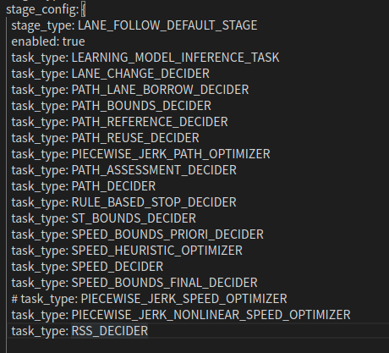
lane_follow

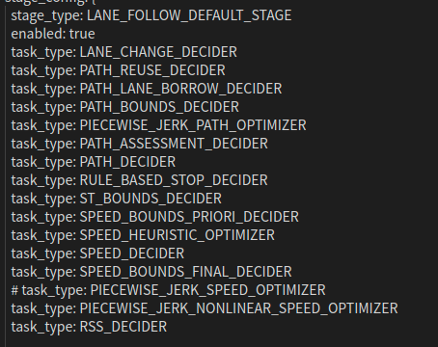

learning_model_inference_task
path_reference_decider

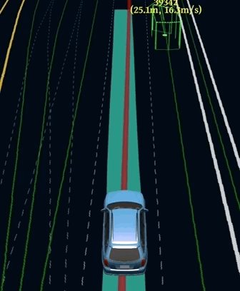
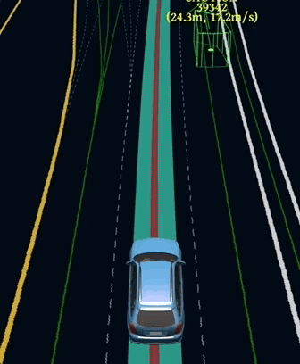
e2e

hybird
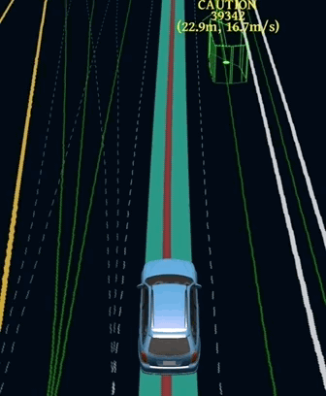

stage_config: {
stage_type: LEARNING_MODEL_RUN
enabled: true
task_type: LEARNING_MODEL_INFERENCE_TASK
task_type: LEARNING_MODEL_INFERENCE_TRAJECTORY_TASK
task_config: {
task_type: LEARNING_MODEL_INFERENCE_TASK
learning_model_inference_task_config {
model_type: CNN_LSTM
cpu_model_file: "/apollo/modules/planning/data/model/cpu_test_model_cnn_lstm.pt"
gpu_model_file: "/apollo/modules/planning/data/model/gpu_test_model_cnn_lstm.pt"
use_cuda: true
}
}

# NO_LEARNING / E2E / HYBRID / RL_TEST / E2E_TEST / HYBRID_TEST
learning_mode: NO_LEARNING

