**def** zad1(): Unit ={  
 **var** b = 102  
 **var** a: String = *delit*(b).toString  
 *print*(a + ": ")  
 **var** sum: Int=0  
 **for** (i<- a)  
 sum+=Integer.*parseInt*(i.toString)  
 *println*(sum)  
}  
  
**def** delit(num: Int): Int ={  
 **var** del: Int= 0  
 **for** (i <- 2 to num/2){  
 **if** (num%i==0) del=i  
 }  
 del  
}



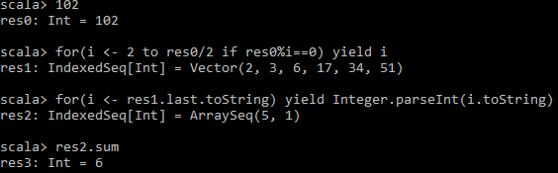

**def** zad2(): Unit ={  
 **var** b = ArrayBuffer[Int]()  
 b ++= (1 to 5)  
 b++=b++b  
 *println*(b)  
}



