Feasibility Analysis

For

NuApp

Version 1.0 approved

Prepared by NVS Abhilash

NIIT University

17/9/16

1. **Project Description –**

The product is a mobile application to help students of NIIT University to be able to view their current timetable with ease; to be able to apply gatepass through a mobile application itself and the application must notify the student and concerned parent / guardian about the same; to be able to view their issued books, to be notified about the reissue date; to be able to search for specific book availability in the library; and to view their “non-detail” attendance in the app.

1. **Current Situation –**

Currently their are three different application for the purpose. Student has to login into moodle, then go to gatepass service, then apply for gatepass. Simillary to check timetable we again need to login into Nucleus then check.

1. **Organizational and Technical Aspects –**

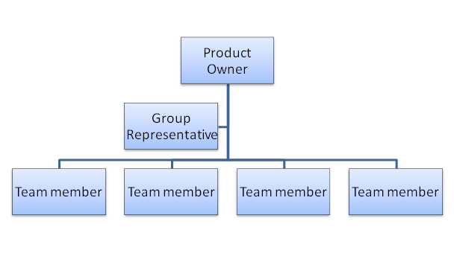

1. **Information Assessment –**

We conducted an online survey that was filled by our target customer i.e. the students of NIIT University.

Based on survey here are few points that we would like to share,

1. The survey was answered by 181 students of NIIT University.
2. 76.8 % of the people are not satisfied with the current scenario.
3. 89.5% of the people who answered the survey would love to download an application that tackles the problems that are discussed above.

Below is the few screenshots regarding the same:-

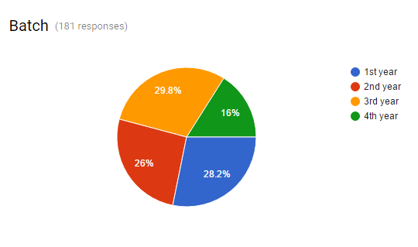

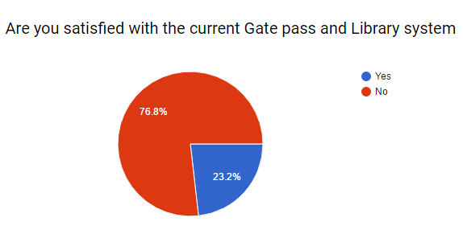

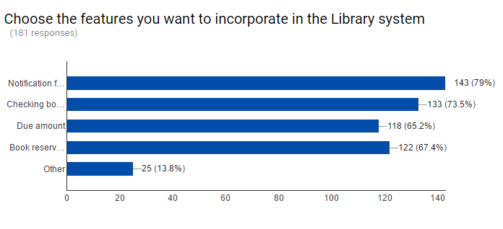

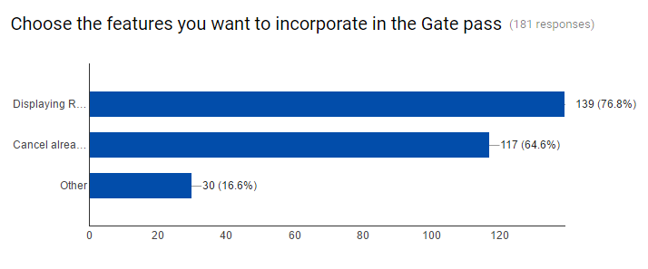

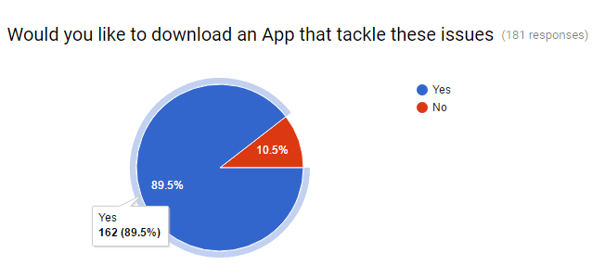

**6. Conclusion –**

**Product/service desirability**: - After going through the responses and the feedbacks we can say that kind of service is highly desirable.

**Product/service demand**: - As per responses we can conclude that such services are highly demanded by the students of NIIT University.

**Product/service feasibility**: - *Feasible*