**BLACKBOX TESTING**

**TEST CASE 1: PROCESS BUTTON TEST CASE**

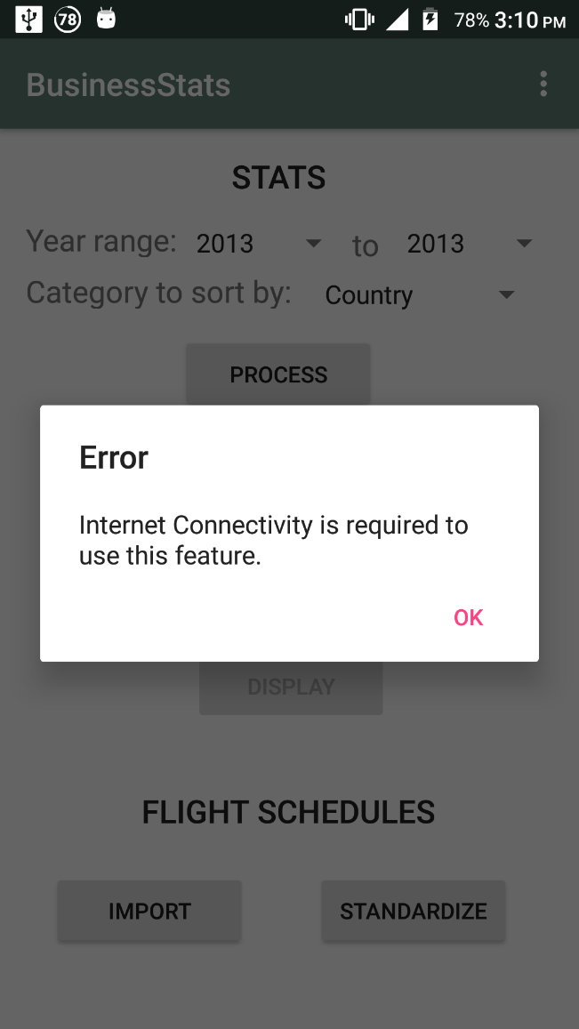 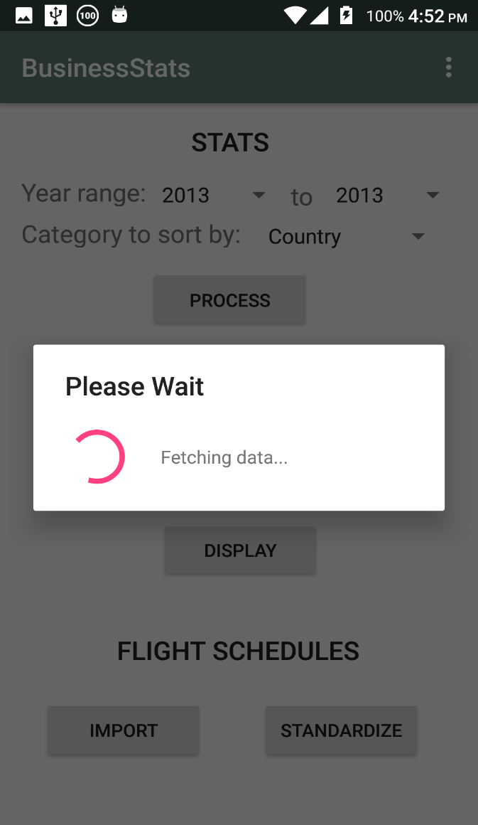 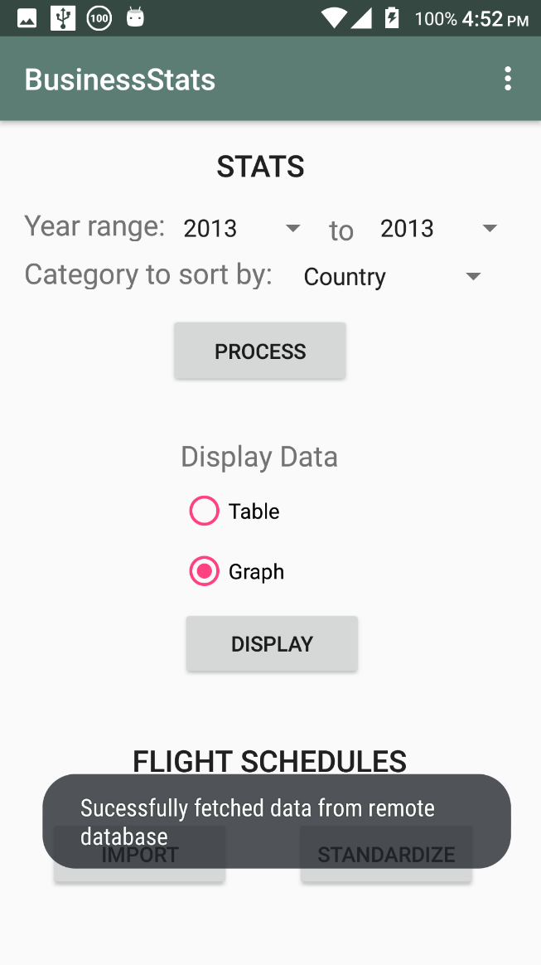

The process button retrieves data from the main remote tour database.

**Positive Test case scenario:** Data is retrieved in JSON format and stored in the local SQLite Database. The graph and table display options get enabled.

**Negative Test case scenario:** There is no internet connection. The app displays an error like in the image shown above. If error was not handled in the code, the app would have crashed.

**TEST CASE 2: EXCEL STANDARDIZER TEST CASE**

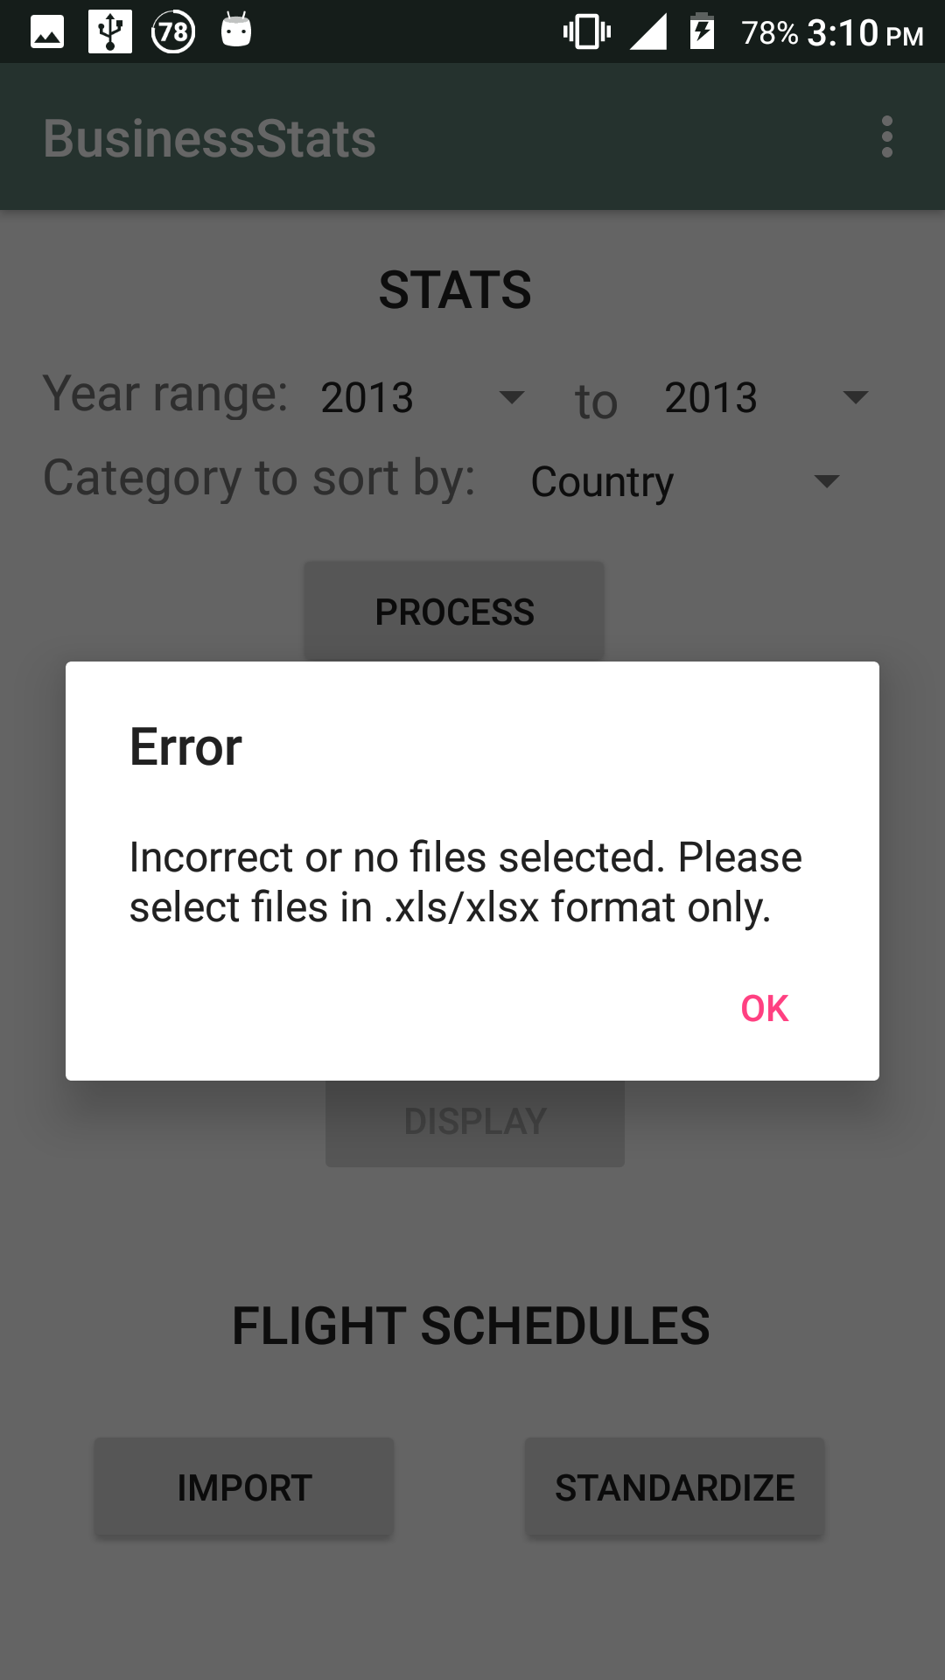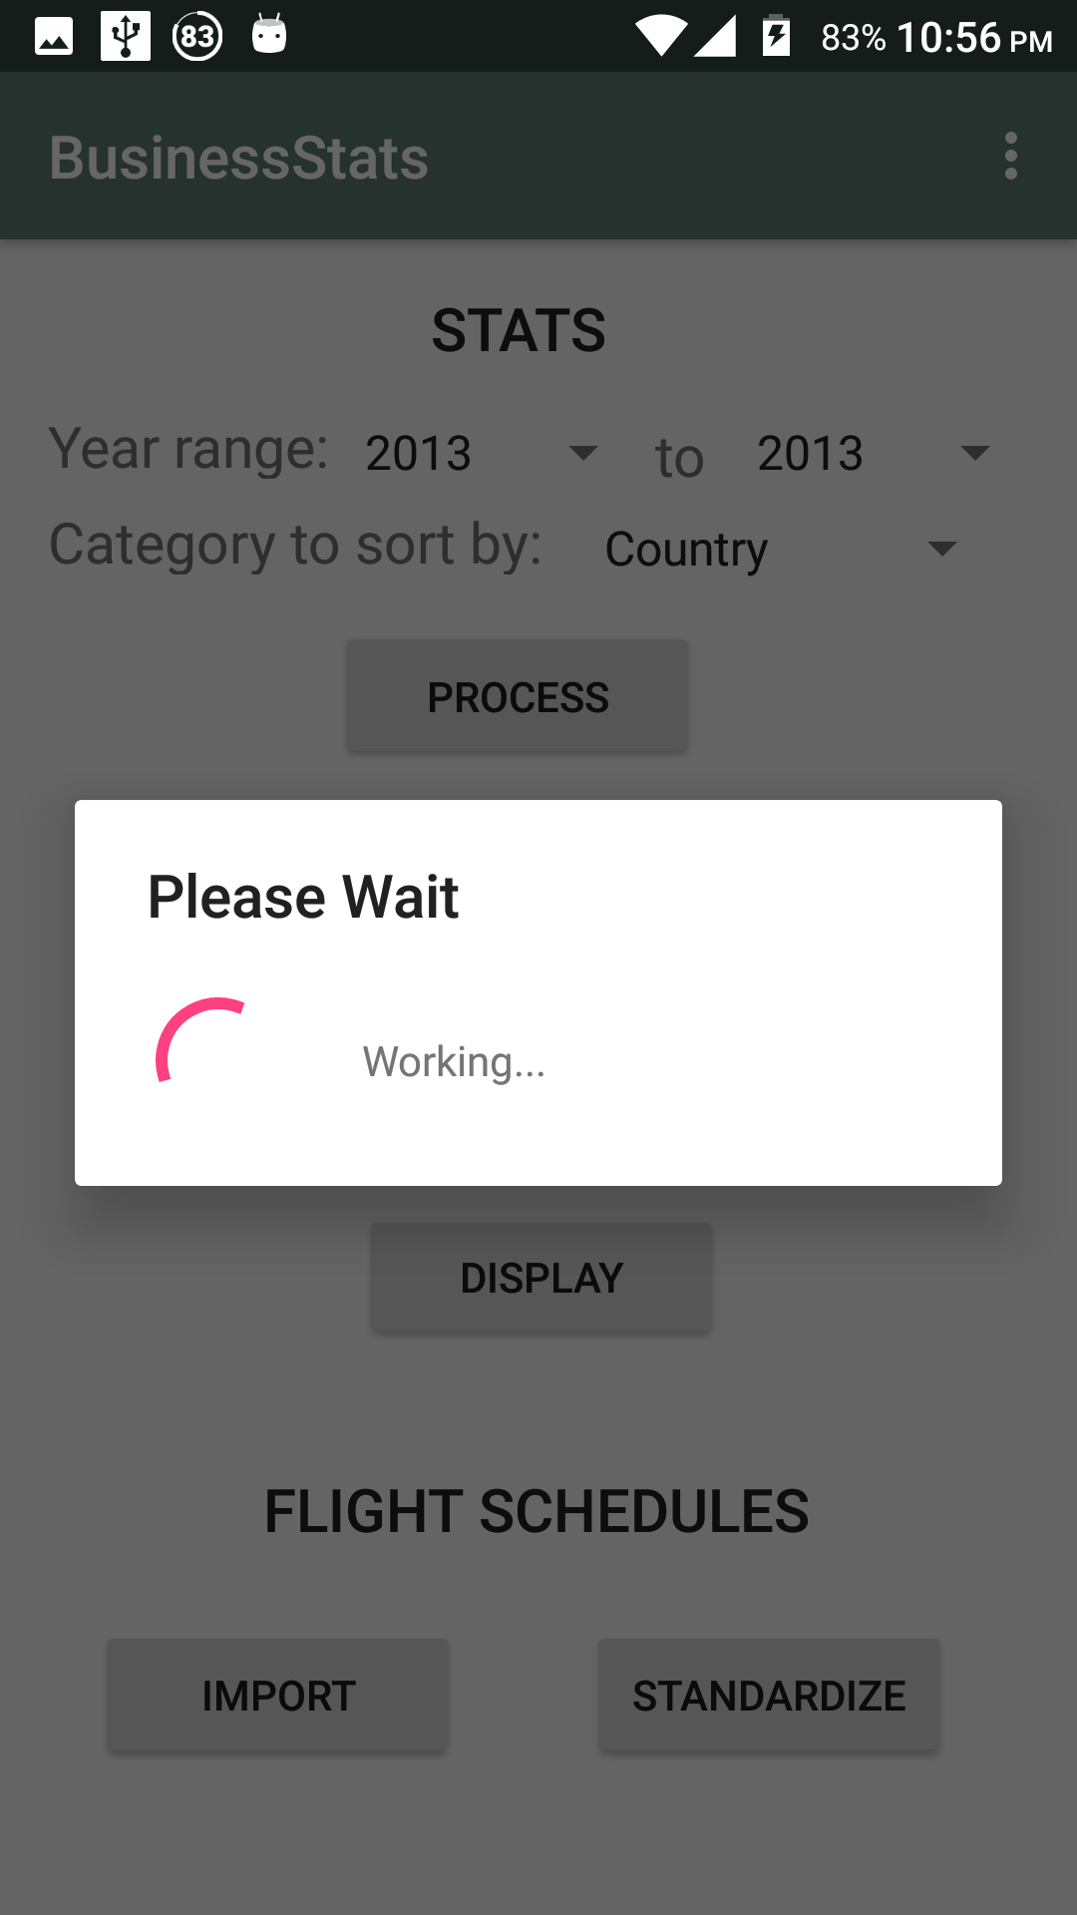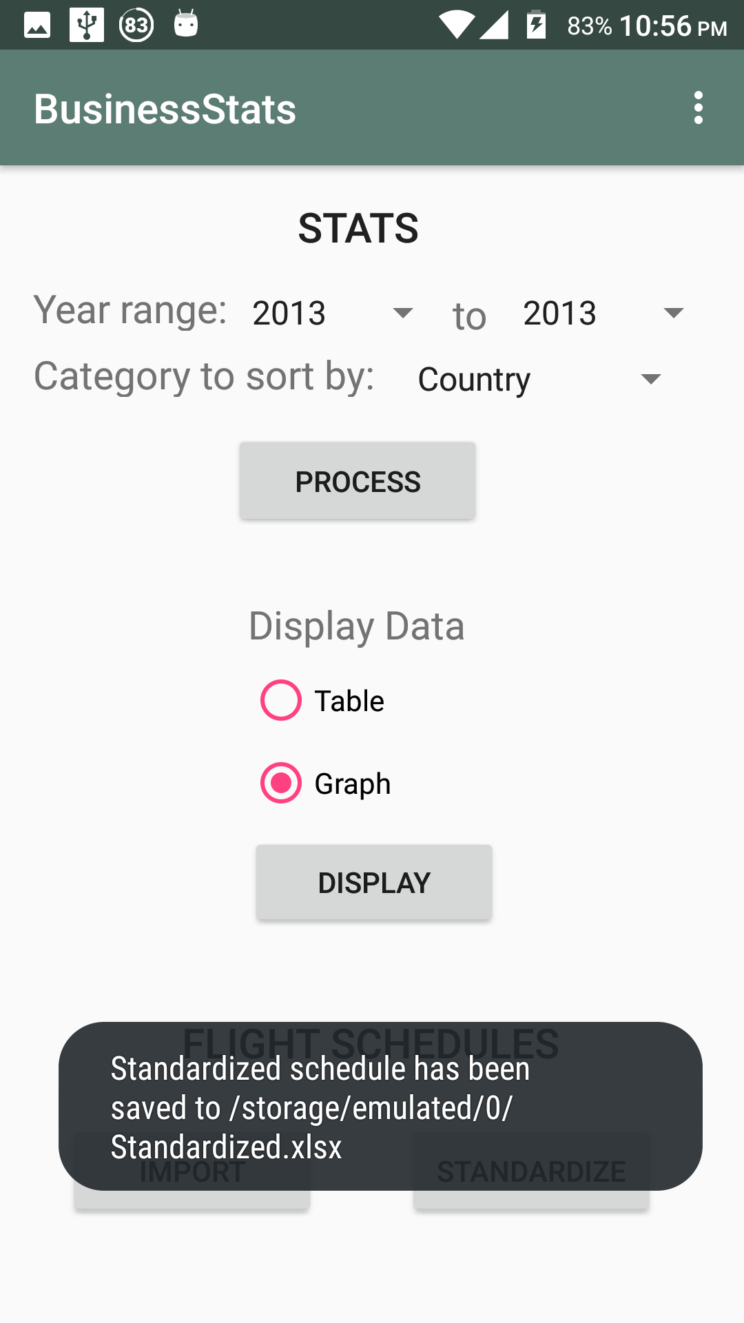

The import button opens a screen which allows the user to select flight schedule files in excel format. The standardize button then proceeds to read the imported files, tear them apart and merge and standardize all the imported files.

**Positive Test case scenario:** Files are read from device storage, standardized and saved to the device’s internal storage/SD card.

**Negative Test case scenario 1:** No file is selected in the import view. Pressing standardize will generate an error message. App will not crash because this exception has been handled in the code.

**Negative Test case scenario 2:** Files with extensions other than .xls/xlsx are selected in the import view. Pressing standardize will generate an error message. App will not crash because this exception has been handled in the code to prevent unexpected results.

**Negative Test case scenario 3:** Device storage is full. The app will generate an error saying that there is no space remaining on the device’s Internal storage/SD Card.

**Negative Test case scenario 4:** App has not been granted storage permissions by the user. The app will fail to read/write from device storage and generate an error.

**TEST CASE 3: YEAR SELECTION TEST CASE**

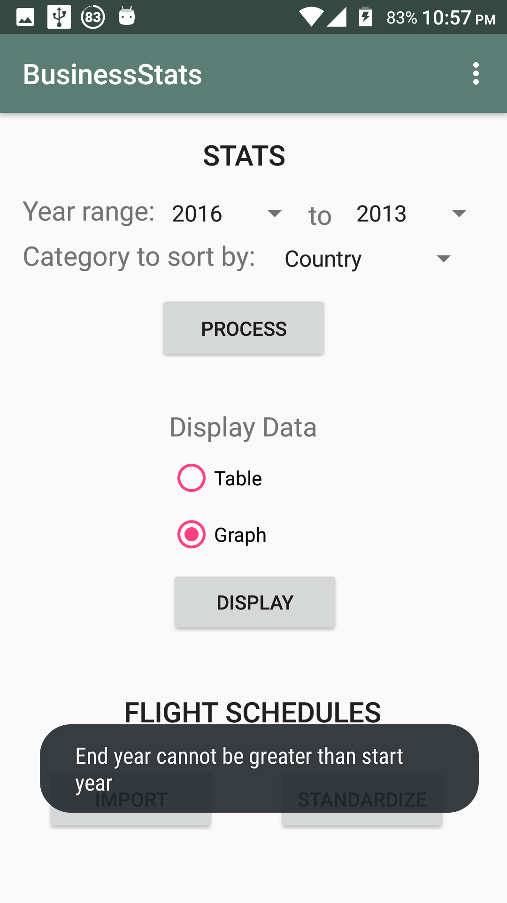

**Positive Test case scenario:** The start year is smaller than or equal to the end year. App is able to generate the required query and show the required data in the table/graph.

**Negative Test case scenario:** The start year is greater than the end year. The app generates an error to prevent it from crashing.