OOP METRICS

Tools Used:SourceMonitor

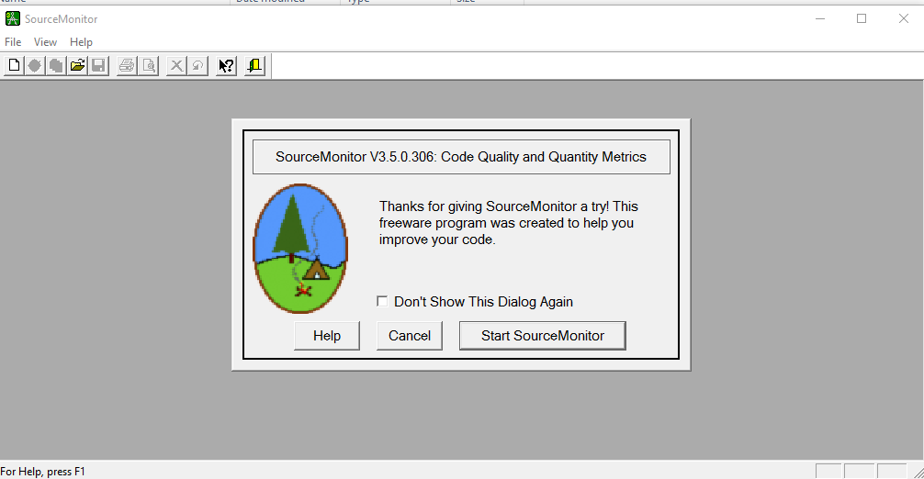

Results Achieved:

